1. Import the project as maven project.
2. Maven clean

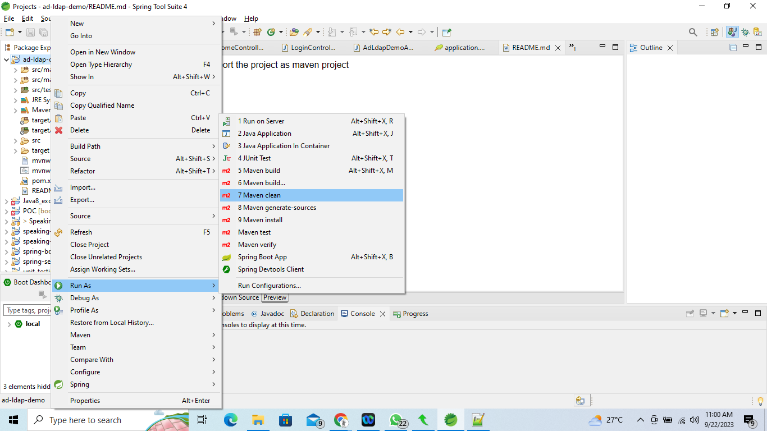

1. Maven install

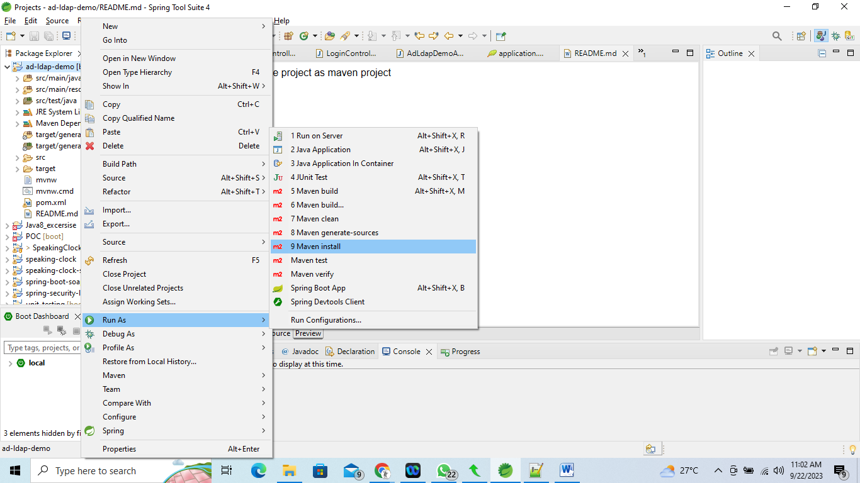

1. Run as spring boot app

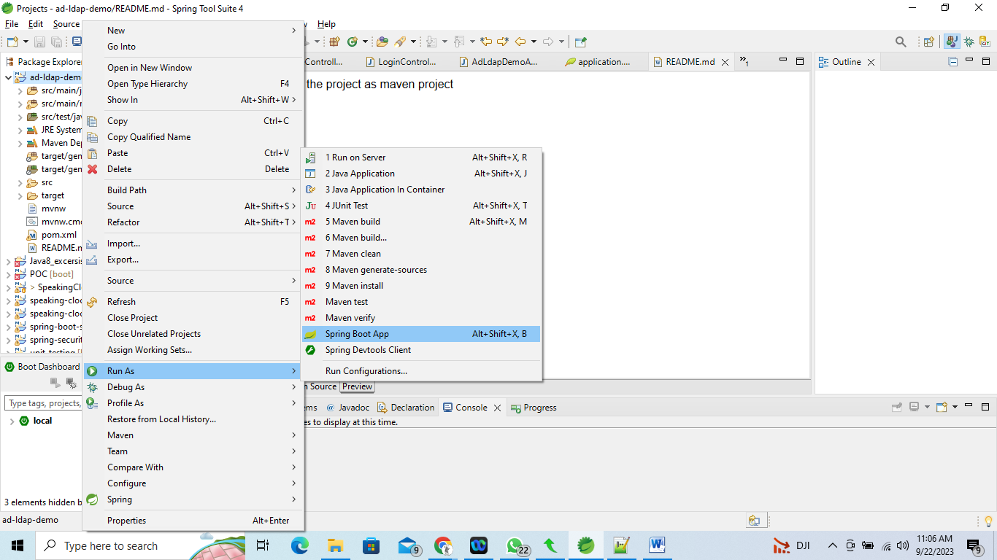

1. Open LDAP enabled URL:

Thats it on configuration front. Now we will run our application and access *http://localhost:8999/profile .* You will be redirected to login page as[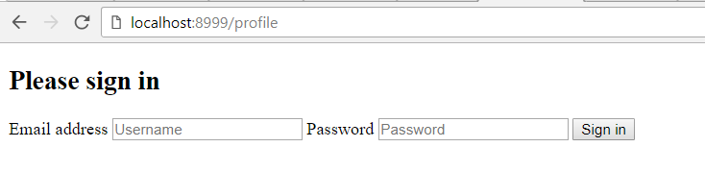](https://www.opencodez.com/wp-content/uploads/2017/10/login-page.png)

Now try and put any of the users from below. All users have a password as *password*

* riemann
* gauss
* euler
* euclid

If you enter correct user/password you will be taken to profile page else it will show you login error.[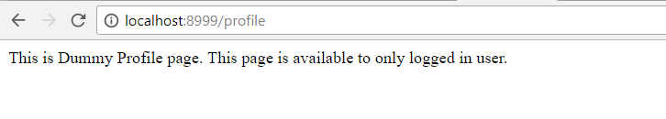](https://www.opencodez.com/wp-content/uploads/2017/10/logged-in-user.png)