* ACER ASPIRE E5-473-32GU I3 WIN10 TROPICAL YELLOW LAPTOP
* ACER ASPIRE E5-473-33UF I3 WIN10 CORAL PINK LAPTOP
* ACER ASPIRE E5-473-342W I3 WIN10 DENIM BLUE LAPTOP
* ACER ASPIRE E5-473-35EQ I3 WIN10 COTTON WHITE
* ACER ASPIRE E5-473-387A I3 WIN10 OCEAN BLUE LAPTOP
* ACER ASPIRE E5-473G-598N I5 NVIDIA OCEAN BLUE LAPTOP
* Beautiful Form

A variety of vivid interior colors with a stylish textile pattern are enjoyable to the eye and pleasant to touch. Additional edge highlights emphasize the stylish look of the entire series and are complemented by the smart undercut design that is both good looking and lets you easily raise the lid with just one hand.

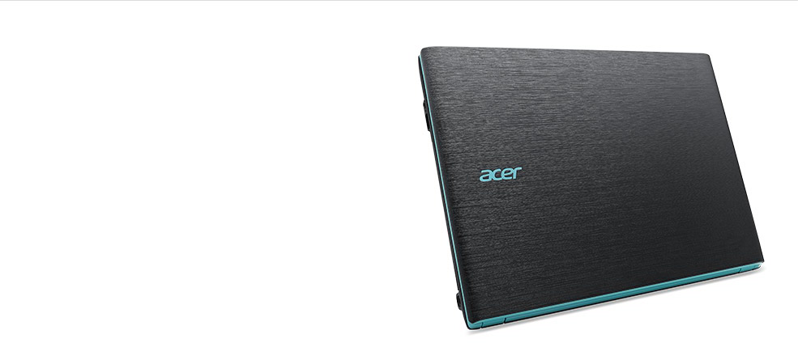

* SENSATIONAL EFFECTS



With added media enhancements and options, you get an even richer media experience. Our Acer True Harmony delivers more lifelike and richer audio while Skype-certified components deliver crystal clear, instant communication and uninterrupted audio and video, without fear of echoes, gaps or lags. You can even opt for models with an optical drive and/or Full HD display

* FUNCTIONS BETTER

Better? You bet. Enhancements to the features you’ve come to know and expect give you both added power and capability to get things done. You get better, faster wireless networking, greatly improved touchpad usability, and data storage increased in both size and speed. Add in eye care and power-off USB charging and you’re really full function.



* **ACER ASPIRE E5-473-53C0 I5 DOS C.GREY LAPTOP**

**Processor: INTEL CORE I5 5200U (2.20GHZ)**  
Operating System: DOS  
Memory: 2GB DDR3  
Graphics: INTEL HD GRAPHICS  
Display Size: 14? HD DISPLAY  
Storage: 500GB HDD SATA  
Note: SALE PRICE IS AVAILABLE FOR ONLINE TRANSACTION ONLY  
  
**Product Description  
Aspire E  
  
The new Aspire E Series laptops provide a comprehensive range of choices for every-day users, with lots of appealing feature options and an attractive design that exceeds expectations. With many enhanced components, color choices, and a textured surface, the Aspire E series is a good bit better at delivering a good bit more.  
  
Beautiful form  
  
A variety of vivid interior colors with a stylish textile pattern are enjoyable to the eye and pleasant to touch. Additional edge highlights emphasize the stylish look of the entire series and are complemented by the smart undercut design that is both good looking and lets you easily raise the lid with just one hand.  
  
Sensational effects  
  
With added media enhancements and options, you get an even richer media experience. Our Acer TrueHarmony delivers more lifelike and richer audio while Skype-certified components deliver crystal clear, instant communication and uninterrupted audio and video, without fear of echoes, gaps or lags.  
  
Functions better  
  
Better? You bet. Enhancements to the features you’ve come to know and expect give you both added power and capability to get things done. You get better, faster wireless networking, greatly improved touchpad usability, and data storage increased in both size and speed. Add in eye care and power-off USB charging and you’re really full function.**

* **ACER ASPIRE E5-551G-F57K LAPTOP**
* SUPERIOR PRODUCTIVITY

Experience new speed while web browsing, communicating and playing videos on the Aspire E5 with Intel® or AMD processing and ample memory. Enjoy control of Windows 8 with an HD touchscreen1, and view everything comfortably on the crisp matte LED display. A large hard drive provides more space for your media.

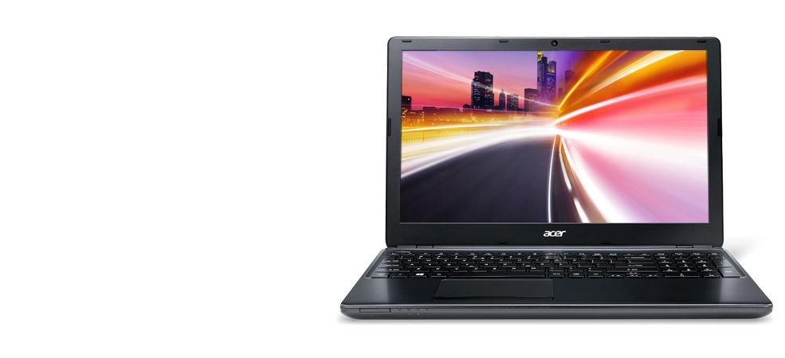

* BEAUTIFULLY SLIM

The Aspire E5 houses a built-in DVD player yet is a remarkable 25.3 mm1 thin. These notebooks provide a robust and affordable mobile platform for your work, slim enough to slip into your backpack or briefcase with ease



* SENSATIONAL FUN

Your movies and videos will look stunning in 1920 x 1080 resolution on the Full HD1 display, giving you a truly cinematic experience. Go even larger using HDMI® to connect to your high-definition TV. Discrete graphics options from AMD and NVIDIA® amplify visuals for all your media



* EVERLASTING MEMORIES

The Aspire E5 packs an M-DISC Ready™ Drive1 that can preserve your precious data for centuries. Students, parents, or anyone with irreplaceable files will appreciate peace of mind knowing that personal information and priceless memories are safe.

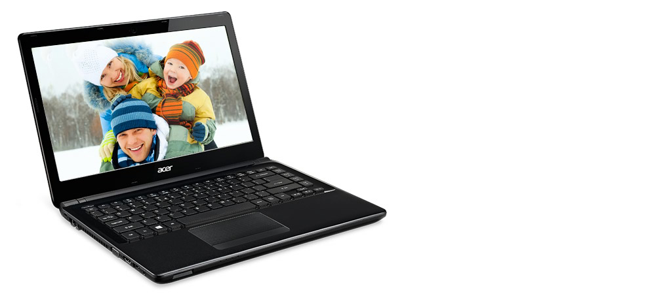

* ACER ASPIRE SWITCH 10E (SW3-013-14EP)

**VERSATILE SHAPE-SHIFTER**

This device’s perfectly designed Acer Snap Hinge™ 2 lets you snap the keyboard part on or off with a simple push or pull. Switch effortlessly between four very useful modes: notebook, tablet, tent, and display.



**EYE-CATCHING TRENDSETTER**  
The Aspire Switch 10 E comes in a range of trendy colors that all work perfectly with its dynamic shape and elegant textile-pattern texturing to create one great-looking device. Choose the color that suits you, and watch your friends turn green with envy.



**.**

**POWERFUL PRODUCER**

An Intel quad-core processor gives ample power for serious work and fun, and 12 hours of battery life lets you compute on the go throughout the day. This 2-in-1 runs on Windows 8.1 and features all the Microsoft Office programs1 you need to get it done.



**DATA PROTECTOR**

Acer SwitchLock™ lets you lock this keyboard dock’s HDD so it only works with the tablet part. Use the tablet as the HDD’s key – simply snap the tablet off the keyboard to lock the HDD. All your HDD data is now protected and can’t be stolen. Simply snap the tablet back on to unlock all that data.

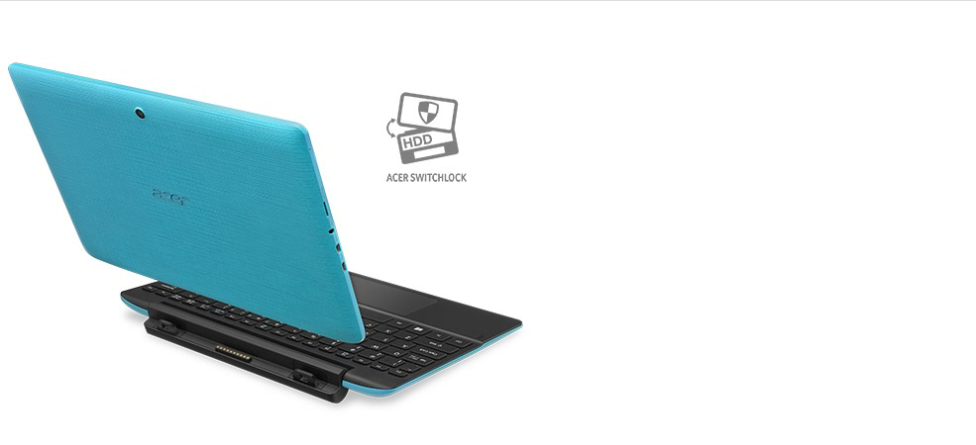

**FRIEND OF YOUR EYES**

This device features Acer VisionCare™, so you can switch on Acer BluelightShield™ to reduce stress-causing blue light when you need to look at the screen for long periods. Acer LumiFlex™ auto-boosts contrast when you use this device in direct sunlight – no more squinting when you step outside!



**GREAT ENTERTAINER**  
The HD screen features IPS technology2, so you get clear images when viewing from any angle. The screen is also made of ultra-tough Gorilla™ Glass, which protects against scratches and also makes scratches less visible. Dual speakers deliver serious sound and work with dual cameras to ensure great video calls.

* ACER E5-473-53C0

Windows 8.1 Single Language

Intel® Core™ i5-4200U processor Dual-core 1.60 GHz

35.6 cm (14") HD (1366 x 768) 16:9

Intel® HD 4400 with Shared Memory

4 GB, DDR3L SDRAM

500 GB HDD

**Product details of Acer Aspire E5-473-53C0 14" Intel Core i5-5200U 2GB (Grey)**

**Aspire E**

Don’t settle for less

The new Aspire E Series laptops provide a comprehensive range of choices for every-day users, with lots of appealing feature options and an attractive design that exceeds expectations. With many enhanced components, color choices, and a textured surface, the Aspire E series is a good bit better at delivering a good bit more.

**Beautiful form**

A variety of vivid interior colors with a stylish textile pattern are enjoyable to the eye and pleasant to touch. Additional edge highlights emphasize the stylish look of the entire series and are complemented by the smart undercut design that is both good looking and lets you easily raise the lid with just one hand.

**Sensational effects**With added media enhancements and options, you get an even richer media experience. Our Acer TrueHarmony delivers more lifelike and richer audio while Skype-certified components deliver crystal clear, instant communication and uninterrupted audio and video, without fear of echoes, gaps or lags.

**Functions better**

Better? You bet. Enhancements to the features you've come to know and expect give you both added power and capability to get things done. You get better, faster wireless networking, greatly improved touchpad usability, and data storage increased in both size and speed. Add in eye care and power-off USB charging and you’re really full function.

* ACER ES1-431

Specs:

Intel Pentium Quad  
Intel Pentium Quad Core N3700 Processor,  
Intel HD Graphics, 500GB Hard Drive,  
Windows 8.1 with Bing, 2GB DDR3 Memory,   
14-inch HD LED Display1

* ACER ONE14-Z1402

Linpus™ Linux®

Intel® Celeron® 2957U processor Dual-core 1.40 GHz

35.6 cm (14") HD (1366 x 768) 16:9 CineCrystal

Intel® HD Graphics with Shared Memory

2 GB, DDR3L SDRAM

500 GB HDD

* ACER R11

Windows 10 Home

Intel® Pentium® N3700 processor Quad-core 1.60 GHz

29.5 cm (11.6") HD (1366 x 768) 16:9

Intel® HD Graphics with Shared Memory

4 GB, DDR3L SDRAM

500 GB HDD

* ASUS X453S
* Model: ASUS X453S-WX031T
* Operation System: Windows 10
* Processor: Intel® Celeron® Quad-Core N3150 Processor
* Dimensions (H x W X D cm): 34.8 x 24.2 x 2.53
* Weight: 2.0 kg
* Memory: 2GB DDR3L 1600 MHz SDRAM
* Hard Disk: 500GB HDD
* Display Screen: 14.0-inch HD LED Display
* Optical Media Drive: Super-Multi DVD
* Screen Resolution: 1366x768
* Network & Communication: Integrated 802.11 b/g/n, BT 4.0 support (on WLAN+ BT 4.0 combo card)
* Connectivity: 1 x COMBO audio jack, 1 x VGA port/Mini D-sub 15-pin for external monitor, 1 x USB 3.0 port(s), 1 x USB 2.0 port(s), 1 x RJ45 LAN Jack for LAN insert, 1 x HDMI
* VGA Web Camera
* Certified for Skype
* Power Supply: 33 W
* Product Warranty: 1-year parts and service; 6 months on battery; no warranty on software and accessories
* Red Hot Gadget Promo: FREE GENIUS SPEAKER (SP-S110)s
* ASUS X455L
* Processor Type: Intel Core i5 4210U Processor
* Processor Speed: 2.7 GHz
* Screen Size: 14" LED Backlight Display
* RAM: 4 GB RAM
* Hard Disk: 1 TB HDD
* Optical Drive: DVD RW
* Graphics Card: Intel HD Graphics 4400
* Audio/Speaker: Yes
* Networking: Wi-Fi, Bluetooth, USB
* Webcam: Yes
* Card Reader: Yes
* Battery: 6 Cell Battery