* **A4TECH HS-100 BLACK HEADSET**

Brand: A4 Tech

Item Weight: 481 g

Product Dimensions: 24.5 x 22.5 x 11 cm

Item model number: HS-100

Series: HS 100

Form Factor: Headband Headset

* **A4TECH HS-28 BLACK/ORANGE HEADSET**

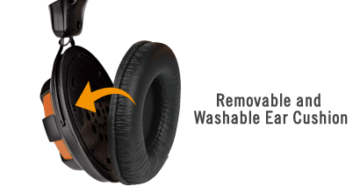

Top of Form

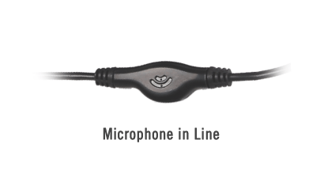

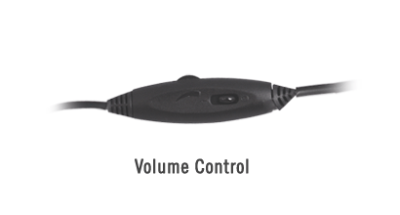

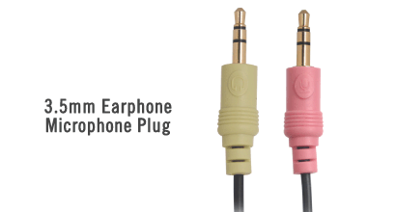

Bottom of Form

* **A4TECH HS-50 I-CHAT W/ MIC HEADSET**

Top of Form

* Comfort fit stereo headset
* Volume and microphone switch in-line—quick access to headset volume control and microphone
* Quad-rate ear cushions design helps to relieve pressure for all day comfort
* Earphone hook included—Convenient and practical for you to hang your headset up when you do not use it
* Easy adjustable headband ensures optimum fit and comfort
* Ideal for voice chat or VoIP calling
* Open-air, light-weight design, all day comfort and reliability
* Superior sound quality – Transparent bass-driven sound
* Adjustable headband & boom microphone stay comfortably in place
* Noise canceling microphone delivers clean, crisp sound
* In-line volume & microphone control

Bottom of Form

# A4TECH HS-5P HEADSET

# Sleek behind-the-neck design. Ultra-light weight for powerful sound and comfortable listening on the move. Earphone hook included, convenient and practical for you to hang your headset up when you do not use it.

# A4TECH HS-66 I-CHAT HEADSET

# Quality internet head-phone delivers a full rich sound, noise canceling microphone helps eliminate background noise. Handy in-line volume and microphone volume controller. Ultra-light weight for powerful sound and comfortable listening on the move.

# A4TECH HS-7P HEADSET

# Quality internet headphone delivers a full rich sound. Easy adjustable headband ensures optimum fit and comfort. Volume and microphone switch in-line—quick access to headset volume control and microphone

# LOGITECH H150 W/ MIC CLOUD WHITE HEADSET

* Full stereo sound

Lets you enjoy your voice and video calls.

* Noise-canceling microphone

You won’t have to compete with background noise to be heard—which means crystal clear calls with work, family and friends.

* Versatile design

The microphone can be worn on either your left or right side.

* Rotating boom

You simply rotate the microphone out of the way when you’re not using it.

# LOGITECH H150 W/ MIC FUCSHIA PINK HEADSET

* Full stereo sound

Lets you enjoy your voice and video calls.

* Noise-canceling microphone

You won’t have to compete with background noise to be heard—which means crystal clear calls with work, family and friends.

* Versatile design

The microphone can be worn on either your left or right side.

* Rotating boom

You simply rotate the microphone out of the way when you’re not using it.

# LOGITECH H150 W/ MIC SKY BLUE HEADSET

* Full stereo sound

Lets you enjoy your voice and video calls.

* Noise-canceling microphone

You won’t have to compete with background noise to be heard—which means crystal clear calls with work, family and friends.

* Versatile design

The microphone can be worn on either your left or right side.

* Rotating boom

You simply rotate the microphone out of the way when you’re not using it.

# LOGITECH H340 USB BLACK HEADSET

* Versatile headset: Great for Internet calls and listening to music from your Mac or Windows computer
* Plug-and-play USB connection: Simply plug the headset into your PC for quick and easy stereo audio
* Clear digital sound: Pure USB digital audio for crystal clear music and calls
* Rotating boom microphone: Reduces background noise for clear chats, rotates up and hides away when you’re listening to music
* Comfortable design: Lightweight adjustable headband and foam ear cups for a feel-good fit

# LOGITECH H390 USB W/ MIC HEADSET

# Feeling good

# You’ll be comfortable with this headset thanks to the plush ear pads and padded headband that adjusts to you.

# Loud and clear

# The noise-canceling microphone cuts background noise—and rotates out of the way when you’re not using it.

# Easy listening

# You’ve got it easy—this plug-and-play usb headset gives you quick access to volume and mute controls.

* **PLANTRONICS AUDIO 478 FOLDABLE USB HEADSET**

Folding USB stereo headset is incredibly lightweight, has clear HD sound and is Skype™ Certified for clear calls on the go.

# SALAR K97 OVER-THE-EAR HEADPHONES (BLUE)

* Headset type/design: Over-The-Ear Headphones
* Frequency response: 20 Hz – 20 kHz
* Sensitivity/Sound pressure level: 80dB
* Plug type and length: 3.5mm Stereo Jack
* Cable type and lenght: 1m TPE cable
* Maximum Input Power: 5 mW Impedance: 32 ohms
* Compatibility with devices: Compatible with most mobile phones, mp3 players, and computers