* **AOC 19.53INCH M2060SWD LED DVI + VGA LED BLACK MONITOR**

Display Size: 19.53” Wide (496 mm diagonal)

Native Resolution: 1920 x 1080

Response Time: 16 ms (GTG)

Viewing Angle (horizontal): 178°(H)

Viewing Angle (vertical): 178°(V)

Analog Input: 15 Pin D-SUB connector

Digital Input: 24 Pin DVI-D Connector

Product Description

FUHD MVA Panel

Wide View – No changes in brightness or color from any viewing angle.

Real Color – Consistent, unifonn color at all points on the screen.

High contrast ratio (3000:1) image look brighter, sharper, more detailed and vivid.

Ultra Low Power Consumption

The LED backlight panel requires 50% less energy than typical 4CCFL monitors.

LED Panel: Hg Free

Mercury (Hg) is poisonous, producing toxic environment waste.

Unlike the CCFL backlight in traditional monitors, the LED backlight panel contains no Hg.

Screen+ Software

The bundled Screen+ software splitis the PC workspace into four self-contatined panes to group application windows for easier viewing. Screen+ also supports multiple monitors.

Dynamic Contrast Ratio (DCR)

Ultra-high Dynamic Contrast Ratio of 20,000,000:1 displays darker images with more depth and detail.

Eco Mode

Hotkey adjustment of display settings suit 5 different viewing styles: Text, Inter-net, game, Movie and Sport.

e-Saver

Software enables user to set the low power configuration of monitor when PC is in screen Saver, On, Off, Sleep. User can choose the time to turn monitor off to save power consumption

i-Menu

Included PC software allows the user to change the OSD settings using their mouse.

Off Timer

To save power, a timer can be set to automatically turn off the monitor after a user-defined interval.

Hair-Line Texture

Brushed surface texture provides a luxury look and feel.

Energy Star

TCO Certified Display 5.2

* **AOC 21.5 E2250SWD LED/(1920X1080) BLACK MONITOR**

22-inch class (21.5-inch viewable) LED widescreen display  
1920 x 1080 optimum resolution for crisp images  
20,000,000:1 dynamic contrast ratio for easy-to-read text  
200 cd/m brightness  
5 ms response time prevents drag  
RGB D-Sub and DVI-HDCP inputs  
Measures 15.5 by 22.2 by 4.3 inches (HxWxD) and weighs 7.2 pounds

# AOC 21.5INCH I2269VW IPS LED BLACK MONITOR

The AOC I2269VW features a borderless screen with a sleek and slim design. The ultra-thin IPS panel ensures a consistent image appearance from all viewing positions. Boasting 1920×1080 full HD resolution, a 50,000,000:1 contrast ratio, and a 5ms response time, the AOC I2269VW presents your movies, games, and documents with a new level of sharpness and fidelity. VGA and DVI-D inputs enable compatibility with most of today’s video equipment. It’s also Energy-Star certified, which means a reduced electric bill and lower environment impact. The detachable multi-purpose stand makes installation flexible.

* newegg*INNOVATIVE IPS PANEL* This sleek display features an IPS (In-Plane Switching) panel, a superior type of screen that offers a consistent image appearance, higher definition, better color accuracy, and greater light transmission from all viewing positions.
* newegg*STUNNING IMAGE QUALITY* The AOC I2269VW boasts an amazing 1920 x 1080 resolution at 60Hz, with a 16:9 aspect ratio and an impressive 50,000,000:1 dynamic contrast ratio. With a response time of 5ms, you can watch videos or play games free of ghosts and blurs.
* newegg*LED BACKLIGHT* Powered by LED backlight technology, the AOC I2269VW produces a vibrant picture with brighter whites and darker blacks. It is also more eco-friendly, as the LED light source contains less hazardous substances compared to CCFL light sources.
* newegg*SLIM DESIGN WITH ULTRA-NARROW BEZEL* The display’s ultra-narrow bezel measures just 2mm for a borderless appearance, so it’s ideally suited for use in dual- or multiple-monitor setups. Plus, the ultra-slim monitor can also be detached from the stand, and be wall-mounted with the VESA 75mm Wall Mount Compliant feature.
* newegg*NON-REFLECTIVE, ANTI-GLARE MATTE COATING* This screen features a non-reflective, anti-glare matte coating that won’t leave fingerprints or smudges – it’ll remain as clean as new!
* newegg*MULTIMEDIA CONNECTIVITY* the i2269Vw comes with VGA and DVI-D with HDCP for multimedia connectivity.
* **ASUS 18.5INCH VS197DE (1366X768) BLACK MONITOR**

### **Exclusive Game Plus function**

Exclusive GamePlus functionhotkey to enable OSD crosshair and timer functions. Select from four different crosshair to suit your gaming environment, and keep track of spawn and build times with the on-screen timer.



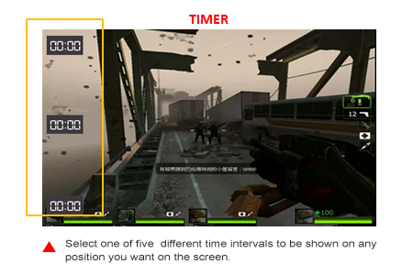

### **Vivid, lifelike visuals**

### **The latest IPS technology with 178 Wide-view angles**

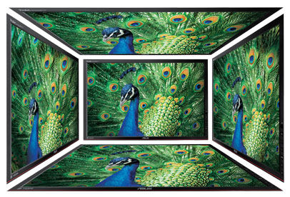

VC239 series feature with In-Plane Switching technology panel with a 178° wide-view angle that minimizes color shift on both horizontal and vertical planes to ensure quality visuals from almost any direction.



### **80,000,000:1 ASUS Smart Contrast Ratio**

With ASUS Smart Contrast Ratio (ASCR) of 80,000,000:1 and 250cd/m² brightness, VC239H augments display contrast and sharpness by adjusting backlighting luminance to achieve the deepest blacks and brightest whites for truly lifelike visuals

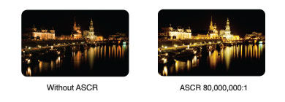



### **ASUS-exclusive Vivid Pixel Technology**

The Vivid Pixel Technology enhances outline, sharpness, and color saturation of images and videos to deliver high-quality visual experience.



#### **Monitor without Vivid Pixel**

* Image quality mainly depends on panel itself
* Blur happens if original quality of an image is bad
* Usually people don’t notice this detail because no comparison was made



#### **VC series – In-Plane Switching technology panel incorporated with Vivid Pixel**

* In-Plane Switching technology panel known for its excellent image quality
* Vivid Pixel default at 25 automatically fine-tunes image quality
* See more differences by choosing among 5 options in Vivid Pixel setting

To deliver a more comfortable viewing experience, ASUS Eyecare monitors adopts Flicker free and Low Blue Light technology to clear out the distracted flicker shown on the screen and help reduce eye fatigue for long-period watching.

Conventional monitors without Eye Care technology

With Flicker-free and Low Blue Light Technology

### **Quick Fit Virtual Scale for true what you see is what you get**

ASUS includes its exclusive Quick Fit Virtual Scale feature with the VC239, allowing you to preview photos and documents on-screen in their actual size prior to printing. It can be activated via a monitor hotkey, and serves as a highly useful guide to accurately view and edit photos in their native size.

**Supporting Formats:**

* Document: A4, Letter
* Photo: 8”x10”, 5”x7”, 4”x6”, 3”x5”, 2”x2”
* Grid: Alignment

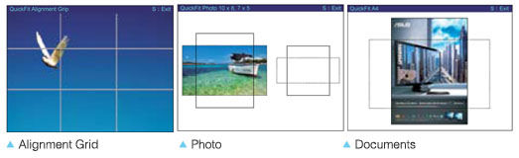

# ASUS 23INCH VC239H SLIM IPS LED/(1920X1080)/5MS MONITOR

# ASUS 27INCH VX279H (1920X1080) LED MONITOR

### **Superior Image Quality Meets Frameless Elegant Design**

Inspired by millennia of artistic legacy, the new VX279H sports an elegant and precision-crafted sundial design. The VX279H features an edge-to-edge frameless panel with 178° ultra-wide viewing angle AH-IPS A+ panel for incredible visuals. It’s ultra-slim and ergonomic design can be tilted to provide you comfortable viewing experiences, while dual HDMI/MHL ports offers extensive connectivity options.

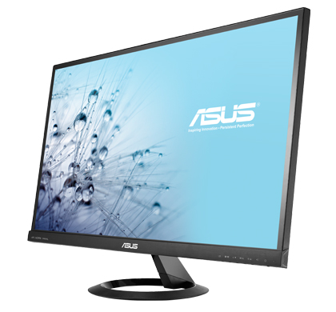

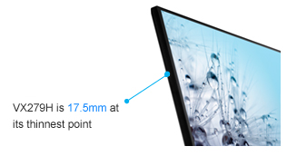

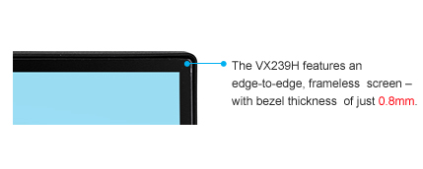

### **Extensive Connectivity and Built-in Stereo Speaker for Multimedia Enjoyment**

VX279H comes with rich connectivity including dual HDMI/MHL ports and D-sub so that users could easily share MHL mobile devices* content on a much bigger screen as well as charging MHL devices simultaneously. Also connect VX279H with Full HD Blu-ray Disc players and myriad HD playback devices like DVD players and set-top boxes for limitless entertainment and multimedia enjoyment with the built-in stereo speakers.

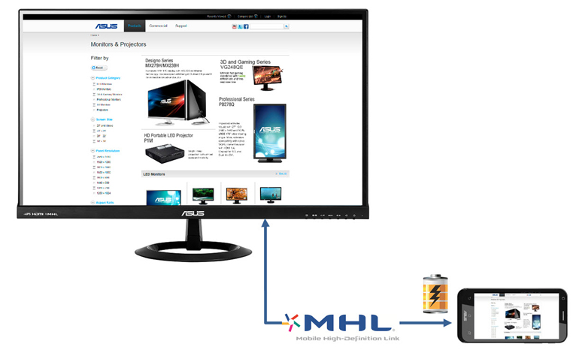  
* For the MHL enabled product list, please refer to <http://www.mhlconsortium.org/>

### **Vivid, lifelike visuals**

### **The latest IPS technology with 178?Wide-view angles**



VX279H features a 16:9 aspect ratio LED-backlit AH-IPS A+ panel with a 178° wide-view angle that minimizes color shift on both horizontal and vertical planes to ensure quality visuals from almost any direction. AH-IPS is the latest in IPS technology – delivering improved color accuracy plus increased energy efficiency.

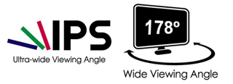

### **80,000,000:1 ASUS Smart Contrast Ratio**

With ASUS Smart Contrast Ratio (ASCR) of 80,000,000:1 and 250cd/m² brightness, VX279H augments display contrast and sharpness by adjusting backlighting luminance to achieve the deepest blacks and brightest whites for truly lifelike visuals





### **ASUS-exclusive VividPixel Technology**

The VividPixel Technology enhances outline, sharpness, and color saturation of images and videos to deliver high-quality visual experience.



#### **Monitor without VividPixel**

* Image quality mainly depends on panel itself
* Blur happens if original quality of an image is bad
* Usually people don’t notice this detail because no comparison was made



#### **VX series – IPS panel incorporated with VividPixel**

* IPS panel known for its excellent image quality
* VividPixel default at 25 automatically fine-tunes image quality
* See more differences by choosing among 5 options in VividPixel setting

# BENQ 21.5INCH GW2255 (1920X1080) WIDESCREEN BLACK MONITOR

### **http://benqimagetest.blob.core.windows.net/benq-img/148_1_resource_ext.cfm Brilliant Image Quality**

#### **VA LED Leads the Way**

After launching the world’s first VA LED monitor, BenQ – the world’s leading LED monitor brand – is now taking the lead to introduce VA LED to our home & offcie offering: GW Series! Built with the dream combination of LED with VA panel, GW Series is bound to bring a whole new visual experience and enjoyment to you with truly authentic colors, deeper blacks, higher contrast and sharper details.

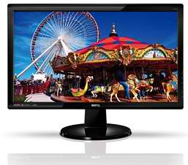

### **Flicker-free Backlight for Visual Pleasure**

The Flicker-free technology eliminates flickering at all brightness levels and effectively reducing eye fatigue. Conventional LCD screens flicks 200 times per second. Your eyes may not see flickers, but can certainly feel them. Free your eyes from flickers by switching to Flicker-free Monitors and let your eyes do less work.



BenQ is the 1st monitor brand to obtain the TÜV Rheinland certification for its Flicker-free technology.  
Herewith the claim from TÜV Rheinland: “The certified product is a LCD-display which contains direct current backlight system. This system reduces the main cause of flicker, and thus provides a more pleasant viewing experience.”

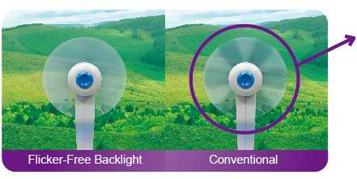

#### **Visible Flickering**

Place a fan before the monitor screen to check through the spinning fans for flickering

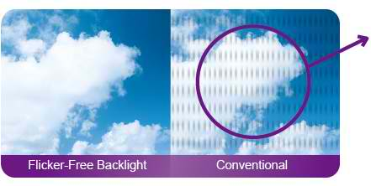

#### **Visible Flickering**

Use your camera to take a picture of the monitor screen to check for flickering

### **3000:1 Native Contrast Ratio and 20M:1 Dynamic Contrast Ratio for Depth and Definition**

The GW2255 comes with a native contrast ratio of 3000:1 and dynamic contrast ratio of 20M:1 to add color depth and definition to darkened and complex motion pictures, so that everything you see, from the brightest white to the darkest black, is perfectly rendered to deliver the clearest, smoothest picture performance during movies and video games.



### **Full HD 1080p 16:9 Visual Perfection**

The BenQ GW2255 supports the Full HD 1080p with 16:9 aspect ratio – allowing the subtlest details to stand out with richer, more realistic colors, making your viewing experience even more absorbing.

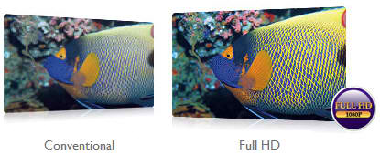

### **Superior Response Time**

Enjoy high dynamic videos without ghosting or other artifacts with 6ms GTG response time.



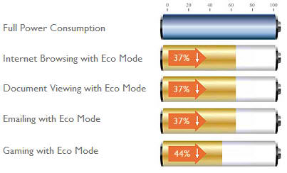

### **Improved Eco Mode for Higher Energy Efficiency**

The improved Eco Mode adjusts the backlight brightness level to ensure the highest display quality is presented to you with the highest energy efficiency. This intelligent mode reduces at least 37% of the power consumed by document viewing, Internet browsing and emailing and up to 44% of the power consumed by gaming.

### **Senseye® Visual Solution to Your Everyday Viewing Needs**

Experience the truest colors of the world with the BenQ Senseye® Human Vision Technology. With the help of its six proprietary calibration techniques, Senseye® delivers only the best viewing quality in each of its six pre-set viewing modes –Standard, Movie, Game, Photo, sRGB, and Eco – with the Eco Mode especially designed to save power and money.







### **Windows® 8 and Windows® 7 compatible**

The GW2255 has passed Windows 8 and Windows 7 certification and are fully compatible with both systems. Plug in the GW2255 to your computer, and Windows will recognize it instantly, making setup and connection effortless.

### **ecoFACTS Label**

ecoFACTS can tell you how eco-friendly BenQ products are!  
Development of eco-friendly products, BenQ doesn’t just want to comply with green regulations passively, but also to actively develop eco-friendly products!  
ecoFACTS declares BenQ’s greatest efforts on the replacement of hazardous substances, material selection, packaging design, energy-saving design and other aspects of the products.





### **Energy Star Qualified**

The GW2255 complies with the requirement of ENERGY STAR® Program for Computer Monitors, Version 5.2. Now you can enjoy saving energy and money as well as keeping the Earth lookin’ great!

* **BENQ 24. XL2430T 144HZ GAMING MONITOR**

Compact exterior and adjustable scale design build for effortless game set- up

144Hz High refresh rate, 1ms fast response time for ultra-smooth game experience, best for FPS RTS and MOBA game

Color Vibrancies allows easy setting to meet personal color preferences

Black equalizer provides visual clarity in dark scene

Motion Blur Reduction enhance clarity in fast gaming

144Hz refresh rate, 1ms response time (GTG) for fast gaming

Black equalizer 2.0 – Dynamically adjusts to give not only a competitive edge, but a perfect image

Motion Blur Reduction 2.0- Reduces blur to deliver smoother gaming experience

Color Vibrancy – 20 color levels available for each mode to give you the most accurate colors

Revolution Eyes Technology- Zero Flicker & Low Blue Light for extended viewing comfort

# BENQ 24INCH GL2460 FLICKER FREE LED WIDESCREEN MONITOR

Comes with an ultra-high dynamic contrast ratio of 12M:1.

#### **Enjoyment for Your Everyday Home and Work Life**

Whether you’re catching up on your favorite show on the Internet or viewing documents, the BenQ GL2460 LED Monitor is the ideal choice. Featuring Flicker Free technology with optimized Eco Mode, a dynamic ratio of 12M:1, and GTG response time of 2 MS, this 24-inch 16:9 LED monitor delivers every image detail with ideal viewing quality.

##### **LED Leads the Way**

LED backlighting offers significant advantages over the CCFL technology used in older LCD monitors. These advantages encompass not only performance metrics such as higher dynamic contrast, no light leakage and Flicker Free, but also environmental factors, like a manufacturing process and disposal that produces fewer pollutants.

##### **An Integral Part of Your Home and Workplace Décor**

The GL60 series blends well with any décor, adding a hint of low-key elegance to your living space with its high-gloss frame and base stand streamlined by a curvaceous neck that creates stunning visual fluidity. Beautiful from any angle, the back of the GL2460 is carbon fiber patterned to recreate the powerful drive of a racing car and energize their whole appearance.

Incorporating a 16 mm slim bezel display, the GL60 series creates a sophisticated look while keeping things compact. You’ll find multi-panel configuration for home entertainment or office viewing use much simpler with less distraction from the monitor frame.

##### **Reading Mode for an Optimized Reading Experience**

For a more comfortable reading experience, BenQ has adjusted the monitors colour temperature, brightness, contrast ratio and sharpness to create the Reading Mode, which stimulates the look of printed paper to help reduce the eye discomfort typically caused by prolonged and focused use of eyes on computer monitors.

##### **Flicker Free Backlight**

The GL2460 is upgraded to eliminate flickering at all brightness levels. Test your computer monitor for flickering by:

1. Place a fan before the monitor screen to check through the spinning fans for flickering
2. Use your camera to take a picture of the monitor screen to check for flickering

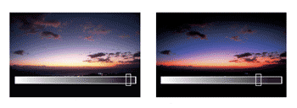

BenQ LED monitor, left, and conventional LCD monitors, right.



BenQ monitor, right, with Full HD, and conventional LCD monitors, left.



Conventional monitor, left, and BenQ monitor, right.

##### **12M:1 Ultra High Dynamic Contrast for Depth and Definition**

The GL2460 comes with an ultra-high dynamic contrast ratio of 12M:1 to add colour depth and definition to darkened and complex motion pictures, so that everything you see, from the brightest white to the darkest black, is rendered to deliver the clearest, smoothest picture performance during movies and video games.

##### **Full HD 1080p 16:9 Visual Perfection**

The BenQ GL2460 supports the Full HD 1080p with 16:9 aspect ratio, allowing the subtle details to stand out with rich, realistic colours, making your viewing experience even more absorbing.

##### **Improved Eco Mode for High Energy Efficiency**

The improved Eco Mode adjusts the backlight brightness level to ensure the highest display quality is presented to you with energy efficiency. This intelligent mode reduces at least 37 per cent of the power consumed by document viewing, internet browsing and emailing up to 44 per cent of the power consumed by gaming.



Senseye 3 delivers ideal viewing quality in each of its six pre-set viewing modes.

##### **Senseye 3 Visual Solution to Your Everyday Viewing Needs**

Experience true colours of the world with the BenQ Senseye Human Vision Technology. With the help of its six proprietary calibration techniques, Senseye 3 delivers ideal viewing quality in each of its six pre-set viewing modes — standard, movie, game, photo, sRGB, and Eco. The Eco mode especially designed to save power and money.

##### **Superior Response Time**

Enjoy high dynamic videos without ghosting or other artefacts with 2 ms GTG response time.



##### **Windows 8 and Windows 7 Compatible**

The GL2460 has passed Windows 8 and Windows 7 certification and is fully compatible with both colour systems. Plug in the GL2460 to your computer, and Windows will recognize it instantly, making set up and connection effortless.

##### **Eco FACTS Label**

BenQ doesn’t just want to comply with green regulations passively, but also to actively develop eco products. Eco FACTS declares BenQ’s greatest efforts on the replacement of hazardous substances, material selection, packaging design, energy-saving design and other aspects of the products.

##### **Energy Star Qualified**

# BENQ 24INCH GW2470H LED WIDESCREEN MONITOR

### **Celebrating Minimalism at Its Finest**

#### **Everyday Enjoyment for Leisure and Business**

A perfect embodiment of The Bauhaus’ “less is more” minimalism design philosophy, the GW2470H is a delightful complement to almost any modern space. Every aspect of its form and feature is reduced to unify simplicity and functionality into pure aesthetics. On top of it all, users get to enjoy the sheerest visual pleasure and optimal eye comfort with BenQ’s exclusive eye-caring technology. The GW2470H is not only a celebration of minimalist lifestyle and modern sleekness but also the gateway to everyday enjoyment for leisure and business.



### **Designed Simply for the Ultimate Sophistication**

“Simplicity is the ultimate sophistication.” – Leonardo da Vinci

Exquisitely refined to complement your home and office, every detail of the GW2740H exemplifies the highest craftsmanship. The T-shaped base surface in the front is brushed with hairline treatment and adorned by a rectangular-shaped glossy black embellishment. The housing styled in black is fashioned with delicate patterns in the back to subtly catch the eye. With this classic minimalistic wonder, the GW2740H is everything you seek for the ultimate sophistication.

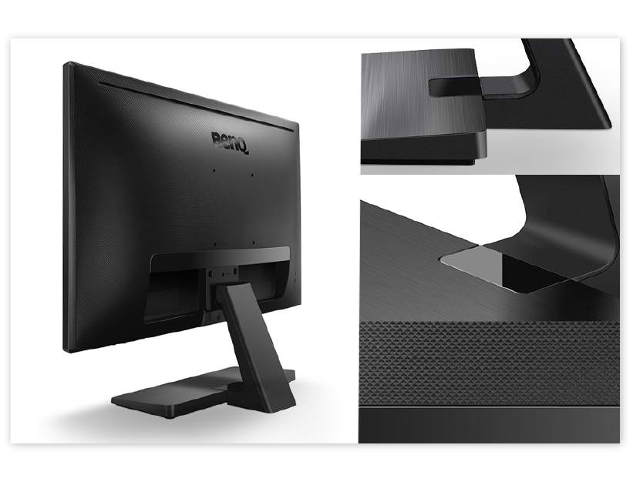

### **Flicker-free Backlight for Visual Pleasure**

The Flicker-free Technology eliminates flickering at all brightness levels and reduces eye fatigue effectively. Conventional LCD screens flicker at the rate of 200 times per second. Your eyes may not see the flickers but they can certainly feel them. So relieve your eyes from the uncomfortable flickering effect by switching to a BenQ Flicker-free monitor.



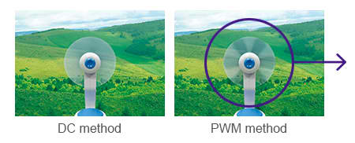

#### **Visible Flickering**

Place a fan before the monitor screen to check through the spinning fans for flickering



#### **Visible Flickering**

Use your camera to take a picture of the monitor screen to check for flickering

### **Better Eye Protection With Low Blue Light Modes**

Every Monitor produces a strain of blue spectrum light that is one of the critical causes of eye damage, eye strain, headaches and sleeping discorders. BenQ’s unique Low Blue LightTM technology is designed to deal with the everyday problem of blue light exposure and allows healthier time spent in front of your computer. Switch to one of the four preset Blue Light Modes (Multimedia – 30%, Web-browsing – 50%, Office – 60%, Reading – 70%;) and reward yours eyes without having to lose the visual enjoyment.

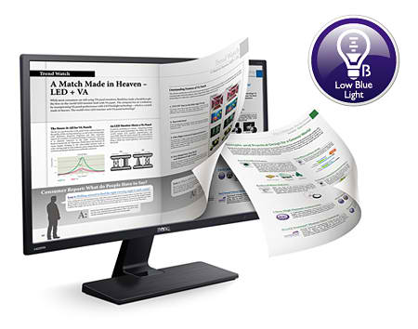

### **3000:1 Native Contrast Ratio for Color Depth and Definition**

An ultra-high native contrast of 3000:1, which is three times of that of general panels, adds astonishing color depth and definition to darkened, complex images with the greatest subtlety and clarity. With a native contrast ratio this high, you can expect an infinite dynamic contrast ratio that far exceeds your expectations.



VA



Conventional

### **True 8-bit Color Performance**

An 8-bit VA panel delivers smoother and more stable color transitions by rendering a total of 16.7 million color shades simultaneously. A 6-bit panel with Advanced Frame Rate Control (AFRC) requires interpolation to display the same number of colors as a true 8-bit panel does.

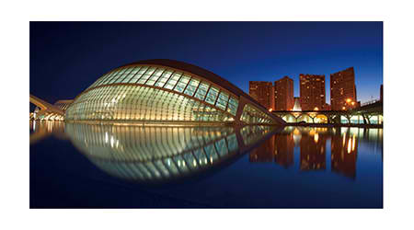

VA

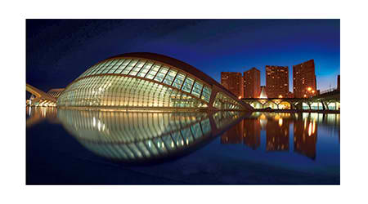

Conventional



### **178°/178° Wide-Viewing Angles**

VA panels bring truly authentic colors and ultra sharp details from left, right, above and below to your eyes with a wide-viewing angle of 178°/178°. Viewing, as you know it, will never be the same.

### **HDMI Multimedia Interface**

The latest HDMI high-speed multimedia interface* makes these monitors incredibly convenient to use – now you can enjoy digital entertainment effortlessly even with additional multimedia equipment in the future.

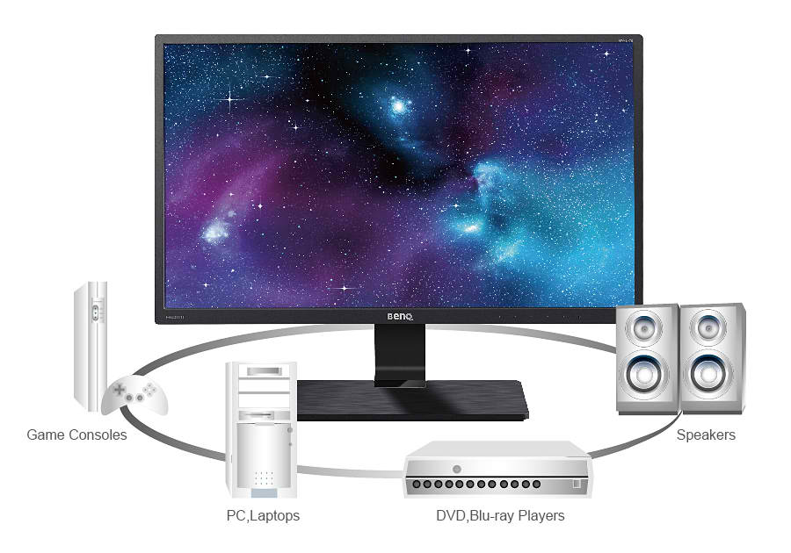



### **Win 10 Compatible**

The GW2470H has passed Windows 10 certification and is fully compatible with Windows 10 color systems. Plug in the GW2470H monitor to your computer, and Windows 10 will recognize it instantly, making setup and connection effortless.

### **Eco FACTS Label**

ecoFACTS can tell you how eco-friendly BenQ products are!  
Development of eco-friendly products, BenQ doesn’t just want to comply with green regulations passively, but also to actively develop eco-friendly products!  
ecoFACTS declares BenQ’s greatest efforts on the replacement of hazardous substance, material selection, packaging design, energy-saving design and other aspects of the products.





### **Energy Star Qualified**

The GW2470H complies with the requirement of ENERGY STAR® Program for computer Monitors, Version 6.0. Now you can enjoy saving energy and money as well as keeping the Earth looking’ great!

# DELL 21.5INCH S2216H IPS LED BLACK MONITOR

A reliable and affordable 22? Monitor with essential features that meet everyday office demands.  
  
Essential features: Great display quality at multiple angles with VESA-mount compatibility and tilt options, as well as a VGA and DisplayPort.  
Dependable performance: Uncompromising quality testing standards with 3-year warranty and service ensure long-term performance.  
Eco-conscious design: Save energy with power-efficient

# LG 15.6? 16M37A WIDESCREEN BLACK MONITOR

1. Top of Form
2. LED MONITOR
3. FAST RESPONSE TIME
4. READER MODE
5. SUPER ENERGY SAVING
6. DUAL SMART SOLUTIONBottom of Form

# LG 18.5? 19M37A (1366X768)/FLICKER SAFE BLACK MONITOR

1. READER MODE
2. FLICKER SAFE
3. COLOR WIZARD
4. SMART ENERGY SAVING