* **A4TECH X-710BK USB BLK MOUSE**

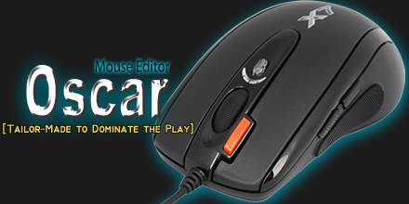



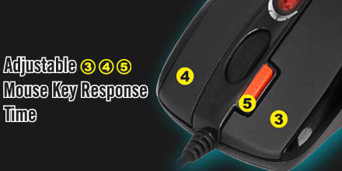



* Oscar Classical Script Exchange Site —Upload Preferable Scripts, Win the Honorable Prize! For an ordinary computer mouse, the moue itself is restricted by its default settings, even for those programmable ones, you are still bounded by its limited applications. A4Tech’s X7 “Oscar Mouse Editor” breaks through this barrier, users are able to establish homemade programs by using simple logic commands (such as “Loop”, “If”, “Equal to”, “Interval Repeat”, “Jump”…etc.) or by using command combinations (like “Change the Time Delay between commands”, “Control cursor absolute/relative displacements”, “Mouse simulation”, “Keyboard simulation”, “Record the keyboard & mouse continuous actions”…etc.). Simplicity, high effectiveness, and the overwhelming power of Oscar will bring you the unprecedented experience and dominate the play!
* The customizable “DPI Button” with Color Indicator” instantly shifts multiple sensitivity levels between 100 – 2000 dpi. The mouse gives you quick access from pixel-precise targeting to lightning-fast maneuvers without pausing the action.
* You can set mouse key responding time between 3-30ms. It not only extends the mouse key switch lifetime but also offers quick response over your opponents during the game play.
* Instead of complex and repetitive mouse operations, you can tailor-made your mouse and perform any one-click game stunts to win the games effortlessly.
* Store your favorite macros in the 16K memory, and play on any other computers instantly. No driver is needed.
* Designed with extreme fast report rate up to 1ms with full-speed USB (Maximum 1000Hz reports/sec) , the mouse allows you to fight 8 times faster than 8ms with an normal low speed USB mouse(125Hz).

# GENIUS TRAVELER 6000Z WIRELESS BLUE MOUSE

# GENIUS TRAVELER 6000Z WIRELESS RED MOUSE

2.4GHz Wireless Optical Mouse

**Genius introduces a new wireless optical mouse – Traveler 6000Z. It gives you the comfortable, intuitive control you expect for your PC.**

**Featuring a precision 1000 dpi optical engine, Traveler 6000Z provides great cursor control for browsing documents or Internet pages. The contoured shape is suitable for either hand and the gently curved sides give your hand the support and comfort you need for all-day use. A convenient pico receiver snaps into the mouse for easy storage. To save on battery purchases, Traveler 6000Z is designed with only one AA battery and a power switch is added to extend the battery life. The Traveler 6000Z is the perfect choice for a versatile, comfortable, and dependable mouse.**

* **LOGITECH B100 USB BLK MOUSE**

### **An office basic with built-in quality.**

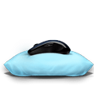

#### **Comfort in hand**

Left-handed or right, you can work comfortably all day long with this ambidextrous mouse.



#### **Smooth operator**

You’re in control with smooth, responsive optical tracking that moves the cursor just where you want it.



#### **Ready in no time**

This plug-and-play mouse is simple to set up—you just plug it in to your USB and get back to business.

# LOGITECH M185 RED WIRELESS MOUSE

Top of Form

### **Plug-and-forget nano receiver**

It works with Window®, Mac, Chrome OS™ or Linux®-based computers. So small and unobtrusive, you can plug it into a USB port and forget about it. Plus, you can say good-bye to worries about lost receivers.

### **Logitech reliability**

You get the high quality and reliability that have made Logitech the global leader for mice—plus a three-year limited hardware warranty.

### **Logitech Advanced 2.4 GHz wireless connectivity**

You get the reliability of a cord with wireless convenience and freedom—fast data transmission and virtually no delays or dropouts.

### **Plug-and-play simplicity**

No software, no hassles—you simply plug in the tiny nano receiver and start using your mouse right away.

### **Comfy, contoured shape**

The contoured design feels good in either hand and offers more comfort than a touchpad.

### **Perfect for laptops**

Your mouse works with Windows®, Mac, Chrome OS™ and Linux®. No matter what type of computer you own today—or buy tomorrow— you can depend on your mouse to work like you expect.

Bottom of Form

# LOGITECH M238 PLAY BLUE FACETS WIRELESS MOUSE

### **The fun (almost) never stops**

Go longer on a single battery. The M238 wireless mouse lasts up to 12 months.*

Battery life may vary based on user and computing conditions.

### **Colorful mice that play nice with others**

The Play Collection mice are compatible with Windows®, Mac®, Chrome OS™ and Linux® operating systems.

### **We also do long-distance**

This mouse can respond from up to 10m (33 ft)* away, thanks to the included Nano receiver.If you already have a Unifying receiver, you can pair this mouse to it.

*Actual wireless range may vary with use, settings and environmental conditions.

### **Hold on tight everybody**

Fly through long web pages or documents with the comfortable scroll wheel.