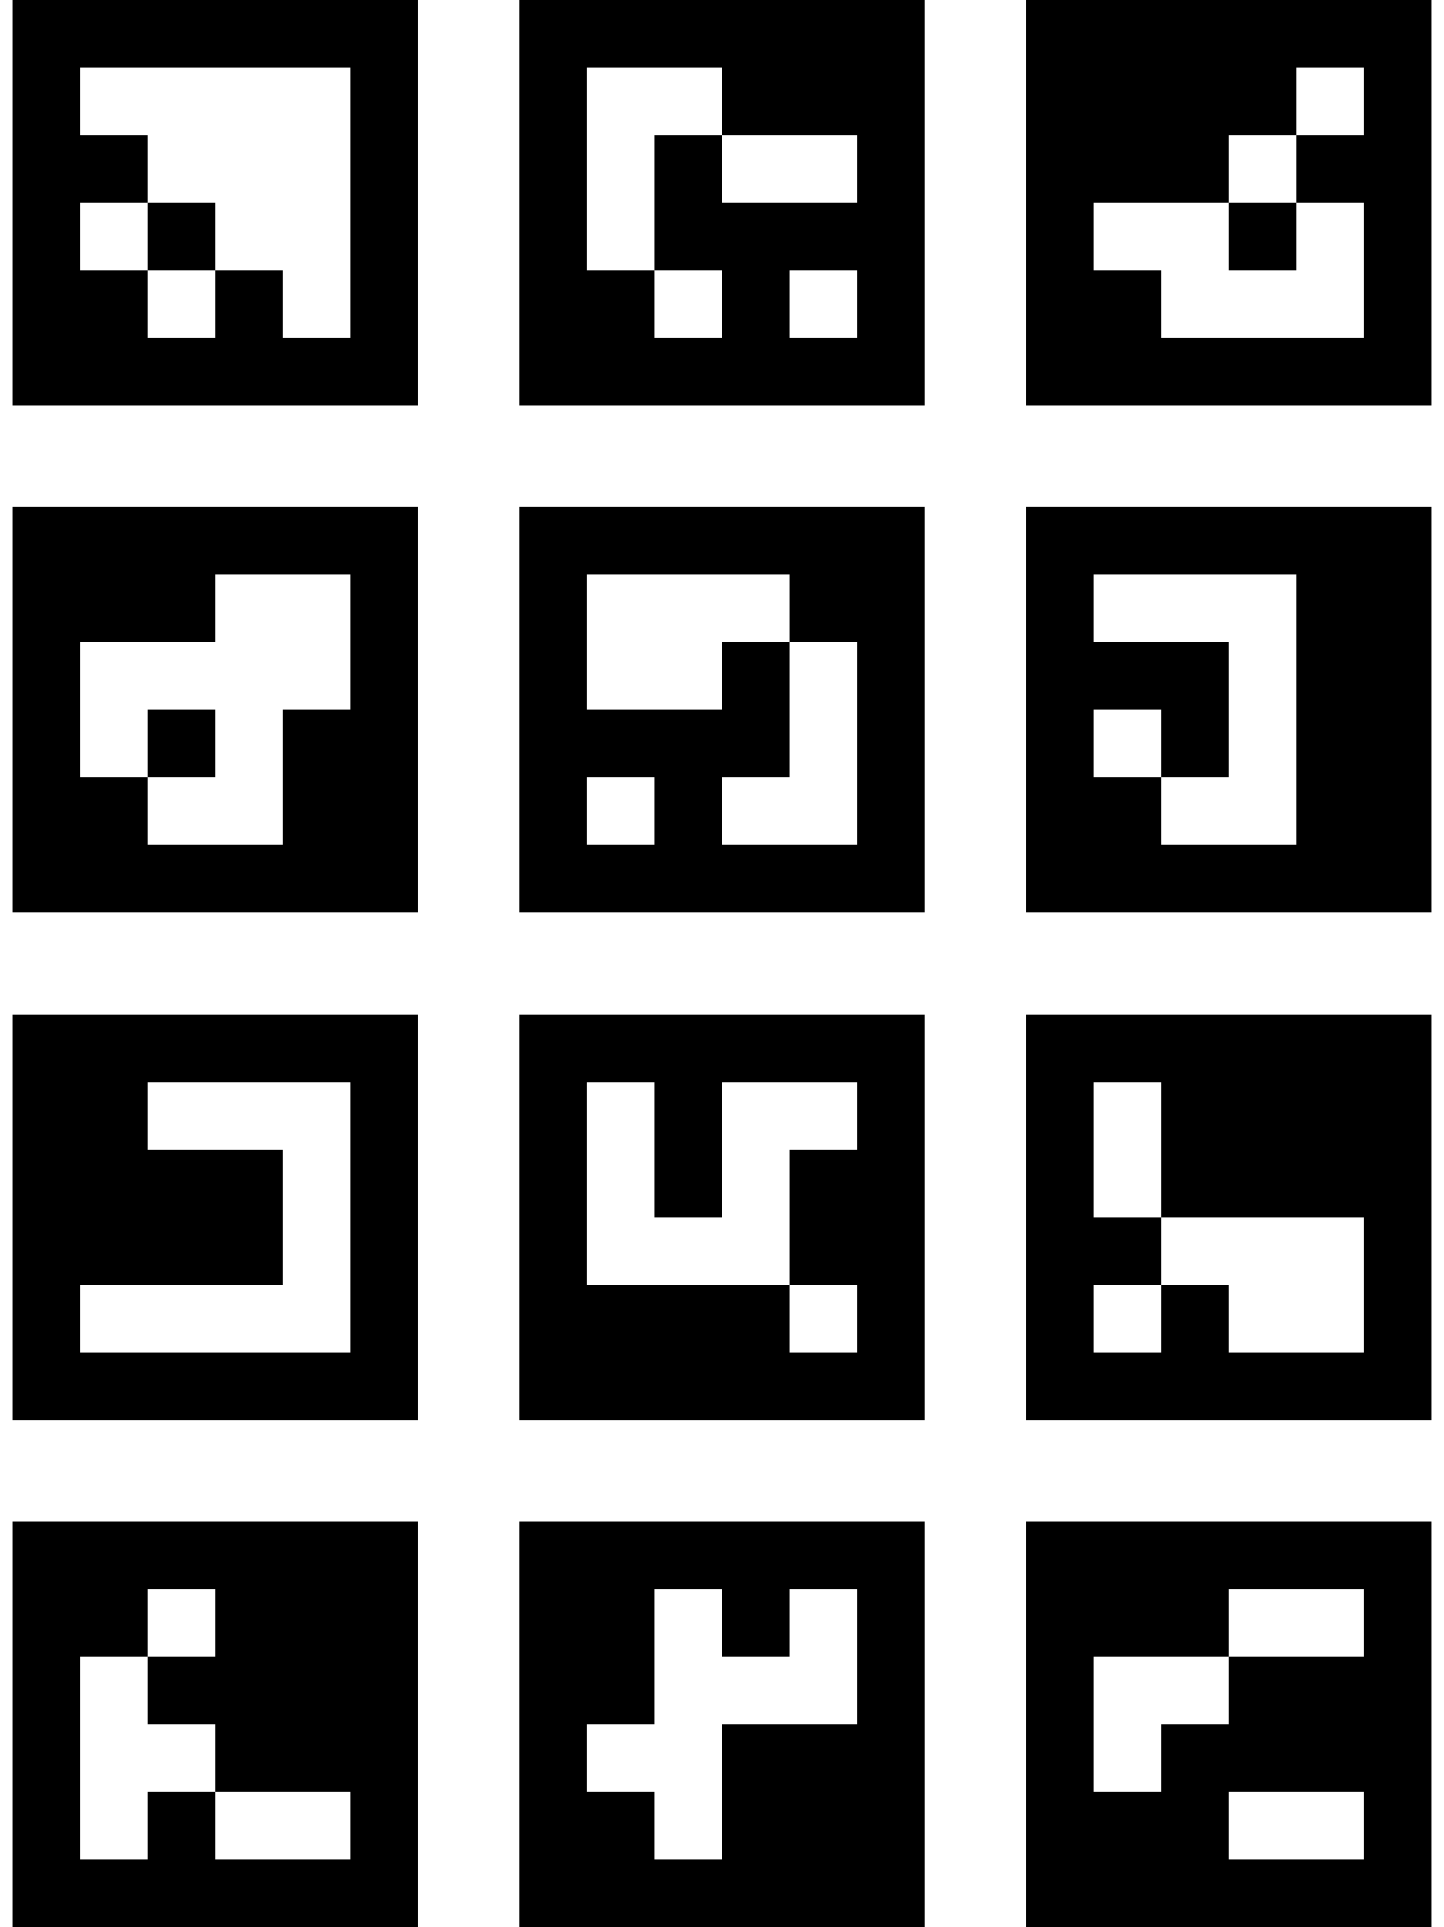

ArucoBoard 3x4, Dictionary 0, 47.5mm Marker

