Bug 01 Log

What's Wrong?
Game does not pay out at correct level. When player wins on 1 match, balance does not increase.

Additional Observations
- Seemingly when a player wins one match with a payout of 2:1, the balance increases at 1:1
- Seemingly when a player wins one match with a payout of 3:1, the balance increases at 2:1

Initial Hypothesis
- The math being used to calculate the balance after each round is not taking the bet amount into account.

Process
- [Action] Read the code to familiarize oneself with methods and what they do.
- [Observation] The ongoing balance is calculated using the receiveWinnings function
- [Observation] The calculation for winnings appears to be correct
- [Observation] The calculation for receiveWinnings appears to be correct
- [Observation – New Hypothesis] The takeBet function appears to subtract the bet from the balance irrespective of whether the player wins or loses.
- [Action] Define a test case in UAT format that will reliably reproduce the buggy behaviour. Commit the test case.
- [Action] Define a test script in UAT format that will reliably reproduce the buggy behaviour. Commit the test script.
- [Action] Create a jUnit test for each of the following scenarios 1:1, 2:1, 3:1.
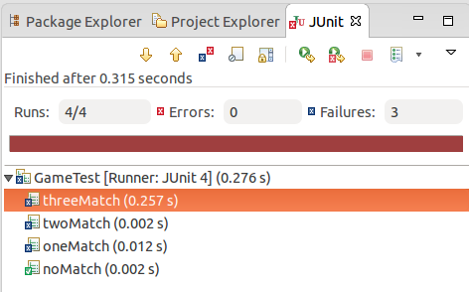
- [Action] Save StackTrace Output for examination.
- [Observation] Player.takeBet and Player.recieveWinnings are both behaving as they should
- [New Hypothesis] If takeBet and recieveWinnings are enacted using an if/else statement then the bug will be fixed.
- [Action] Tested Hypothesis
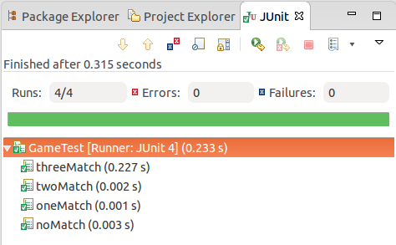
- [Observation] It worked.

Bug 02 Log

What's Wrong?
The game ends prematurely when the player's balance is near zero but still greater than the betting limit.

Initial Hypothesis
- It's likely that the game is doing a greater than comparison between the balance and the bet or between the balance and the limit, instead of a greater than or equal to comparison.
- Hypothesis → if the balance and the bet are equal, the game ends... yes or no?

Process
- [Action] Create a UAT that recreates the bug.
- [Simplification] Create a test scenario where the bet and the balance are isolated and a single round is played at a time.
- [Action] Test to see if the test scenario can be played when the balance exceeds the bet.
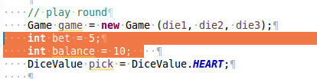
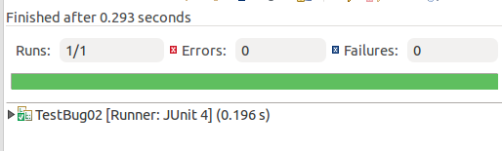
- [Observation] It passes.
- [Action] Test to see if the test scenario can be played when the balance and the bet are equal.
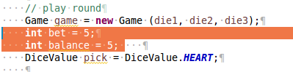

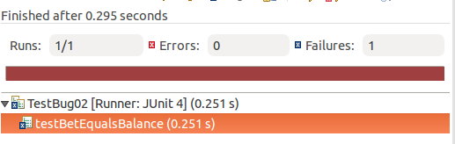
- [Action] The test fails. Save stack trace output.
- [Observation] The method in question is player.balanceExceedsLimitBy()
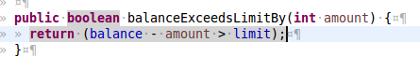
- [Narrow Hypothesis] The bug occurs when the balance minus the bet equals zero and the limit equals zero, so the game ends.
- [Action] Test new hypothesis by changing the balanceExceedsLimitBy method.
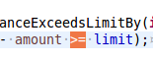
- [Action] Rerun automated test.
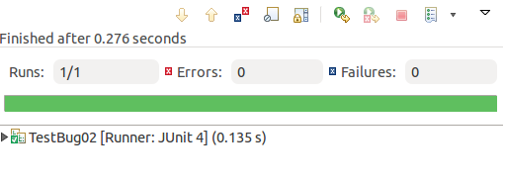
- [Observation] It worked. Bug resolved.

Bug 03 Log

What's Wrong?
Crown and Anchor games have an approximate 8% bias to the house. So the win / (win+lose) ratio
should approximately equal 0.42. This does not appear to be the case.

Initial Hypothesis
- It appears as if the dice results are not random. I believe this would skew the results.
- Hypothesis → the randomness of the dice results is skewing the win count... yes or no?

Process
- [Observation] The dice results appear to repeat themselves in a non-random way.
- [Question] But first let's check that the win ratio is being calculated correctly as-is. i.e., is the math behind winCount, loseCount, (float) winCount/(winCount+loseCount)) behaving correctly?
- [Observation] After inspecting the code in Main.java it appears that both winCount and loseCount are incrementing correctly and the ratio appears to be calculating correctly.
- [Observation] If the math calculations are sound, then the randomness of the game itself is now suspect. (see initial observation above).
- [Action] Create a UAT to recreate the bug.
- [Action] Create automated test to recreate bug.

