1. 选中vol.core类型，右键

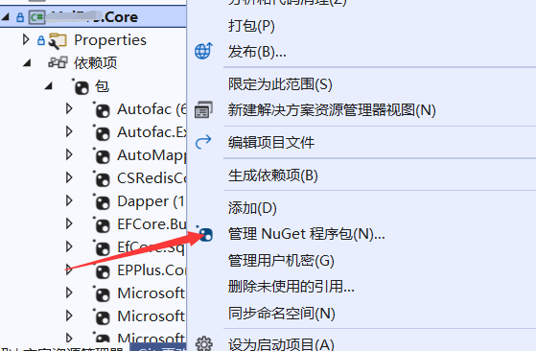

1. 搜索EfCore.SqlServer2008Query

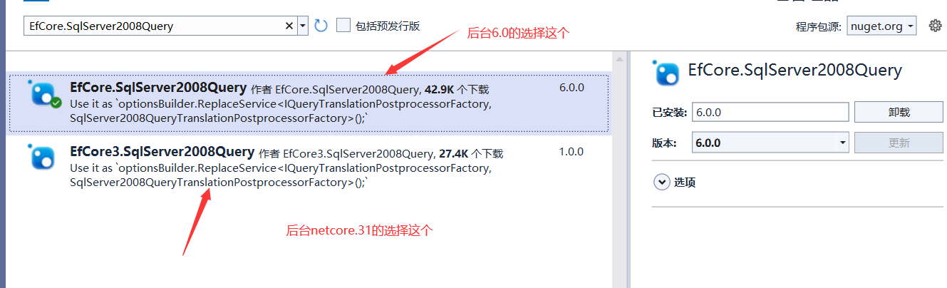

1. 打开VOLContext文件配置添加

optionsBuilder.ReplaceService<IQueryTranslationPostprocessorFactory, SqlServer2008QueryTranslationPostprocessorFactory>();

