V3_DSS_R2_2013SEP



HL7 Version 3 Standard: Decision Support Service (DSS),
Release 2
DSTU Specification, December 2013

Project Lead and Editor:
Kensaku Kawamoto, MD, PhD; University of Utah
Contributors:
Ohad Young; dbMotion
David Boaz; dbMotion
David Shields; University of Utah
Bryn Rhodes; Veracity Solutions
Brett Esler; Pen Computer Systems
Ken Rubin; Hewlett-Packard
Manfred Koethe, MS; 88solutions
Alean Kirnak; Software Partners
Clayton Curtis, MD, PhD; Veterans Health Administration
Robert Hausam, MD; OntoReason
Alan Honey, PhD; ii4sm

Project Sponsors:
HL7 CDS Work Group

HL7 SOA Work Group

Copyright © 2013 Health Level Seven International ® ALL RIGHTS RESERVED. The reproduction of this material in any form is strictly forbidden without the written permission of the publisher. HL7 and Health Level Seven are registered trademarks of Health Level Seven International. Reg. U.S. Pat & TM Off.
Table of Contents
Table of Contents 2
1 Preface 4
2 Revision History 5
2.1 Revisions of HL7 DSS Release 1 Specification Compared to OMG CDSS Version 1.0 Specification 5
2.2 Revisions of HL7 DSS Release 2 Specification Compared to HL7 DSS Release 1 Specification 6
3 Acronyms 7
4 Service Overview and Business Case 8
4.1 Problem Addressed by the Specification 8
4.2 Functional Capabilities of a Decision Support Service (DSS) 10
4.3 Overall Potential Scope of the Service 12
4.4 Reason Why the Service Specification is Needed 13
4.4.1 Explanation of Why the Service is Needed 13
4.4.2 Explanation of Why a Standard is Needed for the Service 13
4.4.3 Vendor Viewpoint and Potential Business Opportunity or Niche 14
4.4.4 Consumer Viewpoint and the Value Offered by the Work Product 14
5 Normative References 15
6 DSS Platform Independent Model 16
6.1 Foundational Model Elements 16
6.1.1 Described Data Object 16
6.1.2 Scoping Entity 16
6.1.3 Entity Identifier and Interaction Identifier 17
6.1.4 Item Identifier 18
6.1.5 Scoped Data Object 18
6.2 Metadata Model Elements 19
6.2.1 Service Profile 19
6.2.2 Semantic Signifier and Related Classes 21
6.3 Knowledge Module Model Elements 24
6.3.1 Knowledge Module Description 24
6.3.2 Semantic Requirement 29
6.3.3 Trait 31
6.3.4 Knowledge Module Data Requirement Elements 34
6.3.5 KM Evaluation Result Semantics 39
6.4 Exception Model Elements 40
6.5 KM Search Criteria Model Elements 42
6.5.1 Search Criteria 42
6.6 Evaluation Payload Elements 44
6.6.1 Evaluation Request Model 44
6.6.2 Evaluation Response Model 46
6.7 Metadata Discovery Interface 48
6.7.1 listProfiles 49
6.7.2 describeProfile 49
6.7.3 describeScopingEntity 49
6.7.4 describeScopingEntityHierarchy 49
6.7.5 describeSemanticRequirement 50
6.7.6 describeSemanticSignifier 50
6.7.7 describeTrait 50
6.8 Query Interface 51
6.8.1 listKMs 51
6.8.2 findKMs 52
6.8.3 getKMDescription 53
6.8.4 getKMEvaluationResultSemantics 53
6.8.5 getKMDataRequirements 53
6.8.6 getKMDataRequirementsForEvaluationAtSpecifiedTime 54
6.9 Evaluation Interface 55
6.9.1 evaluate 55
6.9.2 evaluateAtSpecifiedTime 56
6.9.3 evaluateIteratively 57
6.9.4 evaluateIterativelyAtSpecifiedTime 58
6.10 Profiles and Semantic Requirements Specified as a Part of this Specification 59
6.10.1 Overview 59
6.10.2 HSSP Simple Evaluation DSS Functional Profile, Version 2.0 60
6.10.3 HSSP Complete DSS Functional Profile, Version 2.0 60
6.10.4 HSSP Minimum DSS Semantic Profile, Version 2.0 61
6.10.5 HSSP Minimum DSS Trait Set Requirement, Version 2.0 61
6.10.6 HSSP Simple Evaluation DSS Conformance Profile, Version 2.0 68
6.10.7 HSSP Complete DSS Conformance Profile, Version 2.0 68
6.11 Minimal Requirement for Claiming Conformance to HSSP DSS Standard 69
6.12 Future Specifications of Profiles and Semantic Requirements 69
7 DSS Platform Specific Model for SOAP XML Web Services 70
7.1 PSM-Specific Conformance Criteria 70
8 DSS Platform Specific Model for RESTful XML Web Services 71
8.1 PSM-Specific Conformance Criteria 71
8.2 Example Security Implementation Using HMAC 71
8.2.1 Assumptions 72
8.2.2 Prelude 72
8.2.3 Transaction 72
8.3 Exception Handling 73
9 Appendices 74
9.1 Appendix I: Description of Associated Machine Consumable Files 74
9.2 Appendix II: Relationship to OMG Specifications 75
9.3 Appendix III: Related Activites, Documents, and Standards 75

Preface

A decision support service (DSS) receives patient data as the input and returns patient-specific conclusions as the output. As such, it can significantly facilitate the implementation of systems that require patient-specific inferencing, such as clinical decision support (CDS) systems and quality reporting systems. The present DSS specification represents one member of a family of healthcare service specifications being jointly developed by HL7 and the Object Management Group (OMG) through the Healthcare Services Specification Project (HSSP)., As per the HSSP process, the required capabilities of a DSS were identified in an HL7 Draft Standard for Trial Use (DSTU) in December 2006 (the HL7 DSS Service Functional Model, Version 1.0). Subsequently, a fully implementable DSS specification based on the HL7 DSTU was developed by the OMG Healthcare Domain Task Force. This OMG DSS specification was first adopted as an OMG draft standard and then recommended for adoption as a normative OMG standard in December 2010 (the OMG CDSS Specification, Version 1.0)., Within OMG, the DSS standard is known as the Clinical Decision Support Service (CDSS) standard to indicate its focus on the clinical domain. In this document, the terms DSS and CDSS are used interchangeably when referring to the OMG DSS specification. The OMG DSS standard was developed in close consultation with members of the HL7 CDS Work Group to ensure that the DSS specification could be brought back into the HL7 community following completion of the OMG standardization process.

This present specification is a normative HL7 specification that is based on the normative OMG DSS standard, with minor revisions that are clearly noted in Section 2. These minor revisions are expected to be introduced back into the OMG standard, as the intent is for the HL7 and OMG DSS standards to be semantically interoperable. Like the OMG standard, the present DSS specification includes a platform-independent model (PIM) for the DSS as well as a platform-specific model (PSM) for SOAP XML Web services. The original HL7 DSS DSTU was a functional specification that described the behavior of a DSS but was intentionally not specified at a technical level required for implementation. The present HL7 DSS normative specification includes technical details required for implementation, including WSDLs and XSDs for implementing a DSS as a SOAP Web service. A catalogue of these machine-consumable files can be found in Appendix I of this document.

Of note, an open-source implementation of this specification will be made available through the multi-institutional OpenCDS effort (http://www.opencds.org).

Revision History

Revisions of HL7 DSS Release 1 Specification Compared to OMG CDSS Version 1.0 Specification
At the core of this specification are the Platform Independent Model (PIM) and Platform Specific Model (PSM) for the DSS, along with the accompanying machine-readable files. These core aspects of the present specification are semantically identical to the OMG CDSS Version 1.0 specification, except as specified below. It is expected that these revisions will be brought back into the OMG community in the future to ensure full alignment of the OMG and HL7 DSS standards.

- Revision 1: addition of DSSRuntimeException to all operations
  - In order to account for runtime errors not otherwise covered by other named exceptions, a DSSRuntimeException has been added to all DSS operations.

- Revision 2: correction of business IDs of trait and trait criteria semantic signifiers
  - The semantic signifiers of trait and trait criteria specified in Section 6.10.5 have been corrected so that their business IDs include root global element names, which had been omitted in error. For example, for the Explanation trait, its semantic signifier's business ID is now HsspDssTraitSchema.Explanation instead of HsspDssTraitSchema.

- Revision 3: clarification of KMItem description
  - The description of KMItem has been clarified to note that its scoping entity may be a knowledge module or another entity. The exact change is as follows:
  - Original description:
    - The superclass of all knowledge module sub-items. For example, Data Requirement Group or Item. It contains the item identifier, which consists of the identifier of the knowledge module as well as a unique identifier within the knowledge module. It inherits name and description information from DescribedDO.
  - Revised description:
    - The superclass of all knowledge module sub-items. For example, Data Requirement Group or Item. It contains the item identifier, which consists of the identifier of the scoping entity as well as a unique identifier within the scoping entity. The scoping entity may be the knowledge module within which the KMItem resides, a different knowledge module, or an entity other than the knowledge module. This approach enables items such as data requirements to be decoupled from specific knowledge modules and reused across knowledge modules. This class inherits its name and description information from DescribedDO.

- Revision 4: updating of versioned namespaces of machine-consumable files
  - Where the above changes resulted in updates to machine-consumable files, versioned namespaces have been updated to use the date-based version of "201105" instead of "201012".

Furthermore, while the OMG CDSS Version 1.0 specification includes informative Resource Directory Description Language (RDDL) files to describe its XML namespaces, this specification does not include RDDL files. RDDL files are not included as the use of such resource descriptors are expected within the OMG community but not within the HL7 community.

Revisions of HL7 DSS Release 2 Specification Compared to HL7 DSS Release 1 Specification

- Added a responseId element to the iterative and final response messages.
  - This enables logging of outputs to be traced separately for each requested Knowledge Module.

- Added a new profile to support RESTful Web services for the Evaluation interface as an alternative to the original SOAP interface.
  - No changes were made to any defined operations, and the new RESTful interface is functionally identical to the SOAP interface.

- Extended the DSS Evaluate Profile to include both the evaluate operation and the evaluateAtSpecifiedTime operation.

- Added a requestId and responseId to all evaluation response messages.
  - The requestId is identical to the interactionId provided as part of the associated request.
  - The responseId is a system-generated identifier for tracking and trouble-shooting purposes.

- Updated HL7 version 3 schemas referenced in the specification to the 2012 Normative Edition.

- Added optional CDS output specification to KM Evaluation Result Semantics. Updated Semantic Requirement model to reflect this change (EvaluationResultRequirementBase, AllowedEvaluationResultRequirement, and RequiredEvaluationResultRequirement).

- Updated profile version numbers and dates in schema namespaces.

- Added to responses to all operations a requestId and a responseId.

Acronyms

There are a number of acronyms used in this document.

The following is a brief list of what the most common ones stand for.

Acronym | Full Name
ANSI | American National Standards Institute (U.S.A.)
CDS | Clinical decision support
CDSS | Clinical Decision Support Service (synonymous with DSS)
DRG | Data requirement group
DRI | Data requirement item
DSS | Decision Support Service
HITSP | Health Information Technology Standards Panel (U.S.A.) of ANSI
HL7 | Health Level 7
HSSP | Healthcare Services Specification Project
IHE | Integrating the Healthcare Enterprise
ISO | International Organization for Standardization
KM | Knowledge module
OMG | Object Management Group
PIM | Platform Independent Model
PSM | Platform Specific Model
RIM | Reference Information Model defined by HL7
RM-ODP | Reference Model of Open Distributed Processing defined by ISO
SDO | Standards Development Organization
SFM | Service Functional Model
UML | Unified Modeling Language

Service Overview and Business Case

Problem Addressed by the Specification
The problem addressed by the specification is the need for a standardized approach for leveraging machine-executable medical knowledge in an application-independent manner. Further elaboration on this targeted problem is provided below.

In recent years, research has emerged showing that the healthcare delivered in many industrialized nations falls short of optimal, evidence-based care. In the United States, a nationwide audit assessing 439 quality indicators found that American adults receive only about half of recommended care, and the U.S. Institute of Medicine has estimated that up to 98,000 Americans die each year as the result of preventable medical errors. In the United Kingdom, a retrospective analysis at two London hospitals found that 10.8% of admitted patients experienced adverse events, of which 48% were judged to be preventable and of which 8% led to death. Similarly in Australia, a review of medical records from 28 hospitals identified adverse events in 16.6% of admissions, of which 51% were deemed preventable and of which 4.9% led to death.

One of the most promising strategies for addressing this crisis in care quality is the use of clinical decision support (CDS) systems, which are systems that provide physicians and other healthcare stakeholders with patient-specific assessments or recommendations in order to aid in clinical decision making. Examples of CDS systems include outpatient systems that attach care reminders to the charts of patients in need of specific preventive care services, computerized provider order entry (CPOE) systems that provide patient-specific recommendations as part of the order entry process, and laboratory alerting systems that page physicians when critical lab values are detected.

CDS systems can be highly effective at improving care quality and ensuring patient safety. In a recent systematic review, for example, CDS systems possessing four critical features were found to significantly improve clinical practice in 94% of randomized controlled trials. Despite these promising results, however, the availability of decision support capabilities remains limited in most health care facilities in the U.S. and elsewhere. Although many barriers contribute to this limited use of decision support systems, one important barrier is the difficulty and cost associated with implementing effective decision support systems.

As with other types of applications, a CDS system could be more easily implemented and maintained if software services were available to provide functionality required by the application. Table 4.1 lists some of the services that may be useful for the implementation of a CDS system, including: (i) a DSS, which uses patient data to draw machine-interpretable conclusions regarding patients; (ii) a common terminology service (CTS), which provides access to various terminology operations; (iii) an entity identification service (EIS), which enables the identification of entities (e.g., patients) across systems; (iv) a retrieve, locate, and update service SRLUS), which facilitates the retrieval of patient records across systems, allows for fine-grained queries for patient data, and allows the service client to update the patient record; and (i) an electronic health record (EHR) action brokering service (EABS), which permits the service client to invoke various actions within an EHR. Of note, the HL7-OMG Healthcare Services Specification Project (HSSP) has developed or is developing standards for a number of these services.

All of the services just described facilitate the implementation of a CDS system, as they allow a CDS system to fulfill many of its functional requirements by making requests to existing services. Specifically with regard to the DSS, the service allows a CDS system to reach conclusions regarding a patient by making requests to one or more DSSs. Furthermore, the service allows a single DSS to simultaneously fulfill the patient evaluation requirements of multiple decision support applications. Because the specification and updating of machine-executable decision logic represents one of the most expensive aspects of developing and maintaining a decision support system, this arrangement could significantly reduce the effort required for a CDS system implementation. This reduction in the effort required to implement and maintain a CDS system is the primary business purpose for the DSS. It is hoped that the DSS standard will facilitate the more widespread adoption of CDS systems, which in turn should result in higher quality care and improved patient safety.

Table 4.1. Services potentially useful for the implementation of a CDS system.
Service | Description | Example of Service Use by a CDS system
Decision Support Service (DSS) | Provides machine-interpretable, patient-specific assessments and recommendations given requisite data. | When a patient checks into an outpatient clinic, the clinic’s EHR sends relevant patient data to the DSS, receives back the patient’s care needs (e.g., overdue preventive care procedures, medication incompatibilities), and informs the clinician regarding those care needs.
Common Terminology Service (CTS) | Provides access to various terminology operations (e.g., translation of a code between vocabularies, identification of semantic relationships between codes). | When authoring a rule regarding beta-blocker use following a myocardial infarction, a knowledge engineer provides the CTS with the SNOMED CT code for the beta-blocker drug class and requests all SNOMED CT codes that are subsumed by (i.e., are descendants of) the provided code. The engineer also makes a request to the CTS to translate the SNOMED CT codes to FDA NDC codes. The SNOMED CT and NDC codes indicative of beta-blockers are used to determine whether a patient who has suffered a myocardial infarction is currently prescribed a beta-blocker.
Entity Identification Service (EIS) | Allows the service client to identify entities (e.g., patients) across systems. | When determining whether a patient is in need of an influenza vaccine, a CDS system associated with Health System A uses EISs to identify that the patient has a medical record number with the local health department, as well as with Clinic B. The CDS system provides these system-specific record numbers to the RLUSs of the health department and of Clinic B, and the CDS system requests that the RLUSs retrieve data on the influenza vaccination procedures the patient has received at these sites over the past year. Through this interaction, the CDS system is able to determine that the patient received a flu shot this year at the local health department. As a result, the CDS system correctly concludes that the patient is not in need of a flu shot.
Retrieve, Locate, and Update Service (RLUS) – data location and retrieval component | Allows the service client to locate and retrieve records for a patient across systems. Allows for fine-grained record retrieval (e.g., query for lab tests for a patient from the past 3 months with LOINC codes A, B, or C). | See example above for EIS.
Retrieve, Locate, and Update Service (RLUS) – data update component | Allows the service client to update a patient’s record. | When the hematocrit is entered into the clinical data repository for a patient being treated in the hospital, a CDS system detects that the hematocrit is critically low and sends a page to the intern responsible for the patient’s care. The CDS system makes a request to the RLUS to record into the clinical data repository the details regarding the alert (e.g., when it was sent, to whom it was sent, why it was sent).
EHR Action Brokering Service (EABS) | Allows the service client to request that the EHR performs pre-specified actions. | A clinician consults a decision support module in an EHR to decide on a medication regimen for a patient with hypertension. The CDS system determines that additional data are required to reach a conclusion. The CDS system makes a request to the EABS to collect the required data from the clinician; upon receiving the request, the EABS asks the clinician for the required information through the EHR user interface. The EABS then returns the information to the CDS system so that a conclusion can be reached.

Functional Capabilities of a Decision Support Service (DSS)
A DSS can be conceptually understood as the guardian of one or more modules of medical knowledge, wherein each DSS knowledge module is capable of utilizing coded patient data to arrive at machine-interpretable conclusions regarding the patient under evaluation. The scope of a typical DSS knowledge module is the assessment of a single patient in a specified topic area. The topic area may be narrow (e.g., the need for a glycated hemoglobin test for a patient with diabetes) or broad (e.g., the existence of contraindications to any medications prescribed or about to be prescribed for a patient).

A DSS is used by a DSS client, which is alternatively referred to as a “client” or as a “client system” in this specification. A DSS client is any external entity that interacts with a DSS to obtain its services. Examples of DSS clients include a DSS query system used by an engineer to find and explore knowledge modules at design time or an operational CDS system that interacts with a DSS at run-time.

When requesting a patient evaluation, a client CDS system specifies the knowledge modules to use for the evaluation, and the CDS system also submits the patient data required by the knowledge modules. In return, the DSS returns inferences regarding the patient in a format that has been pre-defined for that knowledge module. For example, an online immunization registry might submit data on a patient’s allergies and on her past immunizations to a DSS and request that the patient be evaluated using the service’s immunization knowledge module. In return, the DSS might return a list of the vaccines for which the patient is ineligible due to contraindications, a list of the vaccines for which the patient is up-to-date, and a list of the vaccines for which the patient is due.

Of note, a DSS knowledge module may or may not have a one-to-one correspondence with an underlying computational construct. For example, the immunization knowledge module just described may be implemented using one computational construct (i.e., a single construct that checks for the need for a number of vaccines) or multiple computational constructs (e.g., one construct that checks for the need for a flu vaccine, a second construct that checks for the need for a pneumococcal vaccine, etc.).

Table 4.2 provides examples of the types of inferences that could be made by a DSS.
Table 4.2. Example inferences that could be made by a DSS.
Sample Evaluation Input | Sample Evaluation Output
Patient age, gender, past health maintenance procedures | List of health maintenance procedures due or almost due
Medication identifier, age, gender, weight, serum creatinine level | Recommended maximum and minimum doses for medication given patient's estimated renal function
Age, gender, co-morbidities, chief complaint | Admission order set in HL7 format
Insurance provider, data relevant to prescription | Whether the prior authorization criteria for prescribing the medication are met

In order to acquire patient evaluations in this manner, a client must be able to obtain several supplemental pieces of information from a DSS. These supplemental information needs consist of the need to (i) identify the knowledge modules that could be used to meet client needs; (ii) know what patient data must be submitted to the DSS in order to obtain an accurate evaluation; and (iii) know the meaning and format of any results that will be returned by the DSS following a patient evaluation. lists these supplemental client information needs; a brief description is also provided for the primary DSS operations that meet these information needs.

Table 4.3. Supplemental information required for obtaining patient evaluations using a DSS, and brief descriptions of the primary service operations that provide the required information.
Supplemental Information Need | Primary Operation Providing Required Information | Description of Service Operation
Identification of knowledge modules meeting client needs | findKMs | Identifies the service’s knowledge modules that meet client search criteria. It is anticipated that the search for appropriate knowledge modules will generally occur at design time.
Information on the data required for evaluating a patient using the specified DSS knowledge modules | getKMDataRequirements | Explicitly specifies the data required for evaluating a patient using the selected knowledge modules
Specification of the meaning and format of the patient evaluation results that will be returned by the specified DSS knowledge modules | getKMEvaluationResultSemantics | Specifies how evaluation results will be returned when the module is used to evaluate a patient
KM = knowledge module

Through the use of these supplemental operations, a service client is able to identify the knowledge modules that are available from one or more DSSs for meeting the service client’s CDS needs. Furthermore, the service client is able to determine what data are needed for requesting a patient evaluation, as well as what will be returned by the DSS as a result of the patient evaluation request. Thus, when the need for a patient evaluation arises in a CDS system, the CDS system is able to (i) obtain the required patient data from its clinical data repositories, (ii) provide the requisite data to the DSS and request that the patient be evaluated using the specified knowledge modules, (iii) obtain machine-interpretable decision support results regarding the patient, and (iv) parse and use the results as appropriate in meeting the functional requirements of the application. Figure 4.1 illustrates this interaction graphically.
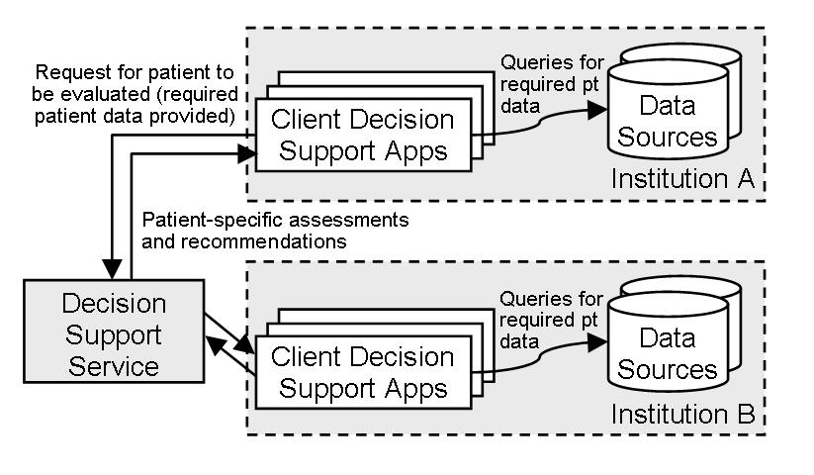
Figure 4.1. Schematic representation of interaction between clients and a DSS.

As an optional feature, a DSS may allow the client to specify an analysis time other than the present when requesting a patient evaluation. This feature is useful, for example, when outpatient care reminder sheets need to be printed in batch during the business day prior to the actual clinic session. Furthermore, the ability to designate any time in the past or the future as the evaluation time significantly facilitates testing, as static test cases will not become obsolete with the passage of time. This ability to specify the time at which a knowledge module evaluation is to take place is similar to how a HL7 v3 RIM Act can be scheduled to occur at a desired point in time through the use of the “intent” mood and the specification of the relevant activityTime.

Overall Potential Scope of the Service
The primary functionality provided by a DSS is the receipt of patient data as the input and the return of patient-specific conclusions as the output. A DSS also provides supplemental operations to support this patient evaluation functionality (Table 4.3).

Of note, a DSS could be used to evaluate entities other than individual patients (e.g., patient populations). For example, a DSS could be used to evaluate a group of patients to assess whether there are any indications of an emerging infectious disease outbreak within that population. However, the primary focus of this specification lies in the use of a DSS to evaluate individual patients.

As described earlier in Section 4.2, the scope of a DSS knowledge module may be narrow (e.g., an infant’s need for a varicella vaccination) or broad (e.g., a patient’s need for any general health maintenance procedures). With regard to the data required for generating the inferences, a DSS knowledge module may require the provision of various types of data. These data requirements may include, but are not limited to, demographic data, data on healthcare acts (e.g., procedures), and data on context (e.g., whether the patient is currently being seen in an outpatient or inpatient setting, or whether a specific diagnostic test can be performed at the current health care facility).

A DSS is permitted to return evaluation results using a variety of information constructs. Information constructs that may be used for communicating decision support results may include, but are not limited to, RIM acts (e.g., an HL7 medication entity with a mood code indicating that the medication should be ordered), dates (e.g., the date that a test was last performed, or the date at which a test will be due), and Boolean values (e.g., whether a patient is in need of a pneumococcal vaccine).

Of note, for both DSS inputs and outputs, the HL7 Virtual Medical Record (vMR) standard may be used as DSS payloads.

With regard to the types of applications intended to be supported by the specification, the DSS is designed primarily to facilitate the implementation and maintenance of systems that assist patient-specific decision making by clinicians (i.e., CDS systems targeted to clinicians). However, the DSS could be used to support other types of applications as well. For example, the inferences obtained from a DSS could be used to generate care reminder letters for patients. Also, patient evaluation requests could be repeated across a patient population in order to obtain population-level statistics. For example, by asking a DSS provider to evaluate each diabetic patient in a clinic with regard to the patient’s compliance with diabetes care guidelines, a reporting system would be able to easily calculate the proportion of diabetic patients in the clinic in compliance with the recommended care metrics. Finally, a DSS could be adapted so that it returns reference information relevant to the care of a patient rather than an assessment or a recommendation regarding the patient.

Of note, several aspects of the DSS are considered to be out of scope in terms of formal specification and standardization. To begin, what a client does with the evaluation result provided by a DSS is considered out of scope for the purposes of standardization. In addition, the mechanism used by a client to obtain the data required for evaluating a patient is also considered to be out of scope. Finally, the mechanism used by a DSS to generate patient-specific evaluation results is also considered out of scope for the purposes of standardization. As long as a DSS meets the functional requirements of the service, it is free to use whatever knowledge representation formalism it believes is most appropriate when implementing its decision support capabilities.

Reason Why the Service Specification is Needed

Explanation of Why the Service is Needed
As discussed in section 4.1, the rationale for creating the DSS specification is as follows: (i) there is a great need to improve the quality and safety of health care; (ii) CDS systems represent one of the most promising strategies for improving care quality, but their use is limited; (iii) one important reason for this limited utilization is the difficulty and cost associated with implementing effective CDS systems; (iv) the widespread adoption of the DSS standard should reduce the cost of implementing and maintaining a CDS system, thereby increasing the utilization of CDS systems in clinical care; and (v) increased utilization of CDS systems should help to improve care quality and to ensure patient safety.

Explanation of Why a Standard is Needed for the Service
Without a commonly agreed upon standard for the DSS, service clients would need to implement different interfaces when dealing with different DSSs or when switching DSSs. Similarly, the lack of a standard would result in service providers reaching only a small fraction of potential clients, as clients would need to invest in provider-specific interfaces before being able to make use of the functionality offered by a DSS.

A commonly accepted standard for the DSS would make it more attractive for service clients to invest in the infrastructure required for using the DSS to meet its decision support needs, as they would be able to use the same interface to interact with multiple service vendors. From the vendor’s perspective as well, a standard for the DSS is needed to increase the pool of potential customers and to reduce the risk involved with investing in the service framework.

Vendor Viewpoint and Potential Business Opportunity or Niche
From the perspective of a vendor, the acceptance of the DSS as an HL7 standard would provide several important benefits. First, a DSS standard should lead to a significant expansion of their potential client base. This expansion should occur due to the fact that clients should be more inclined to invest in the interface required for interacting with a vendor, as the interface would no longer be vendor-specific and would be re-usable for accessing knowledge from other DSS providers. Given this expansion of the client base, and given the highly scalable nature of the service framework, a DSS provider that achieves economies of scale would be able to increase its revenues and earnings, maintain a high quality of service, and lower the price that it charges on a per-client basis.

Also, because the DSS can be implemented as a service wrapper around existing capabilities, a DSS provider that has an established client base would be able to continue providing knowledge services using existing approaches as well (e.g., via existing application programming interfaces). Furthermore, because the DSS does not dictate how knowledge should be represented, the DSS provider can continue to encode medical knowledge using the approach that it deems to be most appropriate for its purposes.

Finally, a vendor with a superior DSS implementation would be able to license its implementation of the framework to other knowledge vendors or to other entities interested in sharing its patient evaluation capabilities via a DSS. Non-vendor entities that may wish to become DSS providers include federal or state organizations with an interest in finding more effective ways of getting their recommendations implemented in practice, such as Medicare, Medicaid, and the Agency for Healthcare Research and Quality in the United States. Also, health systems may be interested in supplementing the knowledge available from commercial DSS providers by acting as a DSS provider itself.

Consumer Viewpoint and the Value Offered by the Work Product
DSS consumers would potentially include any entity that wishes to facilitate the implementation and maintenance of decision support systems. These service consumers may include EHR, CPOE, e-Prescribing, and hospital information system (HIS) vendors, as well as healthcare institutions and their clinical departments.

From the viewpoint of these DSS customers, the primary value offered by the work product is the ability to leverage the decision support capabilities of multiple DSSs through a common service interface. By leveraging the capabilities of the DSS, the service customer should be able to reduce the cost and difficulty associated with developing and maintaining decision support applications.

Another advantage of the DSS framework is that it is highly secure. The DSS client rather than the DSS retrieves all patient data, and there is usually no need for a DSS to know who is being evaluated. Consequently, patient identifiers do not need to be sent to a DSS. Also,the DSS does not need to be authorized to access the client’s data repositories. As a result, a high level of security is attained by the fact that the client controls all read/write calls to its clinical repositories.

A final advantage to the DSS framework is that it significantly facilitates CDS system maintenance, as the medical decision logic used to reach patient evaluations are encapsulated in discrete knowledge modules that are tagged with meta-data, version-controlled, and maintained centrally on behalf of multiple clients.

Normative References

The following normative documents contain provisions which, through reference in this text, constitute provisions of this specification. For dated references, subsequent amendments to, or revisions of, any of these publications do not apply.

Web Services Description Language (WSDL) 1.1, W3C Note 15 March 2001, http://www.w3.org/TR/wsdl

Web Services Description Language (WSDL) 2.0 W3C 26 June 2007 http://www.w3.org/ns/wsdl/

Simple Object Access Protocol (SOAP) Version 1.2 Part 1: Messaging Framework (Second Edition), W3C Recommendation 27 April 2007, http://www.w3.org/TR/soap12-part1/

XML Schema Part 2: Datatypes, W3C Recommendation 02 May 2001, http://www.w3.org/TR/xmlschema-2

XML Path Language (XPath) 1.0, W3C Recommendation 16 November 1999, http://www.w3.org/TR/xpath

ISO/IEC Standard 19757-3:2006, Information technology -- Document Schema Definition Language (DSDL) -- Part 3: Rule-based validation – Schematron, Edition 1, 1 June 2006, http://standards.iso.org/ittf/PubliclyAvailableStandards/c040833_ISO_IEC_19757-3_2006(E).zip

Uniform Resource Locators (URL): A Syntax for the Expression of Access Information of Objects on the Network, 21 March 1994, http://www.w3.org/Addressing/URL/url-spec.txt

HL7 Version 3 Normative Standard, 2012 Edition. Available free to the public at http://www.hl7.org/implement/standards/product_brief.cfm?product_id=282.

HL7 Decision Support Service, Release 1, Service Functional Model Specification. Available free to the public at http://www.hl7.org/dstucomments/ex_showdetail.cfm?dstuid=12.

ISO Standard 3166-1, Country Codes, http://www.iso.org/iso/home/standards/country_codes/country_names_and_code_elements.htm

ISO Standard 639-1, Codes for the Representation of Names of Languages, http://www.loc.gov/standards/iso639-2/php/code_list.php

Service Specifications Framework (SSF), Healthcare Services Specification Project (HSSP), http://hssp.wikispaces.com

DSS Platform Independent Model

The Platform Independent Model (PIM) for DSS represents a platform-independent definition of the DSS interfaces.

The PIM is defined in the accompanying normative UML model, represented as an XMI file. The source Enterprise Architect .EAP model is also provided on a non-normative, reference basis. Elements of this model are presented in this section to clarify and provide guidance on this model.

Note that the models provided below are extracts from the accompanying normative UML model.

Foundational Model Elements
This section defines foundational model elements used by various operations in the DSS.

Described Data Object
The Described Data Object (DescribedDO) is an abstract class that is accompanied by a String description and name. This class is defined in the common package. Note that for the diagram below, as well as for all other model fragment diagrams that follow, the “class” referenced in the top left corner of the diagram (e.g., “class common” in the diagram below) actually refers to the package in which the class resides (e.g., the “common” package for DescribedDO).

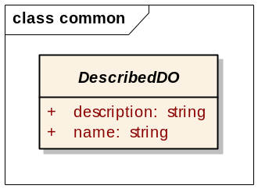
Figure 6.2. Model for Described Data Object.

Scoping Entity
A Scoping Entity (ScopingEntity) is a class that extends the Described Data Object and represents an entity that scopes business objects within a DSS. This class is defined in the metadata.scopingentity package.

The Scoping Entity is identified by a String “id.” The intent of this id is to allow scoping entities to be uniquely identified, so that business objects can be identified in a globally unique manner as long as business object identifiers are unique within a scoping entity.

The “id” must start with lowercase English representations of one of the top-level Internet domain names, currently com, edu, gov, mil, net, org, or one of the English two-letter codes identifying countries as specified in ISO Standard 3166-1 (see Section 5, Normative References). Subsequently, the “id” must start by defining the domain name that is associated with the scoping entity (e.g., “com.clinica,” “com.dbmotion,” “edu.duke,” “org.hl7”). Subsequent identification within the domain associated with the scoping entity, if any, may be specified as is appropriate for the internal naming conventions by the scoping entity. Also, Scoping Entities may have a hierarchical structure described by the existence of parent and children Scoping Entities.
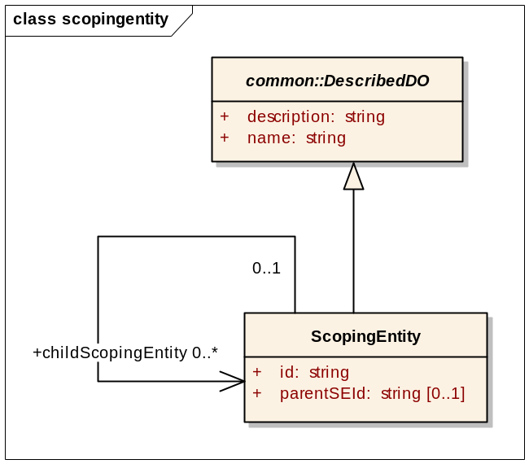
Figure 6.3. Model for Scoping Entity.

Entity Identifier and Interaction Identifier
The Entity Identifier (EntityIdentifier) is used to identify business objects within a DSS. The Entity Identifier consists of the “id” of its Scoping Entity, a String “businessId,” and a String “version.” The Entity Identifier (the combination of scopingEntityId + businessId + version) must be globally unique. The only restriction on the version relates to the versioning of Knowledge Modules, which is discussed later in Section 6.3.1.2, Knowledge Module Version. This class is defined in the common package.

The Interaction Identifier (InteractionIdentifier) represents information that is transmitted as a part of an interaction with a DSS to identify that interaction for logging and debugging purposes. The InteractionIdentifier consists of a scopingEntityId, as well as an interactionId that is unique within the scopingEntityId. A submissionTime is also provided to help identify the interaction. This class is defined in the common package.

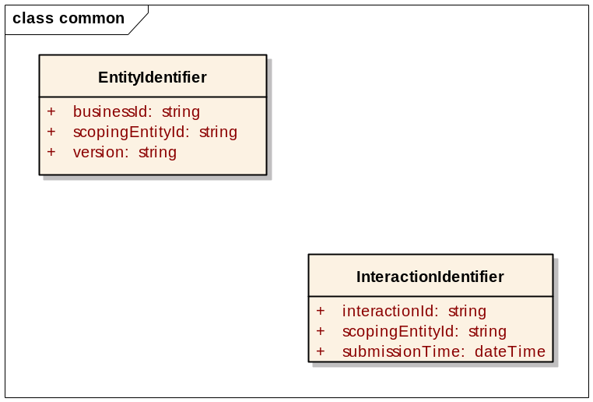
Figure 6.4. Model for Entity Identifier and Interaction Identifier.

Item Identifier
The Item Identifier (ItemIdentifier) is used to identify individual items that constitute subunits of business objects within a DSS. The Item Identifier consists of the Entity Identifier of its containing entity, as well as a String “itemId.” The “itemId” must be unique within the scope of the containing entity, and the complete ItemIdentifier (i.e., combination of containingEntityId + itemId) must be globally unique. This class is defined in the common package.

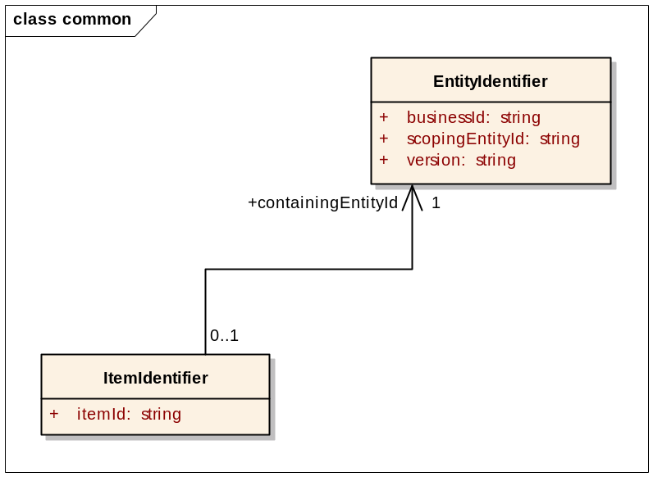
Figure 6.5. Model for Item Identifier.

Scoped Data Object
The Scoped Data Object (ScopedDO) is an extension of the Described Data Object that represents the business object scoped by a scoping entity. This class includes a description, name, and an Entity Identifier. This class is defined in the common package.

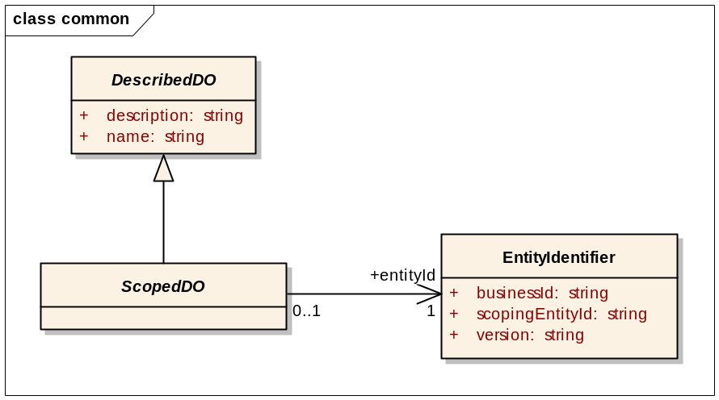
Figure 6.6. Model for Scoped Data Object.

Metadata Model Elements
This section describes the model elements related to service metadata.

Service Profile
The Service Profile (ServiceProfile) is an abstract class that represents a service profile. This class is defined in the metadata.profile package.

Overview of Service Profiles
By design, this specification is designed as a generic service framework which can be adapted in various ways to meet clients’ clinical decision support needs. While this flexibility is desirable, too much flexibility could make it more difficult to implement a DSS and/or to achieve plug-and-play interoperability among multiple DSSs. The specification of profiles allows the service to be constrained to the degree required for implementation and interoperability.

Of note, it is envisaged that many profiles will be defined after the adoption of this specification. Some of these profiles may be specified as formal, balloted profiles defined by standards development organizations such as HL7 and OMG, while other profiles may be specified as informal profiles defined by individual vendors, institutions, geographic regions, and other domains.

Profile Types
Table 6.4 summarizes the types of profiles that may be specified.

Table 6.4. Types of profiles that may be specified for a DSS.
Profile Type | Description
Functional profile | Specifies the list of supported service operations.
Semantic profile | Specifies that all knowledge modules hosted by the service fulfill a specified set of semantic requirements (described in Section 6.3.2, Semantic Requirement).
Conformance profile | Specifies a list of one or more supported functional profiles and one or more supported semantic profiles.

Service Profile Model
The Service Profile’s class model is shown below. In addition, a model that groups profiles by type, used in the metadata discovery interface, is provided below for reference.

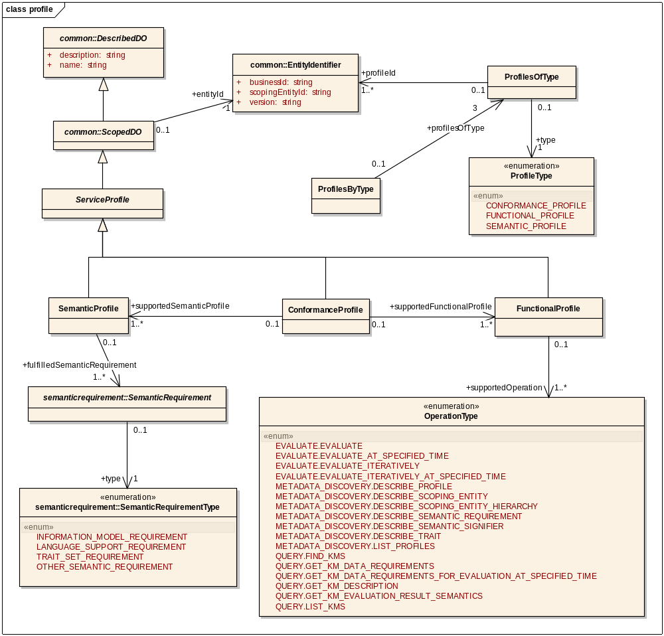
Figure 6.7. Model for Service Profile.

Semantic Signifier and Related Classes
A Semantic Signifier (SemanticSignifier) is a class that represents an information model. This class is defined in the metadata.semanticsignifier package.

Overview of Semantic Signifiers
The HSSP defines semantic signifiers as identifiers of information constructs that specify the structure and meaning of data. Semantic signifiers may identify standardized information constructs from HL7 (e.g., an HL7 version 3 Refined Message Information Model [RMIM]), standardized information constructs from a standards development organization other than HL7 (e.g., a DICOM image format), or non-standard local information constructs (e.g., Health System A’s laboratory data exchange format).

Use of Semantic Signifier within DSS
In this specification, semantic signifiers are used for the following purposes: (1) to specify the semantics by which data should be provided to the DSS for evaluating patients using a knowledge module; (2) to specify the semantics by which the query conditions for knowledge module data requirements are expressed by the DSS; (3) to specify the semantics by which patient evaluation results will be returned by the DSS; (4) to specify the semantics related to the traits and trait search criteria of DSS knowledge modules; and (5) to specify the semantics by which warnings are provided related to knowledge module evaluations.

Semantic Signifier Model
The Semantic Signifier Data Object model is shown below. As noted, a semantic signifier is a Scoped Entity with a computable information model definition (e.g., an XML Schema Definition [XSD]) and zero or more computable integrity ruleset definitions (e.g., Schematrons) and an optional narrative model restriction guide. Currently, these definitions are made accessible via URLs. For the XML Web Service PSM defined in this specification, the XSDComputableDefinition defined below shall be used, consisting of a Uniform Resource Locator (URL) to a single XSD, URLs to zero or more Schematrons, an optional URL to a narrative model restriction guide, and a specification of the global element that serves as the root element of the information model. Note that an XSD used in this context must have the root element defined as a global element so that it can be directly used for automated instance validation. See Section 5, Normative References for normative references to the XSD, Schematron, and URL standards.
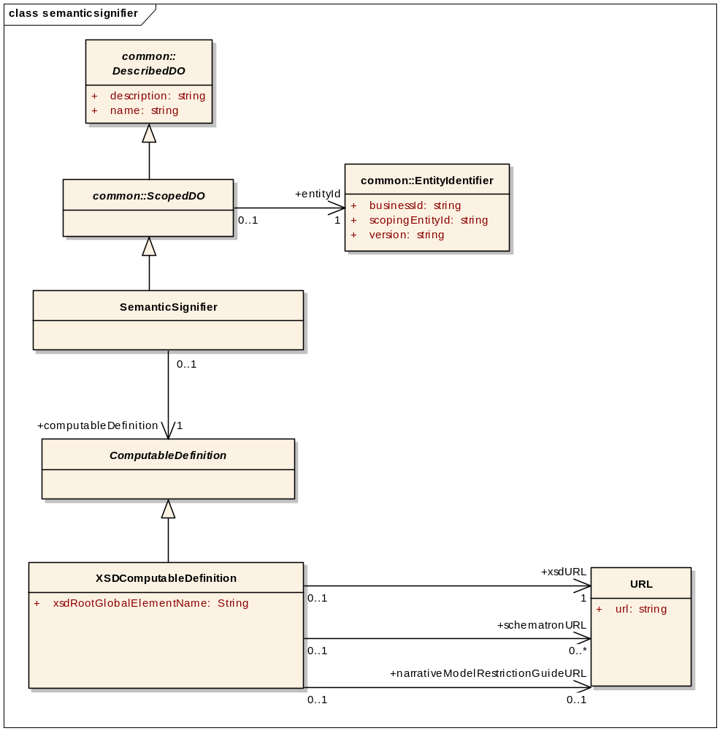
Figure 6.8. Model for Semantic Signifier.

Convention for Referring to HL7 Version 3 Semantic Signifiers
For referring to HL7 version 3 semantic signifiers, the use of the following convention is recommended. Making these recommendations mandatory will be considered in the future.
- For the scoping entity identifier, use “org.hl7”
- For the business identifier, use the following:
  - First part: “v3” followed by the folder tree in which the schema is included in the HL7 Normative Edition of the Version 3 standards. For example, in the HL7 Version 3 Normative Edition for 2012, the first part of the business identifier would be as follows:
    - v3.infrastructure.cda for CDA.xsd, because its folder path is “infrastructure” and then “cda”
    - v3.processable.multicacheschemas for HL7 version 3 messaging schemas, because their folder path is “processable” and then “multicacheschemas”
  - Second part: The name of the schema (e.g., COCT_HD010000UV01, FICR_IN310201UV02), followed by a period and then by the root element or complex type to be used from the schema. For example, if the complex type of interest with the schema COCT_HD010000UV01 is named COCT_HD010000UV01.Encounter, then make this part of the business identifier COCT_HD010000UV01.COCT_HD010000UV01.Encounter.
- For the version, use "1.0" since HL7 version 3 schemas are assigned different identifiers when modified (e.g., MODELX, MODELXUV, MODELXUV01, etc.).
- In the case of XML schemas, almost all HL7 version 3 schemas currently define complex types but do not define elements that can be used for the purposes of automated instance validation. Therefore, it is recommended that DSS providers wishing to use HL7 version 3 XML schemas provide clients with a separate XML schema that defines its focal, root element using the name and semantics of the HL7 complex type. For example, org.hl7.v3.multicacheschemas' COCT_HD010000UV01 schema defines a complex type named COCT_HD010000UV01.Encounter. To use this concept, it is recommended that a DSS provider do the following:
  - Create or otherwise obtain an XML schema in which an element named COCT_HD010000UV01.Encounter is defined, whose type is the COCT_HD010000UV01.Encounter complex type defined in the HL7 version 3 schema.
- An example using this convention is as follows:
Schema | COCT_HD010000UV01
Schema Location within HL7 Normative Edition | processable\multicacheschemas
Complex Type of Interest | COCT_HD010000UV01.Encounter
Scoping Entity Identifier | org.hl7
Business Identifier | v3.processable.multicacheschemas.COCT_HD010000UV01.COCT_HD010000UV01.Encounter

Knowledge Module Model Elements
This section describes the model elements related to knowledge modules (KMs).

Knowledge Module Description
The Knowledge Module Description (KMDescription) and Extended Knowledge Module Description (ExtendedKMDescription) provide core meta-data regarding a DSS knowledge module. The class is modeled in the query.km package. The model is provided below, and relevant aspects of this model are described thereafter.
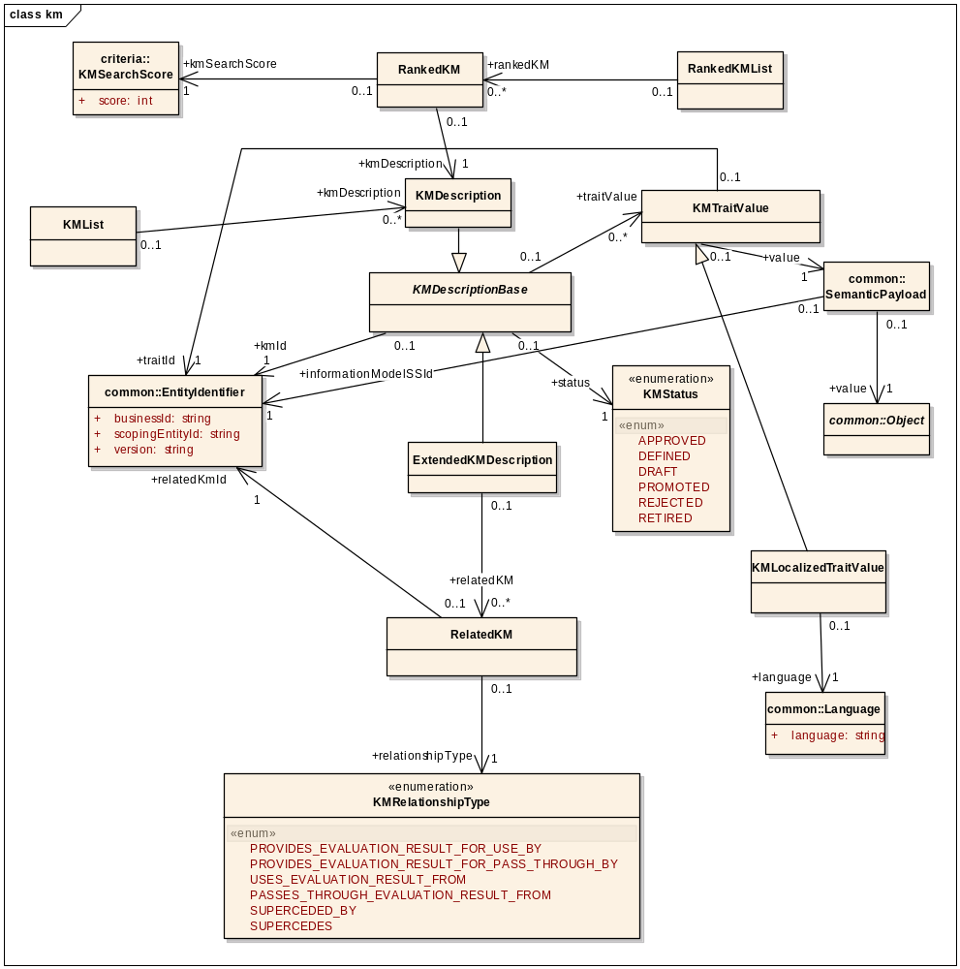
Figure 6.9. Model for Knowledge Module Description.
1

Knowledge Module Status
The allowed values and definitions of a KM status are as follows:
- DRAFT - the KM has been created and can be modified.
- DEFINED - the KM has been defined and is currently in unit test.
- REJECTED - the KM has been tested un-successfully.
- APPROVED - the KM has been tested successfully and can be deployed.
- PROMOTED - the KM has been deployed on a production platform.
- RETIRED - the KM was deployed or approved on a production platform but is no longer active.

The accompanying lifecycle diagram is as follows. Note that the term “rule” in the diagram should be considered to be equivalent to the concept of “KM” in the rest of this specification.

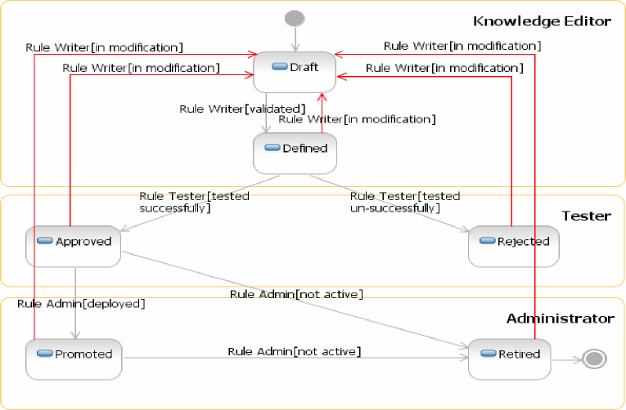

Furthermore, the following are accompanying guidelines for the management of KM status. These guidelines are to be considered normative.
- When a KM is created its status is “DRAFT.” As long as the KM is in this status, every change made does not affect the KM version.
- Every time the KM status changes to “DRAFT,” a new KM version is created, i.e., the lifecycle is restarted.
- Once a KM is “PROMOTED” the user cannot update it. He needs to create a new KM version and restart the life cycle up to “APPROVED.”

- A “RETIRED” KM should no longer be used (e.g., due to changes in underlying clinical guidelines or the availability of an improved version of the KM). A “RETIRED” KM may still be usable, but continued support is not guaranteed. The expectation is that a “RETIRED” KM will be replaced by an improved “PROMOTED” KM. However, this is not guaranteed, as in the case when a KM must be quickly retired due to the emergence of new evidence that a drug that was previously recommended should no longer be prescribed due to serious side effects, but a replacement KM cannot be developed, tested, and promoted before the original KM is retired.

- Whether a given DSS client is allowed to search for and/or use KMs of a given status is outside of the scope of this specification and is up to the DSS provider. For example, a DSS provider may make “DRAFT” KMs available only to internal developers, or a DSS provider may allow clients to continue using “RETIRED” KMs as long as the clients are aware that continued support for such KMs cannot be guaranteed indefinitely. Similarly, KMs with a status other than “PROMOTED” may be searchable by internal developers using the DSS interface but not searchable by a typical client.
- Similar to the above consideration, within KMs of the same status, it is outside of the scope of this specification which KMs are visible to and usable by a DSS’s clients. For example, a DSS provider may decide to segment KMs into sets of knowledge which require different levels of licenses to access.

Knowledge Module Version
A component of the Entity Identifier for a knowledge module is the version. The following are defined as normative requirements for the version.
- As noted above, a new KM version is created each time that a new KM is created or its status is changed to “DRAFT.”
- The KM version shall take the following form: [Major Version Number].[Minor Version Number].[Revision Number] (e.g., 1.0.0).
- Conceptually, the different components of the KM version can be understood as follows:
  - Major Version Number - reflects major changes in the KM’s run-time interface and/or the underlying clinical logic. Starts with 1, and increments up by 1.
  - Minor Version Number - reflects minor changes in the KM’s run-time interface and/or the underlying clinical logic. Starts with 0 within a major version, and increments up by 1.
  - Revision Number - reflects revisions that do not make any significant changes to the KM’s run-time interface or the underlying clinical logic. Starts with 0 within the combination of a major version and minor version, and increments up by 1.
- Which version part to change is up to the discretion of the DSS provider under the conceptual framework above. However, if a KM change involves one of the aspects specified in Table 6.5, then the version change must adhere to the versioning approach specified in the table.
Table 6.5. Possible version number changes given changes to a KM.
 | Change May Be Reflected In Version Part*:
KM Change | Maj | Min | Rev | None | Comments
Modifications to name or description of a Described Object |  |  | X | X | Version change not required, but may wish to update revision number to support version history
Traits
trait value changed | X | X | X | X | Up to DSS provider discretion. Expected to usually result in no change in version or change in revision number.
Data Requirements
Data Requirement Group
Add | X
Delete | X | X |  |  | Providing no longer required data should not cause run-time interaction to fail
Data Requirement Item
Add | X
Delete | X | X |  |  | Providing no longer required data should not cause run-time interaction to fail
Alternative Information Model
Add | X | X
Delete | X |  |  |  | Data requirement item is still required, but consumer may no longer be able to provide the required data
Update
information model (SS*) | X
query model (SS*) | X
Query | X | X |  |  | Includes changes in the use of Consumer Provided Query Parameters
Decision Logic
Change | X | X | X |  | Up to DSS provider discretion
Evaluation Results
Add | X | X |  |  | Up to DSS provider discretion
Delete | X
update information model (SS*) | X
Consumer Provided Query Parameters
Add | X
Delete | X | X |  |  | Up to DSS provider discretion
update type | X
Fulfilled Semantic Requirements
Add | X | X |  |  | Up to DSS provider discretion
Delete | X | X |  |  | Up to DSS provider discretion
*Maj = Major Version Number; Min = Minor Version Number; Rev = Revision Number; None = No change in version. SS = semantic signifier.
The following are valid ways of specifying the version number of a knowledge module to use in the Evaluation operations (see Section 6.9, Evaluation Interface):
- The specific version number (e.g., 2.1.0) - This will result in the evaluation of version 2.1.0.
- The specific major and minor version, with * as the revision number (e.g., 2.1.*) - This will result in the evaluation of the highest revision with the specified major and minor version number (e.g., 2.1.0, 2.1.1, or 2.1.2, depending on the latest available revision).
- The specific major version, with * as the minor version and * as the revision number (e.g., 2.*.*) - This will result in the evaluation of the highest minor version, and the highest revision within that minor version (e.g., if the highest minor version within major version 2 is 3, and the highest revision within version 2.3 is revision 1, then 2.3.1 would be used).

Knowledge Module Relationship
A KM relationship may be of the following types:
- USES_EVALUATION_RESULT_FROM - The current KM uses one or more of the evaluation results from the related KM as an evaluation input.
- PROVIDES_EVALUATION_RESULT_FOR_USE_BY - The current KM provides one or more of its evaluation results to the related KM for usage as an evaluation input.
- PASSES_THROUGH_EVALUATION_RESULT_FROM - The current KM passes through to the consumer one or more of the evaluation results obtained from the related KM.
- PROVIDES_EVALUATION_RESULT_FOR_PASS_THROUGH_BY - The current KM provides one or more of its evaluation results to the related KM for passing the evaluation result through to the consumer.
- SUPERCEDED_BY - The current KM was superceded by the related KM. That is, the related KM should be used instead of the current KM if possible.
- SUPERCEDES - The current KM supercedes the related KM. That is, the current KM should be used instead of the related KM if possible.

Knowledge Module Traits
A KM may possess specified traits. These traits are described in detail in Section 6.3.3, Trait.

Semantic Requirement
A Semantic Requirement (SemanticRequirement) is an abstract class that represents a requirement placed on all knowledge modules within a DSS instance. A DSS semantic profile specifies which semantic requirements must be fulfilled by its KMs (Section 6.2.1.2, Profile Types). The Semantic Requirement class is defined in the metadata.semanticrequirement package. Note that this requirement used to be referred to as KM Requirements in the HL7 DSS SFM DSTU.

Semantic Requirement Types
The table below specifies the types of semantic requirements that may be specified.

Table 6.6. Types of semantic requirements.
Semantic Requirement Type | Description
Trait set requirement | Specifies the list of traits (see Section 6.3.3, Trait) that will or may be associated with the DSS’s knowledge modules. Traits are identified by the identifier of the trait’s scoping entity, the trait identifier, and the trait version. The requirement also specifies if the trait is required or optional for knowledge modules.
Information model requirement | The InformationModelRequirement specifies the information models that (a) can or (b) must be used by DSS knowledge modules claiming conformance to this requirement.  This information model requirement consists of one or more of the following:  (i) allowedDataRequirement - specifies the superset of data requirement models and associated query models that can be used.  (ii) requiredDataRequirement - specifies the data requirement models and associated query models, if any, that must be used.  (iii) allowedWarningModelSSId - specifies the superset of models that can be used by the service to provide warnings regarding evaluations.  (iv) allowedEvaluationResultRequirement - specifies the superset of evaluation result models that can be used and associated CDS output specification models that can be used.  (v) requiredEvaluationResultRequirement - specifies the evaluation result models and associated CDS output specification models, if any, that must be used.
Language support requirement | Specifies the languages that are supported by the DSS.
Other semantic requirement | Uses narrative to specify a semantic requirement for the DSS.

Language Specification
Language shall be specifiied as either a 2-character ISO 639-1 language code or a combination of a 2-character ISO 639-1 language code and a 2-character ISO 3166-1 geographical code, concatenated with a hyphen. Example valid language specifications include: “en,” “en-US,” “en-GB,” and “fr.” ISO 639-1 codes are available at http://www.loc.gov/standards/iso639-2/php/English_list.php, and ISO 3166-1 codes are available at http://www.iso.org/iso/home/standards/country_codes/country_names_and_code_elements.htm. See Section 5 for normative references to these standards.

Semantic Requirement Model
The Semantic Requirement class model is shown below.
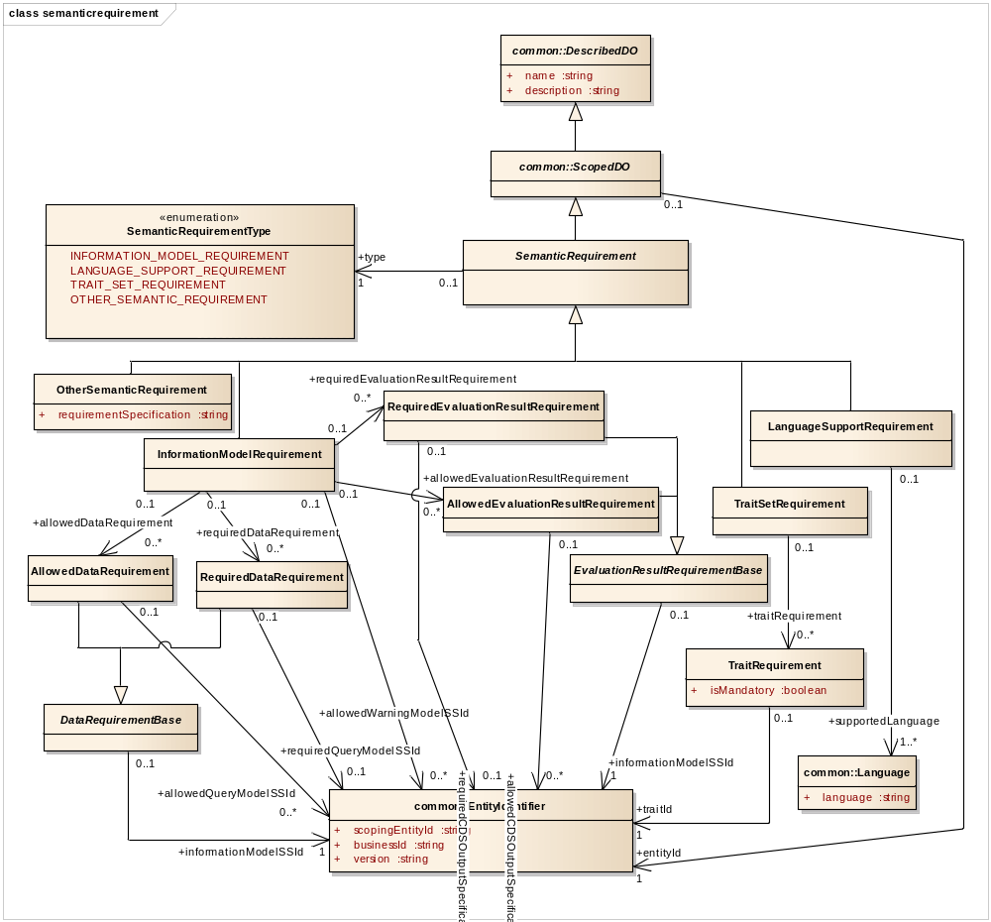
Figure 6.10. Model for Semantic Requirement.

Comprehensive Capture of Key Service Characteristics within Semantic Requirements and Semantic Profiles
In order to allow a DSS consumer to be able to fully understand the key characteristics of a DSS at the level of semantic profiles and constituent semantic requirements, the following are specified as mandatory requirements:
- All traits used within a DSS must be included within a TraitSetRequirement.
- All languages supported by a DSS must be included within a LanguageSupportRequirement.
- All evaluation result information models used within a DSS must be included within an allowedEvaluationResultRequirement.
- All data requirement information models used within a DSS must be included within an AllowedDataRequirement.
- All warning information models used within a DSS must be included within an allowedWarningModelSSId.
- All semantic requirements within a DSS must be represented within a semantic profile.

Trait
A Trait is used in the context of this specification to provide metadata for KMs. This class is defined in the metadata.trait package. Traits can be used to search for KMs or to describe a given KM. Example traits include the last review date, steward organization, and keywords. The information models used to define these traits are specified using semantic signifiers. Also, a Trait may have Trait Criterion (TraitCriterion) objects that represent semantic signifier-identified information models that can be used to express query parameters for searching for KMs with specified trait values. The identifier of a trait criterion must be unique within a trait (i.e., the identifier of a trait criterion consists of the parent trait’s EntityIdentifier plus an itemId that is unique within the scope of the parent trait’s EntityIdentifier). If a trait is language-dependent (e.g., a descriptive text), then the trait value is provided in accordance with the client’s language (see Section 6.3.2.2, Language Specification regarding DSS support for languages, as well as Section 6.8, Query Interface and Section 6.9, Evaluation Interface regarding how individual DSS operations deal with languages).

The data models for the Trait, Trait Value, and Trait Criterion classes are shown below.
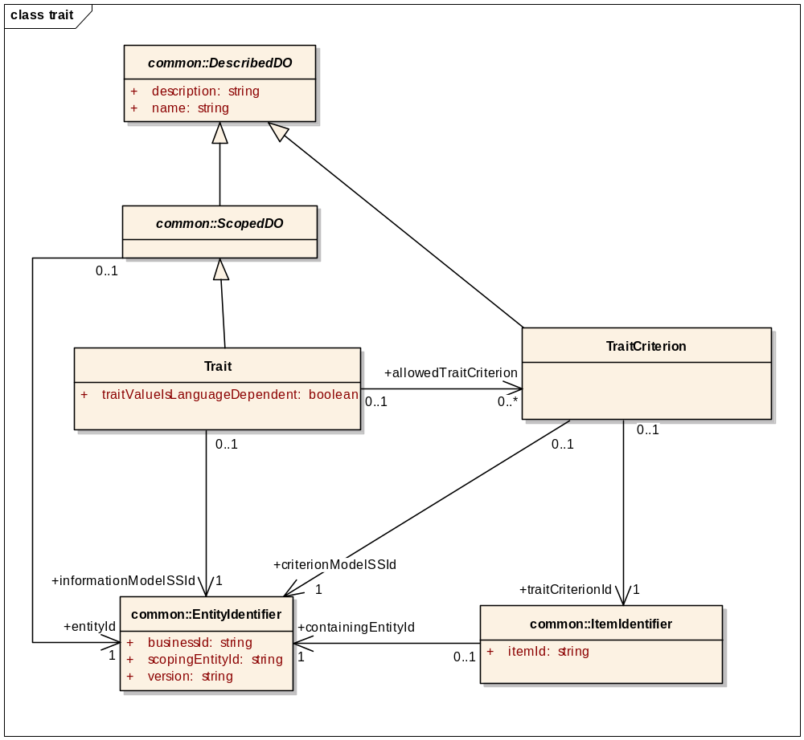
Figure 6.11. Model for Trait.

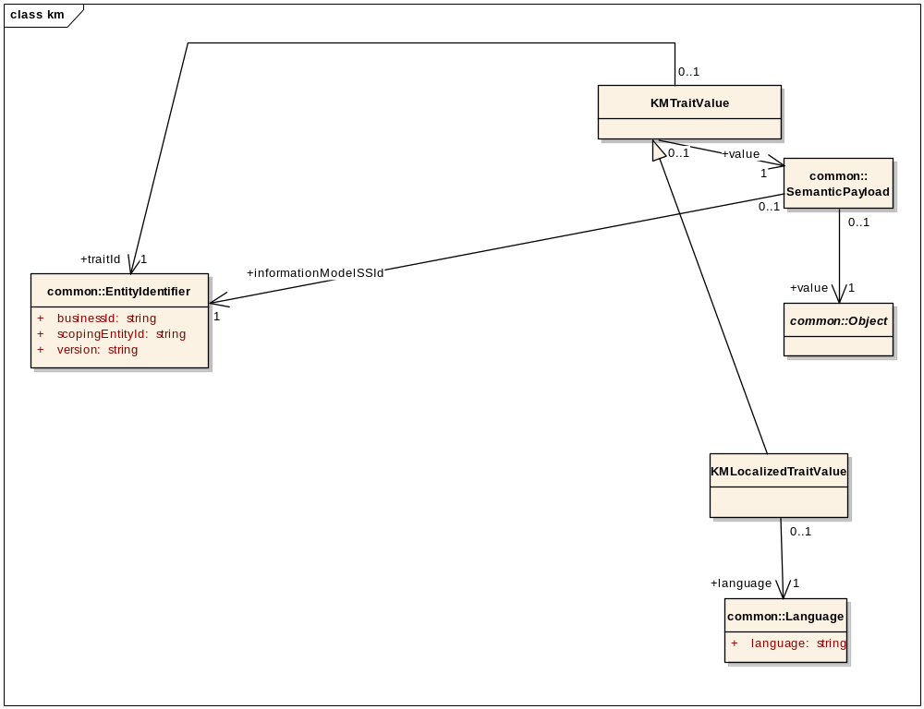
Figure 6.12. Model for Trait Value.

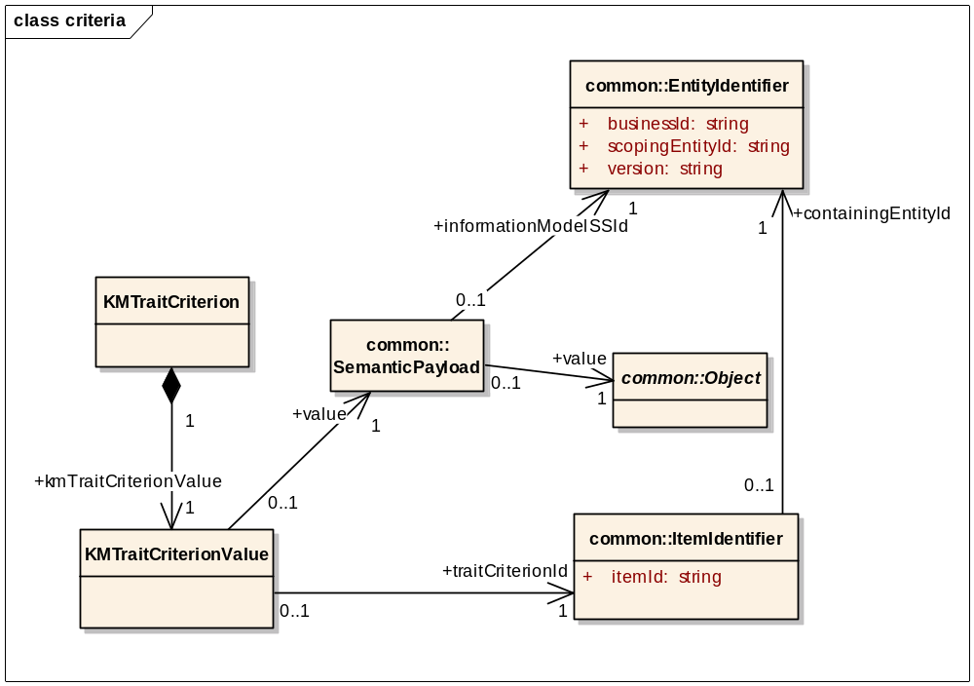
Figure 6.13. Model for Trait Criterion.

Knowledge Module Data Requirement Elements
KMs have data requirements for generating evaluation results. These models are provided in the query.km.dr and query.km.cpqp sections. These model elements are described below.

KM Data Requirement Item
The building block of KM data requirements are KM Data Requirement Items (KMDataRequirementItem class; model shown below). Through a semantic signifier, a KM data requirement item specifies how the data requirement item must be presented to the DSS. In addition, a KM data requirement item may optionally specify query parameters that should be used by the client to restrict the data submitted to the DSS. The information model used to define the query is identified by the query semantic signifier, and the information model-compliant query parameters are specified within the query attribute.

These KM data requirement items may also specify that certain query parameters should be specified by the client. In specifying the use of such consumer-provided query parameters (CPQPs), the identifier of the CPQP is provided along with an unambiguous specification of the path within the query model where the CPQP should be used to replace the placeholder data provided by the DSS. For the XML Web service PSM, this path shall be specified using XPath 1.0. Further details regarding CPQPs are provided in the next section.

Of note, this specification expects patient data to be communicated using information models that utilize absolute date-times to note when a care activity occurred. Use of information models that do not utilize absolute date-times to note when a care activity occurred are outside of the scope of this specification.
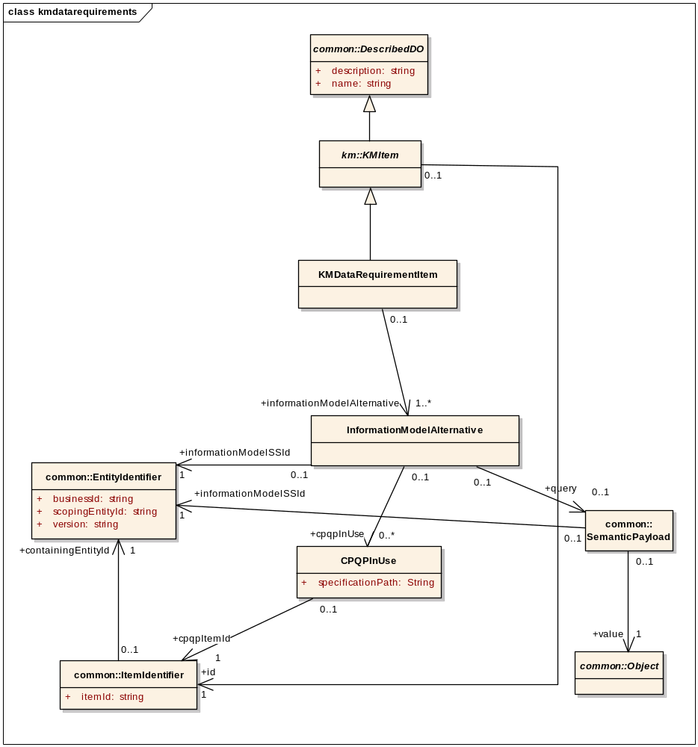
Figure 6.14. Model for KM Data Requirement Item.

Consumer-Provided Query Parameter (CPQP)
CPQPs may be necessary when a DSS KM has no way of knowing a priori what a certain query parameter value should be. This may be the case, for example, if a query parameter model involving a patient identifier is used, or if a query parameter model requires the specification of a specific encounter to analyze. The use of a CPQP allows a DSS to specify that certain query parameters within a KM data requirement item's query model should be specified by the client.

The model of the CPQP is provided below.

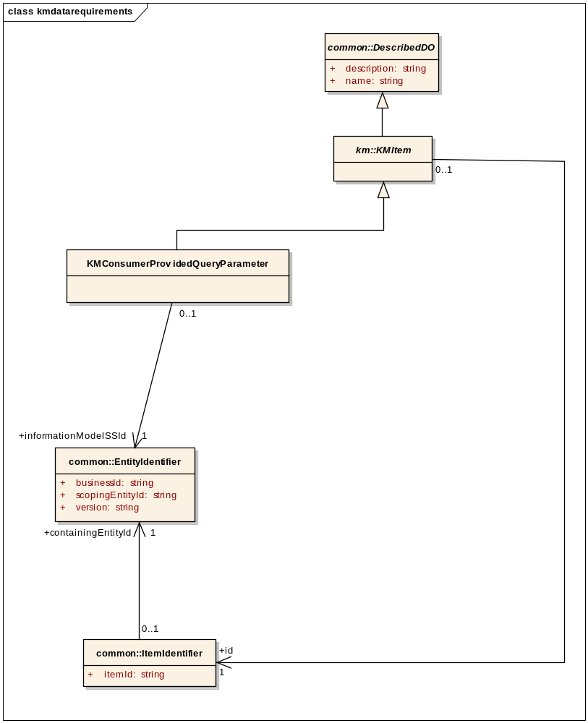
Figure 6.15. Model for Consumer-Provided Query Parameter.

KM Data Requirement Group
KM data requirement items are organized into KM data requirement groups (DRGs). DRGs contain one or more data requirement items. Each of these groups is uniquely identified within a given KM through the KM item identifier. This model is defined in the query.kmdatarequirements package and is provided below.

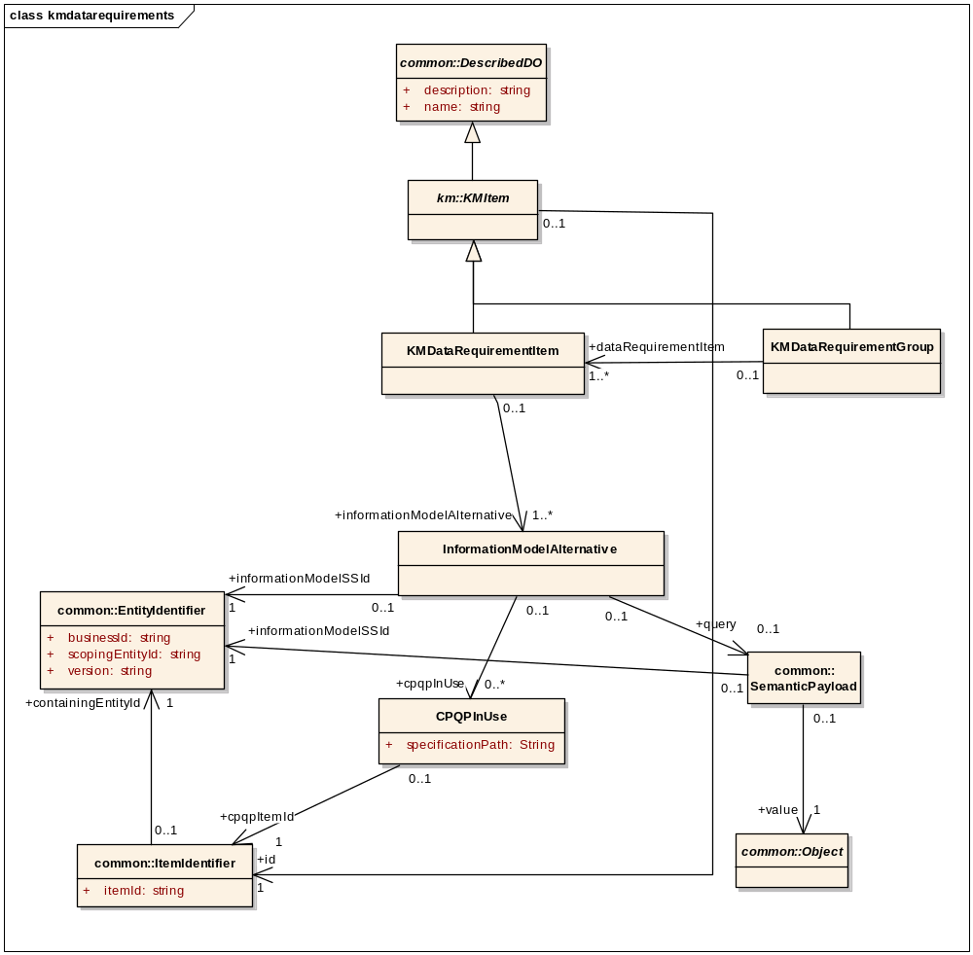
Figure 6.16. Model for KM Data Requirement Group.

KM Data Requirements
The data requirements for a KM are expressed in a manner that supports an iterative interaction model. To support such iterative interaction, the DSS expresses its data requirements in terms of DRGs that must be initially provided as well as additional DRGs that may need to be provided during a subsequent interaction, depending on the results of the initial interaction. If the client wishes to interact with the DSS using a single interaction model, a client can simply provide all of the data required by all of the DRGs. This data requirement model is defined in the query.kmdatarequirements package and explained further below.

As shown in the figure below, in expressing the data requirements for a KM, a DSS specifies one or more DRGs as needing to be provided with an initial evaluation. Also, additional DRGs that may be needed in a future interaction are specified. Furthermore, any CPQPs required within the DRGs are specified. Of note, a client may provide all of the above DRGs with an initial evaluation to ensure that a final conclusion is reached after a single interaction.

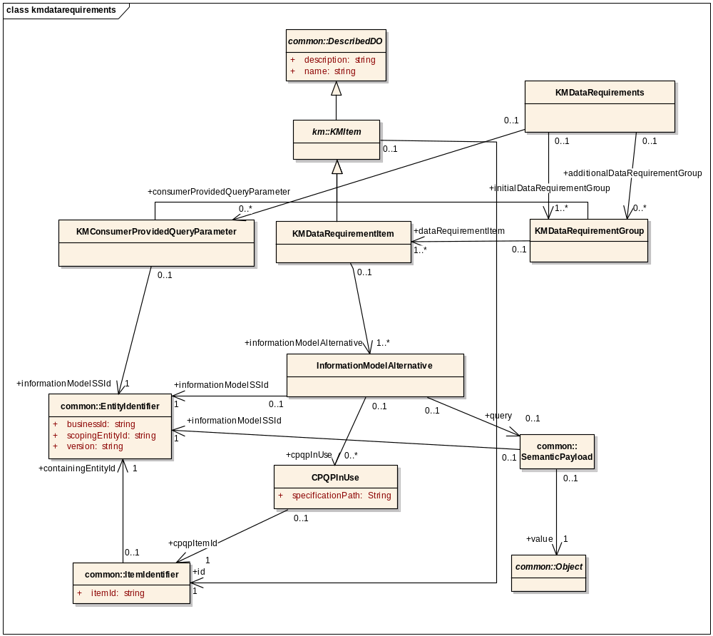
Figure 6.17. Model for KM Data Requirements.

KM Evaluation Result Semantics
KMs return one or more evaluation results as specified by a semantic signifier. This model is defined in the query.evaluationresult package. The optional cdsOutputSpecification enables the specification of additional information on the evaluation results to be returned.

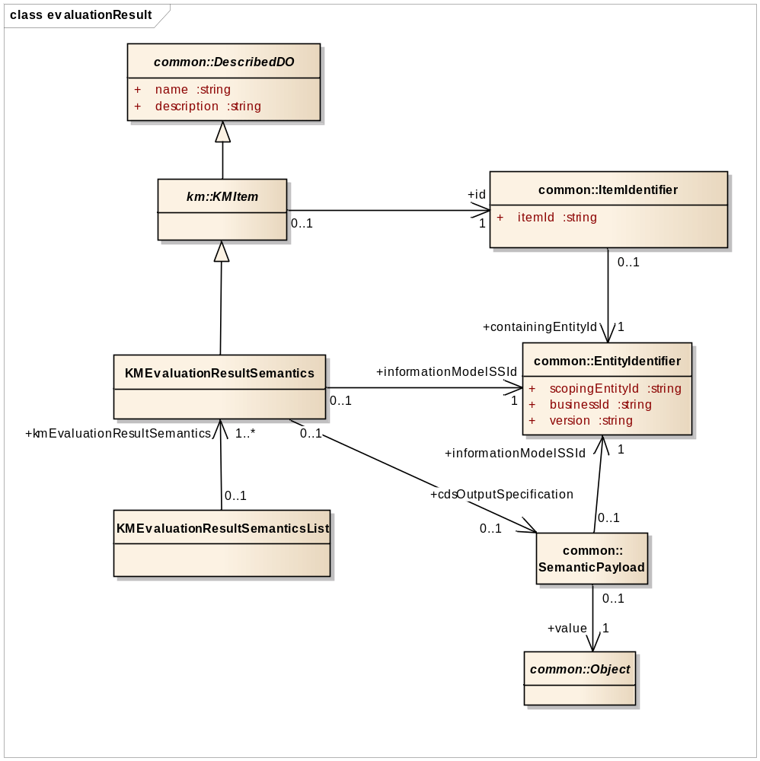
Figure 6.18. Model for KM Evaluation Result Semantics.

Exception Model Elements
Models for exceptions thrown by the service are in the common.exception, evaluation.exception, and query.exception packages. These exception models are not further described here, as they are described in the service operations themselves in Section 6.7, Metadata Discovery Interface, Section 6.8, Query Interface, and Section 6.9, Evaluation Interface. The three models are provided here for reference.

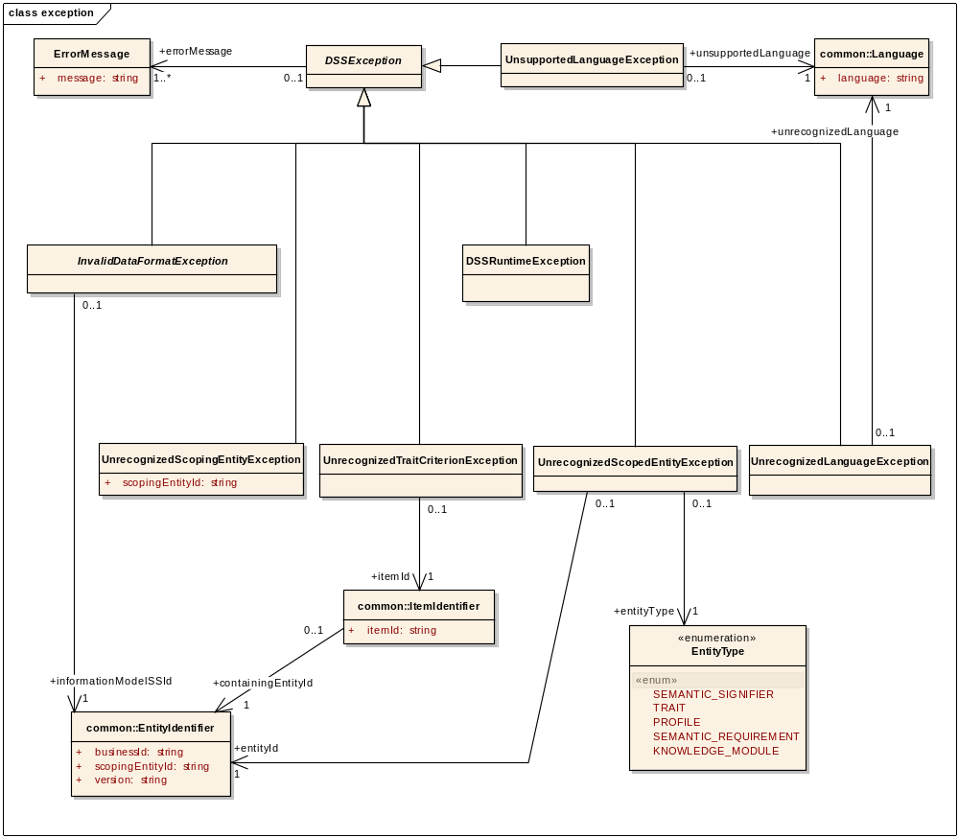
Figure 6.19. Model for Exceptions in common.exception package.
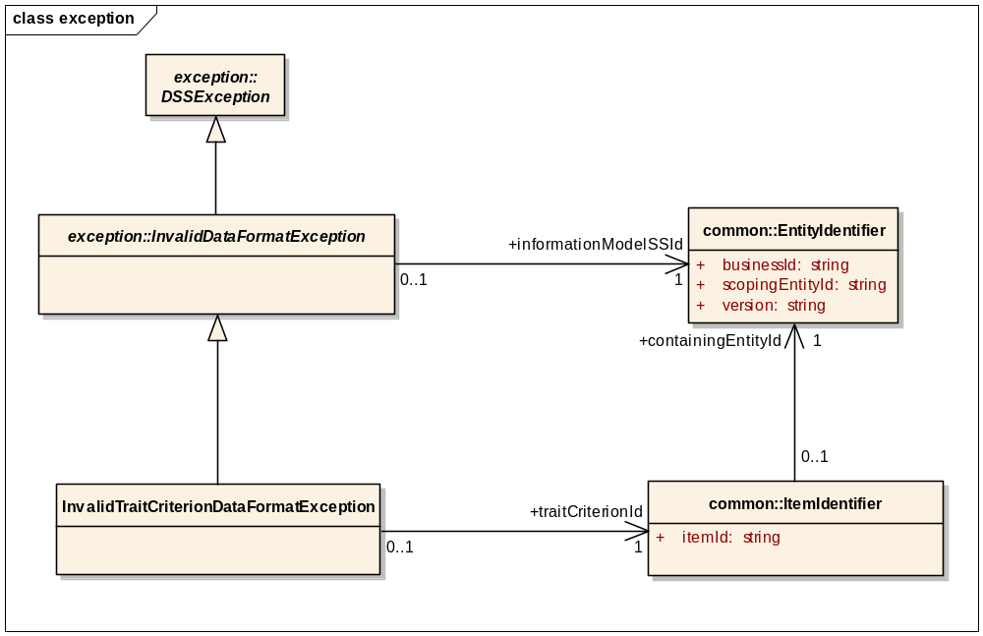
Figure 6.20. Model for Exceptions in query.exception package.

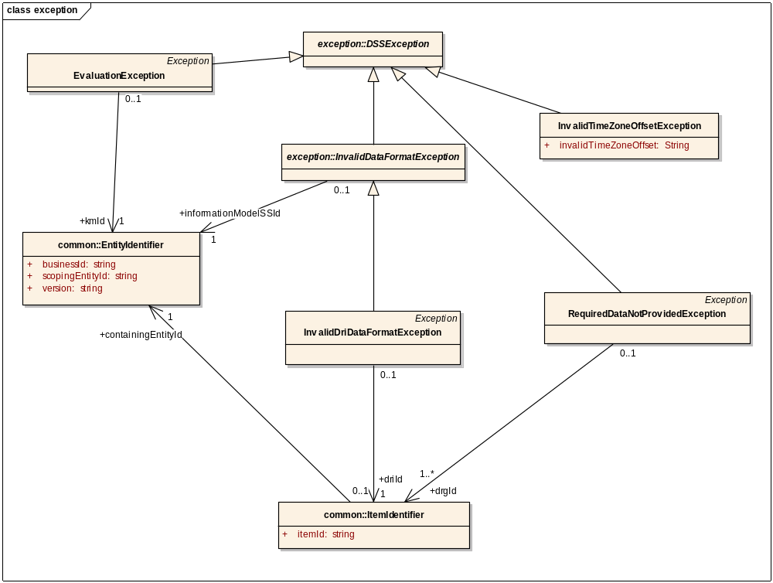
Figure 6.21. Model for Exceptions in evaluation.exception package.

KM Search Criteria Model Elements
KMs may be searched based on various search criteria. A search may identify KMs that fulfill search criteria perfectly or partially, with search results provided in a ranked list based on relevance. This model for search criteria is provided below and further described.

Search Criteria
The search criteria are modeled in the query.criteria packaged and provided below. Search criteria consist of the following:
- The maximum number of KMs to return in the search result (integer; minimum value of 1).
- The minimum search score required for a KM to be included in the search result (integer; value of 1 to 100). A perfect match shall have a score of 100, and a non-perfect match shall have a score of between 1 to 99. Implementations of the scoring mechanism are vendor-specific. One suggestion is to make the score the % of criteria that match.
- Search inclusion and exclusion criteria. An inclusion criterion is used to include KMs into the search result list and/or increase the KMs’ search score, whereas an exclusion criterion is used to exclude KMs from the search result list and/or reduce the KMs’ search score. The following criteria may be used as inclusion and/or exclusion criteria:
  - Knowledge module trait criteria
  - Knowledge module statuses. The possible knowledge module statuses are enumerated in Section 6.3.1.1, Knowledge Module Status.
  - Evaluation result semantics used by a knowledge module
  - Data requirement items in use by a knowledge module
  - Specified relationships to specified knowledge modules
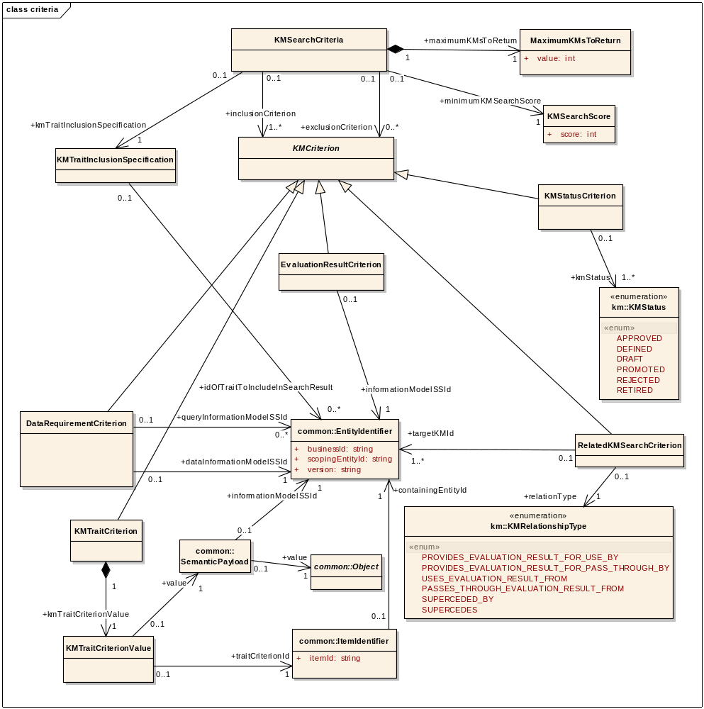
Figure 6.22. Model for KM Search Criteria.

Evaluation Payload Elements
The evaluation.request and evaluation.response packages contain model elements that represent the input and output payloads of the DSS evaluation operations. These model elements are described below.

Evaluation Request Model
The request model for DSS evaluations is shown below.

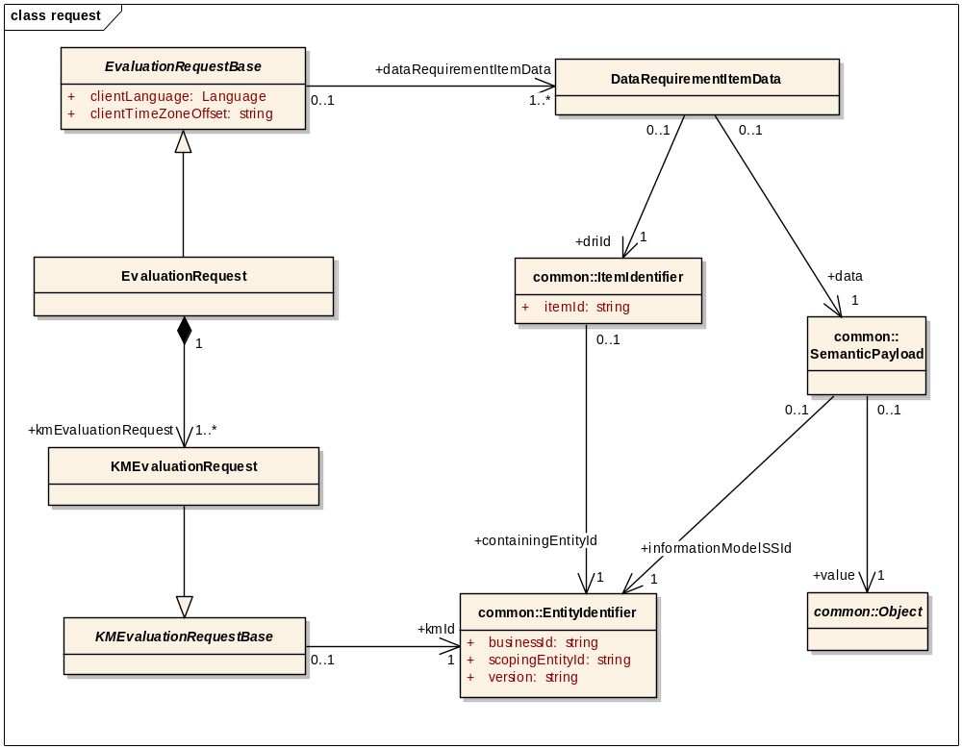
Figure 6.23. Model for Evaluation Request.

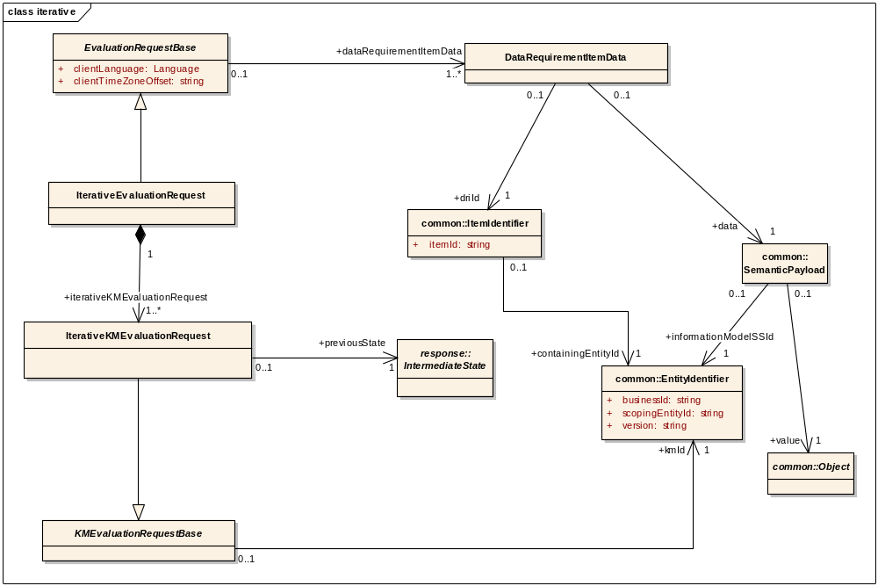
Figure 6.24. Model for Iterative Evaluation Request.

As noted, each evaluation request carries with it DataRequirementItemData, which consist of required data as specified by the knowledge modules as well as a specification of which data requirement item each data item fulfills.

Also note that the request must specify the client's time zone offset from Universal Coordinated Time (UTC). This offset is expressed as +/- hh:mm, e.g., 00:00, -05:00, +07:00. Note that the client's time zone offset cannot be used to determine a geographical time zone. Unless otherwise specified, all time-stamped data provided by the client will be assumed to have this time zone offset.

The evaluation request also contains the client's language. The language is used by the DSS to adjust the evaluation result (e.g., for narrative text included with the evaluation result).

Single-Interaction Evaluation Request
In a single-interaction evaluation request, a list of KMs to be used for the evaluation is provided along with the required data.

Iterative Interaction Evaluation Request
In the case that a DSS is used iteratively for evaluation, an evaluation request is similar to a single-interaction evaluation request, except that (i) the data provided are either the initial data required for an iterative interaction evaluation request or the data specified as being required next during subsequent iterative steps, and (ii) the intermediate state for each KM evaluation returned from the prior response is provided as a part of the request.

Evaluation Response Model
The response model for DSS evaluations is shown below. As noted, the base evaluation response class contains a list of 0 or more final KM evaluation results as pre-specified by the KM using semantic signifiers.

For single-interaction evaluations, the evaluation result consists of these final KM evaluation results if the required data were provided. If the required data were not provided, the evaluation result for a KM indicates which additional data requirement groups needed to have been provided in order to provide a final evaluation result.

For iterative-interaction evaluations, a final KM evaluation result is provided only when all data required for completing the evaluation has been provided. Until that condition is met, the KM evaluation response returns a specification of the data that must be provided during the next interaction, as well as intermediate state data to pass back with the next request.

Moreover, all KM evaluation responses may contain warnings. These warnings include the actual warning, as well as a specification of the information model used to communicate the warning. An example warning may specify that a retired KM was evaluated, along with the identifier of the superceding KM.

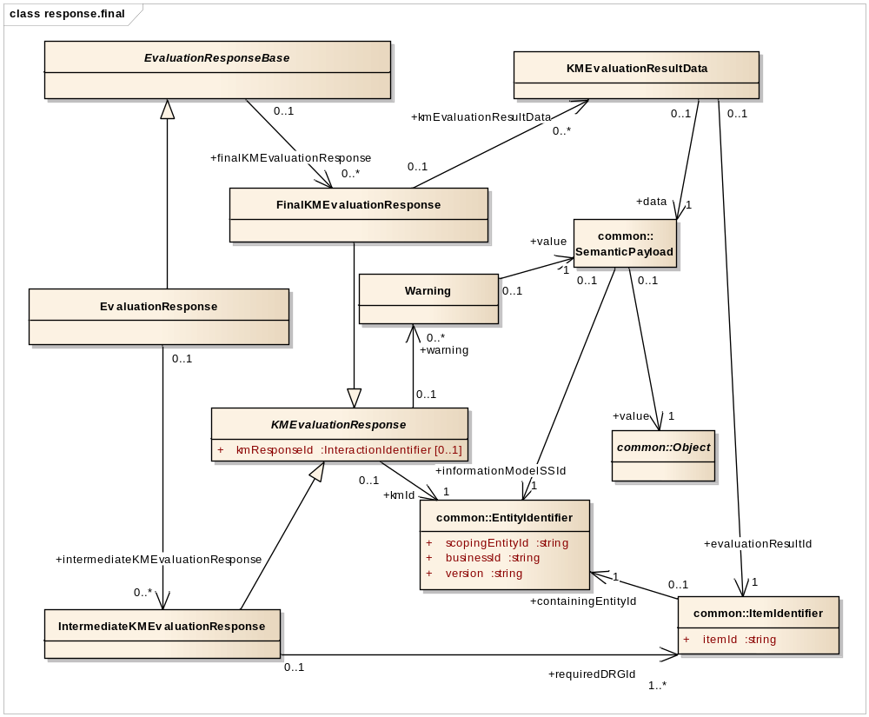
Figure 6.25. Model for Evaluation Response.

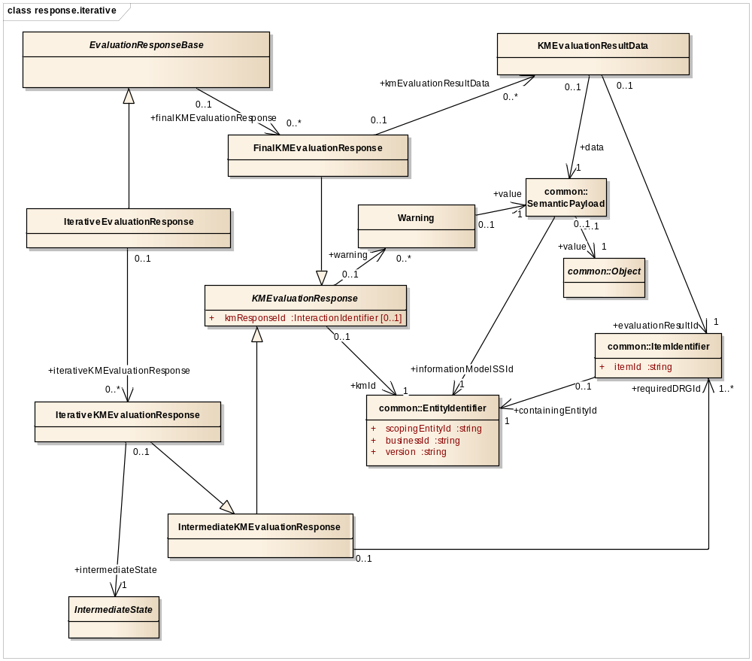
Figure 6.26. Model for Iterative Evaluation Response.

Metadata Discovery Interface
The DSS Metadata Discovery interface is defined in the service.metadatadiscovery package, and provided below. Details of each operation in the interface are then described. These operations are intended to allow a consumer to start with listProfiles and then to use the other operations to identify the capabilities of the service.

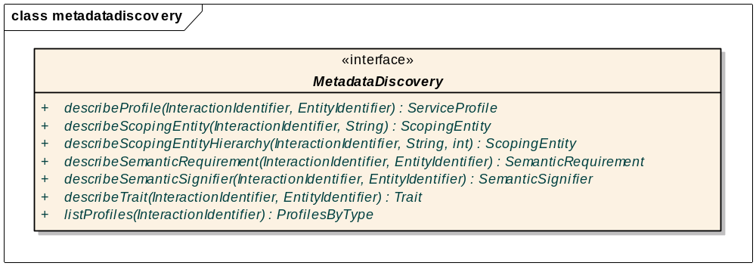
While not specified individually in the definition of DSS operations that follow in Section 6.7, Metadata Discovery Interface, Section 6.8, Query Interface, and Section 6.9, Evaluation Interface, note that the following hold true for all operations across all interfaces:

- All operations may throw a DSSRuntimeException if there is a runtime exception that is not otherwise specifically named.
- All operations may throw an exception if the service request is syntactically invalid (e.g., for the SOAP Web service PSM, the Web service call is non-compliant with the DSS’s WSDL).
- All operations have the following pre-condition: “No preconditions are assumed.”
- All operations have the following post-condition: “If successful, returns output object(s). If unsuccessful, throws exception.”
- All operations have the following invariant: “All operations defined are read-only, with no changes made to the DSS.”
- All operations have an InteractionIdentifier as an Input. Note that if Inputs are otherwise listed as “None”, this means that the sole Input is an InteractionIdentifier.
- All operations include the following in the response (not shown in the interface models): a requestId representing the InteractionIdentifier provided as the input, and a responseId representing the InteractionIdentifier created by the DSS to identify the response.

listProfiles
Description | Returns a list of all of the profiles supported by the service as a ProfilesByType object.
Inputs | None.
Outputs | ProfilesByType (Section 6.2.1.3, Service Profile Model): list of profiles supported by the DSS, grouped by type of profile.
Exception conditions
Aspects left to implementers | Whether and how to sort the output. A suggestion is to order the groups alphabetically by profile type. Within profile types, a suggestion is to sort by the EntityIdentifier of the profiles according to scoping entity identifier, then business identifier, then version.

describeProfile
Description | Throws UnrecognizedScopedEntityException if the specified profile EntityIdentifier is not recognized by the service. If specified EntityIdentifier is recognized by the service, returns a description of the profile as a ServiceProfile object.
Inputs | EntityIdentifier of the profile (Section 6.1.3, Entity Identifier).
Outputs | ServiceProfile (Section 6.2.1.3, Service Profile Model).
Exception conditions | The profile is not recognized by the service (UnrecognizedScopedEntityException).
Aspects left to implementers

describeScopingEntity
Description | Throws UnrecognizedScopingEntityException if the specified scoping entity identifier is not recognized by the service. If specified scoping entity identifier is recognized by the service, returns a description of the scoping entity as a ScopingEntity object. Returned ScopingEntity object does not include any children scoping entities.
Inputs | Scoping entity identifier (String) (Section 6.1.2, Scoping Entity).
Outputs | ScopingEntity (Section 6.1.2, Scoping Entity). Does not include any children scoping entities.
Exception conditions | The scoping entity is not recognized by the service (UnrecognizedScopingEntityException).
Aspects left to implementers

describeScopingEntityHierarchy
Description | Throws UnrecognizedScopingEntityException if the specified scoping entity identifier is not recognized by the service. If specified scoping entity identifier is recognized by the service, returns a description of the scoping entity as a ScopingEntity object. Returned ScopingEntity object includes any descendant scoping entities, up to and including the depth specified.
Inputs | - Scoping entity identifier (String) (Section 6.1.2, Scoping Entity).  - Maximum depth of search (e.g., 2 could result in the inclusion of descendant scoping entities up to the grand children) (positive integer).
Outputs | ScopingEntity (Section 6.1.2, Scoping Entity). Includes any descendant scoping entities, up to and including the depth specified.
Exception conditions | The scoping entity is not recognized by the service (UnrecognizedScopingEntityException).
Aspects left to implementers

describeSemanticRequirement
Description | Throws UnrecognizedScopedEntityException if the specified semantic requirement EntityIdentifier is not recognized by the service. If specified EntityIdentifier is recognized by the service, returns a description of the semantic requirement as a SemanticRequirement object.
Inputs | EntityIdentifier of the semantic requirement (Section 6.1.3, Entity Identifier).
Outputs | SemanticRequirement (Section 6.3.2.3, Semantic Requirement Model).
Exception conditions | The semantic requirement is not recognized by the service (UnrecognizedScopedEntityException).
Aspects left to implementers

describeSemanticSignifier
Description | Throws UnrecognizedScopedEntityException if the specified semantic signifier EntityIdentifier is not recognized by the service. If specified EntityIdentifier is recognized by the service, returns a description of the semantic signifier as a SemanticSignifier object.
Inputs | EntityIdentifier of semantic signifier (Section 6.1.3, Entity Identifier).
Outputs | SemanticSignifier (Section 6.2.2.3, Semantic Signifier Model).
Exception conditions | The semantic signifier is not recognized by the service (UnrecognizedScopedEntityException).
Aspects left to implementers

describeTrait
Description | Throws UnrecognizedScopedEntityException if the specified trait EntityIdentifier is not recognized by the service. If specified EntityIdentifier is recognized by the service, returns a description of the trait used for describing knowledge modules as a Trait object.
Inputs | EntityIdentifier of trait (Section 6.1.3, Entity Identifier).
Outputs | Trait (Section 6.3.1.4, Knowledge Module Traits).
Exception conditions | The knowledge module trait is not recognized by the service (UnrecognizedScopedEntityException).
Aspects left to implementers

Query Interface
The DSS Query interface enables the discovery and characterization of knowledge modules. The Query interface is defined in the service.query package and provided below. Details of each operation in the interface are then described.

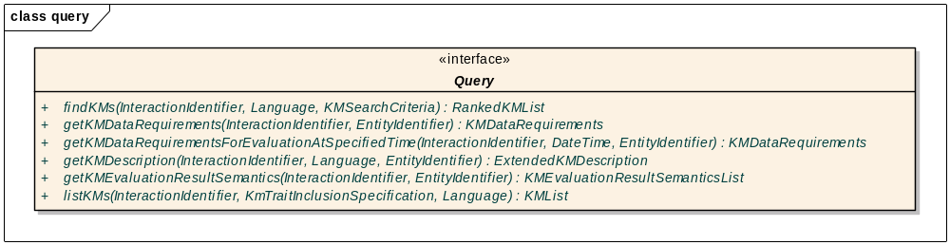

listKMs
Description | Throws one of the exceptions if an exception condition is present. If none of the exception conditions are present, returns a list of all knowledge modules hosted by the service as a KMList object.  Consumers can specify which traits, if any, to include in the KM descriptions returned. Trait values are provided according to the client’s specified language. Note that the language specified by the client must exactly match a language supported by the service. Each KM description includes the status of the KM and its trait values as requested by the consumer.
Inputs | - Client’s Language (Section 6.3.2.2, Language specification).  - KMTraitInclusionSpecification: specification of which KM traits to include in the KM descriptions returned (Section 6.5.1, Search Criteria).
Outputs | List of KMs (KMList; Section 6.3.1, Knowledge Module Description). Each KM includes a specification of the following:  - KM status.  - KM trait values for specified traits, localized according to client language.
Exception conditions | - The client’s specified Language is not recognized (UnrecognizedLanguageException).  - The client’s specified Language is recognized but not supported. Note that the language specified by the client must exactly match a language supported by the service in order to avoid this exception. (UnsupportedLanguageException).  - A knowledge module trait included in the KMTraitInclusionSpecification is not recognized by the service (UnrecognizedScopedEntityException).
Aspects left to implementers | Whether and how to sort the output. A suggestion is to order the KMs by the EntityIdentifier according to scoping entity identifier, then business identifier, then version.

findKMs
Description | Throws one of the exceptions if an exception condition is present. If none of the exception conditions are present, returns knowledge modules fulfilling client search criteria as a RankedKMList object.  A search may identify KMs that fulfill search criteria perfectly or partially. Search results are provided in a ranked list, with more relevant KMs listed first. KMs included in the search result must have a relevance score of 1 to 100. A KM meeting all client search criteria shall have a score of 100, while a KM that does not meet all client search criteria shall not have a score of 100. Implementations of the scoring mechanism are vendor-specific. One suggestion is to make the score the % of criteria that match. For KMs with the same score, relative ordering in the result list denotes their relative relevance.  Consumers can specify which traits, if any, to include in the KM descriptions returned. Trait values are provided according to the client’s specified language. Note that the language specified by the client must exactly match a language supported by the service. Each KM description includes the status of the KM and its trait values as requested by the consumer.
Inputs | - Client’s Language (Section 6.3.2.2, Language specification).  - KMSearchCriteria (Section 6.5.1, Search Criteria).
Outputs | List of knowledge modules fulfilling the search criteria (RankedKMList; Section 6.3.1, Knowledge Module Description).
Exception conditions | - A knowledge module trait included in the KMTraitInclusionSpecification is not recognized by the service (UnrecognizedScopedEntityException).  - A knowledge module specified as the target of a relationship-based search is unrecognized (UnrecognizedScopedEntityException).  - A trait criterion identifier is not recognized (UnrecognizedTraitCriterionException).  - A trait criterion value has an invalid data format (InvalidTraitCriterionDataFormatException).  - An evaluation result semantic signifier specified as a search criterion is not recognized (Unrecognized ScopedEntityException).  - A semantic requirement specified as a search criterion is not recognized (Unrecognized ScopedEntityException).  - A semantic signifier used to specify a data requirement criterion is not recognized (UnrecognizedScopedEntityException).  - The client’s specified Language is not recognized (UnrecognizedLanguageException).
Aspects left to implementers

getKMDescription
Description | Throws one of the exceptions if an exception condition is present. If none of the exception conditions are present, returns a description of the specified knowledge module as an ExtendedKMDescription object.  When language-dependent trait values are available, returns trait values using the client's specified language. Note that the language specified by the client must exactly match a language supported by the service.
Inputs | - EntityIdentifier of knowledge module (Section 6.1.3, Entity Identifier).  - Client’s Language (Section 6.3.2.2, Language specification).
Outputs | ExtendedKMDescription (Section 6.3.1, Knowledge Module Description).
Exception conditions | - The client’s specified Language is not recognized (UnrecognizedLanguageException).  - The client’s specified Language is recognized but not supported. Note that the language specified by the client must exactly match a language supported by the service in order to avoid this exception (UnsupportedLanguageException).  - The requested knowledge module does not exist (UnrecognizedScopedEntityException).
Aspects left to implementers

getKMEvaluationResultSemantics
Description | Throws UnrecognizedScopedEntityException if the specified knowledge module EntityIdentifier is not recognized by the service. If specified EntityIdentifier is recognized by the service, returns a specification of the information model(s) that will be used by the knowledge module when returning an evaluation result as a KMEvaluationResultSemanticsList object.
Inputs | EntityIdentifier of the knowledge module (Section 6.1.3, Entity Identifier).
Outputs | KMEvaluationResultSemanticsList (Section 6.3.5, KM Evaluation Result Semantics).
Exception conditions | The requested knowledge module does not exist (UnrecognizedScopedEntityException).
Aspects left to implementers

getKMDataRequirements
Description | Throws UnrecognizedScopedEntityException if the specified knowledge module EntityIdentifier is not recognized by the service. If specified EntityIdentifier is recognized by the service, returns a specification of the data required by the knowledge module for conducting an evaluation as a KMDataRequirements object.
Inputs | EntityIdentifier of knowledge module (Section 6.1.3, Entity Identifier).
Outputs | KMDataRequirements (Section 6.3.4.4, KM Data Requirements).
Exception conditions | The requested knowledge module does not exist (UnrecognizedScopedEntityException).
Aspects left to implementers

getKMDataRequirementsForEvaluationAtSpecifiedTime
Description | Throws UnrecognizedScopedEntityException if the specified knowledge module EntityIdentifier is not recognized by the service. If specified EntityIdentifier is recognized by the service, returns a specification of the data required by the knowledge module for conducting an evaluation as a KMDataRequirements object.  If there are any query parameters that use absolute date-times (e.g., search 1/1/09 to 7/1/09) instead of relative date-times (e.g., search past 6 months), then these absolute date-time parameters will be populated to be appropriate for an evaluation at the specified date-time. Note that if a DSS provider does not use absolute date-time query parameters, then the DSS provider can implement this operation by simply calling the getKMDataRequirements operation.
Inputs | - DateTime of intended evaluation.  - EntityIdentifier of knowledge module (Section 6.1.3, Entity Identifier).
Outputs | KMDataRequirements (Section 6.3.4.4, KM Data Requirements).
Exception conditions | The requested knowledge module does not exist (UnrecognizedScopedEntityException).
Aspects left to implementers

Evaluation Interface
The DSS Evaluation interface enables data evaluation using knowledge modules. The Evaluation interface is defined in the service.evaluation package and provided below. Details of each operation in the interface are then described.

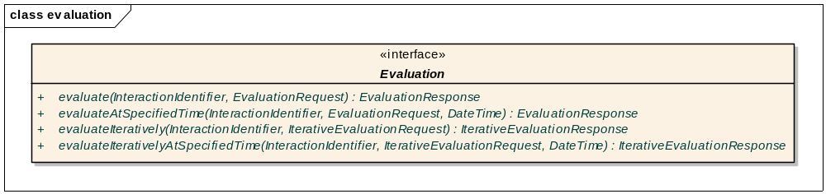

evaluate
Description | Throws one of the exceptions if an exception condition is present. If none of the exception conditions are present, evaluates in a non-iterative fashion one or more knowledge modules using the data provided as an EvaluationRequest object and returns the result(s) of the evaluation as an EvaluationResponse object.  All time-stamped data are considered to have the time zone offset specified by the client, unless otherwise noted.  The provision of excessive data (i.e., unrequired DataRequirementItemData) shall be ignored without leading to an exception. However, a warning may be provided.
Inputs | EvaluationRequest object (Section 6.6.1, Evaluation Request Model)
Outputs | EvaluationResponse object (Section 6.6.2, Evaluation Response Model)
Exception conditions | - The specified time zone offset is invalid (InvalidTimzeZoneOffsetException).  - The client’s specified Language is not recognized (UnrecognizedLanguageException).  - The client’s specified Language is recognized but not supported. Note that the language specified by the client must exactly match a language supported by the service in order to avoid this exception (UnsupportedLanguageException).  - A requested knowledge module does not exist (UnrecognizedScopedEntityException).  - Required data not provided. This exception specifies the data requirement group(s) for which data were required but not provided (RequiredDataNotProvidedException).  - Required data were not provided in the correct format (InvalidDriDataFormatException).  - An exception occurred during the evaluation process (EvaluationException).
Aspects left to implementers

evaluateAtSpecifiedTime
Description | Throws one of the exceptions if an exception condition is present. If none of the exception conditions are present, evaluates in a non-iterative fashion one or more knowledge modules using the data provided as an EvaluationRequest object and returns the result(s) of the evaluation as an EvaluationResponse object.  Conducts evaluation as if it was currently the specified date and time.  All time-stamped data are considered to have the time zone offset specified by the client, unless otherwise noted.  The provision of excessive data (i.e., unrequired DataRequirementItemData) shall be ignored without leading to an exception. However, a warning may be provided.
Inputs | - EvaluationRequest object (Section 6.6.1, Evaluation Request Model).  - DateTime of the evaluation.
Outputs | EvaluationResponse object (Section 6.6.2, Evaluation Response Model)
Exception conditions | - The specified time zone offset is invalid (InvalidTimzeZoneOffsetException).  - The client’s specified Language is not recognized (UnrecognizedLanguageException).  - The client’s specified Language is recognized but not supported. Note that the language specified by the client must exactly match a language supported by the service in order to avoid this exception (UnsupportedLanguageException).  - A requested knowledge module does not exist (UnrecognizedScopedEntityException).  - Required data not provided. This exception specifies the data requirement group(s) for which data were required but not provided (RequiredDataNotProvidedException).  - Required data were not provided in the correct format (InvalidDriDataFormatException).  - An exception occurred during the evaluation process (EvaluationException).
Aspects left to implementers

evaluateIteratively
Description | Throws one of the exceptions if an exception condition is present. If none of the exception conditions are present, evaluates the data provided by the client using one or more knowledge modules and returns the result(s) of the evaluation. Conducts evaluation iteratively, returning intermediate state data and specification of additional required data if final conclusions cannot be initially reached.  All time-stamped data are considered to have the time zone offset specified by the client, unless otherwise noted.  The provision of excessive data (i.e., unrequired DataRequirementItemData) shall be ignored without leading to an exception. However, a warning may be provided.
Inputs | IterativeEvaluationRequest object (Section 6.6.1, Evaluation Request Model).
Outputs | IterativeEvaluationResponse object (Section 6.6.2, Evaluation Response Model).
Exception conditions | - The specified time zone offset is invalid (InvalidTimzeZoneOffsetException).  - The client’s specified Language is not recognized (UnrecognizedLanguageException).  - The client’s specified Language is recognized but not supported. Note that the language specified by the client must exactly match a language supported by the service in order to avoid this exception (UnsupportedLanguageException).  - A requested knowledge module does not exist (UnrecognizedScopedEntityException).  - Required data not provided. This exception specifies the data requirement group(s) for which data were required but not provided (RequiredDataNotProvidedException).  - Required data were not provided in the correct format (InvalidDriDataFormatException).  - An exception occurred during the evaluation process (EvaluationException).
Aspects left to implementers

evaluateIterativelyAtSpecifiedTime
Description | Throws one of the exceptions if an exception condition is present. If none of the exception conditions are present, evaluates the data provided by the client using one or more knowledge modules and returns the result(s) of the evaluation. Conducts evaluation iteratively, returning intermediate state data and specification of additional required data if final conclusions cannot be initially reached.  Conducts evaluation as if it was currently the specified date and time.  All time-stamped data are considered to have the time zone offset specified by the client, unless otherwise noted.  The provision of excessive data (i.e., unrequired DataRequirementItemData) shall be ignored without leading to an exception. However, a warning may be provided.
Inputs | - IterativeEvaluationRequest object (Section 6.6.1, Evaluation Request Model).  - Date and time of the evaluation.
Outputs | IterativeEvaluationResponse object (Section 6.6.2, Evaluation Response Model).
Exception conditions | - The specified time zone offset is invalid (InvalidTimzeZoneOffsetException).  - The client’s specified Language is not recognized (UnrecognizedLanguageException).  - The client’s specified Language is recognized but not supported. Note that the Language specified by the client must exactly match a language supported by the service in order to avoid this exception (UnsupportedLanguageException).  - A requested knowledge module does not exist (UnrecognizedScopedEntityException).  - Required data not provided. This exception specifies the data requirement group(s) for which data were required but not provided (RequiredDataNotProvidedException).  - Required data were not provided in the correct format (InvalidDriDataFormatException).  - An exception occurred during the evaluation process (EvaluationException).
Aspects left to implementers

Profiles and Semantic Requirements Specified as a Part of this Specification

Overview
This specification specifies several profiles and semantic requirements to ensure a minimum level of interoperability among DSSs.

This section defines these normative specifications, which consist of two functional profiles (the HSSP Simple Evaluation DSS Functional Profile and the HSSP Complete DSS Functional Profile), one semantic profile (the HSSP Minimum DSS Semantic Profile), one semantic requirement (the HSSP Minimum DSS Trait Set Requirement), and two conformance profiles (the HSSP Simple Evaluation Conformance Profile and the HSSP Complete DSS Conformance Profile). These specifications are defined below. Moreover, Table 6.4 provides a summary of the operations supported by the functional profiles, and Figure 6.26 outlines the relationships between the profiles specified in this specification.

Table 6.7. Operations supported by functional profiles.
Operation | Supported by HSSP  Simple Evaluation DSS  Functional Profile | Supported by HSSP  Complete DSS  Functional Profile
describeProfile |  | X
describeScopingEntity |  | X
describeScopingEntityHierarchy |  | X
describeSemanticRequirement |  | X
describeSemanticSignifier |  | X
describeTrait |  | X
listProfiles |  | X
findKMs |  | X
getKMDataRequirements |  | X
getKMDataRequirementsForEvaluation AtSpecifiedTime |  | X
getKMDescription |  | X
getKMEvaluationResultSemantics |  | X
listKMs |  | X
evaluate | X | X
evaluateAtSpecifiedTime | X | X
evaluateIteratively |  | X
evaluateIterativelyAtSpecifiedTime |  | X

HSSP Simple Evaluation DSS Functional Profile
HSSP Complete DSS Functional Profile
extends
HSSP Minimum DSS Semantic Profile
HSSP Minimum DSS Trait Set Requirement
fulfills
HSSP Simple Evaluation DSS Conformance Profile
HSSP Complete DSS Conformance Profile
requires
requires
requires
requires
Figure 6.27. Relationships between profiles.

HSSP Simple Evaluation DSS Functional Profile, Version 2.0
To claim conformance to the HSSP Simple Evaluation DSS Functional Profile, version 2.0, a DSS must implement and support the following service operations defined in this specification:
From the Evaluation interface:
evaluate
evaluateAtSpecifiedTime (this has been added for Version 2.0)

The relevant identifying parameters for this profile shall be as follows:
scopingEntityId: org.hssp.dss
businessId: HSSP_Simple_Evaluation_DSS_Functional_Profile
version: 2.0
type: FUNCTIONAL_PROFILE

HSSP Complete DSS Functional Profile, Version 2.0
To claim conformance to the HSSP Complete DSS Functional Profile, version 2.0, a DSS must implement and support all service operations defined in this specification. The relevant identifying parameters for this profile shall be as follows:
scopingEntityId: org.hssp.dss
businessId: HSSP_Complete_DSS_Functional_Profile
version: 2.0
type: FUNCTIONAL_PROFILE

HSSP Minimum DSS Semantic Profile, Version 2.0
To claim conformance to the HSSP Minimum DSS Semantic Profile version 2.0, the service must fulfill the HSSP Minimum DSS Trait Set Requirement, which is specified in Section 6.10.5 below. The relevant identifying parameters for this profile shall be as follows:
scopingEntityId: org.hssp.dss
businessId: HSSP_Minimum_Meta_Data_DSS_Semantic_Profile
version: 2.0
type: SEMANTIC_PROFILE

HSSP Minimum DSS Trait Set Requirement, Version 2.0
To claim conformance to this trait set requirement, all knowledge modules in the DSS must support the traits and trait criteria specified in Section 6.10.5.1 and Section 6.10.5.2 below. The relevant identifying parameters for this semantic requirement shall be as follows:
scopingEntityId: org.hssp.dss
businessId: HSSP_Minimum_DSS_Trait_Set_Requirement
version: 2.0
type: TRAIT_SET_REQUIREMENT

Knowledge Module Traits Required by Trait Set Requirement
Please note that all schemas referenced in this section are included as supplemental files with this specification.

The “root global element name” defined below is specific to the XML Web Service PSM and corresponds to the semantic signifier’s xsdRootGlobalElementName attribute in the XSDComputableDefinition class (see Section 6.2.2.3, Semantic Signifier Model).

StewardOrganization
Description:
The organization acting as the steward of the KM
Trait identifier:
Scoping entity identifier: org.hssp.dss.traits
Business identifier: StewardOrganization
Version: 2.0
Semantic signifier for information model:
Scoping entity identifier: org.hssp.dss
Business identifier: HsspDssTraitSchema.StewardOrganization
Version: 2.0
Root global element name: StewardOrganization
Trait attributes:
Is mandatory: true
Trait value is localized: true

CreationDate
Description:
Date KM was first created
Trait identifier:
Scoping entity identifier: org.hssp.dss.traits
Business identifier: CreationDate
Version: 2.0
Semantic signifier for information model:
Scoping entity identifier: org.hssp.dss
Business identifier: HsspDssTraitSchema.CreationDate
Version: 2.0
Root global element name: CreationDate
Trait attributes:
Is mandatory: true
Trait value is localized: false

LastReviewDate
Description:
Date when KM was last reviewed for accuracy
Trait identifier:
Scoping entity identifier: org.hssp.dss.traits
Business identifier: LastReviewDate
Version: 2.0
Semantic signifier for information model:
Scoping entity identifier: org.hssp.dss
Business identifier: HsspDssTraitSchema.LastReviewDate
Version: 2.0
Root global element name: LastReviewDate
Trait attributes:
Is mandatory: true
Trait value is localized: false

AuthorList
Description:
A list of the KM’s authors. May be empty.
Trait identifier:
Scoping entity identifier: org.hssp.dss.traits
Business identifier: AuthorList
Version: 2.0
Semantic signifier for information model:
Scoping entity identifier: org.hssp.dss
Business identifier: HsspDssTraitSchema.AuthorList
Version: 2.0
Root global element name: AuthorList
Trait attributes:
Is mandatory: true
Trait value is localized: false

FreeTextKeywordList
Description:
A list of free text keywords that characterize the KM. May be empty.
Trait identifier:
Scoping entity identifier: org.hssp.dss.traits
Business identifier: FreeTextKeywordList
Version: 2.0
Semantic signifier for information model:
Scoping entity identifier: org.hssp.dss
Business identifier: HsspDssTraitSchema.FreeTextKeywordList
Version: 2.0
Root global element name: FreeTextKeywordList
Trait attributes:
Is mandatory: true
Trait value is localized: true

CodedValueKeywordList
Description:
A list of coded value keywords that characterize the KM. May be empty. Use of SNOMED CT encouraged.
Trait identifier:
Scoping entity identifier: org.hssp.dss.traits
Business identifier: CodedValueKeywordList
Version: 2.0
Semantic signifier for information model:
Scoping entity identifier: org.hssp.dss
Business identifier: HsspDssTraitSchema.CodedValueKeywordList
Version: 2.0
Root global element name: CodedValueKeywordList
Trait attributes:
Is mandatory: true
Trait value is localized: true

Purpose
Description:
The purpose of a KM, intended for a medical informaticist
Trait identifier:
Scoping entity identifier: org.hssp.dss.traits
Business identifier: Purpose
Version: 2.0
Semantic signifier for information model:
Scoping entity identifier: org.hssp.dss
Business identifier: HsspDssTraitSchema.Purpose
Version: 2.0
Root global element name: Purpose
Trait attributes:
Is mandatory: true
Trait value is localized: true

Explanation
Description:
An explanation of how the KM uses the required data to generate evaluation results, intended for a medical informaticist
Trait identifier:
Scoping entity identifier: org.hssp.dss.traits
Business identifier: Explanation
Version: 2.0
Semantic signifier for information model:
Scoping entity identifier: org.hssp.dss
Business identifier: HsspDssTraitSchema.Explanation
Version: 2.0
Root global element name: Explanation
Trait attributes:
Is mandatory: true
Trait value is localized: true

Knowledge Module Trait Criteria that Must be Available to Query for KMs Based on Trait Value

ReviewedOnOrAfter
Parent trait: LastReviewDate (Section 6.10.5.1.3, LastReviewDate)
Description:
Specifies that LastReviewDate must have been on or after the specified date
Trait criterion identifier:
Containing entity identifier:
Scoping entity identifier: org.hssp.dss.traits
Business identifier: LastReviewDate
Version: 2.0
Item identifier: ReviewedOnOrAfter
Semantic signifier for information model:
Scoping entity identifier: org.hssp.dss
Business identifier: HsspDssTraitSchema.ReviewedOnOrAfter
Version: 2.0
Root global element name: ReviewedOnOrAfter

ReviewedWithinLastXDays
Parent trait: LastReviewDate (Section 6.10.5.1.3, LastReviewDate)
Description:
Specifies that LastReviewDate must have occurred within specified number of days
Trait criterion identifier:
Containing entity identifier:
Scoping entity identifier: org.hssp.dss.traits
Business identifier: LastReviewDate
Version: 2.0
Item identifier: ReviewedWithinLastXDays
Semantic signifier for information model:
Scoping entity identifier: org.hssp.dss
Business identifier: HsspDssTraitSchema.ReviewedWithinLastXDays
Version: 2.0
Root global element name: ReviewedWithinLastXDays

FreeTextKeywordContainsString
Parent trait: FreeTextKeywordList (Section 6.10.5.1.5, FreeTextKeywordList)
Description:
Specifies that at least one free text keyword must contain the specified string
Trait criterion identifier:
Containing entity identifier:
Scoping entity identifier: org.hssp.dss.traits
Business identifier: FreeTextKeywordList
Version: 2.0
Item identifier: FreeTextKeywordContainsString
Semantic signifier for information model:
Scoping entity identifier: org.hssp.dss
Business identifier: HsspDssTraitSchema.FreeTextKeywordContainsString
Version: 2.0
Root global element name: FreeTextKeywordContainsString

CodedValueKeywordExists
Parent trait: CodedValueKeywordList (Section 6.10.5.1.6, CodedValueKeywordList)
Description:
Specifies that the specified code exists as a coded value keyword. Note that because the HL7 version 3 Coded Value with Equivalents schema element is used, the search concept may be specified using multiple vocabularies.
A match on any of the equivalent concept codes shall be considered a keyword match.
Trait criterion identifier:
Containing entity identifier:
Scoping entity identifier: org.hssp.dss.traits
Business identifier: CodedValueKeywordList
Version: 2.0
Item identifier: CodedValueKeywordExists
Semantic signifier for information model:
Scoping entity identifier: org.hssp.dss
Business identifier: HsspDssTraitSchema.CodedValueKeywordExists
Version: 2.0
Root global element name: CodedValueKeywordExists

CodedValueKeywordOrKeywordDescendantExists
Parent trait: CodedValueKeywordList (Section 6.10.5.1.6, CodedValueKeywordList)
Description:
Specifies that the specified concept or a descendant concept exists as a coded value keyword. Note that because the HL7 version 3 Coded Value with Equivalents schema element is used, the search concept may be specified using multiple vocabularies. A match on any of the equivalent concept codes shall be considered a keyword match. Also, note that because a DSS provider may have limited and/or different capabilities for fulfilling this trait search criterion, a client may wish to instead use the CodedValueKeywordExists trait criterion instead (Section 6.10.5.2.4, CodedValueKeywordExists) and specify all of the descendant concepts of interest explicitly.
Trait criterion identifier:
Containing entity identifier:
Scoping entity identifier: org.hssp.dss.traits
Business identifier: CodedValueKeywordList
Version: 2.0
Item identifier: CodedValueKeywordOrKeywordDescendantExists
Semantic signifier for information model:
Scoping entity identifier: org.hssp.dss
Business identifier: HsspDssTraitSchema.CodedValueKeywordOrKeywordDescendantExists
Version: 2.0
Root global element name: CodedValueKeywordOrKeywordDescendantExists

HSSP Simple Evaluation DSS Conformance Profile, Version 2.0
To claim conformance to this profile, a DSS must be conformant with the HSSP Simple Evaluation DSS Functional Profile, version 2.0 (Section 6.10.2, HSSP Simple Evaluation DSS Functional Profile, Version 2.0) and the HSSP Minimum DSS Semantic Profile, version 2.0 (Section 6.10.4, HSSP Minimum DSS Semantic Profile, Version 2.0).

Because the HSSP Simple Evaluation DSS Functional Profile does not contain meta-data operations, conformance to the HSSP Minimum DSS Semantic Profile can be met using the DSS meta-data operations OR alternate means of communicating the relevant meta-data, such as documentation or a Web page. In cases where the DSS meta-data operations are not used, an XML format need not be used for providing the meta-data (e.g., keywords).

The relevant identifying parameters for this profile shall be as follows:
scopingEntityId: org.hssp.dss
businessId: HSSP_Simple_Evaluation_DSS_Conformance_Profile
version: 2.0
type: CONFORMANCE_PROFILE

HSSP Complete DSS Conformance Profile, Version 2.0
To claim conformance to this profile, a DSS must be conformant with the HSSP Complete DSS Functional Profile, version 2.0 (Section 6.10.3, HSSP Complete DSS Functional Profile, Version 2.0) and the HSSP Minimum DSS Semantic Profile, version 2.0 (Section 6.10.4, HSSP Minimum DSS Semantic Profile, Version 2.0). The relevant identifying parameters for this profile shall be as follows:
scopingEntityId: org.hssp.dss
businessId: HSSP_Complete_DSS_Conformance_Profile
version: 2.0
type: CONFORMANCE_PROFILE

Minimal Requirement for Claiming Conformance to HSSP DSS Standard
To claim conformance to the HSSP DSS standard, a DSS must be conformant with the HSSP Simple Evaluation DSS Conformance Profile, version 2.0 (Section 6.10.6, HSSP Simple Evaluation DSS Conformance Profile, Version 2.0).

Future Specifications of Profiles and Semantic Requirements
It is anticipated that more semantic profiles and semantic requirements will be specified in the future. These specifications are expected to take the form of HL7 and OMG-defined specifications as well as specifications defined by other entities, such as individual vendors.

DSS Platform Specific Model for SOAP XML Web Services
The Platform Specific Model (PSM) for SOAP XML Web services is derived from the platform independent model specified in Section 6. The PSM is defined in the accompanying normative WSDL and associated XSD.

Note that, for obvious reasons, the actual URL address of the service (specified in the WSDL as www.exampleLocation.com/evaluation, www.exampleLocation.com/query, and www.exampleLocation.com/ metadata) are non-normative and should be replaced by the implementer. Also note that security handling is outside of the scope of this specification, but should be considered. Typical approaches to handling security may include the use of the WS-Security protocol and Transport Layer Security (TLS). At a minimum, implementers should ensure transport security for patient-identifiable information provided by clients. Implementers should also consider transport security, authentication, and authorization for all service calls. Of note, an implementer may extend the provided WSDLs to incorporate WS-Security conformance and still be considered compliant with the specification.

PSM-Specific Conformance Criteria
The PSM conformance criteria correspond to the conformance criteria defined for the PIM in Section 6. Two separate WSDLs are provided to correspond with the two functional profiles defined in this specification, as follows:
- HSSP Simple Evaluation DSS Functional Profile, Version 2.0: dssEvaluate.wsdl
- HSSP Complete DSS Functional Profile, Version 2.0: dss.wsdl

Of note, a third WSDL (dssBaseComponents.wsdl) defines common components and is used by the two WSDLs noted above.

Also note that while there are minor updates to the schema (xsd file) for this release, the version 2.0 dss.wsdl mentioned above is unchanged from Release 1. The Simple Evaluation DSS Functional Profile, Version 2.0 dssEvaluate.wsdl has been extended to include the evaluateAtSpecifiedTime operation.

DSS Platform Specific Model for RESTful XML Web Services
The Platform Specific Model (PSM) for RESTful XML Web services is derived from the platform independent model specified in Section 6. The PSM is defined in the accompanying normative WSDL and associated XSD.

Note that, for obvious reasons, the actual URL address of the service (specified in the WSDL as www.exampleLocation.com/evaluation, www.exampleLocation.com/query, and www.exampleLocation.com/ metadata) are non-normative and should be replaced by the implementer. Also note that security handling is outside of the scope of this specification, but should be considered. Typical approaches to handling security may include the use of the WS-Security protocol and Transport Layer Security (TLS). The section on security handling provides some sample guidance on a possible security implementation using HMAC tokens. At a minimum, implementers should ensure transport security for patient-identifiable information provided by clients. Implementers should also consider transport security, authentication, and authorization for all service calls. Of note, an implementer may extend the provided WSDLs to incorporate WS-Security conformance and still be considered compliant with the specification.

PSM-Specific Conformance Criteria
The PSM conformance criteria correspond to the conformance criteria defined for the PIM in Section 6. One version 2.0 WSDL is provided to correspond with the first functional profile defined in this specification, as follows:
- HSSP Simple Evaluation DSS Functional Profile, Version 2.0: dssEvaluateRest.wsdl

Of note, this wsdl references the OmgDssSchema.xsd to incorporate the DSS schema elements. This is the same schema used by the SOAP profile.

For the purposes of this profile, the only functionality exposed are the evaluate and evaluateAtSpecifiedTime methods, which support a single evaluation request and response. These methods are modeled as an HTTP POST with the evaluate request as the body of the POST, and the evaluate response as the resulting document. Even though the evaluation is not expected to change state, the call is modeled as an HTTP POST to ensure that the results of the evaluation are not considered a cacheable resource (as they would be with an HTTP GET).

Note also that the service is described using a WSDL 2.0 document. WSDL 2.0 was chosen over WSDL 1.1 for its ability to describe RESTful services. In addition, the RESTful profile differs from the SOAP WSDL in that the types for the operations use the schema types declared in OmgDssSchema directly, rather than indirectly through the message construct.

Although the SOAP functional profiles include an HSSP Complete DSS Functional Profile, that functionality is not supported for REST at this time. We expect that it will be at some point in the future.

Example Security Implementation Using HMAC
As mentioned above, security in general is considered out of scope for the normative aspects of this profile. However, as an informative implementation example, the following scenario describes a potential mechanism for providing security of a RESTful implementation.

The method used is a variation of a symmetric key method designed to minimize chatter while offering robust security. Encryption is not part of the method but is assumed to be happening at the transport layer.
The advantages of this approach are that it is simple to implement, yet still offers robust, low latency authentication using an authentication token that is unique to the time, service URL, request, and user.

The following sections describe the general protocol:

Assumptions
- The service host will not allow anonymous access to Web services.
- The service host implements a user directory and some form of signup/licensing scheme.
- The token creation specification is well documented and unambiguous
- The client will be licensed to use the host's services

Prelude
When a new Web service user account is created, a unique identifier (e.g., a GUID) is generated for the user, and a secret is generated that consists of a random hash value. This information is provided by the service host to the new user one time on account creation.

Transaction
The following steps are involved in securing any transaction from the user:
- The Web service client captures the date-time as seconds since the epoch UTC
- The Web service client concatenates (HttpMethod + URI + RequestBody + Time + UserGuid + UserSecret) into a long string
- The Web server client invokes an HMAC 256 algorithm on the above concatenated string with UserSecret as the Cryptographic key, resulting in a long sequence of bytes, called the token.
- The Web server client converts the token to Base64 and then URLencodes it.
- The Web server client creates two headers in the Web service request stream:
  - X-Time: The same value as was included in creation of the hash
  - Authorization: user-guid : B64Token
- The Web server client sends the request
The following steps are performed by the host to process the authentication and authorization:
- The Web service host receives the request
- The Web service host checks that the X-Time header is recent to within a minute or two (allow for time skew between clocks). If not, returns 403 Forbidden. (Remember that Time has also been part of creating the token)
- The Web service host unpacks the Authorization header and uses the GUID to look up the corresponding secret. The host then checks the user information to determine whether the requesting user is licensed. If the user is not licensed or unknown, the host returns 403 Forbidden.
- The Web service host concatenates HttpMethod + URI + RequestBody + Time + UserGuid + UserSecret.
- The Web service host invokes an HMAC 256 algorithm on the above concatenated string with UserSecret as the Cryptographic key, resulting in a sequence of bytes that should be equivalent to the client token.
- The Web service host converts the token to Base64
- The Web service host then compares the locally created b64 token with the one unpacked from the client's Authorization header. If they match, the vendor can process the request and return the response, otherwise, the vendor returns 401 Unauthorized.
The following snapshot shows an example of the headers of such a request with a sample userId of ‘1’:
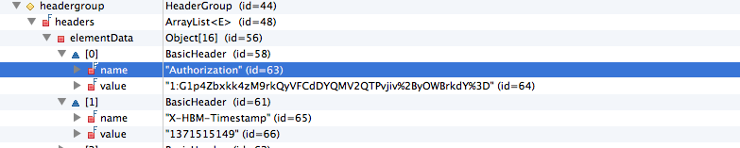

Exception Handling
Unlike SOAP, REST does not have a standard prescribed methodology for dealing with exceptions. Industry best practices generally align around returning any exceptions as the body of the response document, and selecting an appropriate HTTP Status Code for the response.

The REST profile for DSS therefore prescribes that when an exception occurs, the response document will contain the appropriate exception content as defined in the OmgDssSchema.xsd, and the HTTP Status Code will be set according to the following table:

Exception | Condition | HTTP Status Code
InvalidTimeZoneOffsetException | The specified time zone offset is invalid. | 400: Bad Request
UnsupportedLanguageException | The client’s specified Language is recognized but not supported. Note that the language specified by the client must exactly match a language  supported by the service in order to avoid this exception. | 400: Bad Request
UnrecognizedLanguageException | The client’s specified Language is not recognized. | 400: Bad Request
UnrecognizedScopedEntityException | A requested knowledge module does not exist. | 400: Bad Request
RequiredDataNotProvidedException | Required data not provided. This exception specifies the data requirement group(s) for which data were required but not provided. | 400: Bad Request
InvalidDriDataFormatException | Required data were not provided in the correct format. | 400: Bad Request
EvaluationException | An exception occurred during the evaluation process. | 500: Internal Server Error
DSSRuntimeException | A DSSRuntimeException is thrown when the DSS service encounters an error at runtime. This exception is used when the error in question is not covered by the other DSS exception types. | 500: Internal Server Error

Appendices

Appendix I: Description of Associated Machine Consumable Files
File(s) | Status | Description
Normative Content\PIM\dss_xmi.xml | Normative | XMI file of DSS PIM
Normative Content\PSM\dss.wsdl | Normative | WSDL file of DSS PSM for SOAP XML Web services. Supports the complete functional profile.
Normative Content\PSM\ dssEvaluate.wsdl | Normative | WSDL file of DSS PSM for SOAP XML Web services. Supports the simple evaluation functional profile.
Normative Content\PSM\dssEvaluateRest.wsdl | Normative | WSDL file of DSS PSM for RESTful XML Web services. Supports the simple evaluation functional profile.
Normative Content\PSM\ baseWsdl\dssBaseComponents.wsdl | Normative | Abstract base WSDL file containing WSDL type and message definitions. Used by the WSDLs above.
Normative Content\PSM\ baseWsdl\OmgDssSchema.xsd | Normative | XSD file of DSS PSM, for use by DSS WSDLs
Files in Normative Content\Schemas\ hl7v3schemas | Normative | XSD files for normative Health Level 7 version 3 information models obtained from the HL7 2012 Version 3 Normative Edition and used by the HSSP Minimum DSS Trait Set Requirement, Version 2.0 (see Section 6.10.5 of primary specification for details)
Normative Content\Schemas\ hsspschemas\OmgDssTraitSchema.xsd | Normative | XSD file used the by HSSP Minimum DSS Trait Set Requirement, Version 2.0 (see Section 6.10.5 of primary specification for details)
Informative Content\PIM\DSS.EAP | Informative | Enterprise Architect UML model for PIM used to generate normative XMI file for PIM

Appendix II: Relationship to OMG Specifications

OMG Specification | OMG Document Number and/or URL | Relationship to Current Specification
OMG CDSS Specification, Version 1.0 | dtc/10-12-07, dtc/10-12-08 | Basis of current specification. See Sections 1 and 2 for details.
Unified Modeling Language (UML) | http://www.omg.org/technology/documents/formal/uml.htm  formal/07-02-05, formal/07-02-06, ptc/06-10- 06 | Used to define PIM.
XML Metadata Interchange Specification (XMI) | http://www.omg.org/technology/documents/formal/xmi.htm  formal/2005-09-01 | Used to exchange the UML models that define the PIM.
OMG RLUS Technical Specification | health/08-12-03 | RLUS is an HSSP service for locating, retrieving, and updating clinical data. A DSS implementations’ data requirements may be fulfilled using RLUS implementations, although this is not required.
OMG Entity Identification Service (EIS) Technical  Specification | health/08-09-02 | EIS is an HSSP service for identifying entities (e.g., patients) across systems. An EIS may be used to  facilitate the collection of patient data required by a DSS from across various data sources. Note that HL7 now refers to EIS simply as an Identification Service (IS).

Appendix III: Related Activites, Documents, and Standards
Category | Standard, Activity, or Reference Content | Relationship to the DSS Standard
Reference content – relevant prior work | SEBASTIAN | The development of the DSS SFM was informed by a Web service for clinical decision support known as SEBASTIAN (an acronym for System for Evidence-Based Advice through Simultaneous Transaction with an Intelligent Agent across a Network).
Relevant standard – HL7 DSS implementation guide | Context-Aware Knowledge Retrieval (Infobutton) Service-Oriented Architecture Implementation Guide Release 1 | Implementation guide on the use of a DSS to support context-aware knowledge retrieval.
Relevant standards development activity – HL7 | HL7 Virtual Medical Record (vMR) project | The vMR project is defining standard information models for CDS that could be specified as service input or output parameters through the use of semantic signifiers.
Relevant standard – HL7 | Version 3 Reference Information Model (RIM) and RIM-Derived Domain Content | HL7 version 3 content can be specified as service input or output parameters through the use of semantic signifiers.
Relevant standard – HL7 | Arden Syntax | The Arden Syntax is an HL7 standard for representing executable medical knowledge. A DSS implementation could potentially use Arden Syntax Medical Logic Modules (MLMs) to analyze patient data and generate patient- specific inferences.
Relevant standard – HL7 | HSSP Service Specification Framework (SSF) | Main guide for generating HL7 SFMs. Adaptation of the HL7 Development Framework (HDF) for the purpose of generating functional service specifications.
Relevant standard – HL7 | Retrieve, Locate, and Update Service (RLUS) Service Functional Model [RLUS-SFM] | The RLUS SFM is an HSSP functional model for locating, retrieving, and updating clinical data. The DSS SFM is specified so that DSS implementations’ data requirements can be fulfilled in a straightforward manner by using RLUS implementations.
Relevant standard – HL7 | CDS Work Group GELLO standard | Medical knowledge encoded in GELLO could potentially be exposed to clients using a DSS interface.
Relevant standard – ASTM International | Continuity of Care Record (CCR) standard | A DSS implementation could specify that patient data should be provided as service inputs using ASTM International’s CCR.
Relevant standard – ASTM International and HL7 | Continuity of Care Document (CCD) implementation guide for HL7 Clinical Document Architecture (CDA) | A DSS implementation could specify that patient data should be provided as service inputs using CCD.
Relevant standards development activity – OMG | OMG Decision Model and Notation standard specification project (overview presentation available to OMG members at http://www.omg.org/members/cgi-bin/doc?bmi/09-06-09.pdf) | This specification could potentially be of use for a DSS implementer.

Kawamoto, K., Honey, A. and Rubin, K. (2009). The HL7-OMG Healthcare Services Specification Project: motivation, methodology, and deliverables for enabling a semantically interoperable service-oriented architecture for healthcare. Journal of the American Medical Informatics Association 16, 874-81.
Healthcare Services Specification Project (HSSP) Homepage. Available at http://hssp.wikispaces.com. Accessed August 1, 2013.
Health Level 7 (HL7). HL7 Service Functional Model Specification – Decision Support Service (DSS). HL7 Draft Standard for Trial Use - Release 1. Available at http://www.hl7.org/dstucomments/ex_showdetail.cfm?dstuid=12. Accessed August 1, 2013.
Object Management Group (OMG). OMG Clinical Decision Support Service Specification, Version 1.0. Available at http://hssp-dss.wikispaces.com/omg_specification. Accessed August 1, 2013.
Object Management Group (OMG). Machine-Readable Files for OMG Clinical Decision Support Service Specification, Version 1.0. Available at http://hssp-dss.wikispaces.com/omg_specification. Accessed August 1, 2013.
McGlynn EA, Asch SM, Adams J, et al. The quality of health care delivered to adults in the United States. N Engl J Med. 2003;348:2635-2645.
Kohn LT, Corrigan JM, Donaldson MS, eds. To Err is Human: Building a Safer Health System. Washington, DC: National Academy Press; 1999.
Vincent C, Neale G, Woloshynowych M. Adverse events in British hospitals: preliminary retrospective record review. BMJ. 2001;322:517-519.
Wilson RM. The quality in Australian Health Care Study. Medical Journal of Australia 163:458-71, 1995.
Kawamoto K, Houlihan CA, Balas EA, Lobach DF. Improving clinical practice using clinical decision support systems: a systematic review of trials to identify features critical to success. BMJ. 2005;330:765-772.
Healthcare Services Specification Project (HSSP) Homepage. Available at http://hssp.wikispaces.com. Accessed August 1, 2013.
Health Level 7. HL7 Virtual Medical Record (vMR) Project Wiki. Available at http://wiki.hl7.org/index.php?title=Virtual_Medical_Record_(vMR). Accessed August 1, 2013.
1. Kawamoto K and Lobach DF. Design, Implementation, Use, and Preliminary Evaluation of SEBASTIAN, a Standards-Based Web Service for Clinical Decision Support. Proc AMIA Symp. 2005;380-4.

