HL7_CDS_VMR_LM_R2_D1_2014JAN



HL7 Virtual Medical Record for Clinical Decision Support (vMR-CDS) Logical Model, Release 2
March 2014

HL7 DSTU Specification

Sponsored by:
Clinical Decision Support Work Group
Architecture Board

Copyright © 2014 Health Level Seven International ® ALL RIGHTS RESERVED. The reproduction of this material in any form is strictly forbidden without the written permission of the publisher. HL7 and Health Level Seven are registered trademarks of Health Level Seven International. Reg. U.S. Pat & TM Off.
Use of this material is governed by HL7's IP Compliance Policy.
Project Coordinator and Document Editor
Kensaku Kawamoto, MD, PhD, University of Utah
Claude Nanjo, MPH, MAAS, Cognitive Medical Systems

Collaborators
Victor Lee, MD, Zynx Health Incorporated
Aziz Boxwala, MD, PhD, FACMI, Meliorix Inc
David Shields, University of Utah
Mark Roche, MD, MSMI, Roche Consulting
Bryn Rhodes, Veracity Solutions
Robert McClure, MD, MD Partners, Inc.
Howard R. Strasberg, MD, MS, Wolters Kluwer Health
Chad Armstrong, CEO, Evinance
Davide Sottara, PhD, Arizona State University
Andrew K. McIntyre, FRACP, MBBS, Medical-Objects
Yongjian Bao, PhD, GE Healthcare
Peter R. Tattam, Tattam Software Enterprises Pty Ltd
Scott Bolte, MS, GE Healthcare
Peter Scott, MBBS, Medical-Objects
Keith Boone, GE Healthcare
Zhijing Liu, PhD, Siemens Healthcare
Chris Melo, Philips Healthcare
Nathan Hulse, PhD, Intermountain Healthcare
Jim Basilakis, MBBS, MS, University of Western Sydney
Robert Worden, Open Mapping Software, Limited
Daryl Chertcoff, HLN Consulting
Clayton Curtis, MD, PhD, U.S. Veterans Health Administration
Guilherme Del Fiol, MD, PhD, University of Utah
Emory Fry, MD, Uniformed Service University Health Sciences
Jean-Charles Dufour, MD, PhD, Université Aix-Marseille
Laurent CHARLOIS, Université de la Méditerranée

HL7 Project #1017
Universal Realm Draft Standard for Trial Use Specification

Project Sponsor: HL7 Clinical Decision Support Work Group
Co-Sponsor: HL7 Architecture Board

Identifying Information for Specification:
Specification Name and Release Number: HL7 Virtual Medical Record for Clinical Decision Support (vMR-CDS) Logical Model, Release 2
Realm: Universal
Ballot Level: Draft Standard for Trial Use
Ballot Cycle: March 2014
Specification Date: January 2014
Version Number within Release 2: 3.0

Note Regarding Changes since Last Version:
Please refer to the 'Revision History' below for information on updates to the model since the last version.

Note Regarding Specification Name:
This specification was referred to as a Domain Analysis Model until the previous release. It is now referred to as a logical model because the model defined in this specification is in fact a logical model.

Acknowledgments:
The authors wish to acknowledge members of the HL7 Technical Steering Committee and its Task Force on CDS specifications related to the U.S. Standards and Interoperability Framework’s Health eDecisions initiative (www.healthedecisions.org). These individuals have provided significant guidance on the direction and content of this specification.

Name | Organization
Austin Kreisler | Science Applications International Corporation (SAIC)
Anthony Julian | Mayo Clinic
Calvin Beebe | Mayo Clinic
Dale Nelson | Lantana Consulting Group
Jean-Henri Duteau | Duteau Design Inc.
John Quinn | Health Level 7 International
Kai Heitmann | Heitmann Consulting and Services
Keith Boone | GE Healthcare
Ken McCaslin | Quest Diagnostics, Incorporated
Ken Rubin | HP Enterprise Services
Lloyd McKenzie | Gordon Point Informatics Ltd.
Lorraine Constable | Constable Consulting Inc.
Lynn Laasko | Health Level 7 International
Patricia Van Dyke | Moda Health
Paul Knapp | Knapp Consulting Inc.
Ron Parker | Canada Health Infoway
Woody Beeler | Beeler Consulting LLC

We would also like to acknowledge the invaluable contributions from other HL7 Work Groups including Patient Care, Pharmacy, and Nutrition.

Table of Contents
Table of Contents 4
Executive Summary 10
Revision History 12
1. Revisions of DAM Release 2, Version 1.0 Specification Compared to DAM Release 1 Specification 12
2. Revisions of Logical Model Release 2, Version 2.0 Specification Compared to DAM Release 2, Version 1.0 Specification 12
3. Revisions of Logical Model Release 2, Version 3.0 Specification Compared to Logical Model Release 2, Version 2.0 Specification 12
vMR Logical Model Specification 13
1. vMR Goal and General Approach 13
2. Specification History 18
3. Resources Consulted 18
4. Specification Contents 20
5. Constraints on HL7 Version 3 Release 2 Data Types for Use in vMR 21
6. Modeling Common Clinical Concepts Using the vMR 24
Clinical Findings 25
Laboratory Results 25
Imaging Study Findings 26
Diagnostic Test Results 26
Vital Signs 27
Other Physical Exam Findings 27
Pulmonary Artery Catheter Readings 27
Patient Problems, Allergies and Adverse Events 27
Allergy 28
Clinical Diagnosis 29
Adverse Event or Adverse Reaction 29
Patient History 29
Chief Complaint 29
Past Surgical History 29
Past Medical History 30
MAR (Medication Administration Record) 30
Home Meds 30
Social History 30
Family History 30
Signs & Symptoms (e.g., from a review of systems - ROS) 31
Suggested Physician Orders 31
Proposal for a Laboratory Test 31
Proposal for an Imaging Procedure 31
Proposed Diet Order 32
Proposed Respiratory Care Order 32
Proposed Medications 32
Proposed Supply 32
Interdisciplinary Care Planning 33
Patient Problem 33
Patient Goal 33
Intervention 33
Active Order List 34
An Order for a Laboratory Test 34
An order for an Imaging Procedure 34
A Diet Order 34
A Respiratory Care Order 34
Ordered Medications 35
Ordered Supplies 35
7. vMR Logical Model 36
7.1 Model 36
7.1.1 modelParent 36
7.1.1.1 vmr 36
7.1.1.1.1 AbstractCondition 54
7.1.1.1.2 AbstractDeniedCondition 55
7.1.1.1.3 AdministrableSubstance 55
7.1.1.1.4 AdverseEvent 56
7.1.1.1.5 AdverseEventBase 57
7.1.1.1.6 AllergyOrIntolerance 58
7.1.1.1.7 AnchoredEvent 58
7.1.1.1.8 AppointmentProposal 58
7.1.1.1.9 AppointmentRequest 59
7.1.1.1.10 BodySite 60
7.1.1.1.11 ClinicalStatement 60
7.1.1.1.12 CodedIdentifier 61
7.1.1.1.13 CodedRecurringEvent 62
7.1.1.1.14 CommunicationBase 62
7.1.1.1.15 CommunicationEvent 62
7.1.1.1.16 CommunicationOrder 63
7.1.1.1.17 CommunicationProposal 63
7.1.1.1.18 CompositeObservationResult 63
7.1.1.1.19 CompositeSubstanceOrder 64
7.1.1.1.20 CompositeSubstanceProposal 64
7.1.1.1.21 ConditionBase 65
7.1.1.1.22 Constituent 65
7.1.1.1.23 Cycle 66
7.1.1.1.24 CycleEventTiming 66
7.1.1.1.25 DeniedAdverseEvent 67
7.1.1.1.26 DeniedAllergyOrIntolerance 67
7.1.1.1.27 DeniedProblem 68
7.1.1.1.28 Device 68
7.1.1.1.29 Documentation 69
7.1.1.1.30 Dose 69
7.1.1.1.31 DoseRestriction 70
7.1.1.1.32 EncounterBase 70
7.1.1.1.33 EncounterEvent 71
7.1.1.1.34 EnteralFeedingDispenseOrder 71
7.1.1.1.35 EnteralFeedingDispenseProposal 71
7.1.1.1.36 EnteralFeedingOrder 72
7.1.1.1.37 EnteralFeedingProposal 72
7.1.1.1.38 Entity 72
7.1.1.1.39 EvaluatedPerson 73
7.1.1.1.40 ExtendedVmrTypeBase 74
7.1.1.1.41 Facility 74
7.1.1.1.42 Goal 74
7.1.1.1.43 GoalBase 75
7.1.1.1.44 GoalProposal 75
7.1.1.1.45 GroupingClinicalStatement 76
7.1.1.1.46 ImagingOrder 76
7.1.1.1.47 ImagingProposal 77
7.1.1.1.48 LaboratoryOrder 77
7.1.1.1.49 LaboratoryProposal 78
7.1.1.1.50 LocalizationMethod 78
7.1.1.1.51 MissedAppointment 79
7.1.1.1.52 MotionManagement 79
7.1.1.1.53 NameValuePair 79
7.1.1.1.54 NoKnownAllergy 80
7.1.1.1.55 NutrientModification 80
7.1.1.1.56 ObservationBase 81
7.1.1.1.57 ObservationResult 81
7.1.1.1.58 OralDietBase 82
7.1.1.1.59 OralDietOrder 82
7.1.1.1.60 OralDietProposal 83
7.1.1.1.61 Organization 83
7.1.1.1.62 PCAOrder 84
7.1.1.1.63 PCAProposal 84
7.1.1.1.64 Person 84
7.1.1.1.65 Practitioner 85
7.1.1.1.66 Problem 85
7.1.1.1.67 ProcedureBase 86
7.1.1.1.68 ProcedureEvent 86
7.1.1.1.69 ProcedureOrder 87
7.1.1.1.70 ProcedureProposal 87
7.1.1.1.71 Qualification 88
7.1.1.1.72 RadiotherapyOrder 89
7.1.1.1.73 RadiotherapyProposal 89
7.1.1.1.74 RadiotherapySimulation 90
7.1.1.1.75 RecurringEvent 91
7.1.1.1.76 RelatedClinicalStatement 91
7.1.1.1.77 RelatedEntity 91
7.1.1.1.78 RelatedEvaluatedPerson 92
7.1.1.1.79 RelationshipDescriptorBase 92
7.1.1.1.80 RespiratoryCareOrder 92
7.1.1.1.81 RespiratoryCareProposal 93
7.1.1.1.82 Schedule 94
7.1.1.1.83 ScheduledAppointment 95
7.1.1.1.84 ScheduledProcedure 95
7.1.1.1.85 Specimen 95
7.1.1.1.86 StringNameValuePair 95
7.1.1.1.87 SubstanceAdministrationEvent 96
7.1.1.1.88 SubstanceAdministrationOrder 96
7.1.1.1.89 SubstanceAdministrationProposal 97
7.1.1.1.90 SubstanceClinicalStatementBase 98
7.1.1.1.91 SubstanceDispenseEvent 99
7.1.1.1.92 SubstanceDispenseOrder 100
7.1.1.1.93 SubstanceDispenseProposal 102
7.1.1.1.94 SupplyBase 103
7.1.1.1.95 SupplyEvent 104
7.1.1.1.96 SupplyOrder 104
7.1.1.1.97 SupplyProposal 105
7.1.1.1.98 TextureModification 105
7.1.1.1.99 UndeliveredProcedure 106
7.1.1.1.100 UndeliveredSubstanceAdministration 106
7.1.1.1.101 UndeliveredSupply 106
7.1.1.1.102 VMR 108
7.1.1.1.103 VaccinationProtocol 108
7.1.1.1.104 Value 109
7.1.1.1.105 extendedvMRTypes 109
7.1.1.2 dataTypes 109
7.1.1.2.1 AD 111
7.1.1.2.2 ADXP 112
7.1.1.2.3 ANY 112
7.1.1.2.4 AddressPartType 113
7.1.1.2.5 BL 114
7.1.1.2.6 CD 115
7.1.1.2.7 CO 117
7.1.1.2.8 CS 117
7.1.1.2.9 CalendarCycle 118
7.1.1.2.10 Code 119
7.1.1.2.11 Compression 119
7.1.1.2.12 Decimal 119
7.1.1.2.13 ED 120
7.1.1.2.14 EN 122
7.1.1.2.15 ENXP 123
7.1.1.2.16 EntityNamePartQualifier 123
7.1.1.2.17 EntityNamePartType 125
7.1.1.2.18 EntityNameUse 125
7.1.1.2.19 HXIT 126
7.1.1.2.20 II 127
7.1.1.2.21 INT 128
7.1.1.2.22 IVL 128
7.1.1.2.23 IVL_CO 128
7.1.1.2.24 IVL_INT 129
7.1.1.2.25 IVL_PQ 130
7.1.1.2.26 IVL_QTY 130
7.1.1.2.27 IVL_REAL 131
7.1.1.2.28 IVL_TS 131
7.1.1.2.29 IntegrityCheckAlgorithm 132
7.1.1.2.30 PIVL_TS 132
7.1.1.2.31 PQ 133
7.1.1.2.32 PostalAddressUse 134
7.1.1.2.33 QSET 135
7.1.1.2.34 QTY 136
7.1.1.2.35 REAL 136
7.1.1.2.36 RTO 136
7.1.1.2.37 ST 137
7.1.1.2.38 TEL 137
7.1.1.2.39 TS 138
7.1.1.2.40 TelecommunicationAddressUse 138
7.1.1.2.41 TelecommunicationCapability 139
7.1.1.2.42 TimeStamp 140
7.1.1.2.43 Uid 140
7.1.1.2.44 Uri 140
7.1.1.2.45 XP 140
7.1.1.2.46 set_EntityNamePartQualifier 141
7.1.1.2.47 set_EntityNameUse 141
7.1.1.2.48 set_PostalAddressUse 141
7.1.1.2.49 set_TelecommunicationAddressUse 141
7.1.1.2.50 set_TelecommunicationCapability 141
7.1.1.3 cdsInput 141
7.1.1.3.1 CDSContext 142
7.1.1.3.2 CDSInput 143
7.1.1.3.3 CDSResource 143
7.1.1.4 cdsInputSpecification 144
7.1.1.4.1 CDSInputSpecification 145
7.1.1.4.2 ClinicalStatementInputSpecification 146
7.1.1.4.3 CodedAttributeRequirement 146
7.1.1.4.4 EvaluatedPersonInputSpecification 147
7.1.1.4.5 PatientInputSpecification 147
7.1.1.4.6 RelatedEntityInputSpecification 147
7.1.1.4.7 RelatedEvaluatedPersonInputSpecification 148
7.1.1.4.8 TimeAttributeRequirement 149
7.1.1.5 cdsOutput 149
7.1.1.5.1 CDSOutput 150
7.1.1.5.2 CDSOutputAsDataType 151
7.1.1.5.3 CDSOutputAsStringNameValuePairs 151
7.1.1.5.4 CDSOutputAsVMR 151
7.1.1.6 cdsOutputSpecification 151
7.1.1.6.1 AttributeOutputSpecification 153
7.1.1.6.2 CDSOutputAsDataTypeSpecification 153
7.1.1.6.3 CDSOutputAsStringNameValuePairSpecification 153
7.1.1.6.4 CDSOutputAsVMRSpecification 153
7.1.1.6.5 CDSOutputSpecification 154
7.1.1.6.6 ClinicalStatementOutputSpecification 154
7.1.1.6.7 EntityOutputSpecification 155
7.1.1.6.8 EvaluatedPersonOutputSpecification 155
7.1.1.6.9 PatientOutputSpecification 155
7.1.1.6.10 RelatedClinicalStatementOutputSpecification 156
7.1.1.6.11 RelatedEntityOutputSpecification 156
7.1.1.6.12 RelatedEvaluatedPersonOutputSpecification 156

Executive Summary
A Virtual Medical Record (vMR) for Clinical Decision Support (CDS) is a data model for representing clinical data relevant to CDS, which entails providing clinicians or patients with clinical knowledge and patient-related information, intelligently filtered or presented at appropriate times, to enhance patient care.¹ The vMR encompasses data about a patient's demographics and clinical history, as well as CDS inferences about the patient (e.g., recommended clinical interventions). For the sake of brevity, the vMR for CDS will be simply referred to as the vMR in the remainder of this document. However, it is important to note that the scope of the vMR is specifically CDS.

The term vMR has historically been used in the CDS community to refer to a simplified representation of the clinical record that is suitable and safe for CDS artifact authors and implementers to directly manipulate in order to derive patient-specific assessments and recommendations. Historically, the challenge has been that different organizations used different vMRs. As a consequence, CDS resources (e.g., decision rules) written against one vMR could not be directly re-used by a different organization. This has been a significant problem, because the development of CDS resources is oftentimes an expensive and time-consuming endeavor.

Due to the intended use of the vMR, a primary goal is simple and intuitive representation of data that is easy and safe for typical CDS artifact authors and implementers to understand, author, use, and implement. Because most CDS artifact authors and implementers in most organizations have little or no previous knowledge of HL7 version 3 concepts and conventions such as null flavors, mood codes, and negation indicators, a primary purpose of the vMR is to take the rich semantic content of the HL7 version 3 body of work and to express it in a format that is more approachable for a typical CDS artifact implementer. For instance, mood codes such as PRP, EVN, or GOL are represented as explicit classes such as ProcedureProposal, Goal, or SubstanceAdministrationEvent rather than as coded attributes within the corresponding concept. Similarly, the vMR handles negation indicator through explicit classes such as DeniedProblem or UndeliveredProcedure. Note that in these cases the V3 concepts expressed in this fashion can be fairly easily transformed into their V3 counterpart as no information loss occurs. For instance, a SubstanceAdministrationEvent can be mapped to classCode ACT and moodCode EVN, and a DeniedProblem may be mapped to a V3 concept representation of a Problem with a negation indicator of 'true'. A driving principle for this work has been that if a typical CDS artifact author or implementer may make an error with potential patient safety implications due to complexity, such complexity should be simplified to the greatest extent possible.

In order to achieve this goal of ensuring patient safety and clinical quality, the vMR does the following:
- Uses a simplified version of the HL7 version 3 data types release 2
- Uses a simplified representation of clinical data that may be mappable to HL7 version 3 semantics. While sample mappings have been conducted manually between HL7 V3 artifacts and the vMR, exhaustive or automatic mapping has not been attempted to date.

The vMR intends to model and capture 100% of the clinical concepts and attributes that are relevant for CDS. However, because one important intended use of the vMR is its use within CDS rules engines, and because such rules engines require a stable underlying data model, the vMR uses the 80-20 rule for the underlying model, wherein
- the 80% of common and stable clinical elements and attributes are directly represented in the model,
- while the 20% less common and less stable data elements and attributes are represented using generic model extension mechanisms such as coded extension attributes, related clinical statements and related entities coupled with templates.

This base specification is intended to be further constrained for specific CDS interoperability scenarios. vMR templates are the vehicles for specifying such contraints.

This specification represents a logical model for the vMR, and includes the following:
- A specification of the vMR
- A specification of a constrained version of the HL7 version 3 Release 2 data types for use in the vMR
- Structural specifications for CDS engines' inputs and outputs, which are composed primarily of vMR data
- A structural specification for identifying input and output data requirements for specific CDS use cases
- Guidance on how to represent common patterns of clinical information using the vMR
- An example of how relevant content from a Consolidated Clinical Document Architecture (CCDA) instance can be represented as a vMR instance. CCDA is a set of implementation guides for the CDA. The actual specification for CCDA is "HL7 Implementation Guide for CDA® Release 2: IHE Health Story Consolidation, DSTU Release 1.1".

Note that the underlying data models are intended to serve several related roles: (i) the underlying data model for use in inference engines; (ii) a potential payload format for representing the inputs and outputs from such inference engines; and (iii) the core components of CDS knowledge artifacts such as order sets and documentation templates.

Several resources needed for fully leveraging the vMR are being defined in additional specifications. These resources include the following:
- Templates that constrain the vMR and its components for specific interoperability settings.
- Platform-specific implementation approaches for the vMR, including in particular XML.

This specification includes an example of how relevant sections of a CCDA would be represented in a vMR. There are ongoing efforts to develop open-source tooling to map between HL7 balloted information structures and the vMR. The HL7 vMR project team plans on continuing the development of these types of mapping resources and to contribute them through HL7 and through other dissemination channels.

Until the previous release, this specification was referred to as a Domain Analysis Model (DAM). It is now referred to as a logical model to be more accurate in its characterization.

Revision History

1. Revisions of DAM Release 2, Version 1.0 Specification Compared to DAM Release 1 Specification

Compared to the DAM Release 1 specification, the DAM Release 2 Version 1.0 specification includes the following revisions:
- Additional classes and attributes incorporated, especially with regard to orders and proposals
- Added capability for clinical statements and entities to be extended through the use of name-value pairs in addition to the use of clinical statement relationships and entity relationships
- CDS output specification added, to parallel the existing CDS input specification

2. Revisions of Logical Model Release 2, Version 2.0 Specification Compared to DAM Release 2, Version 1.0 Specification

Compared to the DAM Release 2 Version 1.0 specification, the Logical Model Release 2 Version 2.0 specification includes the following revisions:
- Converted name from Domain Analysis Model to Logical Model
- Clarified purpose and intent of the vMR
- Converted data types to become a constrained subset of the HL7 version 3 data types release 2
- Added an example instantiation of a CCDA as a vMR
- Modified CDS output to be an abstract class
- Modified CDS context to contain additional attributes
- Added a grouping clinical statement to enable clinical statements to be grouped (e.g., a group of clinical statement proposals, at least one of which should be performed)
- Added an explicit AllergyOrIntolerance class

3. Revisions of Logical Model Release 2, Version 3.0 Specification Compared to Logical Model Release 2, Version 2.0 Specification

Compared to the DAM Release 2 Version 2.0 specification, the Logical Model Release 2 Version 3.0 specification includes the following revisions:
  - Made updates to the model to align more closely with FHIR and other relevant HL7 models
  - Aligned examples with underlying model
  - Made a number of clarifying updates to the documentation

vMR Logical Model Specification

vMR Goal and General Approach

The primary goal of this specification is to provide a simple and intuitive representation of clinical data that is easy and safe for a typical CDS artifact author and implementer to understand, author, use, and implement. Another important goal is to define a stable underlying data model for CDS rules engines. Here, we describe the general approach taken to achieve these goals and provide examples to illustrate why the approach was taken to achieve the goals of the effort.

In order to achieve the goal of ensuring patient safety and clinical quality, the vMR does the following:
- Uses a simplified version of the HL7 version 3 data types release 2, through constraining away (i) a number of optional elements and attributes from the full model and (ii) data types that are not referenced in the vMR.
  - In particular, the optional null flavor attribute has been constrained away from the ANY base data type, for the following reasons.
    - The concept of a null flavor is not typically understood by a typical CDS Artifact Author, and therefore may lead to safety issues if the concept is included.
    - A null flavor indicates that valid data is not available, and provides the reason why the valid data is not available. While potentially important for documentation purposes or for human consumption purposes, for the purposes of automated CDS, the reason why valid data is not available is generally immaterial. In cases where one needs to specify the reason why valid data is not available, such information can be conveyed using explicit model elements, such as an Observation noting data is not available, along with a related observation of why the data is not available.
  - There are a number of other optional elements and attributes within the HL7 version 3 data types which may be important for the purposes of documentation or human consumption but are not needed for automated CDS. For example, the ConceptDescriptor (CD) data type in the full data type specification contains a codingRationale that specifies the reason a particular code has been provided. However, such an attribute is not required for automated CDS. By constraining out such elements and attributes that may be useful for other purposes but not for automated CDS, we reduce the complexity of the data types and thereby make it less likely that a CDS artifact author or implementer will make mistakes due to an incomplete or inaccurate understanding of the data types.
- Uses a simplified representation of clinical content that may be mappable to HL7 version 3 semantics, in particular the CCDA Release 1.1.
  - A primary aspect of simplification is reducing the deep level of nesting that exists in many HL7 version 3 models
    - For example, in the vMR, most problem attributes such as problem status are represented as a direct attribute of the problem class rather than as a deeply nested related observation.
In the CCDA Release 1.1, for example, specifying that a patient has had asthma since 1950 may be represented as follows (example adapted from CCDA sample at http://bluebuttonplus.org/healthrecords.html#problemlist):

<entry
typeCode="DRIV">
<act classCode="ACT" moodCode="EVN">
<!-- Problem act template -->
<templateId root="2.16.840.1.113883.10.20.22.4.3"/>
<id root="ec8a6ff8-ed4b-4f7e-82c3-e98e58b45de7"/>
<code code="CONC" codeSystem="2.16.840.1.113883.5.6"
displayName="Concern"/>
<statusCode code="completed"/>
<effectiveTime><low value="20070103"/></effectiveTime>
<entryRelationship typeCode="SUBJ">
<observation classCode="OBS" moodCode="EVN">
<!-- Problem observation template -->
<templateId root="2.16.840.1.113883.10.20.22.4.4"/>
<id root="ab1791b0-5c71-11db-b0de-0800200c9a66"/>
<code code="409586006" codeSystem="2.16.840.1.113883.6.96"
displayName="Complaint"/>
<statusCode code="completed"/>
<effectiveTime><low value="19500101"/></effectiveTime>
<value xsi:type="CD" code="195967001"
codeSystem="2.16.840.1.113883.6.96" displayName="Asthma"/>
<entryRelationship typeCode="REFR">
<observation classCode="OBS" moodCode="EVN">
<!-- Status observation template -->
<templateId root="2.16.840.1.113883.10.20.22.4.6"/>
<code xsi:type="CE" code="33999-4"
codeSystem="2.16.840.1.113883.6.1" codeSystemName="LOINC"
displayName="Status"/>
<statusCode code="completed"/>
<value xsi:type="CD" code="55561003"
codeSystem="2.16.840.1.113883.6.96"
codeSystemName="SNOMED CT" displayName="Active"/>
</observation>
</entryRelationship>
</observation>
</entryRelationship>
</act>
</entry>

Sample CCDA Release 1.1 Representation that Patient has Had Asthma Since 1950

In order to just express a CDS condition that a “patient currently has active asthma” using this model, for example, a CDS Artifact Author would need to specify something like the following:

entry[@typeCode=“DRIV” and
act[@classCode=“ACT” and
@moodCode=“EVN” and
templateId[@root=“2.16.840.1.113883.10.20.22.4.3”] and
code[@codeSystem=“2.16.840.1.113883.5.6” and @code=“CONC”] and
statusCode[@code=“completed”] and
entryRelationship[@typeCode=“SUBJ” and
observation[@classCode=“OBS” and @moodCode=“EVN” and
templateId[@root=“2.16.840.1.113883.10.20.22.4.4”] and
code[@codeSystem=“2.16.840.1.113883.6.96” and @code=“409586006”] and
statusCode[@code=“completed”] and
effectiveTime[low[@value<=“20130814”]] and
value[@xsi:type=“CD” and @codeSystem=“2.16.840.1.113883.6.96” and @code=“95967001”] and
entryRelationship[@typeCode=“REFR” and
observation[@classCode=“OBS” and @moodCode=“EVN” and
templateId[@root=“2.16.840.1.113883.10.20.22.4.6”] and
code[@xsi:type=“CE” and
@codeSystem=“2.16.840.1.113883.6.1” and
@code=“33999-4”
] and
statusCode[@code=“completed”] and
value [@xsi:type=“CD” and
@codeSystem=“2.16.840.1.113883.6.96” and
@code=“55561003”
]
]
]

]
]
]
Sample CDS Expression that “Patient Currently Has Active Asthma” Using CCDA Release 1.1 Data Model
Of note, the CCDA has many fixed values within templates. If one were to take advantage of this aspect of the CCDA, an expression with the equivalent semantics could be written in a much more concise form as shown in the figure below.

However, this approach does have the limitation of needing to consult an external template definition to make sense of the logical expression. Moreover, the verbosity of the CCDA may present performance challenges in real-time applications.

//cda:observation[@negationInd != "true"
and templateId/@root = "2.16.840.1.113883.10.20.22.4.4"
and effectiveTime/low[@value<="20130814"]
and value[@code="195967001"]
and entryRelationship/observation[
templateId/@root=“2.16.840.1.113883.10.20.22.4.6”
and value/@code="55561003"
]
]

Sample CDS Expression that “Patient Currently Has Active Asthma” Using CCDA Release 1.1 Data Model and Leveraging Semantics of CCDA Templates

In an XML implementation of the vMR, the same clinical information above would be represented as something like the following:

<clinicalStatement xsi:type="vmr:Problem">
<templateId root="2.16.840.1.113883.3.1829.11.7.2.5"/>
<conditionCode codeSystem="2.16.840.1.113883.6.96" code="195967001"><displayName value="Asthma"/></conditionCode>
<conditionEffectiveTime><low value="19500101"/><conditionEffectiveTime>
<conditionStatus codeSystem="2.16.840.1.113883.6.96" code="55561003"><displayName value="Active"/></conditionStatus>
</clinicalStatement>

Sample vMR Representation that Patient has Had Asthma Since 1950

Using this vMR model, to express a CDS condition that a “patient currently has active asthma” using this model, a CDS Artifact Implementer would simply need to specify something like the following:

clinicalstatement[@xsi:type=“vmr:Problem” and
templateId[@root=“2.16.840.1.113883.3.1829.11.7.2.5”] and
conditionCode[@codeSystem=“2.16.840.1.113883.6.96” and @code=“195967001”] and
conditionEffectiveTime[low[@value<=“20130814”]] and
conditionStatus[@codeSystem=“2.16.840.1.113883.6.96” and @code=“55561003”]
]

Sample CDS Expression that “Patient Currently Has Active Asthma” Using vMR Data Model

  - In addition to reducing deep nesting, another primary aspect of simplification in the vMR is the intentional omission of elements that may be needed for the purposes of documentation, but not needed for the purposes of automated CDS
    - For example, informants and custodians of data are not explicitly modeled in the vMR (although they could be expressed if needed using related entities)
    - The only exception to this general rule is the inclusion of human-directed content (e.g., comment fields) for clinical statement proposals and orders, which may be needed in CDS knowledge artifacts such as order sets.
  - A final primary aspect of simplification is the utilization of alternate, more intuitive representations of certain HL7 version 3 concepts
    - Specifically, we use alternate methods to express the following concepts: mood code, negation indicator, and inversion indicator
    - The notion of mood is explicitly represented by class names. For example, moods for Encounter are represented explicitly through classes named AppointmentProposal, AppointmentRequest, ScheduledAppointment, and EncounterEvent.
    - The notion of negation indicator is also explicitly represented by class names. For example, the MissedAppointment class indicates an encounter event did not occur, rather than using an EncounterEvent with a negation indicator of true.
    - These approaches are needed for patient safety reasons. For example, if the vMR were to include a negation indicator, and a CDS artifact implementer was not familiar with the term, he or she may write the rule “Give Medication X if Problem Y exists,” which may result in medication X being recommended when Problem Y does not exist, because Problem Y has a negation indicator of true, and the CDS Artifact Author did not know to write the rule as “Give Medication X if Problem Y exists and Problem Y has a negation indicator of false.”

In addition to simplification, because one important intended use of the vMR is its use within CDS rules engines, and because such rules engines require a stable underlying data model, the vMR does the following:
- Uses the 80-20 rule for the underlying model, wherein frequently used and common data elements and attributes are directly represented in the model, whereas data elements and attributes anticipated to be less commonly needed for CDS are represented using generic model extension mechanisms.
  - These extension mechanisms include the use of related clinical statements, related entities, and extensible attributes. Please see the model specification below for further information on these extension mechanisms.
  - This approach is taken so that the base vMR model can remain relatively stable over time.
- Please note that the use of the 80-20 rule means that a number of data elements and attributes defined in HL7 version 3 models are intentionally omitted from the base data model, with the intention for such data elements and attributes to be represented through the vMR extension mechanisms above if needed.
  - In essence, unless a data element or attribute is anticipated to be needed for common CDS use cases, they are intentionally omitted from the model.

Specification History
The vMR DAM Release 1 was initially balloted in May 2010 as an informative specification. Following the incorporation of ballot input and implementations of the candidate specification in efforts such as OpenCDS (www.opencds.org), the vMR DAM Release 1 was re-balloted in September 2011 as an informative specification and published. The vMR DAM Release 2 Version 1.0 was balloted in May 2013 and passed as an informative specification. The vMR Logical Model Release 2 Version 2.0 was balloted in September 2013 and passed as an informative specification. The vMR Logical Model Release 2 Version 3.0 was balloted in January 2014 and passed as a Draft Standard for Trial Use (DSTU).

Resources Consulted
Specification of the vMR has been informed by a number of relevant efforts. In particular, initial development of the vMR was heavily influenced by a goal of representing the semantics of the HL7 Continuity of Care Document (CCD) relevant to CDS. Additional data model standards that have been considered in the development of the vMR include the following.
- HITSP C32, C80, C83, and C154 specifications.
- HL7 Clinical Statement Pattern, Release 1
- HL7 Pedigree model, Release 1
- HL7 Immunization model, Release 2
- HL7 Pharmacy model, Release 1
- HL7 Observations model, Release 1
- HL7 Fast Healthcare Interoperability Resources (FHIR)
- HL7 Version 3 Domain Analysis Model: Diet and Nutrition Orders, Release 2
- HL7 Allergy model from Patient Care Work Group

In addition to reviewing existing standards, the vMR project team conducted a multi-institutional analysis of CDS data needs encompassing 20 CDS systems from 4 nations, which included both large-scale home-grown CDS systems (e.g., CDS systems of the Veterans Health Administration, Intermountain Healthcare, and Partners Healthcare) as well as a number of commercial CDS systems (Siemens Soarian, Eclipsys Sunrise, Medical-Objects CDS, Altos OncoEMR, Hughes riskApps, Wolters Kluwer Health Infobutton API, and Medi-Span). This analysis identified the use of 131 atomic data elements across the 20 CDS systems. A manuscript summarizing the findings from this study is available at http://www.ncbi.nlm.nih.gov/pmc/articles/PMC3041317/. The vMR was designed to enable the explicit representation of the data elements identified as being commonly used by these CDS systems.

Furthermore, for proposals and orders, the information required for inclusion in the vMR was determined through an analysis of actual proposals and orders included within the order sets of hundreds of hospitals.

Specification Contents
This specification includes the following content:
- A detailed specification of how the HL7 version 3 release 2 data types have been constrained, for the reasons outlined above (Section 5)
- An explanation of how common clinical concepts are represented using the vMR (Section Error: Reference source not found)
- The vMR logical model (Section 7). Please note that the documentation in this section is auto-generated from the vMR UML model.
- A separate file archive that accompanies this document contains the following artifacts:
  - The Enterprise Architect UML model (.EAP) containing the vMR logical model
  - An XMI UML file (.xmi) exported from Enterprise Architect
  - An example CCDA and an example vMR representation of the same content (as it relates to CDS)

Separate HL7 documents provide specifications for implementing the vMR using specific implementation technologies, such as XML and GELLO.

Constraints on HL7 Version 3 Release 2 Data Types for Use in vMR

The vMR logical model includes a constrained version of the HL7 version 3 release 2 data types from the 2012 Normative Edition of HL7. The guiding principles and methodologies for this constraining process were as follows:
- Keep the original elements and attributes, except where elements and attributes are optional and not necessary for CDS purposes
- Explicitly identify the optional elements and attributes that have been constrained out

With regard to the UML model of the data types included in this specification, the following are additional differences compared to the UML representation of the HL7 version 3 release 2 data types.
- Where a collection is used as an attribute (e.g., where CD.translation is Set(CD)), the attribute was represented using a repeating version of the foundational element (e.g., CD[0..*]). This was done because collection types are not otherwise used within the vMR.
- Interfaces and methods defined in the HL7 version 3 release 2 data types are not carried forward into the vMR, as the vMR in general does not define interfaces and methods for its classes.
- The Uri type is replaced with the XML anyURI type for TEL.value
- The XML type is replaced with the XML anyType type for ED.xml
- The Binary type is replaced with the XML base64Binary

Of note, the above differences in the UML model do NOT carry over to the XML model, because the HL7 XML Implementation Technology Specification for the HL7 version 3 release 2 data types also use the same conventions (representation of collections as repeating foundational elements; no inclusion of interfaces and methods; use of anyURI for TEL.value; use of anyType for ED.xml). Thus, at the XML instance level as defined in the HL7 vMR-CDS XML Specification, the data types used in the vMR are designed to validate using the more comprehensive XML schema defined in the HL7 Version 3 Standard: Implementation Technology Specification R2 -- ISO Harmonized Dataypes, R1 (http://www.hl7.org/implement/standards/product_brief.cfm?product_id=48).

Specified in the table below is the cataloging of all HL7 version 3 release 2 data types and enumerations used in the vMR, along with a specification of what constraints, if any, have been placed on the data type. Of note, if a base data type (e.g., ANY) has been constrained, data types that extend the base data type automatically inherit those constraints. Such inherited constraints are not separately identified in this table.

HL7 Version 3 Release 2 Data Type used in vMR | Constraints Placed on Data Type (Empty = No Constraints)
AD | - constrained out useablePeriod  - constrained out isNotOrdered
ADXP | - type attribute constrained from 0..1 to 1..1
ANY | - constrained to remove all optional elements
BL | - value attribute constrained from 0..1 to 1..1
CD | - constrained out codingRationale  - constrained out source
CO
Code
CS
Decimal
ED | - constrained out thumbnail  - constrained out translation
EN
ENXP
HXIT | - constrained to remove all optional elements
II | - root is 1..1 instead of 0..1 due to constraint on ANY to constrain out nullFlavor  - constrained out displayable, scope, and reliability
INT | - value is 1..1 instead of 0..1 due to constraint on ANY to constrain out nullFlavor and constaint on QTY to constrain out expression
IVL_CO | - constrained out width and any
IVL_INT | - constrained out width and any
IVL_PQ | - constrained out width and any
IVL_QTY | - constrained out width and any
IVL_REAL | - constrained out width and any
IVL_TS | - constrained out width and any
PQ | - constrained out codingRationale and translation  - constrained value and unit to be 1..1 instead of 0..1 due to constraint on ANY to constrain out nullFlavor
QSET | - constrained to remove all optional elements
QTY | - constrained to remove all optional elements
REAL | - constrained value to be 1..1 instead of 0..1 due to constraint on ANY to constrain out nullFlavor and on QTY to constrain out expression
RTO | - constrained numerator and denominator to be 1..1 instead of 0..1 due to constraint on ANY to constrain out nullFlavor and on QTY to constrain out expression.
ST | - constrained out language and translation  - constrained value to be 1..1 instead of 0..1 due to constraint on ANY to constrain out nullFlavor.
TEL | - constrained out useablePeriod.  - constrained value to be 1..1 instead of 0..1 due to constraint on ANY to constrain out nullFlavor.
TS | - constrained value to be 1..1 instead of 0..1 due to constraint on ANY to constrain out nullFlavor  - uses a simple type of TimeStamp rather than string so that the constraints verbally specified in the data model are expressed in a machine-computable format
Uid
XP | - constrained out nullFlavor, code, codeSystem, codeSystemVersion, and language  - constrained value to 1..1 from 0..1 due to nullFlavor being constrained out.

HL7 Version 3 Release 2 Enumerations and Sets used in vMR | Constraints Placed on Enumerations (Empty = No Constraints)
AddressPartType
EntityNamePartQualifier
EntityNamePartType
EntityNameUse
IntegrityCheckAlgorithm
PostalAddressUse
set_EntityNamePartQualifier
set_EntityNameUse
set_PostalAddressUse
set_TelecommunicationAddressUse
set_TelecommunicationCapability
TelecommunicationAddressUse
TelecommunicationCapability

Of note, we anticipate that future releases of the vMR logical model may specify alternate data type profiles, such as a data type profile that uses the full HL7 version 3 release 2 data types or a data type profile that places fewer or more constraints on the HL7 version 3 release 2 data types.

Modeling Common Clinical Concepts Using the vMR

The following section is non-normative and is intended to illustrate the use of vMR to model common clinical concepts.

The vMR can be used to model and structure a variety of common clinical concepts useful for CDS. This document aims to illustrate how some of these concepts map to vMR classes and provides some high-level guidance on how to perform such mappings. Note that this document is not intended to act as a comprehensive guide on how to perform such mappings or to provide a comprehensive list of all clinical concepts and categories found in a patient record. Rather, it is intended to provide general guidance on the most common concepts facing clinicians at the point of care.

Many concepts in vMR have a coded attribute to describe the semantics of the instance of a class. For instance, procedure concepts such as ImagingOrder or LabOrder inherit a procedureCode (CD) attribute from ProcedureBase. In addition to such semantic attributes, other attributes are often provided to represent specific characteristics of a concept. For instance, ProcedureBase defines a procedureMethod which provides additional information about how the procedure is to be performed. Similarly, LaboratoryOrder specifies a specimen attribute. Yet, many terminologies often precoordinate some of these characteristics directly into the semantic code. Attributes such as method, and specimen are often embedded in the test name (e.g., blood culture, Chest X-ray). In such cases, artifact developers may chose to ignore those characteristics of a concept already precoordinated in the concept's semantic code as such attributes are generally optional in nature. However, terminologies may not be entirely consistent in their degree of precoordination, and as such, an artifact author may need to resort to some post-coordination in order to properly describe the concept. Furthermore, in some cases, the Artifact Author may wish to provide more specific semantics than what is specified by the base semantic term (e.g., blood taken from the R antecubital fossa). In some cases, an artifact author may also choose to provide a post-coordinated version of the concept even though the semantic code for the concept is precoordinated in order to facilitate computability of the term. Precoordinated terms pose a significant parsing challenge without the aid of terminology services and, in cases where no such service exists, an artifact author may choose to specify specific characteristics of the concept even if these are already precoordinated in the term itself.

The source of information that is typically used to model the patient record for CDS purposes may come from both structured and unstructured sources. Examples of structured or semi-structured sources might include (i) a patient record persisted in or generated from an EHR system in a format such as the CCDA or (ii) other structured content in electronic form that may be emitted from a clinical system (e.g., lab results, medication orders).

Unstructured sources of content often include information in narrative form. For example, unstructured content may exist within the following items:

- Physician progress notes such as physician SOAP notes
- Nursing notes
- Consult notes
- Discharge summaries
- Procedure notes (invasive and non-invasive)
- Notes of radiologists’ interpretations of imaging studies or other clinicians’ interpretations of diagnostic test results
- Patient history and physical examination notes (H&P notes)

Structured content may in some cases be convertible into the vMR using one or more automated transformation steps. In other cases, some manual processing may be required to ensure a semantically accurate conversion (e.g., to properly map between terminologies with different levels of granularity).

Similarly, unstructured content must first be converted into a structured form if it is to be actionable by a CDS system. This conversion may be done manually by a clinician or may benefit from the application of sophisticated technologies such as Natural Language Processing (NLP) and entity extraction and alignment.

Once captured, the following clinical concepts may be modeled using the vMR as described in the following sections.

Clinical Findings
Clinical findings about a patient may be documented as part of an assessment performed during a patient visit, based on the result of a test or diagnostic procedure, or based on a patient interview. The following table describes how these findings are typically captured in the vMR. An individual measurement or observation is typically represented in the vMR as an ObservationResult with the concept to be measured being captured under ObservationResult.observationFocus and the measurement (or other value type) captured in the ObservationResult.value attribute. The value specified for the observation can be any of the vMR-constrained ISO 21090 data types. For instance, it may be a physical quantity or a coded field. Observation also supports fields to represent the clinical interpretation of the observation, the time the observation was made, or the body site relevant to this observation.

A panel or any grouping of related observations such as a Complete Blood Count (CBC) or a blood pressure with a systolic or diastolic component, on the other hand, may be captured as a CompositeObservationResult that can support arbitrary levels of nesting based on subgrouping needs. Note that for a CompositeObservationResult,observationFocus generally describes the type of observation grouping in question.

Observation results and panels can be related to the procedures that generated them via the use of the relatedClinicalStatement. For instance, a laboratory panel may be associated to a ProcedureEvent using a related Clinical Statement relationship that indicates that the procedure was the source of the panel. It is important to note that the action that produces the observation results is generally a procedure. For instance, the action of measuring a vital sign is a procedure. A blood pressure measurement collected through the act of measuring vital signs is an observation result.

Laboratory Results
Example Concepts: Blood panels such as CBC with differential, liver panel, etc...

Relevant vMR Classes: Use ObservationResult to capture an individual measurement. Use CompositeObservationResult to describe a panel of results.

How to model: “CBC Results - WBC =7.2 thousands of wbc/mcL, …”

A CBC Panel is modeled as a CompositeObservationResult consisting of individual ObservationResults or other CompositeObservationResults for each component of the panel: WBC, RBC, HCT, Hgb, etc.

The CompositeObservationResult.observationFocus may be a “Complete blood count (hemogram) panel" [LOINC: 58410-2].

An individual component is modeled using the ObservationResult class. For instance, WBC may be modeled as follows:

ObservationResult.observationFocus = "Leukocytes [#/​volume] in Blood by Automated count” [LOINC: 6690-2].
ObservationResult.value – A PQ data type that represents the actual measurement: 7,200 white blood cells/mcL.

Similarly, a hemoglobin measurement may be modeled as follow:

ObservationResult.observationFocus = "Hemoglobin [Mass/​volume] in Blood" [LOINC: 718-7].
ObservationResult.value – A PQ representing the measurement of 19 g/dL.
ObservationResult.interpretation may be a code specifying ‘Elevated’.

Imaging Study Findings
Example Concepts: CT scans, MRI, plain radiographs, ultrasounds

Relevant vMR Classes: Use ObservationResult to capture an individual measurement. Use CompositeObservationResult to describe a composite result.

How to model: “Patient has pulmonary edema”

Similar to a blood panel above, the vMR supports the grouping of related observations obtained during a review of an imaging procedure using a CompositeObservationResult. The observationFocus may be a code for the ‘interpretation of MRI’ for instance. This group consists of a number of ObservationResults such as, for instance, an observation that the patient has Pulmonary Edema.

In this case, ObservationResult.observationFocus is the code “Imaging interpretation (observable entity)” [SNOMED: 282290005] with a value of “Pulmonary edema (disorder)” [SNOMED: 19242006].

Upon examining the results of an imaging procedure, a physician may conclude that the patient has congestive heart failure and relate the Imaging ProcedureEvent via a related clinical statement to an instance of the Problem class that captures this new diagnosis and the set of observations associated with this procedure.

Diagnostic Test Results
Example Concepts: EKG, pulmonary function test, EEG

Relevant vMR Classes: Use ObservationResult to capture an individual measurement. Use CompositeObservationResult to describe a composite result.

How to model: “Patient has ST-segment elevation”

ObservationResult.observationFocus = "ST-T segment by EKG" [LOINC: 8620-7]
ObservationResult.observationResult = "ST segment elevation (finding)" [SNOMED: 76388001]

How to model: “Patient has ST amplitude readings of X from the various leads"

These readings can be modeled as a CompositeObservationResult with each reading being a child ObservationResult.

CompositeObservationResult.observationFocus = a code indicating the collection of such measurements

As for the individual readings they may have an ObservationResult.observationValue of type PQ for the amplitude of the segment and the ObservationResult.observationFocus could be any one of the LOINC codes listed below:

18548-8, ST amplitude.J point+20 ms Lead II
18549-6, ST amplitude.J point+20 ms Lead III
18550-4, ST amplitude.J point+20 ms Lead V1
18551-2, ST amplitude.J point+20 ms Lead V2
18552-0, ST amplitude.J point+20 ms Lead V3
18553-8, ST amplitude.J point+20 ms Lead V4
18554-6, ST amplitude.J point+20 ms Lead V5
18555-3, ST amplitude.J point+20 ms Lead V6
18556-1, ST amplitude.J point+60 ms Lead AVF
18557-9, ST amplitude.J point+60 ms Lead AVL

Vital Signs

Example Concepts: Temperature, blood pressure, heart rate, respiratory rate

Relevant vMR Classes: Use ObservationResult to capture an individual measurement. Use CompositeObservationResult to describe a composite result.

How to model: "Vital sign measurements including (among other measurements) body temperature of 101.3 deg F"

CompositeObservationResult.observationFocus = "Vital signs measurements" [LOINC: 29274-8]
ObservationResult.observationFocus = "Body temperature" [LOINC: 8310-5]
ObservationResult.value = 101.3 deg F expressed as a PQ

Other Physical Exam Findings

Example Concepts: Auscultation findings

Relevant vMR Classes: Use ObservationResult to capture an individual measurement. Use CompositeObservationResult to describe a composite result.

How to model: "Auscultation reveals inspiratory crackles"

ObservationResult.observationFocus = "Breath sound qualifier by Auscultation" [LOINC: 33424-3].
ObservationResult.value = "Inspiratory crackles (finding)" [SNOMED: 75252003]

Pulmonary Artery Catheter Readings

Example Concepts: Pulmonary artery pressure

Relevant vMR Classes: Use ObservationResult to capture an individual measurement. Use CompositeObservationResult to describe a composite result.

How to model: "Pulmonary artery pressure of 7 mm Hg"

ObservationResult.observationFocus = "Pulmonary artery wedge mean blood pressure" [LOINC: 8587-8]
ObservationResult.value = 7 mm Hg expressed as a PQ

Patient Problems, Allergies and Adverse Events

Patient problems and traits are captured in the vMR using the Problem and DeniedProblem classes. Allergies and substance intolerances are captured by the vMR classes AllergyOrIntolerance and DeniedAllergyOrIntolerance. This includes such patient traits as drug or food allergies. Note that the vMR captures the denial of a problem or allergy as a concrete class. (AdverseEvent and DeniedAdverseEvent follow a similar pattern.) For instance, an allergy to Penicillin may be captured as either an AllergyOrIntolerance or DeniedAllergyOrIntolerance depending on the semantics as shown below:

Class: AllergyOrIntolerance
conditionCode: "Drug Allergy" [SNOMED: 91936005]
agent: Penicillin
Semantics: Patient has an allergy to penicillin

Class: DeniedAllergyOrIntolerance
conditionCode: "Drug Allergy" [SNOMED: 91936005]
agent: Penicillin
Semantics: Patient does not have an allergy to penicillin

While the Problem and AllergyOrIntolerance classes indicate the documentation of the presence of a clinical condition in the patient’s record, the DeniedProblem or DeniedAllergyOrIntolerance indicates the documentation of a patient’s (or physician’s) denial that such a problem exists.

AdverseEvent and DeniedAdverseEvent, on the other hand, document the occurrence of an adverse event at some point in time. It is often after the occurrence of an adverse reaction to a substance for instance that an AllergyOrIntolerance may be documented.

Please note: Allergies are represented as special types of conditions embodied in the AllergyOrIntolerance class, whereas individual adverse events are represented as adverse events.

Also note that a problem resulting from an adverse event should not be confused with the adverse event. A fall is an adverse event whereas the fracture resulting from the fall is a problem. In general, as a rule of thumb, if something can naturally be represented as a problem, it should probably be represented as a problem.

Iatrogenic issues should generally be represented as both an adverse event and problem where feasible. These may include hospital-acquired pneumonia, central-line infections, or deep-venous thrombosis occurring during a hospitalization.

In some cases, the iatrogenic event will be distinct from the resulting problem. For example, an inadvertent liver laceration during surgery is an adverse event whereas the resulting liver bleeding is the problem.

Note that 'Never-Events' are adverse events while the resulting conditions from these events are problems.

Allergy

Example Concepts: Food or drug allergies

Relevant vMR Classes: AllergyOrIntolerance, DeniedAllergyOrIntolerance

How to model: “Patient is allergic to Penicillin”

AllergyOrIntolerance.conditionCode = "Drug allergy (disorder)" [SNOMED: 416098002]
AllergyOrIntolerance.agent = "Penicillin" [RxNorm: 70618] (TTY=IN)
AllergyOrIntolerance.criticality = "Life threatening severity (qualifier value)" [SNOMED: 442452003]

Clinical Diagnosis

Example Concepts: Diabetes, congestive heart failure

Relevant vMR Classes: Problem, DeniedProblem

How to model: “Patient has had diabetes since 1990”

Problem.conditionCode = "Diabetes mellitus (disorder)" [SNOMED: 73211009]
Problem.conditionEffectiveTime.low = 19900617

Adverse Event or Adverse Reaction

Example Concepts: Adverse reaction to an agent, falls, adverse surgical events, hospital infections

Relevant vMR Classes: AdverseEvent, DeniedAdverseEvent

How to model: “Patient had an anaphylaxis reaction to peanuts”

AdverseEvent.adverseEventCode = "Anaphylaxis (disorder)" [SNOMED: 39579001]
AdverseEvent.adverseEventAgent = "Peanut - dietary (substance)" [SNOMED: 256349002]
AdverseEvent.severity = "Symptom moderate (finding)" [SNOMED: 162469005]
AdverseEvent.criticality = "Life threatening severity (qualifier value)" [SNOMED: 442452003]

Patient History
The vMR also supports the capture of a patient’s medical history through a variety of mechanisms listed below.

Chief Complaint

Example Concepts: Cough, pain, fever, fatigue

Relevant vMR Classes: ObservationResult

How to model: “Patient complains of cough”

ObservationResult.observationFocus = "Chief complaint (nominal scale)" [LOINC: 8661-1]
ObservationResult.observationValue = "Complaining of cough (finding)" [SNOMED: 272039006]

Past Surgical History

Example Concepts: Appendectomy, hernia repair

Relevant vMR Classes: ProcedureEvent

How to model: “Patient has undergone total knee replacement surgery on right knee”

ProcedureEvent.procedureCode = "Total replacement of right knee joint (procedure)" [SNOMED: 443682009]
ProcedureEvent.procedureTime = A valid date for the procedure.

Past Medical History

Example Concepts: Diabetes, congestive heart failure

Relevant vMR Classes: Problem

How to model: See Patient Problems and Adverse Events Section

MAR (Medication Administration Record)

Example Concepts: Warfarin 5mg PO administered on 12/10/2013 at 3pm

Relevant vMR Classes: SubstanceAdministrationEvent

How to model:

SubstanceAdministrationEvent.substance.substanceCode = "aspirin" [RxNorm: 435504] (TTY=SCD)
SubstanceAdministrationEvent.administrationTimeInterval = date when medication was administered.

Home Meds

Example Concepts: Warfarin 5mg, 30 day supply, dispensed on 12/01/2013

Relevant vMR Classes: SubstanceDispenseEvent

How to model:

SubstanceDispenseEvent.substance.substanceCode = "aspirin" [RxNorm: 435504] (TTY=SCD)
SubstanceDispenseEvent.dispenseTime = date medication was dispensed.

Social History

Example Concepts: Sexual behavior, smoking status, alcohol intake, illicit drug use

Relevant vMR Classes: ObservationResult

How to model: “Patient smokes 1 pack per day”

ObservationResult.observationFocus = "Tobacco smoking consumption (observable entity)" [SNOMED: 266918002]
ObservationResult.value (CD) = "Moderate cigarette smoker (10-19 cigs/day)" [SNOMED: 230062009]
Additional data, such as pack-years or exact quantity of cigarettes smoked per day, may also need to be specified.

Family History

Example Concepts: Mother has diabetes

Relevant vMR Classes: Patient.relatedEvaluatedPerson.otherEvaluatedPerson.clinicalStatement

How to model: “Mother has diabetes”

relatedEvaluatedPerson.targetRole = "Mother (person)" [SNOMED: 72705000]
relatedEvaluatedPerson.clinicalStatement[type:Problem].conditionCode = "Diabetes mellitus (disorder)" [SNOMED: 73211009]

Signs & Symptoms (e.g., from a review of systems - ROS)

Example Concepts: Pain, fever

Relevant vMR Classes: ObservationResult

How to model: “Patient has pain”

See Clinical Findings section above.

Suggested Physician Orders
The following section of a patient record enumerates proposed clinical actions for the given patient. These are modeled using the various vMR proposal classes. The following text lists examples of proposed orders for a given patient.

Typically, a plan is produced as a result of an assessment. Hence, a planned procedure or substance administration/dispense may be related to one or more patient problems using a related clinical statement.

Proposal for a Laboratory Test

Example Concepts: A blood panel, a stool analysis

Relevant vMR Classes: LaboratoryProposal

How to model: “Hemoglobin A1c test”

LaboratoryProposal.procedureCode = "Hemoglobin A1c/​Hemoglobin.total in blood" [LOINC: 4548-4]

Proposal for an Imaging Procedure

Example Concepts: CT Scan, MRI, X-Rays

Relevant vMR Classes: ImagingProposal

How to model: “Head CT with contrast”

ImagingProposal.procedureCode = "Computed tomography of entire head (procedure)" [SNOMED: 408754009]
ImagingProposal.contrast = true

Proposed Diet Order

Example Concepts: An oral diet order

Relevant vMR Classes: OralDietProposal

How to model: "Consistent carbohydrate diet"

OralDietProposal.dietType = "Consistent carbohydrate diet (regime/therapy)" [SNOMED US Extension Concept ID = 435651000124106]

Proposed Respiratory Care Order

Example Concepts: Oxygen delivery

Relevant vMR Classes: RespiratoryCareProposal

How to model: “Oxygen by nasal cannula”

RespiratoryCareProposal.procedureCode = "Oxygen administration by nasal cannula (procedure)" [SNOMED: 371907003]

Proposed Medications

Example Concepts: Aspirin, Lisinopril

Relevant vMR Classes: SubstanceAdministrationProposal, PCAProposal, EnteralFeedingProposal, CompositeIVProposal

How to model: “Administer to patient 488 mg Aspirin po qd”

SubstanceAdministrationProposal.substance.substanceCode = "Aspirin" [RxNorm: 435504] (TTY=SCD)
SubstanceAdministrationProposal.frequency.cycle.cycleTiming[type:CodedRecurringEvent].repeatCode = "Daily (qualifier value)" [SNOMED: 69620002]
SubstanceAdministrationProposal.dose.doseQuantity.low/high = 488 mg
SubstanceAdministrationProposal.dose.deliveryRoute = "Oral route (qualifier value)" [SNOMED: 26643006]

Proposed Supply

Example Concepts: Wheel chair

Relevant vMR Classes: SupplyProposal

How to model: “Wheel chair to bedside”

SupplyProposal.supplyCode = "Wheel chair, device (physical object)" (SNOMED: 58938008)

Interdisciplinary Care Planning
This is the component of the electronic health record that addresses interdisciplinary plans of care. It is a collection of problems, goals, and interventions to address one or more health concerns to guide resolution of acute care needs and to achieve healthy living.

Patient Problem

Example Concepts: At risk for falls, diabetes

Relevant vMR Classes: Problem

How to model: “At risk for falls”

Problem.conditionCode = "At risk for falls (finding)" [SNOMED: 129839007]

Patient Goal

Example Concepts: Reduce risk of falls, lose weight

Relevant vMR Classes: GoalProposal and Goal

How to model: "Reduce risk of falls"

Goal.goalFocus = "Falls (finding)" [SNOMED: 161898004]
Goal.targetGoalValue (Value: BL) = False

Intervention

Example Concepts: Patient assessments

Relevant vMR Classes: Procedure

How to model: “Fall risk assessment”

Procedure.procedureCode = “Fall risk assessment (procedure)” [SNOMED: 414191008]

Active Order List
This section of a patient record enumerates the list of all active orders that have not yet been fulfilled for this patient. These are modeled in the vMR using the various vMR order classes.

An Order for a Laboratory Test

Example Concepts: A blood panel, a stool analysis

Relevant vMR Classes: LaboratoryOrder

How to model: “Hemoglobin A1c”

LaboratoryOrder.procedureCode = "Hemoglobin A1c/​Hemoglobin.total in blood" [LOINC: 4548-4]

An order for an Imaging Procedure

Example Concepts: CT Scan, MRI, X-Rays

Relevant vMR Classes: ImagingOrder

How to model: “Head CT with contrast”

ImagingOrder.procedureCode = "Computed tomography of entire head (procedure)" [SNOMED: 408754009]
ImagingOrder.contrast= true

OR

ImagingOrder.procedureCode = "Computerized axial tomography of brain with radiopaque contrast (procedure)" [SNOMED: 396207002]

A Diet Order

Example Concepts: An oral diet order

Relevant vMR Classes: OralDietOrder

How to model: "Consistent carbohydrate diet"

OralDietOrder.dietType = "Consistent carbohydrate diet (regime/therapy)" [SNOMED US Extension Concept ID = 435651000124106]

A Respiratory Care Order

Example Concepts: Oxygen delivery

Relevant vMR Classes: RespiratoryCareOrder

How to model: “Oxygen by nasal cannula”

RespiratoryCareOrder.procedureCode = "Oxygen administration by nasal cannula (procedure)" [SNOMED: 371907003]

Ordered Medications

Example Concepts: Aspirin, Warfarin

Relevant vMR Classes: SubstanceAdministrationOrder, PCAOrder, EnteralFeedingOrder, CompositeIVOrder

How to model: “Administer to patient 325 mg Aspirin po qd”

SubstanceAdministrationOrder.substance.substanceCode = “Aspirin” [RxNorm: 1191].
SubstanceAdministrationOrder.frequency.cycle.cycleTiming[type:CodedRecurringEvent].repeatCode = code for ‘QD’
SubstanceAdministrationOrder.dose.doseQuantity.low/high = 325 mg
SubstanceAdministrationOrder.dose.deliveryRoute = Code for ‘PO’

Ordered Supplies

Example Concepts: Wheel chair

Relevant vMR Classes: SupplyOrder

How to model: “Wheel chair to bedside”

SupplyOrder.supplyCode = "Wheel chair, device (physical object)" (SNOMED: 58938008)

vMR Logical Model
Details of the vMR Logical Model are provided below.

Model
Type: Package
Package:

modelParent
Type: Package
Package: Model

The modelParent package is the parent package containing the following subsidiary model packages:

- cdsInput: specifies the data input used by CDS systems. A CDS system is considered to be an information system that provides clinicians, staff, patients or other individuals with knowledge and person-specific information, intelligently filtered or presented at appropriate times, to enhance health and health care. A CDS system user is an individual who makes use of such a CDS system for the purposes of enhancing health and health care.

- cdsOutput: specifies the data output generated by CDS systems.

- cdsInputSpecification: specifies the specific CDS input data required for a specific CDS input use case.

- cdsOutputSpecification: specifies the specific CDS output which will be created for a specific CDS output use case.

- vmr: specifies data about a patient relevant for CDS.

- dataTypes: specifies data types used. The data types are a simplified/constrained version of the HL7 version 3 datatypes specification, release 2, which is itself based on the implementable specification of ISO 21090 data types.

Note that this is a platform-independent, logical data model from which platform-specific data models can be derived.

vmr
Type: Package «XSDschema»
Package: modelParent

Specifies data about a patient relevant for CDS.

vmr - (Class diagram)
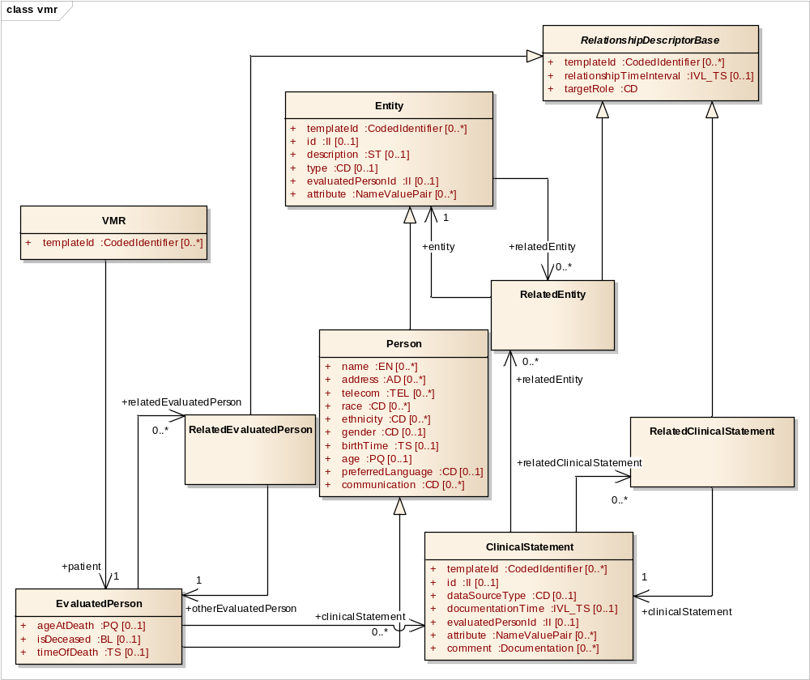
Figure: 1

clinicalStatement - (Class diagram)
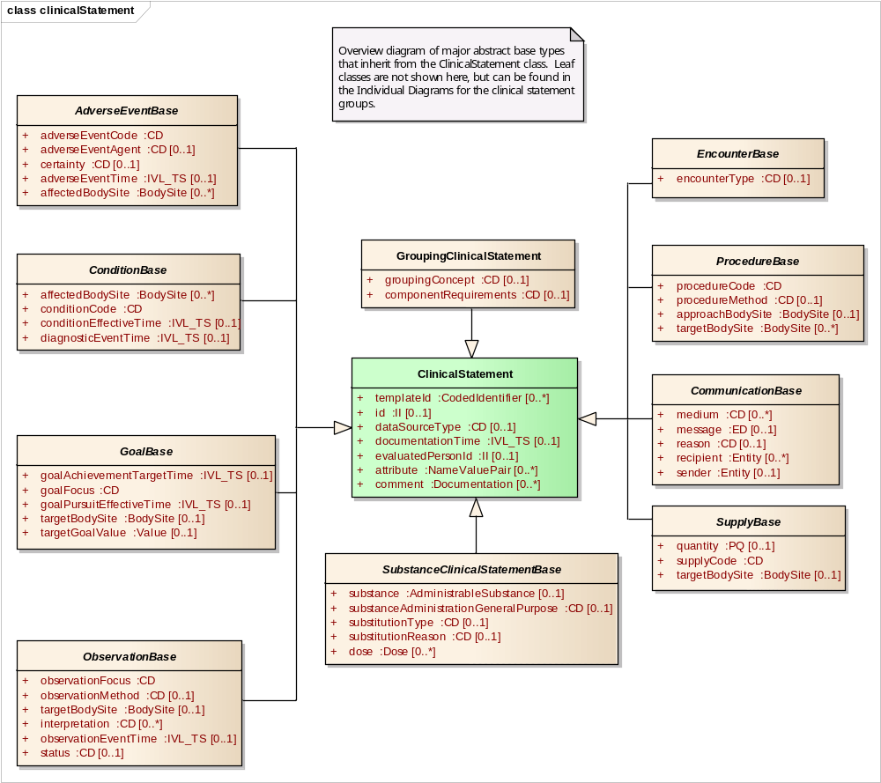
Figure: 2

entity - (Class diagram)
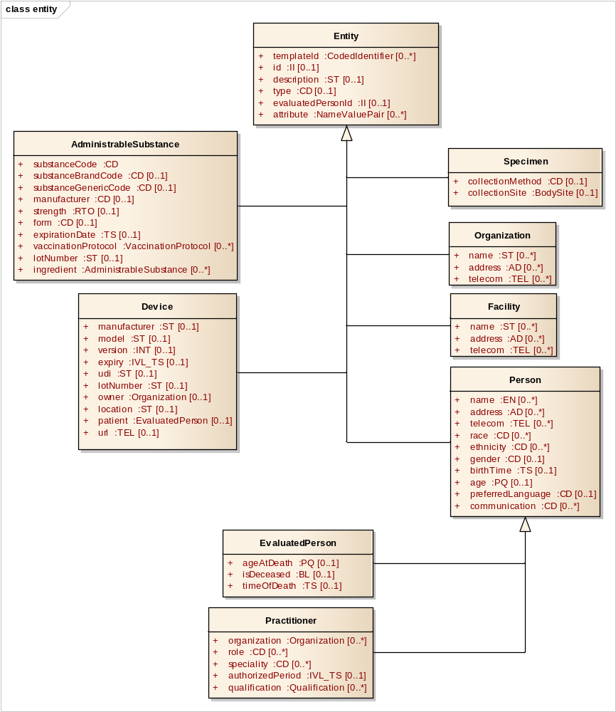
Figure: 3

extendedvMRTypes - (Class diagram)
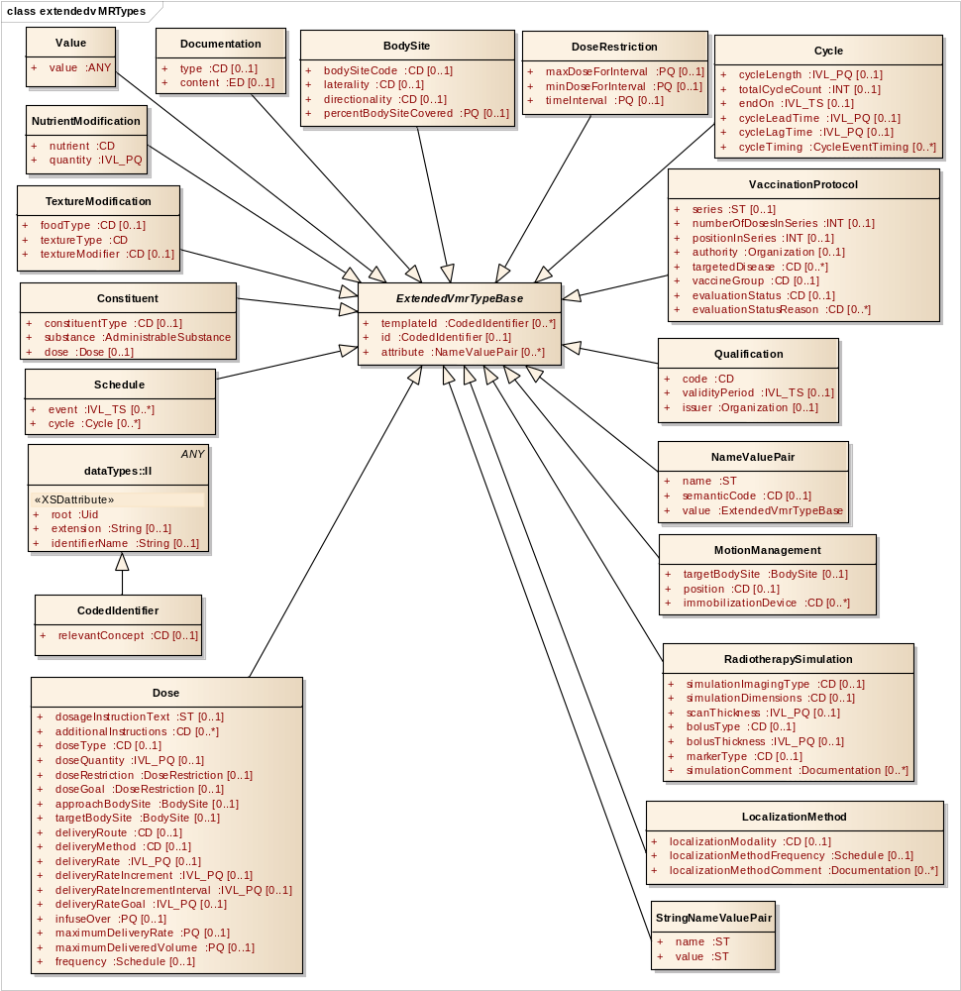
Figure: 4

adverseEvent - (Class diagram)
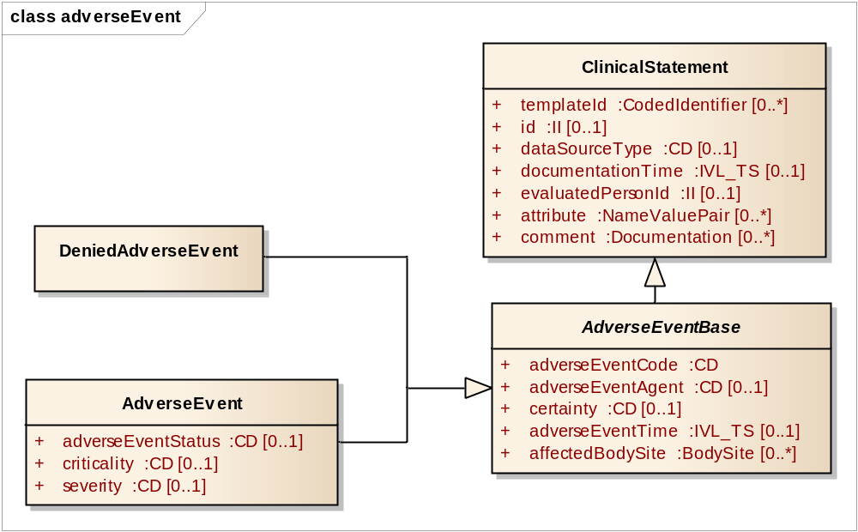
Figure: 5

communication - (Class diagram)
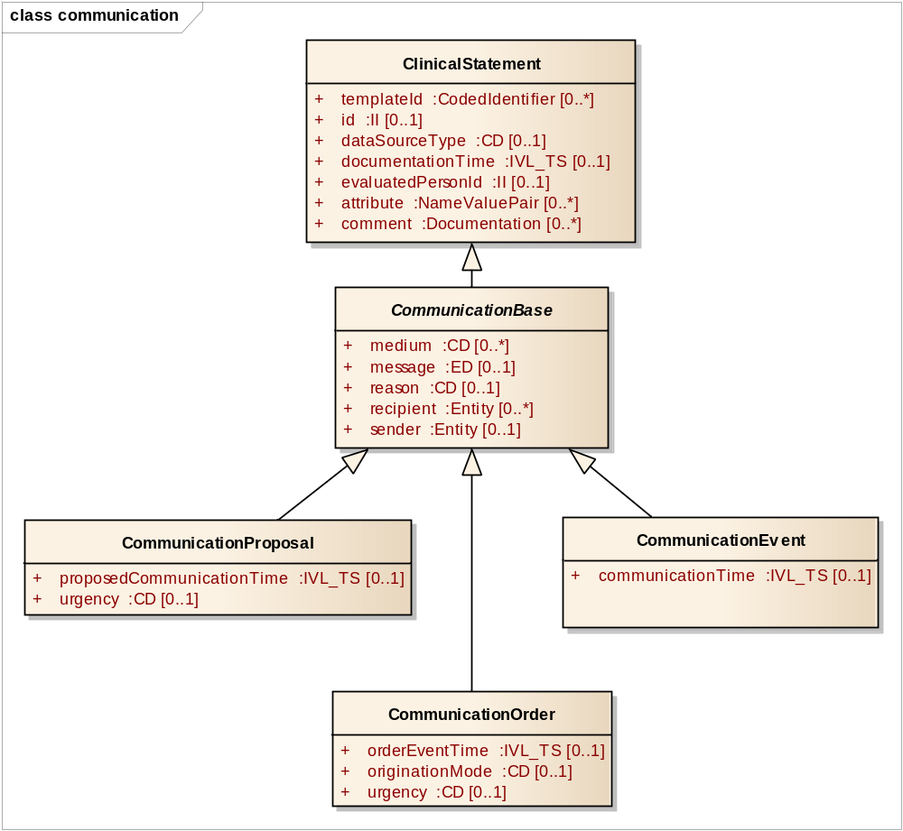
Figure: 6

encounter - (Class diagram)
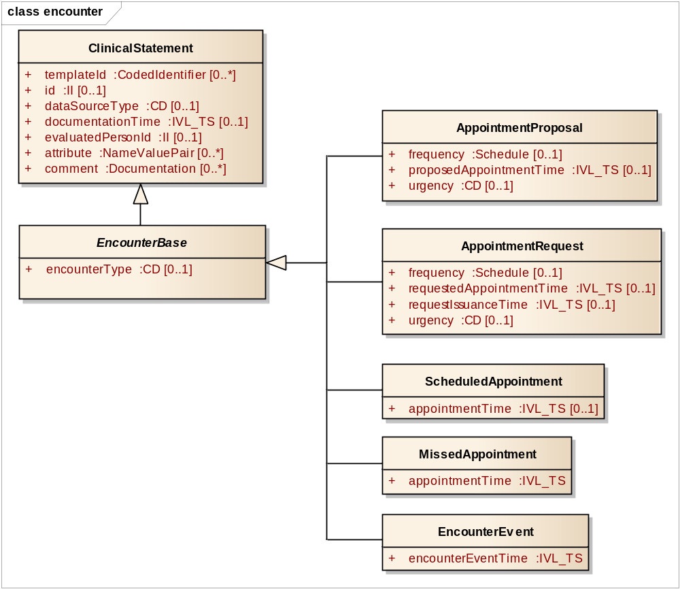
Figure: 7

goal - (Class diagram)
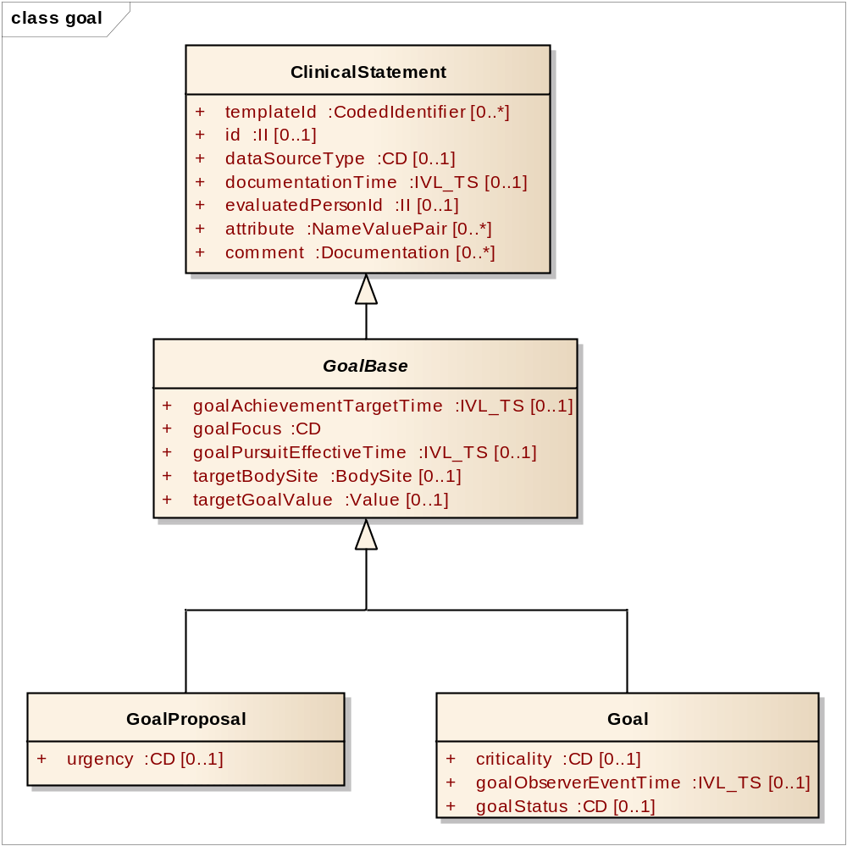
Figure: 8

oralDiet - (Class diagram)
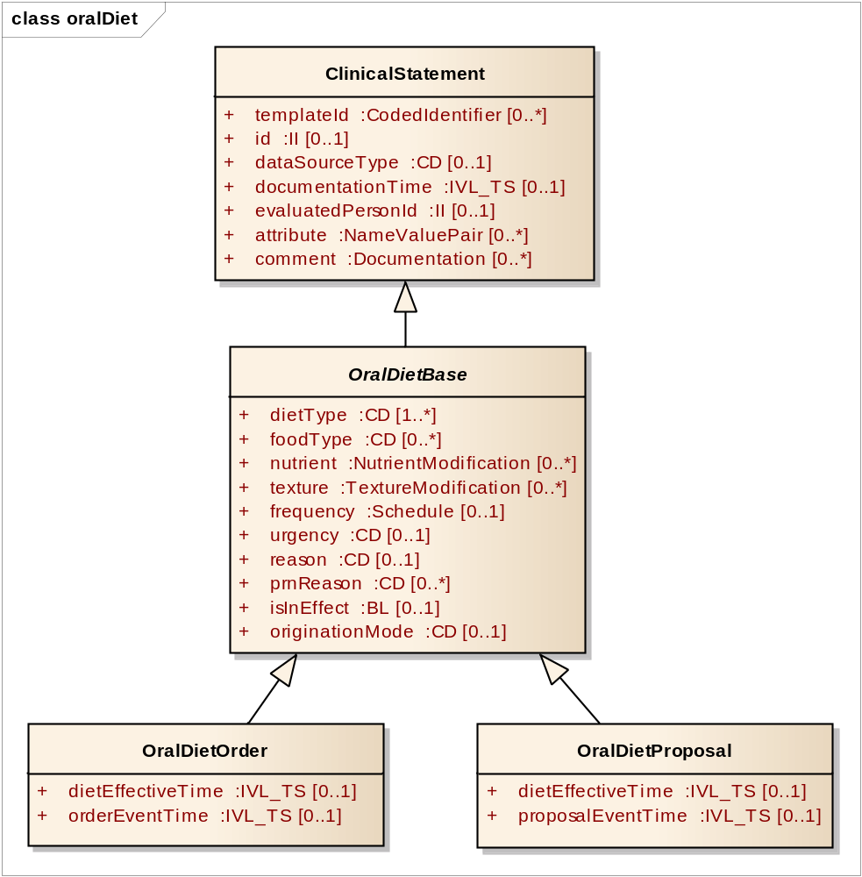
Figure: 9
observation - (Class diagram)
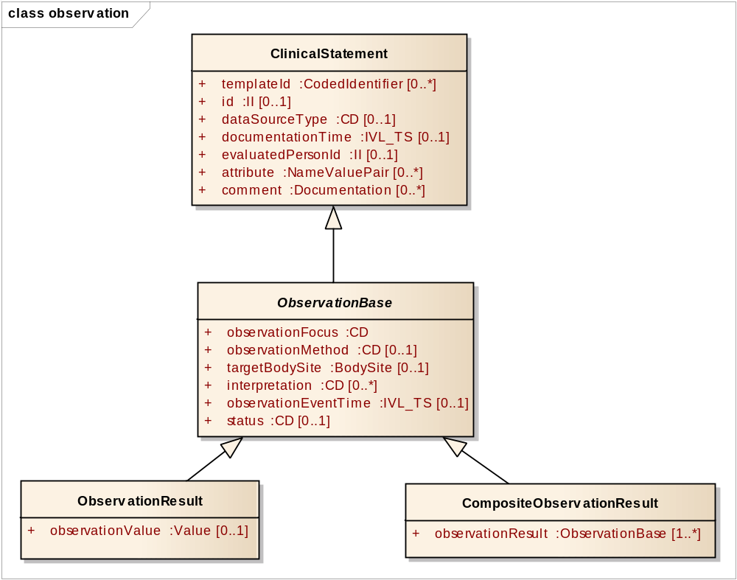
Figure: 10

problemAllergyIntolerance - (Class diagram)
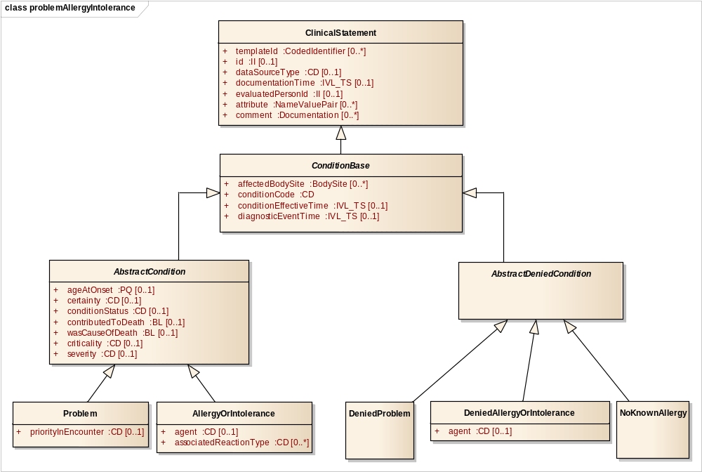
Figure: 11
procedure - (Class diagram)
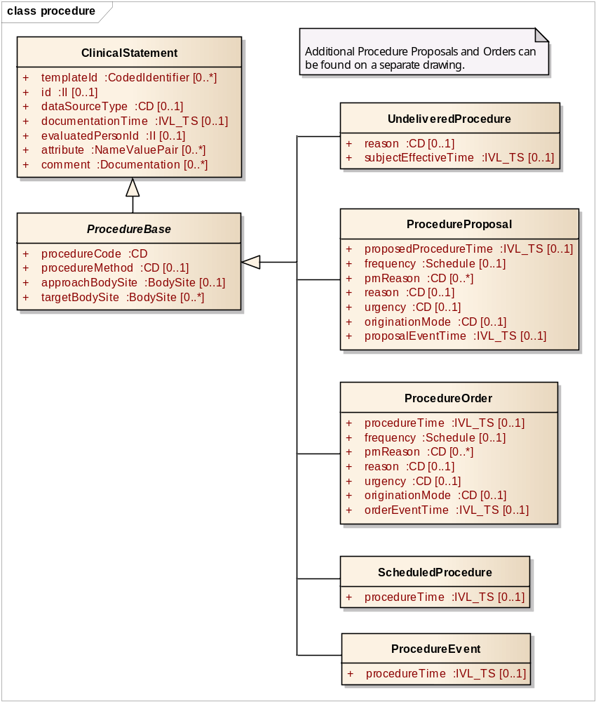
Figure: 12

procedureExtensions - (Class diagram)
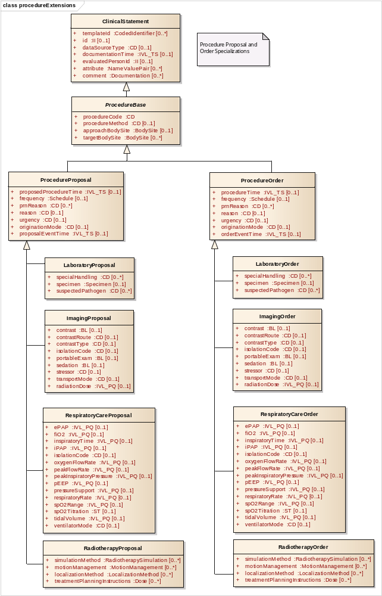
Figure: 13
schedule - (Class diagram)
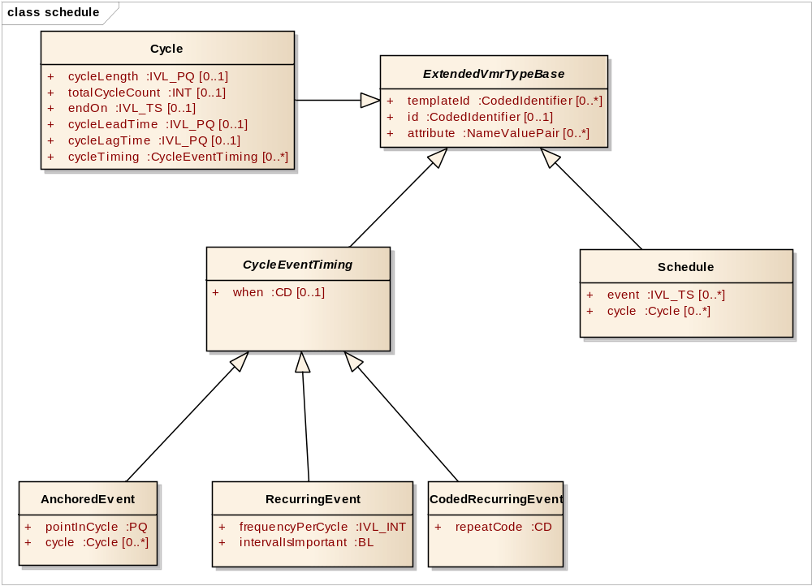
Figure: 14

substanceAdministration - (Class diagram)
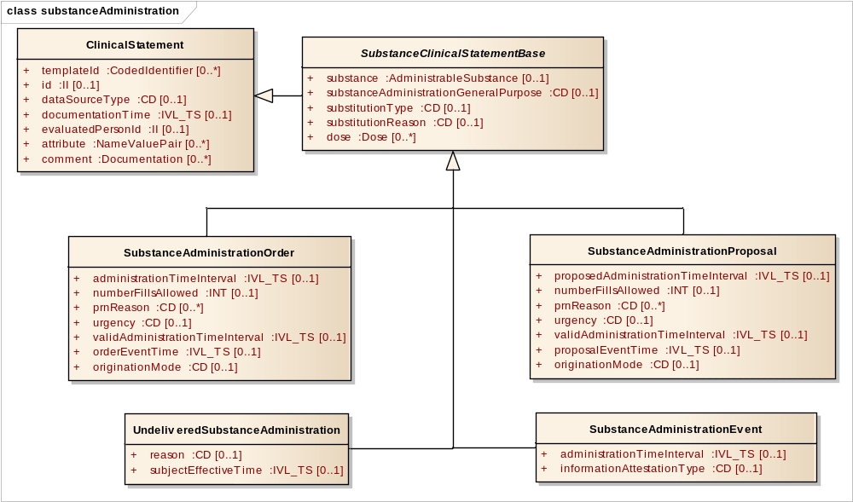
Figure: 15

substanceAdministrationExtensions - (Class diagram)
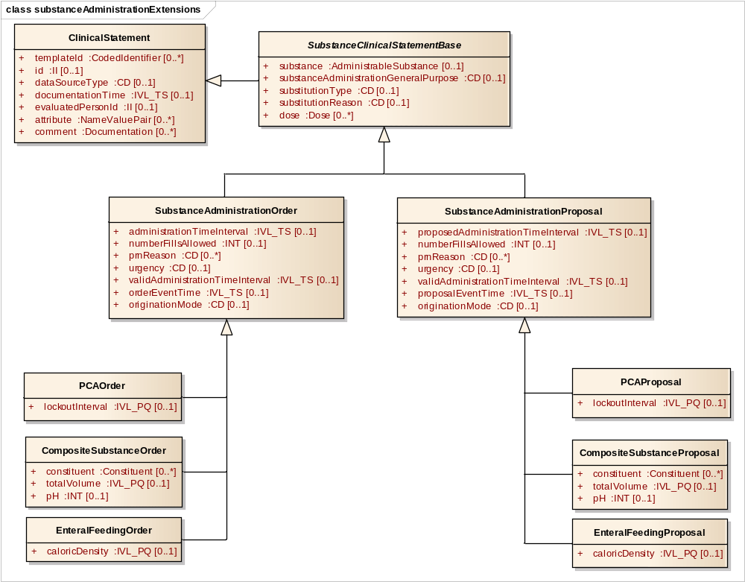
Figure: 16

substanceDispense - (Class diagram)
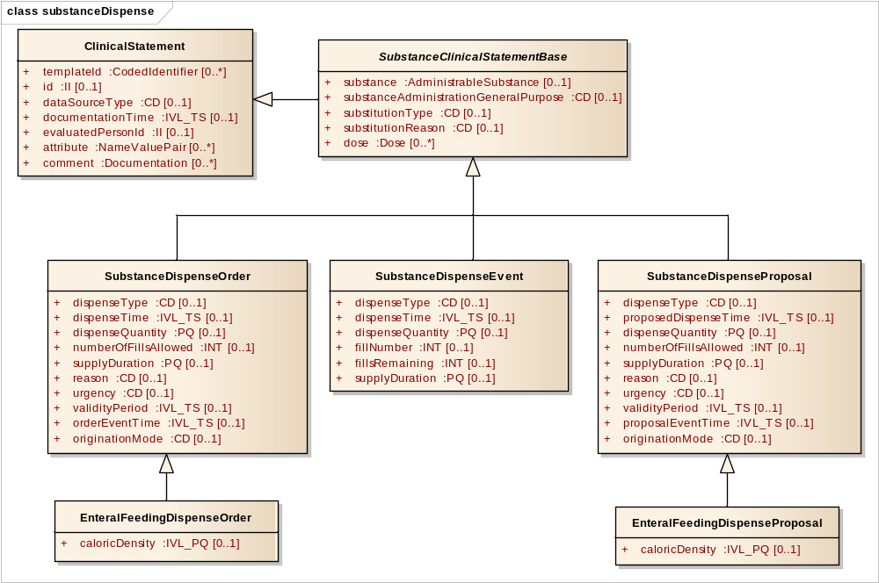
Figure: 17
supply - (Class diagram)
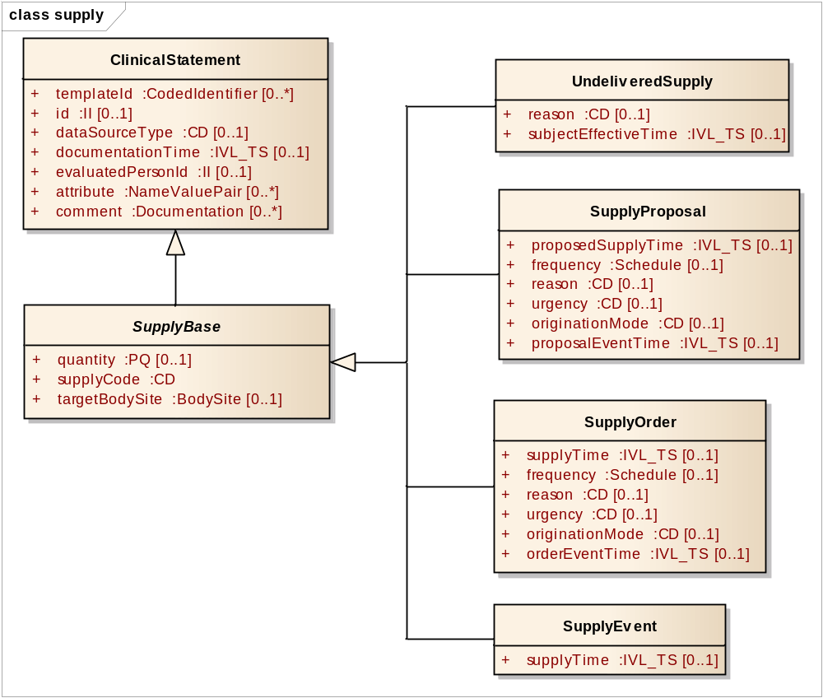
Figure: 18

AbstractCondition
Type: Class ConditionBase
Package: vmr

An assertion regarding a clinical condition of the subject that needs to be treated or managed.

Attributes
Attribute | Notes
ageAtOnset  PQ [0..1] | The subject's age when the problem began.
certainty  CD [0..1] | Code indicating degree of certainty about the problem or allergy to an agent, such as 'Known' or 'Suspected'.
conditionStatus  CD [0..1] | State of the problem. E.g., active, inactive, resolved.
contributedToDeath  BL [0..1] | Whether the problem contributed to the subject's death.
wasCauseOfDeath  BL [0..1] | Whether the problem was the cause of the subject's death.
criticality  CD [0..1] | Criticality:  Applies to things about a patient - problems, observations, etc. (does not apply to actions)  Characterizes impact on life, or durable impact on physiological function or on quality of life. Includes concepts such as life-threatening, or potential loss of function or capacity. E.g., Life threatening, potentially requires hospitalization, self-resolving. Different from severity in that a moderate subarachnoid hemorrhage is likely to be highly important, whereas a moderate headache is not.
severity  CD [0..1] | Severity:  Applies to things about a patient - problems, observations, etc. (does not apply to actions)  Characterizes the intensity of the manifestation of the problem or observation or an adverse event  Includes concepts such as mild, moderate, severe

AbstractDeniedCondition
Type: Class ConditionBase
Package: vmr

A denial of the existence of a condition, problem, or allergy.

AdministrableSubstance
Type: Class Entity
Package: vmr

A material, generally but not exclusively a medication or antigen, of a particular constitution that can be given to a person to enable a clinical effect. An administrable substance may have component administrable substances.

Attributes
Attribute | Notes
substanceCode  CD | The code that identifies the substance with as much specificity as appropriate, or as required by a template. E.g., aspirin, lisinopril. May be either a generic or brand code, unless otherwise restricted by a template.
substanceBrandCode  CD [0..1] | A code describing the product as a branded or trademarked entity from a controlled vocabulary.
substanceGenericCode  CD [0..1] | A code describing the product as a substance produced and distributed without patent protection.
manufacturer  CD [0..1] | The organization that produces the substance. This is a CD and not an II because there are managed code systems for manufacturers.
strength  RTO [0..1] | The concentration or amount of the administrable substance. E.g., 250 mg per 5 ml or 250 mg per tablet.
form  CD [0..1] | The physical form of the substance as presented to the subject. E.g., tablet, patch, injectable, inhalant.
expirationDate  TS [0..1] | Date substance expires.  Requirement: This is useful input for an Immunization CDS engine. Expired administrations can not count and must be repeated.
vaccinationProtocol  VaccinationProtocol [0..*] | Contains information about the protocol under which the vaccine was administered.
lotNumber  ST [0..1] | The number assigned by the manufacturer to the batch of manufactured substances in which this substance instance belongs. Used for quality control purposes.
ingredient  AdministrableSubstance [0..*] | The ingredients of a composite substance. E.g., a polyvalent vaccine or a composite medication.

AdverseEvent
Type: Class AdverseEventBase
Package: vmr

Unfavorable healthcare event (e.g., death, rash, difficulty breathing, a fall, or an adverse surgical event) that may or may not have been caused by some agent (e.g., a medication, immunization, food, or environmental agent).

Use AdverseEvent to model adverse reaction. An adverse reaction is type of adverse event that is characterized by an undesired or unexpected negative reaction to an agent (generally a medication or a food item).

An adverse reactions can range from a mild reaction, such as a harmless rash to a severe and life-threatening reaction. They can occur immediately or develop over time. For example, a patient may develop a rash after taking a particular medication.

In the case of adverse reactions, if a given agent is thought to cause multiple reactions, these reactions should be represented using multiple adverse events.

Note that allergies are represented as special types of conditions embodied in the AllergyOrIntolerance class, whereas individual adverse events are represented as adverse events.

Note that a problem resulting from adverse event should not be confused with the adverse event. A fall is an adverse event whereas the fracture resulting from the fall is a problem. In general, as a rule of thumb, if something can naturally be represented as a problem, it should be represented as a problem.

Iatrogenic issues should generally be represented as both an adverse event and problem where feasible. For instance, hospital-acquired pneumonia, central-line infections, or deep-venous thrombosis occurring during a hospitalization.

In some cases, the iatrogenic event will be distinct from the resulting problem. For example, an inadvertent liver laceration during surgery is an adverse event whereas the resulting liver bleeding is the problem.

Note that 'Never-Events' are adverse events while the resulting condition from these events are problems.

Attributes
Attribute | Notes
adverseEventStatus  CD [0..1] | The state of the effects of this adverse event. E.g., active, inactive, resolved.
criticality  CD [0..1] | Criticality:  Applies to things about a patient - problems, observations, etc. (does not apply to actions)  Characterizes impact on life, or durable impact on physiological function or on quality of life. Includes concepts such as life-threatening, or potential loss of function or capacity. E.g., Life threatening, potentially requires hospitalization, self-resolving. Different from severity in that a moderate subarachnoid hemorrhage is likely to be highly important, whereas a moderate headache is not.
severity  CD [0..1] | Severity:  Applies to things about a patient - problems, observations, etc. (does not apply to actions)  Characterizes the intensity of the manifestation of the problem or observation or an adverse event. Includes concepts such as mild, moderate, severe. If the adverseEventCode is rash and severity is moderate, it means that the adverse event was a moderate rash.

AdverseEventBase
Type: Class ClinicalStatement
Package: vmr

Abstract base class for both adverse events and denied adverse events.

Attributes
Attribute | Notes
adverseEventCode  CD | Coded nature of the effects of the adverse event; maps to the "value" of an adverse event observation. For an adverse event due to an identified agent, this is the reaction code. E.g., hives, difficulty breathing.
adverseEventAgent  CD [0..1] | The causative agent of the adverse event, identified with as much specificity as available, or as required by a template. E.g., penicillin, peanuts.
certainty  CD [0..1] | Code indicating whether adverse reaction to agent is 'Known' or 'Suspected'.  Note: This field is only intended to state the degree of certainty one has about an agent causing the adverse reaction. It is not intended to state the level of certainty of the adverse event statement itself.
adverseEventTime  IVL_TS [0..1] | The time that reflects when the subject experienced the adverse event (in the case of AdverseEvent) or when the subject did not experience the adverse event (in the case of DeniedAdverseEvent).
affectedBodySite  BodySite [0..*] | A body site affected by the adverse event.

AllergyOrIntolerance
Type: Class AbstractCondition
Package: vmr

An allergy or intolerance triggered by a known or suspected agent. Note that one class is used to represent both concepts as it is often difficult to distinguish the two.

Attributes
Attribute | Notes
agent  CD [0..1] | An agent that causes or contributes to the allergy or intolerance, identified with as much specificity as available, or as required by a template. Used for allergies, intolerances, and other reactions to a known agent. E.g., penicillin, peanuts, latex.
associatedReactionType  CD [0..*] | A code that indicates specific reactions that occurred. Example: Rash, Hives, immune-mediated.

AnchoredEvent
Type: Class CycleEventTiming
Package: vmr

Identifies the timing of a point-in-time occurrence and optionally a sub-cycle in a cycle that starts at a specific point in the cycle and may span a duration of time.

For instance give a medication on the fifth, 10th, and 18th day of a 24-day cycle for a duration of 1 day each time, three times per day.

Attributes
Attribute | Notes
pointInCycle  PQ | The point within the cycle. For instance, for a cycle of 21 days, the 5th day in the cycle is equivalent to a pointInCycle = 5 day (read as Day 5).
cycle  Cycle [0..*] | If the occurrence has a duration and a frequency, it should be specified as a cycle.  For instance, give medication X on day 5 of a 22 day cycle, three times a day for 2 days.

AppointmentProposal
Type: Class EncounterBase
Package: vmr

Proposal, e.g., by a CDS system, for an Encounter to take place.

Attributes
Attribute | Notes
frequency  Schedule [0..1] | How often the proposed appointments must take place.
proposedAppointmentTime  IVL_TS [0..1] | Proposed time for appointment. Optional, as the proposer (e.g., a CDS system) may wish to simply propose an appointment of a type (e.g., encounter with eye professional) without specifying a specific appointment time interval.  If frequency >= 2, then specifies proposed period within which the appointments should take place. In these cases, it is assumed that the appointments should be evenly distributed within the timeframe. E.g., if proposed time is 1/1/2011 to 12/31/2011, and frequency is 3, ideal appointment times would be 1/1/2011, 12/31/2011, and in the middle of the year.
urgency  CD [0..1] | Urgency:  Applies to actions - orders or proposals (does not apply to problems, observations)  Characterizes how quickly an action must be initiated  Includes concepts such as stat, urgent, routine

AppointmentRequest
Type: Class EncounterBase
Package: vmr

A request by a provider to schedule an appointment.

Attributes
Attribute | Notes
frequency  Schedule [0..1] | How often the requested appointments must take place.
requestedAppointmentTime  IVL_TS [0..1] | Requested time for appointment.  If frequency >= 2, then specifies requested period within which the appointments should take place. In these cases, it is assumed that the appointments should be evenly distributed within the timeframe. E.g., if requested time is 1/1/2011 to 12/31/2011, and frequency is 3, ideal appointment times would be 1/1/2011, 12/31/2011, and in the middle of the year.
requestIssuanceTime  IVL_TS [0..1] | Time when the encounter appointment was requested by the provider, as opposed to the time it was requested for.
urgency  CD [0..1] | Urgency:  Applies to actions - orders or proposals (does not apply to problems, observations)  Characterizes how quickly an action must be initiated  Includes concepts such as stat, urgent, routine

BodySite
Type: Class ExtendedVmrTypeBase
Package: vmr

A location on an EvaluatedPerson's body. E.g., left breast, heart.

Attributes
Attribute | Notes
bodySiteCode  CD [0..1] | A location on an EvaluatedPerson's body. May or may not encompass laterality. E.g., lung, left lung.
laterality  CD [0..1] | The side of the body, from the EvaluatedPerson's perspective. E.g., left, right, bilateral.
directionality  CD [0..1] | This is further specification of the body part by adding directionality, such as "upper", "lower", "frontal", "medial", etc.
percentBodySiteCovered  PQ [0..1] | Percent of the body site structured of relevance within this clinical context. For instance, this is often relevant in radiotherapy where a total dose volume applies to only a portion of the target body site (e.g., 60% of the left kidney).

ClinicalStatement
Type: Class
Package: vmr

A record of something of clinical relevance that is being done, has been done, can be done, or is intended or requested to be done. A class that serves as the basis for other more specific clinical statements, such as ObservationEvent and ProcedureProposal. It is a concrete class that can be used as is or specialized as needed.

Naming and modeling conventions:
- in general, attribute names end in 'Code' if and only if the name of the attribute overlaps with the name of the parent class
- times are named as follows: Time is the default suffix for these attributes. EventTime is used to distinguish the time an order is placed vs. when the ordered act should take place. EffectiveTime and TimeInterval are used when there is a desire to emphasize that a prolonged time interval (e.g., > 1 day) can be used rather than a point in time or a short time interval. Note that regardless of the naming convention, IVL_TS attributes allow time intervals of any length.
- subjectEffectiveTime is the time that is primarily related to the subject's experience of disease or treatment events (or durations), rather than when those events were reported or recorded by the performer
- performerEventTime is the event time that is primarily related to the performer, rather than the subject.
- the state between ordering and the ordered event occurring is modeled only in cases of procedures and encounters, due to the substantial rate at which orders do not result in events.

Approaches to representing specific statements:
- No known allergies --> NoKnownAllergy with conditionCode reflecting the type of 'No known allergy' statements (e.g., 'No known allergy', 'No known medication allergy', 'No known food allergy')
- No known medications --> UndeliveredSubstanceAdministration with substance that is the root-level code for medications.
- No known problems --> DeniedProblem with conditionCode that is the root-level code for problems or conditions.
- Patient takes an unknown drug --> SubstanceAdministrationEvent where code for substance represents "unknown medication".

Attributes
Attribute | Notes
templateId  CodedIdentifier [0..*] | The identifier of a set of constraints placed on a clinical statement. If there are multiple templates specified for the element, then the element must satisfy ALL constraints defined in ANY template at that level.
id  II [0..1] | A unique ID of this clinical statement for reference purposes. It must be provided if user wants it returned as part of any output, otherwise it will be auto-generated, if needed, by CDS system. Does not need to be the actual ID of the source system.
dataSourceType  CD [0..1] | A categorization of the type of information source making the clinical statement. Can be used, for example, to provide relevant information regarding the reliability of input data or to mark specific pieces of data as having been generated by a CDS system. E.g., administrative system, patient care devices, clinical system, patient or family member, external CDS system, this CDS system. Optional in the base vMR, but should consider providing when available.
documentationTime  IVL_TS [0..1] | The time when the clinical statement was documented (e.g., entered into an electronic health record system by a care provider).
evaluatedPersonId  II [0..1] | The 'owner' of this clinical statement.
attribute  NameValuePair [0..*] | A user-specified attribute for this class. The field 'attribute' supports user-defined attribute extensions for clinical concepts. New concepts defined in this manner need to have an associated template. Refer to Implementation Guide for details.
comment  Documentation [0..*] | A comment, instruction, or note associated with the clinical statement. The type specifies the type of comment (e.g., 'Provider Instruction', 'Patient Instruction', 'Reason for Procedure', 'Consult Note', etc...) and the value of the comment represents the free text value.

CodedIdentifier
Type: Class II
Package: vmr

An II with an additional code to represent the associated concept. This is relevant for templates that are associated with a particular concept such as Barium Enema for instance.

Attributes
Attribute | Notes
relevantConcept  CD [0..1] | Code specifying the concept represented by this identifier.

CodedRecurringEvent
Type: Class CycleEventTiming
Package: vmr

Specification of a repetitive schedule element as a code.

Attributes
Attribute | Notes
repeatCode  CD | A code indicating the frequency of the occurrence. For instance, Q8H or TID.

CommunicationBase
Type: Class ClinicalStatement
Package: vmr

A communication is a message sent between a sender and a recipient for a purpose and about a topic.

The specific type of entity (e.g., Attending Physician or Public Health Agency) is identified by the entityType of the sender or recipient.

There maybe a related clinical statement that identifies the topic of the communication in greater detail.

Attributes
Attribute | Notes
medium  CD [0..*] | The communication medium, e.g., email, fax
message  ED [0..1] | Text and other information to be communicated to the recipient
reason  CD [0..1] | An indication, purpose or reason for why this action is being proposed., e.g., notify, alert, remind.
recipient  Entity [0..*] | The entity (e.g., person, organization, clinical information system, or device) which is the intended target of the communication.
sender  Entity [0..1] | The entity (e.g., person, organization, clinical information system, or device) which is the source of the communication.

CommunicationEvent
Type: Class CommunicationBase
Package: vmr

A communication event that is occurring or has occurred. E.g., an alert that was sent, a Direct message that was sent.

Attributes
Attribute | Notes
communicationTime  IVL_TS [0..1] | Time when the communication was conducted.

CommunicationOrder
Type: Class CommunicationBase
Package: vmr

An order to communicate. E.g., a physician requests to be notified when a lab result is available.

Attributes
Attribute | Notes
orderEventTime  IVL_TS [0..1] | The time when the order was made.
originationMode  CD [0..1] | The mode the order was received (such as by telephone, electronic, verbal, written). This describes 'how' the communication was done as opposed to dataSourceType which specifies the 'where' and 'from'.
urgency  CD [0..1] | Urgency:  Applies to actions - orders or proposals (does not apply to problems, observations)  Characterizes how quickly an action must be initiated  Includes concepts such as stat, urgent, routine

CommunicationProposal
Type: Class CommunicationBase
Package: vmr

A proposal to communicate. E.g., the CDS system proposes that an alert be sent to a responsible provider, the CDS system proposes that the public health agency be notified about a reportable condition.

Attributes
Attribute | Notes
proposedCommunicationTime  IVL_TS [0..1] | The time interval in which the communication is proposed to be sent
urgency  CD [0..1] | Urgency:  Applies to actions - orders or proposals (does not apply to problems, observations)  Characterizes how quickly an action must be initiated  Includes concepts such as stat, urgent, routine

CompositeObservationResult
Type: Class ObservationBase
Package: vmr

The findings from an observation represented as a composition of child observation results. CompositeObservationResult may consist of two or more ObservationResults, one or more CompositeObservationResults, or two or more of a combination of ObservationResult and CompositeObservationResult. E.g., Complete Blood Count, Basic Chemistry Panel. A

Attributes
Attribute | Notes
observationResult  ObservationBase [1..*] | Component observation. May be either a simple ObservationResult or a CompositeObservationResult. E.g., Hematocrit in a Complete Blood Count.

CompositeSubstanceOrder
Type: Class SubstanceAdministrationOrder
Package: vmr

A class representing an order for a composite medication such as IV fluid that may consist of one or more additives mixed into a diluent. Additives and diluents are represented as constituents with the appropriate constituentType.

Attributes
Attribute | Notes
constituent  Constituent [0..*] | A substance that composes this composite medication such as an additive or diluent in a composite IV.
totalVolume  IVL_PQ [0..1] | The total volume of the overall mixture such as the volume of the bag.
pH  INT [0..1] | The pH of the composite IV. This field may be important for Total Parenteral Nutrition.

CompositeSubstanceProposal
Type: Class SubstanceAdministrationProposal
Package: vmr

A class representing a proposal for a composite medication such as IV fluid that may consist of one or more additives mixed into a diluent. Additives and diluents are represented as constituents with the appropriate constituentType.

Attributes
Attribute | Notes
constituent  Constituent [0..*] | A substance that composes this composite medication such as an additive or diluent in a composite IV.
totalVolume  IVL_PQ [0..1] | The total volume of the overall mixture such as the volume of the bag.
pH  INT [0..1] | The pH of the composite IV. This field may be important for Total Parenteral Nutrition.

ConditionBase
Type: Class ClinicalStatement
Package: vmr

Abstract base class for problems, which are clinical conditions that need to be treated or managed.

Note that allergies are represented as a special type of conditions represented by the AllergyOrIntolerance concept, whereas individual adverse events are represented as adverse events.

Attributes
Attribute | Notes
affectedBodySite  BodySite [0..*] | A body site affected by the problem (in the case of Problem) or not affected by the problem (in the case of DeniedProblem).
conditionCode  CD | This is the code that identifies the problem or condition with as much specificity as available, or as required by a template. It might be an ICD9, ICD10, or SNOMED code, or whatever vocabularies are appropriate to describe the problem or condition. E.g., diabetes mellitus, congestive heart failure.
conditionEffectiveTime  IVL_TS [0..1] | The time that is primarily related to the subject's experience of the disease or condition, rather than when those events were reported or recorded by the evaluator.
diagnosticEventTime  IVL_TS [0..1] | The time when the evaluator identified the subject as having the condition (in the case of Problem for instance) or as not having the condition (in the case of DeniedProblem for instance). The same principles apply to AllergyOrIntolerance.

Constituent
Type: Class ExtendedVmrTypeBase
Package: vmr

A component of a multi-component substance administration. May be an additive in a composite IV.

Attributes
Attribute | Notes
constituentType  CD [0..1] | Indicates the category of the constituent. For instance, for a composite IV, the constituent may be either a 'diluent' or an 'additive'. For a TPN order, the constituent category may be a nutrient grouping such as 'electrolyte' or 'lipid', etc...
substance  AdministrableSubstance | Generally the ingredient of the constituent (e.g., dopamine) such as an additive in a composite IV.
dose  Dose [0..1] | The dose of the constituent that makes up the whole. E.g., 500ml 50% Dextrose solution

Cycle
Type: Class ExtendedVmrTypeBase
Package: vmr

Represents a predictable periodic interval where events may occur at specific points within this interval. Examples may include:

1. An event that may occur TID.
2. An event that may occur TID but at specific times such as 8am, noon, and 3pm.
3. An event that may occur three times a day but the interval is not important.
4. An event that may occur three times a day where the interval between events must be 8hrs (Q8H).

Note that cycles may be nested. For instance,
A chemotherapy regimen where a substance is administered TID on day 1,5,10 of a 10-day cycle.

Attributes
Attribute | Notes
cycleLength  IVL_PQ [0..1] | The duration of the overall cycle or subcycle.
totalCycleCount  INT [0..1] | Number of times to repeat the cycle including the first one. When not specified, assumed to be 1.
endOn  IVL_TS [0..1] | Point in time when the cycle should end.
cycleLeadTime  IVL_PQ [0..1] | Negative offset between the end of the previous cycle and the start of the next cycle. That is, the start of the next cycle shall start before the end of the previous cycle.
cycleLagTime  IVL_PQ [0..1] | Positive offset between the end of the first cycle and the start of the second one. That is, the start of the next cycle shall start after then end of the previous cycle.
cycleTiming  CycleEventTiming [0..*] | Identifies a repeating pattern to the intended time periods such as the number of occurrences in a given time period, the days in a multi-day cycle, or a code representing the frequency of occurrence for a given cycle.

CycleEventTiming
Type: Class ExtendedVmrTypeBase
Package: vmr

Identifies a repeating pattern to the intended time periods such as the number of occurrences in a given time period, the days in a multi-day cycle, or a code representing the frequency of occurrence for a given cycle.

Attributes
Attribute | Notes
when  CD [0..1] | A code that identifies the occurrence of daily life that determine timing.  This is an example value set with codes taken from http://hl7.org/fhir/v3/TimingEvent:  HS HS event occurs [duration] before the hour of sleep (or trying to).  WAKE WAKE event occurs [duration] after waking.  AC AC event occurs [duration] before a meal (from the Latin ante cibus).  ACM ACM event occurs [duration] before breakfast (from the Latin ante cibus matutinus).  ACD ACD event occurs [duration] before lunch (from the Latin ante cibus diurnus).  ACV ACV event occurs [duration] before dinner (from the Latin ante cibus vespertinus).  PC PC event occurs [duration] after a meal (from the Latin post cibus).  PCM PCM event occurs [duration] after breakfast (from the Latin post cibus matutinus).  PCD PCD event occurs [duration] after lunch (from the Latin post cibus diurnus).  PCV PCV event occurs [duration] after dinner (from the Latin post cibus vespertinus).

DeniedAdverseEvent
Type: Class AdverseEventBase
Package: vmr

A denial that the subject has or had the specified adverse event. E.g., if adverseEventCode is hives, adverse event agent is penicillin, and documentation time is 2011-05-01, an assertion was made on 2011-05-01 that the subject does not get hives as a reaction to penicillin.

DeniedAllergyOrIntolerance
Type: Class AbstractDeniedCondition
Package: vmr

An statement denying the presence of an allergy or intolerance to a specific agent.

Attributes
Attribute | Notes
agent  CD [0..1] | An agent that causes or contributes to the allergy or intolerance, identified with as much specificity as available, or as required by a template. Used for allergies and intolerances to a known agent. E.g., penicillin, peanuts, latex.

DeniedProblem
Type: Class AbstractDeniedCondition
Package: vmr

An statement denying the presence of a clinical condition.

Device
Type: Class Entity
Package: vmr

This resource identifies an instance of a manufactured thing that is used in the provision of healthcare without being substantially changed through that activity. The device may be a machine, an insert, a computer, an application, etc. This includes durable (reusable) medical equipment as well as disposable equipment used for diagnostic, treatment, and research for healthcare and public health.

Attributes
Attribute | Notes
manufacturer  ST [0..1] | A name of the manufacturer.
model  ST [0..1] | The "model" - an identifier assigned by the manufacturer to identify the product by its type. This number is shared by the all devices sold as the same type.
version  INT [0..1] | The version of the device, if the device has multiple releases under the same model, or if the device is software or carries firmware.
expiry  IVL_TS [0..1] | Date of expiry of this device (if applicable).
udi  ST [0..1] | FDA Mandated Unique Device Identifier. Use the human readable information (the content that the user sees, which is sometimes different to the exact syntax represented in the barcode) - see http://www.fda.gov/MedicalDevices/DeviceRegulationandGuidance/UniqueDeviceIdentification/default.htm.
lotNumber  ST [0..1] | Lot number assigned by the manufacturer.
owner  Organization [0..1] | An organization that is responsible for the provision and ongoing maintenance of the device.
location  ST [0..1] | The resource may be found in the specified location.
patient  EvaluatedPerson [0..1] | Patient information, if the resource is affixed to a person.
url  TEL [0..1] | A network address on which the device may be contacted directly.

Documentation
Type: Class ExtendedVmrTypeBase
Package: vmr

This type may be used to represent documentation that is either free text or richer in format (e.g., XML or HTML) where provenance is not relevant. The type of the documentation is determined by a code that represents the type of documentation ("e.g., a consult note, a provider instruction, a patient instruction, etc...). It is intended to represent comment fields and notes such as those associated with order entry forms.

Attributes
Attribute | Notes
type  CD [0..1] | - Code that specifies the type of document represented: E.g., 'Instructions to Provider', 'Patient Instructions', 'Special Handling', etc...
content  ED [0..1] | This element may be used to capture both the free text expression of the content, and/or the content of this document in encapsulated data format such as XML, XHTML or PDF.

Dose
Type: Class ExtendedVmrTypeBase
Package: vmr

How the medication is to be used by or administered to the patient.

Attributes
Attribute | Notes
dosageInstructionText  ST [0..1] | Free text dosage instructions for cases where the instructions are too complex to code.
additionalInstructions  CD [0..*] | Additional instructions such as "Swallow with plenty of water" which may or may not be coded.
doseType  CD [0..1] | The type of dose. E.g., initial, maintenance, loading, demand.
doseQuantity  IVL_PQ [0..1] | The amount of substance. E.g., 1 tab, 325 mg, 1-2 tabs, 2QY.
doseRestriction  DoseRestriction [0..1] | Specifies the maximum (or, in some cases the minimum) dose that can be given in a specified time interval.
doseGoal  DoseRestriction [0..1] | Target dose goal. Note that the dose goal differs from dose restriction. Typically, the dose goal will be less than the dose restriction.
approachBodySite  BodySite [0..1] | The body site used for gaining access to the target body site for the purposes of the substance administration.
targetBodySite  BodySite [0..1] | The body site where the substance is delivered.
deliveryRoute  CD [0..1] | The physical route through which the substance is administered. E.g., IV, PO.
deliveryMethod  CD [0..1] | Methodology used to administer the substance. E.g., gastric feeding tube, gastrostomy, drip
deliveryRate  IVL_PQ [0..1] | Rate of substance administration. E.g., 1000 mL/hr.
deliveryRateIncrement  IVL_PQ [0..1] | Change in the dosing rate; usually an increase for a patient who is initiating tube feeding. E.g., 20 mL/hour.
deliveryRateIncrementInterval  IVL_PQ [0..1] | Period of time after which the deliveryRateIncrement should be attempted. E.g., 4 hours.
deliveryRateGoal  IVL_PQ [0..1] | The target rate to reach for this infusion. Note that deliveryRateGoal is typically less than the maximum delivery rate which is the rate not to exceed. For enteral feeding orders, a target tube feeding rate of 75ml/hour may be specified.
infuseOver  PQ [0..1] | Represents the actual time the medication is infused. Note the difference between infuseOver and, say, administrationTimeInterval (duration). An orderable may call for infusing a patient TID for an hour each time over a duration of 5 days.
maximumDeliveryRate  PQ [0..1] | The maximum rate of substance administration. This value may be used as a stopping condition when a deliveryRateIncrement is specified without a count.
maximumDeliveredVolume  PQ [0..1] | The maximum volume of fluid to administer to a patient.
frequency  Schedule [0..1] | The interval in between dosings. For instance, 'Every 8 hours', TID, BID, q8h, etc... Frequency may be represented as either a code or as an interval.

DoseRestriction
Type: Class ExtendedVmrTypeBase
Package: vmr

Referred to in CDA release 2 as maxDoseQuantity. Specifies the maximum dose that can be given in a specified time interval.

Attributes
Attribute | Notes
maxDoseForInterval  PQ [0..1] | Maximum amount of substance that can be given within the specified time interval.
minDoseForInterval
PQ [0..1]
timeInterval  PQ [0..1] | The time interval during which the dose specified is the maximum or minimum amount that should be administered.  Note: if the timeInterval is left out, it will be implied to be the duration of the treatment. It is preferable, however, to specify a value for timeInterval.

EncounterBase
Type: Class ClinicalStatement
Package: vmr

The abstract base class for an encounter of an EvaluatedPerson with the healthcare system. If an encounter or appointment has been canceled, it should simply not be provided using this model. This allows the encounter and appointment classes to be used without an explicit encounter status check.

Attributes
Attribute | Notes
encounterType  CD [0..1] | Identifies the setting of the encounter with as much specificity as available, or as required by a template. E.g., outpatient encounter, inpatient encounter.

EncounterEvent
Type: Class EncounterBase
Package: vmr

EncounterEvent is the record of an interaction between an EvaluatedPerson and the healthcare system. It can be used to group observations and interventions performed during that interaction, through the use of relatedClinicalStatements.

Attributes
Attribute | Notes
encounterEventTime  IVL_TS | The time of the encounter.

EnteralFeedingDispenseOrder
Type: Class SubstanceDispenseOrder
Package: vmr

A clinical order for dispensing an enteral feeding product. That is, the product is to be dispensed but not administered to the patient.

Attributes
Attribute | Notes
caloricDensity  IVL_PQ [0..1] | Diet proposals may be fully precoordinated in a terminology or specified by type only and allowing the nutrients (eg, specification of calories, carbohydrates, protein, fat, sodium, potassium, etc.) to be post-coordinated.

EnteralFeedingDispenseProposal
Type: Class SubstanceDispenseProposal
Package: vmr

A clinical proposal for dispensing an enteral feeding product. That is, the product is to be dispensed but not administered to the patient.

Attributes
Attribute | Notes
caloricDensity  IVL_PQ [0..1] | Diet proposals may be fully precoordinated in a terminology or specified by type only and allowing the nutrients (eg, specification of calories, carbohydrates, protein, fat, sodium, potassium, etc.) to be post-coordinated.

EnteralFeedingOrder
Type: Class SubstanceAdministrationOrder
Package: vmr

A class representing enteral nutrition orders for the delivery of enteral-fed substances (eg, Nutren, Ensure, RenalCal) for patients who are unable to consume diets orally; enteral feedings can be delivered to the stomach or varying parts of the small intestines using a variety of tube placement methods, depending on the clinical scenario. For instance, Nutren via nasogastric tube, 20 ml/hour, increase by 20 ml every 4 hours, goal of 75 ml/hour, water flushes 125 ml every shift.

Attributes
Attribute | Notes
caloricDensity  IVL_PQ [0..1] | The number of calories specified for this order. E.g., 800 cal.

EnteralFeedingProposal
Type: Class SubstanceAdministrationProposal
Package: vmr

A class representing enteral nutrition proposals for the delivery of enteral-fed substances (eg, Nutren, Ensure, RenalCal) for patients who are unable to consume diets orally; enteral feedings can be delivered to the stomach or varying parts of the small intestines using a variety of tube placement methods, depending on the clinical scenario. For instance, Nutren via nasogastric tube, 20 ml/hour, increase by 20 ml every 4 hours, goal of 75 ml/hour, water flushes 125 ml every shift.

Attributes
Attribute | Notes
caloricDensity  IVL_PQ [0..1] | The number of calories specified for this proposed order. E.g., 800 cal.

Entity
Type: Class
Package: vmr

A physical thing, group of physical things or an organization. It is a concrete class that can be used as is or specialized as needed.

Attributes
Attribute | Notes
templateId  CodedIdentifier [0..*] | The identifier of a set of constraints placed on an Entity. If there are multiple templates specified for the element, then the element must satisfy ALL constraints defined in ANY template at that level.
id  II [0..1] | The entity's unique identifier. Used for internal tracking purposes. It must be provided if user wants it returned as part of any output, otherwise it will be auto-generated, if needed, by CDS system. Does not need to be the entity's "real" identifier.
description  ST [0..1] | Human narrative for display purposes.
type  CD [0..1] | The specific type of entity. E.g., healthcare organization, medical facility, a type of device such as a pacemaker. For specimens, this may be blood, urine, sputum, etc...
evaluatedPersonId  II [0..1] | The ID of the evaluated person that this entity has a direct relationship to, generally the patient, but may be a different evaluatedPersonId when family history data is included, or related data pertinent to the patient but directly belonging to another evaluated person is present. This element is not normally needed when all relevant patient data is included in a single structured vMR, but may be essential when pieces of the vMR are furnished or referenced as separate structures in CDS inputs or outputs.
attribute  NameValuePair [0..*] | A user-specified attribute for this class. The field 'attribute' supports user-defined attribute extensions for entities. New concepts defined in this manner need to have an associated template. Refer to Implementation Guide for details.

EvaluatedPerson
Type: Class Person
Package: vmr

A person who is the subject of evaluation by a CDS system. May be the focal patient or some other relevant person (e.g., a relative or a sexual contact). Includes demographic attributes, clinical statements, and related entities.

Attributes
Attribute | Notes
ageAtDeath  PQ [0..1] | The age at which the person died.  Included to support family history-based inferencing.
isDeceased  BL [0..1] | Whether the person is deceased.  Included to support family history-based inferencing.
timeOfDeath  TS [0..1] | The time at which the person expired.

ExtendedVmrTypeBase
Type: Class
Package: vmr

Abstract base class for extended vMR types.

Attributes
Attribute | Notes
templateId  CodedIdentifier [0..*] | The identifier of a set of constraints placed on an extended vMR data type. If there are multiple templates specified for the element, then the element must satisfy ALL constraints defined in ANY template at that level.
id  CodedIdentifier [0..1] | Optional unique identifier for the extended vmr type.
attribute
NameValuePair [0..*]

Facility
Type: Class Entity
Package: vmr

A property such as a building that has been established to enable the performance of specific activities, typically by organizations. E.g., a hospital or clinic.

Attributes
Attribute | Notes
name  ST [0..*] | A word or a combination of words by which a facility is known.
address  AD [0..*] | The place or the name of the place where a facility is located or may be reached.
telecom  TEL [0..*] | A locatable resource of a facility that is identified by a URI, such as a web page, a telephone number (voice, fax or some other resource mediated by telecommunication equipment), an e-mail address, or any other locatable resource that can be specified by a URL.

Goal
Type: Class GoalBase
Package: vmr

A clinical end or aim towards which effort is directed.

Attributes
Attribute | Notes
criticality  CD [0..1] | Criticality:  Applies to things about a patient - problems, observations, etc. (does not apply to actions)  Characterizes impact on life, or durable impact on physiological function or on quality of life. Includes concepts such as life-threatening, or potential loss of function or capacity. E.g., Life threatening, potentially requires hospitalization, self-resolving. Different from severity in that a moderate subarachnoid hemorrhage is likely to be highly important, whereas a moderate headache is not.
goalObserverEventTime  IVL_TS [0..1] | The time that the observer made a note of the goal. It is primarily related to the creator or observer of the goal, rather than the subject.
goalStatus  CD [0..1] | State of the attempt to reach this goal. E.g., active, inactive.

GoalBase
Type: Class ClinicalStatement
Package: vmr

Abstract base class for a goal, which is a clinical end or aim towards which effort is directed.

Attributes
Attribute | Notes
goalAchievementTargetTime  IVL_TS [0..1] | The time that is targeted for the goal to be attained. For example, there may be a goal to reach a weight of X pounds by a particular date.
goalFocus  CD | This is the code that identifies the metric that is the clinical subject of the goal with as much specificity as available, or as required by a template. Typically a measurable clinical attribute of the subject. E.g., weight, blood pressure, hemoglobin A1c level.
goalPursuitEffectiveTime  IVL_TS [0..1] | The time in which the subject pursues the goal. This includes pursuing maintenance of a goal that has already been achieved.  The end time of the interval may be "open" or not stated, if the goal is being indefinitely pursued. This time is optional, as, for example, a CDS system may simply wish to propose weight loss without specifying a pursuit effective time.
targetBodySite  BodySite [0..1] | The body site that serves as the target of the goal. E.g., waist.
targetGoalValue  Value [0..1] | The metric whose achievement would signify the fulfillment of the goal. E.g., 150 pounds, 7.0%.

GoalProposal
Type: Class GoalBase
Package: vmr

Proposal, e.g., by a CDS system, for establishing the goal specified.

Attributes
Attribute | Notes
urgency  CD [0..1] | Urgency:  Applies to actions - orders or proposals (does not apply to problems, observations)  Characterizes how quickly an action must be initiated  Includes concepts such as stat, urgent, routine

GroupingClinicalStatement
Type: Class ClinicalStatement
Package: vmr

A clinical statement which serves to group other clinical statements. For example, a grouping clinical statement could contain an intervention proposal and a substance administration proposal, one of which should be completed.

Attributes
Attribute | Notes
groupingConcept  CD [0..1] | The clinical concept motivating the composition. E.g., Insulin Sliding Scale, Steroid Taper, etc...
componentRequirements  CD [0..1] | The requirements for the contained components. E.g., do at least one, do all.

ImagingOrder
Type: Class ProcedureOrder
Package: vmr

An order to perform an Imaging study. For instance, Chest Radiograph - PA and Lateral.

Attributes
Attribute | Notes
contrast  BL [0..1] | Specification of whether contrast should be administered as part of the imaging study (e.g., Yes, No, Per Radiology)
contrastRoute  CD [0..1] | Specification of the route of contrast (e.g., Oral, IV, Per Radiology) to be given as part of an imaging proposal
contrastType  CD [0..1] | Specification of the kind of contrast (e.g., Barium, Gastrograffin) to be given as part of an imaging proposal. For example, Barium, Gastrograffin.
isolationCode  CD [0..1] | Specification for type of precautions that should be taken when in proximity to the patient. For instance, Airborne Precautions, Contact Precautions, Droplet Precautions, Standard Precautions.
portableExam  BL [0..1] | Designation of whether or not the imaging procedure should be performed at the patient's bedside (Yes) or if the procedure can be conducted in the location of the performing department (No)
sedation  BL [0..1] | 'true' if patient will require sedation for this procedure.
stressor  CD [0..1] | Type of physiologic or pharmacologic stress that will be subjected to the patient during the imaging procedure. For example, Adenosine, Dipyrdomole, Persantine, Thallium, Cardiolite, Dobutamine, Treadmill.
transportMode  CD [0..1] | Specification of how a patient will be moved from their hospital room to the performing department
radiationDose  IVL_PQ [0..1] | The amount of radiation intended to be administered to a patient.

ImagingProposal
Type: Class ProcedureProposal
Package: vmr

A proposal for an Imaging Order. For instance, Chest Radiograph - PA and Lateral.

Attributes
Attribute | Notes
contrast  BL [0..1] | Specification of whether contrast should be administered as part of the imaging study (e.g., Yes, No, Per Radiology)
contrastRoute  CD [0..1] | Specification of the route of contrast (e.g., Oral, IV, Per Radiology) to be given as part of an imaging proposal
contrastType  CD [0..1] | Specification of the kind of contrast (e.g., Barium, Gastrograffin) to be given as part of an imaging proposal. For example, Barium, Gastrograffin.
isolationCode  CD [0..1] | Specification for type of precautions that should be taken when in proximity to the patient. For instance, Airborne Precautions, Contact Precautions, Droplet Precautions, Standard Precautions.
portableExam  BL [0..1] | Designation of whether or not the imaging procedure should be performed at the patient's bedside (Yes) or if the procedure can be conducted in the location of the performing department (No)
sedation  BL [0..1] | 'true' if patient will require sedation for this procedure.
stressor  CD [0..1] | Type of physiologic or pharmacologic stress that will be subjected to the patient during the imaging procedure. For example, Adenosine, Dipyrdomole, Persantine, Thallium, Cardiolite, Dobutamine, Treadmill.
transportMode  CD [0..1] | Specification of how a patient will be moved from their hospital room to the performing department
radiationDose  IVL_PQ [0..1] | The amount of radiation intended to be administered to a patient.

LaboratoryOrder
Type: Class ProcedureOrder
Package: vmr

An order for a laboratory test.

Attributes
Attribute | Notes
specialHandling  CD [0..*] | Special instructions on how to handle a laboratory specimen. For example, 'Keep on ice'.
specimen  Specimen [0..1] | The source of the laboratory specimen to be collected.
suspectedPathogen  CD [0..*] | The pathogen or pathogens that are felt to be the most likely cause of the patient's condition that led to the laboratory procedure proposal. For instance, Staphylococcus, Streptococcus, Pseudomonas, Neisseria.

LaboratoryProposal
Type: Class ProcedureProposal
Package: vmr

A proposal for a laboratory test.

Attributes
Attribute | Notes
specialHandling  CD [0..*] | Special instructions on how to handle a laboratory specimen. For example, 'Keep on ice'.
specimen  Specimen [0..1] | The type of specimen to be collected.
suspectedPathogen  CD [0..*] | The pathogen or pathogens that are felt to be the most likely cause of the patient's condition that led to the laboratory procedure proposal. For instance, Staphylococcus, Streptococcus, Pseudomonas, Neisseria.

LocalizationMethod
Type: Class ExtendedVmrTypeBase
Package: vmr

The imaging modality and the frequency with which it will be used to confirm that a tumor/target is in the same position at the time of treatment as it was at the time of simulation are defined. For example, an order may indicate that a cone-beam CT (CBCT)should be acquired just prior to each treatment to confirm that a lung tumor is within a target volume.

Attributes
Attribute | Notes
localizationModality  CD [0..1] | Defines the imaging modality to be used to verify the positioning of a patient and/or target prior and/or during a radiation treatment. For example, a patient may have a cone-beam CT prior to treatment to verify that a lung tumor is within the targeted volume.
localizationMethodFrequency  Schedule [0..1] | Defines how often the localization imaging should be performed. For example, a patient may have a cone-beam CT taken only once every 5 treatments.
localizationMethodComment  Documentation [0..*] | Additional comments pertaining to the localization method.

MissedAppointment
Type: Class EncounterBase
Package: vmr

An appointment that was (i) scheduled, (ii) not rescheduled or canceled, and (iii) for which the EvaluatedPerson did not show up.

Attributes
Attribute | Notes
appointmentTime  IVL_TS | The time of the scheduled appointment that was missed.

MotionManagement
Type: Class ExtendedVmrTypeBase
Package: vmr

Class representing a method to control the positioning and movement of a specific area of the body. Such motion management may be conducted during a procedure.

Attributes
Attribute | Notes
targetBodySite  BodySite [0..1] | The area of the body whose motion is to be managed.
position  CD [0..1] | Position defines the way that a patient should be positioned for a given procedure. Examples might include:  - Head: Tilted left or right, neck extended  - Body: Prone, supine, on left/right side  - Arms: Down by side, on chest, above head  - Legs: flat, bent
immobilizationDevice  CD [0..*] | Immobilization device refers to the device or devices used to maximize reproducibility of positioning and to minimize motion of a part of a body for each radiation treatment. For example, a commonly used immobilization device is a thermoplastic mask for patients being treated to the head and neck region.

NameValuePair
Type: Class ExtendedVmrTypeBase
Package: vmr

Class that represents a generic Name-Value-Pair object where the name is generally a token (a string without spaces), a semantic category that is controlled by a terminology and a value which may be any type deriving from ANY and/or defined by a template.

Attributes
Attribute | Notes
name  ST | The name of the attribute or parameter.
semanticCode  CD [0..1] | A code representing the concept embodied by this name-value pair.
value  ExtendedVmrTypeBase | The value of the parameter or attribute. Can be any value extended from ExtendedVmrTypeBase, including ANY.

NoKnownAllergy
Type: Class AbstractDeniedCondition
Package: vmr

Use this class to model 'No known allergies' or 'No known drug allergies', or more generally, no known allergy to a class of substances.

Common denials of allergies or intolerances to a class of agents can be expressed as follows:

- No known allergies --> NoKnownAllergy with a conditionCode stating 'No known allergies'.
- No known drug allergies --> NoKnownAllergy with conditionCode stating 'No known drug allergies'.
- No known food allergies --> NoKnownAllergy with conditionCode stating 'No known food allergies'.

NutrientModification
Type: Class ExtendedVmrTypeBase
Package: vmr

Nutrient modifications allows the post-coordination of diets in cases where such post-coordination is required. Diets can vary greatly in how they are represented in terminologies. The most common use case for Nutrient modification is to represent a nutrient that can be either stated as a quantity or a range

NutrientModification consists of the nutrient (e.g., Sodium) and the amount in the diet (e.g., 20-30g). Note that nutrient is required and of type CD. The 'quantity' attribute is also required and can express a range.

Attributes
Attribute | Notes
nutrient  CD | The type of nutrient that this diet contains. Nutrient types include: carbohydrates, lipids and fats, salts such as Sodium or Potassium, fibers, and also fluids.
quantity  IVL_PQ | The quantity of nutrient or bound to consider for this diet. For instance, 40mg, <40mg, 30mg<x<60mg, etc...

ObservationBase
Type: Class ClinicalStatement
Package: vmr

The abstract base class for an observation which represents a result (e.g., a laboratory value), a clinical finding (e.g., sitting, tachypneic, rebound tenderness), or an inferred finding such as one produced by a CDS system (e.g., patient is in need of an HbA1c test).

Attributes
Attribute | Notes
observationFocus  CD | This is the code that identifies the focus of the observation with as much specificity as available, or as required by a template. E.g., serum potassium level, hemoglobin A1c level, smoking status.
observationMethod  CD [0..1] | The approach used to make the observation. E.g., direct measurement, indirect calculation, Enzyme-Linked Immunosorbent Assay.
targetBodySite  BodySite [0..1] | The body site where the observation is being made. E.g., left lung.
interpretation  CD [0..*] | Explanation of the results (e.g., fracture seen on x-ray), including an indication of the deviation of the result value from the reference range for the observation (e.g., high, low, within normal limits).
observationEventTime  IVL_TS [0..1] | Time for the completion of the observation, including the interpretation.
status  CD [0..1] | The state of the observation. E.g., preliminary, final. The status of a CompositeObservationResult should not be inconsistent with the status of individual component observation results.

ObservationResult
Type: Class ObservationBase
Package: vmr

The findings from an observation.

Attributes
Attribute | Notes
observationValue  Value [0..1] | Actual observed results. E.g., 6.5 mg/dL, 5.7%.  If the observationFocus is not observed, one may use an observationValue of type CD with a code indicating that the observationFocus was not observed.

OralDietBase
Type: Class ClinicalStatement
Package: vmr

Concept generally representing food and/or a nutritional supplement prepared from food ingredients that is self-administered by a patient and consumed orally. Note that nutritional supplements derived from a specific product such as an Ensure shake or Metamucil should be represented using SubstanceAdministration or SubstanceDispense-related classes.

Attributes
Attribute | Notes
dietType  CD [1..*] | Specifies the type of diet ordered. The dietCode may specify what kind of diet is ordered such as 'Consistent carbohydrate diet'.
foodType  CD [0..*] | Indicates what type of food the diet should contain.
nutrient  NutrientModification [0..*] | Consists of the nutrient (e.g., Sodium) and the amount in the diet (e.g., 20-30g).
texture  TextureModification [0..*] | Specifies or modifies the texture for one or more types of food in a diet.
frequency  Schedule [0..1] | The interval in between occurrences. For instance, 'Every 8 hours', TID, BID, q8h, etc... Frequency may be represented as either a code or as an interval.
urgency  CD [0..1] | Urgency:  Applies to actions - orders or proposals (does not apply to problems, observations)  Characterizes how quickly an action must be initiated  Includes concepts such as stat, urgent, routine
reason  CD [0..1] | An indication, purpose or reason for why this diet is being or has been proposed/ordered.
prnReason  CD [0..*] | Indication that the diet is to be used only in specified circumstances. Typically, not used.
isInEffect  BL [0..1] | Indicates whether the diet item is currently in effect for the patient.
originationMode  CD [0..1] | The mode the order was received (such as by telephone, electronic, verbal, written). This describes 'how' the communication was done as opposed to dataSourceType which specifies the 'where' and 'from'.

OralDietOrder
Type: Class OralDietBase
Package: vmr

A class representing a wide variety of allowable types of meals and/or specification of meal and/or nutrient restrictions for an individual patient, based on the patient's clinical condition.

Includes diet- and nutrition-related orders for a patient/resident including orders for oral diet, either general or therapeutic (medical) nutritional supplements.

Attributes
Attribute | Notes
dietEffectiveTime  IVL_TS [0..1] | Indicates when the ordered diet is to be effective. The end point of this interval is often not specified - the diet is ended when it is canceled or replaced by a new item.
orderEventTime  IVL_TS [0..1] | The time when the order was made.

OralDietProposal
Type: Class OralDietBase
Package: vmr

A class representing a proposal for a wide variety of allowable types of meals and/or specification of meal and/or nutrient restrictions for an individual patient, based on the patient's clinical condition.

Includes diet- and nutrition-related proposals for a patient/resident including proposals for oral diet, either general or therapeutic (medical) nutritional supplements.

Attributes
Attribute | Notes
dietEffectiveTime  IVL_TS [0..1] | Indicates when the proposed diet is to be effective. The end point of this interval is often not specified - the diet is ended when it is canceled or replaced by a new item.
proposalEventTime  IVL_TS [0..1] | The time when the proposal was made.

Organization
Type: Class Entity
Package: vmr

An Entity representing a formalized group of persons or other organizations with a common purpose and the infrastructure to carry out that purpose. E.g., a healthcare delivery organization.

Attributes
Attribute | Notes
name  ST [0..*] | A word or a combination of words by which an organization is known.
address  AD [0..*] | The place or the name of the place where an organization is located or may be reached.
telecom  TEL [0..*] | A locatable resource of an organization that is identified by a URI, such as a web page, a telephone number (voice, fax or some other resource mediated by telecommunication equipment), an e-mail address, or any other locatable resource that can be specified by a URL.

PCAOrder
Type: Class SubstanceAdministrationOrder
Package: vmr

Order represents a Patient Controlled Analgesic. For instance, morphine PCA, 5 mg loading dose, followed by 10 mg/hr basal rate, 1 mg demand dose, lockout interval 10 min.

Attributes
Attribute | Notes
lockoutInterval  IVL_PQ [0..1] | The amount of time that must elapse after a PCA demand dose is administered before the next PCA demand dose can be delivered. For example, 10 minutes

PCAProposal
Type: Class SubstanceAdministrationProposal
Package: vmr

Order proposal represents a Patient Controlled Analgesic. For instance, morphine PCA, 5 mg loading dose, followed by 10 mg/hr basal rate, 1 mg demand dose, lockout interval 10 min.

Attributes
Attribute | Notes
lockoutInterval  IVL_PQ [0..1] | The amount of time that must elapse after a PCA demand dose is administered before the next PCA demand dose can be delivered. For example, 10 minutes

Person
Type: Class Entity
Package: vmr

A human being.

Attributes
Attribute | Notes
name  EN [0..*] | A word or a combination of words by which a person is known.
address  AD [0..*] | The place or the name of the place where a person is located or may be reached.
telecom  TEL [0..*] | A locatable resource of a person that is identified by a URI, such as a web page, a telephone number (voice, fax or some other resource mediated by telecommunication equipment), an e-mail address, or any other locatable resource that can be specified by a URL.
race  CD [0..*] | The person's race. Race is a classification of humans into large groups by various factors, such as heritable phenotypic characteristics or geographic ancestry. E.g., White, Asian.
ethnicity  CD [0..*] | The person's ethnicity. An ethnicity or ethnic group is a group of people whose members identify with each other through a common heritage. E.g., Hispanic.
gender  CD [0..1] | The person's gender. E.g., male, female. Typically will consist of administrative gender, with clinical gender noted using ObservationEvents.
birthTime  TS [0..1] | The date on which the person was born.
age  PQ [0..1] | The person's age at the time of CDS evaluation. May potentially be provided instead of birthTime when birthTime is not available. E.g., 3.5 months, 63 years.
preferredLanguage  CD [0..1] | The person's language of preference. E.g., English.
communication  CD [0..*] | Languages which may be used to communicate with this person.

Practitioner
Type: Class Person
Package: vmr

A person who is directly or indirectly involved in the provisioning of healthcare.

Attributes
Attribute | Notes
organization  Organization [0..*] | The organization that the practitioner represents.
role  CD [0..*] | Roles which this practitioner is authorized to perform for the organization.
speciality  CD [0..*] | Specific specialty of the practitioner.
authorizedPeriod  IVL_TS [0..1] | The period during which the person is authorized to act as a practitioner in these role(s) for the organization.
qualification  Qualification [0..*] | Qualifications obtained by training and certification.

Problem
Type: Class AbstractCondition
Package: vmr

An assertion regarding a clinical condition of the subject that needs to be treated or managed.

Note, for allergies or substance intolerances including food, use the AllergyOrIntolerance class.

Attributes
Attribute | Notes
priorityInEncounter  CD [0..1] | Specification of whether a diagnosis is a “primary” diagnosis or a “secondary” diagnosis. The “primary” diagnosis is the main reason for an encounter (eg, hospitalization or a visit to an outpatient clinic, urgent care, ED, etc.), is the main focus of diagnosis/treatment/evaluation for that encounter, and would likely determine how the encounter is billed. A “secondary” diagnosis could be a diagnosis that may or may not relate to the primary diagnosis, may or may not have been addressed during the encounter, and likely would not impact billing. An encounter would typically have a single primary diagnosis and either zero, one, or many secondary diagnoses.

ProcedureBase
Type: Class ClinicalStatement
Package: vmr

Abstract base class for a procedure, which is a series of steps taken on a subject to accomplish a clinical goal. Procedures include diagnostic testing, consultations, referrals, nursing procedures, making observations, and other clinical interventions excluding substance administrations.

Attributes
Attribute | Notes
procedureCode  CD | This is the code that identifies the procedure with as much specificity as available, or as required by a template. E.g., appendectomy, coronary artery bypass graft surgery.
procedureMethod  CD [0..1] | Describes the method used for the procedure and can vary depending on the procedure. For example, a surgical procedure method might be laparoscopic surgery or robotic surgery; an imaging procedure such as a chest radiograph might have methods that represent the views such as PA and lateral; a laboratory procedure like urinalysis might have a method of clean catch; a respiratory care procedure such as supplemental oxygen might have a method of nasal cannula, hood, face mask, or non-rebreather mask.
approachBodySite  BodySite [0..1] | The body site used for gaining access to the target body site. E.g., femoral artery for a coronary angiography.
targetBodySite  BodySite [0..*] | The body site where the procedure takes place. E.g., coronary blood vessels for coronary angiography.

ProcedureEvent
Type: Class ProcedureBase
Package: vmr

The actual event of performing a procedure.

Attributes
Attribute | Notes
procedureTime  IVL_TS [0..1] | Time when procedure was done.

ProcedureOrder
Type: Class ProcedureBase
Package: vmr

An order for procedure to be done. Orders for making an observation (e.g., Pneumonia Severity Index, blood pressure, or PHQ-9 Depression Assessment) are also included in the scope of ProcedureOrder.

Attributes
Attribute | Notes
procedureTime  IVL_TS [0..1] | Ordered time for procedure.  If frequency >= 2, then specifies period within which the procedures should take place. In these cases, it is assumed that the procedures should be evenly distributed within the timeframe. E.g., if ordered time is 1/1/2011 to 12/31/2011, and frequency is 3, ideal procedure times would be 1/1/2011, 12/31/2011, and in the middle of the year.
frequency  Schedule [0..1] | The interval in between procedures. For instance, 'Every 8 hours', TID, BID, q8h, etc... Frequency may be represented as either a code or as an interval.
prnReason  CD [0..*] | Indication for the procedure such as shortness of breath; Reasons such as "SpO2 less than x%" should be addressed as a PRN Instruction rather than a PRN Reason as it is unlikely that a value set can be identified for such range of possible observations. For example, Pain, Shortness of Breath, Insomnia, Nausea.  If trying to further characterize the prnReason, use the available comment attribute rather than the narrative attribute of the CodeableConcept.
reason  CD [0..1] | An indication, purpose or reason for why this action is being proposed.
urgency  CD [0..1] | Urgency:  Applies to actions - orders or proposals (does not apply to problems, observations)  Characterizes how quickly an action must be initiated  Includes concepts such as stat, urgent, routine
originationMode  CD [0..1] | The mode the order was received (such as by telephone, electronic, verbal, written). This describes 'how' the communication was done as opposed to dataSourceType which specifies the 'where' and 'from'.
orderEventTime  IVL_TS [0..1] | The time when the order was made.

ProcedureProposal
Type: Class ProcedureBase
Package: vmr

Proposals for a procedure to take place, e.g., generated by a CDS system or by a consulting clinician. Proposals for making an observation (e.g., Pneumonia Severity Index, blood pressure, or PHQ-9 Depression Assessment) are also included in the scope of ProcedureProposal.

Attributes
Attribute | Notes
proposedProcedureTime  IVL_TS [0..1] | Requested time for procedure.  If frequency >= 2, then specifies requested period within which the procedures should take place. In these cases, it is assumed that the procedures should be evenly distributed within the timeframe. E.g., if requested time is 1/1/2011 to 12/31/2011, and frequency is 3, ideal procedure times would be 1/1/2011, 12/31/2011, and in the middle of the year.
frequency  Schedule [0..1] | The interval in between procedures. For instance, 'Every 8 hours', TID, BID, q8h, etc... Frequency may be represented as either a code or as an interval.
prnReason  CD [0..*] | Indication for the proposed procedure such as shortness of breath; Reasons such as "SpO2 less than x%" should be addressed as a PRN Instruction rather than a PRN Reason as it is unlikely that a value set can be identified for such range of possible observations. For example, Pain, Shortness of Breath, Insomnia, Nausea.  If trying to further characterize the prnReason, use the available comment attribute rather than the narrative attribute of the CodeableConcept.
reason  CD [0..1] | An indication, purpose or reason for why this action is being proposed.
urgency  CD [0..1] | Urgency:  Applies to actions - orders or proposals (does not apply to problems, observations)  Characterizes how quickly an action must be initiated  Includes concepts such as stat, urgent, routine
originationMode  CD [0..1] | The mode the order was received (such as by telephone, electronic, verbal, written). This describes 'how' the communication was done as opposed to dataSourceType which specifies the 'where' and 'from'.
proposalEventTime  IVL_TS [0..1] | The time when the order was proposed.

Qualification
Type: Class ExtendedVmrTypeBase
Package: vmr

Qualifications obtained by training and certification.

Attributes
Attribute | Notes
code  CD | Coded representation of the qualification.
validityPeriod  IVL_TS [0..1] | Period during which the qualification is valid.
issuer  Organization [0..1] | Organization that regulates and issues the qualification.

RadiotherapyOrder
Type: Class ProcedureOrder
Package: vmr

An order for a radiotherapy procedure.

Attributes
Attribute | Notes
simulationMethod  RadiotherapySimulation [0..*] | In this part of the RadiotherapyOrder, the type of imaging and any accessories that will be used during the simulation session are defined. For example, an order might indicate that the simulation should be done using a 4-dimensional PET-CT with 5mm slices, no bolus and wire (to mark surgical scar).
motionManagement  MotionManagement [0..*] | In this part of the RadiotherapyOrder, the positioning and type of immobilization for various parts of the body are defined. For example, an order might indicate that the head should be hyper-extended and immobilized in a head-support and thermoplastic mask.
localizationMethod  LocalizationMethod [0..*] | In this part of the RadiotherapyOrder, the imaging modality and the frequency it will be used to confirm that a tumor/target is in the same position at the time of treatment as it was at the time of simulation are defined. For example, an order may indicate that a cone-beam CT (CBCT)should be acquired just prior to each treatment to confirm that a lung tumor is within a target volume.
treatmentPlanningInstructions  Dose [0..*] | In this part of the RadiotherapyOrder, the radiation delivery techniques to be used for treatment and the physician’s goals for how much radiation dose targets and normal tissues should receive are defined. For example, an order might indicate that a treatment should use intensity modulate x-ray radiation (IMXT) to deliver at least 50 Gy to 95% of a planning target volume but no more than 20 Gy to 20% of the total lung volume.  Please note the following guidance vis-a-vis dose:  1. The target volume delineation is captured as the dose's targetBodySite. Values may include: GTV, ITV, CTV and PTV, for instance.  2. doseQuantity may be used to represent 'dose per fraction' - e.g., 2 GY  3. doseRestriction may be used to represent to total dose or the number of fractions for a given volume delineation. Note that this value may specify either a minimum or maximum volume - e.g., 30 GY

RadiotherapyProposal
Type: Class ProcedureProposal
Package: vmr

A proposal for a radiotherapy procedure.

Attributes
Attribute | Notes
simulationMethod  RadiotherapySimulation [0..*] | In this part of the RadiotherapyProposal, the type of imaging and any accessories that will be used during the simulation session are defined. For example, an order might indicate that the simulation should be done using a 4-dimensional PET-CT with 5mm slices, no bolus and wire (to mark surgical scar).
motionManagement  MotionManagement [0..*] | In this part of the RadiotherapyProposal, the positioning and type of immobilization for various parts of the body are defined. For example, an order might indicate that the head should be hyper-extended and immobilized in a head-support and thermoplastic mask.
localizationMethod  LocalizationMethod [0..*] | In this part of the RadiotherapyOrder, the imaging modality and the frequency it will be used to confirm that a tumor/target is in the same position at the time of treatment as it was at the time of simulation are defined. For example, an order may indicate that a cone-beam CT (CBCT)should be acquired just prior to each treatment to confirm that a lung tumor is within a target volume.
treatmentPlanningInstructions  Dose [0..*] | In this part of the RadiotherapyProposal, the radiation delivery techniques to be used for treatment and the physician’s goals for how much radiation dose targets and normal tissues should receive are defined. For example, an order might indicate that a treatment should use intensity modulate x-ray radiation (IMXT) to deliver at least 50 Gy to 95% of a planning target volume but no more than 20 Gy to 20% of the total lung volume.  Please note the following guidance vis-a-vis dose:  1. The target volume delineation is captured as the dose's targetBodySite. Values may include: GTV, ITV, CTV and PTV, for instance.  2. doseQuantity may be used to represent 'dose per fraction' - e.g., 2 GY  3. doseRestriction may be used to represent to total dose or the number of fractions for a given volume delineation. Note that this value may specify either a minimum or maximum volume - e.g., 30 GY

RadiotherapySimulation
Type: Class ExtendedVmrTypeBase
Package: vmr

The type of imaging and any accessories that will be used during a simulation session for radiotherapy. For example, an order might indicate that the simulation should be done using a 4-dimensional PET-CT with 5mm slices, no bolus and wire (to mark surgical scar).

Attributes
Attribute | Notes
simulationImagingType  CD [0..1] | Defines the type of imaging modality to be used. E.g., PET-CT, CT alone, CT-PET, CT-MRI, MRI alone.
simulationDimensions  CD [0..1] | Defines whether the imaging is volumetric (3D) and whether motion over time will be modeled (4D). E.g., 2D, 3D or 4D
scanThickness  IVL_PQ [0..1] | Defines the distance between each imaging slice. E.g., 5mm between axial slices of a CT scan.
bolusType  CD [0..1] | Defines the type of tissue-equivalent material that will be placed on a patient’s skin at the time of treatment to minimize the skin-sparing effect of high energy photon beams. For example, paraffin wax may be used as a bolus.
bolusThickness  IVL_PQ [0..1] | Defines the thickness of the bolus material to be used. E.g., 5mm thick
markerType  CD [0..1] | Defines the type of marker that will be used to define the targeted area for treatment planning or localize the targeted area during treatment. For example, gold coils may be placed within a tumor for localization during treatment.
simulationComment  Documentation [0..*] | Additional information pertaining to the simulation

RecurringEvent
Type: Class CycleEventTiming
Package: vmr

Specifies timing as a number of times the event occurs in the cycleLength and whether the time interval is important.

For instance, if the cycle length is 24 hours, the frequencyPerCycle is 3 and the intervalIsImportant is true, this is equivalent to stating that the event should occur every 8 hours (Q8H).

Attributes
Attribute | Notes
frequencyPerCycle  IVL_INT | Indicates how often the event should occur. If one specifies a range for frequencyPerCycle, it shall be interpreted as a frequency which may range from Low to High.
intervalIsImportant  BL | Specifies whether a fixed interval between occurrences is important when true.  For instance, every 8 hours may mean:  Q8H - the interval between each occurrence has to be 8 hours (intervalIsImportant = true)  TID - the occurrence should happen 3 times within a 24 hour period but could occur with meals or when the patient is awake, etc... (intervalIsImportant = false)

RelatedClinicalStatement
Type: Class RelationshipDescriptorBase
Package: vmr

The container for a relationship between a source and a target Clinical Statement.

RelatedEntity
Type: Class RelationshipDescriptorBase
Package: vmr

A class that specifies the nature of the relationship between a source and target entity.

RelatedEvaluatedPerson
Type: Class RelationshipDescriptorBase
Package: vmr

Person who has a clinical relationship to the patient and whose clinical data is relevant to that patient. This can include a relative, or sexual partner, etc...

Notes to implementers: Do not use RelatedEntity to describe persons related to the patient. Use this related person instead.

RelationshipDescriptorBase
Type: Class
Package: vmr

The relationship between one class and another.

Attributes
Attribute | Notes
templateId  CodedIdentifier [0..*] | The identifier of a set of constraints placed on a relationship. If there are multiple templates specified for the element, then the element must satisfy ALL constraints defined in ANY template at that level.
relationshipTimeInterval  IVL_TS [0..1] | The timeframe in which the relationship existed. E.g., timeframe when a Person served as the primary care provider for an EvaluatedPerson.
targetRole  CD | The function or position served by the target Entity in relation to the source Entity. E.g., primary care provider, health insurance provider.

RespiratoryCareOrder
Type: Class ProcedureOrder
Package: vmr

Orders that encompass supplemental oxygen (eg, nasal cannula, face mask), BiPAP/CPAP, and mechanical ventilation. While these are vastly different respiratory care concepts, the associated data elements can be constrained through templates.

Attributes
Attribute | Notes
ePAP  IVL_PQ [0..1] | Expiratory positive airway pressure, often expressed in cmH20 in the United States. Example: 5 cmH2O
fiO2  IVL_PQ [0..1] | Fraction of inspired oxygen, expressed as a percentage. For example, 100%.
inspiratoryTime  IVL_PQ [0..1] | Specification of the duration of the positive airway pressume applied by a mechanical ventilator. For example, 1 second.
iPAP  IVL_PQ [0..1] | Inspiratory positive airway pressure, often expressed in cmH20 in the United States. For example, 10 cmH2O
isolationCode  CD [0..1] | Describes the kinds of precautions that should be taken for the patient. Values include: Airborne Precautions, Contact Precautions, Droplet Precautions, Standard Precautions, Neutropenic (Reverse) Precautions
oxygenFlowRate  IVL_PQ [0..1] | The rate at which oxygen is administered to the patient; generally in liters per minute
peakFlowRate  IVL_PQ [0..1] | Specification of the maximum allowable rate of airflow delivered by a mechanical ventilator. For example, 60 L/min.
peakInspiratoryPressure  IVL_PQ [0..1] | Specification of the maximum airway pressure allowed to be delivered by the ventilator in order to prevent barotrauma, applies to volume-controlled ventilation modes. For example, 35 cmH2O.
pEEP  IVL_PQ [0..1] | Positive end expiratory pressure, the alveolar pressure above atmospheric pressure that exists at the end of expiration, often expressed in cmH20 in the United States. For example, 5 cmH2O.
pressureSupport  IVL_PQ [0..1] | Specification of the additional amount of pressure that is added to a mechanical ventilation mode, often CPAP mode. Not to be confused with pressure control ventilation mode. For example, 500 mL
respiratoryRate  IVL_PQ [0..1] | Number of machine-delivered breaths per minute, in the context of mechanical ventilation, expressed as breaths/minute. For example, 14 breaths/minute.
spO2Range  IVL_PQ [0..1] | Target oxygen saturation, expressed as a percentage. For instance, 95-100%
spO2Titration  ST [0..1] | Titration instructions to achieve target oxygen saturation. An example might include: "Titrate oxygen to maintain SpO2 > 93%"
tidalVolume  IVL_PQ [0..1] | Volume of air delivered with each machine-delivered breath, often expressed in mL in the United States. For example, 500 mL.
ventilatorMode  CD [0..1] | Primary setting on a mechanical ventilator that specifies how machine breaths will be delivered to a patient.  Examples:Assist Control (AC), Synchronized Intermittent Mandatory Ventilation (SIMV), Pressure Support Ventilation (PS or PSV), Pressure-Regulated Volume Control (PRVC)

RespiratoryCareProposal
Type: Class ProcedureProposal
Package: vmr

Order proposals that encompass supplemental oxygen (eg, nasal cannula, face mask), BiPAP/CPAP, and mechanical ventilation. While these are vastly different respiratory care concepts, the associated data elements can be constrained through templates.

Attributes
Attribute | Notes
ePAP  IVL_PQ [0..1] | Expiratory positive airway pressure, often expressed in cmH20 in the United States. Example: 5 cmH2O
fiO2  IVL_PQ [0..1] | Fraction of inspired oxygen, expressed as a percentage. For example, 100%.
inspiratoryTime  IVL_PQ [0..1] | Specification of the duration of the positive airway pressume applied by a mechanical ventilator. For example, 1 second.
iPAP  IVL_PQ [0..1] | Inspiratory positive airway pressure, often expressed in cmH20 in the United States. For example, 10 cmH2O
isolationCode  CD [0..1] | Describes the kinds of precautions that should be taken for the patient. Values include: Airborne Precautions, Contact Precautions, Droplet Precautions, Standard Precautions, Neutropenic (Reverse) Precautions
oxygenFlowRate  IVL_PQ [0..1] | The rate at which oxygen is administered to the patient; generally in liters per minute
peakFlowRate  IVL_PQ [0..1] | Specification of the maximum allowable rate of airflow delivered by a mechanical ventilator. For example, 60 L/min.
peakInspiratoryPressure  IVL_PQ [0..1] | Specification of the maximum airway pressure allowed to be delivered by the ventilator in order to prevent barotrauma, applies to volume-controlled ventilation modes. For example, 35 cmH2O.
pEEP  IVL_PQ [0..1] | Positive end expiratory pressure, the alveolar pressure above atmospheric pressure that exists at the end of expiration, often expressed in cmH20 in the United States. For example, 5 cmH2O.
pressureSupport  IVL_PQ [0..1] | Specification of the additional amount of pressure that is added to a mechanical ventilation mode, often CPAP mode. Not to be confused with pressure control ventilation mode. For example, 500 mL
respiratoryRate  IVL_PQ [0..1] | Number of machine-delivered breaths per minute, in the context of mechanical ventilation, expressed as breaths/minute. For example, 14 breaths/minute.
spO2Range  IVL_PQ [0..1] | Target oxygen saturation, expressed as a percentage. For instance, 95-100%
spO2Titration  ST [0..1] | Titration instructions to achieve target oxygen saturation. An example might include: "Titrate oxygen to maintain SpO2 > 93%"
tidalVolume  IVL_PQ [0..1] | Volume of air delivered with each machine-delivered breath, often expressed in mL in the United States. For example, 500 mL.
ventilatorMode  CD [0..1] | Primary setting on a mechanical ventilator that specifies how machine breaths will be delivered to a patient.  Examples:Assist Control (AC), Synchronized Intermittent Mandatory Ventilation (SIMV), Pressure Support Ventilation (PS or PSV), Pressure-Regulated Volume Control (PRVC)

Schedule
Type: Class ExtendedVmrTypeBase
Package: vmr

A schedule that specifies an event that may occur multiple times. Schedules should not be used to record when events did happen but rather when actions or events are expected or requested to occur.

A schedule can be either a list of 'calendar time' events - periods on which the event ought to occur, or a single event with repeating criteria, or just repeating criteria with no actual event as represented by the 'cycle' concept and attribute.

Attributes
Attribute | Notes
event  IVL_TS [0..*] | Identifies specific time periods when the event should occur.  Some schedules are just explicit lists of times.
cycle  Cycle [0..*] | Identifies a repeating pattern to the intended time periods.  If present, the Schedule.event indicates the time of the first occurrence.

ScheduledAppointment
Type: Class EncounterBase
Package: vmr

A clinical appointment that has been scheduled. If rescheduled, the appointmentTime may change.

Attributes
Attribute | Notes
appointmentTime  IVL_TS [0..1] | The time of the scheduled appointment.

ScheduledProcedure
Type: Class ProcedureBase
Package: vmr

A procedure that has been scheduled to take place.

Attributes
Attribute | Notes
procedureTime  IVL_TS [0..1] | The time of the scheduled procedure.

Specimen
Type: Class Entity
Package: vmr

A sample of tissue, blood, urine, water, air, etc., taken for the purposes of diagnostic examination or evaluation.

Attributes
Attribute | Notes
collectionMethod  CD [0..1] | Specification of how the laboratory specimen should be obtained
collectionSite  BodySite [0..1] | Site from which the specimen was collected.

StringNameValuePair
Type: Class ExtendedVmrTypeBase
Package: vmr

Class that represents a generic StringName-StringValue-Pair object where the name is just an ST and the value is
also an ST and defined by a template.

Attributes
Attribute | Notes
name  ST | A String representing the name of the attribute.
value  ST | A String representing the value of the attribute.

SubstanceAdministrationEvent
Type: Class SubstanceClinicalStatementBase
Package: vmr

The actual administration of the substance.

Handling of entries in "current medication list" with no other data than current medications could be as follows:
- SubstanceAdministrationEvent with documentationTime = time when snapshot was taken of current medication list, administrationTimeInterval = null if no data provided on when medication was started or stopped, administrationTime with specified Low but null High if data only provided on when medication was started.

To specify "patient takes an unknown drug", use a code for substance that represents "unknown medication".

Attributes
Attribute | Notes
administrationTimeInterval  IVL_TS [0..1] | The time when the substance is administered. An unspecified high time interval signifies that the administration is ongoing. Left optional to allow use for a medication list that does not have this data.
informationAttestationType  CD [0..1] | How the substance administration was claimed or verified. E.g., patient-reported, observed by care provider, performed by care provider. Can be used as a gauge of reliability, or when verified substance administration (e.g., for tuberculosis treatment) is required.

SubstanceAdministrationOrder
Type: Class SubstanceClinicalStatementBase
Package: vmr

A clinical order for the administration of a substance. Describes the event of a patient being given a dose of a medication. This may be as simple as swallowing a tablet or it may be a long running infusion.

Medication prescription represents both the dispense of a medication and dosing instructions. It can be modeled using both a SubstanceAdministrationOrder and a SubstanceDispenseOrder related by a RelatedClinicalStatement or grouped under a GroupedClinicalStatement.

Attributes
Attribute | Notes
administrationTimeInterval  IVL_TS [0..1] | Ordered time for administering the substance.
numberFillsAllowed  INT [0..1] | The number of fills allowed. Must be 1 or greater.
prnReason  CD [0..*] | Indication for the ordered procedure such as shortness of breath; Reasons such as "SpO2 less than x%" should be addressed as a PRN Instruction rather than a PRN Reason as it is unlikely that a value set can be identified for such range of possible observations. For example, Pain, Shortness of Breath, Insomnia, Nausea.  If this attribute is specified, it implies that the substance administration is prn (i.e., as needed).  If trying to further characterize the prnReason, use the available comment attribute rather than the narrative attribute of the CodeableConcept.
urgency  CD [0..1] | Urgency:  Applies to actions - orders or proposals (does not apply to problems, observations)  Characterizes how quickly an action must be initiated  Includes concepts such as stat, urgent, routine
validAdministrationTimeInterval  IVL_TS [0..1] | Acceptable time for administering the substance. Distinct from administrationTimeInterval that this time includes acceptable but suboptimal administration times. This is an important aspect of immunizations, which have recommended and acceptable/valid timeframes for administration that can differ.
orderEventTime  IVL_TS [0..1] | Time when order was made.
originationMode  CD [0..1] | The mode the order was received (such as by telephone, electronic, verbal, written). This describes 'how' the communication was done as opposed to dataSourceType which specifies the 'where' and 'from'.

SubstanceAdministrationProposal
Type: Class SubstanceClinicalStatementBase
Package: vmr

Proposal for a substance administration. Used, for example, when a CDS system proposes that a medication or vaccination be given.

Attributes
Attribute | Notes
proposedAdministrationTimeInterval  IVL_TS [0..1] | Proposed time for administering the substance.
numberFillsAllowed  INT [0..1] | The number of fills allowed. Must be 1 or greater.
prnReason  CD [0..*] | Indication for the proposed procedure such as shortness of breath; Reasons such as "SpO2 less than x%" should be addressed as a PRN Instruction rather than a PRN Reason as it is unlikely that a value set can be identified for such range of possible observations. For example, Pain, Shortness of Breath, Insomnia, Nausea.  If this attribute is specified, it implies that the substance administration is prn (i.e., as needed).  If trying to further characterize the prnReason, use the available comment attribute rather than the narrative attribute of the CodeableConcept.
urgency  CD [0..1] | Urgency:  Applies to actions - orders or proposals (does not apply to problems, observations)  Characterizes how quickly an action must be initiated  Includes concepts such as stat, urgent, routine
validAdministrationTimeInterval  IVL_TS [0..1] | Acceptable time for administering the substance. Distinct from proposedAdministrationTimeInterval that this time includes acceptable but suboptimal administration times. This is an important aspect of immunizations, which have recommended and acceptable/valid timeframes for administration that can differ.
proposalEventTime  IVL_TS [0..1] | Time when proposal was made.
originationMode  CD [0..1] | The mode the proposal was received (such as by telephone, electronic, verbal, written). This describes 'how' the communication was done as opposed to dataSourceType which specifies the 'where' and 'from'.

SubstanceClinicalStatementBase
Type: Class ClinicalStatement
Package: vmr

Abstract base class for giving a material of a particular constitution to a person to enable a clinical effect.

Attributes
Attribute | Notes
substance  AdministrableSubstance [0..1] | A material of a particular constitution that can be given to a person to enable a clinical effect.
substanceAdministrationGeneralPurpose  CD [0..1] | The general purpose for the substance administration. E.g., medication, immunization.
substitutionType  CD [0..1] | A code signifying whether a different drug was dispensed from what was prescribed.  Include codes from http://hl7.org/fhir/v3/substanceAdminSubstitution where concept is-a _ActSubstanceAdminSubstitutionCode  A code signifying whether a different drug should be dispensed from what was prescribed.  E http://hl7.org/fhir/v3/substanceAdminSubstitution equivalent  EC http://hl7.org/fhir/v3/substanceAdminSubstitution equivalent composition  BC http://hl7.org/fhir/v3/substanceAdminSubstitution brand composition  G http://hl7.org/fhir/v3/substanceAdminSubstitution generic composition  TE http://hl7.org/fhir/v3/substanceAdminSubstitution therapeutic alternative  TB http://hl7.org/fhir/v3/substanceAdminSubstitution therapeutic brand  TG http://hl7.org/fhir/v3/substanceAdminSubstitution therapeutic generic  F http://hl7.org/fhir/v3/substanceAdminSubstitution formulary  N http://hl7.org/fhir/v3/substanceAdminSubstitution none
substitutionReason  CD [0..1] | A coded concept describing the reason that a different medication should (or should not) be substituted from what was prescribed.  This value set (http://hl7.org/fhir/v3/vs/SubstanceAdminSubstitutionReason) is defined as part of HL7 v3.  CT http://hl7.org/fhir/v3/ActReason continuing therapy  FP http://hl7.org/fhir/v3/ActReason formulary policy  OS http://hl7.org/fhir/v3/ActReason out of stock  RR http://hl7.org/fhir/v3/ActReason regulatory requirement
dose  Dose [0..*] | Indicates how the medication is to be used by the patient.

SubstanceDispenseEvent
Type: Class SubstanceClinicalStatementBase
Package: vmr

This is the Event of a pharmacy filling a prescription or a record of a substance being dispensed but not administered. (E.g.,, “naloxone at bedside”).

Attributes
Attribute | Notes
dispenseType  CD [0..1] | Indicates the type of dispensing event that is performed. Examples include: Trial Fill, Completion of Trial, Partial Fill, Emergency Fill, Samples, etc.  http://hl7.org/fhir/v3/vs/ActPharmacySupplyType  Include codes from http://hl7.org/fhir/v3/ActCode where concept is-a _ActPharmacySupplyType  DF http://hl7.org/fhir/v3/ActCode Daily Fill  EM http://hl7.org/fhir/v3/ActCode Emergency Supply  SO http://hl7.org/fhir/v3/ActCode Script Owing  FF http://hl7.org/fhir/v3/ActCode First Fill  FFC http://hl7.org/fhir/v3/ActCode First Fill - Complete  FFCS http://hl7.org/fhir/v3/ActCode first fill complete, partial strength  FFP http://hl7.org/fhir/v3/ActCode First Fill - Part Fill  FFPS http://hl7.org/fhir/v3/ActCode first fill, part fill, partial strength  FFSS http://hl7.org/fhir/v3/ActCode first fill, partial strength  TFS http://hl7.org/fhir/v3/ActCode trial fill partial strength  TF http://hl7.org/fhir/v3/ActCode Trial Fill  FS http://hl7.org/fhir/v3/ActCode Floor stock  MS http://hl7.org/fhir/v3/ActCode Manufacturer Sample  RF http://hl7.org/fhir/v3/ActCode Refill  UD http://hl7.org/fhir/v3/ActCode Unit Dose  RFC http://hl7.org/fhir/v3/ActCode Refill - Complete  RFCS http://hl7.org/fhir/v3/ActCode refill complete partial strength  RFF http://hl7.org/fhir/v3/ActCode Refill (First fill this facility)  RFFS http://hl7.org/fhir/v3/ActCode refill partial strength (first fill this facility)  RFP http://hl7.org/fhir/v3/ActCode Refill - Part Fill  RFPS http://hl7.org/fhir/v3/ActCode refill part fill partial strength  RFS http://hl7.org/fhir/v3/ActCode refill partial strength  TB http://hl7.org/fhir/v3/ActCode Trial Balance  TBS http://hl7.org/fhir/v3/ActCode trial balance partial strength  UDE http://hl7.org/fhir/v3/ActCode unit dose equivalent
dispenseTime  IVL_TS [0..1] | Time when substance was dispensed.
dispenseQuantity  PQ [0..1] | The amount of substance provided.
fillNumber  INT [0..1] | The current fill number. 1 if it is the first fill on this prescription, 2 if it is the second, etc. Must be 1 or greater.
fillsRemaining  INT [0..1] | The number of fills remaining on prescription.
supplyDuration  PQ [0..1] | The duration (generally in days) this dispensation should last.

SubstanceDispenseOrder
Type: Class SubstanceClinicalStatementBase
Package: vmr

A clinical order for provision of a supply of a medication generally with the intention that it is subsequently consumed by a patient (usually in response to a prescription).

An order for a substance to be dispensed but not administered. (E.g.,, “naloxone at bedside”).

Attributes
Attribute | Notes
dispenseType  CD [0..1] | Indicates the type of dispensing event that is performed. Examples include: Trial Fill, Completion of Trial, Partial Fill, Emergency Fill, Samples, etc.  http://hl7.org/fhir/v3/vs/ActPharmacySupplyType  Include codes from http://hl7.org/fhir/v3/ActCode where concept is-a _ActPharmacySupplyType  DF http://hl7.org/fhir/v3/ActCode Daily Fill  EM http://hl7.org/fhir/v3/ActCode Emergency Supply  SO http://hl7.org/fhir/v3/ActCode Script Owing  FF http://hl7.org/fhir/v3/ActCode First Fill  FFC http://hl7.org/fhir/v3/ActCode First Fill - Complete  FFCS http://hl7.org/fhir/v3/ActCode first fill complete, partial strength  FFP http://hl7.org/fhir/v3/ActCode First Fill - Part Fill  FFPS http://hl7.org/fhir/v3/ActCode first fill, part fill, partial strength  FFSS http://hl7.org/fhir/v3/ActCode first fill, partial strength  TFS http://hl7.org/fhir/v3/ActCode trial fill partial strength  TF http://hl7.org/fhir/v3/ActCode Trial Fill  FS http://hl7.org/fhir/v3/ActCode Floor stock  MS http://hl7.org/fhir/v3/ActCode Manufacturer Sample  RF http://hl7.org/fhir/v3/ActCode Refill  UD http://hl7.org/fhir/v3/ActCode Unit Dose  RFC http://hl7.org/fhir/v3/ActCode Refill - Complete  RFCS http://hl7.org/fhir/v3/ActCode refill complete partial strength  RFF http://hl7.org/fhir/v3/ActCode Refill (First fill this facility)  RFFS http://hl7.org/fhir/v3/ActCode refill partial strength (first fill this facility)  RFP http://hl7.org/fhir/v3/ActCode Refill - Part Fill  RFPS http://hl7.org/fhir/v3/ActCode refill part fill partial strength  RFS http://hl7.org/fhir/v3/ActCode refill partial strength  TB http://hl7.org/fhir/v3/ActCode Trial Balance  TBS http://hl7.org/fhir/v3/ActCode trial balance partial strength  UDE http://hl7.org/fhir/v3/ActCode unit dose equivalent
dispenseTime  IVL_TS [0..1] | Time for dispensing the substance.
dispenseQuantity  PQ [0..1] | The amount of substance provided.
numberOfFillsAllowed  INT [0..1] | An integer indicating the number of repeats of the Dispense. UsageNotes: For example, the number of times the prescribed quantity is to be supplied including the initial standard fill.
supplyDuration  PQ [0..1] | The number of days this dispensation should last.
reason  CD [0..1] | An indication, purpose or reason for why this action is being proposed.
urgency  CD [0..1] | Urgency of the substance administration. Coding system values indicating the urgency of a requested or proposed observation (e.g., please give Vitamin K STAT).
validityPeriod  IVL_TS [0..1] | This indicates the validity period of a prescription (stale dating the Prescription) It reflects the prescriber perspective for the validity of the prescription. Dispenses must not be made against the prescription outside of this period. The lower-bound of the Dispensing Window signifies the earliest date that the prescription can be filled for the first time. If an upper-bound is not specified then the Prescription is open-ended or will default to a stale-date based on regulations. Rationale: Indicates when the Prescription becomes valid, and when it ceases to be a dispensable Prescription.
orderEventTime  IVL_TS [0..1] | Time when order was made.
originationMode  CD [0..1] | The mode the order was received (such as by telephone, electronic, verbal, written). This describes 'how' the communication was done as opposed to dataSourceType which specifies the 'where' and 'from'.

SubstanceDispenseProposal
Type: Class SubstanceClinicalStatementBase
Package: vmr

A clinical proposal for provision of a supply of a medication generally with the intention that it is subsequently consumed by a patient (usually in response to a prescription).

An proposal for a substance to be dispensed but not administered. (E.g.,, “naloxone at bedside”).

Attributes
Attribute | Notes
dispenseType  CD [0..1] | Indicates the type of dispensing event that is performed. Examples include: Trial Fill, Completion of Trial, Partial Fill, Emergency Fill, Samples, etc.  http://hl7.org/fhir/v3/vs/ActPharmacySupplyType  Include codes from http://hl7.org/fhir/v3/ActCode where concept is-a _ActPharmacySupplyType  DF http://hl7.org/fhir/v3/ActCode Daily Fill  EM http://hl7.org/fhir/v3/ActCode Emergency Supply  SO http://hl7.org/fhir/v3/ActCode Script Owing  FF http://hl7.org/fhir/v3/ActCode First Fill  FFC http://hl7.org/fhir/v3/ActCode First Fill - Complete  FFCS http://hl7.org/fhir/v3/ActCode first fill complete, partial strength  FFP http://hl7.org/fhir/v3/ActCode First Fill - Part Fill  FFPS http://hl7.org/fhir/v3/ActCode first fill, part fill, partial strength  FFSS http://hl7.org/fhir/v3/ActCode first fill, partial strength  TFS http://hl7.org/fhir/v3/ActCode trial fill partial strength  TF http://hl7.org/fhir/v3/ActCode Trial Fill  FS http://hl7.org/fhir/v3/ActCode Floor stock  MS http://hl7.org/fhir/v3/ActCode Manufacturer Sample  RF http://hl7.org/fhir/v3/ActCode Refill  UD http://hl7.org/fhir/v3/ActCode Unit Dose  RFC http://hl7.org/fhir/v3/ActCode Refill - Complete  RFCS http://hl7.org/fhir/v3/ActCode refill complete partial strength  RFF http://hl7.org/fhir/v3/ActCode Refill (First fill this facility)  RFFS http://hl7.org/fhir/v3/ActCode refill partial strength (first fill this facility)  RFP http://hl7.org/fhir/v3/ActCode Refill - Part Fill  RFPS http://hl7.org/fhir/v3/ActCode refill part fill partial strength  RFS http://hl7.org/fhir/v3/ActCode refill partial strength  TB http://hl7.org/fhir/v3/ActCode Trial Balance  TBS http://hl7.org/fhir/v3/ActCode trial balance partial strength  UDE http://hl7.org/fhir/v3/ActCode unit dose equivalent
proposedDispenseTime  IVL_TS [0..1] | Proposed time for dispensing the substance.
dispenseQuantity  PQ [0..1] | The amount of substance to be provided.
numberOfFillsAllowed  INT [0..1] | An integer indicating the number of repeats of the Dispense. UsageNotes: For example, the number of times the prescribed quantity is to be supplied including the initial standard fill.
supplyDuration  PQ [0..1] | The duration (generally in days) this dispensation should last.
reason  CD [0..1] | An indication, purpose or reason for why this action is being proposed.
urgency  CD [0..1] | Urgency of the substance administration. Coding system values indicating the urgency of a requested or proposed observation (e.g., please give Vitamin K STAT).
validityPeriod  IVL_TS [0..1] | This indicates the validity period of a prescription (stale dating the Prescription) It reflects the prescriber perspective for the validity of the prescription. Dispenses must not be made against the prescription outside of this period. The lower-bound of the Dispensing Window signifies the earliest date that the prescription can be filled for the first time. If an upper-bound is not specified then the Prescription is open-ended or will default to a stale-date based on regulations. Rationale: Indicates when the Prescription becomes valid, and when it ceases to be a dispensable Prescription.
proposalEventTime  IVL_TS [0..1] | Time when proposal was made.
originationMode  CD [0..1] | The mode the proposal was received (such as by telephone, electronic, verbal, written). This describes 'how' the communication was done as opposed to dataSourceType which specifies the 'where' and 'from'.

SupplyBase
Type: Class ClinicalStatement
Package: vmr

Abstract base class for the provision of some clinical material or equipment to the subject, such as a wheelchair.

Attributes
Attribute | Notes
quantity  PQ [0..1] | Amount of material described by the supplyCode.
supplyCode  CD | This is the code that identifies the material supplied with as much specificity as available, or as required by a template. E.g., wheelchair, bandages.
targetBodySite  BodySite [0..1] | Body site where supply is to be used.

SupplyEvent
Type: Class SupplyBase
Package: vmr

The provision of some clinical material or equipment to the subject, such as a wheelchair.

Attributes
Attribute | Notes
supplyTime  IVL_TS [0..1] | When the supply was delivered.

SupplyOrder
Type: Class SupplyBase
Package: vmr

A provider's order to deliver the supply.

Attributes
Attribute | Notes
supplyTime  IVL_TS [0..1] | Ordered time for supply.  If frequency >= 2, then specifies period within which the supplies should take place. In these cases, it is assumed that the supplies should be evenly distributed within the timeframe. E.g., if ordered time is 1/1/2011 to 12/31/2011, and frequency is 3, ideal supply times would be 1/1/2011, 12/31/2011, and in the middle of the year.
frequency  Schedule [0..1] | The interval in between supply orders. For instance, 'Every 8 hours', TID, BID, q8h, etc... Frequency may be represented as either a code or as an interval.
reason  CD [0..1] | An indication, purpose or reason for why this action is being proposed.
urgency  CD [0..1] | Urgency:  Applies to actions - orders or proposals (does not apply to problems, observations)  Characterizes how quickly an action must be initiated  Includes concepts such as stat, urgent, routine
originationMode  CD [0..1] | The mode the order was received (such as by telephone, electronic, verbal, written). This describes 'how' the communication was done as opposed to dataSourceType which specifies the 'where' and 'from'.
orderEventTime  IVL_TS [0..1] | The time when the supply was ordered.

SupplyProposal
Type: Class SupplyBase
Package: vmr

Proposal, e.g., by a CDS system, for a Supply to be delivered.

Attributes
Attribute | Notes
proposedSupplyTime  IVL_TS [0..1] | Requested time for supply.  If frequency >= 2, then specifies requested period within which the supplies should take place. In these cases, it is assumed that the supplies should be evenly distributed within the timeframe. E.g., if requested time is 1/1/2011 to 12/31/2011, and frequency is 3, ideal supply times would be 1/1/2011, 12/31/2011, and in the middle of the year.
frequency  Schedule [0..1] | The interval in between supply orders. For instance, 'Every 8 hours', TID, BID, q8h, etc... Frequency may be represented as either a code or as an interval.
reason  CD [0..1] | An indication, purpose or reason for why this action is being proposed.
urgency  CD [0..1] | Urgency:  Applies to actions - orders or proposals (does not apply to problems, observations)  Characterizes how quickly an action must be initiated  Includes concepts such as stat, urgent, routine
originationMode  CD [0..1] | The mode the proposal was received (such as by telephone, electronic, verbal, written). This describes 'how' the communication was done as opposed to dataSourceType which specifies the 'where' and 'from'.
proposalEventTime  IVL_TS [0..1] | The time when the supply was proposed.

TextureModification
Type: Class ExtendedVmrTypeBase
Package: vmr

TextureModification specifies or modifies the texture for one or more types of food in a diet.

The purpose of this use case is to notify Food & Nutrition Services of an order that relates to food texture modification such as ground, chopped, or puree, for a patient/ resident. Texture modification is part of the diet order and may have different textures ordered for different food groups, e.g., ground meat, or individual foods for one patient/resident. In addition, texture modification could include snacks and meals at different consistencies recommended by the Speech and Language Pathologist (SLP) and/or the physician which must be communicated to Food & Nutrition Services or patient/resident care staff.

Attributes
Attribute | Notes
foodType  CD [0..1] | Indicates what type of food that the texture modification applies to.
textureType  CD | A code that identifies any texture modifications that should be made, eg. Pureed, Easy to Chew.
textureModifier  CD [0..1] | A further modification to the texture, eg. Pudding Thick.

UndeliveredProcedure
Type: Class ProcedureBase
Package: vmr

Documentation that a procedure was not delivered. E.g., documentation that a surgery was not performed because the patient refused.

Attributes
Attribute | Notes
reason  CD [0..1] | The reason the procedure was not performed. E.g., patient refused, inadequate time.
subjectEffectiveTime  IVL_TS [0..1] | Time when procedure might have been done, but was not. Optional, as may simply want to note that a procedure was never done.

UndeliveredSubstanceAdministration
Type: Class SubstanceClinicalStatementBase
Package: vmr

Documents the non-delivery of a substance. E.g., documents that an influenza immunization was not given because the patient refused or had an adverse reaction to a previous flu vaccine.

Attributes
Attribute | Notes
reason  CD [0..1] | Reason why the substance was not administered.
subjectEffectiveTime  IVL_TS [0..1] | Time interval when subject did not receive substance. Optional, as may simply want to note that a particular substance was never administered.

UndeliveredSupply
Type: Class SupplyBase
Package: vmr

Documentation that the indicated material was not provided to the subject.

Attributes
Attribute | Notes
reason  CD [0..1] | The reason the supply was not provided. E.g., patient refused, inadequate time.
subjectEffectiveTime  IVL_TS [0..1] | Time when the supply should have been delivered, but was not. Optional, as may simply want to note that a supply was never done.

VMR
Type: Class
Package: vmr

A virtual medical record (vMR) contains data about a patient relevant for CDS, either with regard to the data used for generating inferences (input) or the conclusions reached as a result of analyzing the data (output). A vMR may contain, for example, problems and medications or CDS-generated assessments and recommended actions. Note that CDS-generated assessments and recommended actions would typically be considered a CDS output but could also be used as a CDS input as well (e.g., prior CDS system recommendations could influence current CDS system recommendations).

This model does allow for the presence of data belonging to related persons (such as in the case of family history, or public health infectious disease cases) for a single patient. These related persons are modeled as EvaluatedPersons who have associated ClinicalStatements. Note that this model is not designed to be a data model for providing CDS for a large population.

Note that enumerations and value domains are anticipated to be specified in profiles in additional ballots.

Attributes
Attribute | Notes
templateId  CodedIdentifier [0..*] | The identifier of a set of constraints placed on a vMR. If there are multiple templates specified for the element, then the element must satisfy ALL constraints defined in ANY template at that level.

VaccinationProtocol
Type: Class ExtendedVmrTypeBase
Package: vmr

Contains information about the protocol under which the vaccine was administered.

Attributes
Attribute | Notes
series  ST [0..1] | One possible path to achieve presumed immunity against a disease - within the context of an authority. E.g., 3-dose Hepatitis B Series
numberOfDosesInSeries  INT [0..1] | The recommended number of doses to achieve immunity.
positionInSeries  INT [0..1] | Nominal position in a series.
authority  Organization [0..1] | The organization that issues the vaccination protocol.
targetedDisease  CD [0..*] | The targeted disease.
vaccineGroup  CD [0..1] | Grouping used by immunization forecasters to indicate when patient achieves goal for immunity against disease. E.g., Hepatitis B Vaccine Group.
evaluationStatus  CD [0..1] | Indicates if the immunization event should "count" against the protocol. Values may include substandard (recalled, expired), invalid, extraneous/unnecessary, valid
evaluationStatusReason  CD [0..*] | Provides an explanation as to why an immunization event should or should not count against the protocol.

Value
Type: Class ExtendedVmrTypeBase
Package: vmr

Class that represents a generic value which may be of any type deriving from ANY.

Attributes
Attribute | Notes
value  ANY | The value of the attribute.

extendedvMRTypes
Type: UMLDiagram
Package: vmr

dataTypes
Type: Package «XSDschema»
Package: modelParent

Specifies data types used. The data types are a simplified/constrained version of the HL7 version 3 datatypes specification, release 2, which is itself based on the implementable specification of ISO 21090 data types.

dataTypes - (Class diagram)
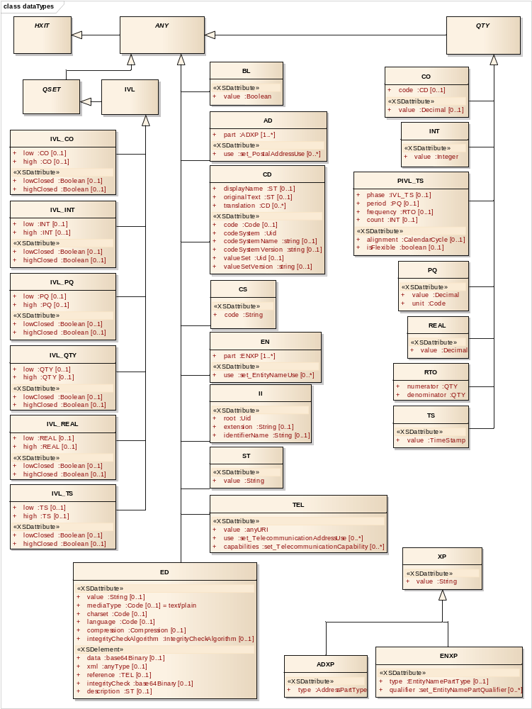
Figure: 19

simpleTypesAndEnums - (Class diagram)
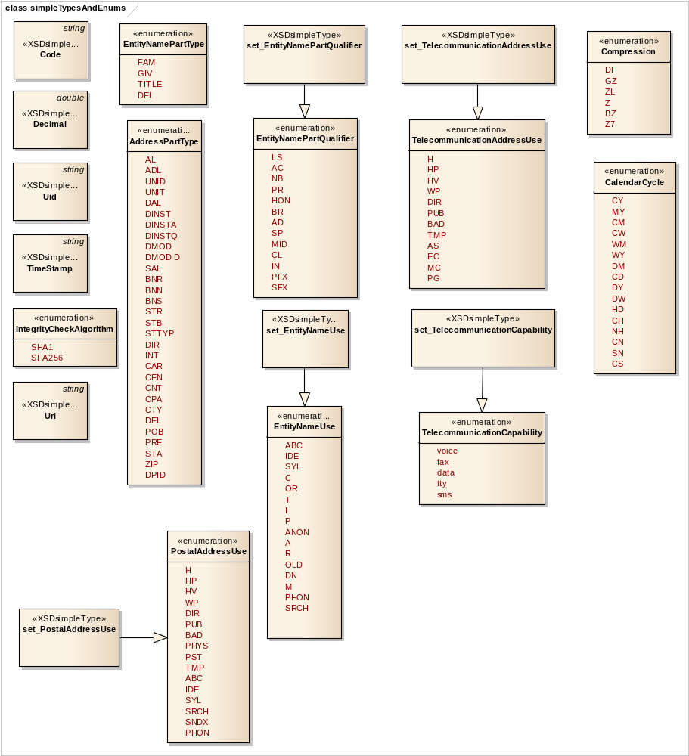
Figure: 20

AD
Type: Class ANY
Package: dataTypes

Mailing and home or office addresses.

AD is primarily used to communicate data that will allow printing mail labels, or that will allow a person to physically visit that address. The postal address datatype is not supposed to be a container for additional information that might be useful for finding geographic locations (e.g., GPS coordinates) or for performing epidemiological studies. Such additional information should be captured by other, more appropriate data structures.

Addresses are essentially sequences of address parts, but add a "use" code and a valid time range for information about if and when the address can be used for a given purpose.

Attributes
Attribute | Notes
part  ADXP [1..*] | A sequence of address parts, such as street or post office Box, city, postal code, country, etc.
use  set_PostalAddressUse [0..*] | A set of codes advising a system or user which address in a set of like addresses to select for a given purpose.  An address without specific use code might be a default address useful for any purpose, but an address with a specific use code would be preferred for that respective purpose.  If populated, the values contained in this attribute SHALL be taken from the HL7 PostalAddressUse code system.

ADXP
Type: Class XP
Package: dataTypes

A part with a type-tag signifying its role in the address. Typical parts that exist in about every address are street, house number, or post box, postal code, city, country but other roles may be defined regionally, nationally, or on an enterprise level (e.g. in military addresses).

Attributes
Attribute | Notes
type  AddressPartType | Whether an address part names the street, city, country, postal code, post box, address line 1, etc.  The value of this attribute SHALL be taken from the HL7 AddressPartType code system.

ANY
Type: Class HXIT
Package: dataTypes

Defines the basic properties of every data value. This is conceptually an abstract type, meaning that no proper value can be just a data value without belonging to any concrete type. Every public concrete type is a specialization of this general abstract DataValue type.

However exceptional values (nullFlavored values) may be of type ANY, except for the exceptional values that imply the nullFlavor INV, since this requires a type to be meaningful. Note that not all nullFlavors may be used with the type ANY.

This class is maintained here despite the lack of attributes to maintain compatibility with the ISO 21090 data structure.

We have also made it abstract to be consistent with the lack of support for nullFlavors.

AddressPartType
Type: Enumeration
Package: dataTypes

Specifies whether an address part names the street, city, country, postal code, post box, etc. If the type is NULL the address part is unclassified.

CodeSystem "AddressPartType", OID: 2.16.840.1.113883.5.16, Owner: HL7

Attributes
Attribute | Notes
AL | Address Line: An address line is for either an additional locator, a delivery address or a street address. An address generally has only a delivery address line or a street address line, but not both.
ADL | Additional Locator : This can be a unit designator, such as apartment number, suite number, or floor. There may be several unit designators in an address (e.g., "3rd floor, Appt. 342"). This can also be a designator pointing away from the location, rather than specifying a smaller location within some larger one (e.g., Dutch "t.o." means "opposite to" for house boats located across the street facing houses)
UNID | Unit Identifier : The number or name of a specific unit contained within a building or complex, as assigned by that building or complex
UNIT | Unit Designator: Indicates the type of specific unit contained within a building or complex. E.g. Apartment, Floor
DAL | Delivery Address Line: A delivery address line is frequently used instead of breaking out delivery mode, delivery installation, etc. An address generally has only a delivery address line or a street address line, but not both.
DINST | Delivery Installation Type: Indicates the type of delivery installation (the facility to which the mail will be delivered prior to final shipping via the delivery mode.) Example: post office, letter carrier depot, community mail center, station, etc.
DINSTA | Delivery Installation Area: The location of the delivery installation, usually a town or city, and is only required if the area is different from the municipality. Area to which mail delivery service is provided from any postal facility or service such as an individual letter carrier, rural route, or postal route.
DINSTQ | Delivery Installation Qualifier: A number, letter or name identifying a delivery installation. E.g., for Station A, the delivery installation qualifier would be 'A'.
DMOD | Delivery Mode: Indicates the type of service offered, method of delivery. For example: post office box, rural route, general delivery, etc.
DMODID | Delivery Mode Identifier: Represents the routing information such as a letter carrier route number. It is the identifying number of the designator (the box number or rural route number).
SAL | Street Address Line: A street address line is frequently used instead of breaking out build number, street name, street type, etc. An address generally has only a delivery address line or a street address line, but not both.
BNR | Building Number: The number of a building, house or lot alongside the street. Also known as "primary street number". This does not number the street but rather the building.
BNN | Building Number Numeric: The numeric portion of a building number
BNS | Building Number Suffix: Any alphabetic character, fraction or other text that may appear after the numeric portion of a building number
STR | Street Name: The name of the street, including the type
STB | Street Name Base: The base name of a roadway or artery recognized by a municipality (excluding street type and direction)
STTYP | Street Type: The designation given to the street. (e.g. Street, Avenue, Crescent, etc.)
DIR | Direction (e.g., N, S, W, E)
INT | Intersection: An intersection denotes that the actual address is located at or close to the intersection of two or more streets
CAR | Care Of: The name of the party who will take receipt at the specified address, and will take on responsibility for ensuring delivery to the target recipient
CEN | Census Tract: A geographic sub-unit delineated for demographic purposes.
CNT | Country
CPA | County or Parish: A sub-unit of a state or province. (49 of the United States of America use the term "county;" Louisiana uses the term "parish".)
CTY | Municipality: The name of the city, town, village, or other community or delivery center
DEL | Delimiter: Delimiters are printed without framing white space. If no value component is provided, the delimiter appears as a line break.
POB | Post Box: A numbered box located in a post station.
PRE | Precinct: A subsection of a municipality
STA | State or Province: A sub-unit of a country with limited sovereignty in a federally organized country.
ZIP | Postal Code: A postal code designating a region defined by the postal service.
DPID | Delivery Point Identifier : A value that uniquely identifies the postal address.

BL
Type: Class ANY
Package: dataTypes

BL stands for the values of two-valued logic. A BL value can be either true or false.

Attributes
Attribute | Notes
value  Boolean | The value of the BL.

CD
Type: Class ANY
Package: dataTypes

A CD is a reference to a concept defined in an external code system, terminology, or ontology.

A CD may also contain an original text or phrase that served as the basis of the coding.

Attributes
Attribute | Notes
code  Code [0..1] | The plain code symbol defined by the code system, or an expression in a syntax defined by the code system which describes the concept.  Code SHALL be an exact match to a plain code symbol or expression defined by the code system. If the code system defines a code or expression that includes whitespace, the code SHALL include the whitespace. An expression can only be used where the codeSystem either defines an expression syntax, or there is a generally accepted syntax for the codeSystem. A code system may be defined that only defines an expression syntax with bindings to other code Systems for the elements of the expression.  It is at the discretion of the interpreting system whether to check for an expression instead of a simple code and evaluate the expression instead of treating the expression as a code. In some cases, it may be unclear or ambiguous whether the code represents a single symbol or an expression. This usually arises where the code system defines an expression language and then defines pre-coordinated concepts with symbols which match their expression, e.g. UCUM. In other cases, it is safe to treat the expression as a symbol. There is no guarantee that this is always safe: the definitions of the codeSystem should always be consulted to determine how to handle potential expressions.
codeSystem  Uid | The code system that defines the code, or if no code was found, the codeSystem in which no code was found.  Code systems SHALL be referred to by a UID, which allows unambiguous reference to standard code systems and other local codesystems. Where either ISO or HL7 have assigned UID to code Systems, then these UIDs SHALL be used. Otherwise implementations SHALL use an appropriate ISO Object Identifier (OID) or UUID to construct a globally unique local coding system identifier.
codeSystemName  string [0..1] | The common name of the coding system.  The code system name has no computational value. codeSystemName can never modify the meaning of codeSystem and cannot exist without codeSystem.  Information Processing Entities claiming direct or indirect conformance SHALL NOT functionally rely on codeSystemName. In addition, they MAY choose not to implement codeSystemName; but SHALL NOT reject instances because codeSystemName is present.  Note: The purpose of a code system name is to assist an unaided human interpreter of a code value to interpret codeSystem.
codeSystemVersion  string [0..1] | If applicable, a version descriptor defined specifically for the given code system.
valueSet  Uid [0..1] | The value set that applied when this CD was created.
valueSetVersion  string [0..1] | The version of the valueSet in which the code was found.
displayName  ST [0..1] | A name, title, or representation for the code or expression as it exists in the code system.  If populated, the displayName SHALL be a valid human readable representation of the concept as defined by the code system at the time of data entry. The displayName SHALL conform to any rules defined by the codingSystem; if the codeSystem does not define a human representation for the code or expression, then none can be provided. displayName is included both as a courtesy to an unaided human interpreter of a code value and as a documentation of the name used to display the concept to the user. The display name has no functional meaning; it SHALL never exist without a code; and it SHALL never modify the meaning of the code. A display name may not be present if the code is an expression for which no display name has been assigned or can be derived. Information Processing Entities claiming direct or indirect conformance MAY choose not to implement displayName but SHALL NOT reject instances because displayName is present.  Display names SHALL not alter the meaning of the code value. Therefore, display names SHOULD NOT be presented to the user on a receiving application system without ascertaining that the display name adequately represents the concept referred to by the code value. Communication SHALL NOT simply rely on the display name. The display name's main purpose is to support implementation debugging.
originalText  ST [0..1] | The text as seen and/or selected by the user who entered the data which represents the intended meaning of the user.  Note: Local implementations may influence what is required to represent that original text.  Original text can be used in a structured user interface to capture what the user saw as a representation of the code on the data input screen, or in a situation where the user dictates or directly enters text, it is the text entered or uttered by the user.  It is valid to use the CD datatype to store only the text that the user entered or uttered. In this situation, original text will exist without a code. In a situation where the code is assigned sometime after the text was entered, originalText is the text or phrase used as the basis for assigning the code.  The original text SHALL be an excerpt of the relevant information in the original sources, rather than a pointer or exact reproduction. Thus the original text SHALL be represented in plain text form. In specific circumstances, when clearly descirbed the context of use, the originalText may be a reference to some other text artefact for which the resolution scope is clearly described.  Values of type CD MAY have a original text despite not having a code. Any CD value with no code signifies a coding exception. In this case, originalText is a name or description of the concept that was not coded.
translation  CD [0..*] | Translation of the base code / codeSystem to other codeSystems.

CO
Type: Class QTY
Package: dataTypes

Represents data where coded values are associated with a specific order.

Note: CO may be used for things that model rankings and scores, e.g. likert scales, pain, Apgar values, etc, where there is a) implied ordering, b) no implication that the distance between each value is constant, and c) the total number of values is finite. CO may also be used in the context of an ordered code system. In this case, it may not be appropriate or even possible to use the value attribute, but CO may still be used so that models that make use of such code systems may introduce model elements that involve statements about the order of the terms in a domain.

The relative order of values in a code system need not be independently obvious in the literal representation of the CO. It these circumstances, is expected that an application will look up the ordering of these values from some definition of the code system.

Some of the code systems will directly assign numerical value to the concepts that are suitable for some mathemetical operations.

Though it would generally make sense, applications SHOULD not assume that the translations of the code, if provided, will have the same ordering as the CO. Translations SHALL not be considered when the ordering of the code system is determined.

Attributes
Attribute | Notes
code  CD [0..1] | A code representing the definition of the ordinal item
value  Decimal [0..1] | A numerical value associated with the coded ordinal value.  The value may be constrained to an integer in some contexts of use. If code is nonNull, value SHALL only be nonNull if the code system explicitly assigns a value to the concept.

CS
Type: Class ANY
Package: dataTypes

Coded data in its simplest form, where only the code is not predetermined.

The code system and code system version are implied and fixed by the context in which the CS value occurs.

Due to its highly restricted functionality, CS SHALL only be used for simple structural attributes with highly controlled and stable terminologies where:
- all codes come from a single code system
- codes are not reused if their concept is deprecated
- the publication and extensibility properties of the code system are well described and understood

Attributes
Attribute | Notes
code  String | The plain code symbol defined by the code system. If the code value is empty or null, then there is no code in the code system that represents the concept.  Code SHALL only contain characters that are either a letter, a digit, or one of '.', '-', '_' or ':'. Code systems that are used with CS SHALL NOT define code symbols or expression syntaxes that contain whitespace or any other characters not in this list.

CalendarCycle
Type: Enumeration
Package: dataTypes

Attributes
Attribute | Notes
CY | year
MY | month of the year
CM | month (continuous)
CW | week (continuous)
WM | week of the month
WY | week of the year
DM | day of the month
CD | day (continuous)
DY | day of the year
DW | day of the week (begins with monday)
HD | hour of the day
CH | hour (continuous)
NH | minute of the hour
CN | minute (continuous)
SN | second of the minute
CS | second (continuous)

Code
Type: Class string
Package: dataTypes

A code representing the string data. For example, the string data may be a user-message out of a message-catalog where the code represents the identifier of the message in the message catalog.

Compression
Type: Enumeration
Package: dataTypes

The compression algorithm, specified in the HL7 CompressionAlgorithm code system.

Attributes
Attribute | Notes
DF | Deflate : The deflate compressed data format as specified in IETF RFC 1951.
GZ | GZIP : A compressed data format that is compatible with the widely used GZIP utility as specified in IETF RFC 1952(uses the deflate algorithm).
ZL | ZLIB : A compressed data format that also uses the deflate algorithm. Specified as IETF RFC 1950.
Z | Compress : Original UNIX compress algorithm and file format using the LZC algorithm (a variant of LZW). Patent encumbered and less efficient than deflate.
BZ | BZIP : bzip-2 compression format. See [http://www.bzip.org/] for more information.
Z7 | Z7 : 7z compression file format. See [http://www.7-zip.org/7z.html] for more information.

Decimal
Type: Class double
Package: dataTypes

A number that is not restricted to an integer, and may contain fractional values between two integers.

ED
Type: Class ANY
Package: dataTypes

Data that is primarily intended for human interpretation or for further machine processing outside the scope of this specification. This includes unformatted or formatted written language, multimedia data, or structured information as defined by a different standard (e.g., XML-signatures.)
Encapsulated data can be present in two forms, inline or by reference. The content is the same whether it is located inline or remote. Inline data is communicated or moved as part of the encapsulated data value, whereas by-reference data may reside at a different location: a URL/URI that provides reference to the information required to locate the data. Inline data may be provided in one of 3 different ways:

1) as a plain sequence of characters (value)
2) as a binary (a sequence of bytes) (data
3) as xml content (xml)

Content SHALL be provided if the ED has no nullFlavor. The content may be provided in-line (using only one of value, data or xml), or it may be provided as a reference.Content may be provided in-line and a reference also may be given; in these cases, it is expected that the content of the reference will be exactly the same as the in-line content. Information Processing Entities are not required to check this, but may regard it as an error condition if the content does not match

Attributes
Attribute | Notes
value  String [0..1] | A simple sequence of characters that contains the content.  If value is used, the mediatype is fixed to text/plain and the charset must be consistent with the String Character Set. Refer to section 6.7.5 for more details
data  base64Binary [0..1] | A simple sequence of byte values that contains the content. (Base64 Encoded String).
xml  anyType [0..1] | The content represented in plain XML form.  A direct representation is provided for XML. This is because this specification includes an XML serialization of the data, and this xml attribute is handled specially in the serialisation form. The xml data is not different in any semantic sense to the same data if represented in the value or data attributes.
reference  TEL [0..1] | A URL the target of which provides the binary content.  The semantic value of an encapsulated data value is the same, regardless whether the content is present as inline content or just by reference. However, an encapsulated data value without inline content behaves differently, since any attempt to examine the content requires the data to be downloaded from the reference. An encapsulated data value may have both inline content and a reference.  If data is provded in the value, data or xml attributes, the reference SHALL point to the same data. It is an error if the data resolved through the reference does not match either the integrity check, data as provided, or data that had earlier been retrieved through the reference and then cached. The mediatype of the ED SHALL match the type returned by accessing the reference.  The reference may contain a usablePeriod to indicate that the data may only be available for a limited period of time. Whether the reference is limited by a usablePeriod or not, the content of the reference SHALL be fixed for all time. Any application using the reference SHALL always receive the same data, or an error. The reference cannot be reused to send a different version of the same data, or different data
mediaType  Code [0..1] | Identifies the type of the encapsulated data and can be used to determine a method to interpret or render the content.  The IANA defined domain of media types is established by the IETF RFCs 2045 and 2046. mediaType has a default value of text/plain and cannot be null. If the media type is different to text/plain, the &#60;i&#62;mediaType&#60;/i&#62; attribute SHALL be populated.  If the content is compressed using a specified compression algorithm, the mediaType SHALL refer the mediaType of the uncompressed data, whether the data is accessed by reference or not.
charset  Code [0..1] | An Internet Assigned Numbers Authority (IANA) Charset Registered character set and character encoding for character-based encoding types&#60;b&#62;. &#60;/b&#62;  Whenever the content of the ED is character type data in any form, the charset property needs to be known. If the content is provided directly in the value attribute, then the charset SHALL be a known character set consistent with the String Character Set. Refer to section 6.7.5 for more details. If the content is provided as a reference, and the access method does not provide the charset for the content (such as by a mime header), then the charset SHALL be conveyed as part of the ED
language  Code [0..1] | The human language of the content. Valid codes are taken from the IETF RFC 3066. If this attribute is null, the language may be inferred from elsewhere, either from the context or from unicode language tags, for example.  Conformance profiles SHOULD define defaulting rules for language for a given usage environment of this specification.  Note: While language attribute usually alters the interpretation of the text, the language attribute does not alter the meaning of the characters in the text.
compression  Compression [0..1] | The compression algorithm, if any, used on the raw byte data.  If the attribute is null, the data is not compressed. Compression only applies to the binary form of the content.  If populated, the value of this attribute SHALL be taken from the HL7 CompressionAlgorithm code system.  Some compression formats allow multiple archive files to be embedded within a single compressed volume. Applications SHALL ensure that the decompressed form of the data conforms to the stated media type.
integrityCheck  base64Binary [0..1] | A checksum calculated over the binary data  The purpose of this property, when communicated with a reference is for anyone to validate later whether the reference still resolved to the same content that the reference resolved to when the encapsulated data value with reference was created. If the attribute is null, there is no integrityCheck.  It is an error if the data resolved through the reference does not match the integrity check.  The integrity check is calculated according to the integrityCheckAlgorithm. By default, the Secure Hash Algorithm-1 (SHA-1) shall be used. The integrity check is binary encoded according to the rules of the integrity check algorithm.  The integrity check is calculated over the raw binary data that is contained in the data component, or that is accessible through the reference. No transformations are made before the integrity check is calculated. If the data is compressed, the Integrity Check is calculated over the compressed data.
integrityCheckAlgorithm  IntegrityCheckAlgorithm [0..1] | The algorithm used to compute the integrityCheck value.  If populated, the value of this attribute SHALL be taken from the HL7 IntegrityCheckAlgorithm code system.
description  ST [0..1] | An alternative description of the media where the media is not able to be rendered.  E.g. Short text description of an image or sound clip, etc. This attribute is not intended to be a complete substitute for the original. For complete substitutes, use the &#34;translation&#34; property.  The intent of this property is to allow compliance with disability requirements such as those expressed in American&#39;s with Disability Act (also known as &#34;Section 508&#34;), where there is a requirement to provide a short text description of included media in some form that can be read by a screen reader. This is similar to a very short thumbnail with mediaType = text/plain.

EN
Type: Class ANY
Package: dataTypes

A name for a person, organization, place or thing.

Examples: Jim Bob Walton, Jr., Health Level Seven, Inc., Lake Tahoe, etc. An entity name may be as simple as a character string or may consist of several entity name parts, such as, Jim, Bob, Walton, and Jr., Health Level Seven, and Inc.

Entity names are essentially sequences of entity name parts, but add a "use" code.

Attributes
Attribute | Notes
part  ENXP [1..*] | A sequence of name parts, such as given name or family name, prefix, suffix, etc.
use  set_EntityNameUse [0..*] | A set of codes advising a system or user which name in a set of names to select for a given purpose.  A name without specific use code might be a default name useful for any purpose, but a name with a specific use code would be preferred for that respective purpose. Names SHOULD not be collected without at least one use code, but names MAY exist without use code, particularly for legacy data.  If populated, the values contained in this attribute SHALL be taken from the HL7 EntityNameUse2 code system.

ENXP
Type: Class XP
Package: dataTypes

A part with a type code signifying the role of the part in the whole entity name, and qualifier codes for more detail about the name part type. (Typical name parts for person names are given names, and family names, titles, etc.).

Attributes
Attribute | Notes
type  EntityNamePartType [0..1] | Indicates whether the name part is a given name, family name, prefix, suffix, etc.  The value of this attribute SHALL be taken from the HL7 EntityNamePartType2 code system.
qualifier  set_EntityNamePartQualifier [0..*] | The qualifier is a set of codes each of which specifies a certain subcategory of the name part in addition to the main name part type.  For example, a given name may be flagged as a nickname (CL), a family name may be a name acquired by marriage (SP) or a name from birth (BR).  If populated, the values contained in this attribute SHALL be taken from the HL7 EntityNamePartQualifier2 code system.

EntityNamePartQualifier
Type: Enumeration
Package: dataTypes

The qualifier is a set of codes each of which specifies a certain subcategory of the name part in addition to the main name part type. For example, a given name may be flagged as a nickname, a family name may be a pseudonym or a name of public records.

CodeSystem "EntityNamePartTypeQualifierR2", OID: 2.16.840.1.113883.5.1122, Owner: HL7

Attributes
Attribute | Notes
LS | Legal Status : For organizations a suffix indicating the legal status, e.g., "Inc.", "Co.", "AG", "GmbH", "B.V." "S.A.", "Ltd." Etc.
AC | Academic : Indicates that a prefix like "Dr." or a suffix like "M.D." or "Ph.D." is an academic title
NB | Nobility : In Europe and Asia, there are still people with nobility titles (aristocrats). German "von" is generally a nobility title, not a mere voorvoegsel. Others are "Earl of" or "His Majesty King of..." etc. Rarely used nowadays, but some systems do keep track of this
PR | Professional : Primarily in the British Imperial culture people tend to have an abbreviation of their professional organization as part of their credential suffices
HON | Honorific : A honorific such as "The Right Honourable" or "Weledelgeleerde Heer".
BR | Birth : A name that a person was given at birth or established as a consequence of adoption.  Note: this is not used for temporary names assigned at birth such as "Baby of Smith" - which is just a name with a use code of "TEMP".
AD | Acquired : A name part a person acquired.  The name part may be acquired by adoption, or the person may have chosen to use the name part for some other reason.  Note: this differs from an Other/Psuedonym/Alias in that an acquired name part is acquired on a formal basis rather than an informal one (e.g. registered as part of the official name)
SP | Spouse : The name assumed from the partner in a marital relationship. Usually the spouse's family name. Note that no inference about gender can be made from the existence of spouse names
MID | Middle Name : Indicates that the name part is a middle name.  Usage Notes:  In general, the english 'middle name' concept is all of the given names after the first. This qualifier may be used to explicitly indicate which given names are considered to be middle names.  The middle name qualifier may also be used with family names. This is a Scandinavian use case, matching the concept of "mellomnavn" / "mellannamn". Note that there are specific rules that indicate what names may be taken as a mellannamn in different Scandinavian countries
CL | Callme : Callme is used to indicate which of the various name parts is used when interacting with the person
IN | Initial : Indicates that a name part is just an initial. Initials do not imply a trailing period since this would not work with non-Latin scripts. Initials may consist of more than one letter, e.g., "Ph." could stand for "Philippe" or "Th." for "Thomas"
PFX | Prefix : A prefix has a strong association to the immediately following name part. A prefix has no implicit trailing white space (it has implicit leading white space though).
SFX | Suffix : A suffix has a strong association to the immediately preceding name part. A suffix has no implicit leading white space (it has implicit trailing white space though).

EntityNamePartType
Type: Enumeration
Package: dataTypes

Indicates whether the name part is a given name, family name, prefix, suffix, etc.

CodeSystem "EntityNamePartTypeR2", OID: 2.16.840.1.113883.5.1122, Owner: HL7

Attributes
Attribute | Notes
FAM | Family : Family name, this is the name that links to the genealogy. In some cultures (e.g. Eritrea) the family name of a son is the first name of his father
GIV | Given: Given name.  Note: don't call it "first name" since this given names do not always come first
TITLE | Title : Part of the name that is acquired as a title due to academic, legal, employment or nobility status etc.  Note: Title name parts include name parts that come after the name such as qualifications
DEL | Delimiter : A delimiter has no meaning other than being literally printed in this name representation. A delimiter has no implicit leading and trailing white space

EntityNameUse
Type: Enumeration
Package: dataTypes

A set of codes advising a system or user which name in a set of names to select for a given purpose.

CodeSystem "EntityNameUseR2", OID: 2.16.840.1.113883.5.1120, Owner: HL7

Attributes
Attribute | Notes
ABC | Alphabetic: Alphabetic transcription of name (Japanese: romaji)
IDE | Ideographic : Ideographic representation of name (e.g., Japanese kanji, Chinese characters)
SYL | Syllabic: Syllabic transcription of name (e.g., Japanese kana, Korean hangul)
C | Customary : Known as/conventional/the one you normally use
OR | Official Registry Name : the formal name as registered in an official (government) registry, but which name might not be commonly used. May correspond to the concept of legal name
T | Temporary : A temporary name. Note that a name valid time can provide more detailed information. This may also be used for temporary names assigned at birth or in emergency situations.
I | Indigenous/Tribal: e.g. Chief Red Cloud
P | Other/Pseudonym/Alias: A non-official name by which the person is sometimes known. (This may also be used to record informal names such as a nickname)
ANON | Anonymous : Anonymous assigned name (used to protect a person's identity for privacy reasons)
A | Business Name : A name used in a Professional or Business context .  Examples: Continuing to use a maiden name in a professional context, or using a stage performing name (some of these names are also pseudonyms)
R | Religious : A name assumed as part of a religious vocation. e.g. Sister Mary Francis, Brother John
OLD | No Longer in Use : This name is no longer in use (note: Names may also carry valid time ranges . This code is used to cover the situations where it is known that the name is no longer valid, but no particular time range for its use is known)
DN | Do Not Use : This name should no longer be used when interacting with the person (i.e . in addition to no longer being used, the name should not be even mentioned when interacting with the person)  Note: applications are not required to compare names labeled "Do Not Use" and other names in order to eliminate name parts that are common between the other name and a name labeled "Do Not Use".
M | Maiden Name : A name used prior to marriage.  Note that marriage naming customs vary greatly around the world. This name use is for use by applications that collect and store "maiden" names. Though the concept of maiden name is often gender specific, the use of this term is not gender specific. The use of this term does not imply any particular history for a person's name, nor should the maiden name be determined algorithmically
PHON | Phonetic : The name as understood by the data enterer, i.e. a close approximation of a phonetic spelling of the name, not based on a phonetic algorithm.
SRCH | Search Type Uses: A name intended for use in searching or matching

HXIT
Type: Class
Package: dataTypes

Information about the history of this value: period of validity and a reference to an identified event that established this value as valid.

Because of the way that the types are defined, a number of attributes of the datatypes have values with a type derived from HXIT. In these cases the HXIT attributes are constrained to null. The only case where the HXIT attributes are allowed within a datatype is on items in a collection (DSET, LIST, BAG, HIST).
The use of these attributes is generally subject to further constraints in the specifications that make use of these types.

This class is maintained here despite the lack of attributes to maintain compatibility with the ISO 21090 data structure.

II
Type: Class ANY
Package: dataTypes

An identifier that uniquely identifies a thing or object.

Examples are object identifier for HL7 RIM objects, medical record number, order id, service catalog item id, Vehicle Identification Number (VIN), etc. Instance identifiers are usually defined based on ISO object identifiers.

An identifier allows someone to select one record, object or thing from a set of candidates. Usually an identifier alone without any context is not usable. Identifiers are distinguished from concept descriptors as concept descriptors never identify an individual thing, although there may sometimes be an individual record or object that represents the concept.

Information Processing Entities claiming direct or indirect conformance SHALL never assume that receiving applications can infer the identity of issuing authority or the type of the identifier from the identifier or components thereof.

Attributes
Attribute | Notes
root  Uid | A unique identifier that guarantees the global uniqueness of the instance identifier.  If root is populated, and there is no extension, then the root is a globally unique identifier in its own right. In the presence of a non-null extension, the root is the unique identifier for the "namespace" of the identifier in the extension. Note that this does NOT necessarily correlate with the organization that manages the issuing of the identifiers. A given organization may manage multiple identifier namespaces, and control over a given namespace may transfer from organization to organization over time while the root remains the same.  This field can be either a DCE UUID, an Object Identifier (OID), or a special identifier taken from lists that may be published by ISO or HL7.  Comparison of root values is always case sensitive. UUID's SHALL be represented in upper case, so UUID case should always be preserved.  The root SHALL not be used to carry semantic meaning - all it does is ensure global computational uniqueness.
extension  String [0..1] | A character string as a unique identifier within the scope of the identifier root.  The root and extension scheme means that the concatenation of root and extension SHALL be a globally unique identifier for the item that this II value identifies.  Some identifier schemes define certain style options to their code values. For example, the U.S. Social Security Number (SSN) is normally written with dashes that group the digits into a pattern "123-12-1234". However, the dashes are not meaningful and a SSN can also be represented as "123121234" without the dashes. In the case where identifier schemes provide for multiple representations, HL7 or ISO may make a ruling about which is the preferred form and document that ruling where that respective external identifier scheme is recognized.  If no extension attribute is provided in a non-null II, then the root is the complete unique identifier.
identifierName  String [0..1] | A human readable description for this identifier.

INT
Type: Class QTY
Package: dataTypes

Integer numbers (-1,0,1,2, 100, 3398129, etc.) are precise numbers that are results of counting and enumerating. Integer numbers are discrete, the set of integers is infinite but countable. No arbitrary limit is imposed on the range of integer numbers.

Attributes
Attribute | Notes
value  Integer | The value of the INT. Note that this specification imposes no limitations on the size of integer, but most implementations will map this to a 32 or 64 bit integer.

IVL
Type: Class QSET
Package: dataTypes

A set of consecutive values of an ordered base datatype.

Any ordered type can be the basis of an IVL; it does not matter whether the base type is discrete or continuous. If the base datatype is only partially ordered, all elements of the IVL must be elements of a totally ordered subset of the partially ordered datatype. For example, PQ is considered ordered. However the ordering of PQs is only partial; a total order is only defined among comparable quantities (quantities of the same physical dimension). While IVLs between 2 and 4 meter exists, there is no IVL between 2 meters and 4 seconds

This class is maintained here despite the lack of attributes to maintain compatibility with the ISO 21090 data structure.

IVL_CO
Type: Class IVL
Package: dataTypes

A set of consecutive values of an ordered base datatype.

Any ordered type can be the basis of an IVL; it does not matter whether the base type is discrete or continuous. If the base datatype is only partially ordered, all elements of the IVL must be elements of a totally ordered subset of the partially ordered datatype. For example, PQ is considered ordered. However the ordering of PQs is only partial; a total order is only defined among comparable quantities (quantities of the same physical dimension). While IVLs between 2 and 4 meter exists, there is no IVL between 2 meters and 4 seconds

Attributes
Attribute | Notes
low  CO [0..1] | This is the low limit. If the low limit is not known, it may be null.  The low limit SHALL NOT be positive infinity.
high  CO [0..1] | This is the high limit. If the high limit is not known, it may be null.  The high limit SHALL NOT be negative infinity, and SHALL be higher than the low limit if one exists.
lowClosed  Boolean [0..1] | This attribute is called lowIsClosed in the ISO 21090 specification and lowClosed in the HL7 Data Types R2 specification.  Whether low is included in the IVL (is closed) or excluded from the IVL (is open).
highClosed  Boolean [0..1] | This attribute is called highIsClosed in the ISO 21090 specification and highClosed in the HL7 Data Types R2 specification.  Whether high is included in the IVL (is closed) or excluded from the IVL (is open).

IVL_INT
Type: Class IVL
Package: dataTypes

A set of consecutive values of an ordered base datatype.

Any ordered type can be the basis of an IVL; it does not matter whether the base type is discrete or continuous. If the base datatype is only partially ordered, all elements of the IVL must be elements of a totally ordered subset of the partially ordered datatype. For example, PQ is considered ordered. However the ordering of PQs is only partial; a total order is only defined among comparable quantities (quantities of the same physical dimension). While IVLs between 2 and 4 meter exists, there is no IVL between 2 meters and 4 seconds.

Attributes
Attribute | Notes
low  INT [0..1] | This is the low limit. If the low limit is not known, it may be null.  The low limit SHALL NOT be positive infinity.
high  INT [0..1] | This is the high limit. If the high limit is not known, it may be null.  The high limit SHALL NOT be negative infinity, and SHALL be higher than the low limit if one exists.
lowClosed  Boolean [0..1] | This attribute is called lowIsClosed in the ISO 21090 specification and lowClosed in the HL7 Data Types R2 specification.  Whether low is included in the IVL (is closed) or excluded from the IVL (is open).
highClosed  Boolean [0..1] | This attribute is called highIsClosed in the ISO 21090 specification and highClosed in the HL7 Data Types R2 specification.  Whether high is included in the IVL (is closed) or excluded from the IVL (is open).

IVL_PQ
Type: Class IVL
Package: dataTypes

A set of consecutive values of an ordered base datatype.

Any ordered type can be the basis of an IVL; it does not matter whether the base type is discrete or continuous. If the base datatype is only partially ordered, all elements of the IVL must be elements of a totally ordered subset of the partially ordered datatype. For example, PQ is considered ordered. However the ordering of PQs is only partial; a total order is only defined among comparable quantities (quantities of the same physical dimension). While IVLs between 2 and 4 meter exists, there is no IVL between 2 meters and 4 seconds.

Attributes
Attribute | Notes
low  PQ [0..1] | This is the low limit. If the low limit is not known, it may be null.  The low limit SHALL NOT be positive infinity.
high  PQ [0..1] | This is the high limit. If the high limit is not known, it may be null.  The high limit SHALL NOT be negative infinity, and SHALL be higher than the low limit if one exists.
lowClosed  Boolean [0..1] | This attribute is called lowIsClosed in the ISO 21090 specification and lowClosed in the HL7 Data Types R2 specification.  Whether low is included in the IVL (is closed) or excluded from the IVL (is open).
highClosed  Boolean [0..1] | Whether high is included in the IVL (is closed) or excluded from the IVL (is open).

IVL_QTY
Type: Class IVL
Package: dataTypes

A set of consecutive values of an ordered base datatype.

Any ordered type can be the basis of an IVL; it does not matter whether the base type is discrete or continuous. If the base datatype is only partially ordered, all elements of the IVL must be elements of a totally ordered subset of the partially ordered datatype. For example, PQ is considered ordered. However the ordering of PQs is only partial; a total order is only defined among comparable quantities (quantities of the same physical dimension). While IVLs between 2 and 4 meter exists, there is no IVL between 2 meters and 4 seconds.

Attributes
Attribute | Notes
low  QTY [0..1] | This is the low limit. If the low limit is not known, it may be null.  The low limit SHALL NOT be positive infinity.
high  QTY [0..1] | This is the high limit. If the high limit is not known, it may be null.  The high limit SHALL NOT be negative infinity, and SHALL be higher than the low limit if one exists.
lowClosed  Boolean [0..1] | This attribute is called lowIsClosed in the ISO 21090 specification and lowClosed in the HL7 Data Types R2 specification.  Whether low is included in the IVL (is closed) or excluded from the IVL (is open).
highClosed  Boolean [0..1] | This attribute is called highIsClosed in the ISO 21090 specification and highClosed in the HL7 Data Types R2 specification.  Whether high is included in the IVL (is closed) or excluded from the IVL (is open).

IVL_REAL
Type: Class IVL
Package: dataTypes

A set of consecutive values of an ordered base datatype.

Any ordered type can be the basis of an IVL; it does not matter whether the base type is discrete or continuous. If the base datatype is only partially ordered, all elements of the IVL must be elements of a totally ordered subset of the partially ordered datatype. For example, PQ is considered ordered. However the ordering of PQs is only partial; a total order is only defined among comparable quantities (quantities of the same physical dimension). While IVLs between 2 and 4 meter exists, there is no IVL between 2 meters and 4 seconds.

Attributes
Attribute | Notes
low  REAL [0..1] | This is the low limit. If the low limit is not known, it may be null.  The low limit SHALL NOT be positive infinity.
high  REAL [0..1] | This is the high limit. If the high limit is not known, it may be null.  The high limit SHALL NOT be negative infinity, and SHALL be higher than the low limit if one exists.
lowClosed  Boolean [0..1] | This attribute is called lowIsClosed in the ISO 21090 specification and lowClosed in the HL7 Data Types R2 specification.  Whether low is included in the IVL (is closed) or excluded from the IVL (is open).
highClosed  Boolean [0..1] | This attribute is called highIsClosed in the ISO 21090 specification and highClosed in the HL7 Data Types R2 specification.  Whether high is included in the IVL (is closed) or excluded from the IVL (is open).

IVL_TS
Type: Class IVL
Package: dataTypes

A set of consecutive values of an ordered base datatype.

Any ordered type can be the basis of an IVL; it does not matter whether the base type is discrete or continuous. If the base datatype is only partially ordered, all elements of the IVL must be elements of a totally ordered subset of the partially ordered datatype. For example, PQ is considered ordered. However the ordering of PQs is only partial; a total order is only defined among comparable quantities (quantities of the same physical dimension). While IVLs between 2 and 4 meter exists, there is no IVL between 2 meters and 4 seconds.

Attributes
Attribute | Notes
low  TS [0..1] | This is the low limit. If the low limit is not known, it may be null.  The low limit SHALL NOT be positive infinity.
high  TS [0..1] | This is the high limit. If the high limit is not known, it may be null.  The high limit SHALL NOT be negative infinity, and SHALL be higher than the low limit if one exists.
lowClosed  Boolean [0..1] | This attribute is called lowIsClosed in the ISO 21090 specification and lowClosed in the HL7 Data Types R2 specification.  Whether low is included in the IVL (is closed) or excluded from the IVL (is open).
highClosed  Boolean [0..1] | This attribute is called highIsClosed in the ISO 21090 specification and highClosed in the HL7 Data Types R2 specification.  Whether high is included in the IVL (is closed) or excluded from the IVL (is open).

IntegrityCheckAlgorithm
Type: Enumeration
Package: dataTypes

The algorithm used to compute the integrityCheck value.

Attributes
Attribute | Notes
SHA1 | Secure Hash Algorithm - 1 : This algorithm is defined in FIPS PUB 180-1: Secure Hash Standard. As of April 17, 1995
SHA256 | Secure Hash Algorithm - 256 : This algorithm is defined in FIPS PUB 180-2: Secure Hash Standard

PIVL_TS
Type: Class QTY
Package: dataTypes

An interval of time that recurs periodically. PIVL has two properties, phase and period/frequency. phase specifies the "interval prototype" that is repeated on the period/frequency.

Attributes
Attribute | Notes
phase  IVL_TS [0..1] | A prototype of the repeating interval, specifying the duration of each occurrence and anchors the PIVL sequence at a certain point in time. phase also marks the anchor point in time for the entire series of periodically recurring intervals. If count is null or nullFlavored, the recurrence of a PIVL has no beginning or ending, but is infinite in both future and past.  The width of the phase SHALL be less than or equal to the period
period  PQ [0..1] | A time duration specified as a reciprocal measure of the frequency at which the PIVL repeats.
frequency  RTO [0..1] | The number of times the PIVL repeats (numerator) within a specified time-period (denominator). The numerator is an integer, and the denominator is a PQ.TIME.  Only one of period and frequency should be specified. The form chosen should be the form that most naturally conveys the idea to humans. i.e. Every 10 mins (period) or twice a day (frequency).
alignment
CalendarCycle [0..1]
isFlexible  boolean [0..1] | Indicates whether the exact timing is up to the party executing the schedule e.g., to distinguish "every 8 hours" from "3 times a day".  Note: this is sometimes referred to as "institution specified timing".
count  INT [0..1] | The number of times the period repeats in total. If count is null, then the period repeats indefinitely both before and after the anchor implicit in the phase.

PQ
Type: Class QTY
Package: dataTypes

A dimensioned quantity expressing the result of measuring.

Attributes
Attribute | Notes
value  Decimal | The number which is multiplied by the unit to make the PQ.
unit  Code | The unit of measure specified in the Unified Code for Units of Measure (UCUM).  UCUM defines two forms of expression, case sensitive and case insensitive. PQ uses the case sensitive codes. The codeSystem OID for the case sensitive form is 2.16.840.1.113883.6.8. The default value for unit is the UCUM code "1" (unity).  Equality of physical quantities does not require the values and units to be equal independently. Value and unit is only how we represent physical quantities. For example, 1 m equals 100 cm. Although the units are different and the values are different, the physical quantities are equal. Therefore one should never expect a particular unit for a physical quantity but instead allow for automated conversion between different comparable units.  The unit SHALL come from UCUM, which only specifies unambiguous measurement units. Sometimes it is not clear how some measurements in healthcare map to UCUM codes.  Note: The general pattern for a measurement is value unit of Thing. In this scheme, the PQ represents the value and the unit, and the Thing is described by some coded concept that is linked to the PQ by the context of use. This maps obviously to some measurements, such as Patient Body Temperature of 37 Celsius, and 250 mg/day of Salicylate.  However for some measurements that arise in healthcare, the scheme is not so obvious. Two classic examples are 5 Drinks of Beer, and 3 Acetaminophen tablets. At first glance it is tempting to classify these measurements like this: 5 drinks of Beer and 3 Acetaminophen tablets. The problem with this is that UCUM does not support units of "beer", "tablets" or "scoops".  The reason for this is that neither tablets or scoops are proper units. What kind of tablets? How big is the glass? In these kinds of cases, the concept that appears to be a unit needs to further specified before interoperability is established. If a correct amount is required, then it is generally appropriate to specify an exact measurement with an appropriate UCUM unit. If this is not possible, then the concept is not part of the measurement. UCUM provides a unit called unity for use in these cases. The proper way to understand these measurements as 3 1 Acetaminophen tablets, where 1 is the UCUM unit for unity, and the Thing has a qualifier. The context of use will need to provide the extra qualifying information.

PostalAddressUse
Type: Enumeration
Package: dataTypes

A set of codes advising a system or user which address in a set of like addresses to select for a given purpose.

CodeSystem "PostalAddressUse", OID: 2.16.840.1.113883.5.1012, Owner: HL7

Attributes
Attribute | Notes
H | Home address : A communication address at a home, attempted contacts for business purposes might intrude privacy and chances are one will contact family or other household members instead of the person one wishes to call. Typically used with urgent cases, or if no other contacts are available.
HP | Primary Home: The primary home, to reach a person after business hours.
HV | Vacation Home: A vacation home, to reach a person while on vacation.
WP | Work Place: An office address. First choice for business related contacts during business hours.
DIR | Direct: Indicates a work place address or telecommunication address that reaches the individual or organization directly without intermediaries. For phones, often referred to as a 'private line'.
PUB | Public: Indicates a work place address or telecommunication address that is a 'standard' address which may reach a reception service, mail-room, or other intermediary prior to the target entity.
BAD | Bad Address: A flag indicating that the address is bad, in fact, useless.
PHYS | Physical Visit Address: Used primarily to visit an address.
PST | Postal Address: Used to send mail.
TMP | Temporary Address: A temporary address, may be good for visit or mailing. Note that an address history can provide more detailed information.
ABC | Alphabetic: Alphabetic transcription of name (Japanese: romaji)
IDE | Ideographic: Ideographic representation of name (e.g., Japanese kanji, Chinese characters)
SYL | Syllabic: Syllabic transcription of name (e.g., Japanese kana, Korean hangul)
SRCH | Search Type Uses: A name intended for use in searching or matching.
SNDX | Soundex: An address spelled according to the SoundEx algorithm.
PHON | Phonetic: The address as understood by the data enterer, i.e. a close approximation of a phonetic spelling of the address, not based on a phonetic algorithm.

QSET
Type: Class ANY
Package: dataTypes

Abstract; specializes ANY

Parameter: T : QTY

An unordered set of distinct values which are quantities.

Any ordered type can be the basis of an QSET; it does not matter whether the base type is discrete or continuous. If the base datatype is only partially ordered, all elements of the QSET must be elements of a totally ordered subset of the partially ordered datatype (for example, PQ is only ordered when the units are consistent. Every value in a QSET(PQ) must have the same canonical unit).

QSET is an abstract type. A working QSET is specified as an expression tree built using a combination of operator (QSI, QSD, QSU, QSP) and component types (QSC, QSS and IVL; and, for TS, PIVL and EIVL).

QSETs SHALL not contain null or nullFlavored values as members of the set.

This class is maintained here despite the lack of attributes to maintain compatibility with the ISO 21090 data structure.

QTY
Type: Class ANY
Package: dataTypes

The quantity datatype is an abstract generalization for all datatypes whose domain values has an order relation (less-or-equal) and where difference is defined in all of the datatype's totally ordered value subsets.

The quantity type abstraction is needed in defining certain other types, such as the interval, and probability distributions.

REAL
Type: Class QTY
Package: dataTypes

Fractional numbers. Typically used whenever quantities are measured, estimated, or computed from other real numbers. The typical representation is decimal, where the number of significant decimal digits is known as the precision.

Attributes
Attribute | Notes
value  Decimal | The value of the REAL.

RTO
Type: Class QTY
Package: dataTypes

A quantity constructed as the quotient of a numerator quantity divided by a denominator quantity.
Common factors in the numerator and denominator are not automatically cancelled out.
The RTO datatype supports titers (e.g., "1:128") and other quantities produced by laboratories that truly represent ratios. Ratios are not simply "structured numerics", particularly blood pressure measurements (e.g. "120/60") are not ratios.
Notes:
1. Ratios are different from rational numbers, i.e., in ratios common factors in the numerator and denominator never cancel out. A ratio of two real or integer numbers is not automatically reduced to a real number. This datatype is not defined to generally represent rational numbers. It is used only if common factors in numerator and denominator are not supposed to cancel out. This is only rarely the case. For observation values, ratios occur almost exclusively with titers. In most other cases, REAL should be used instead of the RTO.
2. Since many implementation technologies expect generics to be collections, or only have one parameter, RTO is not implemented as a generic in this specification. Constraints at the point where the RTO is used will define which form of QTY are used.

Attributes
Attribute | Notes
numerator  QTY | The quantity that is being divided in the ratio
denominator  QTY | The quantity that divides the numerator in the ratio.  The denominator SHALL not be zero.

ST
Type: Class ANY
Package: dataTypes

The character string datatype stands for text data, primarily intended for machine processing (e.g., sorting, querying, indexing, etc.) or direct display. Used for names, symbols, presentation and formal expressions.

A ST SHALL have at least one character or else be null.

Attributes
Attribute | Notes
value  String | The actual content of the string.

TEL
Type: Class ANY
Package: dataTypes

A locatable resource that is identified by a URI, such as a web page, a telephone number (voice, fax or some other resource mediated by telecommunication equipment), an e-mail address, or any other locatable resource that can be specified by a URL.

The address is specified as a Universal Resource Locator (URL) qualified by time specification and use codes that help in deciding which address to use for a given time and purpose.

The value attribute is constrained to be a uniform resource locator specified according to IETF RFCs 1738 and 2806 when used in this datatype.

Note: The intent of this datatype is to be a locator, not an identifier; this datatype is used to refer to a locatable resource using a URL, and knowing the URL allows one to locate the object. However some use cases have arisen where a URI is used to refer to a locatable resource. Though this datatype allows for URIs to be used, the resource identified SHOULD always be locatable. A common use of locatable URIs is to refer to SOAP attachments.

Attributes
Attribute | Notes
value  anyURI | A uniform resource identifier specified according to IETF RFC 2396.  The URI specifies the protocol and the contact point defined by that protocol for the resource.  Examples: Notable uses of the telecommunication address datatype are for telephone and telefax numbers, e-mail addresses, Hypertext references, FTP references, etc.
use  set_TelecommunicationAddressUse [0..*] | One or more codes advising system or user which telecommunication address in a set of like addresses to select for a given telecommunication need.  The telecommunication use code is not a complete classification for equipment types or locations. Its main purpose is to suggest or discourage the use of a particular telecommunication address. There are no easily defined rules that govern the selection of a telecommunication address. Conformance statements may clarify what rules may apply or how additional rules are applied.  If populated, the values contained in this attribute SHALL be taken from the HL7 TelecommunicationAddressUse code system
capabilities  set_TelecommunicationCapability [0..*] | One or more codes advising a system or user what telecommunication capabilities are known to be associated with the telecommunication address.  If populated, the values contained in this attribute SHALL be taken from the HL7 TelecommunicationCapability code system

TS
Type: Class QTY
Package: dataTypes

A quantity specifying a point on the axis of natural time. A point in time is most often represented as a calendar expression.

Attributes
Attribute | Notes
value  TimeStamp | The value of the TS. value is a string with the format "YYYY[MM[DD[HH[MM[SS[.U[U[U[U]]]]]]]]][+|-ZZzz]" that conforms to the constrained ISO 8601 defined in ISO 8824 (ASN.1) under clause 32 (generalized time). The format should be used to the degree of precision that is appropriate.

TelecommunicationAddressUse
Type: Enumeration
Package: dataTypes

One or more codes advising a system or user which telecommunication address in a set of like addresses to select for a given telecommunication need.

CodeSystem "TelecommunicationAddressUse", OID: 2.16.840.1.113883.5.1011, Owner: HL7

Attributes
Attribute | Notes
H | Home address : A communication address at a home, attempted contacts for business purposes might intrude privacy and chances are one will contact family or other household members instead of the person one wishes to call. Typically used with urgent cases, or if no other contacts are available
HP | Primary Home: The primary home, to reach a person after business hours.
HV | Vacation Home: vacation home, to reach a person while on vacation.
WP | Work Place: An office address. First choice for business related contacts during business hours.
DIR | Direct: Indicates a work place address or telecommunication address that reaches the individual or organization directly without intermediaries. For phones, often referred to as a 'private line'.
PUB | Public: Indicates a work place address or telecommunication address that is a 'standard' address which may reach a reception service, mail-room, or other intermediary prior to the target entity.
BAD | Bad Address: A flag indicating that the address is bad, in fact, useless.
TMP | Temporary Address: A temporary address, may be good for visit or mailing. Note that an address history can provide more detailed information.
AS | Answering Service: An automated answering machine used for less urgent cases and if the main purpose of contact is to leave a message or access an automated announcement.
EC | Emergency Contact: A contact specifically designated to be used for emergencies. This is the first choice in emergencies, independent of any other use codes.
MC | Mobile Contact: A telecommunication device that moves and stays with its owner. May have characteristics of all other use codes, suitable for urgent matters, not the first choice for routine business.
PG | Pager: A paging device suitable to solicit a callback or to leave a very short message.

TelecommunicationCapability
Type: Enumeration
Package: dataTypes

One or more codes advising a system or user what telecommunication capabilities are known to be associated with the telecommunication address.

CodeSystem "TelecommunicationCapabilities", OID: 2.16.840.1.113883.5.1118, Owner: HL7

Attributes
Attribute | Notes
voice | Voice : This device can receive voice calls (i.e. talking to another person, or a recording device, or a voice activated computer)
fax | Fax : This device can receive faxes.
data | Data : This device can receive data calls (i.e. modem)
tty | Text : This device is a text telephone.
sms | SMS : This device can receive SMS messages

TimeStamp
Type: Class string
Package: dataTypes

Represents a timestamp such as 20101127235417.123+0930

Uid
Type: Class string
Package: dataTypes

A unique identifier string is a character string which identifies an object in a globally unique and timeless manner. The allowable formats and values and procedures of this data type are strictly controlled by HL7. At this time, user-assigned identifiers SHALL only be certain character representations of ISO Object Identifiers (OID) and DCE Universally Unique Identifiers (UUID). In addition, HL7 reserves the right to assign other forms of UIDs (RUID), such as mnemonic identifiers for code systems.
The sole purpose of UID is to be a globally and timelessly unique identifier. The form of UID, whether it is an OID, a UUID or a RUID, is entirely irrelevant. As far as HL7 is concerned, the only thing one can do with a UID is denote to the object for which it stands. Comparison of UIDs is literal, i.e. if two UIDs are literally identical, they are assumed to denote to the same object. If two UIDs are not literally identical they may not denote to the same object. Note that this comparison is case sensitive; (OID)s do not have letters subject to case, (UUID)s are fixed to uppercase, and (RUID)s have a fixed case.
protected type UniqueIdentifierString alias UID specializes ST.SIMPLE;
No difference in semantics is recognized between the different allowed forms of UID. The different forms are not distinguished by a component within or aside from the identifier string itself.
Even though this specification recognizes no semantic difference between the different forms of the unique identifier forms, there are differences of how these identifiers are built and managed, which is the sole reason to define subtypes of UID for each of the variants.

Uri
Type: Class string
Package: dataTypes

Universal Resource Identifier

XP
Type: Class
Package: dataTypes

A part of a name or address. Each part is a character string.

Attributes
Attribute | Notes
value  String | The actual string value of the part.

set_EntityNamePartQualifier
Type: Class EntityNamePartQualifier
Package: dataTypes

set_EntityNameUse
Type: Class EntityNameUse
Package: dataTypes

set_PostalAddressUse
Type: Class PostalAddressUse
Package: dataTypes

set_TelecommunicationAddressUse
Type: Class TelecommunicationAddressUse
Package: dataTypes

set_TelecommunicationCapability
Type: Class TelecommunicationCapability
Package: dataTypes

cdsInput
Type: Package «XSDschema»
Package: modelParent

Specifies input data used by CDS systems.

cdsInput - (Class diagram)
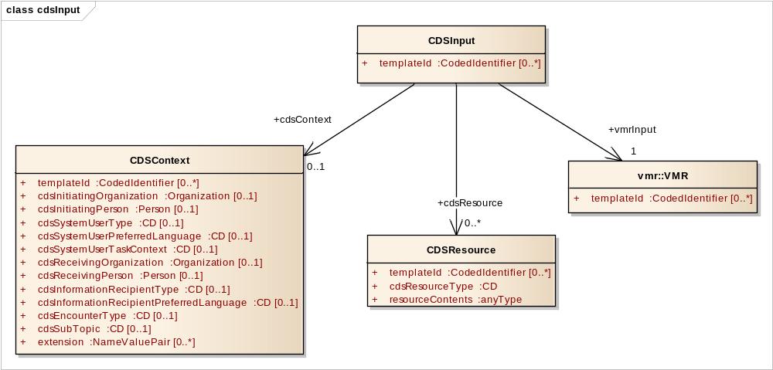
Figure: 21

CDSContext
Type: Class
Package: cdsInput

The situation or context within which a CDS evaluation is made. Included in CDS inputs for HL7 Context-Aware Knowledge Retrieval (Infobutton) Knowledge Request standard. Used, for example, to generate human-readable care guidance in the end-user's preferred language.

Attributes
Attribute | Notes
templateId  CodedIdentifier [0..*] | The identifier of a set of constraints placed on the CDS context. If there are multiple templates specified for the element, then the element must satisfy ALL constraints defined in ANY template at that level.
cdsInitiatingOrganization  Organization [0..1] | Organization that initiated the CDS request.
cdsInitiatingPerson  Person [0..1] | Person in the initiating organization who initiated the CDS request.
cdsSystemUserType  CD [0..1] | The type of individual using the CDS system. E.g., patient, healthcare provider, or specific type of healthcare provider (physician, nurse, etc.).
cdsSystemUserPreferredLanguage  CD [0..1] | Preferred language of the person who is using the system. Used, for example, to indicate the language in which the user interface should be rendered. E.g., English, Spanish.
cdsSystemUserTaskContext  CD [0..1] | The task that a CDS system user is performing. E.g., laboratory results review, medication list review. Can be used to tailor CDS outputs, such as recommended information resources.
cdsReceivingOrganization  Organization [0..1] | Organization that the response will be directed towards.
cdsReceivingPerson  Person [0..1] | Person in the receiving organization that the response will be directed towards.
cdsInformationRecipientType  CD [0..1] | The type of individual who consumes the CDS content. May be different from CDS system user type (e.g., if clinician is getting disease management guidance for provision to a patient). E.g., patient, healthcare provider, or specific type of healthcare provider (physician, nurse, etc.).
cdsInformationRecipientPreferredLanguage  CD [0..1] | Preferred language of the person who will consume the CDS content. Used, for example, to indicate the language in which the content should be written. E.g., English, Spanish.
cdsEncounterType  CD [0..1] | The type of patient encounter (e.g., inpatient, outpatient) in which the knowledge request takes place. Encounter type (Value set: ActEncounterCode [2.16.840.1.113883.1.11.13955])
cdsSubTopic  CD [0..1] | Narrows down the knowledge request by specifying a subdomain of interest (e.g., indications, contraindications, dose).
extension  NameValuePair [0..*] | Section for user-defined CDSContext attributes.

CDSInput
Type: Class
Package: cdsInput

The parent class containing the data used by a CDS system to generate inferences. Includes an input vMR and optionally CDS context and/or CDS resource data.

As a specific example, a CDSInput may be used as the primary input data payload for a CDS guidance service compliant with the HL7 Decision Support Service standard. Further information regarding this type of use case can be found in the HL7 Decision Support Service specification and the HL7 Decision Support Service Implementation Guide.

Attributes
Attribute | Notes
templateId  CodedIdentifier [0..*] | The identifier of a set of constraints placed on a CDS input. If there are multiple templates specified for the element, then the element must satisfy ALL constraints defined in ANY template at that level.

CDSResource
Type: Class
Package: cdsInput

A resource independent of individual patients, provided to a CDS engine to facilitate patient evaluation. Includes, for example, local antibiogram data (local susceptibility profile of microbes to different antimicrobial agents), local formulary restrictions, or CDS system user preference on which guidelines to use for health maintenance (e.g., HEDIS vs. USPSTF).

Attributes
Attribute | Notes
templateId  CodedIdentifier [0..*] | The identifier of a set of constraints placed on a CDS resource. If there are multiple templates specified for the element, then the element must satisfy ALL constraints defined in ANY template at that level.
cdsResourceType  CD | The type of CDS resource, as defined by a coded taxonomy. A resource independent of individual patients, provided to a CDS engine to facilitate patient evaluation. E.g., local antibiogram, local formulary restrictions, CDS system user preference on which guidelines to use for health maintenance (e.g., HEDIS vs. USPSTF). The specified data structure used to convey the related resourceContents must be identifiable from the cdsResourceType.
resourceContents  anyType | The data structure of the resource depends on the CDS resource type. E.g., local antibiogram data, local formulary restrictions, CDS system user preference on which guidelines to use for health maintenance (e.g., HEDIS vs. USPSTF).

cdsInputSpecification
Type: Package «XSDschema»
Package: modelParent

Specifies the specific CDS input data required for a specific CDS use case.

cdsInputSpecification - (Class diagram)
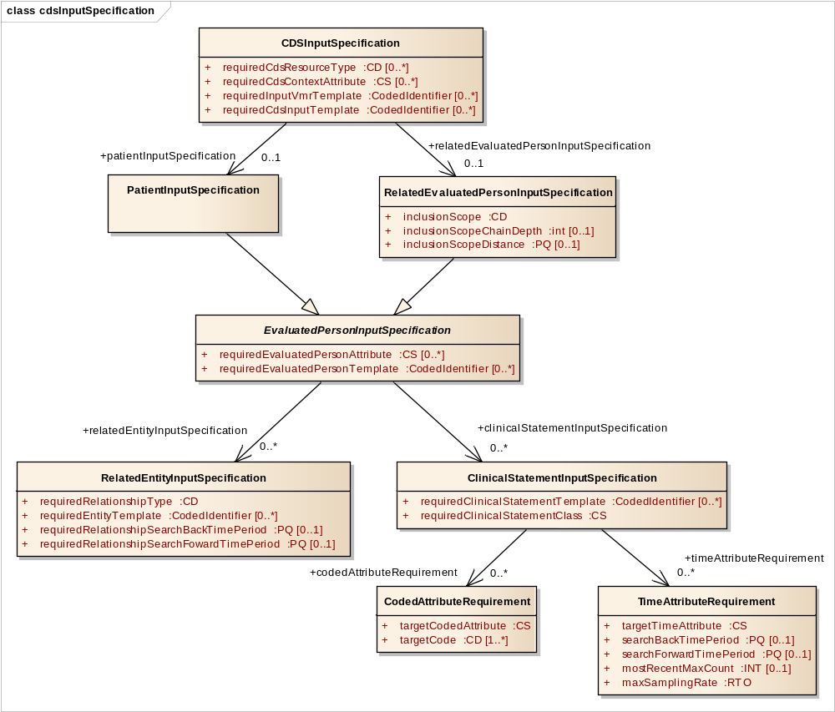
Figure: 22

CDSInputSpecification
Type: Class
Package: cdsInputSpecification

The parent class containing the data required by a specific CDS use case. For example, this class can be used to specify that the evaluation of a patient for the need for a mammogram requires the following data: (i) gender; (ii) age; (iii) past mastectomy history; and (iv) past mammogram history.

Can include a detailed input specification for the focal patient as well as for related evaluated persons. Note that it is assumed that the superset of data required for related evaluated persons are the same for each of the related evaluated persons (e.g., relatives). If input specifications are not provided regarding patients or other evaluated persons, then this signifies that no further constraints are being placed on required data other than what is expressed through the input data model and its existing template(s).

As a specific example, a CDSInputSpecification may be used to specify required CDS input by a CDS guidance service compliant with the HL7 Decision Support Service standard. Specifically, this type of specification can be encapsulated within the “query” section of a Decision Support Service’s specification of knowledge module data requirements. Further information regarding this type of use case can be found in the HL7 Decision Support Service specification and the HL7 Decision Support Service Implementation Guide.

Attributes
Attribute | Notes
requiredCdsResourceType  CD [0..*] | The type of CDS resource required. Required input parameters (e.g., mammogram testing frequency) can be specified using this attribute (e.g., with a CD representing mammogram testing frequency).
requiredCdsContextAttribute  CS [0..*] | The CDS context attribute (e.g., CDS system user preferred language) required.
requiredInputVmrTemplate  CodedIdentifier [0..*] | Identifier of a set of constraints that must be placed on the CDS input.
requiredCdsInputTemplate  CodedIdentifier [0..*] | Identifier of a set of constraints that must be placed on the input vMR.

ClinicalStatementInputSpecification
Type: Class
Package: cdsInputSpecification

Specifies the clinical statements required regarding the evaluated person of interest. Can include CodedAttributeRequirements and TimeAttributeRequirements.

If no CodedAttributeRequirement specified, all relevant clinical statements are required regardless of their coded attributes. If no TimeAttributeRequirement specified, all relevant clinical statements are required regardless of their time attributes. All specified CodedAttributeRequirements and TimeAttributeRequirements should be fulfilled in provided ClinicalStatements.

Attributes
Attribute | Notes
requiredClinicalStatementTemplate  CodedIdentifier [0..*] | Identifier of a set of constraints that must be placed on the ClinicalStatement. Allows, for example, the specification of required detailed clinical models that correspond to templates.
requiredClinicalStatementClass  CS | The specific leaf-level class of clinical statement required. E.g., ProcedureOrder,  ObservationResult.

CodedAttributeRequirement
Type: Class
Package: cdsInputSpecification

A requirement for a coded attribute of a clinical statement. Specified in terms of the target coded attribute and the code(s) for that attribute that allow the requirement to be fulfilled.

Attributes
Attribute | Notes
targetCodedAttribute  CS | The coded attribute subject to restriction. If the coded attribute is a direct attribute of the clinical statement, represented using the name of the coded attribute. E.g., problemCode, problemStatus. If the coded attribute resides within a class nested within the clinical statement, represented as [containing class attribute name].[coded attribute name]. E.g., affectedBodySite.bodySiteCode, substance.substanceCode.
targetCode  CD [1..*] | A target code for the target coded attribute. If a clinical statement has a target coded attribute (e.g., problem code) that matches one of the target codes (e.g., ICD9CM 250.00), then the coded attribute requirement is met.

EvaluatedPersonInputSpecification
Type: Class
Package: cdsInputSpecification

Specifies the data required for an evaluated person. Can include (i) a specification of the person attributes (e.g., gender) required; (ii) a specification of the templates that must be applied; (iii) a specification of the data required for related entities; and (iv) a specification of the clinical statements required.

Attributes
Attribute | Notes
requiredEvaluatedPersonAttribute  CS [0..*] | Required attribute of the EvaluatedPerson. Note that if an attribute is required by a specified template, it must be provided regardless of whether its need is specified here.
requiredEvaluatedPersonTemplate  CodedIdentifier [0..*] | Identifier of a set of constraints that must be placed on the EvaluatedPerson.

PatientInputSpecification
Type: Class EvaluatedPersonInputSpecification
Package: cdsInputSpecification

The data required for the patient. Is a specialization of the EvaluatedPersonInputSpecification class.

RelatedEntityInputSpecification
Type: Class
Package: cdsInputSpecification

Specifies the data required regarding entities related to the evaluated person of interest.

Attributes
Attribute | Notes
requiredRelationshipType  CD | Required type of relationship to Entities other than EvaluatedPersons, if available. Note that requirements for other EvaluatedPersons are specified separately within the RelatedEvaluatedPersonInputSpecification class. E.g., primary care provider, health insurance provider.
requiredEntityTemplate  CodedIdentifier [0..*] | Identifier of a set of constraints that must be placed on the related Entity.
requiredRelationshipSearchBackTimePeriod  PQ [0..1] | This requirement is met if the relationship time interval overlaps with the time interval that starts at (index evaluation time - requiredRelationshipSearchBackTimePeriod) and ends at (index evaluation time). The earlier point is considered to be exclusive and the ending point is considered to be inclusive. E.g., if the index evaluation time is 7/1/2011 at 4pm and the requiredRelationshipSearchBackTimePeriod is 1 year, then this requirement is met if the relationshipTimeInterval overlaps with any time after 4pm on 7/1/2010 and up to and including 7/1/2011 at 4pm.
requiredRelationshipSearchFowardTimePeriod  PQ [0..1] | This requirement is met if the relationship time interval overlaps with the time interval that starts at (index evaluation time) and ends at (index evaluation time + requiredRelationshipSearchForwardTimePeriod). The earlier point is considered to be exclusive and the ending point is considered to be inclusive. E.g., if the index evaluation time is 7/1/2011 at 4pm and the requiredRelationshipSearchForwardTimePeriod is 1 year, then this requirement is met if the relationshipTimeInterval overlaps with any time after 4pm on 7/1/2011 and up to and including 7/1/2012 at 4pm.

RelatedEvaluatedPersonInputSpecification
Type: Class EvaluatedPersonInputSpecification
Package: cdsInputSpecification

The data required for evaluated persons related to the patient. Is a specialization of the EvaluatedPersonInputSpecification class. Includes a specification of the scope of evaluated persons that are required.

Attributes
Attribute | Notes
inclusionScope  CD | The scope of evaluated persons to include. E.g., relative, sexual contacts, persons living in affected geographic zone.
inclusionScopeChainDepth  int [0..1] | The number of links to traverse to identify evaluated persons within the specific scope. E.g., 3 in combination with scope of relative would indicate up to 3rd degree relatives. If neither inclusionScopeChainDepth nor inclusionScopeDistance are specified, then all available evaluated persons with the indicated scope should be included. E.g., if inclusion scope is sexual contact and no scope depth/distance is specified, then all sexual contacts of the focal person and of other persons related through sexual contact should be included.
inclusionScopeDistance  PQ [0..1] | The distance to traverse to identify evaluated persons within the specific scope. E.g., 5 miles in combination with scope of living in affected area would indicate people living within a 5 mile radius of a location of interest. If neither inclusionScopeChainDepth nor inclusionScopeDistance are specified, then all available evaluated persons with the indicated scope should be included. E.g., if inclusion scope is sexual contact and no scope depth/distance is specified, then all sexual contacts of the focal person and of other persons related through sexual contact should be included.

TimeAttributeRequirement
Type: Class
Package: cdsInputSpecification

A requirement for a time attribute of a clinical statement. Specified in terms of the target time attribute and the required time interval for that attribute in relationship to the index evaluation time. A searchBackTimePeriod and/or a searchForwardTimePeriod must be provided.

Attributes
Attribute | Notes
targetTimeAttribute  CS | The time attribute targeted for restriction. E.g., procedure time, substance dispensation time.
searchBackTimePeriod  PQ [0..1] | The time attribute requirement is met if the target time attribute overlaps with the time interval that starts at (index evaluation time - searchBackTimePeriod) and ends at (index evaluation time). The earlier point is considered to be exclusive and the ending point is considered to be inclusive. E.g., if the index evaluation time is 7/1/2011 at 4pm and the searchBackTimePeriod is 1 year, then the time attribute requirement is met if the targetTimeAttribute has overlaps with anytime after 4pm on 7/1/2010 and up to and including 7/1/2011 at 4pm.
searchForwardTimePeriod  PQ [0..1] | The time attribute requirement is met if the target time attribute overlaps with the time interval that starts at (index evaluation time) and ends at (index evaluation time + searchForwardTimePeriod). The earlier point is considered to be exclusive and the ending point is considered to be inclusive. E.g., if the index evaluation time is 7/1/2011 at 4pm and the searchForwardTimePeriod is 1 year, then the time attribute requirement is met if the targetTimeAttribute has overlaps with anytime after 4pm on 7/1/2011 and up to and including 7/1/2012 at 4pm.
mostRecentMaxCount  INT [0..1] | The maximum number of most recent clinical statements to return.
maxSamplingRate  RTO | In the case where there are large number of available clinical statements, it may be useful to specify a sampling rate to reduce the number to be evaluated. For example, when there have been large numbers of vital signs taken by automated equipment, it may be useful to evaluate a subset of the entire group.

cdsOutput
Type: Package «XSDschema»
Package: modelParent

Specifies output data generated by CDS systems.

cdsOutput - (Class diagram)
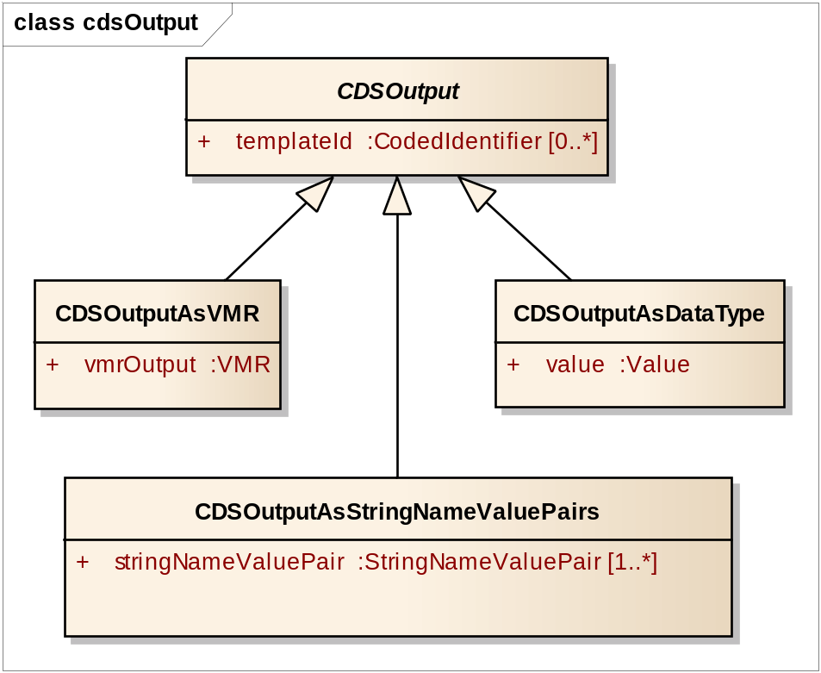
Figure: 23

CDSOutput
Type: Class
Package: cdsOutput

The parent class containing the data used by a CDS system to communicate inferences. Can use the vMR data structure or a base data type to communicate the results.

As a specific example, a CDSOutput may be used as the primary output data payload for a CDS guidance service compliant with the HL7 Decision Support Service standard. Further information regarding this type of use case can be found in the HL7 Decision Support Service specification and the HL7 Decision Support Service Implementation Guide.

Attributes
Attribute | Notes
templateId  CodedIdentifier [0..*] | The identifier of a set of constraints placed on a CDS output. If there are multiple templates specified for the element, then the element must satisfy ALL constraints defined in ANY template at that level.

CDSOutputAsDataType
Type: Class CDSOutput
Package: cdsOutput

A single data element of ANY data type as output of CDS.

Attributes
Attribute | Notes
value  Value | The value of the CDS output.

CDSOutputAsStringNameValuePairs
Type: Class CDSOutput
Package: cdsOutput

A set of string name value pairs to communicate the results.

Attributes
Attribute | Notes
stringNameValuePair  StringNameValuePair [1..*] | A pair of strings used to communicate an output result from CDS

CDSOutputAsVMR
Type: Class CDSOutput
Package: cdsOutput

A vMR data structure used to communicate the results.

Attributes
Attribute | Notes
vmrOutput  VMR | Output from CDS structured as a VMR record

cdsOutputSpecification
Type: Package «XSDschema»
Package: modelParent

Specifies the specific CDS output data produced for a specific CDS use case.

cdsOutputSpecification - (Class diagram)
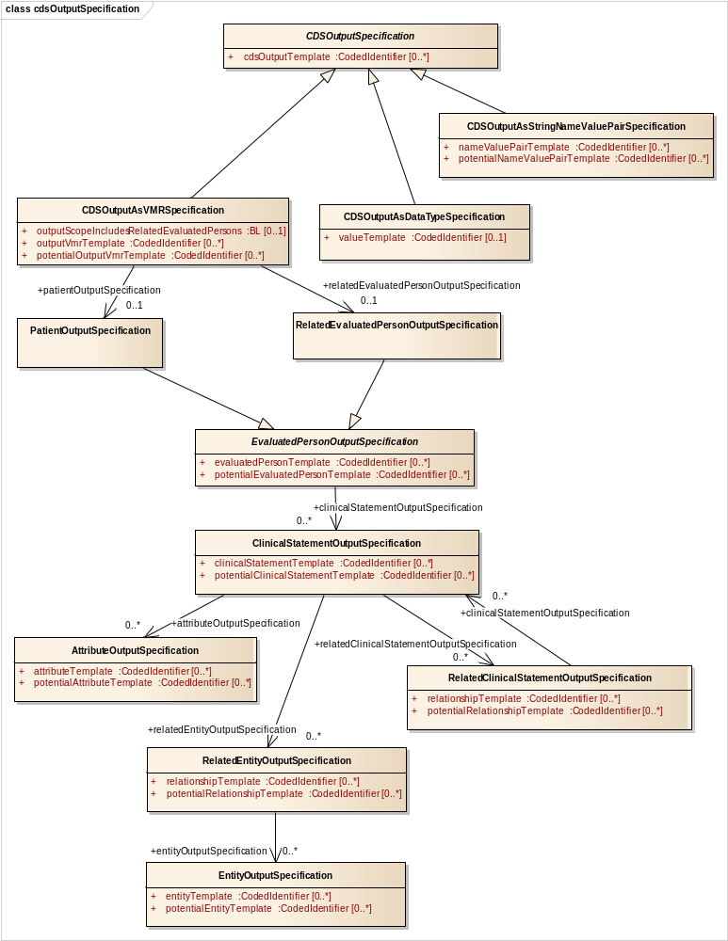
Figure: 24

AttributeOutputSpecification
Type: Class
Package: cdsOutputSpecification

Specifies the attributes contained in the source clinical statement regarding the evaluated person of interest.

Attributes
Attribute | Notes
attributeTemplate  CodedIdentifier [0..*] | Identifier of constrained attribute that SHALL be provided as a part of the parent clinical statement.
potentialAttributeTemplate  CodedIdentifier [0..*] | Identifier of constrained attribute that MAY be provided as a part of the parent clinical statement.

CDSOutputAsDataTypeSpecification
Type: Class CDSOutputSpecification
Package: cdsOutputSpecification

The parent class specifying the data type output to be provided by a specific CDS use case.

Attributes
Attribute | Notes
valueTemplate  CodedIdentifier [0..1] | Identifier of a set of constraints that SHALL be placed on the output value.

CDSOutputAsStringNameValuePairSpecification
Type: Class CDSOutputSpecification
Package: cdsOutputSpecification

The parent class specifying the string name value pair output to be provided by a specific CDS use case.

Attributes
Attribute | Notes
nameValuePairTemplate  CodedIdentifier [0..*] | Identifier of a set of constraints that SHALL be placed on the string name value pair.
potentialNameValuePairTemplate  CodedIdentifier [0..*] | Identifier of a set of constraints that MAY be placed on the string name value pair.

CDSOutputAsVMRSpecification
Type: Class CDSOutputSpecification
Package: cdsOutputSpecification

The parent class specifying the vMR output to be provided by a specific CDS use case. For example, this class can be used to specify that the evaluation of a patient for the need for a mammogram will return a templated observation specifying whether the intervention is needed, and a templated observation specifying when the intervention was last done.

Can include a detailed output specification for the focal patient as well as for related evaluated persons. Note that it is assumed that the superset of results returned for related evaluated persons are the same for each of the related evaluated persons (e.g., relatives). If output specifications are not provided regarding patients or other evaluated persons, then this signifies that no further constraints are being placed on returned results other than what is expressed through the output data model and its existing template(s).

Attributes
Attribute | Notes
outputScopeIncludesRelatedEvaluatedPersons  BL [0..1] | Specifies whether the scope of the output potentially includes related evaluated persons (e.g., family members). If not specified, the default expected behavior is that related evaluated persons will not be included within the scope.
outputVmrTemplate  CodedIdentifier [0..*] | Identifier of a set of constraints that SHALL be placed on the output vMR.
potentialOutputVmrTemplate  CodedIdentifier [0..*] | Identifier of a set of constraints that MAY be placed on the output vMR.

CDSOutputSpecification
Type: Class
Package: cdsOutputSpecification

Abstract base class specifying the output to be provided by a specific CDS use case.

As a specific example, a CDSOutputSpecification may be used to specify details on the CDS output that will be returned by a CDS guidance service compliant with the HL7 Decision Support Service standard. Specifically, this type of specification can be encapsulated within the “CDS output specification” section of a Decision Support Service’s specification of knowledge module evaluation result semantics. Further information regarding this type of use case can be found in the HL7 Decision Support Service specification and the HL7 Decision Support Service Implementation Guide.

Attributes
Attribute | Notes
cdsOutputTemplate  CodedIdentifier [0..*] | Template to identify the output structure and specifications.

ClinicalStatementOutputSpecification
Type: Class
Package: cdsOutputSpecification

Specifies the output clinical statements regarding the evaluated person of interest.

Attributes
Attribute | Notes
clinicalStatementTemplate  CodedIdentifier [0..*] | Identifier of constrained clinical statement that SHALL be provided as a part of the evaluation result.
potentialClinicalStatementTemplate  CodedIdentifier [0..*] | Identifier of constrained clinical statement that MAY be provided as a part of the evaluation result.

EntityOutputSpecification
Type: Class
Package: cdsOutputSpecification

Specifies the entities to be provided as a part of the output.

Attributes
Attribute | Notes
entityTemplate  CodedIdentifier [0..*] | Identifier of constrained entity that SHALL be provided as a part of the entity relationship.
potentialEntityTemplate  CodedIdentifier [0..*] | Identifier of constrained entity that MAY be provided as a part of the entity relationship.

EvaluatedPersonOutputSpecification
Type: Class
Package: cdsOutputSpecification

Specifies the evaluation results to be provided for an evaluated person. Specifies the templates that SHALL or MAY be applied.

Attributes
Attribute | Notes
evaluatedPersonTemplate  CodedIdentifier [0..*] | Identifier of a set of constraints that SHALL be placed on the EvaluatedPerson.
potentialEvaluatedPersonTemplate  CodedIdentifier [0..*] | Identifier of a set of constraints that MAY be placed on the EvaluatedPerson.

PatientOutputSpecification
Type: Class EvaluatedPersonOutputSpecification
Package: cdsOutputSpecification

The evaluation results to be returned for the patient. Is a specialization of the EvaluatedPersonOutputSpecification class.

RelatedClinicalStatementOutputSpecification
Type: Class
Package: cdsOutputSpecification

Specifies the clinical statements related to the source clinical statement regarding the evaluated person of interest.

Attributes
Attribute | Notes
relationshipTemplate  CodedIdentifier [0..*] | Identifier of constrained clinical statement relationship that SHALL be provided as a part of the parent clinical statement.
potentialRelationshipTemplate  CodedIdentifier [0..*] | Identifier of constrained clinical statement relationship that MAY be provided as a part of the parent clinical statement.

RelatedEntityOutputSpecification
Type: Class
Package: cdsOutputSpecification

Specifies the entities related to the source clinical statement regarding the evaluated person of interest.

Attributes
Attribute | Notes
relationshipTemplate  CodedIdentifier [0..*] | Identifier of constrained entity relationship that SHALL be provided as a part of the parent clinical statement.
potentialRelationshipTemplate  CodedIdentifier [0..*] | Identifier of constrained entity relationship that MAY be provided as a part of the parent clinical statement.

RelatedEvaluatedPersonOutputSpecification
Type: Class EvaluatedPersonOutputSpecification
Package: cdsOutputSpecification

The results that will be provided for evaluated persons related to the patient. Is a specialization of the EvaluatedPersonOutputSpecification class.

1 Osheroff et al., Improving Outcomes with Clinical Decision Support: An Implementer's Guide, HIMSS, 2005.

