Task1

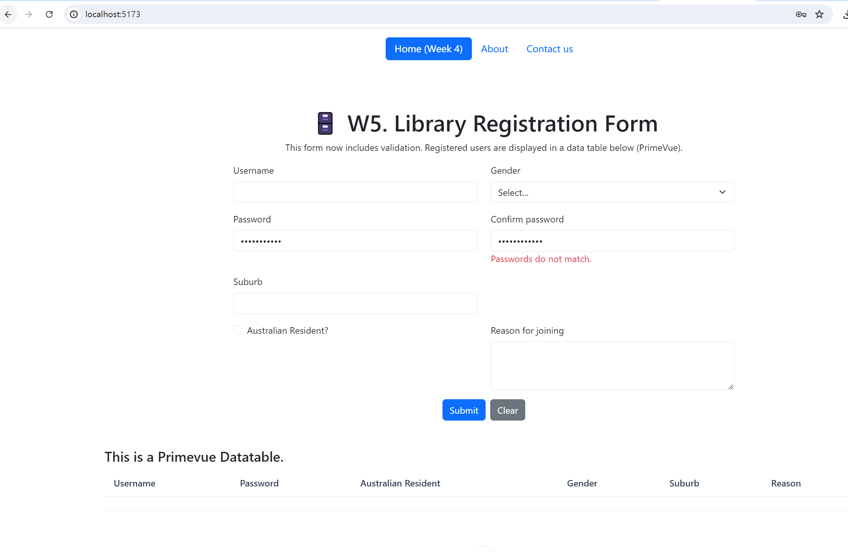

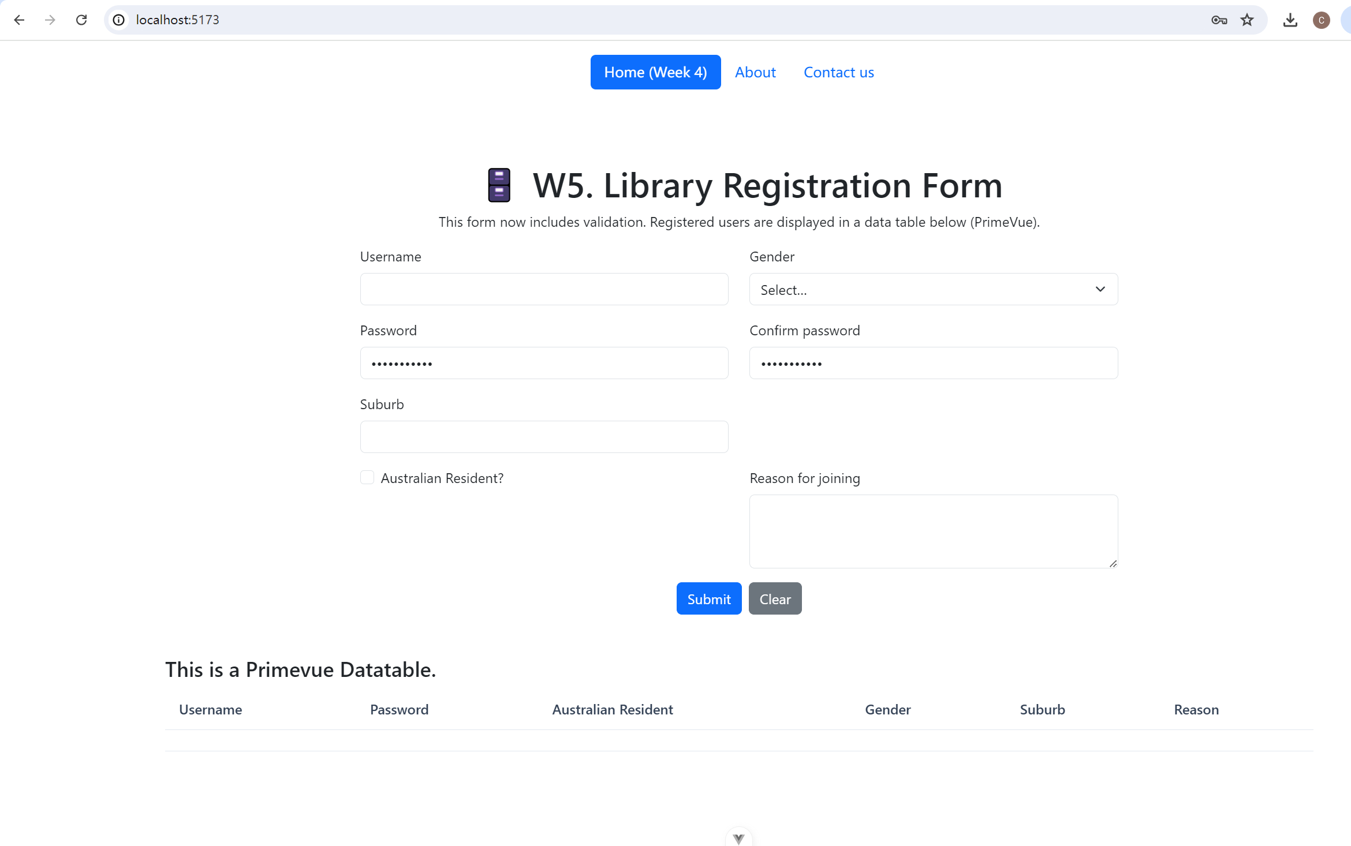

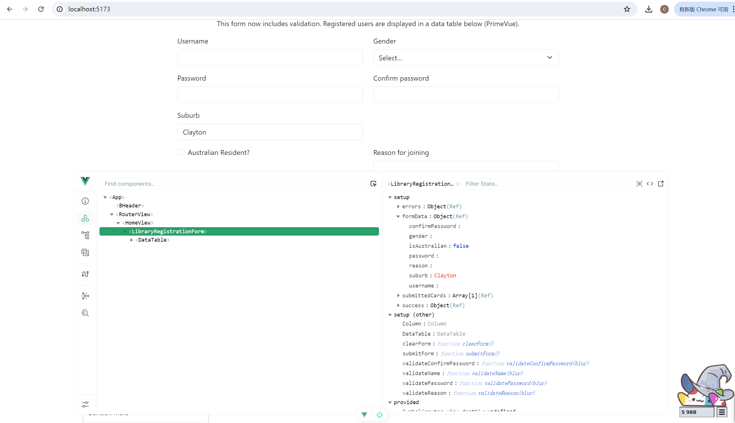

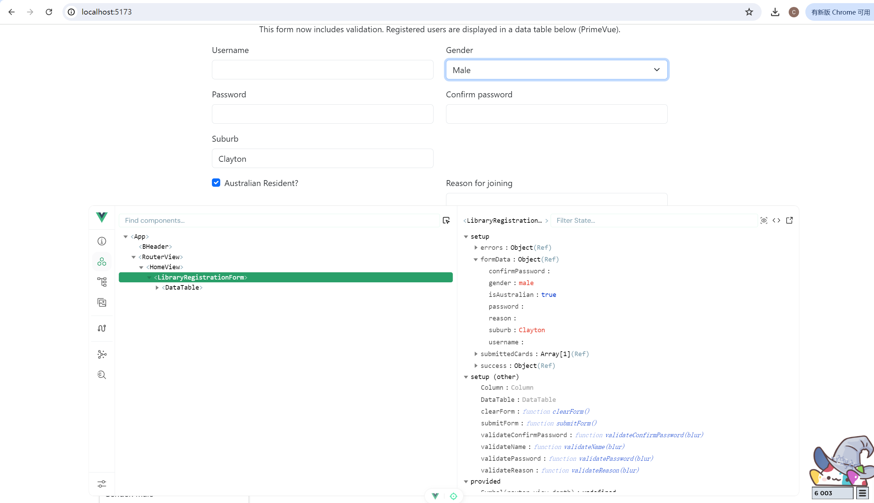

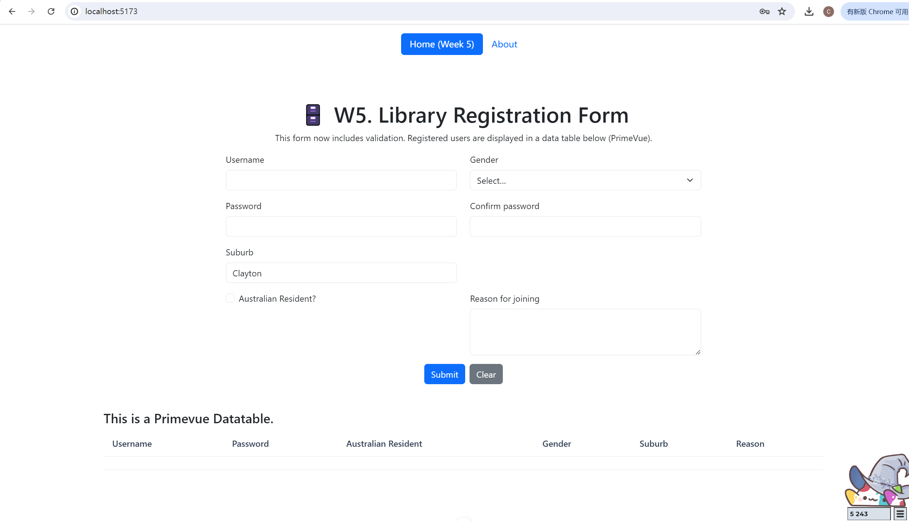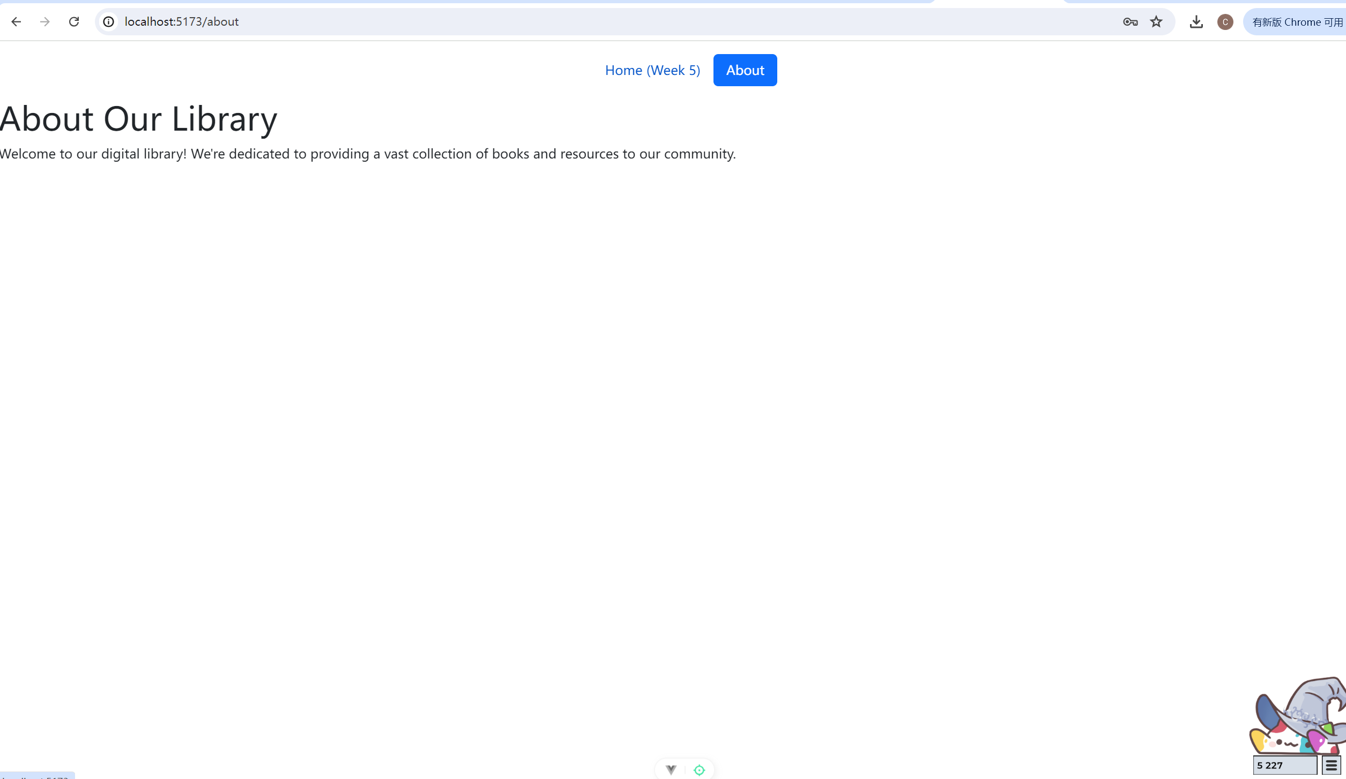

Task2

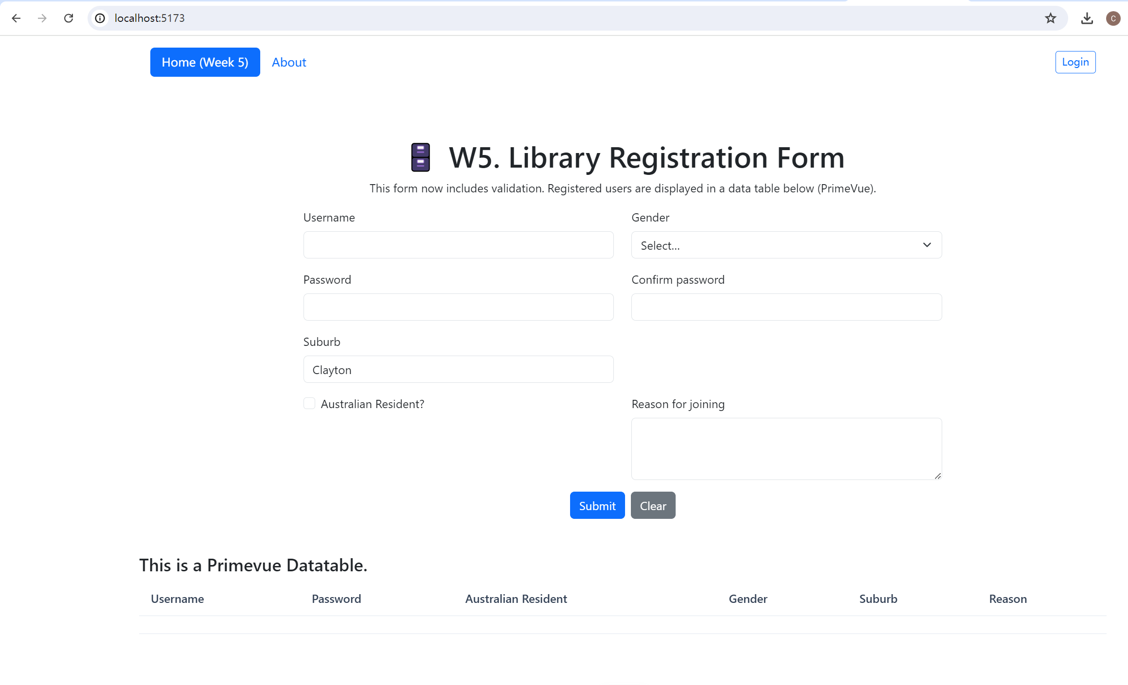

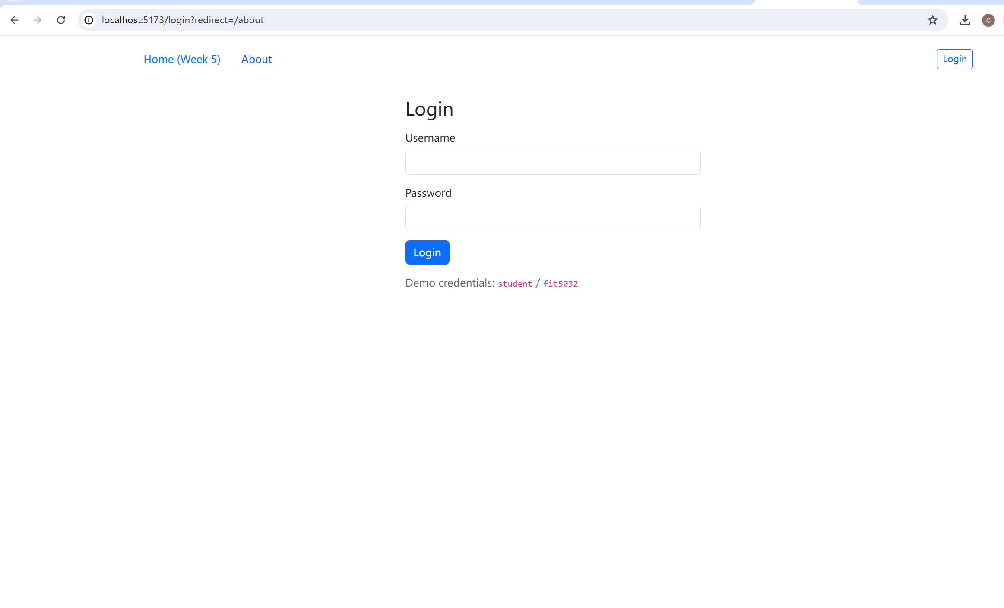

router/index.js

import { createRouter, createWebHistory } from 'vue-router'

import HomeView from '../views/HomeView.vue'

import AboutView from '../views/AboutView.vue'

import LoginView from '../views/LoginView.vue'

import { isAuthenticated } from '../stores/auth'

const router = createRouter({

history: createWebHistory(),

routes: [

{ path: '/', name: 'Home', component: HomeView },

// Protected page

{ path: '/about', name: 'About', component: AboutView, meta: { requiresAuth: true } },

// Auth routes

{ path: '/login', name: 'Login', component: LoginView },

// Fallback

{ path: '/:pathMatch(.\*)\*', redirect: '/' }

]

})

// Simple auth guard

router.beforeEach((to, from, next) => {

if (to.meta.requiresAuth && !isAuthenticated.value) {

// send user to login and remember where they wanted to go

next({ name: 'Login', query: { redirect: to.fullPath } })

} else {

next()

}

})

export default router

src/App.vue

<script setup>

import JSONLab from './components/JSONLab.vue'

import BHeader from './components/BHeader.vue'

import LibraryRegistrationForm from './components/LibraryRegistrationForm.vue'

</script>

<template>

<div class="main-container">

<header>

<BHeader />

</header>

<main class="main-box">

<router-view />

</main>

</div>

</template>

<style scoped>

/\* header {

line-height: 1.5;

}

.logo {

display: block;

margin: 0 auto 2rem;

}

@media (min-width: 1024px) {

header {

display: flex;

place-items: center;

padding-right: calc(var(--section-gap) / 2);

}

.logo {

margin: 0 2rem 0 0;

}

header .wrapper {

display: flex;

place-items: flex-start;

flex-wrap: wrap;

}

} \*/

</style>

src/views/HomeView.vue

<script setup>

import LibraryRegistrationForm from '../components/LibraryRegistrationForm.vue'

</script>

<template>

<LibraryRegistrationForm />

</template>