Sprint 2 Report, Slug’s Bus Schedule

T.E.A.M. : Riwen Mao, Joshua Palis, Cyrus Hyett, Calvin La

# Actions to stop doing

* No more surprise meeting, nobody can catch that.
* Use push --force on GitHub. It wipes out teammates’ commits

# Actions to start doing

* The team should push their changes more often, to be consistent with the continuous integration approach.
* Have a more consistent meeting schedule, so the team can make sure that everyone can attend.
* Reach teammates for help when facing troubles.

# Actions to keep doing

* The team should keep constant communication so that any issues that might affect the task completion can be taken into account and allow us to make changes.
* The team should continue to introduce new ideas to add to the application because it fosters creativity and teamwork.
* The team should keep supporting each other because it helps increase moral, productivity and promotes team bonding.

# Work completed/not completed

## Completed

* I am a user, and I want to see what routes I can take from my bus stop, so that I can choose which bus to take.
* I am a developer, and I want to know the user's location via GPS, so that I can find out the nearest bus stop.

## Not completed

* None

# Work completion rate

* Total number of user stories completed during the prior sprint.
  + 2 user stories
* Total number of estimated ideal work hours completed during the prior sprint.
  + 18 hr, includes both research and development
* Total number of days during the prior sprint.
  + 7 days
* For the previous sprint, the user stories/day and ideal work hours/day figures should be reported.
  + User stories per day: 1/3
  + Ideal work hours per day: 4 hr.
* average user stories/day and average ideal work hours/day figures computed across all sprints to date.
  + Average story/day: 5/12
  + Hours/day: 7 hr.

# Burnup chart

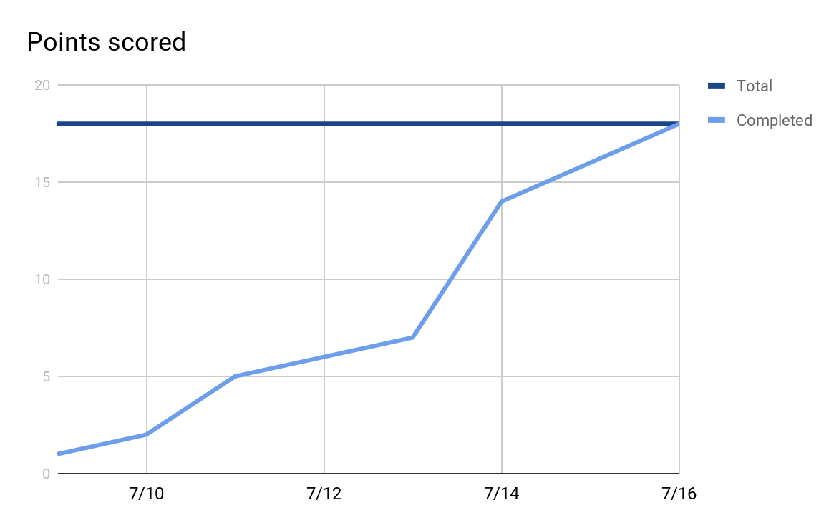

# Scrum board

|  |  |  |  |
| --- | --- | --- | --- |
| User Stories | Tasks not started | Tasks in progress | Tasks Done |
| Routes |  |  | Connect SQL Database to Azure Resource Group |
|  |  |  | Store all available UCSC bus line data we have from Google Maps into excel spreadsheet |
|  |  |  | Use Entity Framework to map Bus Line Data Object (SQL database entities) to the table and columns of our relational database |
|  |  |  | Create home controller to process SQL database entities |
|  |  |  | Through the entities, pass data from the SQL database through the controller and map to their corresponding ViewModel properties |
|  |  |  | Using Razor, display the VIewModel data for each property |
|  |  |  | Style the user interface with the Bootstrap Framework in order to make the web application responsive |
|  |  |  |  |
| Location GPS |  |  | Figure out the concept of acquiring user’s GPS information |
|  |  |  | Get the user’s GPS information. |
|  |  |  |  |
|  |  |  |  |
|  |  |  |  |