**Project Title: “Let’s Hang”**

**Team Members**

* George Awad
* Catherine Liu
* Omar Kaif

**Project Description**

Our application provides users the ability to locate specific meet up locations through a graphical API.

**Sketch of Final Product**

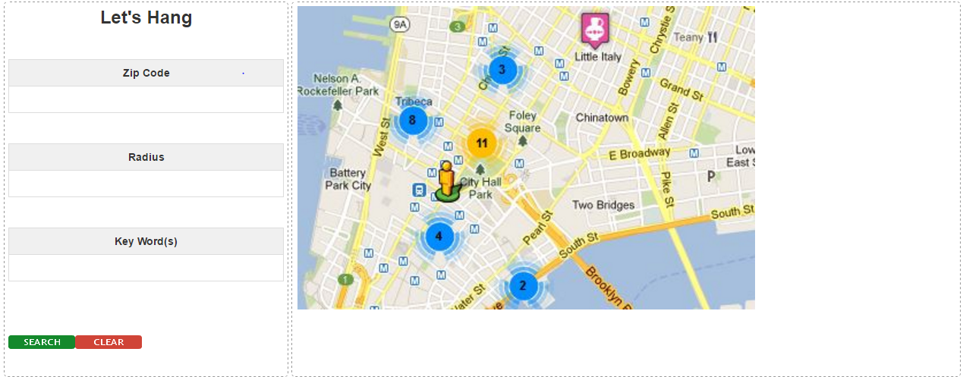

**APIs to be used**

Let’s Hang will leverage the Google Maps API (<https://developers.google.com/maps/>) to visually display hang out spots and the meetup API (<https://www.meetup.com/meetup_api/>) to query meet up locations.

**Rough Breakdown of Tasks (Front End)**

1. Create HTML page for end User
   1. Left side bar will contain a “Zip Code”, “Radius” and “Key Word(s)” field for users to search based on their preferences for the specific field(s) they interact with
   2. A section covering the remaining white space which will portray the visual map for users to see their hang out spots. We will also be using the “Snazzy Info Window” JavaScript plugin for our map markers.
   3. A “Search” button which, when clicked, will search for the criteria entered by the end user in the available fields.
   4. A “Clear” button which, when clicked, will clear any text entered by the end user in the available fields.

**Rough Breakdown of Tasks (Back End)**

1. User Input Validation
   1. Retrieve data from input fields on the front end
2. Convert Zip Code to Longitude/Latitude using Google Maps API
3. AJAX call to pick up both APIs
   1. Call APIs
   2. Pull response from APIs
   3. Display responses on end user’s map