The data distribution of the Python-Plot13 dataset:

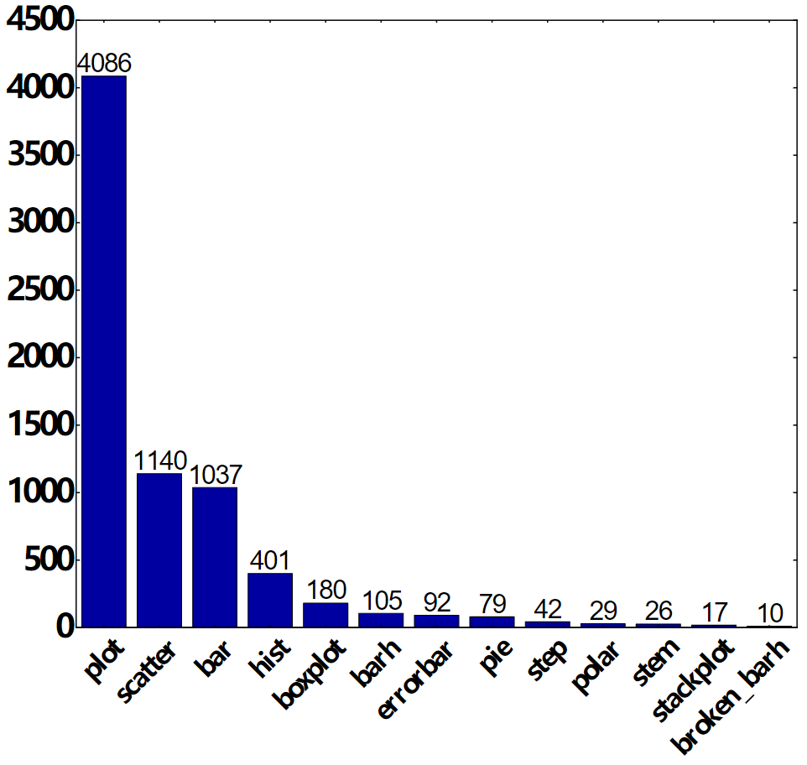

The data distribution of the R-Plot32 dataset:

