|  |
| --- |
| Central Queensland University, Sydney |
| Project Progress Report  Rotary Youth Drive Awareness Project |
| COIT20273: Software Design and Development Project |
|  |
| Lecturer/Tutor: Zakiullah Khan Course Coordinator: Dr. Lily Li |
| **Due date: 7/28/2017** |

Project Members:

Bijay Shahi (12021856)

Keshav Khadka (S0280624)

Pratik Shrestha (S0282733)

|  |  |  |  |
| --- | --- | --- | --- |
| **S.N.** | **Document Name** | **Version** | **Revision Date** |
| 1. | Project progress report | 1.0 | 2017-08-04 |

Table of Contents

1. Program Milestones 1

2. Schedule 2

3. Milestone breakdown and completion 3

4. Staffing 4

5. Effort 4

# 1. Program Milestones

|  |  |  |  |  |
| --- | --- | --- | --- | --- |
| **S.N.** | **Milestone** | **% Completion** | **Description** | **Week Completed** |
| 1 | Project plan submission | 100% | The requirement was analysed in detail. Also, hardware, software and human resources were identified and work break down structure was created. Furthermore, risk plan and quality plan were discussed. | 3rd Week |
| 2 | Progress report 1 submission | 100% | Progress until 4th Week has been listed. | 4th Week |
| 3 | Requirement specification submission | 0% |  |  |
| 4 | Progress report 2 submission | 0% |  |  |
| 5 | Design document submission | 0% |  |  |
| 6 | Progress report 3 submission | 0% |  |  |
| 7 | Progress report 4 submission | 0% |  |  |
| 8 | Implementation and testing document submission | 0% |  |  |
| 9 | Project review and project portfolio submission | 0% |  |  |

# 2. Schedule

|  |  |  |  |  |  |  |  |  |  |  |
| --- | --- | --- | --- | --- | --- | --- | --- | --- | --- | --- |
| **Scheduled Week for Milestone Completion** | | | | | | | | | |  |
| 4 | 5 | 6 | 7 | 8 | 9 | 10 | 11 | 12 |  | **Current Week** |
| 2 |  |  |  |  |  |  |  |  | 4 |
|  | 3 |  |  |  |  |  |  |  | 5 |
|  |  | 4 |  |  |  |  |  |  | 6 |
|  |  |  | 5 |  |  |  |  |  | 7 |
|  |  |  |  | 6 |  |  |  |  | 8 |
|  |  |  |  |  | 7 |  |  |  | 9 |
|  |  |  |  |  |  | 8 |  |  | 10 |
|  |  |  |  |  |  |  | 9 |  | 11 |
|  |  |  |  |  |  |  |  |  | 12 |

**Table 2. Schedule**

# 3. Milestone breakdown and completion

|  |  |  |  |  |  |  |
| --- | --- | --- | --- | --- | --- | --- |
| **Milestone – Project Plan Submission** | | | | | | |
| **Activity** | **Allocation** | | | **Implementation** | | |
| **Personnel** | **From** | **To** | **Personnel** | **Percentage Completed** | **Remarks** |
| Work Breakdown Structure and Schedule | **Keshav Khadka** | **26th July 2017** | **30th July 2017** | **Keshav Khadka** | **100%** |  |
| Identification of Hardware & Software, Feasibility Study | **Keshav Khadka** | **26th July 2017** | **30th July 2017** | **Bijay Shahi** | **100%** |  |
| Risk plan and Quality plan | **Keshav Khadka** | **26th July 2017** | **30th July 2017** | **Pratik Shrestha** | **100%** |  |
| **Milestone –** **Progress report 1 submission** | | | | | | |
| **Activity** | **Allocation** | | | **Implementation** | | |
| **Personnel** | **From** | **To** | **Personnel** | **Percentage Completed** | **Remarks** |
| Progress Report | **Keshav Khadka** | **2nd August 2017** | **4th August 2017** | **Pratik Shrestha** | **100%** |  |

**Table 3. Milestone breakdown and completion**

# 4. Staffing

|  |  |
| --- | --- |
| **Team members** | **Hours worked** |
| Bijay Shahi | 8 hours |
| Keshav Khadka | 10 hours |
| Pratik Shrestha | 8 hours |

# 5. Effort

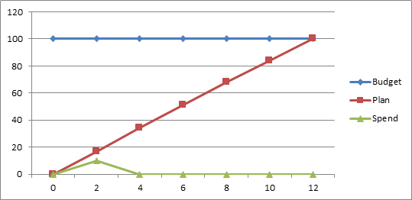

**Fig.1. Effort**