网站：
https://blog.csdn.net/qq_43518924/article/details/105314663
https://blog.csdn.net/m0_58368200/article/details/124534858
https://max.book118.com/html/2021/1108/6015213121004043.shtm
https://blog.csdn.net/weixin_46291251/article/details/118393058
https://www.docin.com/p-2157031223.html

1.
https://blog.csdn.net/qq_43518924/article/details/105314663
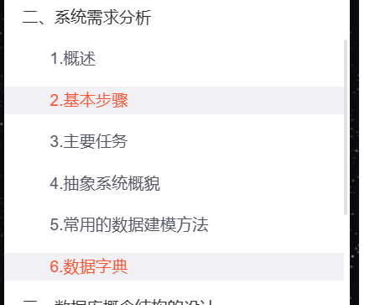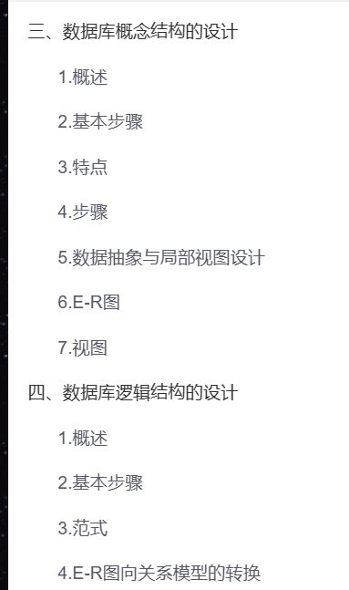
数据模型的优化
2.
https://max.book118.com/html/2021/1108/6015213121004043.shtm
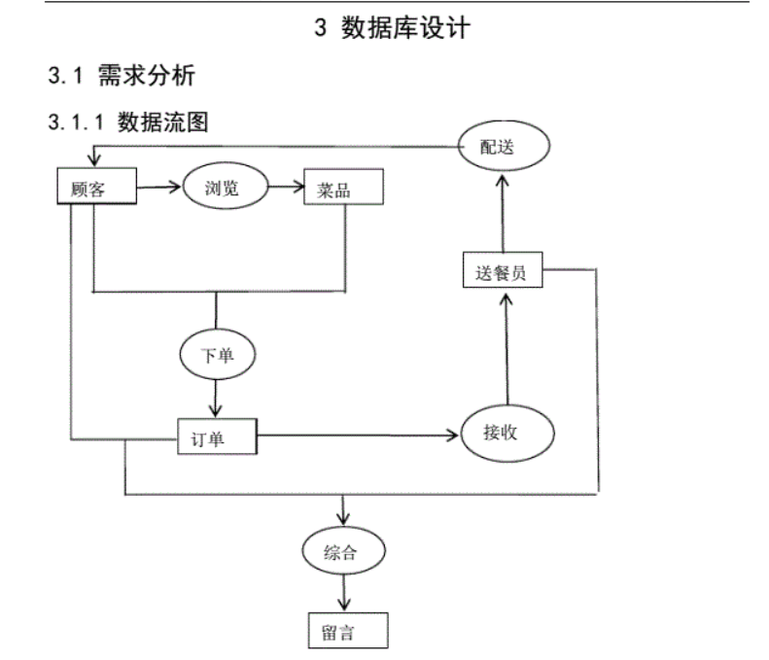
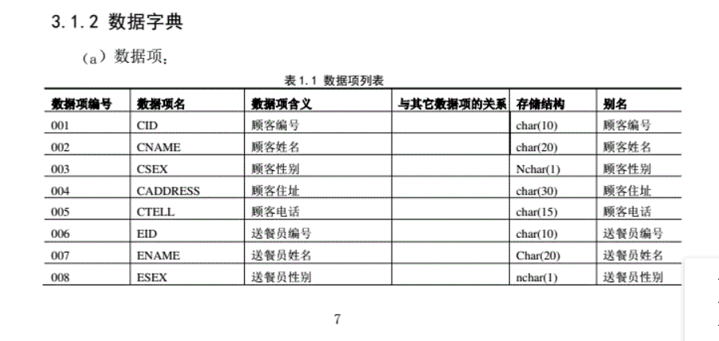
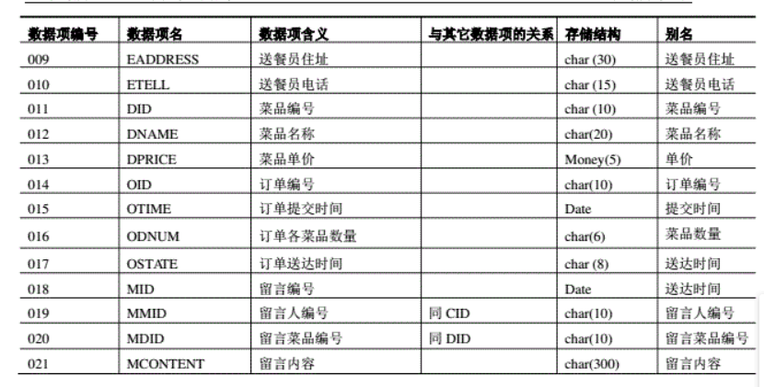
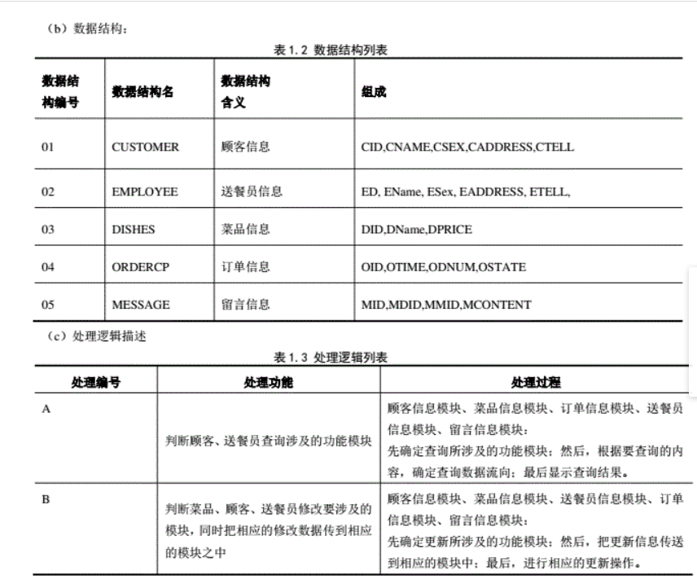
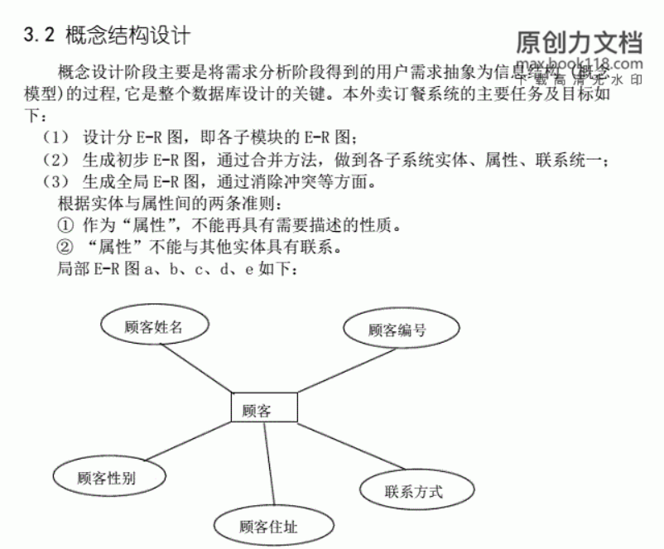
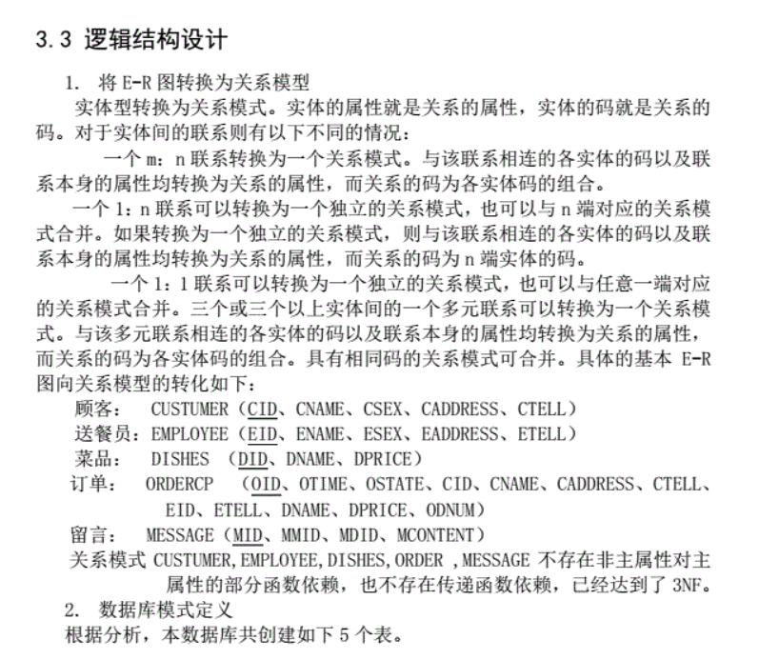
3.
https://blog.csdn.net/weixin_46291251/article/details/118393058

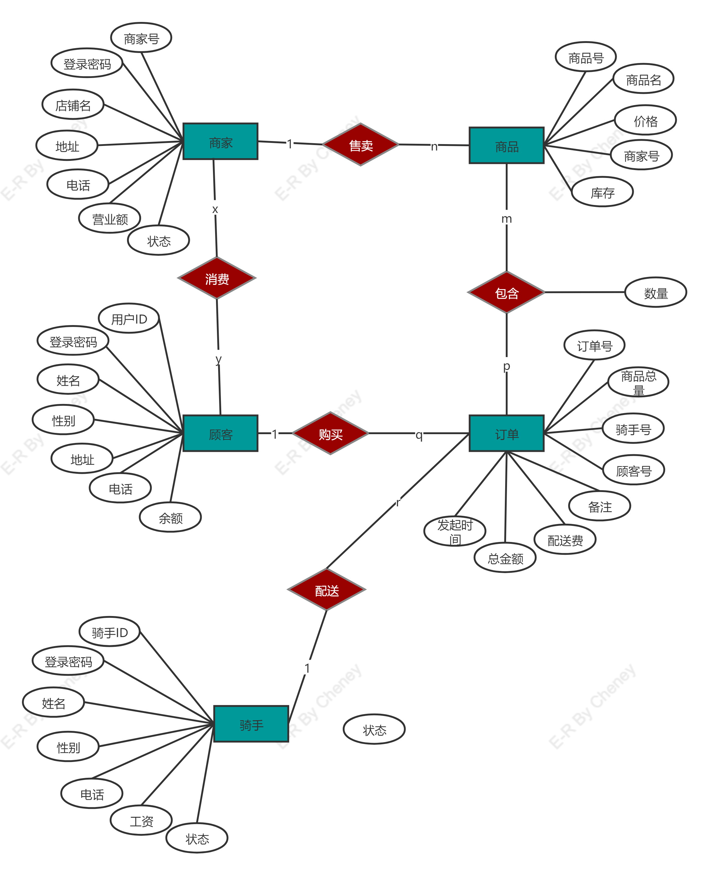
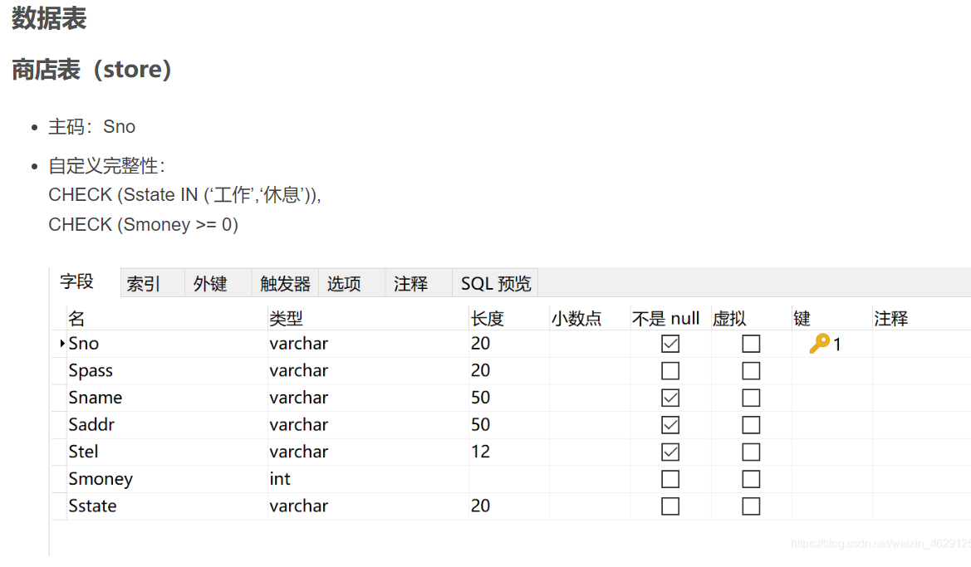
https://blog.csdn.net/m0_58368200/article/details/124534858
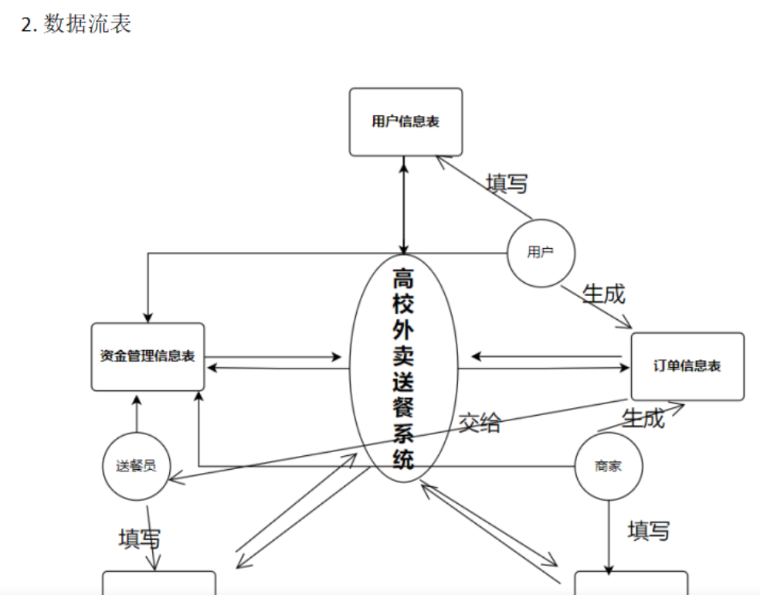
4.
忘记哪个网站了：
