《恶意代码分析》实验报告

年级、专业、班级 |  | 20级信息安全专业01班 |  |  | 姓名 | 蔡欣彤
实验题目 | 感染目标解析
实验时间 | 2023.5.14 |  | 实验地点 | DS3305
实验成绩 |  |  | 实验性质 | □验证性 □设计性 □综合性
教师评价：
□算法/实验过程正确； □源程序/实验内容提交 □程序结构/实验步骤合理；
□实验结果正确； □语法、语义正确； □报告规范；
其他：
评价教师签名：
一、实验目的
1. 验证感染目标搜索过程
2. 验证感染目标解析过程
3. 验证感染内容隐藏过程
二、实验项目内容
编程实现：
- 利用实验二的程序搜索FAT32文件系统下根目录里的.exe文件；
- 读取其中一个PE，解析并列举文件头中的AddressOfEntryPoint、ImageBase、SectionAlignment、FileAlignment、NumberOfSections；
- 解析并列举每个节的Name、VirtualSize、VirtualAddress、SizeOfRawData、PointerToRawData、Characteristics；
将该PE文件的.text节内容写入该文件系统下的隐藏扇区中。
三、实验过程或算法（源程序）
#include <windows.h>
#include <winioctl.h> //DDK驱动开发与控制
#include <stdio.h>
#include <math.h>
#include <stdlib.h>
#include <stdint.h>
#include<iostream>
using namespace std;

int main() {
// LPCWSTR path = "P:\\exp1.exe";

HANDLE hFile;
HANDLE hMapping;
LPVOID pMapping;
hFile = CreateFile("P:\\exp1.exe", GENERIC_READ, FILE_SHARE_READ, NULL, OPEN_EXISTING,
FILE_ATTRIBUTE_NORMAL, NULL);
if (INVALID_HANDLE_VALUE == hFile) {
return 0;
}
//将PE文件映射到内存
hMapping = CreateFileMapping(hFile, NULL, PAGE_READONLY, 0, 0, 0);
if (!hMapping) {
return 0;
}
pMapping = MapViewOfFile(hMapping, FILE_MAP_READ, 0, 0, 0);//返回的是map的开始地址
if (!pMapping) {
return 0;
}

PIMAGE_DOS_HEADER dosheader;
dosheader = (PIMAGE_DOS_HEADER)pMapping;
if (dosheader->e_magic != IMAGE_DOS_SIGNATURE) {
cout << "无效的PE文件" << endl;
return 0;
}

PIMAGE_NT_HEADERS nt_header;
nt_header = (PIMAGE_NT_HEADERS)((BYTE*)pMapping + dosheader->e_lfanew);
if (nt_header->Signature != IMAGE_NT_SIGNATURE) {
cout << "无效的PE文件" << endl;
return 0;
}

PIMAGE_SECTION_HEADER section_header;
section_header = IMAGE_FIRST_SECTION(nt_header);
for (int i = 0; i < nt_header->FileHeader.NumberOfSections;
i++, section_header++) {
cout << section_header->Name << "\t" << section_header->Misc.VirtualSize
<< "\t\t" << section_header->VirtualAddress << "\t\t" <<
section_header->SizeOfRawData << "\t\t"
<< section_header->PointerToRawData << "\t\t\t" << section_header->Characteristics << endl;
}

IMAGE_OPTIONAL_HEADER optional_header;
optional_header = nt_header->OptionalHeader;

cout << "AddressOfEntryPoint:\t" << optional_header.AddressOfEntryPoint << endl;
cout << "ImageBase:\t" << optional_header.ImageBase << endl;
cout << "SectionAlignment:\t" << optional_header.SectionAlignment << endl;
cout << "FileAlignment:\t" << optional_header.FileAlignment << endl;
cout << "NumberOfSections:\t" << nt_header->FileHeader.NumberOfSections << endl;

//AddressOfEntryPoint、ImageBase、
//SectionAlignment、FileAlignment、NumberOfSections

DWORD PointerToRawData = IMAGE_FIRST_SECTION(nt_header)->PointerToRawData;
DWORD SizeOfRawData = IMAGE_FIRST_SECTION(nt_header)->SizeOfRawData;
UINT8* textContent = new UINT8[SizeOfRawData];
memcpy(textContent, (UINT8*)pMapping + PointerToRawData, SizeOfRawData);
int flag = 0;
for (size_t i = 0; i < 1024; ++i)
{
unsigned char c = textContent[i]; // must use unsigned char to print >128 value
flag++;
if (c < 16)
printf("0%x ", c);
else
printf("%x ", c);
if ((flag) % 16 == 0)
printf("\n");
}

CloseHandle(hFile);

HANDLE hdrive;
hdrive = CreateFile(
TEXT("\\\\.\\PhysicalDrive1"), // 物理磁盘
GENERIC_READ | GENERIC_WRITE,
FILE_SHARE_READ | FILE_SHARE_WRITE, // 允许其他应用程序读写磁盘
NULL,
OPEN_EXISTING,
FILE_ATTRIBUTE_NORMAL,
NULL
);
if (CreateFile == INVALID_HANDLE_VALUE) {
// 处理打开磁盘失败的情况
cout << "test" << endl;
return -1;
}
OVERLAPPED overLap = { 0 };
overLap.Offset = 512;
DWORD writeByte;
DWORD readsize = 0;
LARGE_INTEGER offset;//long long signed
offset.QuadPart = (ULONGLONG)59336704 * (ULONGLONG)512;//0
SetFilePointer(hdrive, offset.LowPart, &offset.HighPart, FILE_BEGIN);
if (!WriteFile(hdrive, textContent, SizeOfRawData, &writeByte, &overLap)) {
cout << dec << "error code" << GetLastError() << endl;
}

// CloseHandle(hdrive);

}
四、实验结果及分析和（或）源程序调试过程
（1）利用实验二得到结果：
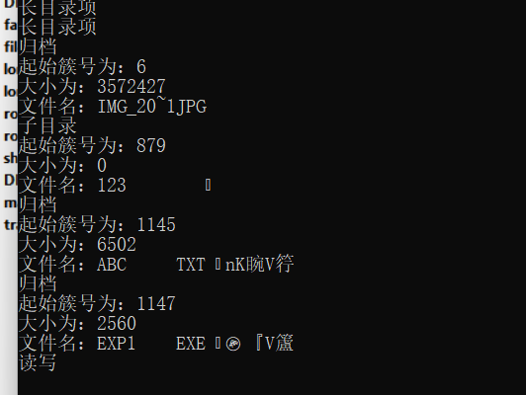
（2）（3）结果：
