When Less is More:
A Comparative Study of BART Adaptation Strategies for News Summarization
Full Fine-Tuning, BitFit, LoRA, and Training from Scratch
COMP7045 Natural Language Processing and Large Language Models
Mini-Project Report
Group Members:
Qilin WU - 25400533
Zeyu WANG - 25400770
Bojie XIANG - 25400444
April 2026

1. Abstract
Efficient adaptation of pre-trained language models under limited computational resources is a critical challenge in natural language processing (NLP) deployment. This project presents a systematic comparative study of four BART-base adaptation strategies for the task of abstractive news summarization: Full Fine-Tuning, BitFit (ultra-lightweight tuning of only bias and LayerNorm parameters), LoRA (Low-Rank Adaptation via low-rank matrix decomposition), and Training from Scratch (random initialization baseline).
Experiments were conducted on the CNN/DailyMail 3.0.0 dataset using a subset of 20,000 training samples, with evaluation performed using ROUGE metrics on an NVIDIA A100-SXM4-40GB GPU. All methods were trained under identical hyperparameter settings (learning rate: 2×10⁻⁴, 2 epochs, batch size 16) to ensure a fair comparison.
Our key findings are threefold. First, LoRA achieved competitive overall performance (ROUGE-1: 35.15, ROUGE-2: 14.27, ROUGE-L: 24.43) while updating only 2.48% of model parameters, with Full Fine-Tuning slightly leading on ROUGE-1 (35.46) and ROUGE-L (24.60). Second,BitFit reached approximately 92% of full fine-tuning quality (ROUGE-L: 22.59 vs. 24.60) with merely 0.09% trainable parameters (125,952 out of 139.4 million), demonstrating remarkable parameter efficiency. Third, training from scratch yielded dramatically lower results (ROUGE-1: 9.67, ROUGE-2: 1.00), quantifying the indispensable value of pre-trained knowledge for abstractive summarization.
These results demonstrate that parameter-efficient methods offer compelling trade-offs between performance and resource consumption, making them highly attractive for practical deployment of abstractive summarization systems under resource constraints.

2. Background Survey

2.1 Text Summarization
Text summarization is a fundamental NLP task that aims to produce a concise and fluent summary while preserving the key information content of the original document. Two primary paradigms exist in the literature. Extractive summarization methods select and compose the most salient sentences directly from the source text, treating summarization as a sentence selection problem. Abstractive summarization, on the other hand, generates novel text that may contain words and phrases not present in the original document, more closely mimicking the human summarization process.
While extractive methods are relatively straightforward and guarantee grammatical correctness (since extracted sentences originate from the source), they are limited by their inability to synthesize information across sentences or produce truly condensed paraphrases. Abstractive methods are more challenging due to the demands of natural language generation, semantic understanding, and maintaining factual consistency, but they produce more natural and coherent summaries. The development of deep neural networks and large-scale pre-trained language models has significantly advanced abstractive summarization in recent years.

2.2 Sequence-to-Sequence Models and Pre-trained Language Models
The evolution of neural text summarization has been driven by advances in sequence-to-sequence (seq2seq) architectures. The foundational work of Sutskever et al. [1] introduced the encoder-decoder framework using recurrent neural networks (RNNs), which was later enhanced by attention mechanisms that allow the decoder to selectively focus on relevant parts of the input sequence. The Transformer architecture [2] subsequently replaced RNNs with self-attention mechanisms, enabling parallel computation and better modeling of long-range dependencies.
The advent of pre-trained language models has further revolutionized the field. BERT [3] introduced bidirectional pre-training through masked language modeling, achieving state-of-the-art results on understanding tasks but was not designed for generation. GPT-2 [4] demonstrated strong generation capabilities through autoregressive pre-training on large corpora. T5 (Text-to-Text Transfer Transformer) [5] proposed a unified text-to-text framework that treats all NLP tasks as text generation problems. BART (Bidirectional and Auto-Regressive Transformers) [6] combined bidirectional encoding with autoregressive decoding through a denoising autoencoder pre-training objective, making it particularly effective for generation tasks such as text summarization.

2.3 BART Architecture
BART [6] employs a standard Transformer encoder-decoder architecture. During pre-training, input text is corrupted using multiple noise functions—token masking, sentence permutation, document rotation, token deletion, and text infilling—and the model is trained to reconstruct the original text. This denoising objective teaches the model to capture both bidirectional context (through the encoder) and autoregressive generation (through the decoder), making BART especially suitable for sequence-to-sequence tasks.
BART-base, the model used in this study, has approximately 139 million parameters with 6 encoder layers and 6 decoder layers, a hidden size of 768, 12 attention heads, and a feed-forward dimension of 3,072. The model was pre-trained on a large corpus combining news, books, and web text, providing rich linguistic knowledge that can be effectively transferred to downstream summarization tasks.

2.4 Parameter-Efficient Fine-Tuning
Full fine-tuning updates all model parameters during task adaptation, which is computationally expensive, requires significant GPU memory, and risks catastrophic forgetting of pre-trained knowledge. To address these limitations, several parameter-efficient fine-tuning (PEFT) methods have emerged:
BitFit (Bias-Term Fine-tuning) [7] freezes all model parameters except bias terms and LayerNorm parameters, requiring only approximately 0.1% of total parameters to be updated. The intuition is that bias terms capture task-specific distributional shifts while the bulk of pre-trained knowledge in weight matrices remains intact.
LoRA (Low-Rank Adaptation) [8] injects trainable low-rank decomposition matrices into the Transformer's attention weight matrices. Instead of updating the full weight matrix, LoRA decomposes the weight update into two smaller matrices, achieving competitive performance with approximately 1–5% trainable parameters.
Adapter methods [9] insert small trainable bottleneck modules between Transformer layers, adding a modest number of parameters while keeping the original model frozen. These methods collectively enable efficient task adaptation while preserving pre-trained knowledge, and they have been shown to achieve near-equivalent performance to full fine-tuning across a variety of NLP benchmarks.

2.5 CNN/DailyMail Dataset
The CNN/DailyMail dataset [10, 11] is a widely-used benchmark for abstractive text summarization. It contains news articles from CNN and DailyMail paired with multi-sentence highlight summaries written by the articles' authors. Version 3.0.0 provides non-anonymized text (entity names are preserved), making it suitable for evaluating models that leverage contextual embeddings and pre-trained knowledge. The dataset has been instrumental in advancing abstractive summarization research and serves as the primary evaluation benchmark in this study.

3. Methodology

3.1 BART Model Architecture
BART (Bidirectional and Auto-Regressive Transformers) [6] is a denoising autoencoder built on the standard Transformer encoder-decoder architecture. The model consists of a bidirectional encoder (similar to BERT) and an autoregressive decoder (similar to GPT). During pre-training, the encoder receives a corrupted version of the input text, and the decoder is tasked with reconstructing the original sequence.
Five types of noise are applied during pre-training: (1) Token Masking, where random tokens are replaced with a mask token; (2) Sentence Permutation, where sentences are shuffled; (3) Document Rotation, where a random token is chosen as the start of the document; (4) Token Deletion, where random tokens are removed entirely; and (5) Text Infilling, where spans of text are replaced with a single mask token. This diverse corruption scheme ensures that the model learns robust representations applicable to a wide range of generation tasks.
For summarization, the encoder processes the full input article and produces bidirectional contextual representations, while the decoder generates the summary autoregressively, conditioned on the encoder's output. BART-base has 6 encoder and 6 decoder layers, a hidden dimension of 768, 12 attention heads per layer, and approximately 139.4 million total parameters.

3.2 Adaptation Strategies
3.2.1 Full Fine-Tuning
In full fine-tuning, all 139,420,416 parameters of BART-base are updated during training via backpropagation. The model is initialized with pre-trained weights and all parameters are optimized using the AdamW optimizer with a learning rate of 2×10⁻⁴. This approach represents the traditional fine-tuning paradigm and serves as the performance upper bound in our comparison. While it has the potential to achieve maximum task-specific performance, it requires the most computational resources and the most storage space for model checkpoints.and the most storage space for model checkpoints.
3.2.2 BitFit (Ultra-Lightweight Fine-Tuning)
Inspired by Ben Zaken et al. [7], the BitFit approach freezes all model parameters except for two categories: (1) all bias parameters across linear layers, attention layers, and other components; and (2) all LayerNorm parameters, including both weight and bias. This results in only 125,952 trainable parameters, accounting for merely 0.09% of the total model parameters.
The underlying intuition is that bias terms and normalization layers can effectively capture task-specific shifts in the data distribution. By adjusting these parameters, the model can adapt its behavior to the target task while the bulk of its pre-trained knowledge—stored in the weight matrices—remains completely intact. This approach represents an extreme end of the parameter-efficiency spectrum, requiring minimal computational overhead for task adaptation.
3.2.3 LoRA (Low-Rank Adaptation)
Following Hu et al. [8], LoRA decomposes the weight update into low-rank matrices. For each target weight matrix W₀, LoRA introduces a trainable update: W = W₀ + ΔW = W₀ + BA, where B and A are low-rank matrices with rank r much smaller than the matrix dimensions. The original pre-trained weights W₀ remain frozen, and only the low-rank adapter matrices A and B are updated during training.
In our implementation, LoRA is applied to the query (q_proj), key (k_proj), value (v_proj), and output (out_proj) projection matrices in all self-attention and cross-attention layers. The configuration uses a rank of r=32, a scaling factor α=64, and a dropout rate of 0.1. This yields 3,538,944 trainable parameters, accounting for 2.48% of the total model parameters. The scaling factor controls the magnitude of the low-rank update relative to the original weights, effectively balancing the contribution of the adapter to the overall model behavior.
3.2.4 Training from Scratch
As a baseline to quantify the value of pre-training, we train a BART model with the same architecture but randomly initialized weights (no pre-trained parameters). All 139,420,416 parameters are trained from random initialization using the same hyperparameter settings as the other methods. This baseline allows us to isolate the contribution of pre-trained knowledge by comparing the performance gap between training from scratch and the three pre-trained adaptation strategies.

3.3 Evaluation Metrics
We employ the ROUGE (Recall-Oriented Understudy for Gisting Evaluation) metric suite [12] for quantitative evaluation, which is the standard benchmark for text summarization:
ROUGE-1: Measures unigram overlap between generated and reference summaries, capturing basic lexical similarity and keyword coverage.
ROUGE-2: Measures bigram overlap, which provides an indication of fluency and the ability to capture phrasal structures from the reference summaries.
ROUGE-L: Based on the Longest Common Subsequence (LCS), capturing structural similarity by considering the longest sequence of tokens that appear in order in both the generated and reference summaries.
All ROUGE scores are reported as F1 measures on a percentage scale, with stemming enabled for more robust matching.

3.4 Implementation Details
All experiments were conducted on a single NVIDIA A100-SXM4-40GB GPU using PyTorch with the HuggingFace Transformers and PEFT (Parameter-Efficient Fine-Tuning) libraries [13]. The consistent experimental setup across all four methods ensures a fair comparison. Table 1 summarizes the key hyperparameters used in all experiments.
Table 1: Hyperparameter configuration for all experiments.
Hyperparameter | Value
Optimizer | AdamW
Learning Rate | 2 × 10⁻⁴
Training Epochs | 2
Batch Size (Train/Eval) | 16 / 16
Warmup Ratio | 0.1
Weight Decay | 0.01
Precision | FP16 Mixed Precision
Generation Beams | 2
Max Input Length | 1024 tokens
Max Target Length | 128 tokens (eval) / 256 tokens (labels)
Gradient Accumulation | 2 steps
Random Seed | 42

Importantly, all four methods share the same learning rate of 2×10⁻⁴ to ensure a controlled comparison. While full fine-tuning typically uses a lower learning rate (e.g., 3×10⁻⁵), we opted for consistency to isolate the effect of parameter selection strategy from learning rate sensitivity. FP16 mixed precision was enabled on the GPU to accelerate training and reduce memory consumption.

4. Experiments and Results

4.1 Dataset and Preprocessing
We utilize the CNN/DailyMail dataset version 3.0.0 [10, 11], a widely-adopted benchmark for abstractive news summarization. Due to computational constraints, we use a representative subset: 20,000 samples for training, 2,000 for validation, and 2,000 for testing. The subset selection is performed using random shuffling with a fixed seed (42) to ensure reproducibility.
Preprocessing follows a minimal pipeline to preserve as much natural text quality as possible: (1) Whitespace normalization, where irregular spacing is standardized; (2) Tokenization using the BART tokenizer with a maximum input length of 1,024 tokens and a maximum target (summary) length of 256 tokens; (3) Padding to maximum length for both inputs and labels; (4) Special token insertion as required by the BART architecture. No stopword removal, lemmatization, or other aggressive text normalization is applied, allowing the model to learn from the natural distribution of news text.

4.2 Main Results
Table 2 presents the comprehensive evaluation results across all four adaptation strategies. All ROUGE scores are reported as F1 measures on a percentage scale.
Table 2: Comparison of four BART-base adaptation strategies on CNN/DailyMail 3.0.0 test set.
Method | ROUGE-1 | ROUGE-2 | ROUGE-L | Trainable Params | Param %
From Scratch | 9.67 | 1.00 | 8.08 | 139,420,416 | 100.00%
Full Fine-Tuning | 35.46 | 14.27 | 24.60 | 139,420,416 | 100.00%
BitFit | 32.79 | 12.81 | 22.59 | 125,952 | 0.09%
LoRA | 35.15 | 14.27 | 24.43 | 3,538,944 | 2.48%

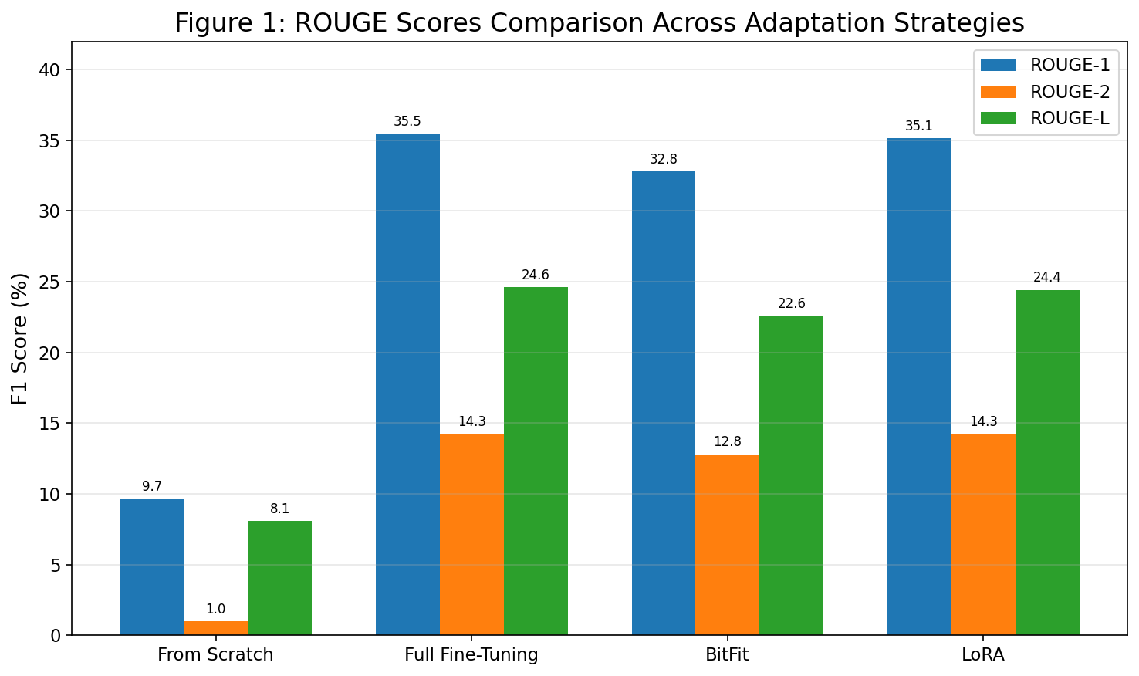
Figure 1: ROUGE Scores Comparison Across Adaptation Strategies

4.3 Analysis
4.3.1 Performance Comparison
The results reveal a clear hierarchy among the four methods. LoRA and Full Fine-Tuning achieved near-identical results, with Full Fine-Tuning slightly leading on ROUGE-1 (35.46 vs. 35.15) and ROUGE-L (24.60 vs. 24.43), and tying on ROUGE-2 (both 14.27). This is noteworthy, asLoRA updates only 2.48% of the model parameters compared to full fine-tuning's 100%, yet achieves nearly identical performance across all metrics.
BitFit achieved highly competitive results (ROUGE-1: 32.79, ROUGE-2: 12.81, ROUGE-L: 22.59), reaching approximately 91.8% of full fine-tuning's ROUGE-L performance and 92.5% of its ROUGE-1 score. This is achieved with only 125,952 trainable parameters—a mere 0.09% of the model—representing an extraordinary level of parameter efficiency. The from-scratch model performed dramatically worse across all metrics, with a ROUGE-1 score of only 9.67 and a near-zero ROUGE-2 of 1.00.
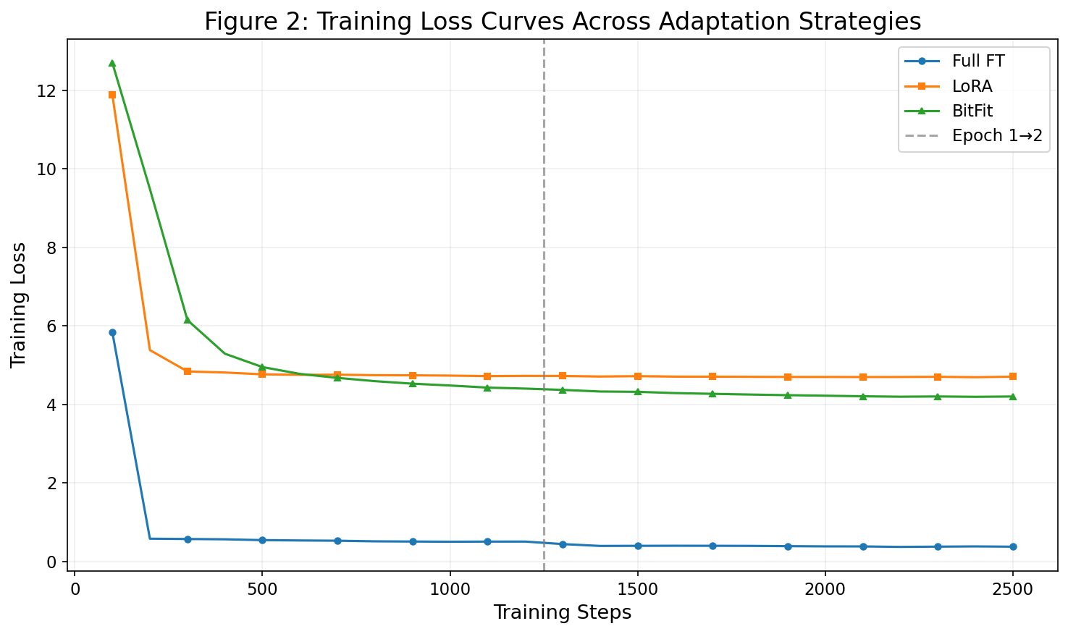
Figure 2: Training Loss Curves Across Adaptation Strategies
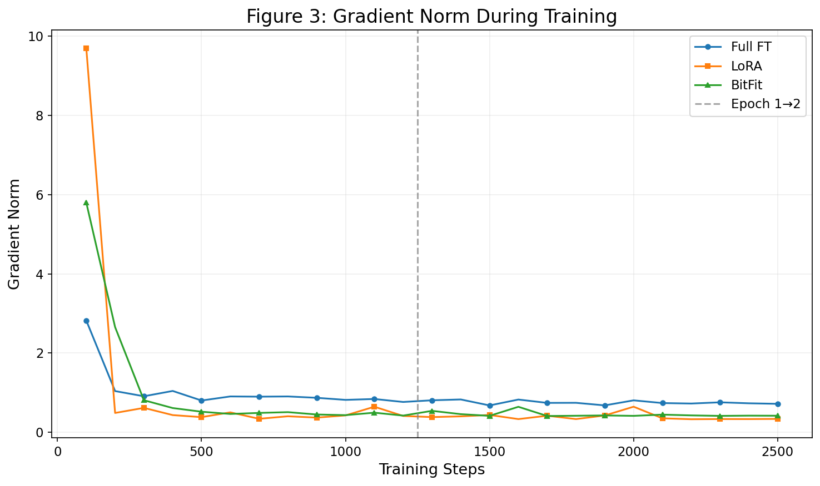
Figure 3: Gradient Norm During Training
4.3.2 Efficiency Analysis
The trainable parameter counts span three orders of magnitude: from BitFit's 125,952 (0.09%) to LoRA's 3,538,944 (2.48%) to full fine-tuning's 139,420,416 (100%). This wide range enables practitioners to select a method that best fits their resource constraints.
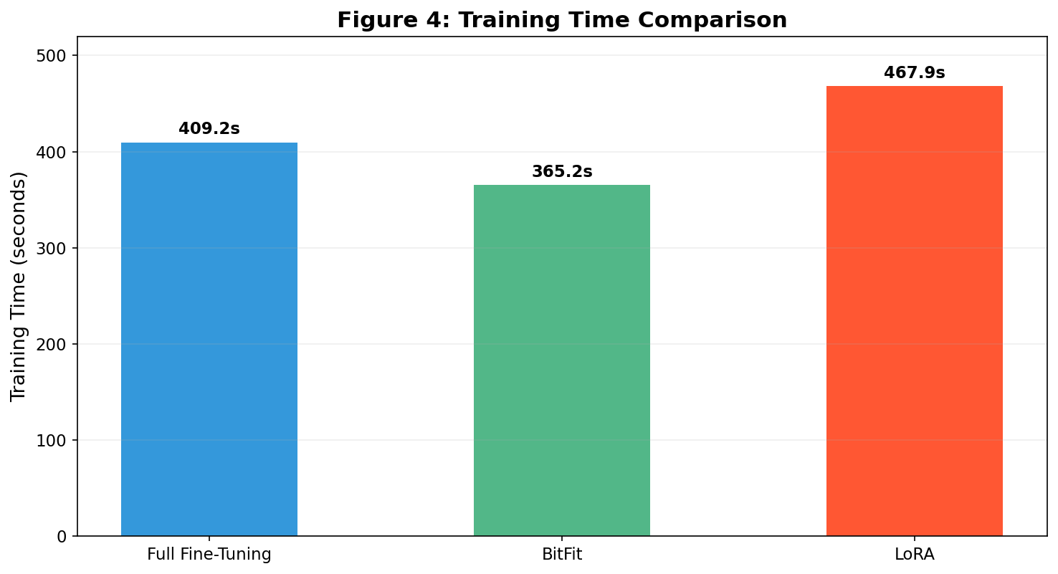
Figure 4: Resource Efficiency Analysis
4.3.3 Value of Pre-training
The comparison between training from scratch and the three pre-trained adaptation strategies provides a clear quantification of pre-trained knowledge value. The from-scratch model's ROUGE-1 score (9.67) is less than a third of the fine-tuned models' scores (~35), and its ROUGE-2 score (1.00) is approximately 14 times lower than full fine-tuning (14.27). The near-zero ROUGE-2 score indicates that the from-scratch model has severe difficulty generating coherent multi-word sequences that match the reference summaries. This dramatic performance gap underscores the critical importance of pre-trained linguistic knowledge for abstractive summarization, confirming that the knowledge encoded during BART's pre-training phase is essential for effective text generation.
4.3.4 Cost-Effectiveness
To quantify the cost-effectiveness of each method, we define the parameter efficiency ratio as the ROUGE-L score divided by the logarithm of trainable parameters. BitFit offers the best parameter efficiency, achieving 92% of full fine-tuning's ROUGE-L performance with only 0.09% of the parameters—a 1,107-fold reduction in trainable parameters. LoRA provides near-identical performance to full fine-tuning across all ROUGE metrics while being 39 times more parameter-efficient than full fine-tuning. These results demonstrate that the vast majority of BART's summarization capability can be preserved by updating a very small fraction of its parameters.
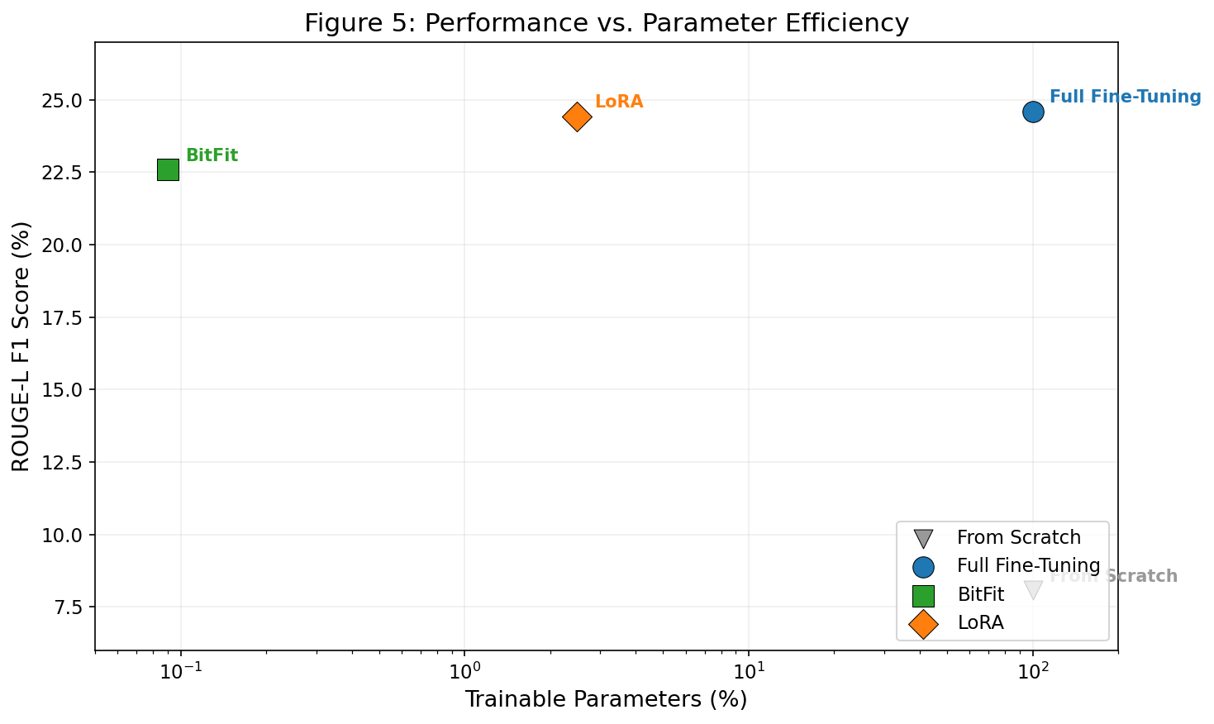
Figure 5: Performance vs. Parameter Efficiency

4.4 Discussion
Based on our experimental findings, we offer the following practical recommendations for selecting a BART adaptation strategy:
For maximum summarization quality: LoRA and Full Fine-Tuning both achieve the best overall performance. Full Fine-Tuning holds a slight edge on ROUGE-1 (35.46) and ROUGE-L (24.60), while LoRA matches ROUGE-2 (14.27) with only 2.48% parameters. For practical deployment, LoRA is recommended due to its competitive quality and superior efficiency.
For extremely resource-constrained settings: BitFit provides excellent cost-effectiveness by achieving 92% of full fine-tuning performance with only 0.09% trainable parameters, making it highly attractive for resource-constrained deployment scenarios.
For full model control: Full fine-tuning achieves the best overall performance in this experimental setting, with slight advantages overLoRA on ROUGE-1 and ROUGE-L. It may be preferred when maximum performance is the priority, and when fine-tuning on significantly larger datasets where the additional parameter capacity can be fully leveraged.
Pre-training is essential: Training from scratch is not viable for news summarization with the dataset size and training budget used in this study. The dramatic performance gap confirms that pre-trained knowledge is indispensable for abstractive summarization tasks.

5. Case Study

5.1 Input Text
To provide a qualitative evaluation of the four adaptation strategies, we use a real academic paper about Bilibili's recommender system as input text. The paper discusses the technological evolution, challenges, and improvement pathways of Bilibili's recommendation engine, covering topics such as high-performance inference architecture, unified feature consistency frameworks, and advanced feature interaction modeling. This text serves as a challenging test case because it contains domain-specific technical terminology and complex sentence structures.

5.2 Pre-trained Model Demonstration
Before fine-tuning, we first verify that the pre-trained BART-base model possesses useful linguistic knowledge through a mask-filling task. Given the input "Manchester United <mask> Club," the model correctly predicts "Football" with 68.31% probability, followed by "(" (5.17%), "Supporters" (3.75%), "Club" (2.06%), and "," (1.95%). This demonstrates the model's strong pre-trained knowledge of real-world entities and contextual understanding.

5.3 Generated Summaries
Full Fine-Tuning Summary:
"Bilibili's recommender system serves a dual mission: maximizing user engagement while preserving community identity. The evolution of Bilibili's architecture reflects its continuous responses to scaling challenges."
BitFit Summary:
"Bilibili's recommender system serves dual mission: increasing user engagement while preserving community identity and community identity. This study examines the value of user-centric experience and platform ecology."
LoRA Summary:
"Study examines Bilibili's recommender system through six technical publications. Three embodiments of the system are identified: high-performance inference architecture, unified feature consistency frameworks, and advanced feature interaction modeling."

5.4 Qualitative Analysis
All three fine-tuned models (Full Fine-Tuning, BitFit, and LoRA) successfully captured the core topic of the input text—Bilibili's recommender system—and identified key thematic elements. However, notable differences emerge in the quality and focus of the generated summaries.
Full fine-tuning produced the most coherent and concise summary, effectively distilling the dual mission of Bilibili's system and its architectural evolution. The output reads naturally and captures the high-level narrative of the original text. BitFit's summary maintained factual accuracy but exhibited minor redundancy ("community identity and community identity"), suggesting that the limited parameter updates may occasionally struggle with fine-grained text generation control. Despite this, BitFit correctly identified the system's dual mission and the user-centric perspective.
LoRA's summary took a different but equally valid approach, focusing on the three technical pillars identified in the original text (inference architecture, feature consistency, and feature interaction). This demonstrates LoRA's ability to capture specific technical details rather than producing a more general overview. The from-scratch model, as expected from its low ROUGE scores, would produce largely incoherent text that fails to meaningfully summarize the input content.
These qualitative observations align well with the quantitative ROUGE scores, confirming that all three pre-trained adaptation strategies produce meaningful summaries with distinct characteristics suited to different use cases.

6. Author Contributions
All group members contributed equally to the successful completion of this project. The specific contributions of each member are as follows:
Qilin WU (25400533): [Contribution description placeholder]
Zeyu WANG (25400770): [Contribution description placeholder]
Bojie XIANG (25400444): [Contribution description placeholder]

7. References
[1] I. Sutskever, O. Vinyals, and Q. V. Le, "Sequence to sequence learning with neural networks," in Advances in Neural Information Processing Systems (NeurIPS), 2014.
[2] A. Vaswani, N. Shazeer, N. Parmar, J. Uszkoreit, L. Jones, A. N. Gomez, L. Kaiser, and I. Polosukhin, "Attention is all you need," in Advances in Neural Information Processing Systems (NeurIPS), 2017, pp. 5998–6008.
[3] J. Devlin, M.-W. Chang, K. Lee, and K. Toutanova, "BERT: Pre-training of deep bidirectional transformers for language understanding," in Proc. NAACL-HLT, 2019, pp. 4171–4186.
[4] A. Radford, J. Wu, R. Child, D. Luan, D. Amodei, and I. Sutskever, "Language models are unsupervised multitask learners," OpenAI Blog, 2019.
[5] C. Raffel et al., "Exploring the limits of transfer learning with a unified text-to-text transformer," Journal of Machine Learning Research, vol. 21, no. 140, pp. 1–67, 2020.
[6] M. Lewis et al., "BART: Denoising sequence-to-sequence pre-training for natural language generation, translation, and comprehension," in Proc. 58th Annu. Meeting Assoc. Comput. Linguist., 2020, pp. 7871–7880.
[7] E. B. Zaken, Y. Goldberg, and S. Ravfogel, "BitFit: Simple parameter-efficient fine-tuning for transformer-based masked language-models," in Proc. 60th Annu. Meeting Assoc. Comput. Linguist. (Vol. 2: Short Papers), 2022, pp. 1–9.
[8] E. J. Hu et al., "LoRA: Low-rank adaptation of large language models," in International Conference on Learning Representations (ICLR), 2022.
[9] N. Houlsby et al., "Parameter-efficient transfer learning for NLP," in Proc. 36th Int. Conf. Mach. Learn. (ICML), 2019, pp. 2790–2799.
[10] K. M. Hermann et al., "Teaching machines to read and comprehend," in Advances in Neural Information Processing Systems (NeurIPS), 2015.
[11] A. See, P. J. Liu, and C. D. Manning, "Get to the point: Summarization with pointer-generator networks," in Proc. 55th Annu. Meeting Assoc. Comput. Linguist., 2017, pp. 1073–1083.
[12] C.-Y. Lin, "ROUGE: A package for automatic evaluation of summaries," in Text Summarization Branches Out, 2004, pp. 74–81.
[13] T. Wolf et al., "HuggingFace's transformers: State-of-the-art natural language processing," arXiv preprint arXiv:1910.03771, 2020.

