**ImREAL Update and Changes (Current Version 2.2.5)**

1. **Wallet Connect Changes.**

* **Added Wallet Connect new feature where Users can use their mobile wallets by scanning the QR code.**
* Tested on.
  + Metamask android
  + Trust Wallet android

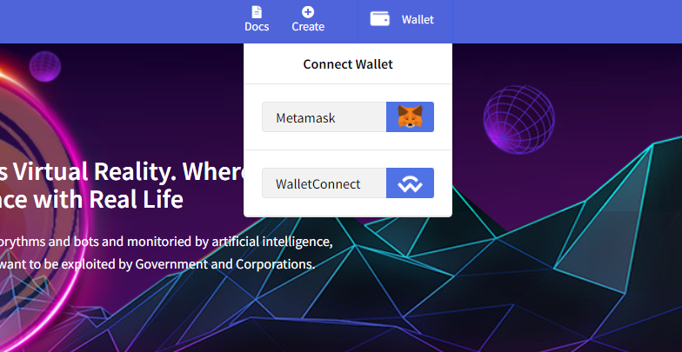

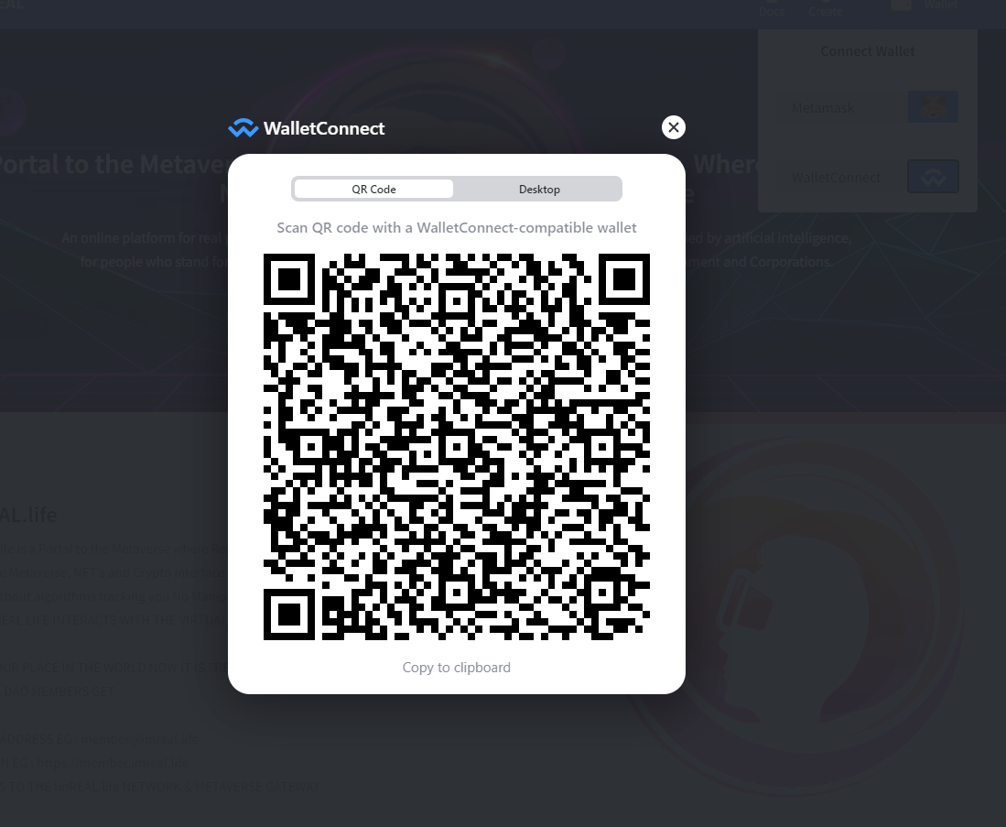

1. **New front page.**

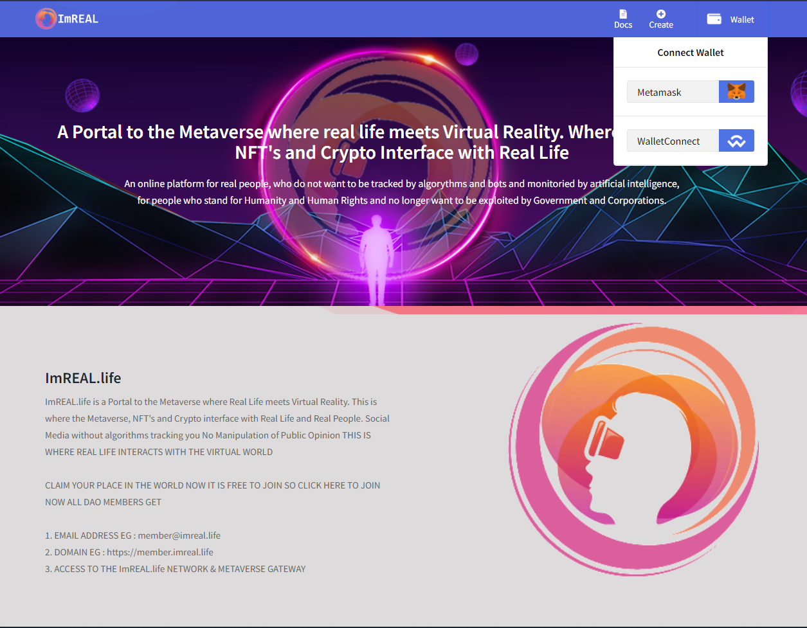



1. **Added “settings panel”** 
   * **This is where users can see the DAO rules**
   * **Change their profile settings**
   * **Can deactivate the DAO if the user is the owner**

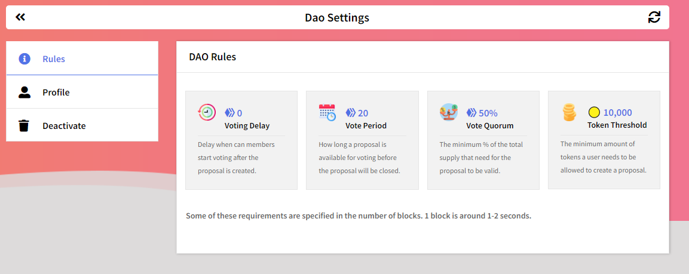

1. **Profile panel**
   * 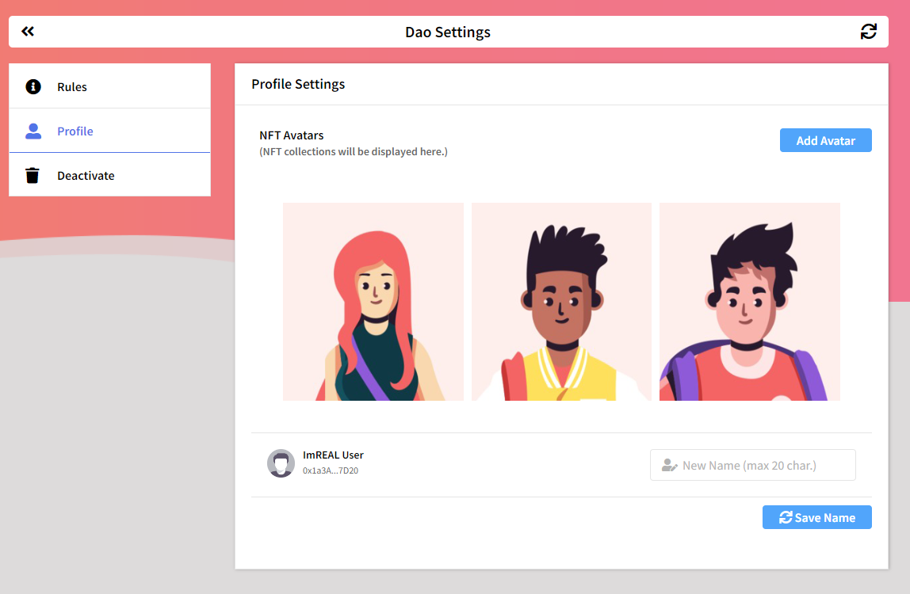**Users that are members to any DAO can change their profile image if they have NFTs if not there are default images from the settings.**
   * **Users can use their NFTs as their avatar all they have to do is provide the NFTs contract address and once the contract address is valid, the system will scan the users owned NFTs and display it to selection tab.**

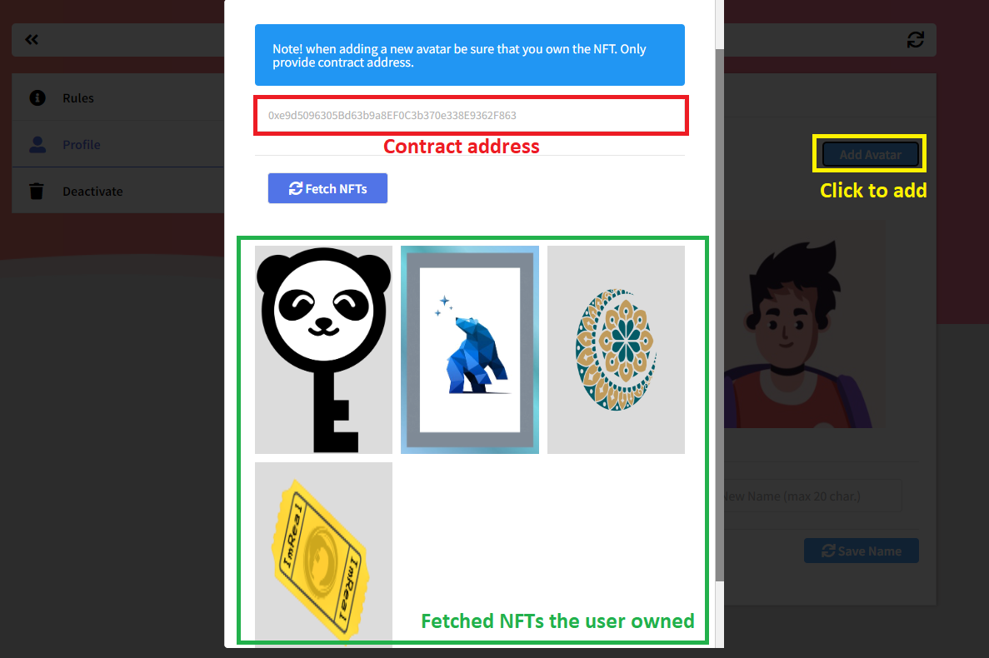

* + **Users can also change their names by inputting their new names under the image display panel.**

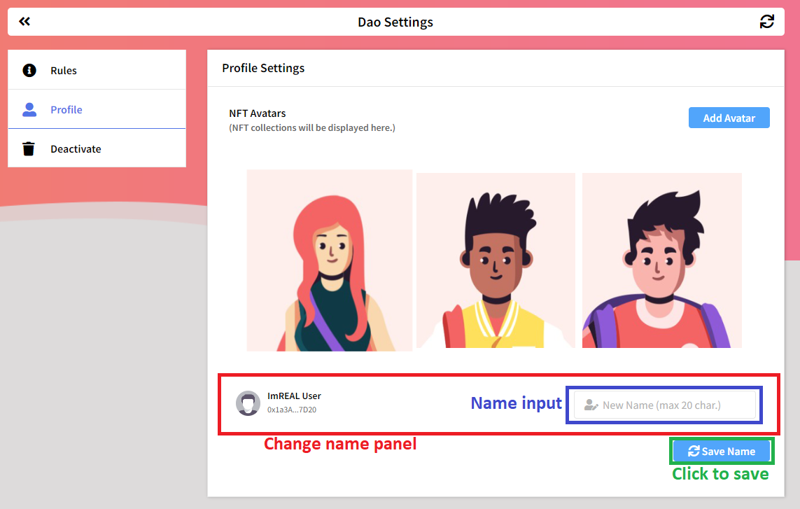

1. **Added Loading indicator to indicate that the page is fetching data and it is also clickable. To reload data without refreshing the whole page.**
   * **Home page.**

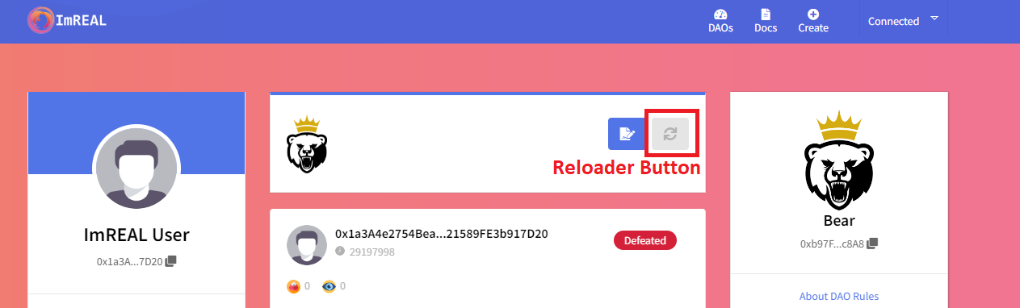

* + 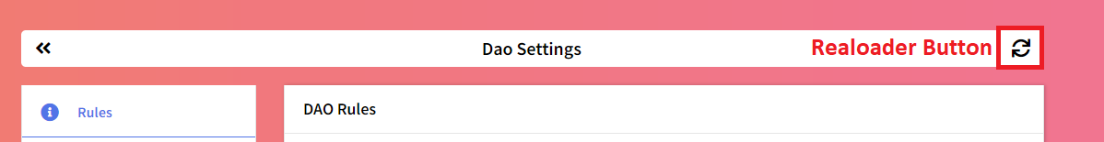**Settings Panel.**
  + **Proposal View page.**

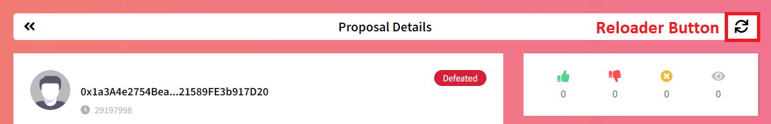

1. **Added deposit feature to “Governance Token” Display.**
   * **This function will deposit some tokens back to the treasury. It is meant to be created for the balance of the DAO.**
   * **This feature detects and calculates if the DAO quorum and all members tokens are equal before you can deposit tokens to the treasury.**

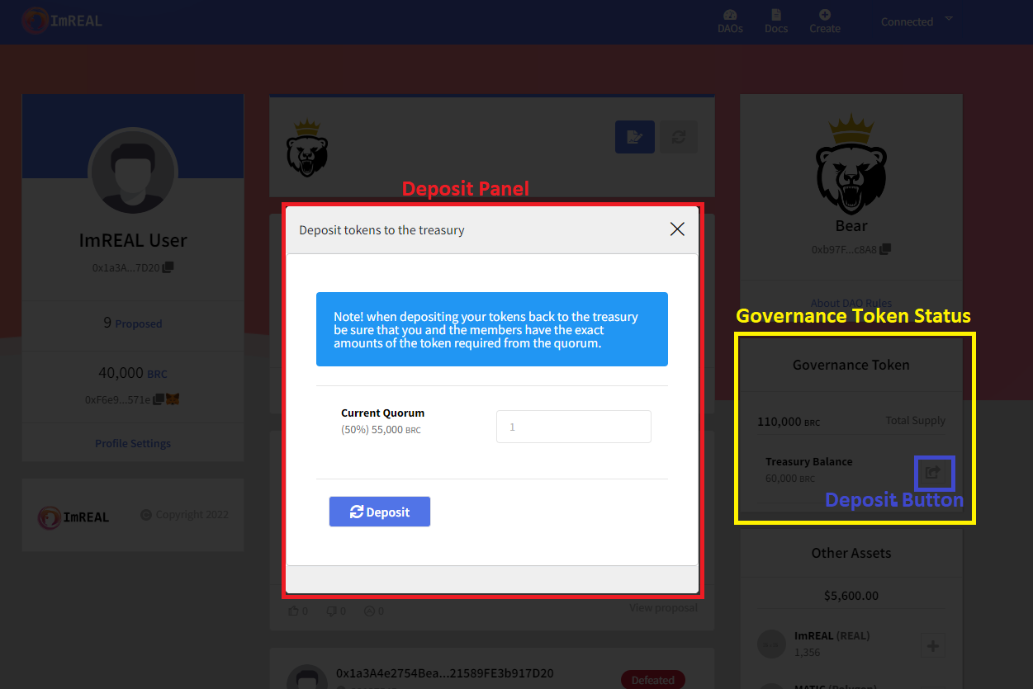

1. **Adjusted some minor fixes that will cause bugs.**
   * **Quorum progress bar will only show If the proposal is active**
   * **Quorum progress bar redesign color changes based on percentage.**
     1. **0 - 49% - RED**
     2. **50 – 89% - BLUE**
     3. **100% Green**
   * **If new member cast vote and create proposal. The system will delegate their token first before proposing and voting automatically.**
   * **Warning and error alerts will automatically change back to default after 10 seconds.**
   * **Google captcha fixed (Bug: Repeating check captcha).**
   * **Added guide on the left side at “DAO Creation” page.**
   * **Remove REALS page.**