**ImREAL Update and Changes (Current Version 2.2.6)**

1. **Admin detection**
   * **Detect if the connected wallet is an admin and admin options will appear**



* + **Admin - this tab has 2 options when hovered.**

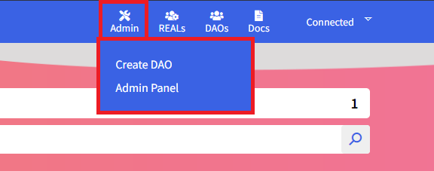

* + - **Create DAO** – This option will bring you to another page where you can create DAO. This will function only if the connected wallet is an admin.
    - **Admin Panel –** This option will bring you to the “Admin Panel” page where some of the controls are operational by the allowed admin accounts only.
  + **Admin Panel – This page has 3 Control Tabs.**

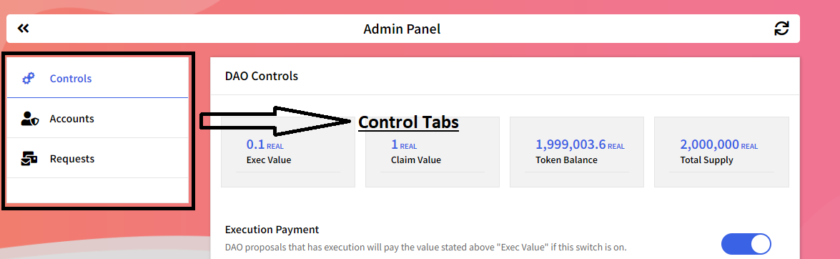

* + - **Controls –** This tab has all the needed control setups for the website.

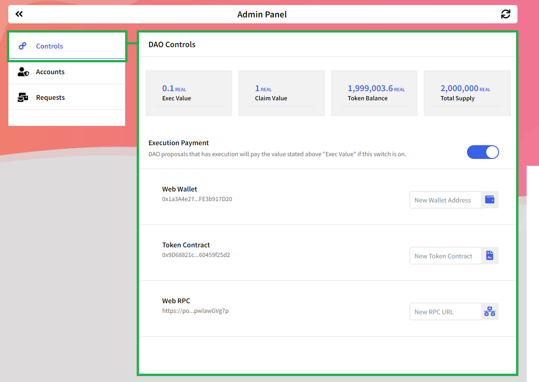

* + - 1. **Exec Value –** This is a display of the current execution payment value. DAO proposals that have an execution function will pay the value displayed from the Exec Value.   
         **“To change the value is by clicking the displayed value and it will trigger an editable content and when the value is inserted it will automatically update the database.”**
      2. **Claim Value –** This is a display of the current Claiming payment if an account is invited to the DAO. The account should claim an NFT first before the account will be known as a member of the DAO. the account should pay a token to claim the membership NFT.

**“To change the value is by clicking the displayed value and it will trigger an editable content and when the value is inserted it will automatically update the database.”**

* + - 1. **Token Balance –** The display of the current token balance circulating the website. **“This is a read only and not editable”**
      2. **Token Supply –** The display of the total minted supply of the token. **“This is a read only and not editable”**
      3. **Execution Payment – this is a switch that will trigger to ON/OFF the “Exec Value”**
      4. **Web Wallet –** This is the currently used wallet for this website. this wallet is the creator of the token contract. all the transaction payments and token minting will be sent to this wallet address.
      5. **Token contract** – This is the contract address created by the "Web Wallet". This is the minter of the Token that is being used on this website.
      6. **Web RPC –** The currently used "RPC URL" to make the website functional. This "RPC URL" is used so that the website can communicate to the “Block Chain”
    - **Accounts –** Account tab is where all the admin accounts that has powers will be displayed.

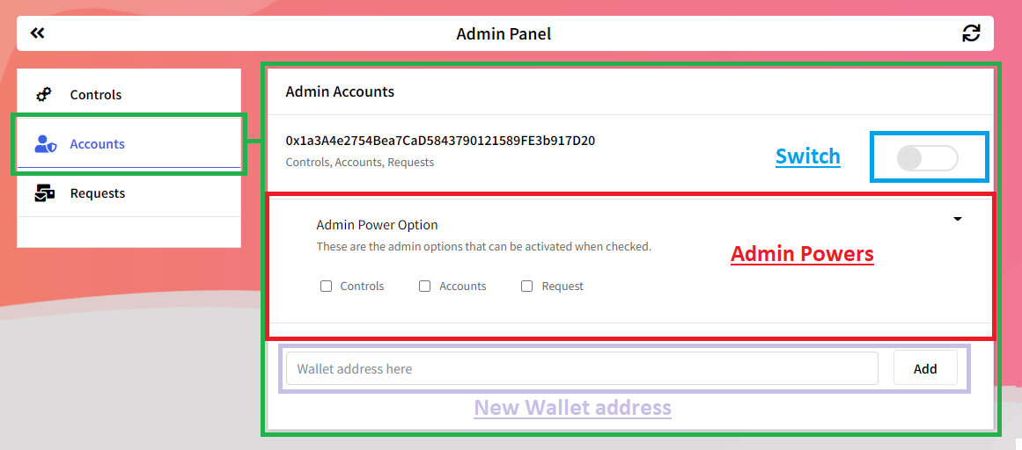

* + - 1. **Admin Power Option** – If this option name is clicked it will trigger a drop-down and shows selectable options. these options will trigger a turn ON if checked. These options are base on the tabs on the left side.
      2. **Switch** – This switch will enable disable the admin account if the switch is toggled.
      3. **New Wallet Address** – This is where you input the new admin wallet address and clicking the “Add” Button.
    - 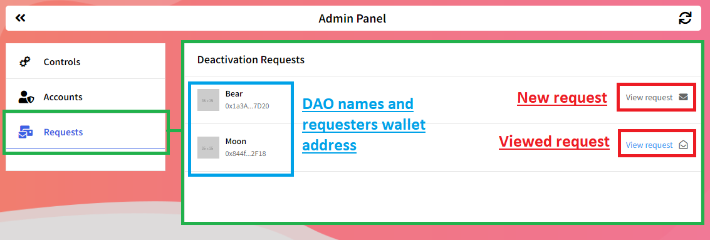**Request –** On this tab all deactivation of DAO requests will be displayed here. By clicking “View request” Will show the Request explanation and email.

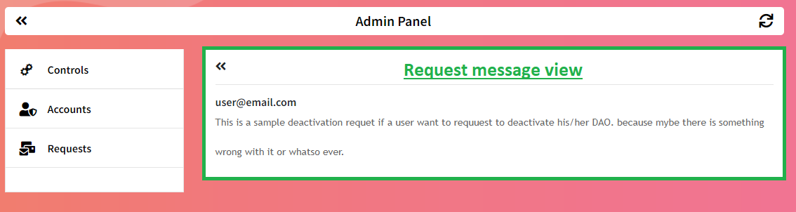



1. **Changes on “DAOs” Header Tab**

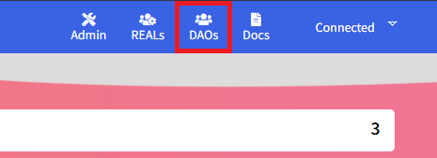

* + **Newly Created DAO**

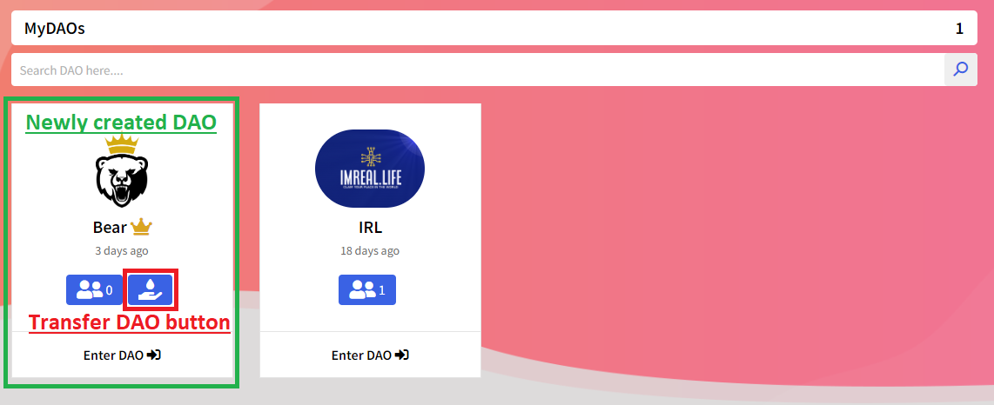

* + - **Newly created DAO -** A newly created DAO by the admin accountwill show a transfer button. This button will then trigger a transfer function to the new owner of this DAO. A modal will pop up with input for a new owner’s wallet address.

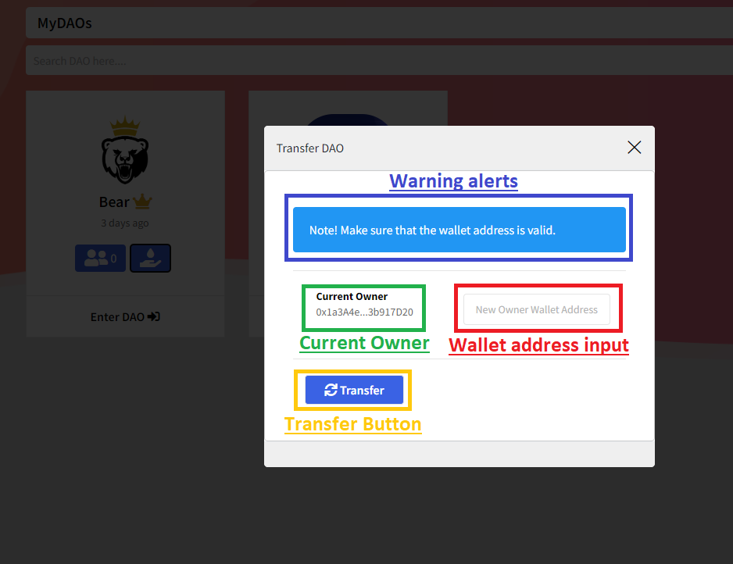

1. **Changes on “REALs” Header Tab –** This tab is for admin account only. This will give admin a views of all the created DAOs.This page has 2 tabs.

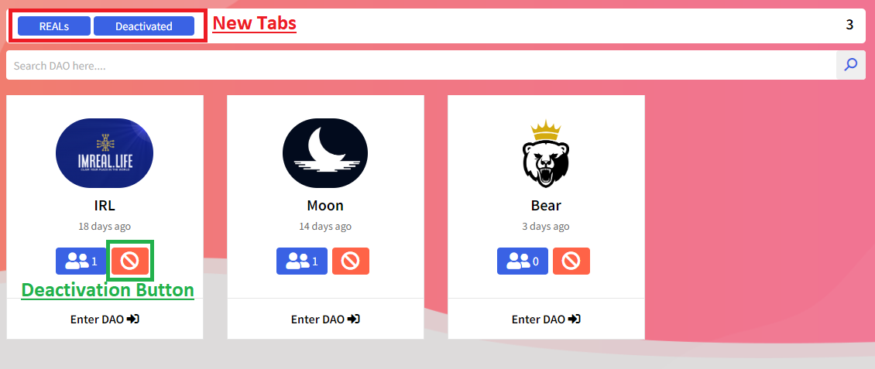

* + **REALs –** This tab will show all the Existing DAO that are currently running.
    - **Deactivation Button –** This button will trigger a deactivation to a DAO if clicked. The DAO will then be shut down and will be transferred to the “Deactivated” Tab.

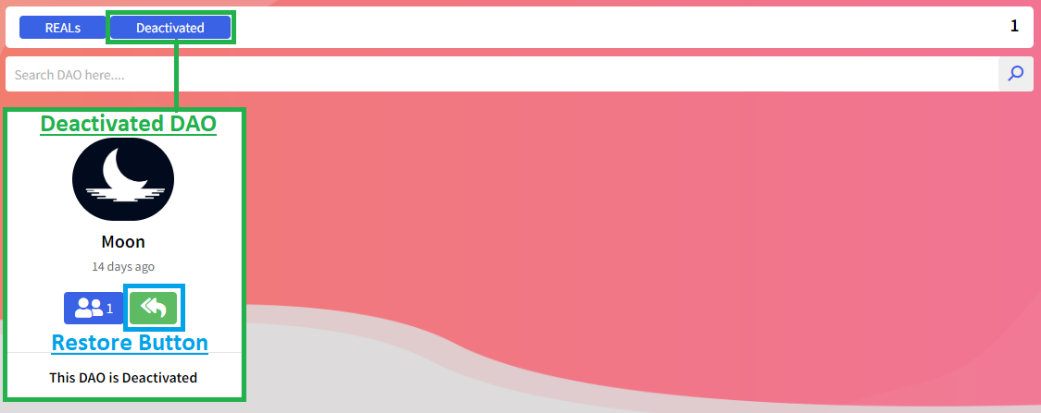

* + **Deactivated –** This tab will display all the deactivated DAOs.
    - **Restore Button** – This button will trigger a restoration to that deactivated DAO. This is for emergncy porpose only.