**Project 1**

**<HANGMAN>**

**CIS-5 45549**

**Name: Christopher Ramirez-Alba**

**Date: 7/19/2017**

**Introduction**

Title: Hangman

This is a guessing game.

Guess a letter and the program will tell you if it is correct, you are given a hint of what type of words will be used and how many letters are in the word through asterisk “ * ”.

There will only be 6 chances at guessing. If guessed incorrectly the game ends and an image of the “HANGMAN” appears above the word that was hidden.

A “Congratulations!!” message will appear if the man is saved and the word is guessed correctly followed by an image of a saved man and the word you discovered.

**Summary**

Project size: About 110 lines

The number of variables: About 11

The number of method: About 2

In this project an ample amount of information was used from what we learned in class and from what was found in the book. It is a simple and quick game for anyone looking to have a challenge. Expanding this game would be a challenge but it is possible by adding a part two of the game which can include a change in difficulty, a continuation to save “HANGMAN’s” wife and family, etc.

I found it challenging to place what I’ve learned into this, I was hoping to get more time to work on a bigger design for a game. Unfortunately we only had a short amount of time with this assignment. What is enjoyable about this game is that with basic understanding of coding the words may be changed to a different criteria or the challenge can get simpler.

**Description**

The main reason for choosing this game is to test my ability to code. I also attempted in applying very basic design idea into the game for the figures to make the game enjoyable and easy to express.

**Flow Chart**

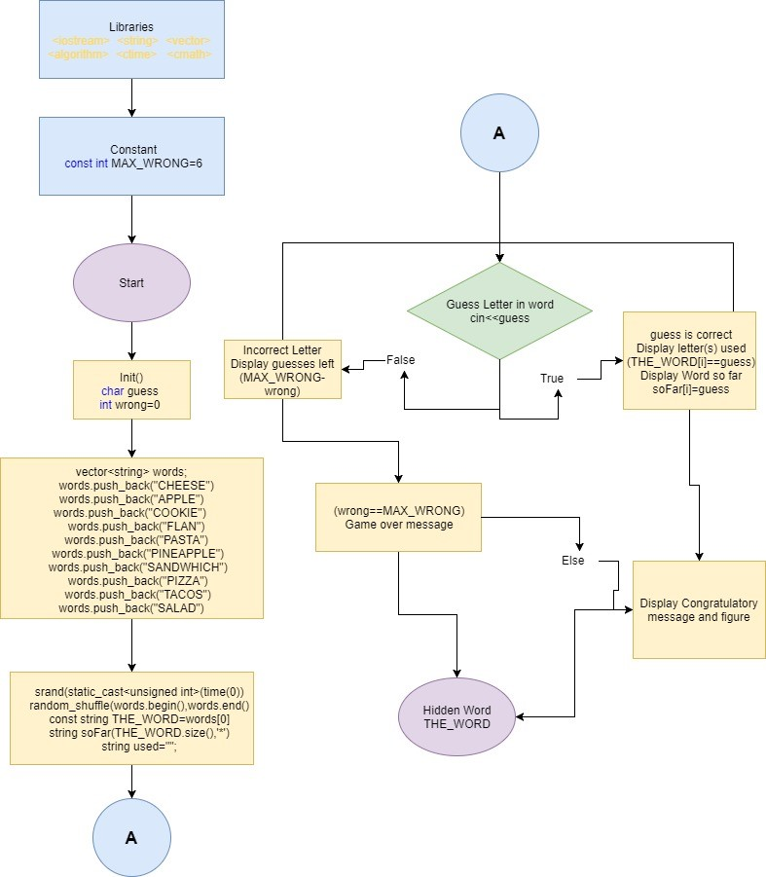

**Pseudo Code**

*Initialize*

*Welcome message displayed*

*Display Amount of guesses available*

*Hint appears*

*Begin choosing letters to find word*

*If letter is not part of word*

*Display amount of attempts left*

*Display previous letters used*

*Display word so far*

*Go to next guess*

*Total 6 guesses per game*

*Repeat information if letter is incorrect*

*Else*

*If letter is correct*

*Display previous letters used*

*Show letters placement in word also, if it is used multiple times in word*

*Go to next guess*

*Repeat information if letter is correct*

*If all guesses are used and word is not found*

*Display Game over message*

*Figure of “HANGMAN” appears*

*Display word answer*

*Else*

*Display Congratulations for winning game*

*Saved “HANGMAN” figures appears*

*Display word answer*

*End Game*



**Program**

/*

* File: main.cpp

* Author: Christopher Ramirez-Alba

* Created on July 16, 2017, 12:54 AM

*Purpose: Project1 Hangman

*/

//System Librariez

#include <iostream> //Input/Output Library

#include <string> //Character sequence

#include <vector> //Array size

#include <algorithm> //Collection of funcions

#include <ctime> //Date and time in value

#include <cmath> //Standard math functions

using namespace std; //Libraries using namespace standard

//User Libraries

//Global Constant

const int MAX_WRONG=6; //Total tries available per game

//Function Prototypes

int main(int argc, char** argv) {

//Declare variables

char guess; //Letters player chooses when game begins

int wrong=0; //Amount of letters that where wrong

//Random words that will be used for game

vector<string> words;

words.push_back("CHEESE"); //Choice for hidden letter being "CHEESE"

words.push_back("APPLE"); //Choice for hidden letter being "APPLE"

words.push_back("COOKIE"); //Choice for hidden letter being "COOKIE"

words.push_back("FLAN"); //Choice for hidden letter being "FLAN"

words.push_back("PASTA"); //Choice for hidden letter being "PASTA"

words.push_back("PINEAPPLE"); //Choice for hidden letter being "PINEAPPLE"

words.push_back("SANDWHICH"); //Choice for hidden letter being "SANDWHICH"

words.push_back("PIZZA"); //Choice for hidden letter being "PIZZA"

words.push_back("TACOS"); //Choice for hidden letter being "TACOS"

words.push_back("SALAD"); //Choice for hidden letter being "SALAD"

//Map inputs to outputs or process the data

srand(static_cast<unsigned int>(time(0))); //Random function for secret word

random_shuffle(words.begin(),words.end()); //Shuffle of words from vector

const string THE_WORD=words[0]; //Characters the word contains

string soFar(THE_WORD.size(),'*'); //Characters switched to asterisk

string used="";

//Process where the Game begins

cout<<" Welcome to Hangman"<<endl; //Introduction to Game

cout<<" --------------------"<<endl;

cout<<"You have exactly "<<(MAX_WRONG-wrong)

<<" guesses, good luck!"<<endl; //Amount of guesses given

cout<<"Hint: All words will be food."<<endl;//Hint for Game

while ((wrong<MAX_WRONG)&&(soFar!=THE_WORD))

{

cout<<"You've used the following letters: "<<used<<endl;//Letters used

cout<<"So far, the word is "<<soFar<<endl; //Letters used in word

cout<<"Enter your guess: "<<endl; //Enter letter to figure out word

cin>>guess;

guess=toupper(guess);

while (used.find(guess)!=string::npos)

{

cout<<"So far you've already guessed "<<guess<<endl;//Letters used

cout<<"Enter a letter please: "<<endl;//Enter letter to figure out word

cin>>guess;

guess=toupper(guess);

}

used+=guess;

if (THE_WORD.find(guess)!=string::npos)

{

//Message give when letter is correct

cout<<"Yes "<<guess<<" is in the word"<<endl;

for (unsigned int i=0; i<THE_WORD.length(); ++i)

{

if (THE_WORD[i]==guess)

{

soFar[i]=guess;

}

}

}

else

{

//Message given when letter is not in word

++wrong;

cout<<"Sorry, "<<guess<<" isn't in the word."<<endl;

cout<<"You have "<<(MAX_WRONG-wrong)<<" guesses left."<<endl;

}

}

//Output and image of Game ending

if (wrong == MAX_WRONG)

{

//Game over message with Image of stick figure

cout<<"Game over, you've been hanged!"<<endl;

cout<<" | "<<endl;

cout<<" 0 "<<endl;

cout<<" /"<<" |"<<" \\ "<<endl;

cout<<" /"<<" |"<<" \\ "<<endl;

cout<<" /"<<" \\ "<<endl;

cout<<" |"<<" | "<<endl;

}

else

{

//Congratulation message with Image of stick figure

cout<<"Congratulation! You've are saved!"<<endl;

cout<<" \\ "<<"0 "<<" /"<<endl;

cout<<" \\"<<" | "<<"/"<<endl;

cout<<" 0"<<" |"<<endl;

cout<<"\\"<<"|"<<"/"<<" / "<<"\\"<<" 0"<<endl;

cout<<"/ "<<"\\"<<" /"<<" \\"<<" \\"<<"|"<<"/"<<endl;

cout<<" / "<<"\\"<<endl;

}

cout<<"YOUR WORD: "<<THE_WORD<<endl;//Output of word used for game

//Exit stage right!

return 0;

}