# Project Assignment

# Design a generic multifunction microwave toaster oven

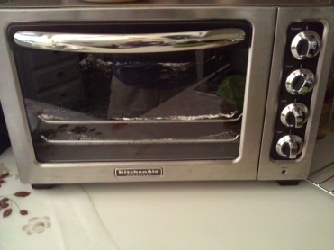

The generic oven shown has the following characteristics

The unit has four dials/selectors as listed below:

*A Function selector: Toast, Broil, Warm, Bake (no need to set the time and the temperature when on Toast)*

*A temperature selector: used to set temp from 0 – 450 degree Fahrenheit*

*A time selector: used to set time from 0 to 60 minutes*

*A toast selector: light (sets time to 1 min.), mild (Sets time to 2 min.), dark (sets time to 3 min). Time is automatically set by the toaster selection.*

The unit is used in the following manner in a general sense:

*“A user opens the oven door, pulls the oven tray out, places the food in the tray, pushes the try back in, closes the oven door then sets the dials (not all of them necessarily). Oven has a light indicator that goes on when oven is in use. When oven is done a bell rings and the light goes off”*

**Tasks**

1. Write a set of simple system requirements for the appliance. (5pts)

2. Using CRC cards analysis and brainstorming –

1. Identify, and list (with detailed description) all the actors and use cases for the appliance, including UML diagrams. (5pts)
2. Perform a design step to design control software to drive the appliance. Show a set of UML diagrams that show the design elements that you have added to the system to control the device. (5pts)
3. Pick a specific use case scenario and completely describe it with all possible variations and alternatives. Generate a UML diagram for your use case. Draw a UML system sequence diagram for the use case and write a detailed explanation of each step in the sequence diagram. (5pts)
4. Identify all the classes and operations that are active in all the use cases you have identified. Make sure to classify boundary entity and controller objects. (10pts)
5. Present the class diagram for your design. Include all multiplicities. (5pts)
6. Provide a component diagram, and a deployment diagram of the software which is used to control the appliance. (5pts)

3. Code your design and create a simulation of the device being used in function main. (10pts)