# Project Assignment

# Design a generic multifunction microwave toaster oven

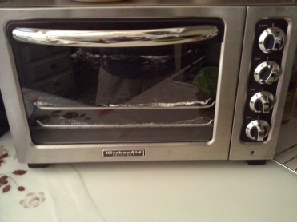

The generic oven shown has the following characteristics

The unit has four dials/selectors as listed below:

*A Function selector: Toast, Broil, Warm, Bake (no need to set the time and the temperature when on Toast)*

*A temperature selector: used to set temp from 0 – 450 degree Fahrenheit*

*A time selector: used to set time from 0 to 60 minutes*

*A toast selector: light (sets time to 1 min.), mild (Sets time to 2 min.), dark (sets time to 3 min). Time is automatically set by the toaster selection.*

The unit is used in the following manner in a general sense:

*“A user opens the oven door, pulls the oven tray out, places the food in the tray, pushes the try back in, closes the oven door then sets the dials (not all of them necessarily). Oven has a light indicator that goes on when oven is in use. When oven is done a bell rings and the light goes off”*

**Tasks**

**1. Write a set of simple system requirements for the appliance. (5pts)**

1. The System must have a Function selector (Toast, Broil, Warm, Bake)
2. The System must have a Temperature selector (0 - 450F)
3. The System must have a Time selector (0-60 minutes)
4. The System must "ding" when the Timer is done
5. The System must include a tray
6. The System must operate on a food item
7. The System must cook food for a specified time period
8. The System must deliver food for consumption
9. The System must have an indicator light
10. The System must have States for Toast-Function ("light [sets time 1min]", "mild [sets time 2min]", "dark [sets time 3min]")

**2. Using CRC cards analysis and brainstorming –**

1. **Identify, and list (with detailed description) all the actors and use cases for the appliance, including UML diagrams. (5pts)**

Actors:

User – The user operates the toaster oven, places food in and takes food out of the toaster oven, opens and closes the door, and sets the dial settings which determine how the toaster oven will function.

Use Cases:

UC1 - TITLE: Cook Food (Toast Preset) PRIMARY ACTOR: User

SUCESS SCENARIO: User inserts food into the Toaster. User Sets the Function "Toast" for the Toaster. User sets Toast selector to desired toast setting (light , mild, dark). User presses “Start”. Toaster sets timer based on preset setting (1min, 2min, 3min, respectively). Toaster Timer begins preset countdown; activates indicator light. Toaster displays current timer during countdown and stops when it reaches 0; turns off indicator light. The Toaster Bell dings to notify the User. User removes food for consumption.

UC2 - TITLE: Cook Food (Manual) PRIMARY ACTOR: User

SUCESS SCENARIO: User inserts food into the Toaster. User sets function to either bake, broil or warm on the Function selector. User Sets the Temperature Dial for the Toaster. User sets the Timer for the Toaster. User presses “Start”. Toaster Timer begins countdown; indicator light turns on. Toaster displays current timer during countdown and stops when it reaches 0; indicator light turns off. The Toaster Bell dings to notify the User. User removes food for consumption.

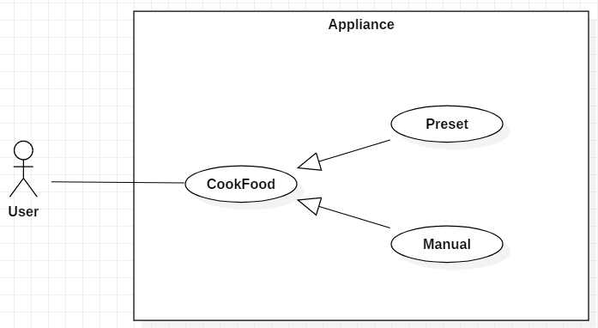

1. **Perform a design step to design control software to drive the appliance. Show a set of UML diagrams that show the design elements that you have added to the system to control the device. (5pts)**

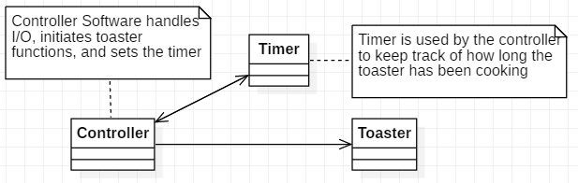

1. **Pick a specific use case scenario and completely describe it with all possible variations and alternatives. Generate a UML diagram for your use case. Draw a UML system sequence diagram for the use case and write a detailed explanation of each step in the sequence diagram. (5pts)**

|  |  |
| --- | --- |
| Actor: User | System: Appliance |
|  | 0: Appliance displays Main Menu.   1. Open Door 2. Insert Food 3. Cook Settings 4. Start 5. Cancel |
| 1: TUCBW User selects option “a” to open door | 2: Appliance opens door, displays next menu.   1. Close Door 2. Insert Food 3. Cook Settings 4. Start 5. Cancel |
| 3: User selects option “b” to insert food | 4: Appliance receives food, displays next menu:  a. Close Door  b. Remove Food  c. Cook Settings  d. Start  e. Cancel |
| 5: User selects “a” to close the door | 6: Appliance closes door, displays next menu a. Open door  b. remove food  c. cook settings d. start e. cancel |
| 7: User selects “c” to go to cook settings | 8: Appliance displays cook settings:  a. Toast  b. Broil  c. Warm  d. Bake |
| 9: User selects “toast” function | 10: Appliance registers toast function, prompts user to select a toast setting:   1. Light 2. Mild 3. Dark |
| 11: User selects desired toast setting | 12: Appliance sets timer and temperature setting based off desired toast setting, returns user to main menu a. Open Door  b. Remove Food  c. Cook Settings  d. Start e. Cancel |
| 13: User selects option “d” | 14: Appliance activates indicator light, begins timer countdown, toasts food for preset duration. Upon finishing, appliance extinguishes indicator light and rings bell. Prompts user to remove food. |
| 15: TUCEW User removes food |  |

**Scenario Table**

|  |  |  |  |  |  |
| --- | --- | --- | --- | --- | --- |
| # | Subject | Subject Action | Other Data/Objects | | Object Acted Upon |
| 1 | User | Selects | Open Door | | ToastController |
| 2.1 | ToastController | Sets | Door Open | | Toaster |
| 2.2 | ToastController | Displays | Menu | | User |
| 3 | User | Selects | Insert Food | | ToastController |
| 4.1 | ToastController | Sets | Tray Inserted | | Toaster |
| 4.2 | ToastController | Displays | Menu | | User |
| 5 | User | Selects | Close Door | | ToastController |
| 6.1 | ToastController | Sets | Door Closed | | Toaster |
| 6.2 | ToastController | Displays | Menu | | User |
| 7 | User | Selects | Cook Setting | | ToastController |
| 8 | ToastController | Displays | Cook Settings Menu | | User |
| 9 | User | Selects | Toast Option | | ToastController |
| 10.1 | ToastController | Sets | Cook setting(toast) | | ToastController |
| 10.2 | ToastController | Displays | Toast setting menu | | User |
| 11 | User | Selects | Toast setting | | ToastController |
| 12.1 | ToastController | Sets | Temperature | | Toaster |
| 12.2 | ToastController | Sets | Time | | Timer |
| 12.3 | ToastController | Displays | Main Menu | | User |
| 13 | User | Selects | Start | | ToastController |
| 14.1 | ToastController | Activates | Decrement time | | Timer |
| 14.2 | ToastController | Activates | Indicator Light | | Toaster |
| 14.3 | Timer Decrements | | | | |
| 14.3.1 | Timer | Prompts |  | ToastController | |
| 14.4 | ToastController | Deactivates | Indicator Light | Toaster | |
| 14.5 | Toaster | Rings bell |  |  | |
| 14.6 | ToastController | Prompts | Remove food | User | |

**Sequence Diagram**

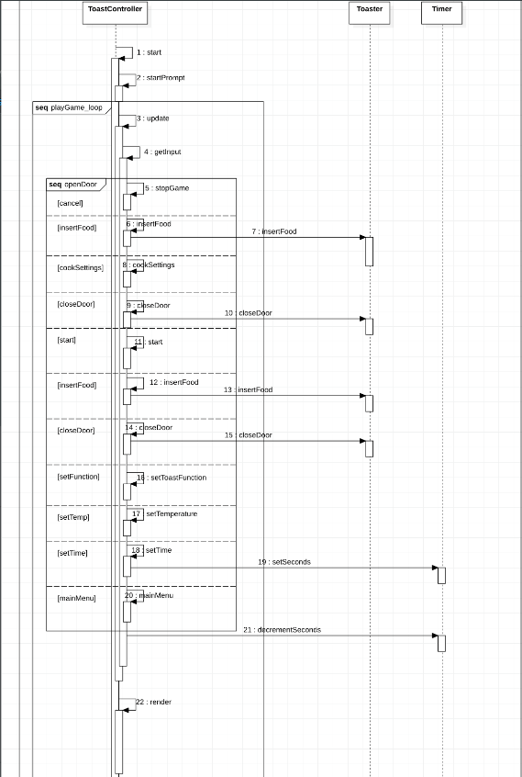

1. **Identify all the classes and operations that are active in all the use cases you have identified. Make sure to classify boundary entity and controller objects. (10pts)**

**Classes** Operations

UC1 - TITLE: Cook Food (Toast Preset) PRIMARY ACTOR: User

SUCESS SCENARIO: User inserts food into the **Toaster**. User Sets the Function "Toast" for the Toaster. User sets **Toast selector** to desired toast setting (light, mild, dark). User presses “Start”. **Toaster** sets **timer** based on preset setting (1min, 2min, 3min, respectively). Toaster **Timer** begins preset countdown; activates indicator light. Toaster displays current timer during countdown and stops when it reaches 0; turns off indicator light. The Toaster Bell dings to notify the User. User removes food for consumption.

UC1 Classes: Toaster, Toast selector, Timer

UC1 Operations: inserts food, sets function, sets desired toast setting, presses start, sets timer, begins countdown, activates indicator light, displays current time, stop when time is 0, turn off indicator light, toaster bell digs, removes food.

UC2 - TITLE: Cook Food (Manual) PRIMARY ACTOR: User

SUCESS SCENARIO: User inserts food into the **Toaster**. User Sets function to either bake, broil, or warm on the **Function selector**. User Sets the **Temperature Dial** for the **Toaster**. User sets the **Timer** for the Toaster. User presses “Start”. Toaster **Timer** begins countdown; indicator lights turn on. Toaster displays current timer during countdown and stops when it reaches 0; indicator lights turn off. The Toaster Bell dings to notify the User. User removes food for consumption.

UC2 Classes: Toaster, Function Selector, Temperature Dial, Timer

UC2 Operations: inserts food, sets function, sets temperature, sets time, presses start, begin countdown, indicator lights turn on, displays current timer, stop when time is 0, indicator lights turn off, toaster bell dings, removes food.

**Actor**: User

**Boundary Object**: Toaster (since it issues command to controller objects such as temperature dial or timer)

**Controller Object**: Function Selector, Temperature Dial, Timer, Indicator light, and toaster bell (updates temperature, function, and time. Displays those entities to the user and awaits for more information from the controller object)

**Entity Object**: Time, Temperature,

1. **Present the class diagram for your design. Include all multiplicities. (5pts)**

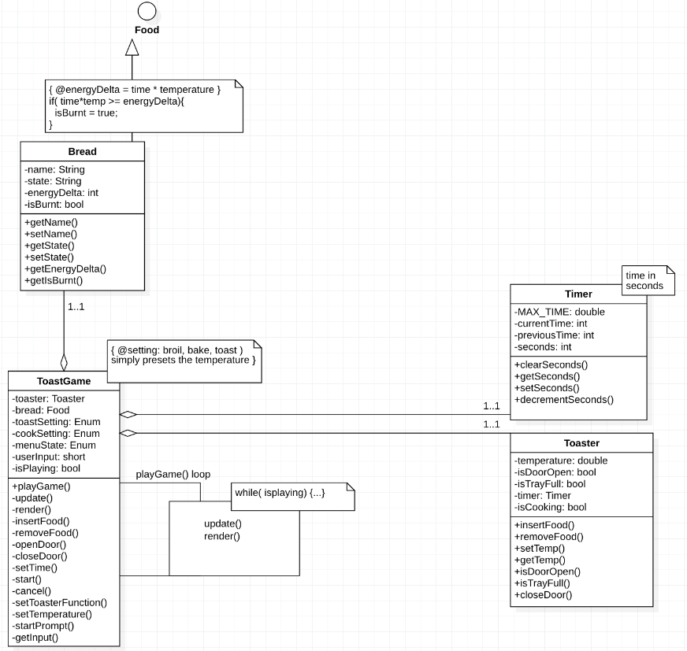

1. **Provide a component diagram, and a deployment diagram of the software which is used to control the appliance. (5pts)**

**Component Diagram**

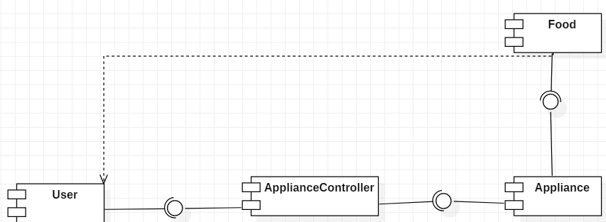

**Deployment Diagram**

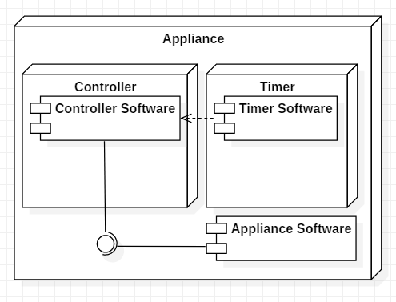

3. Code your design and create a simulation of the device being used in function main. (10pts)