Working prototype: https://cra-test-arc.canada.ca/t1-readmes-nav-2026/

T1 Navigation change plan
As it is now, the current-year T1 form readmes are already linked to from the forms listing page but are not in the forms “folder”. Breadcrumbs point the T1 package, and non-current forms are not linked to from there.
This project assumes this will be implemented entirely before AU for tax year 2026.
Notes: (For parissa to integrate in)
- 5013-G has a readme

Task overview
- Add all non-current forms to the listing table
- Remove all existing prior year T1 forms readmes
- Create new readmes (new templates, with table where applicable) for current and non-current forms that have prior years in the last 10 years (only one readme per form)
  - https://www.canada.ca/en/revenue-agency/services/forms-publications/forms/
  - Update the breadcrumbs
- We have approval to change the H1s of the forms listing page (for cleaner and more consistent H1s and breadcrumbs) as follows:
  - Canada Revenue Agency CRA forms listed by number - Canada.ca
  - Formulaires de l’Agence du revenu du CanadaARC classés par numéro de formulaire - Canada.ca
  - Parissa to check with DUA as well
- For the new “unified” forms (122 EN/FR sets), Karen is working on updated H1s/titles that fit the last 10 years
  - We have some recommended EN and FR phrases to address the region variances and exceptions that translate well (refer to “Suggested H1 endings for T1 federal forms” section below)
- Karen is working on intros/descriptions that fit the last 10 years
  - 1-2 sentences, that describes what this form is, and when you should use it
  - (Emailed Naomi for her input. We can proceed unbounded by meta character limits.)
- Karen is working on keywords (optional)
  - Any relevant terms not in the H1s can be included in the keywords metadata for CRA search purposes
- We need the subject line for each form (suggestion provided was agreed on)
- All guides remain where they are and breadcrumbs remain unchanged
- Starting 2025, the guides will contain a table that points to prior year guides, but prior year guides are not updated
  - The content of the tables on all guides with tables is updated each year to the last 10 year (ajaxed)
  - As time passes, the existing prior guides will be unpublished each year
  - 5013-g is the exception – it will have one readme for all years like the forms.

- Links are updated on all tax package pages (as mocked up in the prototype):
  - The links are updated to the new location of the forms
  - URL parameters and anchors (e.g.: ?yr=2018&rgn=mb#prvs-yrs) are added to all prior year links to:
    - Jump to the prior year table section
    - Filter the table by the year
    - Create the rescue/return sentence before table (e.g.: To find other 2018 forms or guides you may need for Alberta, return to the 2018 Income tax package for Alberta.)
- Link management:
  - We will need to run a (grep) search to find all other links to forms readmes and update them
  - We wil have to decide in each case, whether the prior year links will be updated to point to the new page or its table section
  - Set up redirects for all prior year forms. The list is in the Excel file.
    - I confirmed that redirects can have anchors in them.
    - Question: Does it make sense to redirect to the table for the prior year links?
- Update all current year guides to replace the last two H2 sections with a new one that includes a table:
  - Anchors on the current year guides to the forms need to be reviewed and updated to point to the table, or directly to a particular format
  - The Previous-year versions link existing on prior year guides can be updated to point to the current year guide table (optional)

Suggested H1 endings for T1 federal forms
The following suggestions are for made considering clarity, consistency and brevity. I believe provincial forms are clear enough and do not need these details.
When it is for all regions/groups (eg: 5000-S7)
I don't think we can specify provinces and territories, because then we have to say non-residents too. And it does not need to be that clear because the tax package pages specify which are needed for each year
- (for all)
- (pour tous)
When it is for all, but with exceptions (eg: 5000-S2)
- (for all except QC and non-residents)
- (pour tous sauf QC et non-résidents)
When provinces are specified and vary by year (eg: 5000-R)
- (for multiple provinces and territories)
- (pour plusieurs provinces et territoires)
For one province only (eg: 5009-R)
- (for AB)
- (pour AB)

Technical implementation plan (mostly for WebDev)
- Updating all referring links is a huge job, so perhaps it can be done in stages (this is up to WebDev)
- The forms and guides table data JSON files are ready for 2025 on UT. (Outdated! Update templates from GitHub before use)
- \\omega.dce-eir.net\etm\ETMWinHeadProd\cra_web_ut\cra_htdocs\test\mathieu\t1-table-data
- They have also been added to AEM assets folder (May be outdated)
  - pbg-table-json | AEM Assets | Files
  - pub-table-json | AEM Assets | Files
- The JSON files can also be reviewed on Github:
(t1-readmes-nav-2026) Github repository sitemap - Canada.ca
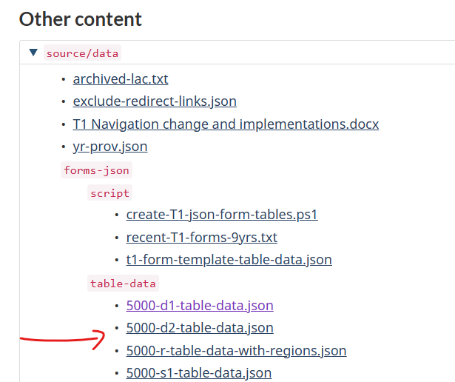
- All tables have a provisional Filter emphasis and a “Clear filter” button below the tables
- We have a new D2GC script and set of template that takes care of 3 separate situations modeled in 5000-S2, 5015-R and 5009-R
- PP has advised they don’t want to approve the use of content fragments. They would prefer to fix the loading order of ajaxed content. In the meantime, the dymanic code will be hardcoded into the D2GC templates.
- Forms 5000-R and 5015-R, can be initially generated with D2GC, and then they must be updated to include the province column
- The list of forms has been double checked against the FUG and is acurate for 2025 tax year:
  - cra-test-arc.canada.ca/t1-readmes-nav-2026/source/data/forms-json/script/recent-T1-forms-9yrs.txt
- For guides:
  - The JSON manager can be hard coded for now, until the ajax loading order is fixed
  - 5000-g will have its own Json manager due to the region column, so it can be hardcoded as well
- Come up with an AU process update that is feasible for following years
- Chris completed a heuristic review and has approved the code
- Shayna completed an accessibility review, and corrections have been made

