Response to the Reviewers' Comments on Manuscript FPE-D-18-00388

To: Prof. Ioannis Economou
Editor
Fluid Phase Equilibria

Dear Prof. Economou:

Thank you for your message forwarding the reviewers' comments on our manuscript entitled “Evaluation of the SAFT-γ Mie force field with solvation free energy calculations”. We have carefully addressed all comments, which required us to make changes in the text. To facilitate your evaluation, we have attached an annotated version in which we crossed out in red all removed text and incorporated new content in blue.

The comments and suggestions of both reviewers were important for improving the quality of our manuscript. However, with all due respect, we have disagreed with Reviewer #1 regarding the suitability of the model parameters we obtained for a specific substance (phenanthrene). Thus, we decided to maintain the same parameters of the original version. The reasons why we made this choice are presented in the response to that reviewer.

We hope the revised version of our manuscript is suitable for publication in this journal.

Sincerely yours,

Charlles R. A. Abreu  Assistant Professor  Federal University of Rio de Janeiro | Isabela Quintela Matos  Ph.D. Student  Cornell University

Comments by Reviewer#1

In this work, the authors have been evaluated the performance of a coarse-grained model, which is based on the SAFT-g Mie Force field, to calculate the solvation free energy of asphaltene – like molecules in both aqueous and organic solvents. In order to carry out this evaluation, Molecular Dynamics simulation in the expanded ensemble was used. The authors provide a full description of the used methods.
Based on the main results, the authors state that SAFT-g Mie force field exhibits low deviations from experimental data, which represent an important advance of the use of SAFT-g Mie force field to model solvation free energy, and then other related properties, such as Henry constant and solubility.
In general terms, this is a very interesting work and very appropriat for this journal. However, the present version of the manuscript cannot be accepted in the present form due to some parts need to be revised, as they are described below:

In the manuscript, the authors state that the molecular parameters for phenanthrene are not available in the original database (ref. 25).

This is an unappropriated affirmation due to Ref. 25 provides a correlation to calculate the molecular parameters using the values of critical temperature, acentric factor and a liquid density at Tr = 0.7. The following table summarizes the corresponding molecular parameters:
Considering the previous point, the authors rather than calculate the parameters from the Ref. 25, decide to calculate these three parameters only using vapor pressure data. This procedure is not appropriate due to only a single set of data are used to define three molecular parameters. Additionally, some of them scale to temperature or density rather than only vapor pressure. In fact, the authors claim the reported parameter are appropriate to describe the vapor pressure which is a logical conclusion due to these are fixed using three parameters, but these parameters are not able to predict correctly the phase equilibria, as it is shown in the following figures:
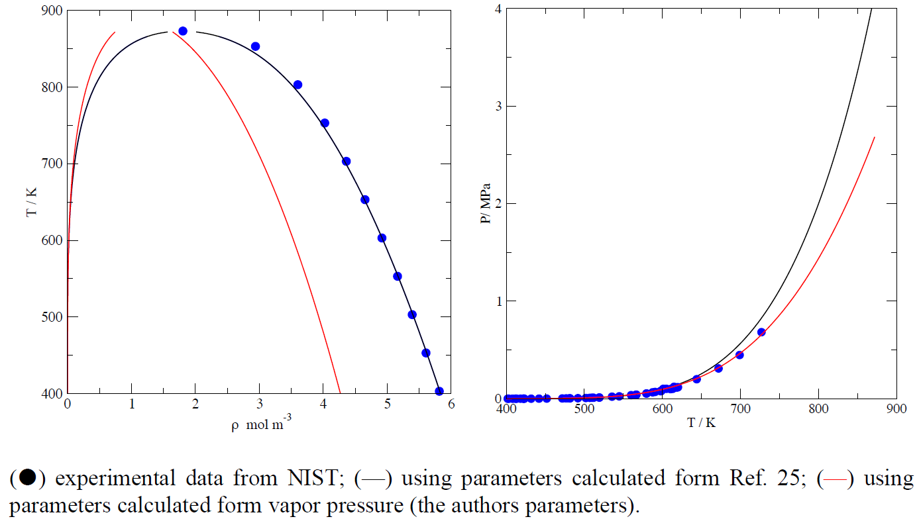
Therefore, the authors need to use the molecular parameters reported in Ref. 25 rather than those obtained from vapor pressure only.

For the revised version, it is necessary to revised some parts of the manuscript due to some
paragraphs are used two or three times.

Response to the Comments

We thank the reviewer for such a careful and detailed review. In what follows, we respectfully present some arguments in favor of our original approach and hope they suffice to make the revised version of our manuscript acceptable for publication.

Reviewer: In the manuscript, the authors state that the molecular parameters for phenanthrene are not available in the original database (ref. 25). This is an unappropriated affirmation due to Ref. 25 provides a correlation to calculate the molecular parameters using the values of critical temperature, acentric factor and a liquid density at Tr = 0.7.

Our answer: We totally agree that Ref. 25 provides a very general and useful correlation for obtaining Mie parameters from a small set of pure-substance experimental data. However, despite our efforts, we were not able to find saturated liquid density data for phenanthrene in publicly available sources. We do not have a license to use the NIST REFPROP Database, which we presume was the tool employed by the reviewer in his/her meticulous analysis of our manuscript. In face of our struggle to find data required for using the correlation, we still believe that our affirmation in the manuscript was appropriate. We added a justification for our adopted procedure on the third page of the revised version. Please find it in the last full paragraph of such page.

Reviewer: This procedure [calculating parameters using vapor pressure data only] is not appropriate due to only a single set of data are used to define three molecular parameters.

Our answer: In the fitting procedure, we employed 15 data points to obtain 3 parameters, which is appropriate from the statistical standpoint. Moreover, the shape of a liquid-vapor saturation curve (vapor pressure vs. temperature) is a complex phase-equilibrium property that depends on the interplay of enthalpic and entropic effects, thus bearing a considerable amount of information about the system. Unfortunately, because the density of the saturated liquid is overlooked in the procedure, our parameters are not expected to be suitable for the calculation of the volumetric properties of pure phenanthrene. This becomes clear with the results kindly provided by the reviewer. Also on page 3 of the revised manuscript, we state explicitly that the parameters should not be used for volumetric property calculations.

Reviewer: Therefore, the authors need to use the molecular parameters reported in Ref. 25 rather than those obtained from vapor pressure only.

Our answer: We used the parameters reported in Ref. 25 for benzene, toluene, pyrene, and anthracene. As claimed above, however, the parameters for phenanthrene were not reported in such reference. Besides, using the parameters provided by the reviewer would require a license which we do not possess. In view of these facts, we insist on using the parameters obtained from fitting the vapor pressure curve only. In the manuscript, Table 2 contains free energies of solvation in 1-octanol predicted for phenanthrene (using our set of parameters) and for anthracene (using the parameters of Ref. 25). As one can observe, the best prediction was done with our own parameters. Of course, such a single example is not enough for a comparison between the two strategies, but at least it demonstrates that our strategy should not be entirely discarded.

During the reviewing process, we realized that the acentric factor of anthracene used in Ref. 25 (ω=0.3314) is very different from the value reported in the book “The Properties of Gases and Liquids”, 5th Ed., by Poling et al. (ω=0.501). As an exercise, we took an Antoine model* for anthracene from the NIST Chemistry WebBook and the critical temperature used in Ref. 25 (T_{c}=876 K). By extrapolating the model up to T_{c}, we obtained a critical pressure of 29.2 bar. Then, by applying the acentric factor definition, the answer we obtained was 0.473, which is much closer to 0.501 than to 0.3314. For phenanthrene, the values are ω=0.479 from Poling et al. and ω=0.474 from an Antoine model** analysis using T_{c}=873.15 K, which compare much more consistently with the value ω=0.53148 provided by the reviewer.

The acentric factor plays a crucial role in the correlation of Ref. 25 as it determines the repulsive exponent of the Mie potential, then affecting the other parameters as well. The inconsistency among properties coming from the same source (i.e. NIST) called our attention and could possibly be another reason why the solvation free energy was less suitably predicted for anthracene than for phenanthrene. This discussion has been included in the manuscript (on pages 7 and 8).

*https://webbook.nist.gov/cgi/cbook.cgi?ID=C120127
**https://webbook.nist.gov/cgi/cbook.cgi?ID=C85018

Reviewer: For the revised version, it is necessary to revised some parts of the manuscript due to some paragraphs are used two or three times.

Our answer: We thank the reviewer for pointing this out and we sincerely apologize for such a foolish mistake. The repeated paragraphs have been completely removed.

Comments by Reviewer #2

Given that it is currently unfeasible to design chemical processes only using calculations based on first principles, like quantum mechanics and molecular simulations, there has been great interest in the so-called multiscale approach, in which information obtained from more detailed models are used to fit the parameters of coarser models. This paper takes the opposite approach by transferring parameters fitted for an equation of state to molecular simulations. This is certainly not the first paper to follow this path but the specific application is new. Further, given the plethora of existing experimental data for macroscopic properties that can be modeled with an equation of state, this approach makes it possible to apply molecular simulations to systems whose force field is unknown. Therefore, work in this area is relevant and potentially of practical interest. The authors focus on the evaluation of solvation free energy calculations, with emphasis on components present in asphaltenes because of their importance to the oil industry.

The paper is generally well-written. The literature review provided in the Introduction section is informative and discusses recent contributions to the field. Likewise, the sections that describe the methodology provide enough detail to reproduce the calculations. The equation of state parameters were taken from the literature, with exception of phenantrene, whose parameters were fitted for the submitted paper. The results are well discussed, with special attention to hydration energies, which could only be modeled properly using a binary interaction parameter fitted from molecular simulations. Despite this, the case of water is important because it highlights the need for future improvements in the coarse-grained force field.

Overall, I think this is an excellent paper that should be published. I have the following requests for minor comments and/or changes:

1) MBAR: appears in page 5 but the meaning of the acronym is given in page 6 for the first time. The acronym definition should be presented in the its first use in the text.

2) Table 5 is mentioned before Table 4 in the text. These tables should be renumbered.

3) Page 11, column 1, third line from the bottom of the page: it should be "compatible".

4) Pages 11 and 12: Starting from the paragraph beginning with "Overall, …" in page 11 until the end of section 4, the authors mostly summarize what was discussed before. I think that this part of the text should be much shorter.

Response to the Comments

Reviewer: MBAR: appears in page 5 but the meaning of the acronym is given in page 6 for the first time. The acronym definition should be presented in the its first use in the text.

Our answer: We thank the reviewer for pointing this out. The acronym MBAR is now properly defined on page 5 and the method is now referred to by its full name in the abstract.

Reviewer: Table 5 is mentioned before Table 4 in the text. These tables should be renumbered.

Our answer: We agree with the reviewer. The mentioned tables are now in the appropriate order.

Reviewer: Page 11, column 1, third line from the bottom of the page: it should be "compatible".

Our answer: We thank the reviewer for pointing this out. This mistake has been corrected.

Reviewer: Pages 11 and 12: Starting from the paragraph beginning with "Overall, …" on page 11 until the end of section 4, the authors mostly summarize what was discussed before. I think that this part of the text should be much shorter.

Our answer: In fact, the mentioned paragraph should not be in Section 4, but only in the conclusion section. This and other paragraphs were mistakenly repeated in the original version of the manuscript due to our poor ability with using an automatic version control system. We apologize for this fault. All improper repetitions have been fully removed.

