Parallelizing JPEG Image Compression

Paul Miranda, Hamilton Turner

Table of Contents
Project Objectives 3
Background 3
Related Work 3
Problem Description 3
Solution Approach 3
Experimental Evaluation 3
Conclusions 3

Project Objectives

The main objective of this work was to increase the speed of compressing and converting image data into the JPEG standard using multiprocessor programming paradigms.

Background
The JPEG format was established in _____ by ____. It increased in popularity during ____. Due to the current trend towards multicore computers, coupled with the popularity of the JPEG format, motivates the need for high-efficiency JPEG image compression.

Standard JPEG compression operates into a small number of primary steps: the color format of the original image is converted to YCrCb, the image is sampled into a grid of blocks, a Discrete Cosine Transform is performed on each block, and lastly the resulting data is encoded using Huffman encoding.

*overview of how JPEG compression works*
*properties of DCT and huffman that make this appealing for JPEG*

Related Work

Problem Description

Solution Approach
The first step in increasing the speed of compression was identifying the major bottlenecks of a single-threaded JPEG compression approach. We wrote a bootstrapping framework that allowed our team to identify the major time bottlenecks within JPEG compression. The figure below shows our initial timing results for seven images. We broke the timing test into preparing the data structures needed to compress the image, which composes converting the color scheme, building DCT tables, and building Huffman tables. This graph tells us that both of these operations are expensive, so we needed finer timing information.
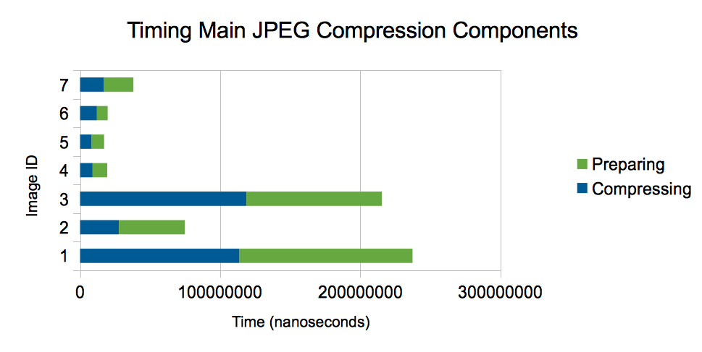
We next tested to identify the main components of the preparation stage. It rapidly became obvious that the main bottleneck for preparing for JPEG compression was converting the color scheme. Java's PixelGrabber class was used to read pixel-level red-green-blue (RGB) data from multiple possible types of image files. This RGB data was then converted to the YCrCb data scheme that is needed for JPEG compression.

Within the area of compressing the data, it was determined that the DCT operation and the Huffman encoding operation took similar amounts of time. *TODO add in a chart or some data supporting this claim*

Parallelizing Color Scheme Conversion

Our first approach to parallelizing the color scheme conversion included creating three dedicated threads, one per component. The chart below shows timing results for using this approach on ~200 images. A positive bar indicates that the multithreaded approach was faster, while a negative bar indicates that the single threaded approach was faster. It is apparent from these results that the single threaded approach is outperforming the multithreaded approach frequently.

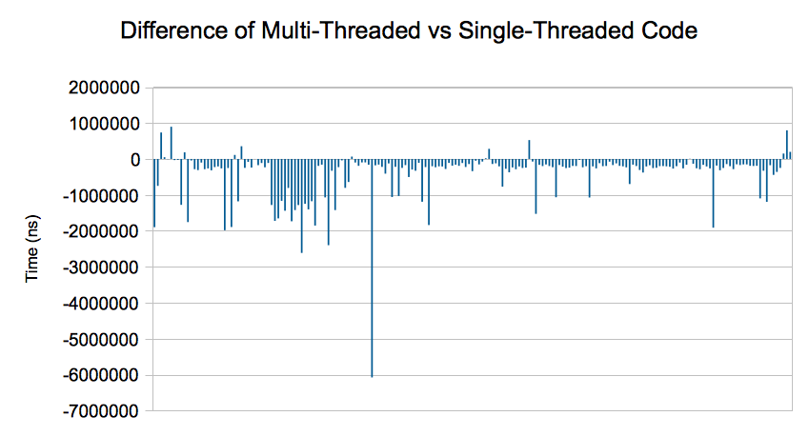
Looking more closely into the code, we noticed that each separate component has to run a loop similar to the following:
for (y = 0; y < imageHeight; ++y) {
for (x = 0; x < imageWidth; ++x) {
r = ((values[index] >> 16) & 0xff);
g = ((values[index] >> 8) & 0xff);
b = (values[index] & 0xff);

// Color Conversion
Y[y][x] = (float) ((0.299 * r + 0.587
* g + 0.114 * b));
index++;
}
}
After some testing, we determined that the primary gain in time was due to calculating the RGB values for each pixel three times (once per component thread), while the single-threaded approach was able to only calculate these values once. This prompted us to make each thread process some pixel region of the image, calculating and storing all of the components for that region. At this point, we decided that perhaps retrieving the pixel data from the files could also be multithreaded. We began by writing a single worker that would access a shared counter, get the next un-converted column in the image, grab the pixels, and convert them. Multiple worker threads could be launched, and they would terminate when there were no more columns. This approach was massively slower than the single-threaded approach, by an order of magnitude. After testing, we determined that the PixelGrabber class was where most of the slowdown was occurring inside of each worker thread. Reading background information on the PixelGrabber, it became apparent that PixelGrabber was internally translating between a number of possible ways to store image data and RGB values, and depending upon how the data is stored internally different methods of reading the data out are faster or slower. The recommended method of using PixelGrabber is to request all the pixels that you will eventually want and allow PixelGrabber to internally optimize how the pixels are read out. By forcing PixelGrabber to only read small chunks of data, such as a single row or a single column, we were slowing the entire operation down massively.

Our final approach uses PixelGrabber in a single-threaded manner to retrieve all the pixel data. Internally, PixelGrabber can optimize the manner in which pixels are retrieved and written into memory. Once all pixels are read in, we launch multiple worker threads, passing each thread a handle to an array containing the initial RGB values, a handle to the array where the Y component values should be stored, a handle to the array where the Cr component values should be stored, and a handle to the array where the Cb component values should be stored. All workers share an AtomicInteger that stores the last-converted row. Each worker grabs the next row to convert, converts the color scheme of that row from RGB to YCrCb pixel by pixel, and stores the output values. As each thread realizes that all rows have been processed it terminates itself.

Parallelizing DCT and Huffman Encoding

Experimental Evaluation

Conclusions

