Quite simply

Housing and transportation are most household's two largest expenditure categories, and are a major financial burden for many lower-income households. As a result, increasing housing and transportation affordability is an important planning objective. In recent years, planners have developed a better understanding of what this means and how to evaluate affordable housing development strategies.  
  
What is Affordability?  
Affordability refers to households' ability to purchase essential goods and services, and so depends on their ability to control costs, for example, to reduce housing and transport expenditures so more money is available for food, healthcare and education. Although all households want to save money—even wealthy households enjoy cheaper limousine fuel and discounted first-class airfares—affordability applies primarily to lower-income households that have difficulty purchasing basic goods. Not every household will take advantage of all money-saving opportunities, some may choose more expensive homes or vehicles than absolutely necessary for practical purposes, but the ability to save money increases affordability and economic security.

## **Affordable Housing Strategies**

Five common strategies for increasing housing affordability are described and compared below.

**1. Maintain Older Housing**

**2. Government Subsidized Housing**

**3. Urban Fringe Development**

**4. Affordable Housing Mandates ("Inclusionary Zoning")**

**5. Reduce Infill Development Costs**

**…..**

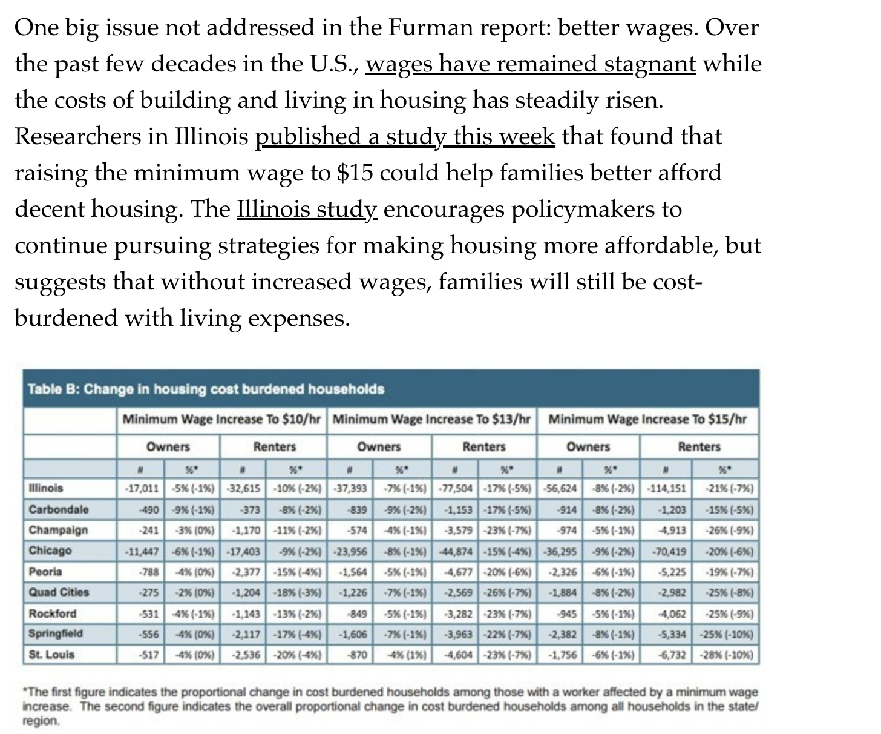

[**https://www.handhousing.org/seven-innovative-affordable-housing-strategies-in-higher-cost-markets-lessons-from-around-the-u-s/**](https://www.handhousing.org/seven-innovative-affordable-housing-strategies-in-higher-cost-markets-lessons-from-around-the-u-s/)

**Ref:** [**https://www.planetizen.com/node/85106/evaluating-affordable-housing-development-strategies**](https://www.planetizen.com/node/85106/evaluating-affordable-housing-development-strategies)