AI Lab 09

18L-1139

**Q1:**

Accuracy

**Sigmoid:**

313/313 - 0s - loss: 0.3414 - accuracy: 0.8762

Test accuracy: 0.8762000203132629

**Tanh:**

313/313 - 0s - loss: 0.3275 - accuracy: 0.8851

Test accuracy: 0.8851000070571899

**Relu:**

313/313 - 0s - loss: 0.3273 - accuracy: 0.8863

Test accuracy: 0.8863000273704529

Selected: relu

**Q2:**

**Relu with 128, 128:**

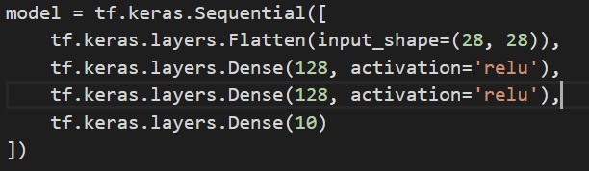

313/313 - 0s - loss: 0.3518 - accuracy: 0.8836

Test accuracy: 0.8835999965667725

**Relu with 128, 100:**

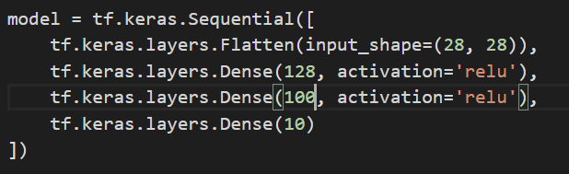

313/313 - 0s - loss: 0.3306 - accuracy: 0.8802

Test accuracy: 0.8802000284194946

**Relu with 128, 75:**

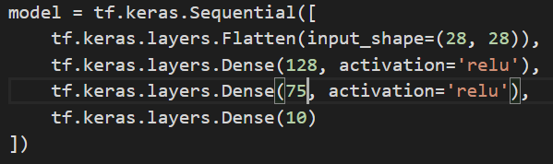

313/313 - 0s - loss: 0.3457 - accuracy: 0.8783

Test accuracy: 0.8783000111579895

Relu with 128,128 has most accuracy.

**Q3:**

Changed data to mnist handwritten

**Sigmoid:**

313/313 - 0s - loss: 0.0765 - accuracy: 0.9747

Test accuracy: 0.9746999740600586

**Tanh:**

313/313 - 0s - loss: 0.0733 - accuracy: 0.9783

Test accuracy: 0.9782999753952026

**Relu:**

313/313 - 0s - loss: 0.0900 - accuracy: 0.9784

Test accuracy: 0.9783999919891357

**Selected:** relu (max accuracy)

**Relu with 128,128:**

313/313 - 0s - loss: 0.0992 - accuracy: 0.9761

Test accuracy: 0.9761000275611877

**Relu with 128, 100:**

313/313 - 0s - loss: 0.0812 - accuracy: 0.9806

Test accuracy: 0.9805999994277954

**Relu with 128, 75:**

313/313 - 0s - loss: 0.0950 - accuracy: 0.9778

Test accuracy: 0.9778000116348267

Relu with 128, 100 has most accuracy.