Course Four

Regression Analysis: Simplifying Complex Data Relationships
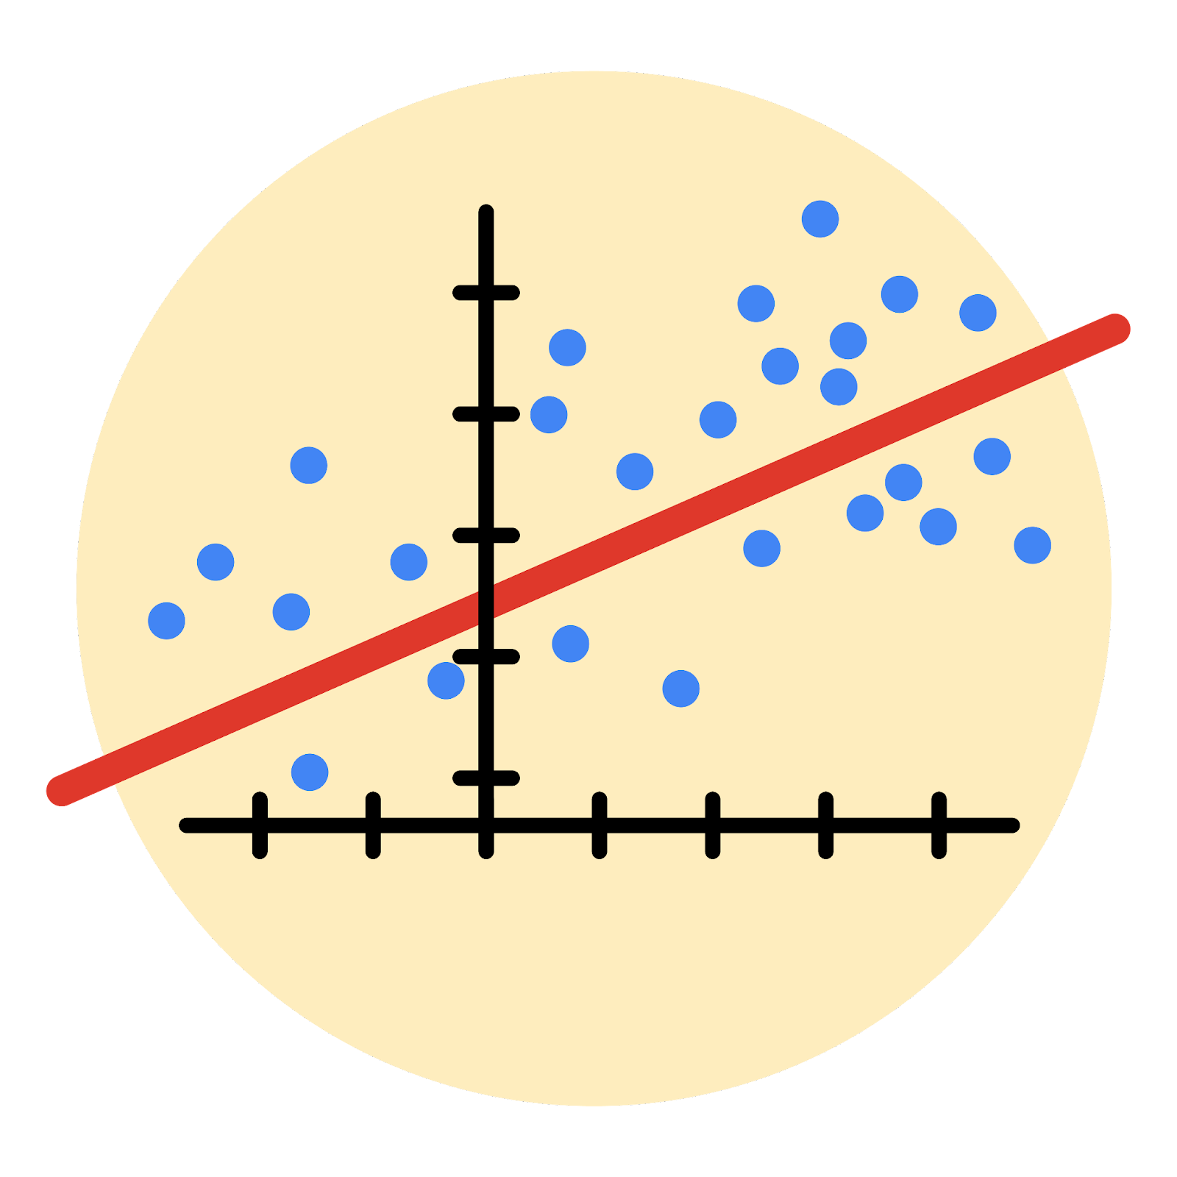

Instructions
Use this PACE strategy document to record decisions and reflections as you work through this end-of-course project. As a reminder, this document is a resource that you can reference in the future, and a guide to help you consider responses and reflections posed at various points throughout projects.

Course Project Recap
Regardless of which track you have chosen to complete, your goals for this project are:
- Complete the questions in the Course 4 PACE strategy document
- Answer the questions in the Jupyter notebook project file
- Build a multiple linear regression model
- Evaluate the model
- Create an executive summary for team members

Relevant Interview Questions
Completing the end-of-course project will empower you to respond to the following interview topics:
- Describe the steps you would take to run a regression-based analysis
- List and describe the critical assumptions of linear regression
- What is the primary difference between R² and adjusted R²?
- How do you interpret a Q-Q plot in a linear regression model?
- What is the bias-variance tradeoff? How does it relate to building a multiple linear regression model? Consider variable selection and adjusted R².
Reference Guide
This project has seven tasks; the visual below identifies how the stages of PACE are incorporated across those tasks.
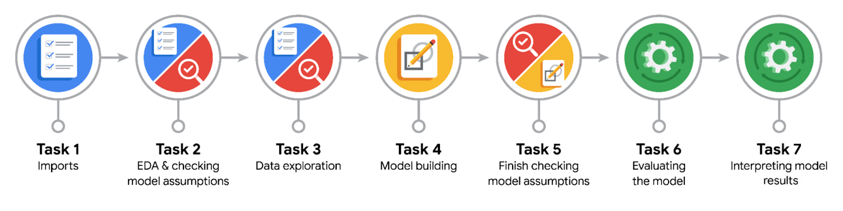

Data Project Questions & Considerations
PACE: Plan Stage
- Who are your external stakeholders for this project?
External stakeholders are Juliana Soto (Finance and Administration Department Head) and Titus Nelson (Operations Manager) at the NYC TLC. The deliverable is a multiple linear regression model that estimates taxi fares before the ride.

- What are you trying to solve or accomplish?
The goal is to build a multiple linear regression model that estimates taxi fare amounts based on trip characteristics (such as trip distance and trip duration). An accurate pre-ride fare estimate helps the NYC TLC give riders upfront pricing transparency and supports operational planning.

- What are your initial observations when you explore the data?
Initial observations from prior EDA work on this dataset: the data contains 408,294 rows and 18 columns. Several data quality issues were identified that will need handling before modelling — negative fare and total amounts (likely payment reversals), zero trip distances (cancelled trips or recording errors), zero passenger counts, and a RatecodeID value of 99 that does not match the documented codes. The datetime columns (tpep_pickup_datetime, tpep_dropoff_datetime) are stored as object type and need conversion before deriving trip duration. Cash tips are not recorded in the dataset, which is a structural limitation — this rules out using tip_amount as a reliable feature. The numerical variables (fare_amount, trip_distance, passenger_count) have a wide range with clear outliers in the upper tail.

- What resources do you find yourself using as you complete this stage?
Resources used in the Plan stage: course materials from the Google Advanced Data Analytics Certificate (particularly Course 4 regression analysis content), prior project documentation from Courses 1–3 of the Automatidata scenario (PACE documents, EDA findings, data quality log, hypothesis testing results), the NYC TLC data dictionary, and Python library documentation (pandas, statsmodels, scikit-learn, seaborn, matplotlib).

PACE: Analyze Stage
- What are some purposes of EDA before constructing a multiple linear regression model?
EDA before building an MLR model serves several purposes: identifying missing values, nulls, and duplicates so they can be addressed; identifying outliers and deciding on handling strategies (drop, cap, impute); understanding the distributions of variables to assess what statistical inferences are valid; checking for multicollinearity between predictor variables, since highly correlated predictors weaken coefficient interpretability; identifying variables that are near-constant and therefore unlikely to be predictive; and spotting opportunities to feature engineer new variables (such as deriving trip duration from datetime columns) that better capture the underlying signal.

- Do you have any ethical considerations at this stage?
Ethical considerations at this stage centre on the data itself and how it might affect users of the model. The TLC dataset reflects historical taxi trips, so any patterns learned by the model inherit whatever biases exist in that history — for example, if certain neighbourhoods were historically underserved, the model could carry that pattern forward. Cash tips are not recorded in the dataset, which is a structural blind spot that limits any analysis involving tips. Fare estimates presented to riders also carry direct impact: inaccurate estimates could mislead them, with underestimates causing frustration when actual fares are higher and overestimates potentially deterring legitimate trips. Location data (pickup and dropoff IDs) also warrants care — while aggregated data is fine for modelling, individual trip-level exposure could raise privacy concerns.

PACE: Construct Stage
- Do you notice anything odd?
A few things stood out during the modelling work. First, negative values in fare_amount and duration — impossible in reality, most likely payment reversals or recording errors. Second, two horizontal lines in the scatter plot of fare_amount vs mean_duration: one at $62.50 (the artifact of the outlier cap imputed during cleaning) and another at $52, which turned out to be the JFK flat-rate fare (RatecodeID = 2). This is a structural pricing rule that violates the linearity assumption for those specific trips, since a JFK ride costs $52 regardless of distance or duration. Third, mean_distance and mean_duration are highly correlated with each other (Pearson = 0.87) — a multicollinearity concern that weakens individual coefficient interpretability, though the overall model still predicts accurately. Finally, the model actually performed slightly better on the test set than on the training set, which is unusual — likely a mild sign of data leakage from computing mean_distance and mean_duration on the full dataset rather than just the training set.

- Can you improve it? Is there anything you would change about the model?
Several improvements could be made to the model. First, the multicollinearity between mean_distance and mean_duration (Pearson = 0.87) weakens individual coefficient interpretation — one option would be to drop one of them or combine them into a single feature; alternatively, Ridge or Lasso regularisation could stabilise the coefficients while retaining both. Second, the model treats JFK flat-rate trips (RatecodeID = 2) as regular fares even though they are structurally fixed at $52 regardless of distance or duration; a better approach would be to separate those trips out and impute $52 directly after model prediction, rather than forcing the linear model to fit them. Third, mean_distance and mean_duration were computed on the full dataset, which introduces data leakage — best practice would be to compute those averages using only the training data and map them onto the test set, preventing test-set information from influencing training. Finally, the negative fare and duration values were imputed with 0; it would be worth comparing that approach against simply dropping those rows to see which yields a more robust model.

- What resources do you find yourself using as you complete this stage?
Resources used in the Construct stage include course materials from the Google Advanced Data Analytics Certificate (particularly the modules on regression modelling, model evaluation, and interpreting coefficients), the results of the EDA and feature engineering completed in the Analyze stage, and Python library documentation. Key libraries used at this stage were scikit-learn (LinearRegression, StandardScaler, train_test_split, and the metrics module for R², MAE, MSE, and RMSE), pandas and numpy for data manipulation, and matplotlib and seaborn for visualising residuals and model outputs.

PACE: Execute Stage
- What key insights emerged from your model(s)?
The model produced several key insights. First, taxi fare amount has a strong linear relationship with the primary predictors — mean_distance and mean_duration — with the model explaining approximately 87% of the variance in fare amount (R² ≈ 0.87 on the test set). Second, mean_distance emerged as the most influential predictor: after unscaling the standardised coefficient back to original units, fare increases by approximately $2 for every additional mile travelled. Third, the residual diagnostics showed that errors are normally distributed and centred near zero, confirming that the model's predictions are unbiased across the range of fare values. Fourth, the model surfaced a structural feature of NYC taxi pricing that a purely linear approach cannot capture: JFK trips (RatecodeID = 2) are charged a flat $52 regardless of distance or duration, which appeared as a distinct horizontal band in the scatter plots and shows up as systematic residuals in the diagnostic plots. This finding suggests the model can be improved by handling these trips separately from the linear prediction.

- What business recommendations do you propose based on the models built?
Several business recommendations follow from the model. First, deploy the model as an upfront fare estimator that shows riders an expected fare at the point of booking, using pickup and dropoff zones (to look up historical mean distance and duration for the route), day of week, time of day, and rush hour status — all of which are known before the trip begins. Second, handle JFK trips (RatecodeID = 2) as a separate case: since the fare is a fixed $52 regardless of distance or duration, impute this value directly rather than relying on the model's linear prediction. Third, communicate the estimate transparently — the model's mean absolute error is approximately $2, meaning most predicted fares will land within a couple of dollars of the actual amount, and framing this appropriately to riders will build trust. Fourth, the model should be periodically retrained on newer data to reflect changes in pricing structures, traffic patterns, and demand over time. Finally, follow-up work could explore adding features such as weather conditions or event schedules, and testing regularised regression (Ridge or Lasso) to address the multicollinearity between mean_distance and mean_duration.

- To interpret model results, why is it important to interpret the beta coefficients?
Interpreting the beta coefficients is important for several reasons. They quantify how much each predictor influences the outcome — for example, in this model each additional mile of mean_distance adds approximately $2 to the fare, holding other variables constant. The sign of each coefficient indicates the direction of the effect (positive = increases fare, negative = decreases), and the magnitude ranks predictor importance so you can see which variables matter most. Coefficients also enable actionable business insights: a stakeholder cannot act on "the model is 87% accurate," but they can act on "for every additional mile, fare increases by $2." They are equally important for stakeholder communication — non-technical audiences understand concrete unit-based interpretations more easily than model-fit metrics. Finally, coefficients serve as a model validation check: signs and magnitudes should align with domain intuition (positive for distance and duration, in this case). An unexpected sign or an unusually large magnitude is a red flag worth investigating before deployment.

- What potential recommendations would you make?
Several recommendations would improve the model and support its long-term utility. First, handle JFK trips separately by imputing the flat rate of $52 for all trips where RatecodeID = 2, rather than relying on the linear model to predict them. Second, address the data leakage issue by computing mean_distance and mean_duration using only the training set and then mapping those values onto the test set, preventing test-set information from contaminating training. Third, test Ridge or Lasso regularisation to stabilise coefficient estimates given the multicollinearity between mean_distance and mean_duration. Fourth, consider engineering additional features that could capture more of the variance in fare amounts — such as weather conditions, event schedules, or holiday indicators. Finally, the model should be periodically retrained on newer data to reflect ongoing changes in pricing structures, traffic patterns, and demand.

- Do you think your model could be improved? Why or why not? How?
The model performs well as it stands, with a test R² of approximately 0.87 and a mean absolute error of around $2, indicating strong predictive accuracy and unbiased residuals. However, several improvements are still possible. Some data quality issues were addressed during cleaning (negative fares and durations imputed to zero, extreme outliers capped via IQR-based winsorization), but other structural issues remain: JFK flat-rate trips are still fit linearly rather than imputed as $52, multicollinearity between mean_distance and mean_duration (Pearson = 0.87) weakens individual coefficient interpretability, and the route-level mean features were computed on the full dataset rather than only the training set, introducing mild data leakage. Addressing these — by imputing JFK fares directly, testing Ridge or Lasso regularisation, and re-engineering the mean features using training data only — should further strengthen the model.

- What business/organizational recommendations would you propose based on the models built?
Addressed in earlier business recommendations question

- Given what you know about the data and the models you were using, what other questions could you address for the team?
Beyond the fare prediction model itself, the same or related data could address several other questions for the team. For instance: how do weather conditions, holidays, and major events affect taxi demand across different zones? Which pickup and dropoff zones generate the most revenue, and are there underserved areas that could benefit from targeted service? What time-of-day patterns emerge in ride volume and profitability, and how do these vary across boroughs? How does payment method influence tipping behaviour among credit card users, building on the Course 3 A/B test findings? Which trips are most likely to be cancelled, and can that be predicted in advance to help with dispatching? These questions extend the analytical value of the TLC dataset well beyond fare prediction.

- Do you have any ethical considerations at this stage?
Addressed in earlier ethical considerations question

