Implement a linear regression model with a single neuron model

Linear regression is one of the simplest machine learning models used for predicting a continuous target variable based on one or more predictor variables. The simplest form of a linear regression model, which uses a single feature, can be visualized as a straight line fitted to a scatter plot of the data.

### **Single Neuron Model**

A single neuron model, also known as a perceptron, can be used to implement linear regression. This model consists of the following components:

* **Inputs (features)**: The data points.
* **Weights**: Coefficients that determine the importance of each input.
* **Bias**: An additional parameter that allows the model to fit the data better.
* **Activation Function**: For linear regression, this is typically a linear function (i.e., no activation function).

**import numpy as np**

**import matplotlib.pyplot as plt**

**# Generate some synthetic data**

**np.random.seed(0)**

**X = 2 * np.random.rand(100, 1)**

**y = 4 + 3 * X + np.random.randn(100, 1)**

**# Function to perform linear regression using a single neuron model**

**def linear_regression(X, y, learning_rate=0.01, epochs=1000):**

**m, n = X.shape**

**X_b = np.c_[np.ones((m, 1)), X] # add bias term (x0 = 1)**

**theta = np.random.randn(n + 1, 1) # initialize weights randomly**

**for epoch in range(epochs):**

**gradients = 2/m * X_b.T.dot(X_b.dot(theta) - y)**

**theta -= learning_rate * gradients**

**return theta**

**# Train the model**

**theta = linear_regression(X, y)**

**# Plot the results**

**plt.plot(X, y, "b.")**

**plt.plot(X, theta[0] + theta[1] * X, "r-")**

**plt.xlabel("x")**

**plt.ylabel("y")**

**plt.title("Linear Regression with a Single Neuron Model")**

**plt.show()**

**# Display the learned parameters**

**print(f"Intercept (bias): {theta[0][0]}")**

**print(f"Slope (weight): {theta[1][0]}")**

Output:

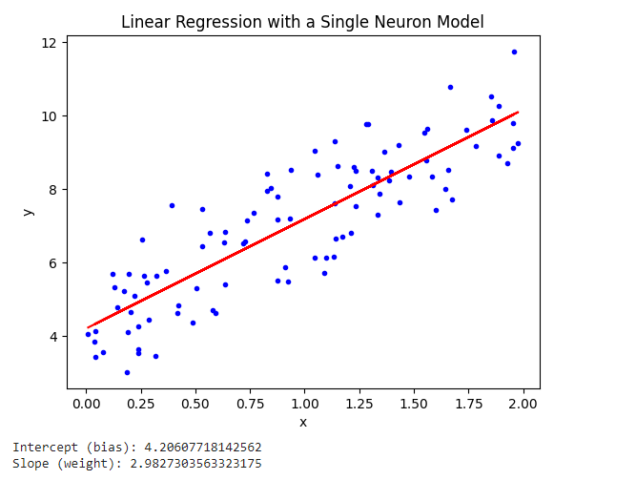

### **Explanation of the Code**

1. **Data Generation**: We generate some synthetic data for testing the model.
2. **Function Definition**: The linear_regression function performs linear regression using gradient descent.
   * X_b is the input matrix with an additional bias term.
   * theta is the parameter vector (weights and bias) initialized randomly.
   * In each epoch, we compute the gradients and update the parameters using the gradient descent algorithm.
3. **Training the Model**: We call the linear_regression function to train the model on the synthetic data.
4. **Plotting**: We plot the original data points and the fitted line to visualize the results.
5. **Parameter Display**: We print the learned parameters (intercept and slope).

The np.random.seed(0) function is used to set the seed for NumPy's random number generator. By setting a seed, you ensure that the sequence of random numbers generated is the same every time you run the code. This is essential for reproducibility, especially when debugging or comparing results across different runs.

### **How It Works**

1. **Random Number Generation**: Random number generators (RNGs) in computers are actually deterministic algorithms that produce sequences of numbers that only appear random. These sequences are determined by an initial value called the "seed."
2. **Seeding the RNG**: By setting the seed with np.random.seed(0), you initialize the RNG to a specific starting point. This means that every time you set the seed to the same value and then generate random numbers, you'll get the same sequence of numbers.
3. **Reproducibility**: This is particularly useful when you want to ensure that your experiments or simulations are reproducible. Other people (or you, at a later time) can run the same code and get the same results.

### **y = 4 + 3 * X + np.random.randn(100, 1)**

1. **4 + 3 * X**:
   * This creates a **linear relationship between X and y**.
   * 4 is the intercept (bias term), and 3 is the slope (weight).
   * For each value in X, it computes the corresponding y value based on the equation y=4+3xy

X_b = np.c_[np.ones((m, 1)), X

**np.ones((m, 1))**:

* This creates an array of shape (m, 1) **filled with ones.**
* Here, m is the **number of samples** in X.
* Each element in this array represents the bias term (intercept) for each sample.

**np.c_[...]**:

* np.c_ is a NumPy function that **concatenates arrays** along the second axis (columns).
* It is used to horizontally stack the arrays passed to it.

**np.c_[np.ones((m, 1)), X]**:

* This **concatenates the column of ones (bias terms) with the original feature matrix X.**
* The result is a new matrix X_b that has an additional column of ones at the beginning.