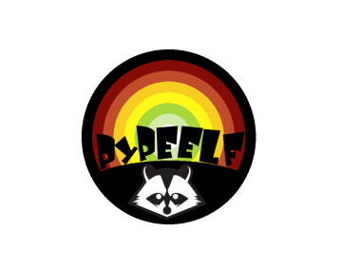PyPEELF Documenation

By +NCR, mbordese, Gunther

2009-08-22

**Edited By**: Gunther

© 2009 the PyPEELF Group

**Preface:**

PyPEELF is a multi-platform binary editor. PyPEELF enables you to view and edit PE32, PE32+ and ELF binary files. It is developed in Python. This manual consists primarily of a function reference and explanations of some of PyPEELF’s major features, and other supplemental information.

Table of Contents

**Preface:** 1

1.1 Getting Started 3

1.1.1 What is PyPEELF? 3

1.1.2 What can PyPEELF do? 3

1.1.3 Something Useful 3

1.2 Compilation & Configuration 4

2.1 Design Guidelines 4

3.1 Problems 5

3.1.1 Read the FAQ 5

3.1.2 Other Problems 5

3.1.3 Bug Reports 5

## Getting Started

Here we would like to show the very basics of PyPEELF in a short, simple tutorial. This text only deals with handling of PE32, PE32+ and ELF files, though PyPEELF currently is not capable of supporting Mach-O file format.

### What is PyPEELF?

PyPEELF is a multi-platform binary editor. PyPEELF enables you to view and edit PE32, PE32+ and ELF binary files.

### What can PyPEELF do?

<Describe what are the features of PyPEELF>

### Something Useful

Let’s do something useful.

<Continue with a simple basic usage of PyPEELF>

## Compilation & Configuration



## Design Guidelines

**loadDirectoryData**

<Desscription>

loadDirectoryData()

**Parameters**

**Return values**

Returns 'true' if the function succeeded.

Returns 'false' if the function fails.

**loadRelocsInfo**

<Description>

**loadRelocsInfo**()

**Parameters**

*pszName* (IN)

*pbyData* (OUT)

*dwSize* (OUT)

dwIndex (OUT)

**Return values**

None.



## Problems

### Read the FAQ

Some problems are more common than others. The most common ones are listed in the PyPEELF FAQ, part of this manual.

### Other Problems

If you want to get help on the mailing list, please try to be precise and give the necessary details about your environment (which operating system, what PyPEELF version, what OS, and preferably enough detials to make others able to reproduce and test your problem.

### Bug Reports

If you think you have found a bug in PyPEELF, please report it. The PyPEELF developers probably don't know about it, and unless you report it, chances are it won't be fixed. Please do not send bug reports in mailing list or personal letters.

Read the » How to report a bug document before submitting any bug reports!