RIDE RENTALS
PROJECT REPORT

Submitted to
UNIVERSITY OF CALICUT
In partial Fulfilment of the requirements of the award for the degree of

BACHELOR OF COMPUTER SCIENCE (2022-2025)

Submitted by
MUHAMMED JUNAID K (RegNo: ZEAWSCS022)
MUHAMMED ADHIL P.A (RegNo: ZEAWSCS021)
ABU SINAN K (RegNo: ZEAWSCS006)

Under the Guidance of
Mrs SHAHLA
(Assistant Professor –Department of Computer Science)



NAAC Accredited with B+ Grade

Mele-Pattambi, 679306, Palakkad
DEPARTMENT OF COMPUTER SCIENCE
LE-MENT COLLEGE OF ADVANCED STUDIES

(Affiliated to University of Calicut)
NAAC Accredited with B+ grade

DEPARTMENT OF COMPUTER SCIENCE
LE-MENT COLLEGE OF ADVANCED STUDIES

(Affiliated to University of Calicut)
NAAC Accredited with B+ grade



CERTIFICATE

This is to certify that the project work entitled
RIDE RENTALS

Is the bonafide record of work done by

MUHAMMED JUNAID K (RegNo: ZEAWSCS022)
MUHAMMED ADHIL P.A (RegNo: ZEAWSCS021)
ABU SINAN K (RegNo: ZEAWSCS006)

Head of the Department Mrs.SHAHLA
Faculty Guide

Submitted for the Viva-Voce Examination held on……………………………………….

INTERNAL EXAMINAR EXTERNAL EXAMINAR

1.

2.

DECLARATION

We hereby declare that the project report entitled “RIDE RENTALS” done as the partial fulfilment of the requirements for the award of the degree of Bachelor of Science (B.sc COMPUTER SCIENCE), is a project report done by us during the duration of our period of study in Sixth Semester in Le-Ment College of Advanced Studies, Pattambi under the guidance of Mrs.SHAHLA Assistant professor of computer science and this has not been previously submitted for the award of Degree in this and other colleges or Universities.

Signature of Students
MUHAMMED JUNAID K (ZEAWSCS022):__________________________

MUHAMMED ADHIL P.A (ZEAWSCS021):__________________________

ABU SINAN K (ZEAWSCS006):____________________________________

Counter Signed by the Guide

Place:
Date:

ACKNOWLEDGEMENT

We are grateful to each and every one who has contributed numerous ways in the development of this project whose efforts have been a healing hand in every footstep towards our destiny.
We give all the glory and honour to the God Almighty, whose divine touch had been the foremost inspiration and guiding light in the fulfilment of this uphill task.
We glad to present the project report entitled “RIDE RENTALS” prepared as a part of our Sixth Semester, BSC Computer Science program.

We take this opportunity to express our deep sense of gratitude and sincere thanks to our Principal Mr SHABEER K.P of Le-Ment College of Advanced studies for giving us an opportunity to take up the project work.

We place on record our Internal Guide Mrs .SHAHLA faculty of the Computer Science department her guidance for smooth completion of this project. Without her determination and enthusiasm this project would be incomplete.
We extend our sincere gratitude to all other staff members of the computer science department, who have contributed to complete this project.
We are extremely grateful to our parents for their moral support and continuous encouragement, which has always been a source of inspiration to us.

We also express our heartfelt thanks to our dear friends who had supported us in our endeavour to complete this project successfully.

ABSTRACT

The "Ride Rentals" platform is a user-friendly web application designed to simplify the car rental process.
Built using Django (Python) for the backend, HTML, CSS, and JavaScript for the frontend, and PostgreSQL for the database, the platform offers a seamless rental experience.
Key features include:
- Advanced filtering by vehicle type (passenger capacity, mileage, gear type, fuel type), price range, and dates.Real-time availability updates and secure online booking.
- Convenient pickup/drop-off location selection.
- Admin dashboard for managing rentals and other tasks.
The platform aims to improve access to rental cars, ensure transparent pricing, and provide a wide vehicle selection. By streamlining the booking process, "Ride Rentals" helps travelers, locals, and businesses save time and money while enjoying a hassle-free rental experience.
.

TABLE OF CONTENTS

Chapter Page No
- Introduction…………………………………………………….……01
1.1 Objectives…………………………………………………………………………
- Software Configuration………………………………………………
2.1 Hardware Requirement…………………………………………………………….
2.2 Software Requirements…………………………………………………..……….
- System Development and Analysis…………………………………….
3.1 Existing System………………………………………………………………….
3.2 Proposal System………………………………………………………………….
- Literature Survey……………………………………………………….
4.1 Feasibility Study………………………………………………………………….
4.1 Technical Feasibility……………………………………………………………..
4.3 Economical Feasibility………………………………………………………….
4.4 Operational Feasibility……………………………………………………………
4.5 Legal Feasibility………………………………………………………………….
4.6 Schedule Feasibility……………………………………………………………….
4.7 Resource Feasibility ……………………………………………………………
- System Design and Development………………………………………
5.1 Design Process……………………………………………………………………
5.2 Notation used in DFD……………………………………………………………
5.2.1 Data Flow Diagram…………………………………………………………….
5.3 Table Design……………………………………………………………………...
5.4 ER Diagram………………………………………………………………………
- Implementation…………………………………………………….......
6.1 Implementation Method………………………………………………………….
6.2 Implementation Plan……………………………………………………………..
6.3 Code……………………………………………………………………………...
6.4 App Screenshot…………………………………………………………………..
- Conclusion……………………………………………………………...
- Scope of Future Work………………………………………………....
- Bibliography…………………………………………………………....

LIST OF FIGURES

Figure Page No

Figure1: Data flow Diagram………………………………………………………….
Figure2: Data Flow Diagram for Admin…………………………………………….
Figure3: Data Flow Diagram for Seller……………………………………………….
Figure4: Data Flow Diagram for User…………………………………………………
Figure5: User Table………………………………………………………………....…
Figure6: Order Table……………………………………………………………………
Figure7: Item Table………………………………………………………………….....
Figure8: Cart Table……………………………………………………………………..
Figure9: Feedback Table………………………………………………………………..
Figure10: Survey Table………………………………………………………………….
Figure11: ER Diagram………………………………………………………………….

1. INTRODUCTION

Introducing "Ride Rentals," a web-based platform designed to revolutionize the car rental experience. In today’s fast-paced world, finding and booking a rental car can be a frustrating process, often involving limited vehicle availability, unclear pricing, and inefficient booking systems. "Ride Rentals" simplifies this process, offering a user-friendly and efficient solution for renting cars directly from Ride Rentals Car Rentals Company.
With "Ride Rentals," users can easily browse and compare available vehicles, check real-time availability, and book a rental car that suits their needs —all in just a few clicks. The platform provides advanced filtering options based on vehicle type, passenger capacity, fuel type, gear type, and price range, ensuring that users can find the perfect car for their journey.
In addition to secure online booking, the platform offers convenient pickup and drop-off location selection, making it an ideal choice for travelers, tourists, local residents, and businesses looking for a reliable car rental service. The built-in admin dashboard allows the company to efficiently manage rentals, track bookings, and maintain a smooth workflow.
By combining ease of use with transparency and efficiency, "Ride Rentals" eliminates the hassle of traditional car rentals and provides a seamless experience for customers. Whether you need a vehicle for a short trip, a business visit, or a long-term rental, Ride Rentals Car Rentals Company ensures that you get the best service with minimal effort.
Say goodbye to complicated booking processes and limited rental options—"Ride Rentals" is here to make car rentals simple, fast, and stress-free!
.

1.1 Objectives

The objective of this project is to develop an efficient and user-friendly online car rental system that streamlines the process of booking, managing, and paying for vehicle rentals while enhancing customer satisfaction. The system aims to improve accessibility by allowing users to access services anytime and anywhere, automate operational processes to reduce manual errors and paperwork, and implement a secure centralized database for managing vehicle inventory, customer information, and transactions. Additionally, the project seeks to ensure secure payment processing that protects sensitive customer data, incorporate features such as real-time vehicle availability and personalized user experiences to boost customer satisfaction, and analyze market trends to adapt services for competitiveness. Furthermore, the project will explore the integration of eco-friendly vehicles into the rental fleet to promote sustainable transportation solutions.

2. SOFTWARE CONFIGURATION

2.1 Hardware Requirements
  - OS: Android 9 or above

- Processor: Snapdragon or Exynos and Mediatek

- Ram: 4 or above

- Rom: 32 or above

2.2 Software Requirements

  - Processor: i3 or Above

- OS: Windows 8 or above

- Frontend: Flutter

- Backend: PHP

- Database: My Sql

- Tools Used: VS code, Android Studio

3. SYSTEM DEVELOPMENT AND ANALYSIS

3.1: Existing System

The existing system of our ecommerce app for clothing incorporates a user-friendly interface that allows customers to browse through a wide range of clothing items conveniently. The app features various categories and filters to streamline the shopping experience, along with detailed product descriptions and images to help users make informed decisions. It includes secure payment gateways to ensure transactions are safe and reliable. Additionally, the app offers personalized recommendations based on user preferences and browsing history to enhance customer engagement and satisfaction. Customer support is readily available through multiple channels to address any queries or concerns promptly. Overall, the existing system aims to provide a seamless and enjoyable shopping experience for clothing enthusiasts.

3.2: Proposed System

Our platform is aimed at enabling clothing stores to enhance their e-commerce capabilities through collaboration. By using our tool, stores can effortlessly list their products and offer customers a smooth shopping experience. The analytic features also help to optimize sales and marketing strategies. Moreover, small-scale fashion businesses can take advantage of the Market section to showcase their products and increase visibility. Customers can also use our platform to locate all available shops in their current location and purchase products from their preferred stores. The system also empowers users to discover the best products based on their needs and preferences, leading to a more personalized and fulfilling shopping experience. Ultimately, our goal is to empower small-scale fashion businesses through e-commerce.

4. LITERATURE SURVEY

4.1 Feasibility Study
The feasibility of an online car rental system project hinges on a comprehensive evaluation of technical, operational, economic, management, and legal factors. Technical feasibility examines the availability of suitable technology; operational feasibility assesses alignment with current business practices and improvements in workflow and paperwork reduction; economic feasibility weighs development and maintenance costs against long-term benefits like increased efficiency; management feasibility ensures effective project management and data sharing solutions; and legal feasibility confirms compliance with relevant laws and regulations. Successful implementation promises to enhance business processes by expanding reach, providing online reservation tools, reducing paperwork, acting as a 24/7 service, and ultimately, boosting return on investment.

4.2 Technical Feasibility

Technical feasibility for the online car rental system involves evaluating the necessary technology and resources required for successful implementation. This includes assessing the software and hardware requirements, such as a robust database management system (e.g., MySQL) for storing vehicle and customer data, and a user-friendly interface that allows customers to easily check car availability, make bookings, and manage their rentals. The system must support multiple users accessing it simultaneously, ensuring that administrative controls are in place to manage user permissions effectively. Additionally, the platform should be designed to operate seamlessly across various devices and browsers without imposing significant hardware demands on users. The project also requires a reliable internet connection to facilitate real-time updates and transactions, making it essential to consider the infrastructure needed for both the rental company and its customers. Overall, the technical feasibility study indicates that with the right technological resources and planning, the online car rental system can be successfully developed and implemented to enhance business operations and customer satisfaction.

4.3 Economical Feasibility

Economic feasibility for the online car rental system involves assessing the costs associated with the development and implementation of the system against the anticipated benefits. This includes analyzing initial development costs such as software design, hardware acquisition, and ongoing operational expenses like maintenance, hosting, and customer support. The project aims to enhance revenue generation through increased customer reach by providing a platform for online bookings, which can lead to higher rental volumes and improved customer retention. Additionally, by automating processes and reducing the need for physical locations, the system can lower operational costs related to staffing and paperwork. The potential for offering competitive pricing and exclusive online deals can attract more customers, further boosting profitability. Overall, the cost-benefit analysis indicates that while there are upfront investments required, the long-term financial gains from increased efficiency, customer satisfaction, and market expansion make the project economically viable.

4.4 Operational Feasibility
Operational feasibility assesses how well the proposed online car rental system solves problems and takes advantage of opportunities. It determines if the system aligns with current business practices, improves work quality, and reduces paperwork. An online system can automate functions, be user-friendly, and free up staff for more productive activities. The existence of online car rental systems overcomes the limitation of business operation hours. Ordinary users with basic computer skills can use the system. The system also improves the quality of work, and the system is designed to be user-friendly and easy to navigate.

4.5 Legal Feasibility
Legal feasibility for the online car rental system involves ensuring that the software and its operations comply with relevant laws and regulations. This includes adherence to consumer protection laws, data privacy regulations, and licensing requirements for operating a car rental business. The system must implement secure data handling practices to protect customer information and payment details, ensuring compliance with cybersecurity laws. Additionally, it is essential to establish clear terms and conditions for rentals, including liability clauses, insurance requirements, and user agreements that outline the responsibilities of both the rental company and customers. By addressing these legal aspects, the project can mitigate risks associated with legal disputes and ensure a trustworthy platform for users.

4.6 Schedule Feasibility
Schedule feasibility assesses the likelihood of completing the online car rental system project within the allocated timeframe. It involves evaluating the project timeline, including key milestones, deadlines, and resource availability. A detailed project schedule should outline phases such as requirements gathering, system design, development, testing, and deployment. By identifying potential bottlenecks and dependencies, the project team can better estimate the time required for each phase and ensure that adequate resources are allocated. Effective project management practices, including regular progress monitoring and adjustments to the schedule as needed, will further enhance the likelihood of timely completion. Overall, a well-structured schedule is crucial for ensuring that the project meets its objectives within the desired timeframe.

4.7 Resource Feasibility
Resource feasibility for the online car rental system evaluates the availability and adequacy of the necessary resources to successfully develop and implement the project. This includes assessing human resources, such as skilled software developers, designers, and project managers, who are essential for building a robust and user-friendly platform. Additionally, it involves evaluating the technological resources required, including hardware (servers, databases) and software (development tools, security measures) that will support the system's functionality. Financial resources must also be considered to ensure there is sufficient budget allocation for development, marketing, and ongoing maintenance. Furthermore, it is important to analyze whether the organization has access to external resources, such as partnerships with vehicle suppliers or third-party service providers for payment processing and customer support. By examining these factors, the project can determine if it has the necessary resources to proceed effectively and sustainably.

5. SYSTEM DESIGN AND DEVELOPMENT

The system design and development of the online car rental platform follows a structured approach using the Software Development Life Cycle (SDLC), specifically employing the waterfall model. This methodology ensures a systematic progression through various phases, including requirements gathering, system design, development, testing, and deployment. The primary goal is to create a user-friendly interface that allows customers to easily browse available vehicles, make bookings, and manage their rentals efficiently
In terms of functional requirements, the system will enable users to search for cars based on location, date, and time while providing detailed information about each vehicle. Users can book cars, select pick-up and drop-off locations, and make secure payments through integrated payment gateways. The system will also send confirmation notifications via email or SMS and allow users to modify or cancel bookings according to the established policies.
The design encompasses both high-level and low-level components. High-level design includes defining the architecture of the system, identifying key modules such as car management, customer management, booking systems, and an admin dashboard. Low-level design delves into specific classes and methods within these modules, detailing interactions and data flow. For example, the car management module will handle adding, updating, and deleting vehicle records, while the booking system will manage availability checks and reservation processes.
.

5.1 Design Process

The design process for the online car rental system follows a structured approach to ensure efficiency and user-friendliness. It begins with requirement analysis, where both functional and non-functional requirements are identified, such as user registration, car search, booking management, and security measures. The next step involves developing the system architecture, outlining key components like the user interface, database, application logic, and external services. High-level design defines major modules such as car management, customer management, booking systems, and an admin dashboard, while low-level design focuses on detailed functionalities within each module. Database design creates a relational schema for storing information about cars, customers, and bookings. Prototyping follows to validate design concepts through wireframes or mockups. The development phase involves implementing the system using suitable programming languages and frameworks. Rigorous testing is conducted to ensure all components function correctly before the deployment phase, where the system is launched on a cloud platform or server. Finally, ongoing maintenance is essential to keep the system operational and updated based on user feedback and evolving requirements. This comprehensive design process ensures a robust and scalable online car rental system that meets the needs of both customers and administrators.

Normalization of Database

Normalization of the database for the online car rental system is crucial to ensure data integrity, eliminate redundancy, and establish logical relationships between data entities. The normalization process typically involves organizing the database into tables and ensuring that they meet the requirements of the first, second, and third normal forms.

- First Normal Form
- Second Normal Form
- Third Normal Form

First Normal Form:

In the first normal form (1NF), all attributes in a table must contain only atomic values, meaning that each field should hold a single value. For instance, a "Customer" table can include fields such as CustomerID, FirstName, LastName, Address, ContactNo, and Email, ensuring that no multi-valued attributes are present.

Second Normal Form:

The second normal form (2NF) requires that all non-key attributes are fully functionally dependent on the primary key. In our "Rental" table, which might include fields like VehiclePlateNo, CustomerID, Hour, Rate, TotalAmount, Date, Time-In, and Time-Out, it is essential that each non-key attribute relates directly to the composite primary key (VehiclePlateNo and CustomerID), thereby avoiding partial dependencies.
Third Normal Form:

Finally, the third normal form (3NF) stipulates that there should be no transitive dependencies among non-key attributes. This means that all attributes must depend only on the primary key. For example, if we have a "Vehicle" table with attributes such as VehiclePlateNo, Type, Brand, Model, ManufacturingDate, and Color, all these attributes should relate directly to VehiclePlateNo without depending on other non-key attributes.

List of Modules

- Admin: Allows the administrator to manage the entire system, including vehicle brands, vehicles, bookings, testimonials, contact queries, registered users, page content, subscribers, and system settings

- Seller: Sellers can add new products, update existing ones, set prices, manage inventory and categorize products. View and manage orders placed for their products, update order status, manage shipping, and generate invoices.

- User: Users can register, log in, and manage their accounts securely. Browse cars by category, search for specific fuel type, and filter products based on various on price. View details of cars descriptions, images, prices, ratings, and reviews.

About the Tools

In this project, I am started with the web based application. To do that initially we choose the programming language as Flutter based Desktop application, front end is made with Flutter and for the back end is PHP. Database layer MySQL. I have used responsive design method for developing User Interface, which is adaptable for any Viewport.

Flutter

Flutter is an open-source UI software development toolkit created by Google, designed to help developers build natively compiled applications for mobile, web, and desktop from a single codebase. Launched in 2017, Flutter has gained significant popularity for its fast development speed, expressive and flexible UI, and ability to create visually appealing applications. One of Flutter's key features is its use of the Dart programming language, which allows developers to write code that can be compiled to native ARM code for optimal performance. The framework also provides a rich set of pre-designed widgets, facilitating the creation of consistent and visually appealing user interfaces across different platforms. Flutter's hot reload feature allows developers to instantly see the impact of their code changes, speeding up the development and debugging process. With its versatility and robust community support, Flutter has become a popular choice for developers aiming to create cross-platform applications efficiently and with a high level of visual fidelity.
Flutter Platform

Flutter is a versatile and cross-platform development framework that allows developers to create applications for various platforms, including mobile, web, and desktop, using a single codebase. The term "Flutter platform" typically refers to the ability of the framework to seamlessly adapt and deploy applications on different operating systems and devices. With Flutter, developers can target iOS and Android for mobile, deploy as a web application, and even extend their reach to desktop platforms like Windows, mac OS, and Linux. This unified development approach streamlines the process of building and maintaining applications, as developers can avoid the need to create separate codebases for each platform. Flutter's platform independence is achieved through its native compilation to machine code, ensuring high performance and a consistent user experience across diverse devices. The framework's adaptability to multiple platforms has made it a popular choice for developers looking to efficiently deliver applications with a consistent look and feel across various devices and operating systems.

PHP

PHP, which stands for Hypertext Pre-processor, is a widely-used server-side scripting language designed for web development. Known for its simplicity, ease of integration, and broad community support, PHP is embedded within HTML code and executed on the server, generating dynamic content that can be sent to the user's browser. PHP supports various databases, making it suitable for developing database-driven web applications. It also boasts a vast ecosystem of libraries and frameworks, such as Laravel and Symfony, that enhance development efficiency and maintainability. Despite some criticisms regarding its syntax and security concerns in the past, PHP has undergone significant improvements with each version release, addressing these issues and contributing to its enduring popularity as a server-side scripting language in the world of web development.

PHP Platform
PHP is a server-side scripting language widely used for web development. It enables the creation of dynamic and interactive web pages by embedding within HTML code. PHP supports various databases, has a large community, and is enhanced by frameworks like Laravel. Despite past criticisms, on-going updates have improved PHP's syntax and security, solidifying its position as a robust platform for building dynamic web applications.

5.2 Notations used in DFD

In Data Flow Diagrams (DFDs) for an E-Commerce app, various symbols and notations are used to represent different elements and relationships within the system. Here are some common notations used in DFDs for E-Commerce applications:

Element Reference Symbol

Process Round (Rectangle)

External Entity (Square)

Data store (open-ended Rectangle)

Data Flow(Arrow)


Data Flow Source/ Destination(oval)
5.2.1 Data Flow Diagram

A data flow diagram (DFD) is a graphical representation of the flow of data through a system. It shows how data moves from input sources to processing and storage, and then to output destinations. In the context of the private bus time and route view system project, a DFD could consist of the following elements:

External entities: These are the actors or entities that interact with the system, such as user, seller, and admin.

Processes: These are the activities that transform the data, such as data validation, calculations, and updates to the database.

Data stores: These are the repositories where data is stored, such as databases or files.

Data flows: These are the paths that data takes as it moves through the system.

1. Level-0-DFD

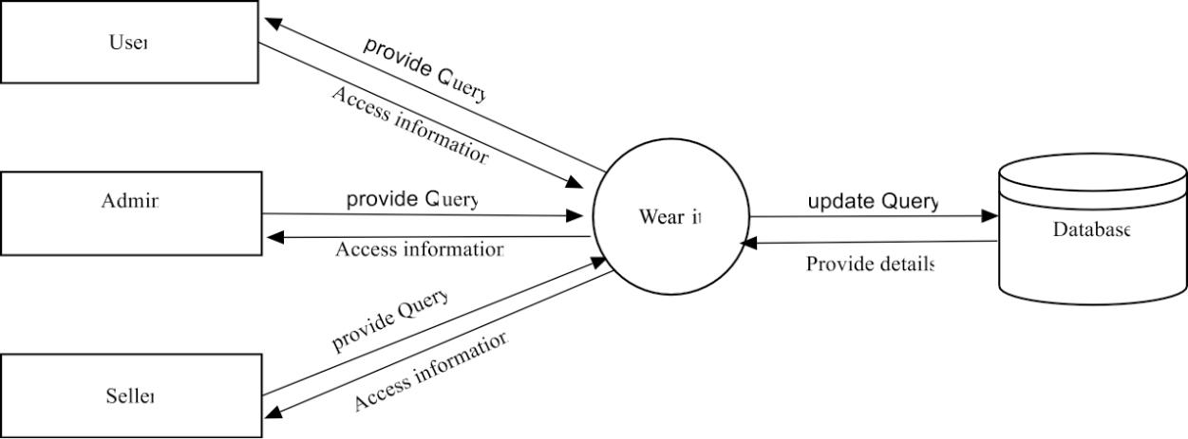

2. Level-1-DFD For Admin

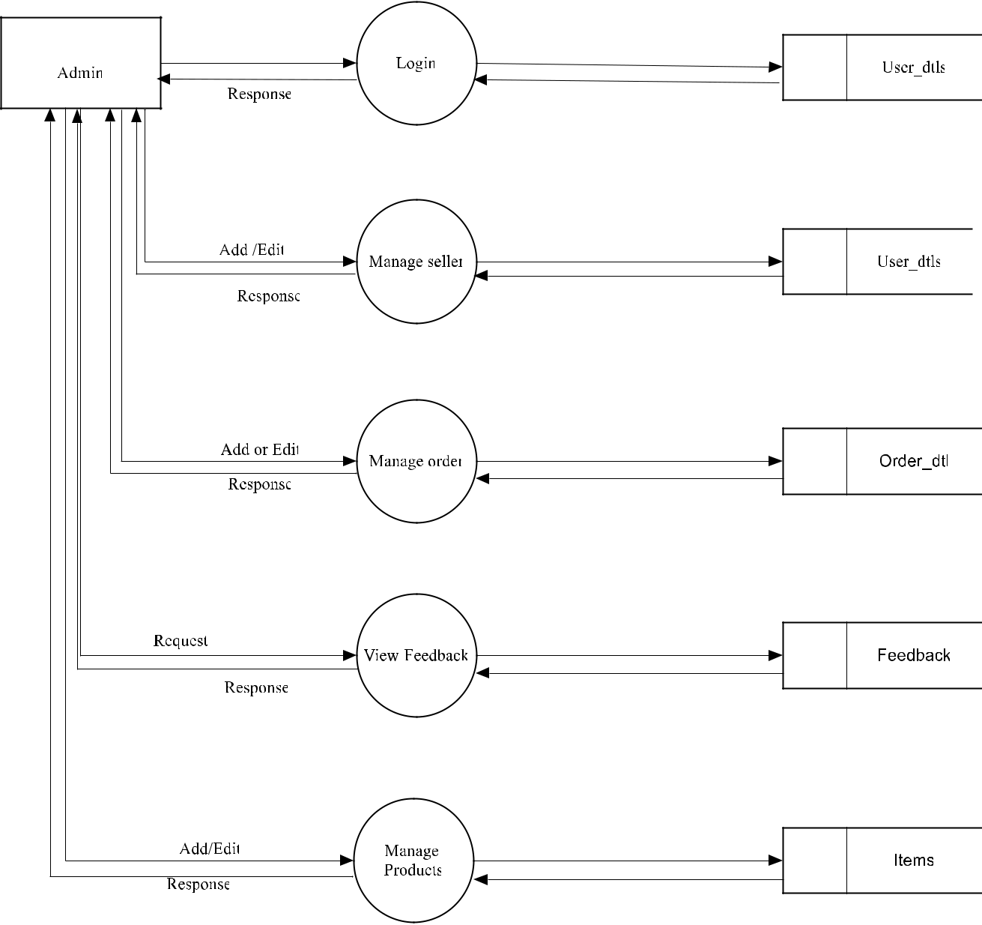

Level-1-DFD for Seller

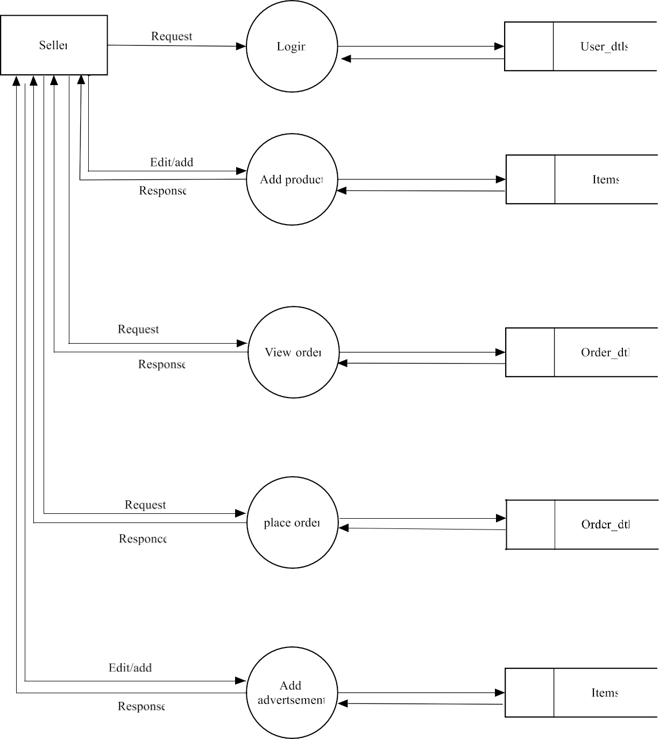

Level-1-DFD for User

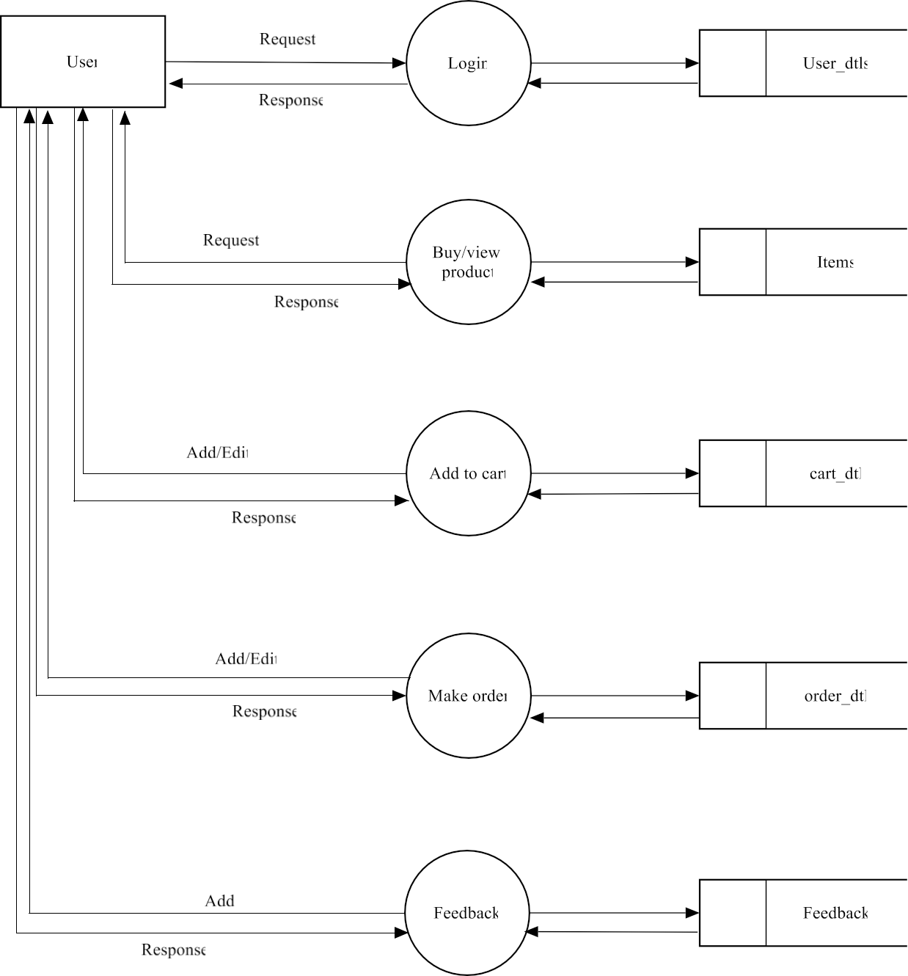

5.3 Table Designs

1. User-Table
Name | Datatype | Constraint
Login id | Int(10) | Primary key
Name | Varchar(50) | Not Null
Password | Varchar(50) | Not Null
Location | Varchar(50) | Not Null
Shop Name | Varchar(50) | Not Null
Image | Varchar(50) | Not Null
Phone | Varchar(20) | Not Null
Address | Varchar(50) | Not Null

2. Order Table
Name | Datatype | Constraint
Id | Int(10) | Primary key
Item id | Int(10) | Foreign key
Quantity | Int(10) | Not Null
Date | Date Time | Not Null
User id | Int(10) | Foreign key
Address | Varchar(100) | Not Null
Amount | Varchar(10) | Not Null
Size | Varchar(10) | Not Null

3. Item table
Name | Datatype | Constraint
Id | Int(11) | Primary key
Item Name | Varchar(50) | Foreign key
Price | Int(10) | Not Null
Seller id | Int(10) | Foreign key
Url | Varchar(500) | Not Null
Review | Int(11) | Not Null
Star | Int(11) | Not Null
Value | Int(11) | Not Null
Category | Varchar(20) | Not Null
Brand | Varchar(20) | Not Null
Trending | Int(10) | Not Null
Advertisement | Int(10) | Not Null

4. Cart table
Name | Datatype | Constraint
Id | Int(10) | Primary key
Item id | Int(10) | Foreign key
Quantity | Int(10) | Not Null
Date | Date time | Not Null
User id | Int(10) | Foreign key
Value | Int(10) | Not Null

5. Feedback Table
Name | Datatype | Constraint
Id | Int(10) | Not Null
Feedback | Varchar(50) | Not Null

6. Survey Table
Name | Datatype | Constraint
User id | Int(50) | Foreign key
Data | Text | Not Null

5.4 Entity –Relationship Diagram

The Entity-Relationship (ER) diagram for an e-Commerce app illustrates the relationships between key entities within the system. The primary entities include User, Product, Category, Order, Order Item, Payment, Cart, Cart Item, and Review. Users can place multiple orders, each associated with a unique order ID, order date, total amount, and status. Each order consists of multiple order items, detailing the purchased products, quantities, and subtotals. Products belong to categories, establishing a many-to-many relationship. Users can leave reviews for products, forming a many-to-many relationship as well. Additionally, users have a cart to which they can add multiple items, forming a one-to-many relationship with cart items.

Each user account is characterized by a user ID, first name, last name, email, password, address, and phone number. Products are identified by a product ID, name, description, price, stock quantity, and a foreign key referencing their associated category. Categories are defined by a category ID and name. Orders have an order ID, user ID, order date, total amount, and status.

Order items are identified by an order item ID, order ID, product ID, quantity, and subtotal. Payments have a payment ID, order ID, payment method, amount, and transaction date. Lastly, reviews are characterized by a review ID, user ID, product ID, rating, comment, and date. This ER diagram provides a comprehensive overview of the entities and their relationships, forming the foundation for developing a robust and well-structured e-Commerce application.

6. IMPLEMENTATION

System implementation is the final phase i.e., putting the utility into action. Implementation is the state in the project where theoretical design turned into working system. The most crucial stage is achieving a new successful system and giving confidence in new system that it will work efficiently and effectively. The system is implemented only after thorough checking is done and if it is found working in according to the specifications. It involves careful planning, investigation of the current system and constraints on implementation, design of methods to achieve. Two checking is done and if it is found working according to the specification, major task of preparing the implementation a reeducating, training the users. The implementation process begins with preparing a plan for the implementation of the system. According to this plan, the activities are to be carried out, discussions made regarding the equipment and resources and the additional equipment has to be acquired to implement the new system. The most important in implementation stage is , gaining the users confidence hat the new system will work and be effective. The system can be implemented only after through testing is done. This method also offers the greatest security since the existing system can take over if the errors are found or inability to handle certain type of transactions while using the new system.

6.1 Implementation Methods

There are several methods for handling the implementation and consists for changing from the old to the new computerized system. The most secure method for conversion from the old system is to run the old and new system in parallel. In this approach ;a person may operate in the manual processing system as well as start operating the new computerized system. Another commonly used method is a direct cut over the existing manual system to the computerized system. The change may be within a week or a day. This strategy requires planning. A working version of the system can also be implemented in one part of the organization and the changes can be made as and when required, but this method is less preference due to the loss of entire system. After the system is Implementation, a review should be conducted to determine whether the system is meeting expecting where improvements are needed.

Implementation is the process of bringing a developed system into operational use and turning it over to the user. Implementation includes all those activities that take place to convert from old system to new. At this stage the theoretical design is turned into a working system. The crucial stage in achieving a successful new system and giving confidence on the system for the users that will work efficiently and effectively.

Implementing an ecommerce app typically involves several key steps:
- Market Research: Understand your target audience, competitors, and market trends.
- Define Requirements: Determine features, functionalities, and technical specifications.
- Choose Technology Stack: Select appropriate platforms, frameworks, and tools based on your requirements and expertise
- Design UI/UX: Create intuitive, user-friendly interfaces for both web and mobile platforms.
- Backend Development: Build robust server-side infrastructure to handle data storage, security, and business
- Frontend Development: Develop responsive and visually appealing client-side interfaces for web and mobile.
- Integration: Integrate payment gateways, shipping APIs, and other third-party services.
- Testing: Perform thorough testing to ensure functionality, performance, and security.
- Deployment: Deploy the app on appropriate hosting platforms and app stores.
- Maintenance: Regularly update, optimize, and enhance the app based on user feedback and technological advancements.
Each step requires careful planning and execution to ensure the success of your ecommerce app.
6.2 Implementation Plan

Implementation plan includes a description of all activities that must occur to implement the new system and to put into operation. It defines the personal responsible for the activities and prepares a time chart for Implementation the system. The Implementation plan should anticipate possible problems and must be able to deal with them. The usual problem may be missing documents ,missed data formats between current and new files, errors in data translation ,missing data etc. Training plats are an important element of the implementation plan. Their purpose is to ensure that all the persons who are associated with the computer based business system possess the necessary knowledge and skills.

Operator training

Operator training is completed in conjunction with its installation and checkout.Operators must become familiar with operational requirements of the new systems.Well prepared manual provide a ready reference to specific duties and step by step operation instruction.

User Training

After the system is implemented successfully, training of the user is one of the most important subtasks of the developer. Even well designed and technically elegant systems can succeed or fail, because of the way they are operated and used. For this purpose user manuals are prepared and handled over to the user to operate the developed system. Thus the users are trained to operate the developed system. Both the hardware and software securities are made to run the developed systems successfully in future. In order to put new application system into use, preparation of user and system documentation, conducting user training with demo, test run for some period to ensure smooth switching over the system are to be prepared.

Documentation

The documentation involves collecting, organizing, and maintaining complete record of programs. The documentation deals with the system department with maximum clarity. Each and every process is explained in detail. The various table used by the system with field details are provided. The system uses various kinds of forms to produce well-structured screen formats. These forms are also documented .the output generated by the system constitutes another part. Documentation of the software provides the following:

Comments

Comments are very useful in documenting a program. It is used to explain logic of the program. It should be used to improve the quality and understanding of the program. It should not be redundant, incorrect or incomplete.

System Manuals

A good software system must contain standard system manuals .In this the statement is clearly
defined, specifies description, detailed flowcharts, and specimen of all input forms and printed outputs.

Operation Manual

A good software package is supported with a good operation manual to ensure the smooth running of the program.

The operation manual must contain the following information:

- Setup and operational details of each program.
- Loading and unloading procedures.
- Starting, running ,and terminating procedures
- List of error conditions with explanation

6.3 Code

- import 'package:fashion_ecommerce_app/screens/main_wrapper/presentation/main_wrapper.dart'; import 'package:fashion_ecommerce_app/widget/custom_text_form_field.dart';
import 'package: flutter/material.dart';

import 'package:flutter_bloc/flutter_bloc.dart';

import 'package:fashion_ecommerce_app/screens/authentication/signup/presentation/signup.dart'; import 'package:get_storage/get_storage.dart';

import '../../../../widget/reuseable_button.dart'; import '../../wrapper/presentation/wrapper_page.dart'; import '../bloc/login_bloc.dart';

class Login extends StatefulWidget {

const Login({Key? key}) : super(key: key);

@override

_LoginState createState() => _LoginState();

}

class _LoginState extends State<Login> {

bool isPasswordVisible = false;

final TextEditingController usernameController = TextEditingController(); final TextEditingController passwordController = TextEditingController();

@override

void initState() {

super.initState();

// clearStorage(); // Call the method to clear storage when the page loads

}

- Future<void> clearStorage() async {

- await GetStorage().remove("user");
- print('storage cleared');

- }

@override

Widget build(BuildContext context) {

return Scaffold(
body: ListView(

keyboardDismissBehavior: ScrollViewKeyboardDismissBehavior.onDrag,

children:[

Padding(

padding: const EdgeInsets.all(16.0),

child: Column(

mainAxisAlignment: MainAxisAlignment.center,

children: [

SizedBox(height: 10),

Image.asset(

'assets/images/wear-it-slogan.jpg', // Change this to your asset path

width: 350, // Adjust the width as needed

height: 350, // Adjust the height as needed

),

SizedBox(height: 10),

CustomTextField(
labelText: "User Name",
controller:usernameController,
hintText: "enter user name",
keyboardType: TextInputType.name,
validator: (value) {
if (value!.isEmpty) {
return 'please enter user name';

}
else if (value.isNotEmpty && value.length < 6)
{
return 'The user name should have atleast 6 characters';

}
else {

return null;

},

icon: Icons.person),

SizedBox(height: 16),

CustomTextField(

labelText: "Password",

controller:passwordController,

obscureText: !isPasswordVisible,

hintText: "enter password",

keyboardType: TextInputType.name,

validator: (value) {

if (value!.isEmpty) {

return 'please enter password';

} else if (value.isNotEmpty && value.length < 5) { return 'The password should have atleast 5 characters';
} else {

return null;

}

},

icon: Icons.key,

suffix: IconButton(

icon: Icon( isPasswordVisible

? Icons.visibility

: Icons.visibility_off,

),

onPressed: () {

setState(() {

isPasswordVisible = !isPasswordVisible;

});

},

),

),
sizedBox(height: 16),

const SizedBox(height: 60),

BlocListener<LoginBloc, LoginState>(

listener: (context,state) {

- if (state is LoginLoading) { // Fixed typo 'State' to 'state'

- // Show a loading indicator

- const CircularProgressIndicator();

- }

if (state is LoginLoaded) {

// Do something when login is loaded

context.read<LoginBloc>().add(AuthenticateEvent(state.userDataLogin));

} else if (state is UserAuthenticated) {

  - Navigate to the main wrapper page when user is authenticated Navigator.pushReplacement(context, MaterialPageRoute(

builder: (context) => const WrapperPage(), ));

} else if (state is LoginError) {

  - Show a snackbar with login error message ScaffoldMessenger.of(context).showSnackBar(

SnackBar(

content: Text('Login failed: ${state.error}'),

duration: Duration(seconds: 3),

),

);

6.4 App Screenshots
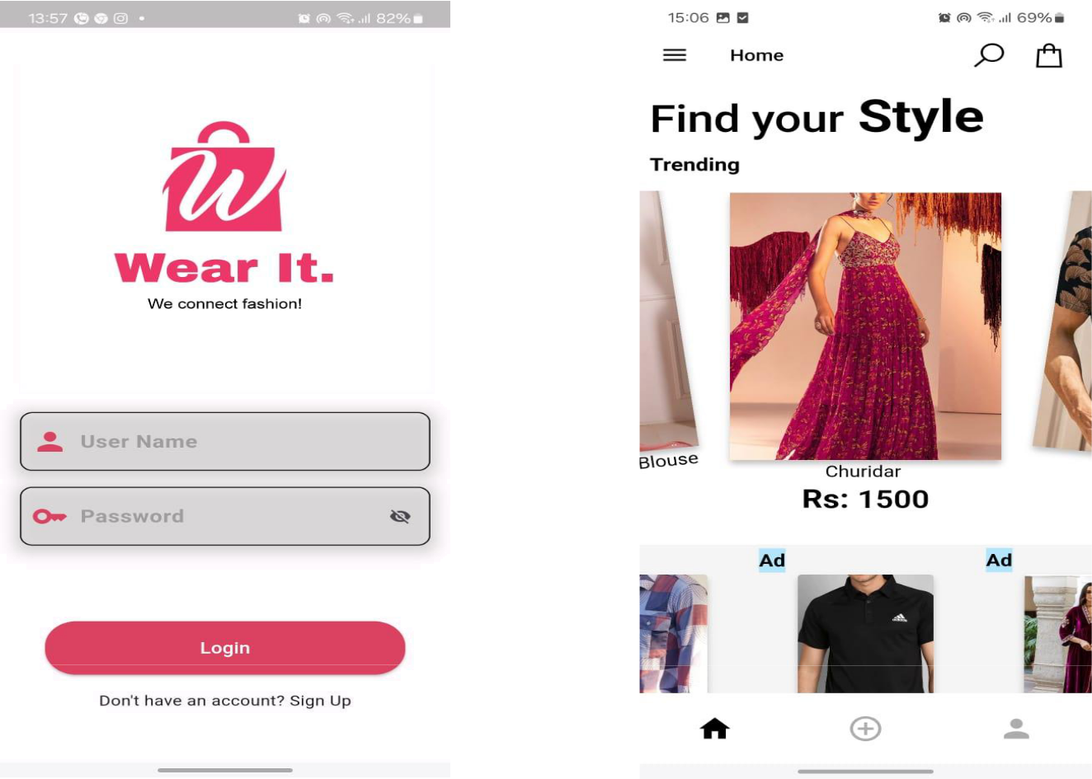
1. Login Page 2. Home Page

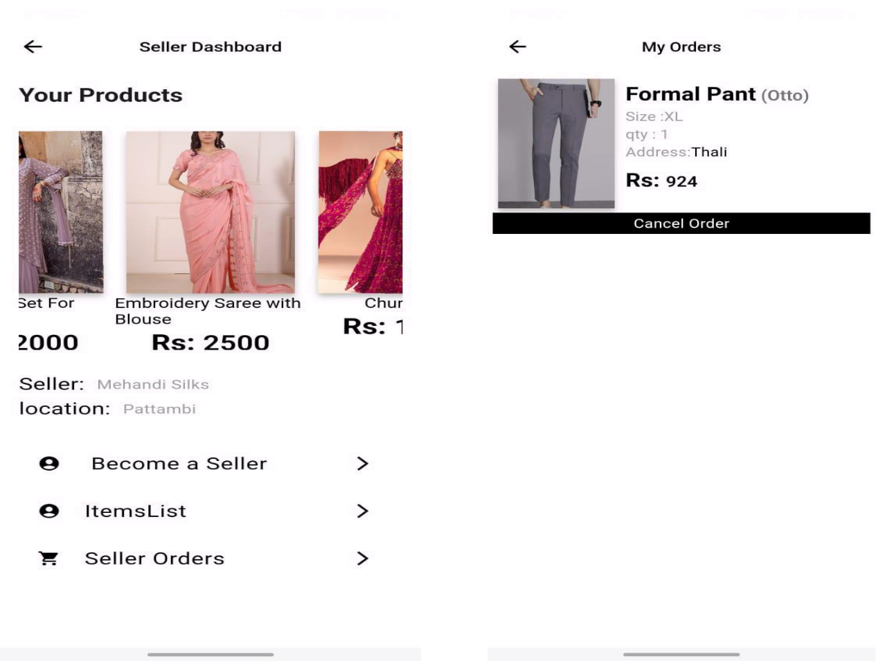
3. Seller Dashboard 4. My Orders

5. Payment
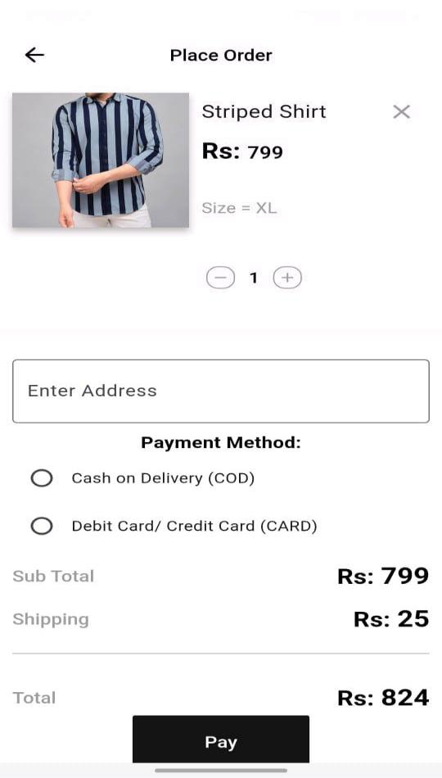

7. CONCLUSION

Our solution offers a unique and Innovative platform for clothing stores to reach a wider Audience and complete in the E-commerce industry .With the rise of Online shopping, it is crucial for clothing stores top adapt and embrace new technologies. E-commerce app typically summarizes key points such as the app’s features, benefits to users potentials for growth and any future developments or enhancements planned. It might also express gratitude to users for their support and feedbacks, and encourage continued engagement with the app. Our conclusion aims to revolutionize the e-commerce industry and bring together clothing stored and online retailing.

8. SCOPE OF FUTURE WORK

In the scope of future work for our clothing e-commerce app, we aim to prioritize several key areas for enhancement. Firstly, personalization features will be refined through advanced algorithms to offer tailored product recommendations and integrate virtual try-on technology for improved visualization. Secondly, we plan to integrate augmented reality (AR) to facilitate virtual fitting experiences, reducing returns and bolstering customer satisfaction. Thirdly, a robust size and fit recommendation system will be developed, leveraging machine learning to suggest optimal sizes based on user data. Additionally, social commerce integration will enhance engagement by enabling seamless sharing of purchases and influencer collaborations. Subscription services will be explored, offering curated clothing items on a regular basis. AI-powered chat bots will provide real-time support and streamline the purchasing process. Visual search functionality will be implemented to allow users to find similar products through image uploads. Sustainability initiatives will be incorporated, promoting eco-friendly options and educating users about product environmental impact. Offline integration will bridge online and in-store experiences, while localization efforts will expand our reach to diverse markets. Furthermore, analytics tools will be utilized to gather insights for continuous improvement, ensuring agility and responsiveness to evolving market dynamics and user preferences.

9. BIBLIOGRAPHY

- IEEE-2016-“Developing a Ecommerce Website” , Authors: Syed Emdad Ullah,Tania Alauddin
- IEEE- 2019-“The Application of E-Commerce on Fashion Shop”, Author : Jonathan, Andrikurniwan
- IEEE-2021-“Cloud Computing and E-Commerce Based Entrepreneurship”, Author : Satender Singh
- IEEE-2010-“Study on the Typical application of E-commerce “,Author: Wang Li
- Principles of Software Engineering – Author : Roger.S.Pressman-7th Edition.

