Django Tutorial

- Create a Django project :
$ django-admin startproject project_name

Project_name
|--project_name > project main app
|_manage.py

Example :
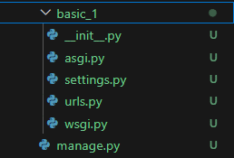


Files in Main App/ :
- urls.py
contains url endpoints and its corresponding function.
Enpoint and return render_function from app/views.p`y

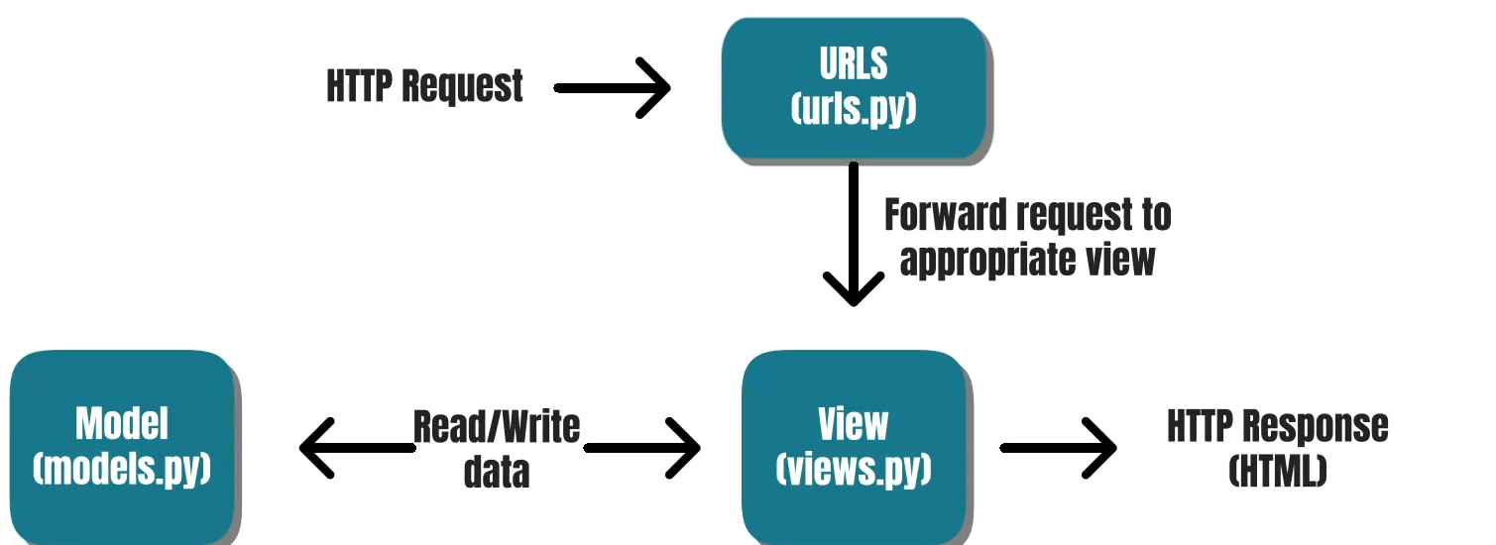

- settings.py
settings or configurations related to project.
Installed_apps, static urls ,Middlewares etc.
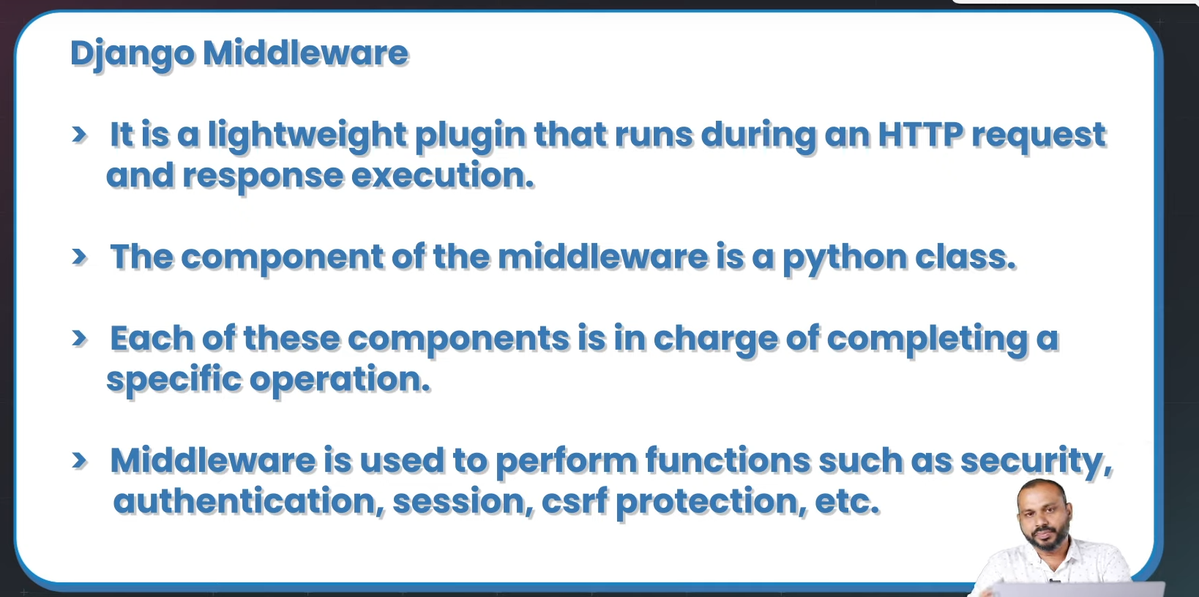
- asgi.py

- wsgi.py
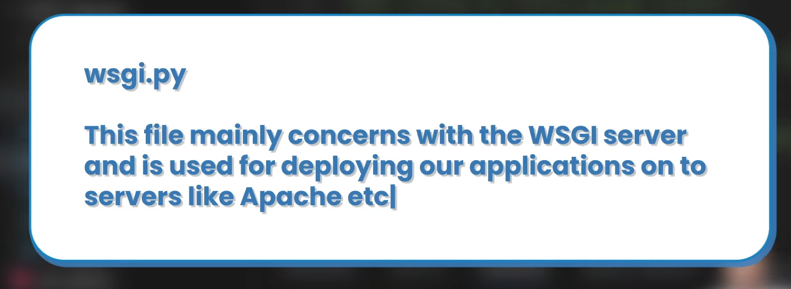
Asgi.py and wsgi.py for deployment
In newapp :
- __init__.py

- Views.py
For template response functions.

- Run a Django project :
$ python manage.py runserver

- Django apps (module) :
App(module) means a group of related urls, templates etc. default app is the project named app it contain configuration or settings only.
Create new app :
$ python manage.py startapp newapp_name
Add app to project :
```
“app_name”
```
To INSTALLED_APPS list in project-app/settings.py
Eg:
INSTALLED_APPS = [
'django.contrib.admin',
'app'
]

- Print hello Django :
newapp/views.py >
def print_hello(request):
return HttpResponse("hello")

projectapp/urls.py >
from django.contrib import admin
from django.urls import path
from newapp import views

urlpatterns = [
path('admin/', admin.site.urls),
path(‘hello/’, views.print_hello)
]
Syntax :
Path(“endpoint/”, function)

- Django file structure :

set html template and render it
template variables ( like jinja2 template language ) = if, for

filters : lower, upper, default:"value", length

eg : { variable | <filter> }
<h1>Title : {{ movie_obj.title | upper }}</h1>

- Static file handling,
create a folder named static in project dir.
Add these in project-main app settings.py :
```
STATIC_URL = 'static/'
STATICFILES_DIR = [
BASE_DIR/ "static"
]
```

STATIC_URL = 'static/'
this is a virtual path, see on image inspect dev tools.

Load static path in template at first :
{% load static %}
Set static file in template (eg) :
<img src="{% static 'images/car.jpg' %}" />

>>>> current status : v = Part 05 - Managing Static Files in Django

V == part 3, t = 0

PostgreSQL Tutorial
System = Win pgsql
- Create database
CREATE DATABASE database_name;
- List databases
\l
- Select database
\c database_name;
- Create table
create table table_name (datatype size, …. );s
- d

