Fire Detection and Alarming System

P.Sri Sai Keerthana, T.R. Sai Shruthi, P Bhanu Prakash, M Praveen

*Computer Science and Engineering, ACE Engineering College, Hyderabad, Telangana, India.*

[peri.keerthana@gmail.com](mailto:peri.keerthana@gmail.com) , [tanjavorerameshsaishruthi@gmail.com](mailto:tanjavorerameshsaishruthi@gmail.com), [bhanuprakashreddy1193@gmail.com](mailto:bhanuprakashreddy1193@gmail.com), [praveenchowdary101@gmail.com](mailto:praveenchowdary101@gmail.com)

***Abstract-*** History has proven that early detection of a fire and the signaling of an appropriate alarm remain significant factors in preventing large losses due to fire. Properly installed and maintained fire detection and alarm systems can help to increase the survivability of occupants and emergency responders while decreasing property losses. Considering that the majority of cities have already installed camera-monitoring systems, this encouraged us to take advantage of the availability of these systems to develop cost-effective vision detection methods. . Deep learning is an emerging concept based on artificial neural networks and has achieved exceptional results in various fields including computer vision. We plan to overcome the shortcomings of the present systems and provide an accurate and precise system to detect fires as early as possible and capable of working in various environments thereby saving innumerable lives and resources. We have made a comparative study of a general CNN (Convolutional Neural Network) model with adam optimizer and the pre trained InceptionV3 model with adam optimizer.

Keywords – fire, deep learning, Kaggle, CNN, InceptionV3, Image Processing, Kiras, Tensorflow, Surveillance video, Alarming system.

I.INTRODUCTION

Fire accidents pose a serious threat to industries, crowded events, social gatherings, and densely populated areas that are observed across India. These kinds of incidents may cause damage to property, environment, and pose a threat to human and animal life.

According to the recent National Risk Survey Report, Fire stood at the third position overtaking corruption, terrorism, and insurgency thus posing a significant risk to our country’s economy and citizens. The recent forest-fires in Australia reminded the world, the destructive capability of fire and the impending ecological disaster, by claiming millions of lives resulting in billions of dollars in damage. Early detection of fire-accidents can save innumerable lives along with saving properties from permanent infrastructure damage and the consequent financial losses. In order to achieve high accuracy and robustness in dense urban areas, detection through local surveillance is necessary and also effective. Traditional opto-electronic fire detection systems have major disadvantages: Requirement of separate and often redundant systems, fault-prone hardware systems, regular maintenance, false alarms and so on. Usage of sensors in hot, dusty industrial conditions is also not possible. Thus, detecting fires through surveillance video stream is one of the most feasible, cost-effective solution suitable for replacement of existing systems without the need for large infrastructure installation or investment.

The existing video-based machine learning models rely heavily on domain knowledge and feature engineering to achieve detection therefore, have to be updated to meet new threats. We aim to develop a classification model using Deep learning and Transfer Learning to recognise fires in images/video frames, thus ensuring early detection and save manual work. This model of Inception V3 can be used to detect fires in surveillance videos and send an alarming email and a siren indicating fire. Unlike existing systems, this neither requires special infrastructure for setup like hardware-based solutions, nor does it need domain knowledge and prohibitive computation for development.

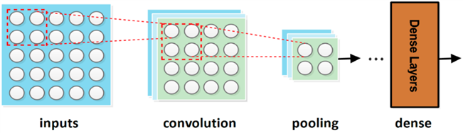

**Figure 1.** General Representation of CNN Model.

**II. RELATED WORK**

**Janku P., Kominkova Oplatkova Z., Dulik T., Snopek P. and Liba J** (2018) [1]. Artificial Neural Network based approaches seen in paper [1] uses Levenberg Maraquardt training algorithm for a fast solution. The accuracy of the algorithm altered between 61% to 92%. False positives ranged from 8% to 51%. This approach yielded high accuracy and low false positive rate, yet it requires immense domain knowledge.

**Shen, D., Chen, X., Nguyen, M., & Yan, W. Q. (2018).** In this paper [2] the author says that the present hardware-based detection systems offer low accuracy along with high occurrence of false alarms consequently making it more likely to misclassify actual fires. It is also not suitable for detecting fires breaking out in large areas such as forests, warehouses, fields, buildings or oil reservoirs. The authors used a simplified YOLO (You Only Look Once) model with 12 layers. Image augmentation techniques such as rotation, adjusting contrast, zooming in/out, saturation and aspect ratio were used to create multiple samples of each image, forming 1720 samples in total.

**Wanda Zaho** (2020) [3]. Novel image fire detection algorithms based on the advanced object detection CNN models of Faster-RCNN, R–FCN, SSD, and YOLO v3 are proposed in this paper. A comparison of the proposed and current algorithms showed that the accuracy of fire detection algorithms based on object detection CNNs is higher than other algorithms. Especially, the average precision of the algorithm based on YOLO v3 which reached to 83.7%, which is higher than the other proposed algorithms in this paper.

**Suhas G , Chetan Kumar , Abhishek B S , Digvijay Gowda K A , Prajwal R** (2020). The authors in the paper [4] have experimented with various deep learning models such as Inception netV3, Inception Net V2, Res Net along with classification algorithms like decision tree, SVM, naïve bayes, logistic regression and have selected ResNet-50-SVM combination for implementation as it offered the best performance metric value with accuracy of 97%.

**III. SYSTEM ARCHITECTURE**

The system includes image preprocessing and image augumentation on the image dataset followed by building of the CNN models.

.

**Figure 2.** System Architecture

The next stage is training the model with the improved dataset obtained from the previous steps and providing the power to the model to build a classification model that can classify images into fire or no fire based on the knowledge gained by the dataset.

The result of the classification is displayed to the user, and depending on the result, further actions are taken. If the result is a fire then alarming system is activated, an email is sent to the concerned stakeholders.

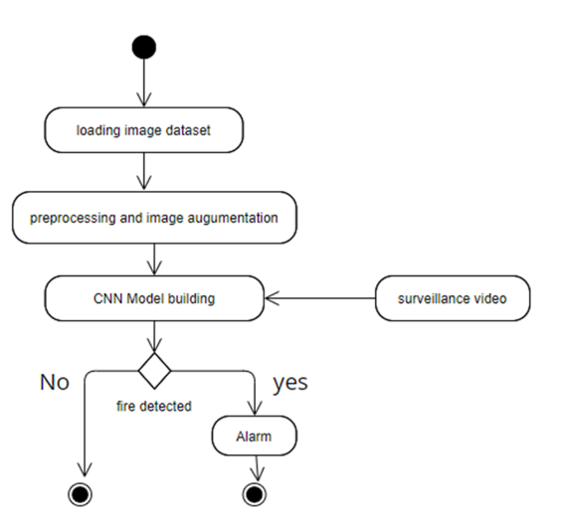

**Figure 3**. Activity Diagram

**IV. ALGORITHMS**

The algorithms included in our project are a sequential CNN model and a pre trained transfer learning model called Inception V3 and the comparision between them based on the optimizer Adam.

Convolutional Neural Networks (CNN)

Convolutional neural networks are special

kind of artificial neural network that can mimic the

human brain activity to analyze data with supervised

learning. CNN is modified multilayer perceptron,

which means fully connected network. It consists of

several layers namely, input layer, output layer and

many hidden layers to make it happen. These hidden

layers are convolutional hence the name convolutional

neural networks. It offers beyond the limit abilities to

perform object detection. These convolutional layers

use several mathematical models to critically evaluate

and analyze data. Then these outputs of the previous

layers are passed to the next layers. There is chance of

overfitting since the network is fully connected. To

avoid this situation, the CNN exploit the hierarchical

pattern in the data and sort them according to their

complexity from simpler to complex patterns

engraved in the layers. The input is given as tensor

with number of inputs x height x width x channels of

input. Now the image is in an abstract form, then the

layers convert this abstract image into a feature map.

This is repeated layer after layer which simulates the

working of brain neurons. Since it is fully connected

network all the output gets filtered and combined as a

single output in the output layer. The number of filters

directly proportional to the feature map size.

Convolutional Neural Networks (CNN)

Convolutional neural networks are special

kind of artificial neural network that can mimic the

human brain activity to analyze data with supervised

learning. CNN is modified multilayer perceptron,

which means fully connected network. It consists of

several layers namely, input layer, output layer and

many hidden layers to make it happen. These hidden

layers are convolutional hence the name convolutional

neural networks. It offers beyond the limit abilities to

perform object detection. These convolutional layers

use several mathematical models to critically evaluate

and analyze data. Then these outputs of the previous

layers are passed to the next layers. There is chance of

overfitting since the network is fully connected. To

avoid this situation, the CNN exploit the hierarchical

pattern in the data and sort them according to their

complexity from simpler to complex patterns

engraved in the layers. The input is given as tensor

with number of inputs x height x width x channels of

input. Now the image is in an abstract form, then the

layers convert this abstract image into a feature map.

This is repeated layer after layer which simulates the

working of brain neurons. Since it is fully connected

network all the output gets filtered and combined as a

single output in the output layer. The number of filters

directly proportional to the feature map size.

Convolutional Neural Networks (CNN)

Convolutional neural networks are special

kind of artificial neural network that can mimic the

human brain activity to analyze data with supervised

learning. CNN is modified multilayer perceptron,

which means fully connected network. It consists of

several layers namely, input layer, output layer and

many hidden layers to make it happen. These hidden

layers are convolutional hence the name convolutional

neural networks. It offers beyond the limit abilities to

perform object detection. These convolutional layers

use several mathematical models to critically evaluate

and analyze data. Then these outputs of the previous

layers are passed to the next layers. There is chance of

overfitting since the network is fully connected. To

avoid this situation, the CNN exploit the hierarchical

pattern in the data and sort them according to their

complexity from simpler to complex patterns

engraved in the layers. The input is given as tensor

with number of inputs x height x width x channels of

input. Now the image is in an abstract form, then the

layers convert this abstract image into a feature map.

This is repeated layer after layer which simulates the

working of brain neurons. Since it is fully connected

network all the output gets filtered and combined as a

single output in the output layer. The number of filters

directly proportional to the feature map size.

Convolutional Neural Networks (CNN)

Convolutional neural networks are special

kind of artificial neural network that can mimic the

human brain activity to analyze data with supervised

learning. CNN is modified multilayer perceptron,

which means fully connected network. It consists of

several layers namely, input layer, output layer and

many hidden layers to make it happen. These hidden

layers are convolutional hence the name convolutional

neural networks. It offers beyond the limit abilities to

perform object detection. These convolutional layers

use several mathematical models to critically evaluate

and analyze data. Then these outputs of the previous

layers are passed to the next layers. There is chance of

overfitting since the network is fully connected. To

avoid this situation, the CNN exploit the hierarchical

pattern in the data and sort them according to their

complexity from simpler to complex patterns

engraved in the layers. The input is given as tensor

with number of inputs x height x width x channels of

input. Now the image is in an abstract form, then the

layers convert this abstract image into a feature map.

This is repeated layer after layer which simulates the

working of brain neurons. Since it is fully connected

network all the output gets filtered and combined as a

single output in the output layer. The number of filters

directly proportional to the feature map size.

Convolutional neural networks are special

kind of artificial neural network that can mimic the

human brain activity to analyze data with supervised

learning. CNN is modified multilayer perceptron,

which means fully connected network. It consists of

several layers namely, input layer, output layer and

many hidden layers to make it happen. These hidden

layers are convolutional hence the name convolutional

neural networks. It offers beyond the limit abilities to

perform object detection. These convolutional layers

use several mathematical models to critically evaluate

and analyze data. Then these outputs of the previous

layers are passed to the next layers. There is chance of

overfitting since the network is fully connected. To

avoid this situation, the CNN exploit the hierarchical

pattern in the data and sort them according to their

**Convolutional Neural Network (CNN)**

Convolutional neural networks are special kind of artificial neural network that can mimic the human brain activity to analyze data with supervised learning. CNN is modified multilayer perceptron, which means fully connected network. It consists of several layers namely, input layer, output layer and many hidden layers to make it happen. These hidden layers are convolutional hence the name convolutional neural networks. It offers beyond the limit abilities toper form object detection. These convolutional layers use several mathematical models to critically evaluate and analyze data. Then these outputs of the previous layers are passed to the next layers. There is chance of overfitting since the network is fully connected. To avoid this situation, the CNN exploit the hierarchical pattern in the data and sort them according to their complexity from simpler to complex patterns engraved in the layers. The input is given as tensor with number of inputs x height x width x channels of input. Now the image is in an abstract form, then the layers convert this abstract image into a feature map. This is repeated layer after layer which simulates theworking of brain neurons. Since it is fully connectednetwork all the output gets filtered and combined as asingle output in the output layer. The number of filters directly proportional to the feature map size. Along with the convolutional layer it also includes a pooling layer to reduce the size of the output from the convolutional layers.

**Inception V3**

Inception v3 is a convolutional neural network for assisting in image analysis and object detection. It is the third edition of Google's Inception Convolutional Neural Network, originally introduced during the ImageNet Recognition Challenge. The design of Inceptionv3 was intended to allow deeper networks while also keeping the number of parameters from growing too large. The Inception V3 model used several techniques for optimizing the network for better model adaptation. It has higher efficiency, It has a deeper network compared to the Inception V1 and V2 models, but its speed isn't compromised. It is computationally less expensive. It uses auxiliary Classifiers as regularizes. This model also involves several layers which includes convolutional layers ,pooling layers and it also includes batch normalization. Using batch normalization makes the network more faster and stable during the training of the network. This may require the use of larger than the normal learning rates, this in turn may speed up the learning process.

**Adam Optimizer**

Adam optimizer involves a combination of two gradient descent methodologies: Adaptive Gradient and RMS propagation.Adaptive Gradient Algorithm (AdaGrad) that maintains a per-parameter learning rate that improves performance on problems with sparse gradients (e.g. natural language and computer vision problems). Root Mean Square Propagation (RMSProp) that also maintains per-parameter learning rates that are adapted based on the average of recent magnitudes of the gradients for the weight (e.g. how quickly it is changing). This means the algorithm does well on online and non-stationary problems (e.g. noisy). Adam realizes the benefits of both AdaGrad and RMSProp.

**V. METHDOLOGY**

The model is divided into two parts in which the first part involves data collection, data preprocessing and data augmentation, the second part involves model building, model training and prediction using real time data using surveillence video, alarming system.

**Dataset, Data Preprocessing and Data Augumentation**

The dataset used for our project is taken from Kaggle named after forest fires which involves two folders namely test and train which has fire images under the folder fire and neutral images or no fire images under neutral. The total images for training 910 fire images and 902 neutral images here we also added few images from google images for the better training of the model. The testing dataset 100 images each for fire and neutral for validiation of the model.

Convolutional Neural Networks (CNN)

Convolutional neural networks are special

kind of artificial neural network that can mimic the

human brain activity to analyze data with supervised

learning. CNN is modified multilayer perceptron,

which means fully connected network. It consists of

several layers namely, input layer, output layer and

many hidden layers to make it happen. These hidden

layers are convolutional hence the name convolutional

neural networks. It offers beyond the limit abilities to

perform object detection. These convolutional layers

use several mathematical models to critically evaluate

and analyze data. Then these outputs of the previous

layers are passed to the next layers. There is chance of

overfitting since the network is fully connected. To

avoid this situation, the CNN exploit the hierarchical

pattern in the data and sort them according to their

complexity from simpler to complex patterns

engraved in the layers. The input is given as tensor

with number of inputs x height x width x channels of

input. Now the image is in an abstract form, then the

layers convert this abstract image into a feature map.

This is repeated layer after layer which simulates the

working of brain neurons. Since it is fully connected

network all the output gets filtered and combined as a

single output in the output layer. The number of filters

directly proportional to the feature map size.

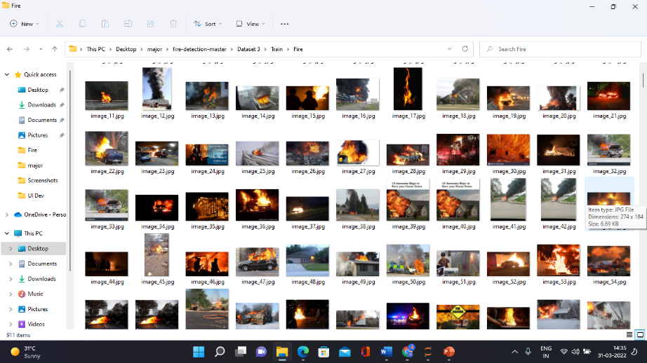

**Figure 4**. Training fire dataset

Choosing a proper dataset is one of the most important task as it acts as a base for the model to gain knowledge and classify the data.



**Figure 5**. Training neutral dataset

Data preprocessing performed here are image rescaling and resizing as images in the dataset are of different sizes and dimensions . Data augumentation performed here are vertical and horizontal flip along with zoom range of .2. The main reason to perform data augumentation is to increase the dataset size from the given dataset. Which is obtained by perfroming various operations on a single image like vertically flipping the image and this becomes a new data for training, similarly we can perform various operations such as vertical flip, zooming the image, blur etc. to increase the dataset.

**Model building, Training, Prediction and Alarming system**

We have built two models which are a simple sequential CNN model with an Adam optimizer and a pre built transfer learning model of Inception Net V3 with an Adam optimizer. The CNN model has 3 convolutional layers with 32, 42 and 64 filters in each layer and having relu as its activation function with a padding of valid along with max pooling of size 2 at each level. The output layer with an activation function of softmax. Using the adam optimizer we have trained the model with the dataset obtained from the first step. The checkpoint was created so that we can save the best model with high accuracy during the training of the model. The Inception V3 model was a pretrained model imported from keras which has 92 convolutional layers along with number of max poolings and batch normalizations to build a better model. Using the adam optimizer we have trained this model with the same datset. Similar to the above model the checkpoint of highest accuracy was created so that we can save the best model for classification. We initially tested with two images from ur test dataset and then predicted by using the surveillance camera for the real time prediction using the model built using OpenCV. If the fire was detected in the video frame for more than 5 frames it trigged the alarm indicating fire and sent a email to the owner indicating the fire.

**VI. RESULTS**

The CNN model built gave the accuracy of 90% and the pretrained transer learning model of Inception Net V3 model gave the accuracy of 98%. While we tried to predict the models with the images from the test dataset the sequential CNN model could not predict that accurately than the Inception net V3 model.

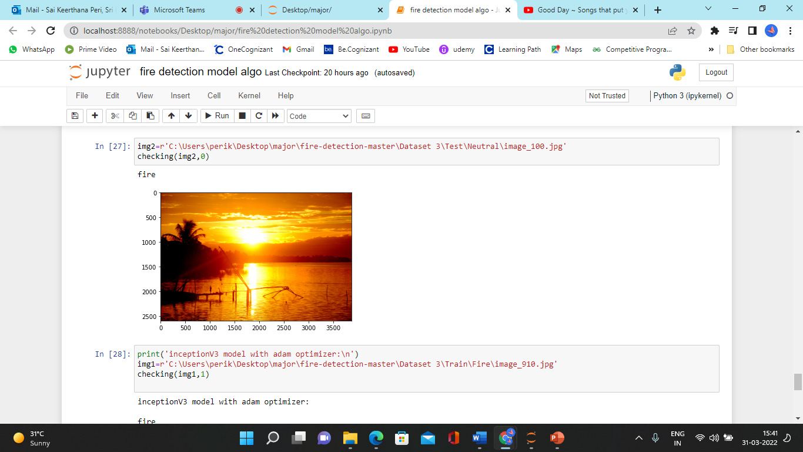

**Figure 6.** CNN model indicating fire for a neutral image

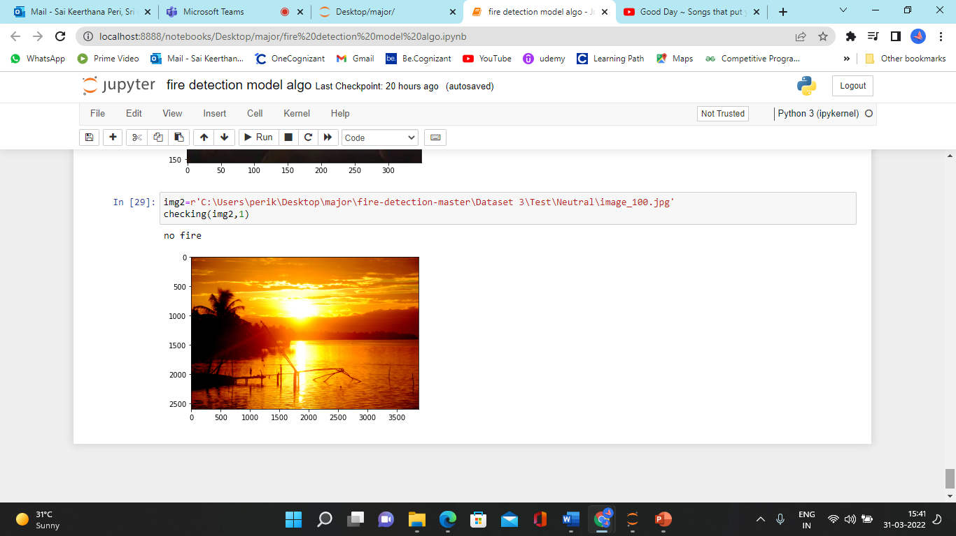

**Figure 7**. InceptionV3 model predicting a neutral image

We can observe that the Inception model can classify better than the sequential CNN model.

**VII. CONCLUSIONS**

The present decade is marked by huge strides in areas of processing, computation and algorithms. This has enabled great progress in many fields including processing of surveillance video streams for recognizing abnormal or unusual events and actions. Fire accidents have caused death and destruction all over the world, consuming countless lives and causing billions in damages. This implies that developing an accurate, early, affordable fire-detection system is imperative Therefore, we have proposed a fire detection model for videos/video frames using transfer learning for deep learning. Based on our observation we can make use of Inception Net V3 model along with adam optimizer for classification. Coming to the project on the whole, it works in real-time and has the ability to send alert emails indicating fire along with a siren. It’s cost-effective, reliable, robust, accurate compared to existing opto-electronic hardware and software-based systems in the market.

**ACKNOWLEDGMENT**

The paper has been composed with kind assistance, guidance from Mr Shashank Tiwari and support of my department who have helped me in this work. We would like to thank all the people whose encouragement and support has made the fulfillment of this work conceivable.

**REFERENCES**

1. Janku P., Kominkova Oplatkova Z., Dulik T., Snopek P. and Liba J. 2018. “Fire Detection in Video Stream by Using Simple Artificial Neural”. Network. MENDEL. 24, 2 (Dec. 2018), 55–60.
2. Shen, D., Chen, X., Nguyen, M., & Yan, W. Q. (2018). “Flame detection using deep learning”. 2018 4th International Conference on Control, Automation and Robotics (ICCAR).
3. Wanda Zaho(2020) “Image fire detection algorithms based on convolutional neural networks” case study in Thermal Engineering book, volume 19.
4. Suhas G , Chetan Kumar , Abhishek B S , Digvijay Gowda K A , Prajwal R (2020).” Fire Detection Using Deep Learning”. International Journal of Progressive Research in Science and Engineering Volume-1, Issue-5, August-2020.