**Swe573 Software Development Practice 2022 - Project Final Deliverables**

*HONOR CODE*

*Related to the submission of all the project deliverables for the Swe573 2022 Spring semester project reported in this report, I Mehmet Samet Taştı declare that:*

*- I am a student in the Software Engineering MS program at Boğaziçi University and am registered for Swe573 course during the 2022 Spring semester.*

*- All the material that I am submitting related to my project (including but not limited to the project repository, the final project report, and supplementary documents) have been exclusively prepared by myself.*

*- I have prepared this material individually without the assistance of anyone else* *with the exception of permitted peer assistance which I have explicitly disclosed in this report.*

*Mehmet Samet Taştı*

**Name:** Mehmet Samet Taştı **Student ID:** 2021719150

**Course:** Swe573 Software Development Practice **Date:** 31/05/2022 **Project Name:** LearnApp

**Git Repository:** <https://github.com/craer504/bounswe573-2022> **Git Tag Version:** v0.9

**Deployment URI:** <https://learnapp0.herokuapp.com/>

**Admin User for Testing: Name:** samet **Password:** 232700st

**Declaration:** I did all the work. Everything used abide by the license and law.

**Project Details:**

**Overview:** This is a project for SWE573 Software Development Practice. Participants can create workspaces and others can join to send messages, text only. I intended to do quiz functionality for each workspace but couldn't make it in time.

**Design:**

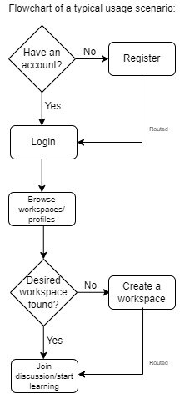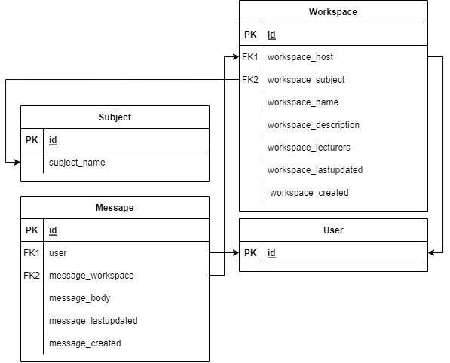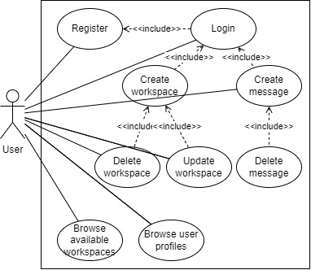

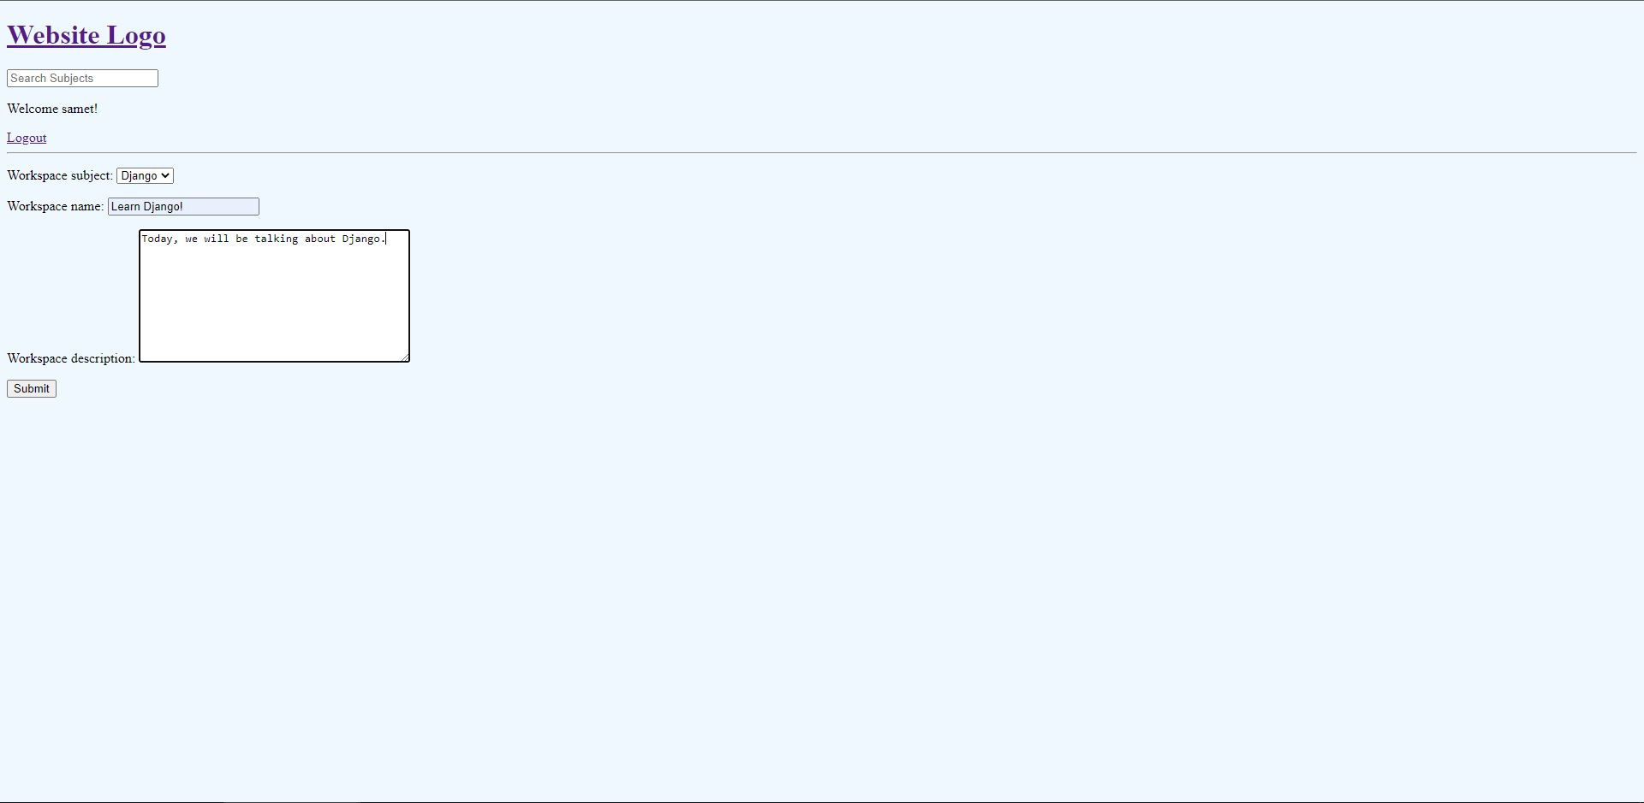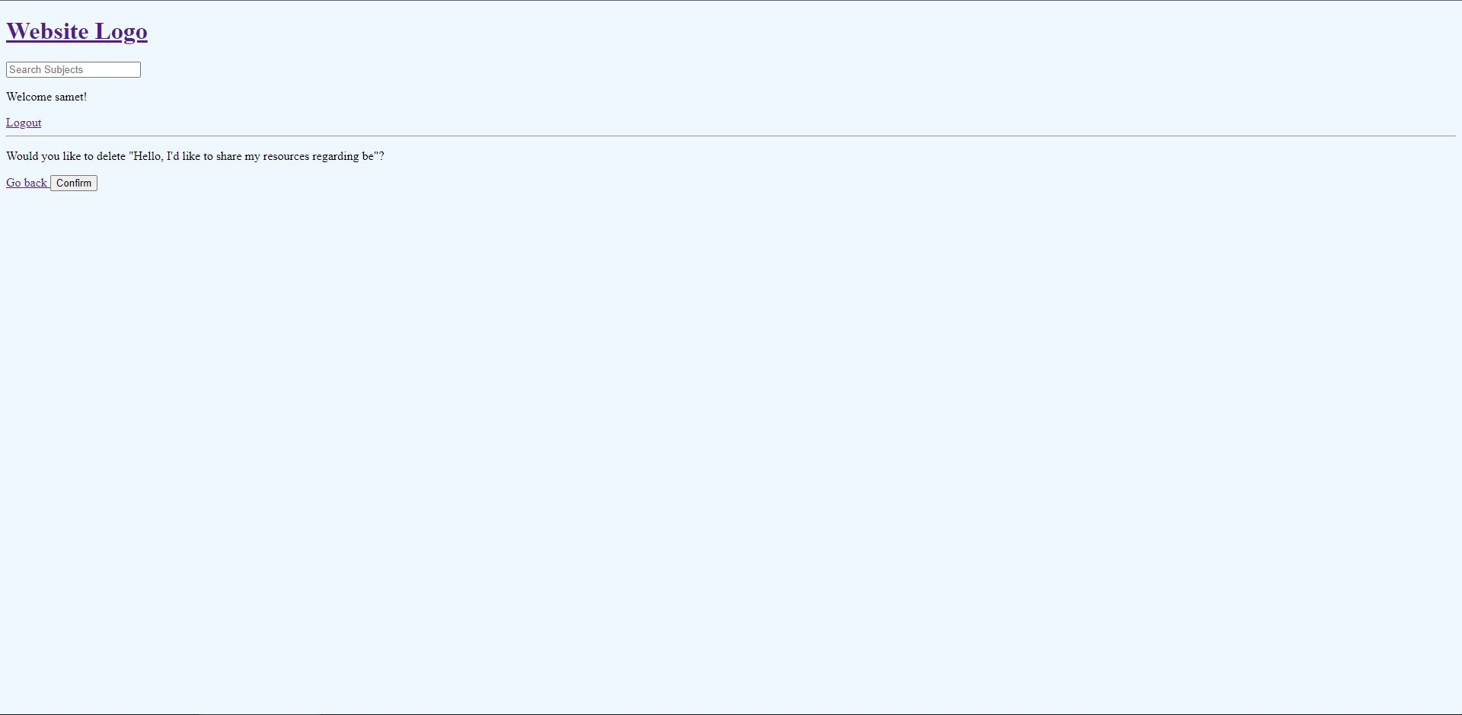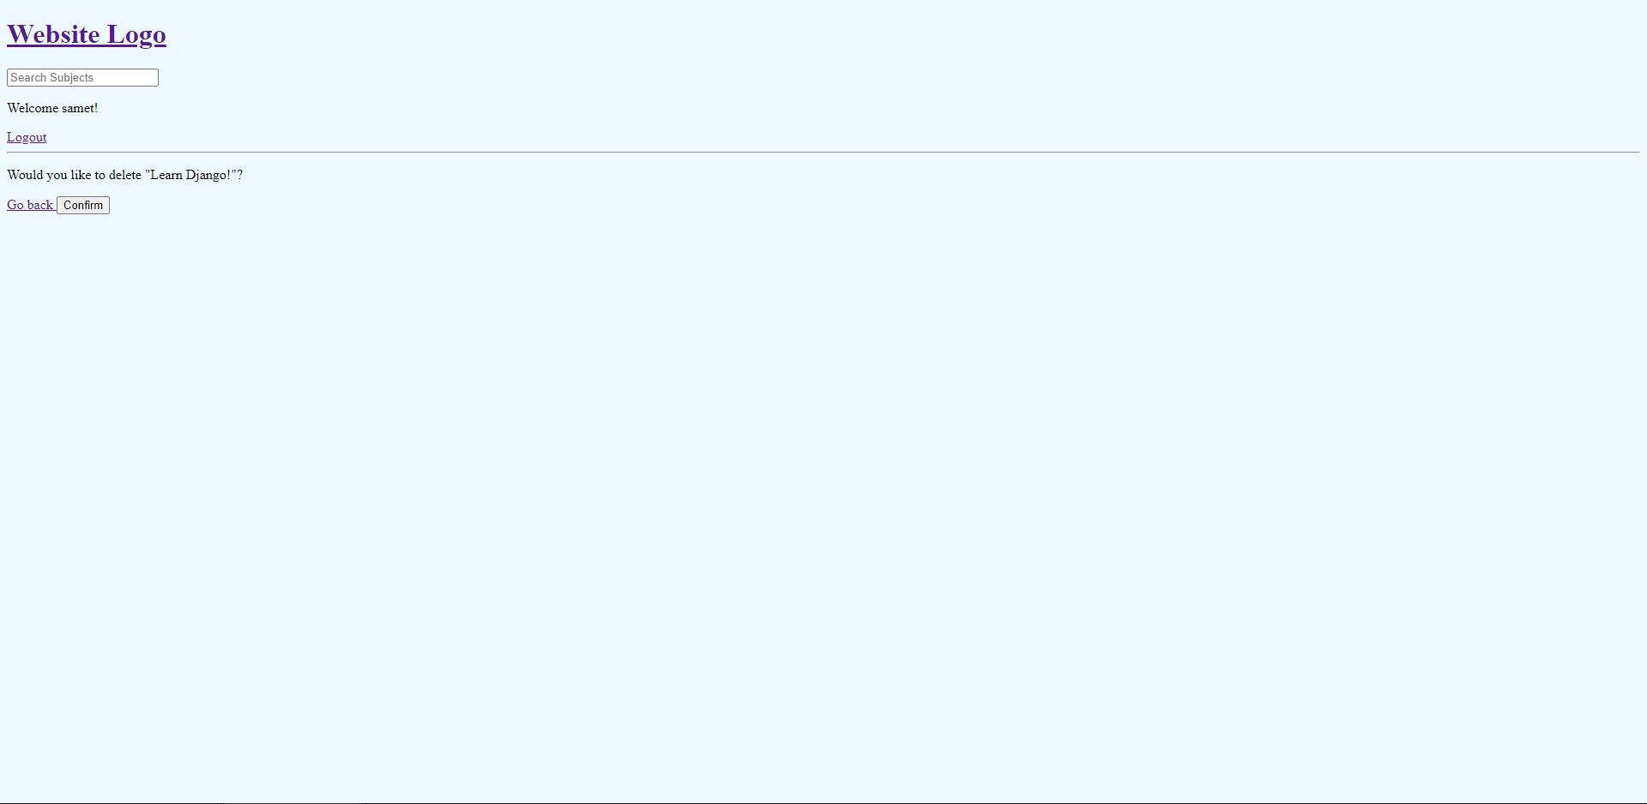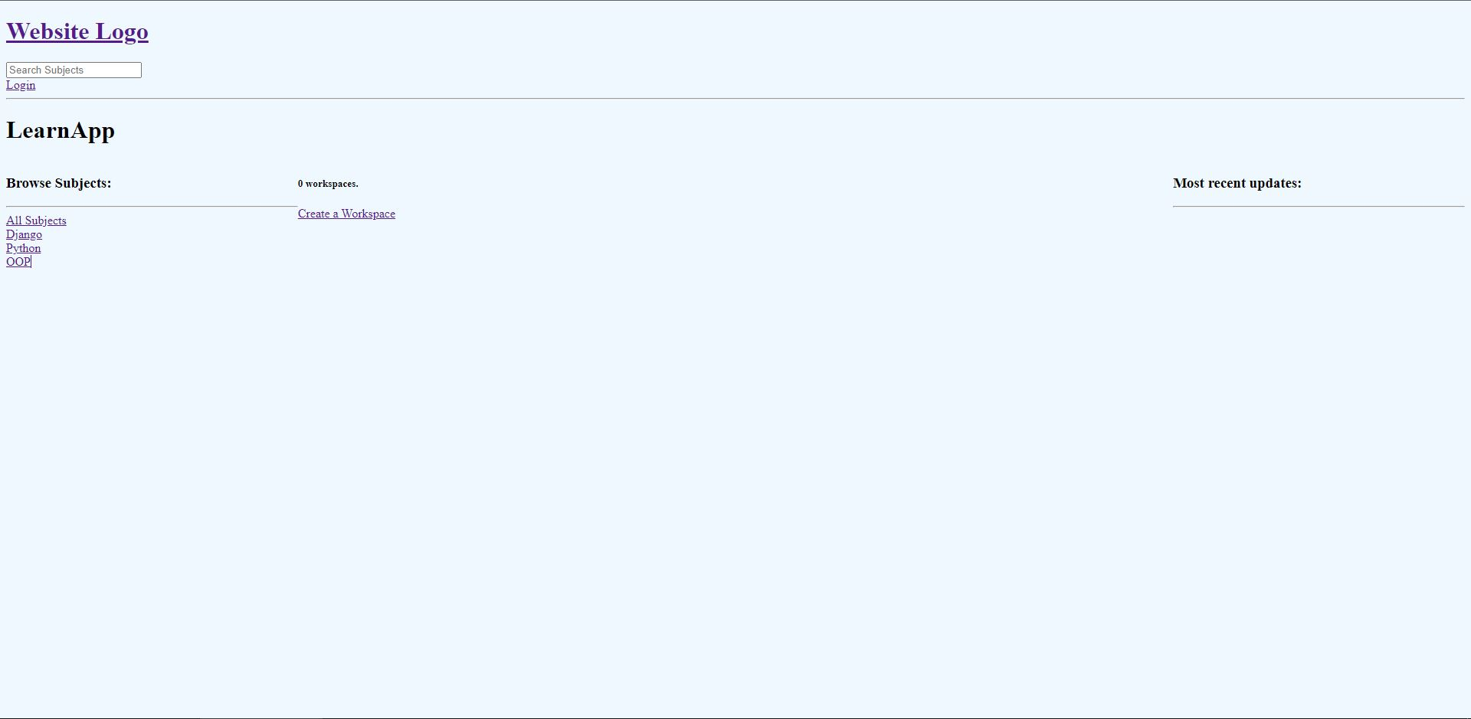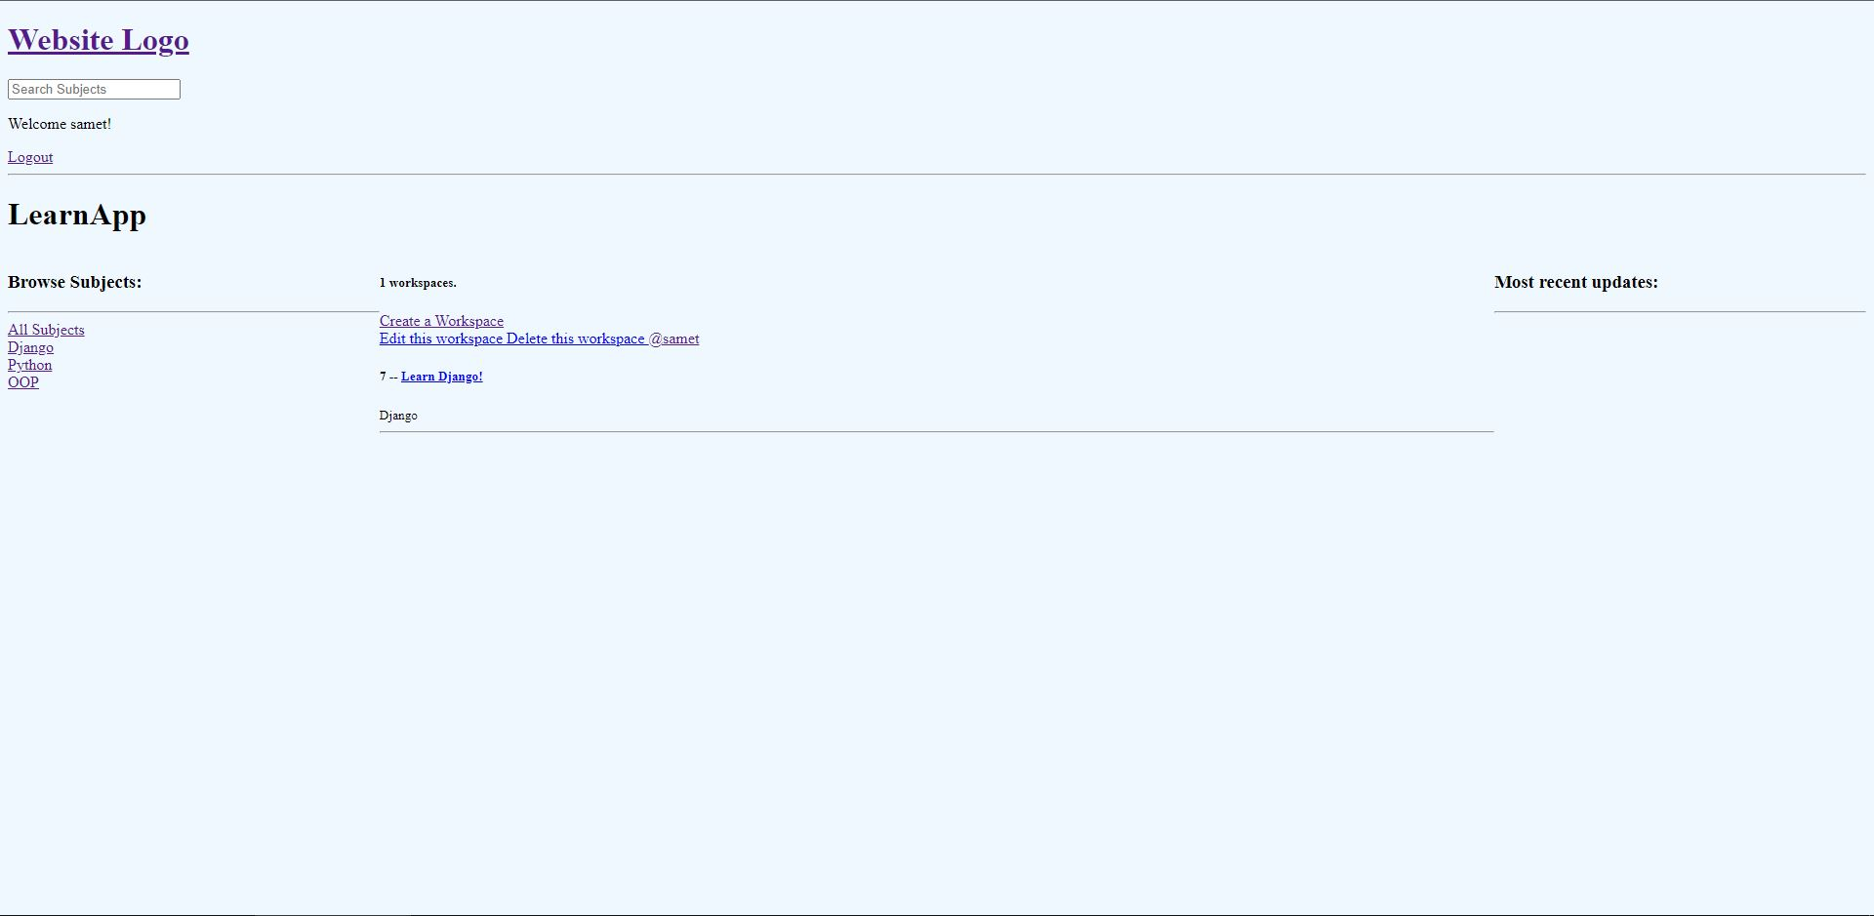

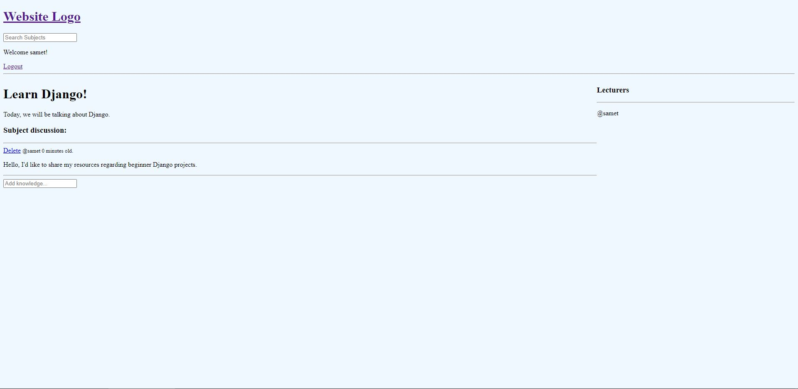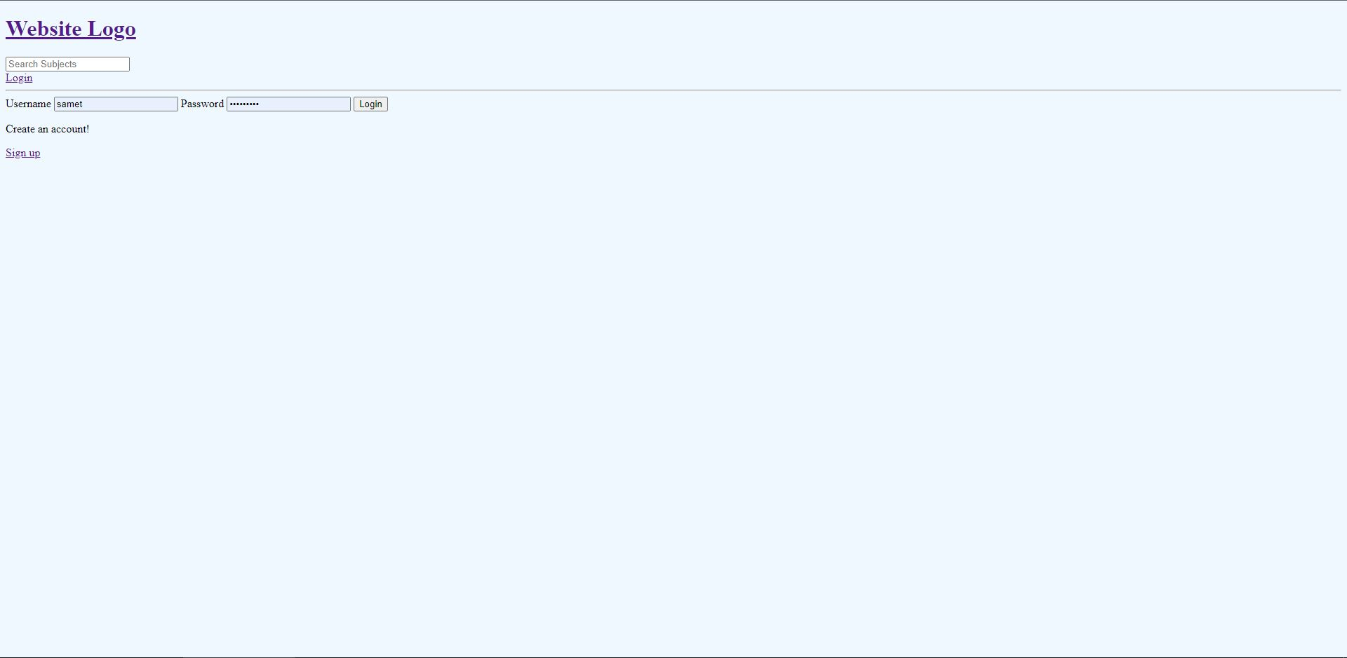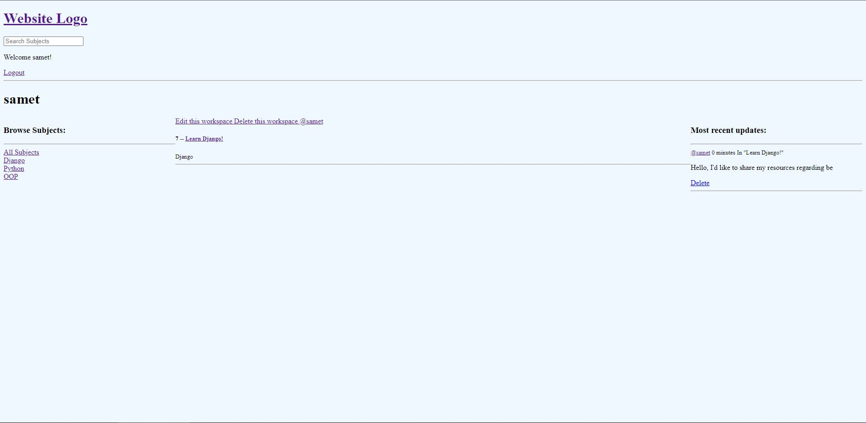

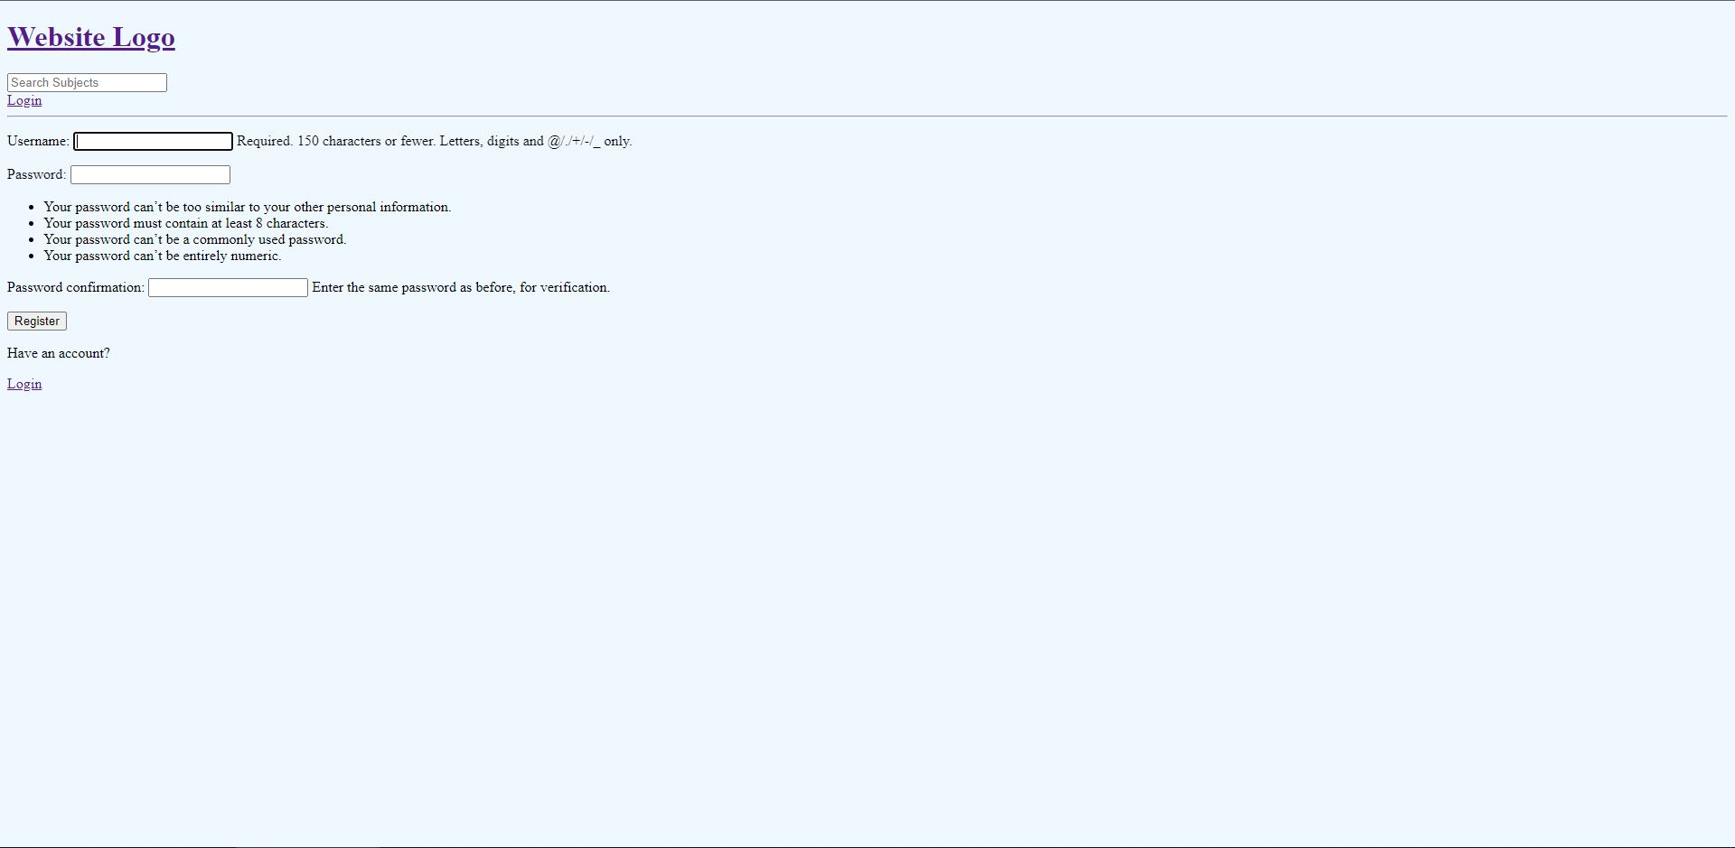

**Requirements:** I completed and tested all my requirements. I really don't know how to write or document tests, so could not do it. I unit tested each functionality while development to validate what functions do. All my requirements:

The system shall let new users register by specifying a username and a password. Completed.

The system shall let users login (authenticate) with their usernames and passwords. Completed.

The system shall ask for confirmation for any deletion operation, both for workspaces and for messages deletion operations. Completed.

The system shall let users search for their desired subjects with a search bar. Completed.

The system shall display user's profile page when their names are clicked on. Completed.

The user profiles shall let other users observe workspaces created and messages sent by the profile owner. Completed.

The system shall let authenticated users create workspaces. Completed.

The workspace creation process shall ask for a name, a topic tag and a description for a workspace. Completed.

The system shall let authenticated users edit their own workspaces; overriding the name, the tag and the description information of that workspace. Completed.

The system shall let authenticated users delete their own workspaces. Completed.

The workspaces shall let users discuss the specified topic with a discussion interface. Completed.

When a user participates in a workspace, that user shall be added to the participant list of that workspace by the system. Completed.

The workspaces shall let users observe who are the current participants in that workspace with a panel. Completed.

The workspace shall let users add quizzes with multiple choice questions. Incomplete.

The system shall filter workspaces when the subjects are selected from the browse menu. Completed.

**Deployment status:** Deployed & dockerized.

**System Requirements:** Any normal PC with a CPU can run this.

**User manual:** Register -> Login -> Browse topics -> Create a workspace -> Join a workspace -> Start discussing the topic.

**Final notes:** I could not add quiz functionality, did not have the time and the energy for it. I tried to implement it three times, but then I gave up. I only added empty HTML to observe how it would look like if the app had that functionality. Other than that, system works just fine, the requirements are met. On a personal note, I objectively had never done any web development prior to this semester, nor any Python, let alone Django, git, deployment, Docker etc., well, I never even had a chance to work in a real software job and therefore it is okay to say that I learned a lot about software engineering in a single course, more than I can ever imagine. I worked on this project to the best of my ability, and this final product is the maximum I can deliver for this time. I am humbly not interested in any of the technologies we have worked on this semester (save the git and software development topics and methodologies, i.e., what really matters in my humble opinion), and I came to dislike Python and any framework that utilizes Python, alongside all the boilerplate web development stuff (e.g., HTML, CSS, JS), it's just not suited for me. This is not an excuse for the lackluster quality being displayed by my project but rather, a friendly note on a semester's end. I wish we had the freedom to choose what projects we could work on but also, I am aware that this is not practical or applicable in the perspective of an instructor, whose judgements regarding the work done by the students must remain on objective ground (which, in this case, resulted in all projects being written in Python and displaying the same behavior, i.e., a workspace app, which makes this course's endeavors somewhat objective). The main problem with my project is that it doesn't have any real "meaningful" workspace interaction utilities (which you sir have pointed out during my presentation) and is text only and I'm ready for the consequences of that lacking. At least I and God knows that I have tried to add a quiz system (and failed miserably) and knowing this fact gives me enough strength to bear the consequences. I know that there is a partial credit system in place, so I had to gamble on what I could deliver and what I could not in my limited time, so I tried the deployment (which at the time I had not done) and after long hours of agony and pain, I was able to deploy my web application on Heroku and I felt great at that time! Thanks for providing us with the opportunity to feel great over small victories which are meaningful on a small, personal scale and which are specks of dust in the great scheme of things cosmic.