TRANSFER 3.3

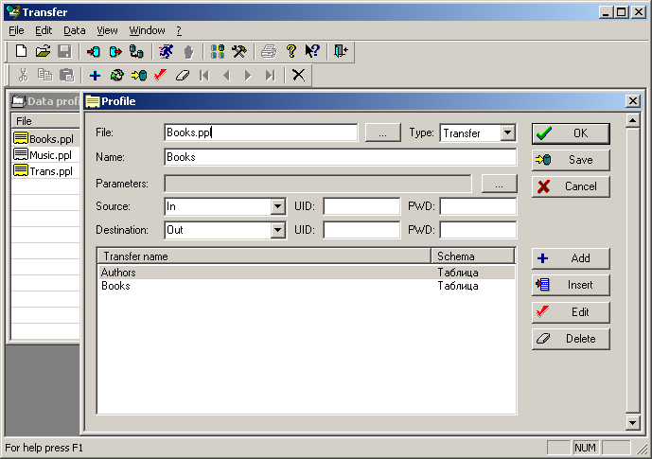

Transfer is the universal customizable utility for data transfer/conversion from one database to another.

Program is written in Microsoft Visual C++ with ODBC API, wich allows to reach the maximum productivity in massive data blocks processing. Program unification is based on standardized interface provided by ODBC drivers. Wide selection of existing ODBC drivers makes Transfer the universal tool to work with both file databases (dBase, Access) and relational databases (Oracle, Sybase, Microsoft SQL). In its work Transfer uses internal format of data representation, that makes it independent from specific data types peculiar to different databases. Embedded internal data definition language allows to customize the program to perform any tasks for information transferring/conversion.

Transfer main features:

- Work with any databases via ODBC interface.
- High performance in data processing.
- SQL query language support.
- Automatic data type convesion during transfer.
- Embedded flexible data structure (profiles) definition language.
- Support of external arguments for a data profile.
- Convenient data profile editor (GUI).
- Stored database procedures' calls during transfer.
- Trigger-based mechanism to make the data processing scenario.
- Possibility to process master-slave tables in one logical block.
- Internal text data convertor from ANSI to OEM and vice versa.
- Options to run from command line.
- Logging all actions in a protocol file.
- Optional SQL-commands execution tracing.
- Automatic message files creation upon the transfer completion.
- Possibility to run automatic file exchange with a remote host.
- Internal LZW data archiver.
- Multilingual support.

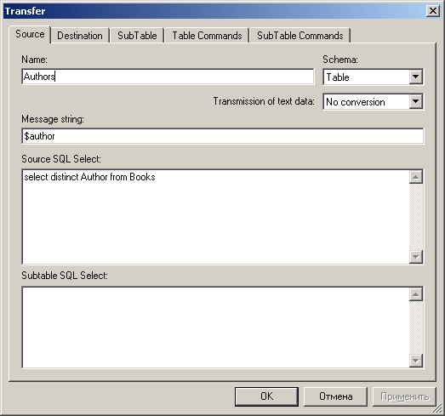

Initially Transfer was developed as a small utility to move financial data between central office and remote branches. However, in a course of time Transfer has become a powerful and flexible tool for data transferring/conversion using ODBC drivers. The complexity of data processing tasks forced to develop the flexible data structure definition language allowing the program to be highly customizable to the particular user needs. The language has rather simple syntax which is not mandatory to remember. Transfer has a convenient profile editor, that allows to define all neccessary parameters for a data profile using a number of dialogs and then save them in a file.

There could be several fields of using Transfer:

- Program is very useful as a utility for quick one-occasion data transfer/conversion from one database to another. Those databases should not neccessarily be of the same type. For example, quite easy you can transfer your data between Access and Oracle. All you need for that - is to define data structures (tables) and corellation between source and destination. You can also use the special feature to automatically create tables in destination database. Data can be conveyed unconditionally or using comparision mode, i.e. only missing rows will be added to the destination table.
- It is possible to use Transfer as powerful tool providing data exchage between central office and remote branches for financial applications. Data can be delivered using any media (diskette, USB drive) or by email. Here the powerful mechanizm of integrated data processing can be used for documents exchange (where the document is treated as a monolithic entity which consists of related data). For data processing automation during information import the event-based scenario can be used by means of special triggers. Also, the big advantage of Transfer is the capability of stored database procedures' calls during data transfer.
- Transfer can also serve as a transmission mechanizm to provide an automatic continuous data exchange between distributed databases. The special data exchange setup allows to plan automatic sessions of data transferring in certain data intervals. Program should be run all the time (be resident). For the convenience of users the program can be minimized to system. To optimize the data file size for sending there is an embedded data archiver in LZW format. The remote hosts can be connected, for example, using Microsoft service "Remote-access server".

