Seizure Lab

IT566-001

Dane Morgan

Aaron Cowley

25 January 2019

Table of Contents

1. Executive Summary 1

2. Background 2

3. Preparation 2

3.1 Documentation 2

3.2 Tools 2

3.3 Lab Sign Up 2

4. Methodology 3

4.1 Access 3

4.2 Visual Scan 4

4.3 Volatile Memory Capture 4

4.4 Device Identification 5

4.5 Chain of Custody Release 5

4.6 Evidence Authentication 5

4.6.1 Digital Evidence Hash Table 5

4.6.2 Document Description and Hash Table 6

5. Lessons Learned 6

6. Bio 6

6.1 Dane Morgan 6

6.2 Aaron Cowley 7

References i

Appendices ii

Appendix A: Search Warrant 1.4.4 ii

Appendix B: Evidence Chain of Custody Tracking Form 1.4.0 ii

Appendix C: Consent to Search Electronic Media 1.4.1. ii

Appendix D: Notes 1.4.3 ii

Appendix D: Workstation 1.1.0 ii

Appendix E: Family Photo 1.1.2 ii

Appendix F: Kittens Photo 1.1.3 ii

Appendix G: Computer Desktop 1.1.1 ii

Appendix H: Digital Evidence Hash Table ii

Appendix I: Document Description and Hash Table ii

Appendix J: Devices Evidence Table iii

Appendix K: Investigator Dane Morgan CV iii

Appendix L: Investigator Aaron Cowley CV iii

# Executive Summary

On 24. January 2019, we Dane Morgan and Aaron Cowley, carried out the seizure and digital evidence collection of an iMac 5 in room CTB 350. We successfully obtained several pieces of evidence, including a volatile memory capture, several photos of the crime scene, and MD5 checksums for each piece of evidence. In addition to the evidence we collected; we, to the best of our knowledge have prepared and completed all necessary documents for the seizure of this computer equipment and digital media as part of this criminal investigation.

# Background

On 18. January 2019, Dr. Justin Giboney informed us that we would perform a digital evidence collection and seizure lab. Giboney also informed us that for the scope of this lab we could use our smart phones to take pictures of evidence.

On 21. January 2019, we received an email from Dr. Justin Giboney instructing us to do the following:

* + 1. Come prepared with everything we need to do a criminal investigation.
    2. Sign up for a time on Google Sheets to come to room CTB 350 to perform our lab

On 22. January 2019, we received email from Dr. Justin Giboney with instructions on how to perform volatile memory collection on macOS and to bring a device to collect volatile memory.

# Preparation

## 3.1 Documentation

To prepare for evidence collection we submitted a request1 for a search warrant from the United States Department of the Treasury. We received our warrant on 24. January 2019 (see Appendix A).

We printed copies of NIST’s “*Evidence of Chain Custody Tracking*” form2 (see Appendix B) and a copy of the United States Secret Service “*Consent to Search Electronic Media*” form3 (see Appendix C).

## 3.2 Tools

As instructed, we brought a USB flash drive (evidence no. 1.0.3) to collect volatile memory. We ensured that our USB drive (evidence no. 1.0.3) was formatted in exFAT so that the drive could be mounted on macOS. In case of drive failure, we bought an additional USB drive (evidence no 1.0.4).

We brought Dane Morgan’s iPhone 7 to take pictures of evidence at the scene.

To take notes, we brought ample graph paper.

## 3.3 Lab Sign Up

As instructed in Dr. Giboney’s email, we signed up a time slot at 1:00PM on 24. January 2019 at 1:00PM

# Methodology

## 4.1 Access

We arrived at CTB 350 at 12:53 PM and were greeted by Dr. Giboney. We presented our search warrant (Appendix A) and search consent (Appendix C) forms to Dr. Giboney. He signed our consent form and Aaron Vivian signed as a witness.

Giboney informed us that he is the lab technical, then he directed us Workstation 1 and informed us that we were welcome to ask 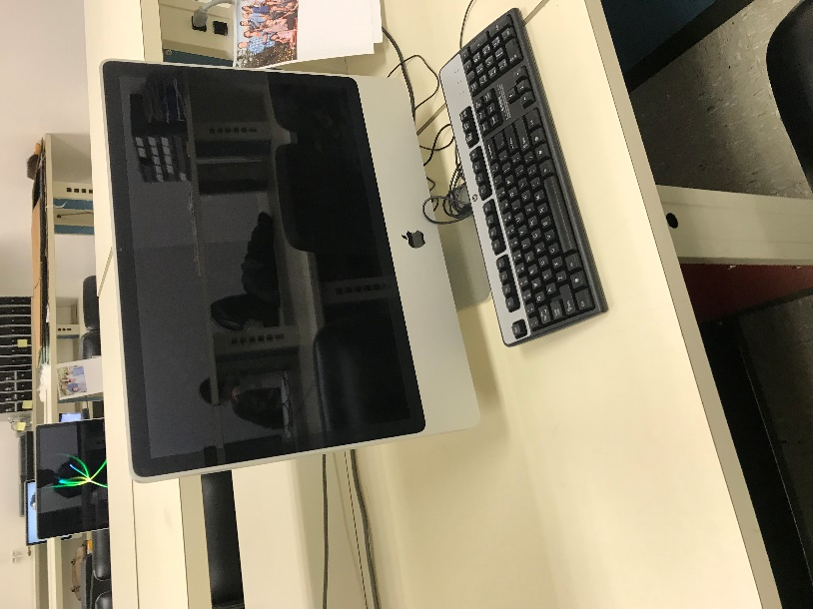him any questions, should we need help.

First, we took pictures of Workstation 1(See Appendix D) and took pictures of the photos that were taped to the desk (See Appendix E and Appendix F).

The following devices were at Workstation 1:

1 iMac 24-inch, Early 2008 (evidence no. 1.0.0)

1 Generic HP Keyboard (evidence no. 1.0.1)

1 Generic HP Optical Mouse (evidence no. 1.0.2)

Figure 4.1.1 Workstation upon arrival (evidence no. 1.1.0)

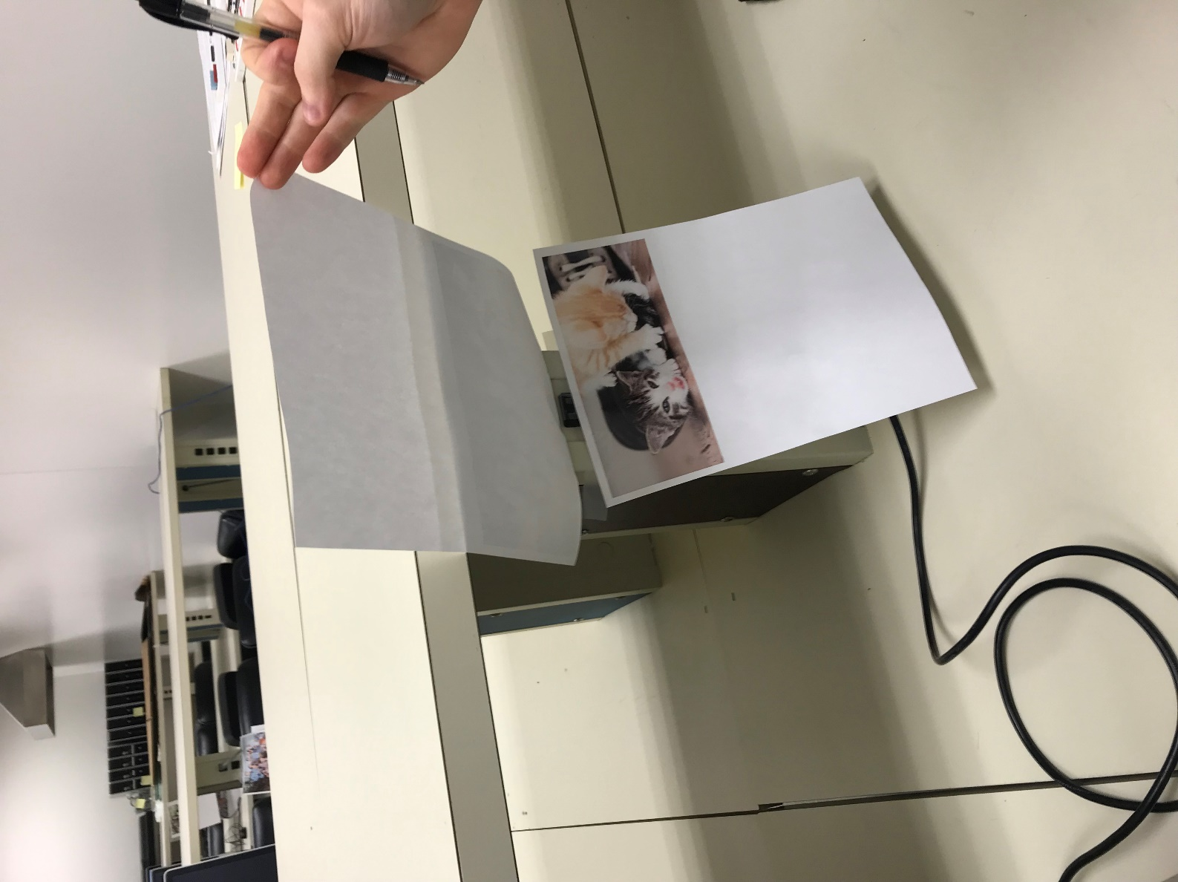As shown above, the computer (evidence no. 1.0.0 ) was asleep. At 12:55PM we hit the space bar to wake it up. A login screen appeared with the user’s name as “Local Admin” with a blank password field. We tried various common password to try and login. After four or five failed login attempts, we tried switching users, this was unhelpful because both username and password fields were blank.

We asked Dr. Giboney if he knew a valid username and password for this machine. Dr. Giboney told us that the username was “ladmin” and the password probably related to the type of cats in the picture.

At 1:00 PM we successfully login with the following credentials:

Figure 4.1.2 Kittens picture (evidence no. 1.1.3)

username: ladmin

password: kittens

## 4.2 Visual Scan

Once logged in, the desktop and application dock showed that following applications were open:

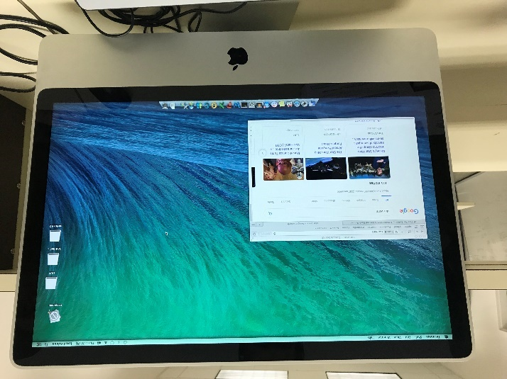Finder

Safari

Sublime Text

Terminal

We then checked to see if computer 1.0.0 had a wired network connection – it did not. Then we confirmed that this computer was not connected to any internal or external network by checking the network status icons in macOS’s Menu Bar.

Figure 4.1.2 Computer 1.0.0 desktop (evidence no. 1.1.1)

## 4.3 Volatile Memory Capture

Once we were done with our initial visual scan of the desktop, we proceed to capture and save volatile memory. We inserted USB drive (evidence no. 1.0.3.), opened Terminal.app, then signed is as the root user with password we had obtained earlier with the following command:

$ sudo su

Now with root access, we changed directories to mountpoint of USB drive (evidence no. 1.0.3.), with the following command:

$ cd /Volumes/sandisk

With our current working directory set to our USB drive (evidence no. 1.0.3.),, we then captured volatile live memory with the following command:

$ /Users/ladmin/Desktop/osxpmem.app/osxpmem -o ./24_january_2019_memcap_ __tests-iMac-5-evno-1-2-0.aff4

At 1:14PM, our memory capture was successfully saved to USB drive (evidence no. 1.0.3.),.

## 4.4 Device Identification

To find more details about the computer (evidence no. 1.0.0) we opened “About This Mac” on the Menu Bar, then clicked “More Information”. From there, were able to find the following information:

Model: iMac 5 (24-inch, Early 2008)

Serial Number: QP220NWZE7

## 4.5 Chain of Custody Release

At 1:22PM, we released the computer (evidence no. 1.0.0) to Justin Giboney and completed the appropriate chain of custody form (Appendix B), then left the premise.

## 4.6 Evidence Authentication

Back at our lab, we inserted USB drive (evidence no. 1.0.3) and copied the volatile memory capture (evidence no. 1.2.0), all photos (evidence no. 1.1.0-3), and documents (evidence no. 1.4.0-4) to our lab machine.

To ensure the integrity of our evidence and documentation, we obtained MD5 checksums of each file. We generated MD5 checksums with the following command:

$ md5sum ./* > seizure-lab-hashes.chk

Below are the hash tables of our evidence and documents.

### 4.6.1 Digital Evidence Hash Table

|  |  |  |  |
| --- | --- | --- | --- |
| *Description* | *Evidence No.* | *Filename* | *MD5 Hash* |
| *iMac-5 Memory Capture* | 1.2.0 | 24_january_2019_memcap_tests-iMac-5-evno-1-2-0.aff4 | ef4b5c1418ad2d2db8c0b0c485e20840 |
| *Workstation* | 1.1.0 | workstation-1.1.0.jpg | d4e389fd54a6ec9867e2ec5f7c690195 |
| *Computer Desktop* | 1.1.1 | desktop-1.1.1.jpg | d47af00d7e438d30dafb9ae0506ec27c |
| *Family Photo* | 1.1.2 | family-picture-1.1.2.jpg | ff2bd31bf17f2b79fd61ca68e27efb19 |
| *Kittens Photo* | 1.1.3 | kittens-1.1.3.jpg | 0db009274b6cef9002765cdb68c28e45 |

### 4.6.2 Document Description and Hash Table

|  |  |  |  |
| --- | --- | --- | --- |
| *Description* | *Evidence No.* | *Filename* | *MD5 Hash* |
| *Evidence of Chain of Custody Tracking Form* | 1.4.0 | evidence-of-chain-of-custody-tracking-form-1.4.0.pdf | 2bb5c939adecb6249921af99c27f2d11 |
| *Consent to Search Electronic Media Form* | 1.4.1. | conset-to-search-electronic-media-1.4.1.pdf | 9ceac6c0cbfbbdaf213b6a69bf5f4ef3 |
| *Search Warrant* | 1.4.2 | search-warrant-1.4.2.pdf | d837901ec913f31addb93b57c33f0d3e |
| *Hand Written Notes* | 1.4.3 | notes-1.4.3.pdf | 6cd5a711842e8887a05cf686893d652c |

To ensure that our evidence could not be lost via data corruption or system failure, we made two copies of each piece of evidence. We saved one copy to Dane Morgan’s lab computer, and second copy to our extra USB drive (evidence no. 1.0.4).

# Lessons Learned

Looking back, there are two mistakes that we could have avoided:

* 1. Take more detailed time series notes.

Next time, we need to be more diligent about writing down everything we do with the corresponding time. Having detailed time-series notes is essential to writing a valid forensic report.

* 1. Pay attention to the applications that are open on the machine we examined.

Next time, after we perform the memory capture, we need to look at all the applications that are open. We missed some evidence because we didn’t look at the pages that were open on Safari and Sublime Text.

# Bio

## 6.1 Dane Morgan

I work in the CSRL as a research assistant and am currently senior in the Cybersecurity major. I am planning on attending graduate school at BYU to earn my master’s degree in Technology. I am a skilled programmer and am a member PyPI, I have published several security related packages to their repository. I am part of BYU’s CCDC Team, I typically lead on hardening Unix-based systems and setting up the IDS/IPS’s. I am skilled with Unix-based systems; however, my knowledge and skill with Windows systems is shallow and limited.

## 6.2 Aaron Cowley

I am a undergrad student in Cybersecurity in the cybersecurity major and currently work as a research assistant for the BYU Cybersecurity Research Lab. I am an avid cybersecurity student and have gained a lot of experience in cybersecurity as a research assistant. I also compete in CCDC competitions that help train me in defensive cybersecurity and incident response.

# References

*Best Practices for Seizing Electronic Evidence.* n.d. https://www.crime-scene-investigator.net/SeizingElectronicEvidence.pdf (accessed January 24, 2019).

IRS. *9.7.2 Civil Seizure and Forfeit | Internal Revenue Service.* n.d. https://www.irs.gov/irm/part9/irm_09-007-002 (accessed January 24, 2019).

*Sample Chain of Custody Form.* n.d. https://www.nist.gov/document/sample-chain-custody-formdocx (accessed January 24, 2019).

# Appendices

## Appendix A: Search Warrant 1.4.4

See attached file: [search-warrant-1.4.2.pdf](https://github.com/deadlift1226/seizure-lab-it566/blob/master/documents/search-warrant-1.4.2.pdf)

## Appendix B: Evidence Chain of Custody Tracking Form 1.4.0

See attached file: [evidence-of-chain-of-custody-tracking-form-1.4.0.pdf](https://github.com/deadlift1226/seizure-lab-it566/blob/master/documents/evidence-of-chain-of-custody-tracking-form-1.4.0.pdf)

## Appendix C: Consent to Search Electronic Media 1.4.1.

See attached file: [conset-to-search-electronic-media-1.4.1.pdf](https://github.com/deadlift1226/seizure-lab-it566/blob/master/documents/conset-to-search-electronic-media-1.4.1.pdf)

## Appendix D: Notes 1.4.3

See attached file: [notes-1.4.3.pdf](https://github.com/deadlift1226/seizure-lab-it566/blob/master/documents/notes-1.4.3.pdf)

## Appendix D: Workstation 1.1.0

See attached file: [workstation-1.1.0.jpg](https://github.com/deadlift1226/seizure-lab-it566/blob/master/evidence/workstation-1.1.0.jpg)

## Appendix E: Family Photo 1.1.2

See attached file: [desktop-1.1.1.jpg](https://github.com/deadlift1226/seizure-lab-it566/blob/master/evidence/family-picture-1.1.2.jpg)

## Appendix F: Kittens Photo 1.1.3

See attached file: [kittens-1.1.3.jpg](https://github.com/deadlift1226/seizure-lab-it566/blob/master/evidence/kittens-1.1.3.jpg)

## Appendix G: Computer Desktop 1.1.1

See attached file: [desktop-1.1.1.jpg](https://github.com/deadlift1226/seizure-lab-it566/blob/master/evidence/desktop-1.1.1.jpg)

## Appendix H: Digital Evidence Hash Table

|  |  |  |  |
| --- | --- | --- | --- |
| *Description* | *Evidence No.* | *Filename* | *MD5 Hash* |
| *iMac-5 Memory Capture* | 1.2.0 | 24_january_2019_memcap_tests-iMac-5-evno-1-2-0.aff4 | ef4b5c1418ad2d2db8c0b0c485e20840 |
| *Workstation* | 1.1.0 | workstation-1.1.0.jpg | d4e389fd54a6ec9867e2ec5f7c690195 |
| *Computer Desktop* | 1.1.1 | desktop-1.1.1.jpg | d47af00d7e438d30dafb9ae0506ec27c |
| *Family Photo* | 1.1.2 | family-picture-1.1.2.jpg | ff2bd31bf17f2b79fd61ca68e27efb19 |
| *Kittens Photo* | 1.1.3 | kittens-1.1.3.jpg | 0db009274b6cef9002765cdb68c28e45 |

See also attached [seizure-lab-hashes.chk](https://github.com/deadlift1226/seizure-lab-it566/blob/master/documents/seizure-lab-doc-hashes.chk) for MD5 checksum validation file

## Appendix I: Document Description and Hash Table

|  |  |  |  |
| --- | --- | --- | --- |
| *Description* | *Evidence No.* | *Filename* | *MD5 Hash* |
| *Evidence of Chain of Custody Tracking Form* | 1.4.0 | evidence-of-chain-of-custody-tracking-form-1.4.0.pdf | 2bb5c939adecb6249921af99c27f2d11 |
| *Consent to Search Electronic Media Form* | 1.4.1. | conset-to-search-electronic-media-1.4.1.pdf | 9ceac6c0cbfbbdaf213b6a69bf5f4ef3 |
| *Search Warrant* | 1.4.2 | search-warrant-1.4.2.pdf | d837901ec913f31addb93b57c33f0d3e |
| *Hand Written Notes* | 1.4.3 | notes-1.4.3.pdf | 6cd5a711842e8887a05cf686893d652c |

See attached file [seizure-lab-doc-hashes.chk](https://github.com/deadlift1226/seizure-lab-it566/blob/master/evidence/seizure-lab-hashes.chk) MD5 checksum validation file

## Appendix J: Devices Evidence Table

|  |  |  |  |
| --- | --- | --- | --- |
| Description | Evidence No. | Serial Number | Quantity |
| iMac 5 24-Inch; Early 2008; | 1.0.0 | QP220NWZE7 | 1 |
| Generic HP Keyboard | 1.0.1 | - | 1 |
| Generic HP Optical Mouse | 1.0.2 | - | 1 |
| SanDisk Cruzer Glide 3.0 256GB; USB drive | 1.0.3 | BQ171225913B | 1 |
| SanDisk USB Flair USB 3.0 16GB; USB drive | 1.0.4 | MSIP-REM-TAD-SDCZ73 | 1 |

## Appendix K: Investigator Dane Morgan CV

See attached file: [DANE_MORGAN_ResumeSep2018.pdf](https://github.com/deadlift1226/seizure-lab-it566/blob/master/cv/DANE_MORGAN_ResumeSep2018.pdf)

## Appendix L: Investigator Aaron Cowley CV

See attached file: [AARON_COWLEY_Resume.pdf](https://github.com/deadlift1226/seizure-lab-it566/blob/master/cv/AARON_COWLEY_Resume.pdf)