**PARADISE LOST : RECORDS OF LONGEVITY IN OTHER NATIONS**

The Bible records that lifespans decreased over a long period, 38 generations. Such a decline would have been witnessed by the entire global population - therefore it should be evident also in the genealogies of other nations.

In order to test this hypothesis, I will be looking at the king lists of several nations. The question I will be asking is “Do the earliest dynasties show extended lifespans or reign spans?”

In order to answer this question I will look at the ancient king lists of Egypt, India, China, Mesopotamia, Sumer, Babylon and Greece.

**EGYPTIAN KINGS**

The first and second dynasties of Egyptian kings can be found in the Turin King list and a translation is shown here -

[Turin king list: Column 2 (pharaoh.se)](https://pharaoh.se/turin-kinglist-column-2)

[Turin king list: Column 3 (pharaoh.se)](https://pharaoh.se/turin-kinglist-column-3)

[Turin Kinglist II,11-III,26/27 (bibliotecapleyades.net)](https://www.bibliotecapleyades.net/egipto/turin_kinglist/0211_0327.htm)

The first dynasty starts in column 3.10. Here is a literal translation for the first 5 Egyptian dynasties -

**DYNASTY 1**

The Dual King, Meni, Life, Prosperity, and Health

The Dual King Ity

The Dual king...

10 +x months 28 days ..

The Dual King Ity

The Dual King Qenty ...

The Dual King Merigeregepen ... **74 years** ...

The Dual King Semsem ... **72 years** ...

The Dual King Qebeh ... **63 years** ...

**DYNASTY 2**

The Dual King Baunetjer ... **95 years** ...

The Dual King Kakau ...

The Dual King Baunetjer ... **95 years** ...

The Dual King Wadjnes ... **70 years** ...

The Dual King Senedj ... **54 years** ...

The Dual King Aaka ... **70 years** ...

The Dual King Neferkasokar **8 years** 3 months x days his lifetime 10

The Dual King Hudjefa, **11 years**, 8 months, 4 days, his lifetime 34 years

The Dual King Bebti ... **27 years**, 2 months, 1 day, his lifetime 40 years ...

**DYNASTY 3**

The Dual King Nebka ... **19 years** ... his lifetime ...

The Dual King Djoserit, he acted as king for **19 years** 1 month, his lifetime ...

The Dual King Djoserti, he acted as king for **6 years** x months ...

The Dual King Hudjefa, **6 years** x months ...

The Dual King Huni, life, prosperity and health, **24 years**, the one who has built Seshem ...

**DYNASTY 4**

The Dual King Snofer(u), **24 years** ...

The Dual King ... **23 years** ...

The Dual King ..., **8 years** ...

The Dual King Kha... x years

The Dual King ... years

The Dual **King** ... **28 years**

The Dual King ... **4 years** ...

The Dual King ... **2 years**

**DYNASTY 5**

The Dual King ...ka..., **7 years** ...

The Dual King ... **12 years**

The Dual King ... he acted as king for ...

The Dual King ... **7 years** ...

The Dual King ... x years ...

The Dual King ... **10 + x years** ...

The Dual King Menkauhor, **8 years**

The Dual King Djedu, **28 years**

The Dual King Unas, **30 years**

The First Dynasty of Egypt is dated to about 3100 B.C.

*Most lines give the name of a particular king, written in a cartouche, followed by the number of years he ruled, and in some cases even by the number of months and days. The number of years credited to some kings of the*[***1st***](https://ancient-egypt.org/history/early-dynastic-period/1st-dynasty/index.html)*and*[***2nd Dynasty***](https://ancient-egypt.org/history/early-dynastic-period/2nd-dynasty/index.html)*is so high, that, in those particular cases, they are most likely not correct. It has sometimes been postulated that this high number of years does not reflect the length of a reign but the age at which the king died. Although this possibility cannot entirely be overruled, it is strange that the writer should choose to note the age of a king in one case and the length of his reign in another.*

[The Ancient Egypt Site - Turin King-List (ancient-egypt.org)](https://ancient-egypt.org/from-a-to-z/t/turin-king-list.html)

This quote shows an acknowledgement that the reign lengths in the first and second dynasties were very high. The third dynasty shows a big drop in reign length.

A polynomial curve fits the data best, with an R2 = 0.73. An exponential curve is the next best fit to this data (R2 = 0.67). A straight line has a lower fit. (R2 = 0.53).

The intercept with the Y-axis appears to be about 100 years – which is the generation gap of pre-diluvian people.

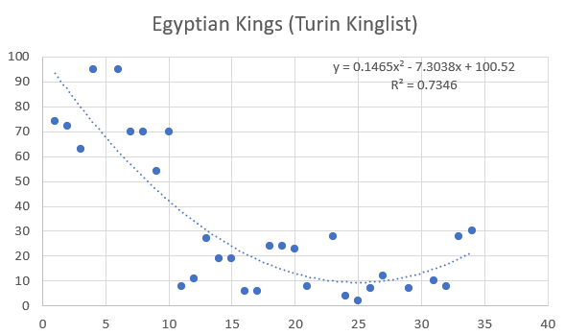

[The Fragments of Hieratic Papyrus at Turin: Containing the Names of Egyption Kings, with the ... : Sir John Gardner Wilkinson : Free Download, Borrow, and Streaming : Internet Archive](https://archive.org/details/fragmentshierat00wilkgoog/page/n63/mode/2up?view=theater)

The data show a sharp decline in reign length 17 generations after King Menes.

Prior to the first dynasty the kings are said to have reigned even longer.

**INDIAN KINGS**

A record of Indian kings can be found here – [The Kings of Indraprastha after Mahabharata | Sanskriti - Hinduism and Indian Culture Website (sanskritimagazine.com)](https://www.sanskritimagazine.com/kings-indraprastha-mahabharata/)

It purports to be a record of every king over a period of 124 generations or 4,157 years, 9 months and 14 days between the event of Mahabharata and the beginning of the Mughal era in 1193.

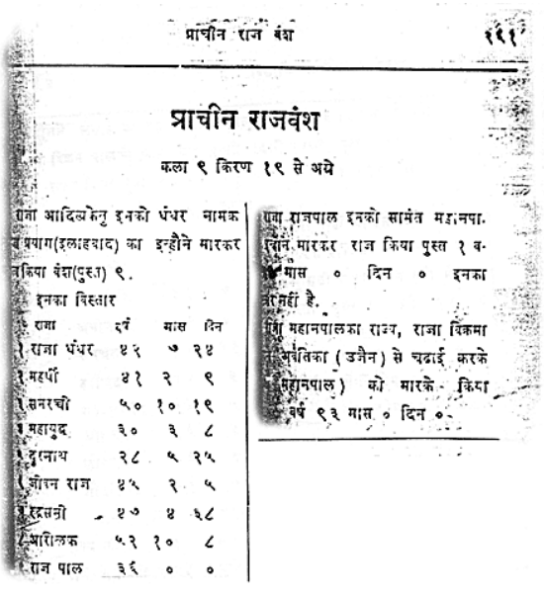

I was curious to see what would emerge when the dates of each of these kings were plotted on a graph. (you can do this for yourself using Microsoft Excel).. An exponential decay curve emerged.

My excel sheet is available here – <https://howbad.info/lifespan.xlsx>

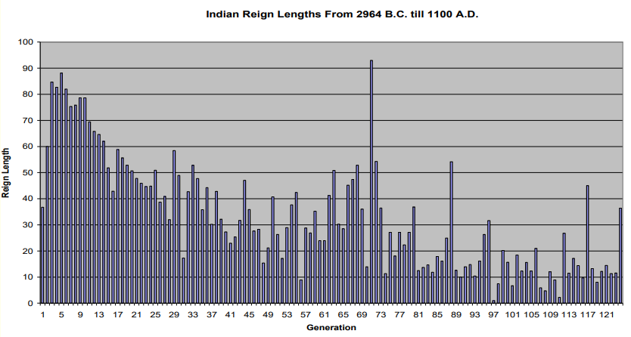

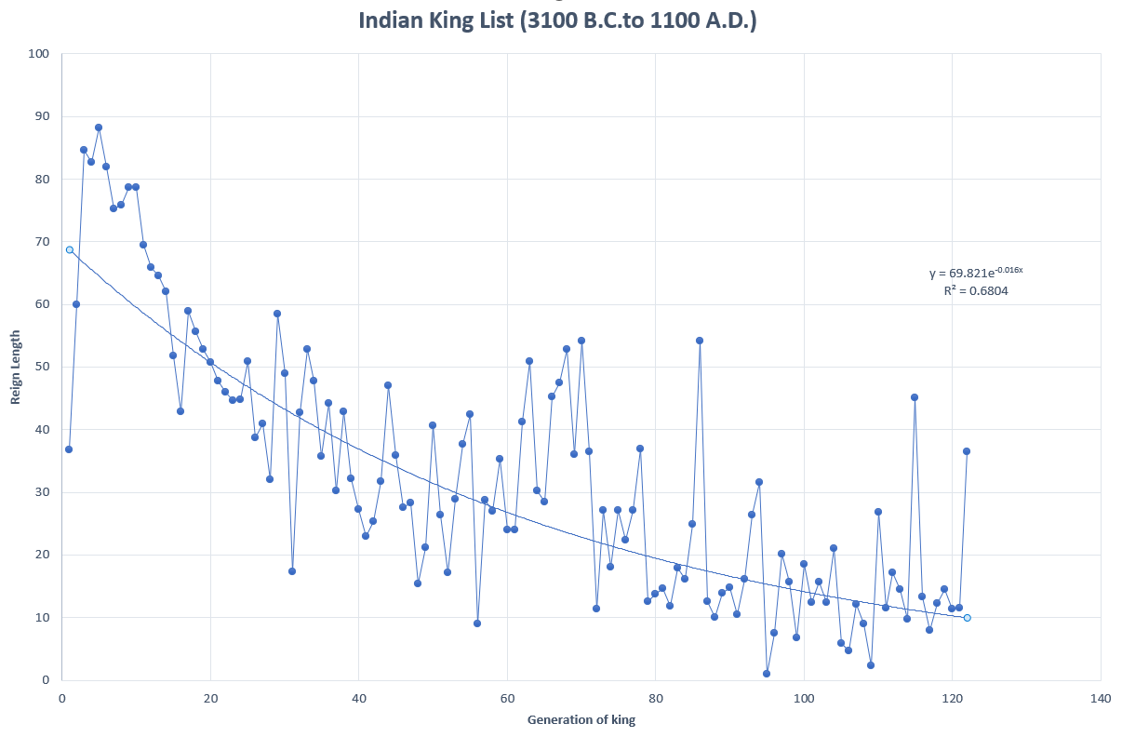

There was a steady decline in reign length over 122 generations of data !! A pattern of exponential decline can be clearly traced. No Hindu has ever mentioned this pattern hidden in their own king list. Perhaps they did not realise it was there.

The best fit curve for this data is an exponential curve (R2 = 0.68), and a y-intercept at 70 years.

During the first 20 generations of kings there was a very steep and constant decline. During this period the line does not alternate up and down, but rather follows a continuous downward path. This suggests an intense exposure to what ever was causing the decline. This period corresponds to the first and second dynasties of Egypt.

After the first 20 generations, the line begins to fluctuate up and down, suggesting that the cause of the decline in lifespan was weaker, though still persistent.

The first 20 generations seem to have suffered direct exposure to the cause; the decline over the remaining generations seem to be the residual effects once that initial exposure had lessened, allowing life to rebound intermittently.

So this data shows the sharpness of the initial decline, the fluctuating and instability of the middle period, until the final tapering out at the lowest level, once the cause of the decline had fully abated. Curiously, it looks as if the decline stopped after 80 generations.

These observations are typical of a natural process of decay, and it is very unlikely that anyone trying to “fake” a decay curve would do this. The persistence of the decline over 80 generations is something that could not be faked or invented, since that would require a rewriting of the entire history of India without anyone noticing.

We can see if a logarithmic curve fits the data better than an exponential curve. R2 = 0.62 and the y-intercept is at 100 years. Visually, the logarithmic curve seems a better fit.

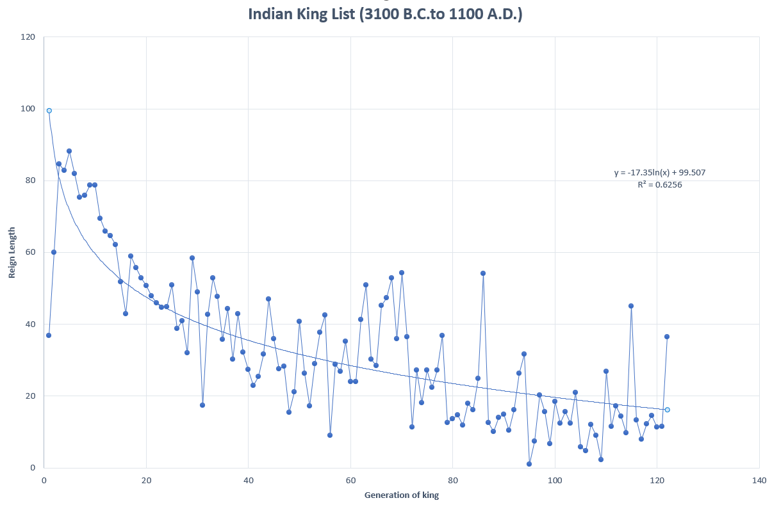

Note also that the earliest reign lengths approach 100 years – we saw the same phenomenon with the Egyptian kings of the first and second dynasties.

**Mahabharata**

The drop in lifespan with each generation was probably due to the steady accumulation of mutations or copying errors. We know that mutations can be produced by radiation, and the decline in lifespan followed the “event of Mahabharata”.

So, what was the Mahabharata event, and could it explain the fall in longevity? The Mahabharata event was a war. Descriptions of this war include the following passages –

*“When then next day came, Samva actually brought forth an iron bolt through which all the  
individuals in the race of the vrishnis and the andhakas became consumed into ashes.  
Indeed, for the destruction of the Vrishnis and the Andhakas, Samva brougt forth, through  
that curse, a fierce iron bolt that looked like a Gigantic messenger of death. The fact  
was duly reported to the king. In distress of mind, the king (Ugrasena) caused that iron  
bolt to be reduced to a fine powder. Men were employed to cast the powder into the sea.”*

[**Mausala Parva**: Section 1 (sacred-texts.com)](https://sacred-texts.com/hin/m16/m16001.htm)

The last sentence ” to cast the powder into sea”, is compatible with the fact that water is a very effective shield for nuclear radiations. Perhaps that was the intention in casting the iron powder into the sea. The next section, Section 2 of the Mausala Parva, describes hair and nails falling out, and animals giving birth to chimera – mutants.

If the Mahabharata war involved weapons that produced radiation, then a global deluge would protect life to some degree from that radiation. Water acts as a shield. Is this why God sent the deluge? Could intense radiation be responsible for the decline in lifespan? Would any life have survived without a deluge to shield us from the harmful radiation effects?

**The Yugas**

Indian tradition divides history into a series of ages or Yugas. Currently we live in the Kali Yuga, which began in 3102 B.C. The yuga prior to the Kali Yuga was called the Dwapar Yuga. During the Kali Yuga lifespan is said to be 100 years, but during the Dwapar Yuga lifespan was 1000 years.

So the Indians have a very specific date when the Kali Yuga began, and hence when lifespan began to decline – 3102 B.C.

This date approximates to the birth of Noah (2948 B.C.)

See [4 YUGAS — SATYA, TRETA, DVAPARA AND KALI YUGA (popularvedicscience.com)](https://popularvedicscience.com/history/yugas/4-yugas/)

**China**

The Shu Ching records a legendary period called the Three Sovereigns and Five Emperors. This period begins with a person named Nuwa who is supposed to have repaired the world after a great Flood. People are described as living to a great age during this period.

The first of the Three Sovereigns is Nuwa

* Fuxi reigned for 115 years
* Yellow emperor 100 years
* Zhuanxu 78 years
* KU 70 years
* Yao 100
* Shun 60
* Shaohao 84
* Zhuanxu 78

[Three Sovereigns and Five Emperors - New World Encyclopedia](https://www.newworldencyclopedia.org/entry/Three_Sovereigns_and_Five_Emperors)

[China's Three Sovereigns and Five Emperors (thoughtco.com)](https://www.thoughtco.com/chinas-three-sovereigns-and-five-emperors-195258)

[Three Sovereigns and Five Emperors - Wikipedia](https://en.wikipedia.org/wiki/Three_Sovereigns_and_Five_Emperors)

[Three Sovereigns and Five Emperors | Religion Wiki | Fandom](https://religion.fandom.com/wiki/Three_Sovereigns_and_Five_Emperors)

[The Three Sovereigns And Five Emperors (Chinese: 三皇五帝; pinyin: Sānhuáng wǔdì; Wade–Giles: San-huang wu-ti) (nouahsark.com)](https://www.nouahsark.com/en/infocenter/culture/history/dynasty/three_sovereigns_and_five_emperors.php)

The legendary period ends with the beginning of the Xia Dynasty and the reign of the Emperor Yu. During Yu’s reign the most central event was the draining of the land after a great flood that had occurred in the reign of the Emperor Yao 238 years earlier. It took more than two hundred years for the flood waters to subside and drain from the land.

Yu the Great established the Xia Dynasty in 2100 B.C.

Sumer

[CUSAS-17-11 (soas.ac.uk)](https://eprints.soas.ac.uk/12833/1/CUSAS-17-11.pdf)

[The Antediluvian Patriarchs and the Sumerian King List | Answers in Genesis](https://answersingenesis.org/bible-history/the-antediluvian-patriarchs-and-the-sumerian-king-list/)

**Sexagesimal Number System**

The Sumerian King List records the lengths of reigns of the kings of Sumer. The initial section deals with kings before the Flood and is significantly different from the rest. When the kingdom durations of the antediluvian section are expressed in an early **sexagesimal** **numerical system**, all durations except two are expressed as multiples of 602. A simple tally of the ciphers used yields six 10x602 signs, six 602 signs and six 60 signs.

The lives of the biblical patriarchs, however, have a precision of one year. If Adam and Noah are not included (as in the King List), and the lives of the patriarchs are similarly rounded to two digits, the sum of the lives has six 103 signs, six 102 signs and six 10 signs. In addition, if the number representing the sum of the ages was wrongly assumed as having been written in the sexagesimal system, the two totals become numerically equivalent.

It is suggested that the Sumerian scribe that composed the original antediluvian list had available a document (possibly a clay tablet) containing numerical information on the ages of eight of the patriarchs similar to that of the Genesis record and that he mistakenly interpreted it as being written in the sexagesimal system.

That the two documents are numerically related is strong evidence for the historicity of the book of Genesis. The fact that the Sumerian account shows up as a numerically rounded, incomplete version of the Genesis description, lacking the latter’s moral and spiritual depth, is a strong argument for the accuracy, superiority, and primacy of the biblical record

**GREEK KINGS :**

Presumably if people lived longer in the past, then they reigned for longer, so we might expect that reign lengths would show a decline in length as lifespan declined. I obtained a list of the kings of Athens here - [List of kings of Athens - Wikipedia](https://en.wikipedia.org/wiki/List_of_kings_of_Athens) , and here - [Eponymous archon - Wikipedia](https://en.wikipedia.org/wiki/Eponymous_archon). This covers a period of 30 generations.

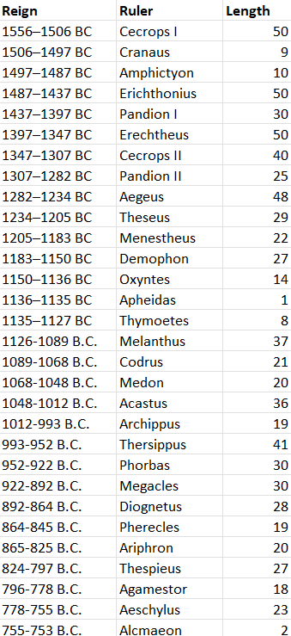

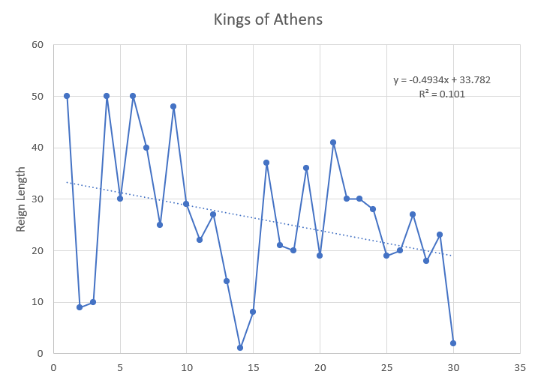

Using Excel to automatically determine the best fit curve, a straight line is obtained, showing a drop in average reign length over this period. The reign length is about 50 years initially, and drops to about 30 years.

Next we look at the Sicyonian king list, found here - [Eusebius' Chronicle, Greek Chronicle, Castor, Porphyrius (attalus.org)](https://www.attalus.org/armenian/euseb10.htm)

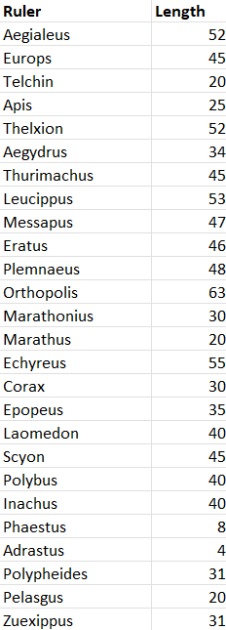

Using Excel to automatically determine the best fit curve, a straight line is obtained, showing a drop in average reign length of 20 years over this period. The reign length is about 50 years initially, and drops to about 30 years.

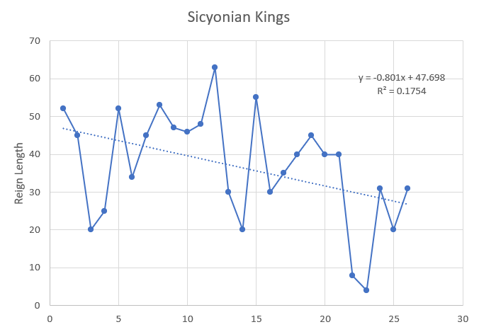

Next we look at the Argive king list, found here - [Eusebius' Chronicle, Greek Chronicle, Castor, Porphyrius (attalus.org)](https://www.attalus.org/armenian/euseb10.htm)

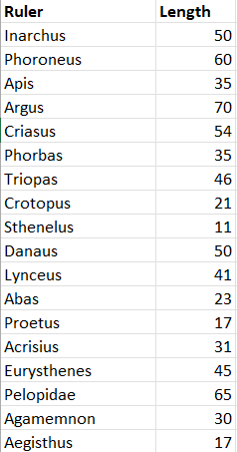

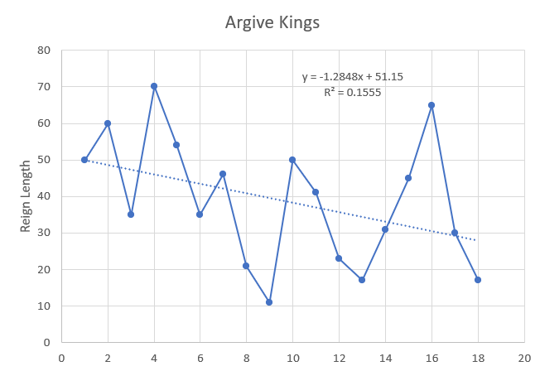

The reign length is about 50 years initially, and drops to about 30 years.