**Paradise Lost - fall in lifespan after the Flood**

Here are the recorded lifespans of each generation from Noah until Manasseh – over a period of 38 generations.

|  |  |  |  |  |
| --- | --- | --- | --- | --- |
|  | **A.M.** | **B.C.** | **Generation** | **Lifespan** |
| **Noah** | 1056 | 2847 | 1 | 950 |
| **Shem** | 1558 | 2345 | 2 | 600 |
| **Arphaxad** | 1658 | 2245 | 3 | 438 |
| **Salah** | 1693 | 2210 | 4 | 433 |
| **Eber** | 1723 | 2180 | 5 | 464 |
| **Peleg** | 1757 | 2146 | 6 | 239 |
| **Reu** | 1787 | 2116 | 7 | 239 |
| **Serug** | 1819 | 2084 | 8 | 234 |
| **Nahor** | 1853 | 2050 | 9 | 148 |
| **Terah** | 1882 | 2021 | 10 | 205 |
| **Abraham** | 1952 | 1951 | 11 | 175 |
| **Sarah** | 1962 | 1941 | 11 | 127 |
| **Ishmael** | 2038 | 1865 | 12 | 137 |
| **Isaac** | 2052 | 1851 | 12 | 180 |
| **Jacob** | 2112 | 1791 | 13 | 147 |
| **Joseph** | 2203 | 1700 | 14 | 110 |
| **Levi** | 2200 | 1697 | 14 | 137 |
| **Kohath** | -- | -- | 15 | 133 |
| **Amram** | -- | -- | 16 | 147 |
| **Miriam** | 2371 | 1532 | 17 | 126 |
| **Aaron** | 2374 | 1529 | 17 | 123 |
| **Moses** | 2377 | 1526 | 17 | 120 |
| **Joshua** | -- | -- | 25 | 110 |
| **David** | 2931 | 972 | 24 | 70 |
| **Rehoboam** | 2988 | 915 | 26 | 58 |
| **Jehoshaphat** | 3054 | 849 | 29 | 60 |
| **Jehoram** | 3061 | 842 | 30 | 40 |
| **Jotham** | 3171 | 732 | 35 | 41 |
| **Ahaz** | 3187 | 716 | 36 | 36 |
| **Hezekiah** | 3216 | 687 | 37 | 54 |
| **Manasseh** | 3260 | 643 | 38 | 67 |

**A continuous decline**

When plotted on a graph of lifespan against generation, a continuous decline in lifespan over 38 generations is discernable.

Excel automatically generates the best fit trendline. The equation is displayed on the graph below.

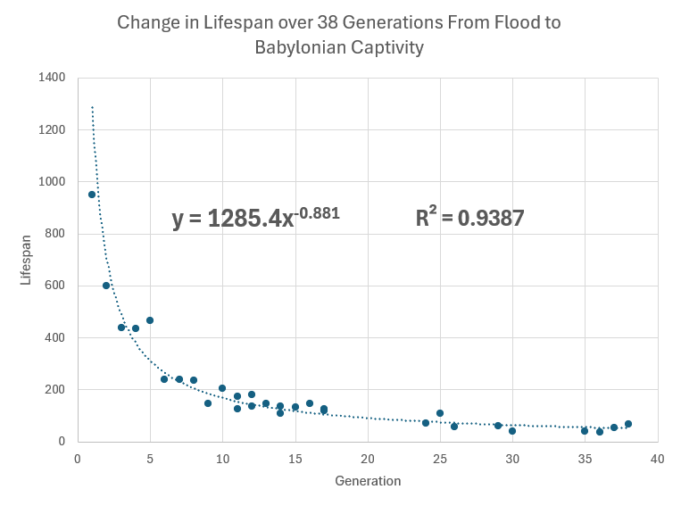

**Were these numbers invented ?**

*“One important point, often overlooked, is that the data are not just found in Genesis 5 and 11. Instead, when you examine the rest of the Bible, we see that the declining trend spans the entire biblical period. Initially, the post-Flood people were living for several centuries. Ten or more generations later, Abraham, Isaac, and Jacob also lived for very long times, but not nearly as long as their ancestors. A few generations after this, the siblings Moses, Aaron, and Miriam died right at the upper edge of the modern human lifespan. By the time we get to king David, we are essentially in the ‘normal’ range of human lifespan. Yet, when combined, the ages fall into a beautiful mathematical continuum. Had someone invented those numbers, perhaps in a scenario where Genesis was written much later than conservative scholars assert, would they have thought to go through the rest of Scripture, teasing out the minutiae that are often buried in inconsequential locations and making sure they also fit the pattern? Consider that ancient people did not have the mathematical tools we have today. Nobody had ever made a graph, and they had only a vague sense of a timeline. They did not have the tools required to fit exponential decay curves to consecutive data points and, since their contemporaries would not have rejected the thought of long lifespans, little reason even to try… Fitting a power function to the biblical data (figure 1), we can see that each generation lives, on average, about 88% as long as the generation prior. Amazingly, the data are very consistent, with an “R-squared” value of 0.94. In other words, the line encompasses about 94% of the variation in the data set. A perfect fit would equal 1.0.”*

**Masoretic vs Septuagint**

Here I have listed the lifespans of the patriarchs from Noah to Abraham as found in the genealogies of the Masoretic text and the Septuagint.

1. Excel was used to determine the best fit decay curve in each case.
2. The degree of variance from this curve was calculated to see which genealogy best fitted a natural decay pattern.

It was found that the Masoretic genealogy has a better fit to a decay curve compared to the Septuagint genealogy. R2 was 0.9426 for Masoretic compared to 0.8103 for Septuagint; the difference is therefore 13%.

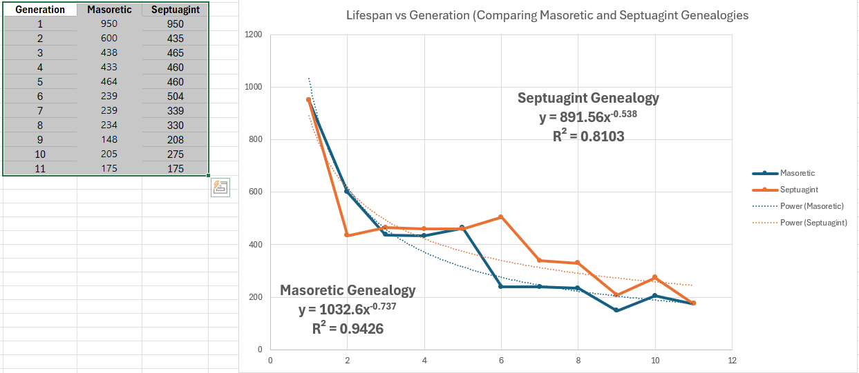

The blue line shows the Masoretic genealogy which has a smoother exponential decline.

Exponential Decay by Date of Birth

[Exponential Decay Old Testament Genealogies | Answers Research Journal](https://answersresearchjournal.org/decay-curve-old-testament-genealogies/)

Exponential Decay by Generation

[The rapid decline in biblical lifespans (creation.com)](https://creation.com/rapid-decline-biblical-lifespans)

Degree of Variation from a Best Fit Decay Curve (Comparison of Masoretic and Septuagint Genealogies)

[The Septuagint vs. The Masoretic Text … A Statistical Perspective (cedarville.edu)](https://digitalcommons.cedarville.edu/cgi/viewcontent.cgi?article=1555&context=icc_proceedings)

Genealogy Septuagint vs Masoretic

<https://digitalcommons.cedarville.edu/cgi/viewcontent.cgi?article=1192&context=icc_proceedings>

[Septuagintal Versus Masoretic Chronology in Genesis 5 and 11 (cedarville.edu)](https://digitalcommons.cedarville.edu/cgi/viewcontent.cgi?article=1192&context=icc_proceedings)

[Microsoft Word - jets64a.doc (etsjets.org)](https://www.etsjets.org/files/JETS-PDFs/64/64-1/JETS_64.1_25-43_Steinmann.pdf)