Homework 7 Answer Key

Melinda K. Higgins, PhD.

April 6, 2017

## Homework 7 - Assignment

Recall the NHANES dataset that we used in Lesson 10.

1. In the dataset there is a discrete variable called SleepTrouble indicating whether each participant has trouble sleeping or not. You are going to build a set of classifiers for this dependent variable. You may use any (set of) independent variable(s) you like except for the variable callsed SleepHrsNight. For each of the model types (null model, logistic regression, decision tree, random forest, k-nearest neighbor) do the following:

* 1A. Build the classifier.
* 1B. Report its effectiveness on the NHANES dataset.
* 1C. Make an appropriate visualization of this model.
* 1D. Interpret the results. What have you learned about people's sleeping habits?

1. Repeat problem 1 except now you are to use the quantitative variable called SleepHrsNight. The model types are as follows: null model, multiple regression, regression tree, random forest.

## Homework 7 - Answer Key

Given the instructions providing in the assignment (above), it is useful to review the code and examples provided in "lesson 10" in Dr. Hertzberg's Github repository at <https://github.com/vhertzb/Lesson10>. Specifically, review the steps in the Lesson10.Rmd R markdown file. This "part 1" covered the code and steps for predicting Diabetes from these variables: Age, Gender, BMI, HHIncome, and PhysActive. The code and examples shown include:

* the "null" model (i.e. the proportion of people with diabetes versus not)
* running KNN (k-Nearest Neighbor Classification) (via knn from the class package)
* a decision tree (via rpart() from the rpart package)
* and using randomForest from the randomForest package

**NOTE**: Lesson 10's Lesson10.Rmd R markdown did not include the code for running a logistic regression for Diabetes, but this was covered earlier around week 5; see <https://github.com/melindahiggins2000/N741linearlogmodels> when we covered generalized linear models. We also did more with logistic regression in week 6, see <https://github.com/melindahiggins2000/N741predict>.

### Load the NHANES dataset and review the variables included

# load the NHANES package with the NHANES dataset  
library(NHANES)

## Warning: package 'NHANES' was built under R version 3.3.3

# create a data object for the NHANES dataset  
dat1 <- NHANES  
  
# list all of the variables included  
names(dat1)

## [1] "ID" "SurveyYr" "Gender"   
## [4] "Age" "AgeDecade" "AgeMonths"   
## [7] "Race1" "Race3" "Education"   
## [10] "MaritalStatus" "HHIncome" "HHIncomeMid"   
## [13] "Poverty" "HomeRooms" "HomeOwn"   
## [16] "Work" "Weight" "Length"   
## [19] "HeadCirc" "Height" "BMI"   
## [22] "BMICatUnder20yrs" "BMI_WHO" "Pulse"   
## [25] "BPSysAve" "BPDiaAve" "BPSys1"   
## [28] "BPDia1" "BPSys2" "BPDia2"   
## [31] "BPSys3" "BPDia3" "Testosterone"   
## [34] "DirectChol" "TotChol" "UrineVol1"   
## [37] "UrineFlow1" "UrineVol2" "UrineFlow2"   
## [40] "Diabetes" "DiabetesAge" "HealthGen"   
## [43] "DaysPhysHlthBad" "DaysMentHlthBad" "LittleInterest"   
## [46] "Depressed" "nPregnancies" "nBabies"   
## [49] "Age1stBaby" "SleepHrsNight" "SleepTrouble"   
## [52] "PhysActive" "PhysActiveDays" "TVHrsDay"   
## [55] "CompHrsDay" "TVHrsDayChild" "CompHrsDayChild"   
## [58] "Alcohol12PlusYr" "AlcoholDay" "AlcoholYear"   
## [61] "SmokeNow" "Smoke100" "Smoke100n"   
## [64] "SmokeAge" "Marijuana" "AgeFirstMarij"   
## [67] "RegularMarij" "AgeRegMarij" "HardDrugs"   
## [70] "SexEver" "SexAge" "SexNumPartnLife"   
## [73] "SexNumPartYear" "SameSex" "SexOrientation"   
## [76] "PregnantNow"

# other packages needed  
library(dplyr)

##   
## Attaching package: 'dplyr'

## The following objects are masked from 'package:stats':  
##   
## filter, lag

## The following objects are masked from 'package:base':  
##   
## intersect, setdiff, setequal, union

library(ggplot2)

## Warning: package 'ggplot2' was built under R version 3.3.3

### Investigate the 2 Outcomes of Interest SleepTrouble and SleepHrsNight

class(dat1$SleepTrouble)

## [1] "factor"

summary(dat1$SleepTrouble)

## No Yes NA's   
## 5799 1973 2228

class(dat1$SleepHrsNight)

## [1] "integer"

summary(dat1$SleepHrsNight)

## Min. 1st Qu. Median Mean 3rd Qu. Max. NA's   
## 2.000 6.000 7.000 6.928 8.000 12.000 2245

So, SleepTrouble is a "Factor" with 2 levels "No" and "Yes" with some missing data "NA"s.

But SleepHrsNight is a numeric variable (specifically an integer) with values ranging from 2 to 12 hours per night.

### Visualize SleepTrouble Outcome of Interest

NOTE: ggplot() codes based on examples at "Cookbook for R" website for the "R Graphics Cookbook" book at <http://www.cookbook-r.com/Graphs/>.

# Bar chart of Frequency/Counts for Skeep Trouble with NAs  
dat1 %>%  
 ggplot(aes(x=SleepTrouble, fill=SleepTrouble)) +  
 geom_bar(stat="count", colour="black") +  
 ggtitle("Frequency of Subjects with Sleep Trouble")

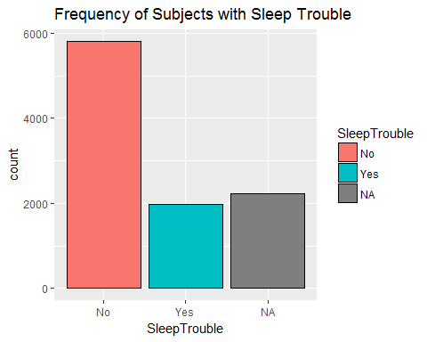

### You'll notice the following for SleepTrouble:

1. It is a factor with 2 levels with values of "No and "Yes", which we can see by running head(dat1$SleepTrouble). It is important to note this since some "classifier" procedures and functions in R assume that the "target" variable is coded 0 or 1.

head(dat1$SleepTrouble)

## [1] Yes Yes Yes <NA> Yes <NA>  
## Levels: No Yes

1. The majority of the subjects do NOT have Sleep Trouble - most are "No"s
2. There are also a decent number of NAs which will be removed in the final analyses - or at least ignored. It will be important to know how the chosen classifier function or procedure handles missing NA data.

### Visualize SleepHrsNight Outcome of Interest

# Histogram overlaid with kernel density curve  
dat1 %>%   
 ggplot(aes(x=SleepHrsNight)) +   
 geom_histogram(aes(y=..density..),   
 binwidth=1,  
 colour="black", fill="yellow") +  
 geom_density(alpha=.2, fill="blue", adjust=2) +  
 ggtitle("Histogram Density Plot of Sleep Hours Per Night")

## Warning: Removed 2245 rows containing non-finite values (stat_bin).

## Warning: Removed 2245 rows containing non-finite values (stat_density).

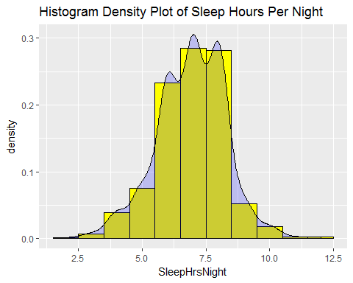

### You'll notice the following for SleepHrsNight:

1. There were still quite a few missing values as seen when we ran the summary(dat1$SleepHrsNight) above. It will be important to know how the chosen classifier function or procedure handles missing NA data.
2. Since this is a numeric outcome, the classifiers chosen will be performing "regression" based models as opposed to "category probability" type models like logistic regression.
3. That said, the distribution of SleepHrsNight is reasonably symmetric and approximately normally distributed which is good with no obvious outliers, even though the range of sleep times is wide from 2 to 12 hours, which is interesting.

## Overall Notes on **Open-Ended Approach** for This Homework 7 Assignment

While the NHANES dataset had 76 variables, it was intended for you to choose a subset you thought would be appropriate for predicting/classifying those with trouble sleeping and/or their time spent sleeping.

A side note on sleep times - given that the hours spent sleeping was numeric and ordinal in nature and was symmetrically and approximately normally distributed, it was OK to approach modeling SleepHrsNight as a continuous/numeric outcome (i.e. a "regression-type" approach). However, it was also OK if you decided to recode this variable into subjects with low sleep times (say < 7) versus more sleep. You could have also looked at recoding SleephrsNight into those with optimal sleep (7-9 hrs) versus less than optimal (which includes both those people with less than 7 hrs and more than 9 hrs - both too little and too much sleep can be problematic). Any of these approaches were OK.

## PART 1 - Build "classifiers" for SleepTrouble

For each of the model types (null model, logistic regression, decision tree, random forest, k-nearest neighbor):

* 1A. Build the classifier.
* 1B. Report its effectiveness on the NHANES dataset.
* 1C. Make an appropriate visualization of this model.
* 1D. Interpret the results. What have you learned about people's sleeping habits?

### Pick a subset of likely variables for predicting Sleep Trouble

For my approach, I'm choosing the following 10 variables as possible predictors of sleep problems:

1. age
2. gender
3. marital status
4. poverty
5. home ownership
6. BMI
7. Diabetes
8. health in general
9. depressed
10. physically active

# build dataset for these 10 variables and SleepTrouble  
people <- NHANES %>%   
 select(Age, Gender, MaritalStatus, Poverty, HomeOwn,  
 BMI, Diabetes, HealthGen, Depressed, PhysActive,  
 SleepTrouble)   
  
# run summary  
summary(people)

## Age Gender MaritalStatus Poverty   
## Min. : 0.00 female:5020 Divorced : 707 Min. :0.000   
## 1st Qu.:17.00 male :4980 LivePartner : 560 1st Qu.:1.240   
## Median :36.00 Married :3945 Median :2.700   
## Mean :36.74 NeverMarried:1380 Mean :2.802   
## 3rd Qu.:54.00 Separated : 183 3rd Qu.:4.710   
## Max. :80.00 Widowed : 456 Max. :5.000   
## NA's :2769 NA's :726   
## HomeOwn BMI Diabetes HealthGen Depressed   
## Own :6425 Min. :12.88 No :9098 Excellent: 878 None :5246   
## Rent :3287 1st Qu.:21.58 Yes : 760 Vgood :2508 Several:1009   
## Other: 225 Median :25.98 NA's: 142 Good :2956 Most : 418   
## NA's : 63 Mean :26.66 Fair :1010 NA's :3327   
## 3rd Qu.:30.89 Poor : 187   
## Max. :81.25 NA's :2461   
## NA's :366   
## PhysActive SleepTrouble  
## No :3677 No :5799   
## Yes :4649 Yes :1973   
## NA's:1674 NA's:2228   
##   
##   
##   
##

# Convert back to dataframe  
people <- as.data.frame(people)  
glimpse(people)

## Observations: 10,000  
## Variables: 11  
## $ Age <int> 34, 34, 34, 4, 49, 9, 8, 45, 45, 45, 66, 58, 54,...  
## $ Gender <fctr> male, male, male, male, female, male, male, fem...  
## $ MaritalStatus <fctr> Married, Married, Married, NA, LivePartner, NA,...  
## $ Poverty <dbl> 1.36, 1.36, 1.36, 1.07, 1.91, 1.84, 2.33, 5.00, ...  
## $ HomeOwn <fctr> Own, Own, Own, Own, Rent, Rent, Own, Own, Own, ...  
## $ BMI <dbl> 32.22, 32.22, 32.22, 15.30, 30.57, 16.82, 20.64,...  
## $ Diabetes <fctr> No, No, No, No, No, No, No, No, No, No, No, No,...  
## $ HealthGen <fctr> Good, Good, Good, NA, Good, NA, NA, Vgood, Vgoo...  
## $ Depressed <fctr> Several, Several, Several, NA, Several, NA, NA,...  
## $ PhysActive <fctr> No, No, No, NA, No, NA, NA, Yes, Yes, Yes, Yes,...  
## $ SleepTrouble <fctr> Yes, Yes, Yes, NA, Yes, NA, NA, No, No, No, No,...

# Convert factors to numeric - the packages just seem to work better that way  
people$Gender <- as.numeric(people$Gender)  
people$MaritalStatus <- as.numeric(people$MaritalStatus)  
people$HomeOwn <- as.numeric(people$HomeOwn)  
people$Diabetes <- as.numeric(people$Diabetes)  
people$HealthGen <- as.numeric(people$HealthGen)  
people$Depressed <- as.numeric(people$Depressed)  
people$PhysActive <- as.numeric(people$PhysActive)  
people$SleepTrouble <- as.numeric(people$SleepTrouble)  
  
summary(people)

## Age Gender MaritalStatus Poverty   
## Min. : 0.00 Min. :1.000 Min. :1.000 Min. :0.000   
## 1st Qu.:17.00 1st Qu.:1.000 1st Qu.:3.000 1st Qu.:1.240   
## Median :36.00 Median :1.000 Median :3.000 Median :2.700   
## Mean :36.74 Mean :1.498 Mean :3.158 Mean :2.802   
## 3rd Qu.:54.00 3rd Qu.:2.000 3rd Qu.:4.000 3rd Qu.:4.710   
## Max. :80.00 Max. :2.000 Max. :6.000 Max. :5.000   
## NA's :2769 NA's :726   
## HomeOwn BMI Diabetes HealthGen   
## Min. :1.000 Min. :12.88 Min. :1.000 Min. :1.000   
## 1st Qu.:1.000 1st Qu.:21.58 1st Qu.:1.000 1st Qu.:2.000   
## Median :1.000 Median :25.98 Median :1.000 Median :3.000   
## Mean :1.376 Mean :26.66 Mean :1.077 Mean :2.618   
## 3rd Qu.:2.000 3rd Qu.:30.89 3rd Qu.:1.000 3rd Qu.:3.000   
## Max. :3.000 Max. :81.25 Max. :2.000 Max. :5.000   
## NA's :63 NA's :366 NA's :142 NA's :2461   
## Depressed PhysActive SleepTrouble   
## Min. :1.000 Min. :1.000 Min. :1.000   
## 1st Qu.:1.000 1st Qu.:1.000 1st Qu.:1.000   
## Median :1.000 Median :2.000 Median :1.000   
## Mean :1.276 Mean :1.558 Mean :1.254   
## 3rd Qu.:1.000 3rd Qu.:2.000 3rd Qu.:2.000   
## Max. :3.000 Max. :2.000 Max. :2.000   
## NA's :3327 NA's :1674 NA's :2228

dim(people)

## [1] 10000 11

# drop any cases/rows with missing data  
# this step creates a complete cases dataset  
people <- na.omit(people)  
summary(people)

## Age Gender MaritalStatus Poverty   
## Min. :20.00 Min. :1.000 Min. :1.000 Min. :0.000   
## 1st Qu.:33.00 1st Qu.:1.000 1st Qu.:3.000 1st Qu.:1.390   
## Median :47.00 Median :2.000 Median :3.000 Median :3.020   
## Mean :47.36 Mean :1.504 Mean :3.133 Mean :2.991   
## 3rd Qu.:60.00 3rd Qu.:2.000 3rd Qu.:4.000 3rd Qu.:5.000   
## Max. :80.00 Max. :2.000 Max. :6.000 Max. :5.000   
## HomeOwn BMI Diabetes HealthGen   
## Min. :1.000 Min. :15.02 Min. :1.000 Min. :1.000   
## 1st Qu.:1.000 1st Qu.:24.20 1st Qu.:1.000 1st Qu.:2.000   
## Median :1.000 Median :27.90 Median :1.000 Median :3.000   
## Mean :1.343 Mean :28.91 Mean :1.104 Mean :2.628   
## 3rd Qu.:2.000 3rd Qu.:32.35 3rd Qu.:1.000 3rd Qu.:3.000   
## Max. :3.000 Max. :81.25 Max. :2.000 Max. :5.000   
## Depressed PhysActive SleepTrouble   
## Min. :1.000 Min. :1.00 Min. :1.000   
## 1st Qu.:1.000 1st Qu.:1.00 1st Qu.:1.000   
## Median :1.000 Median :2.00 Median :1.000   
## Mean :1.271 Mean :1.54 Mean :1.269   
## 3rd Qu.:1.000 3rd Qu.:2.00 3rd Qu.:2.000   
## Max. :3.000 Max. :2.00 Max. :2.000

dim(people)

## [1] 5981 11

### Run Logistic Regression - predict Sleep Trouble

# recode SleepTrouble into 0 (for no sleep trouble)  
# and 1 (for yes Sleep Trouble); so we need to recode  
# values of 2 (which were yes) to 1. We'll use  
# the double equals to find all TRUE values and then convert  
# the logical results into 0's and 1's.  
people$SleepTrouble <- as.numeric(people$SleepTrouble==2)  
  
# model SleepTrouble by rest of variables in people dataset  
fmla <- "SleepTrouble ~ ."  
  
logreg <- glm(fmla,   
 data=people,   
 family=binomial(link="logit"))  
  
summary(logreg)

##   
## Call:  
## glm(formula = fmla, family = binomial(link = "logit"), data = people)  
##   
## Deviance Residuals:   
## Min 1Q Median 3Q Max   
## -1.7326 -0.7861 -0.6401 0.9940 2.2782   
##   
## Coefficients:  
## Estimate Std. Error z value Pr(>|z|)   
## (Intercept) -3.679708 0.304805 -12.072 < 2e-16 ***  
## Age 0.014720 0.002031 7.246 4.29e-13 ***  
## Gender -0.424648 0.061626 -6.891 5.55e-12 ***  
## MaritalStatus -0.075883 0.026265 -2.889 0.003863 **   
## Poverty 0.045281 0.021378 2.118 0.034166 *   
## HomeOwn 0.160152 0.065696 2.438 0.014779 *   
## BMI 0.007454 0.004646 1.604 0.108650   
## Diabetes 0.108480 0.100313 1.081 0.279516   
## HealthGen 0.336741 0.037112 9.074 < 2e-16 ***  
## Depressed 0.667273 0.051389 12.985 < 2e-16 ***  
## PhysActive 0.232138 0.065956 3.520 0.000432 ***  
## ---  
## Signif. codes: 0 '***' 0.001 '**' 0.01 '*' 0.05 '.' 0.1 ' ' 1  
##   
## (Dispersion parameter for binomial family taken to be 1)  
##   
## Null deviance: 6959.2 on 5980 degrees of freedom  
## Residual deviance: 6492.1 on 5970 degrees of freedom  
## AIC: 6514.1  
##   
## Number of Fisher Scoring iterations: 4

people$pred <- predict(logreg,   
 newdata=people,   
 type="response")  
  
# plot predicted probabilities  
ggplot(people,   
 aes(x=pred, color=as.factor(SleepTrouble),   
 linetype=as.factor(SleepTrouble))) +  
 geom_density() +  
 ggtitle("Predicted Probability for Sleep Trouble")

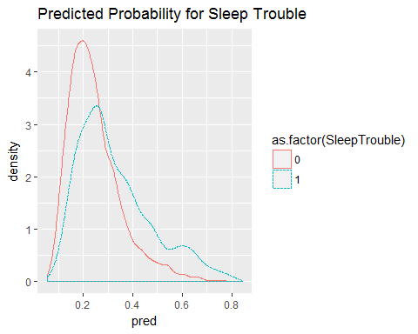

# pick a threshold and get confusion (prediction) matrix  
# test a classifier with a threshold > 0.20  
ctab <- table(pred=people$pred>0.2, SleepTrouble=people$SleepTrouble)  
ctab

## SleepTrouble  
## pred 0 1  
## FALSE 1691 333  
## TRUE 2684 1273

# compute precision = true positives / predicted true  
precision <- ctab[2,2]/sum(ctab[2,])  
precision

## [1] 0.3217084

# compute recall = true positives / actual true  
recall <- ctab[2,2]/sum(ctab[,2])  
recall

## [1] 0.7926526

# look at ROC curve  
library(pROC)

## Warning: package 'pROC' was built under R version 3.3.3

## Type 'citation("pROC")' for a citation.

##   
## Attaching package: 'pROC'

## The following objects are masked from 'package:stats':  
##   
## cov, smooth, var

roccurve <- roc(people$SleepTrouble ~ people$pred)  
plot(roccurve)

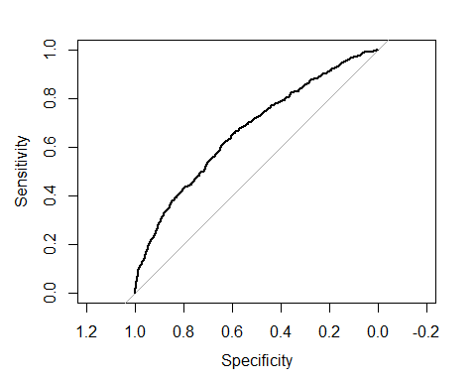

# pull out just the AUC statistic  
auc(roccurve)

## Area under the curve: 0.6681

### NULL MODEL for Logistic Regression

We didn't cover this in class, but to get an "intercept-only" model you use a formula in the form of outcome ~ 1 which basically says model the outcome variable as a function of the intercept indicated by the 1. This formula can be used for any generalized linear modeling approach (linear regression, logistic regression, Poisson regression, etc). You'll notice in running the code steps below that using the intercept only approach does no better than flipping a coin which you see for the ROC curve which is a straight line and the AUC is 0.5 (50/50 guessing does as well as this null model with no predictors). You always want the AUC to be >0.5 and as close to 1.0 as possible. AUCs >0.7 are ok but you really want AUCs >0.8 and >0.9 is even better.

# NULL MODEL for Logistic Regression   
# is basically an intercept-only model with no predictors  
logreg.null <- glm(SleepTrouble ~ 1,   
 data=people,   
 family=binomial(link="logit"))  
  
summary(logreg.null)

##   
## Call:  
## glm(formula = SleepTrouble ~ 1, family = binomial(link = "logit"),   
## data = people)  
##   
## Deviance Residuals:   
## Min 1Q Median 3Q Max   
## -0.7908 -0.7908 -0.7908 1.6216 1.6216   
##   
## Coefficients:  
## Estimate Std. Error z value Pr(>|z|)   
## (Intercept) -1.00216 0.02918 -34.35 <2e-16 ***  
## ---  
## Signif. codes: 0 '***' 0.001 '**' 0.01 '*' 0.05 '.' 0.1 ' ' 1  
##   
## (Dispersion parameter for binomial family taken to be 1)  
##   
## Null deviance: 6959.2 on 5980 degrees of freedom  
## Residual deviance: 6959.2 on 5980 degrees of freedom  
## AIC: 6961.2  
##   
## Number of Fisher Scoring iterations: 4

people$pred.null <- predict(logreg.null,   
 newdata=people,   
 type="response")  
  
# plot predicted probabilities  
ggplot(people,   
 aes(x=pred.null, color=as.factor(SleepTrouble),   
 linetype=as.factor(SleepTrouble))) +  
 geom_density() +  
 ggtitle("Predicted Probability for Sleep Trouble - Null Model")

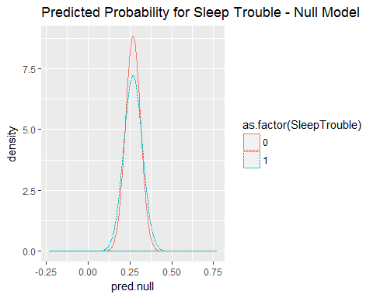

# pick a threshold and get confusion (prediction) matrix  
# test a classifier with a threshold > 0.30  
ctab <- table(pred=people$pred>0.3, SleepTrouble=people$SleepTrouble)  
ctab

## SleepTrouble  
## pred 0 1  
## FALSE 3298 855  
## TRUE 1077 751

# compute precision = true positives / predicted true  
precision <- ctab[2,2]/sum(ctab[2,])  
precision

## [1] 0.4108315

# compute recall = true positives / actual true  
recall <- ctab[2,2]/sum(ctab[,2])  
recall

## [1] 0.4676214

# look at ROC curve  
#library(pROC)  
roccurve <- roc(people$SleepTrouble ~ people$pred.null)  
plot(roccurve)

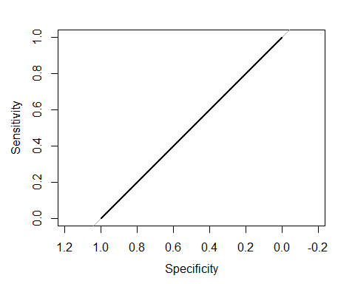

# pull out just the AUC statistic  
auc(roccurve)

## Area under the curve: 0.5

### Try KNN to predict Sleep Trouble

# for knn, rpart and randomForest, set SleepTrouble  
# back to being a factor  
people$SleepTrouble <- as.factor(people$SleepTrouble)  
  
# Apply knn procedure to predict Diabetes  
# use the knn procedure in the class package  
library(class)  
  
# Let's try different values of k to see how that affects performance  
knn.1 <- knn(train = people, test = people, cl = people$SleepTrouble, k = 1)  
knn.3 <- knn(train = people, test = people, cl = people$SleepTrouble, k = 3)  
knn.5 <- knn(train = people, test = people, cl = people$SleepTrouble, k = 5)  
knn.20 <- knn(train = people, test = people, cl = people$SleepTrouble, k = 20)  
  
# see how well they classified  
# Calculate the percent predicted correctly  
  
100*sum(people$SleepTrouble == knn.1)/length(knn.1)

## [1] 100

100*sum(people$SleepTrouble == knn.3)/length(knn.3)

## [1] 90.83765

100*sum(people$SleepTrouble == knn.5)/length(knn.5)

## [1] 87.25966

100*sum(people$SleepTrouble == knn.20)/length(knn.20)

## [1] 77.82979

#overall success  
# Another way to look at success rate against increasing k  
  
table(knn.1, people$SleepTrouble)

##   
## knn.1 0 1  
## 0 4375 0  
## 1 0 1606

table(knn.3, people$SleepTrouble)

##   
## knn.3 0 1  
## 0 4189 362  
## 1 186 1244

table(knn.5, people$SleepTrouble)

##   
## knn.5 0 1  
## 0 4172 559  
## 1 203 1047

table(knn.20, people$SleepTrouble)

##   
## knn.20 0 1  
## 0 4264 1215  
## 1 111 391

### (Version 1) The ensemble method - using the approach from lesson 10 with Age and BMI

The example here uses the same basic code we did in class for lesson 10. This looks at just Age and BMI and no other variables considered in the decision tree and random forest models. The plots also just consider Age and BMI.

library(mosaic)

## Warning: package 'mosaic' was built under R version 3.3.3

## Loading required package: lattice

## Warning: package 'lattice' was built under R version 3.3.3

## Loading required package: mosaicData

## Warning: package 'mosaicData' was built under R version 3.3.3

## Loading required package: Matrix

## Warning: package 'Matrix' was built under R version 3.3.3

##   
## The 'mosaic' package masks several functions from core packages in order to add additional features.   
## The original behavior of these functions should not be affected by this.

##   
## Attaching package: 'mosaic'

## The following object is masked from 'package:Matrix':  
##   
## mean

## The following objects are masked from 'package:pROC':  
##   
## cov, var

## The following objects are masked from 'package:dplyr':  
##   
## count, do, tally

## The following objects are masked from 'package:stats':  
##   
## binom.test, cor, cov, D, fivenum, IQR, median, prop.test,  
## quantile, sd, t.test, var

## The following objects are masked from 'package:base':  
##   
## max, mean, min, prod, range, sample, sum

# Create the grid  
ages <- mosaic::range(~ Age, data = people)  
bmis <- mosaic::range(~ BMI, data = people)  
res <- 100  
fake_grid <- expand.grid(  
 Age = seq(from = ages[1], to = ages[2], length.out = res),  
 BMI = seq(from = bmis[1], to = bmis[2], length.out = res))  
  
#Get the overall proportion, p, of people with Sleep Trouble  
p <- sum(people$SleepTrouble == 1)/length(people$SleepTrouble)  
p

## [1] 0.268517

# Null model prediction  
pred_null <- rep(p, nrow(fake_grid))  
  
form <- as.formula("SleepTrouble ~ Age + BMI")  
  
library(rpart)  
# Evaluate each model on each grid point  
# For the decision tree  
dmod_tree <- rpart(form, data = people,   
 control = rpart.control(cp = 0.005, minbucket = 30))  
  
# results summary  
dmod_tree

## n= 5981   
##   
## node), split, n, loss, yval, (yprob)  
## * denotes terminal node  
##   
## 1) root 5981 1606 0 (0.7314830 0.2685170) *

# For the forest  
set.seed(20371)  
#dmod_forest <- rfsrc(form, data = people,   
# ntree = 201, mtry = 3)  
# try with randomForest instead of randomForestSRC package  
library(randomForest)

## randomForest 4.6-12

## Type rfNews() to see new features/changes/bug fixes.

##   
## Attaching package: 'randomForest'

## The following object is masked from 'package:ggplot2':  
##   
## margin

## The following object is masked from 'package:dplyr':  
##   
## combine

dmod_forest <- randomForest(form, data = people,   
 ntree = 201, mtry = 2)  
  
# results summary  
dmod_forest

##   
## Call:  
## randomForest(formula = form, data = people, ntree = 201, mtry = 2)   
## Type of random forest: classification  
## Number of trees: 201  
## No. of variables tried at each split: 2  
##   
## OOB estimate of error rate: 14.18%  
## Confusion matrix:  
## 0 1 class.error  
## 0 4011 364 0.0832000  
## 1 484 1122 0.3013699

# Now the predictions for tree and forest  
#pred_tree <- predict(dmod_tree, newdata = fake_grid)[, "Yes"]  
pred_tree <- predict(dmod_tree, newdata = fake_grid)[,1]  
summary(pred_tree)

## Min. 1st Qu. Median Mean 3rd Qu. Max.   
## 0.7315 0.7315 0.7315 0.7315 0.7315 0.7315

#table(pred_tree)  
  
# pred_tree <- predict(dmod_tree, newdata = fake_grid)[, 1]  
#pred_forest <- predict(dmod_forest, newdata = fake_grid,   
# type = "prob")[, "Yes"]  
pred_forest <- predict(dmod_forest, newdata = fake_grid, type = "prob")[,1]  
summary(pred_forest)

## Min. 1st Qu. Median Mean 3rd Qu. Max.   
## 0.004975 0.447800 0.666700 0.633400 0.850700 1.000000

#table(pred_forest)  
  
# K-nearest neighbor prediction  
pred_knn <- people %>%  
 select(Age, BMI) %>%  
 knn(test=select(fake_grid, Age, BMI), cl = people$SleepTrouble, k=5) %>%  
 as.numeric() - 1

Next, we want to build a dataframe with all of these predicted models, then gather() it into a long format.

library(tidyr)

## Warning: package 'tidyr' was built under R version 3.3.3

##   
## Attaching package: 'tidyr'

## The following object is masked from 'package:Matrix':  
##   
## expand

# build the data frame  
res <- fake_grid %>%  
 mutate(  
 "Null" = pred_null,   
 "Decision Tree" = pred_tree,  
 "Random Forest" = pred_forest,   
 "K-nearest neighbor" = pred_knn) %>%  
 gather(k="model", value = "y_hat", -Age, -BMI)

## Warning: attributes are not identical across measure variables; they will  
## be dropped

Next let's plot all of these

ggplot(data = res, aes(x = Age, y = BMI)) +  
 geom_tile(aes(fill=y_hat), color = NA) +  
 geom_count(aes(color = SleepTrouble), alpha = 0.4, data = people) +  
 scale_fill_gradient(low = "white", high = "blue") +  
 scale_color_manual(values = c("gray", "gold")) +  
 scale_size(range = c(0,2)) +  
 scale_x_continuous(expand = c(0.02, 0)) +  
 scale_y_continuous(expand = c(0.02, 0)) +  
 facet_wrap(~model)

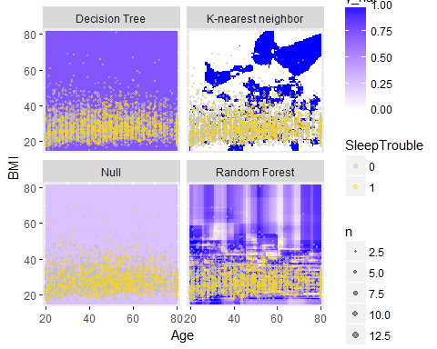

### (Version 2): The ensemble method - using all 10 variables I choose

The decision tree (rpart) and random forest models below use the 10 variables I selected. I then modified the plots to look at the effects of Age and Poverty insead of Age and BMI. I also added plots to show the decision tree and the variable importance plot from random forest so you can see that indeed BMI, Age and Poverty are indeed important in predicting sleep trouble.

people <- people %>%  
 select(Age, Gender, MaritalStatus, Poverty,  
 HomeOwn, BMI, Diabetes, HealthGen, Depressed,  
 PhysActive, SleepTrouble)  
   
# note: all variables are numeric now, except  
# SleepTriuble which is a factor, but coded 0 for no and 1 for yes  
   
# This time let's look at Age and Poverty instead  
# of Age and BMI  
#library(mosaic)  
# Create the grid  
#ages <- mosaic::range(~ Age, data = people)  
#povs <- mosaic::range(~ Poverty, data = people)  
#res <- 100  
#fake_grid <- expand.grid(  
# Age = seq(from = ages[1], to = ages[2], length.out = res),  
# Poverty = seq(from = povs[1], to = povs[2], length.out = res))  
  
#Get the overall proportion, p, of people with Sleep Trouble  
p <- sum(people$SleepTrouble == 1)/length(people$SleepTrouble)  
p

## [1] 0.268517

# Null model prediction  
pred_null <- rep(p, nrow(people))  
  
form <- as.formula("SleepTrouble ~ .")  
  
#library(rpart)  
# Evaluate each model on each grid point  
# For the decision tree  
dmod_tree <- rpart(form, data = people,   
 control = rpart.control(cp = 0.005, minbucket = 30))  
  
# results summary  
dmod_tree

## n= 5981   
##   
## node), split, n, loss, yval, (yprob)  
## * denotes terminal node  
##   
## 1) root 5981 1606 0 (0.7314830 0.2685170)   
## 2) Depressed< 1.5 4721 1055 0 (0.7765304 0.2234696)   
## 4) Age< 43.5 2050 345 0 (0.8317073 0.1682927) *  
## 5) Age>=43.5 2671 710 0 (0.7341820 0.2658180)   
## 10) BMI< 38.985 2489 624 0 (0.7492969 0.2507031) *  
## 11) BMI>=38.985 182 86 0 (0.5274725 0.4725275)   
## 22) Poverty< 4.965 129 47 0 (0.6356589 0.3643411) *  
## 23) Poverty>=4.965 53 14 1 (0.2641509 0.7358491) *  
## 3) Depressed>=1.5 1260 551 0 (0.5626984 0.4373016)   
## 6) Age< 33.5 325 100 0 (0.6923077 0.3076923) *  
## 7) Age>=33.5 935 451 0 (0.5176471 0.4823529)   
## 14) HealthGen< 2.5 258 88 0 (0.6589147 0.3410853) *  
## 15) HealthGen>=2.5 677 314 1 (0.4638109 0.5361891)   
## 30) Depressed< 2.5 453 213 0 (0.5298013 0.4701987)   
## 60) Gender>=1.5 219 86 0 (0.6073059 0.3926941) *  
## 61) Gender< 1.5 234 107 1 (0.4572650 0.5427350)   
## 122) Poverty>=2.69 87 33 0 (0.6206897 0.3793103) *  
## 123) Poverty< 2.69 147 53 1 (0.3605442 0.6394558) *  
## 31) Depressed>=2.5 224 74 1 (0.3303571 0.6696429) *

# draw the tree - see example  
# in the help at help(plot.rpart)  
par(xpd = TRUE)  
plot(dmod_tree, compress = TRUE)  
text(dmod_tree, use.n = TRUE)

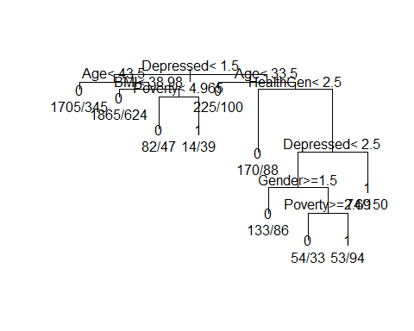

# age and BMI are near the top, but   
# so is Depressed and Poverty  
  
  
# For the forest  
set.seed(20371)  
#dmod_forest <- rfsrc(form, data = people,   
# ntree = 201, mtry = 3)  
# try with randomForest instead of randomForestSRC package  
#library(randomForest)  
dmod_forest <- randomForest(form, data = people,   
 ntree = 201, mtry = 2)  
  
# results summary  
dmod_forest

##   
## Call:  
## randomForest(formula = form, data = people, ntree = 201, mtry = 2)   
## Type of random forest: classification  
## Number of trees: 201  
## No. of variables tried at each split: 2  
##   
## OOB estimate of error rate: 18.66%  
## Confusion matrix:  
## 0 1 class.error  
## 0 4283 92 0.02102857  
## 1 1024 582 0.63760897

varImpPlot(dmod_forest)

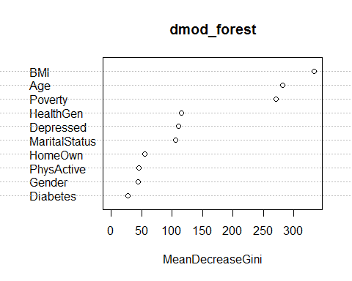

# you'll notice that BMI and Age are at the top  
# of this Variable Important plot  
# also near the top is the Poverty level  
  
# Now the predictions for tree and forest  
# just compute prediction from original data for now  
pred_tree <- predict(dmod_tree)[,1]  
summary(pred_tree)

## Min. 1st Qu. Median Mean 3rd Qu. Max.   
## 0.2642 0.7493 0.7493 0.7315 0.8317 0.8317

#table(pred_tree)  
  
# pred_tree <- predict(dmod_tree, newdata = fake_grid)[, 1]  
#pred_forest <- predict(dmod_forest, newdata = fake_grid,   
# type = "prob")[, "Yes"]  
pred_forest <- predict(dmod_forest, type = "prob")[,1]  
summary(pred_forest)

## Min. 1st Qu. Median Mean 3rd Qu. Max.   
## 0.02778 0.70110 0.88610 0.80180 0.96050 1.00000

#table(pred_forest)  
  
# K-nearest neighbor prediction  
# but look at Age and Poverty  
pred_knn <- people %>%  
 knn(test=people, cl = people$SleepTrouble, k=5) %>%  
 as.numeric() - 1

Next, we want to build a dataframe with all of these predicted models, then gather() it into a long format.

#library(tidyr)  
  
# build the data frame  
  
res <- people %>%  
 mutate(  
 "Null" = pred_null,   
 "Decision Tree" = pred_tree,  
 "Random Forest" = pred_forest,   
 "K-nearest neighbor" = pred_knn) %>%  
 gather(k="model", value = "y_hat", -Age, -Gender,  
 -MaritalStatus, -Poverty, -HomeOwn, -BMI,  
 -Diabetes, -HealthGen, -Depressed, -PhysActive,  
 -SleepTrouble)

## Warning: attributes are not identical across measure variables; they will  
## be dropped

Next let's plot all of these

ggplot(data = res, aes(x = Age, y = Poverty)) +  
 geom_tile(aes(fill=y_hat), color = NA) +  
 geom_count(aes(color = SleepTrouble), alpha = 0.4, data = people) +  
 scale_fill_gradient(low = "white", high = "blue") +  
 scale_color_manual(values = c("gray", "gold")) +  
 scale_size(range = c(0,2)) +  
 scale_x_continuous(expand = c(0.02, 0)) +  
 scale_y_continuous(expand = c(0.02, 0)) +  
 facet_wrap(~model)

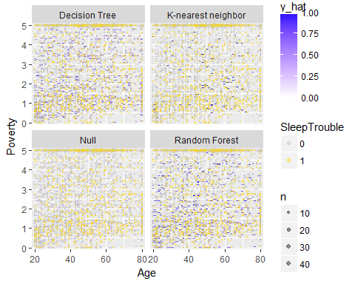

## PART 2 - Build "classifiers" for SleepHrsNight

For each of the model types (null model, logistic regression, decision tree, random forest, k-nearest neighbor):

* 1A. Build the classifier.
* 1B. Report its effectiveness on the NHANES dataset.
* 1C. Make an appropriate visualization of this model.
* 1D. Interpret the results. What have you learned about people's sleeping habits?