Remotely sensing river greenhouse gas exchange velocity using the SWOT satellite

Craig B Brinkerhoff1,\*, Colin J Gleason1, Christopher J Zappa2, Peter A Raymond3, and Merritt H Harlan1

1 Department of Civil & Environmental Engineering, University of Massachusetts, Amherst, MA  
2 Lamont-Doherty Earth Observatory, Columbia University, Palisades, NY  
3 School of the Environment, Yale University, New Haven, CT

\* Correspondence: [Craig B Brinkerhoff <[cbrinkerhoff@umass.edu](mailto:cbrinkerhoff@umass.edu)>](mailto:cbrinkerhoff@umass.edu)

## Key Points

* The BIKER algorithm predicts gas exchange velocity and fluxes solely from simulated SWOT data without calibration
* BIKER is robust to SWOT measurement errors
* BIKER will allow for novel study of gas exchange spatiotemporal dynamics after SWOT’s launch

## Keywords

gas exchange, fluvial geomorphology, remote sensing, open-channel flow, SWOT, biogeochemistry

## Abstract

Extensive research over the past two decades has shown that the global river network emits significant amounts of greenhouse gas. Despite much progress, there is still large uncertainty in the temporal dynamics of gas exchange and thus carbon emissions to the atmosphere. Much of this uncertainty stems from uncertainty in gas exchange velocity (the rate of this diffusive transport). We propose that the NASA/CNES/USKA/CSA SWOT satellite can provide new insights to fluvial gas exchange modeling upon launch in 2022. Here, we present work inferring from synthetic future SWOT observations without in situ calibration. We exploit the unique geomorphology of SWOT-observable rivers to develop a physical model of gas exchange that is remotely sensible and explains 70% of variation across 166 field measurement of . We then couple this model with established inversion techniques to develop BIKER, the ‘Bayesian Inference of the Exchange Rate’ algorithm. We validate BIKER on 47 SWOT-simulated rivers, yielding an algorithm that predicts the timeseries solely from SWOT observations with a by-river median Kling-Gupta Efficiency of 0.37. Similar to remote sensing algorithms for SWOT, BIKER is better at explaining the temporal variation of gas exchange (median correlation coefficient of 0.91), than reproducing the absolute rates of exchange (median normalized RMSE of 37%). Finally, BIKER is robust to measurement errors implicit in the SWOT data. Upon SWOT’s launch, we suggest that BIKER will be useful in mapping global-scale fluvial gas exchange and improving emissions estimates when coupled with river models.

## 1 Introduction

Natural systems play a critical role in the budgeting and accounting of the global carbon cycle under climate change. Following Cole et al. (2007), the global river network is recognized to emit substantial amounts of carbon to the atmosphere via evasion (gas exchange driven by diffusion and near-surface turbulence at th air/water interface), in addition to their long understood role in transporting carbon to the oceans via downstream advection. Current estimates of total carbon dioxide evasion () to the atmosphere from the global river network vary from 650-2000 Tg C/yr (Lauerwald et al., 2015; Liu et al., 2022; Raymond et al., 2013), with 167 Tg-C/yr coming from mountain streams alone (Horgby et al., 2019). Despite rivers’ small percentage of the global land surface (0.67%- Liu et al., 2022), this carbon flux is on par with the total oceanic uptake rate (Gruber et al., 2019; Horgby et al., 2019) and the global forest carbon uptake rate (Pan et al., 2011).

River evasion is increasingly better constrained and is clearly a critical component of the global carbon cycle. Equation 1 represents this riverine flux given (the air-water flux between the water and the air ) and the gas exchange velocity *k*. Consult Appendix A for variable nomenclature used throughout this study.

There is a robust existing literature exploring spatiotemporal patterns in (e.g. Aho, Fair, et al., 2021; Aho & Raymond, 2019; Crawford et al., 2017; Liu & Raymond, 2018; Peter et al., 2014; Ran et al., 2017; Raymond et al., 2000; Rocher‐Ros et al., 2019). This work has lead to recent river-reach explicit modeling of using global hydrography datasets at up to monthly temporal resolutions (Brinkerhoff et al., 2021; Horgby et al., 2019; Liu et al., 2022; Saccardi & Winnick, 2021), but an equivalently sophisticated representation of is still lacking.

The structure of Equation 1 necessitates that calculations of are highly sensitive to measurements/estimates of *k*. However, *k* can only be directly calculated via a known gas flux, eddy-covariance measurements, or tracer additions to the stream (Hall & Ulseth, 2020). In trying to constrain the global fluvial flux across millions of rivers, this calculation is impossible and necessitates the use of predictive models for *k* that are based on easily obtained river hydraulic properties. In that vein, there have been over 20 empirical models developed to predict *k* from river hydraulics, generally using some combination of mean velocity , shear velocity , width , depth , and slope as predictors (Hall & Ulseth, 2020; Wang et al., 2021). These models usually predict , or *k* normalized by a Schmidt number (*Sc*) of 600. This is to remove the effect of water temperature and gas type from predictive models, as warmer waters and lower *Sc* numbers each increase gas exchange rates (Hall & Ulseth, 2020). Specifically, reflects the at 20 degrees Celsius. Through this normalization, these models focus solely on physical explanations for variation in *k* (Hall & Ulseth, 2020).

Applying these *k* models across watersheds, regions, or continents is called ‘upscaling.’ This upscaling allows for estimating the difficult-to-measure *k* term in Equation 1 for any arbitrary number of rivers, but also changes the base parameters that ultimately control the final estimate of . That is, by making *k* a function of hydraulics, is now a direct function of river hydraulics. This functional relationship is described in equation 2. It suggests that estimates are not only at the mercy of the accuracy and spatiotemporal resolution of , but also the accuracy and resolution of our river hydraulics estimates.

Global upscaling has been performed in the literature. Raymond et al. (2013), Lauerwald et al. (2015), and Horgby et al. (2019) all relied on values indirectly estimated using mean annual streamflow models and hydraulic scaling equations to predict the hydraulic terms to in turn predict , while Borges et al. (2015) used a combination of the above method and a constant in space and time to upscale over Africa. More recently, Liu et al. (2022) performed a first upscaling assessment of monthly temporal dynamics in global river , though they relied on monthly modeled streamflow and used the same model for as previous studies (Raymond et al., 2013) to achieve this. In all of these foundational studies, the temporal dynamics of (and thus dynamics in ) were ignored because of hydraulic data limitations. It has been shown at the field-scale that temporal dynamics of gas exchange can vary widely from site to site (Wallin et al., 2011), but it has remained impractical to obtain temporally explicit at continental-to-global scales.

Wang et al. (2021) recently attempted to address this global *k* problem by simulating in 35 rivers of many sizes (widths ranging from 0.23–349m) using a stream metabolism model (Appling et al., 2018) and in situ dissolved oxygen (DO) datasets to infer what must have been to produce their ‘observations’. They then compared this simulated dataset against direct measurements of *k*, finding similar performance and parameter values for process-based models of gas evasion. However, they were still limited by a lack of direct hydraulic measurements and had to rely on hydraulic scaling equations to estimate river depth and velocity. Even though approaches like Wang et al. (2021)’s are incredibly useful for expanding our mechanistic understanding of gas exchange, they are less useful for global upscaling purposes as they rely on high fidelity in situ DO data for every river (Hall & Ulseth, 2020).

We have established that literature has a reasonably good understanding of and a relatively poorer understanding of (and therefore ) across large areas and in time. In theory, the discrepancy between the quality of our and estimates could be alleviated if direct hydraulics measurements (and in turn via Equation 2) were available at the global scale at a sufficient temporal resolution. Spatially and temporally dynamic hydraulic measurements in turn would also address the uncertainty regarding continental-to-global scale temporal dynamics of gas exchange noted earlier.

Conveniently, these hydraulic data will soon be available via the upcoming NASA/CNES/UKSA/CSA Surface Water and Ocean Topography (SWOT) satellite mission. SWOT is expected to launch in late 2022 and provide the world’s first direct measurements of global water surface extent and elevation (and therefore water surface slope) at novel temporal resolutions. SWOT is a wide swath radar interferometer and will sample rivers every 1 to 7 days per 21 day repeat cycle, measuring rivers wider than 100m with a goal of expanding this to rivers at least 50m wide (Biancamaria et al., 2016). Via its direct hydraulic measurements, SWOT is expected to usher in a sea change in global-scale hydrology, and could similarly influence fluvial biogeochemsitry if techniques are developed to ingest SWOT data and infer *k*. In this context, we borrow tools from fluvial geomorphology and existing SWOT algorithms to answer the following two questions:

1. Can we develop a physically-based hydraulic model for unique to SWOT-observed rivers?
2. Can we exploit such a model to infer (and its uncertainty) solely from SWOT observations?

To answer this first question, we use hydraulic geometry- the fundamental geomorphic relationships between streamflow and channel shape (Gleason, 2015; Leopold & Maddock, 1953) to develop a process-based model for large-river (here defined as wider than 50m to align with SWOT). We then take these findings and explore the second question by implementing this hydraulic model, which defines , within an algorithm named BIKER (‘Bayesian Inference of the Evasion Rate’) to infer solely from SWOT measurements. The goal of BIKER is to require no in situ inputs of any kind (although in situ data could be ingested and would improve results) such that it is globally implementable on any SWOT-observable river. We validate BIKER on 47 SWOT-simulated rivers (as SWOT has not yet launched) and explore BIKER’s robustness to the expected measurement errors implicit in the satellite’s observations. Finally, we also couple BIKER’s estimates with to predict gas fluxes and compare these against established literature methods that rely on in situ hydraulic measurements.

This paper is split into two distinct parts: gas-exchange theory/model development (Section 2) and BIKER algorithm development/validation (Section 3). Section 3 is fundamentally dependent on the results presented in Section 2, therefore Section 2 presents both theory and results. Both sections detail the data used. We conclude with a discussion (Section 4) that encompasses both gas exchange theory and remote sensing. Figure 1 conceptually maps out the algorithm’s approach to inferring from SWOT data.

Figure 1: Conceptual overview of the BIKER algorithm. 1: SWOT will directly measure water surface width and elevation (and thus slope) at a series of cross-sections within mass-conserved river reaches. 2: These hydraulics measurements are used to calculate turbulent dissipation in the river channel (Section 3). 3: Turbulent dissipation is used to infer k_{600} via a process-based model (Section 2).

Figure 1: Conceptual overview of the BIKER algorithm. 1: SWOT will directly measure water surface width and elevation (and thus slope) at a series of cross-sections within mass-conserved river reaches. 2: These hydraulics measurements are used to calculate turbulent dissipation in the river channel (Section 3). 3: Turbulent dissipation is used to infer via a process-based model (Section 2).

## 2 Predicting from large-river hydraulic geometry

To predict in the large rivers that SWOT will observe, we start from an established process-based model for , impose hydraulic assumptions that are valid in SWOT-observable rivers, and obtain a model we empirically test. Following a description of the data (Section 2.1), we outline established models (Section 2.2) and then step through our hydraulic assumptions to arrive at an equation that is compatible with SWOT measurements (Section 2.3). We then empirically validate the model (Section 2.4)

### 2.1 Data

We develop our hydraulic model for using multiple datasets of measured and stream hydraulics collected from the literature. In total, we obtain 763 measurements of , with 701 of these measurements previously gathered by Raymond et al. (2012) and Ulseth et al. (2019). The remaining measurements come from Churchill et al. (1964) and Owens et al. (1964). See Table S1 for a complete list of the studies that collected these measurements. All measurements come from tracer studies and thus define at the reach scale.

In addition to hydraulics measured alongside and reported above, we expand our dataset of stream hydraulics using a previously published compilation of in situ hydraulic measurements (Brinkerhoff et al., 2019). That dataset contains over 530,000 unique measurements of river channel velocity, width, and discharge from across the continental United States, originally made to calibrate United States Geological Survey (USGS) stream gauge rating curves and made public by the USGS. This dataset is used to calculate how frequently SWOT observable rivers meet our large-river hydraulic assumptions (Section 2.3).

### 2.2 Process-based hydraulic modeling of river *k*

*k* scales with near-surface turbulence in turbulent streamflows (Hall & Ulseth, 2020), and extensive field and laboratory experiments have converged on the ‘small-eddy model’ for *k* as derived by Lamont & Scott (1970) and empirically anticipated by Calderbank & Moo-Young (1961). This model scales *k* via the smallest-scale turbulent eddies and has been repeatedly empirically validated in freshwater systems (e.g. Katul et al., 2018; Lorke & Peeters, 2006; Moog & Jirka, 1999b; Tokoro et al., 2008; Vachon et al., 2010; Wang et al., 2021; Zappa et al., 2003, 2007). The small-eddy model is provided as Equation 3, where is the dissipation rate of near-surface turbulence, is the kinematic viscosity, and *Sc* is the Schmidt number.

Some laboratory and field observations additionally suggest that open channel flows with small bed roughness do not exhibit homogeneous surface dissipation across the entire reach’s air-water interface (Moog & Jirka, 1999a; Talke et al., 2013). Given this observation, Moog & Jirka (1999a) proposed an extension to the small-eddy model, additionally scaling using a shear Reynold’s number formulation. This is Equation 4 and is referred to here as the ‘Reynolds extension’ model. The Reynolds model is hypothetically useful in low-turbulence scenarios where a relative lack of large-scale eddies effectively ‘filter out’ the number of small-eddies that actually reach the interface and initiate gas exchange (Talke et al., 2013). While scaling *k* via a shear Reynold’s formulation is sometimes done to parameterize wave-breaking gas exchange models in the open ocean (e.g. Brumer et al., 2017; Zhao et al., 2003; Zhao & Toba, 2001), it is infrequently done in rivers. In the context of BIKER, we chose to test this model because large, SWOT-observable rivers are generally the smoothest, least-turbulent flows along the stream-to-ocean continuum where small eddies might not reach the surface. Further, to our knowledge, this Reynolds extension model has never been empirically tested in predicting river *k*, aside from confirming that large-scale eddies differentially move turbulence to the surface in a large river (Talke et al., 2013).

Equations 3 and 4 both rely on , which is non-trivial to measure. When working at large scales, a commonly used model assumes that all turbulence is generated at the bed and transported to the air-water interface via the log-law-of-the-wall (Equation 5). Another approach specific to fluvial settings models *k* via ‘form-drag dissipation’ (Equation 6) which is equivalently the total stream power per unit mass water. This normalized stream power captures the bulk frictional resistance (and thus energy dissipation) via channel banks, meanders, bars, etc. that is unique to fluvial systems (Moog & Jirka, 1999b). Authors have since shown that Equation 6 can reasonably predict *k* in rivers and streams (Raymond et al., 2012; Ulseth et al., 2019; Wang et al., 2021).

### 2.3 Deriving a large-river model

Given the theoretical context provided in Section 2.2, we now turn to SWOT-observable systems specifically. Rivers and streams change predictably along their longitudinal profile from source to sea, and we can exploit the hydraulic geometry of large rivers at the end of this continumn to estimate *k* in SWOT rivers. In general, as river size increases, channels become more rectangular, their shapes elongate (becoming wider quicker than they become deeper) and their hydraulic radii begin to approximate their mean flow depth, i.e.  (Leopold & Maddock, 1953). This is a common assumption in hydraulic and geomorphic modeling of large rivers. For example, SWOT-observable river flows have an average ratio of 0.98 and standard deviation of only 0.02 (n = 22452; see Text S1 for how we built this dataset). We refer to these rivers as ‘hydraulically-wide’.

We therefore assume that all SWOT-observable rivers are hydraulically-wide to derive a model for gas exchange. The overall goal is to reduce the equations down to their fundamental parameters, identifying which terms are SWOT observable and limiting the number of terms not directly measurable via SWOT. To do this, we impose and on the Reynolds extension model (Equation 4) and arrive at Equation 7 (with statistical coefficient ). Equation 7 thus defines gas exchange velocity solely as a function of slope, mean flow depth, and mean flow velocity. This is theoretically valid only in a hydraulically-wide channel.

We also test the performance of three other models for predicting *k* in hydraulically-wide channels via the other three unique combinations of Equations 3-4 and Equations 5-6. While the complete model derivations and results for all four models are provided in Text S2 and Figure S1, the final and best-performing model (Equation 7) is presented and used below.

### 2.4 Model validation

With Equation 7 derived, we now empirically test its strength of fit in hydraulically-wide river flows. We validate on the dataset of in situ measurements of , after filtering for measurements made in hydraulically-wide channels, which was defined as flows whose hydraulic radius was within 1% of their mean flow depth. All told, this amounts to 166 measurements of hydraulically-wide . Equation 7 is assessed via the coefficient of determination () and plotted in Figure 2. Note that Figure 2 axes are plotted in logarithmic space only for visualization: model fit and validation (via ) were calculated in linear space as their models dictate.

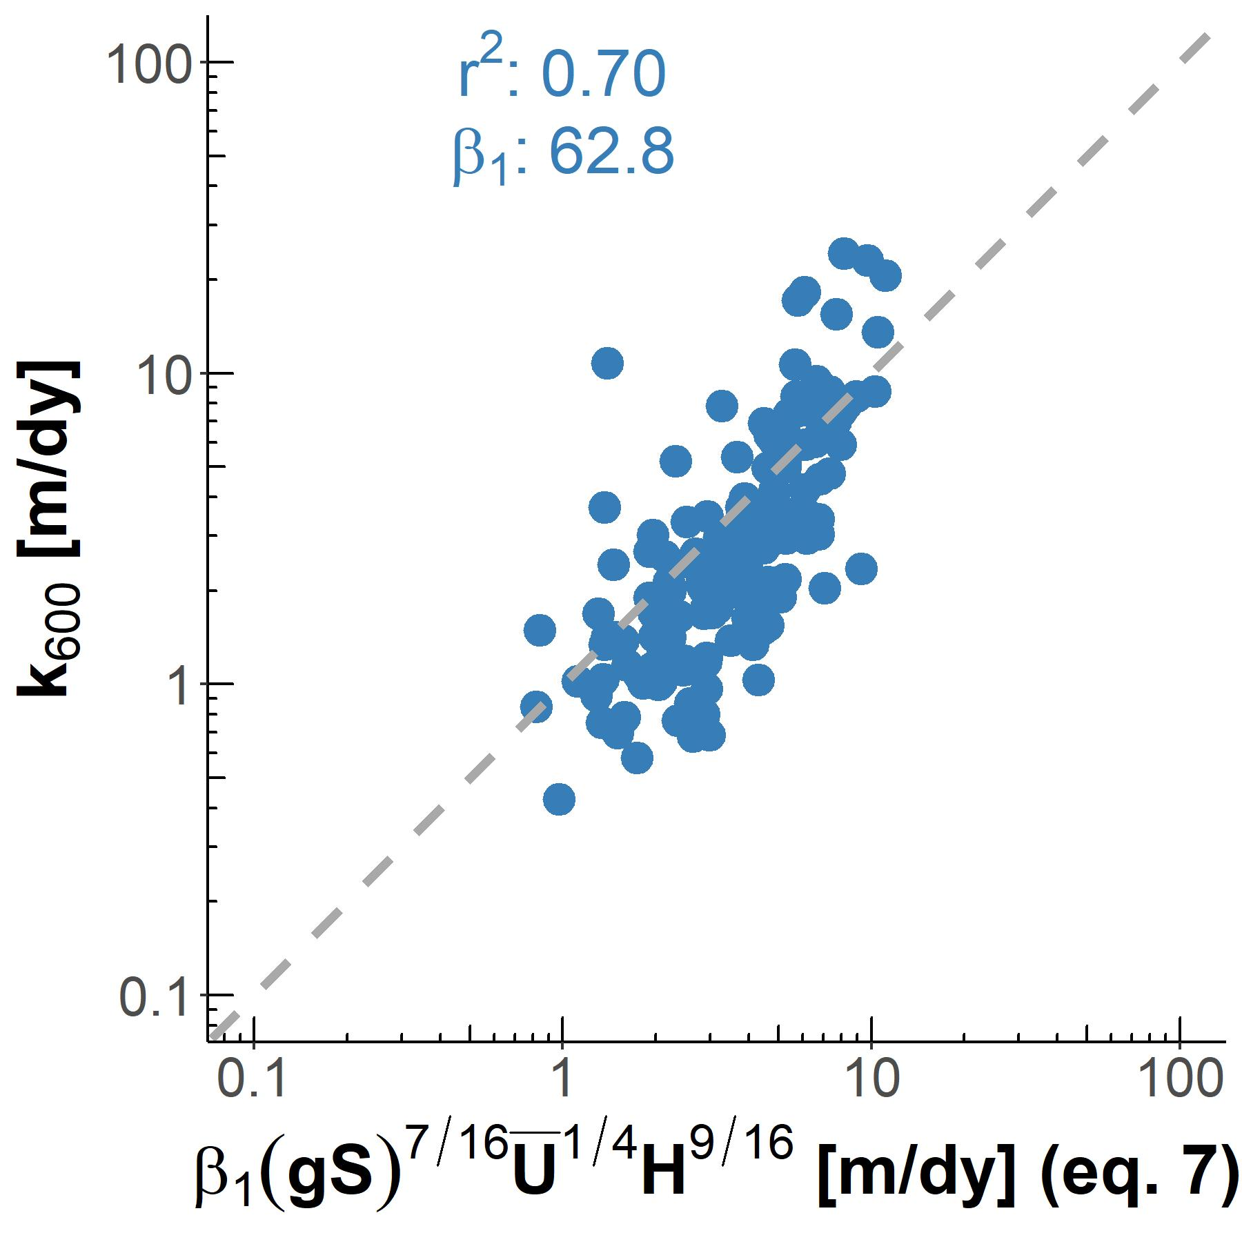

Figure 2: Empirical testing of our large-river model on 166 measurements made in hydraulically-wide rivers. Dashed grey line denotes the 1:1 line. Note that axes are plotted in logarithmic space just for visualization: model fit and validation (via the coefficient of determination ) were calculated in linear space.

Figure 2 shows that Equation 7 explains 70% of variation in observed in hydraulically-wide rivers and accurately captures the scaling dynamics of observed as well. The value for is 62.8, which is similar the fitted parameters in other and models for river *k* (Wang et al., 2021). While the individual residuals can be quite large, the overall scaling of with river hydraulics is strongly captured, remembering that Figure 2 is plotted in logarithmic space. Compared to other combinations of Equations 3-6 (Figure S1), there is also a better fit with the estimates thanks to the addition of the Reynold’s number scaling for low-turbulent flows (as expected). The success of this model in hydraulically-wide channels provides us with a strong physical-model for gas evasion built with SWOT in mind. The river hydraulics terms in Equation 7 (, , and ) can either be directly measured or reasonably inferred from SWOT measurements, effectively opening the door for remotely sensing the gas exchange velocity.

## 3 Exploiting Equation 7 to remotely sense gas exchange velocity

We have shown that scaling via Equation 7 is useful in hydraulically-wide rivers. Further, Equation 7 has only three non-directly-remotely-sensible terms: , mean flow depth, and mean flow velocity. Conveniently, techniques to simultaneously infer mean flow depth and velocity from SWOT data (among other parameters) have been established over the last decade to infer streamflow from SWOT’s measurements (e.g. Andreadis et al., 2020; Brinkerhoff et al., 2020; Brisset et al., 2018; Durand et al., 2014; P.-A. Garambois et al., 2020; P.-A. Garambois & Monnier, 2015; Gleason et al., 2014; Gleason & Smith, 2014; Hagemann et al., 2017; Larnier et al., 2020; Oubanas et al., 2018). For BIKER, we follow the work developed by Hagemann et al. (2017), Brinkerhoff et al. (2020), and Durand et al. (2014) to infer , channel depth and velocity from SWOT observations using a modified form of Manning’s equation. Following a description of the data used (Section 3.1), we detail algorithm development and experimental design (Section 3.2) and then we present the validation results (Section 3.3).

### 3.1 Data

To validate BIKER, we cannot use actual SWOT measurements as SWOT has yet to launch. In the hydrology literature, it has become standard practice to benchmark SWOT-related algorithms on “SWOT-like” data (Durand et al., 2016). We use 47 SWOT-simulated rivers for validation, where these simulated rivers are simply reach-averaged hydraulic model outputs where the water surface heights, slopes, and widths are labelled as RS observations and are used as the sole inputs to BIKER. These datasets are created using standard hydraulic models forced with known inflows and measured bathymetry to model the hydraulic response of the rivers, and then those terms visible to SWOT are extracted to produce hydraulically realistic synthetic observations. These data were published by Frasson et al. (2021) and Durand et al. (2016). See Figure S2 for a map of these river’s locations along the global SWOT river network (Altenau et al., 2021). This river network corresponds to every river that BIKER will be run on once SWOT launches.

We validate BIKER under two different ‘error scenarios’. While SWOT will provide river surface measurements of novel quality and resolution, as with all remote sensing products there are expected errors that will be implicit in these measurements. Here, we validate BIKER under a ‘no-measurement-error’ scenario that reflects an unrealistic measurement as if SWOT has perfect accuracy and precision: we use the hydraulic model output directly as a first test of algorithm validity. 16 of these rivers are then additionally validated under a ‘measurement-error’ scenario that more closely mimics expected SWOT by adding realistic radar errors and sampling along the satellite’s future ground track. SWOT river error modeling was developed by Durand et al. (2020) and then applied to these 16 rivers by Frasson et al. (2021). This error modelling is non-trivial and computationally expensive, and thus we rely on these previously published data.

For evasion and carbon emissions calculations, we use 26 bi-weekly dissolved samples collected by Beaulieu et al. (2012) at one location in the Ohio River (Figure S2) for one calender year from 2008-2009 (Figure S3). Note that this data is for the Ohio River only but was applied to all rivers to provide a physically realistic signal for fluxes with meaningful seasonality and dynamics. Therefore, the raw carbon emissions estimates presented in this paper are meaningless in the context of actually measured carbon emissions from these rivers, but are better than specifying concentrations devoid of context. These data are necessary as we are interested in the effect of BIKER errors on eventual fluxes and comparing these fluxes with published methods. Therefore, applying these ‘unit’ values allows for such a comparison by providing a realistic timeseries.

### 3.2 Section 3 methods

#### 3.2.1 BIKER

BIKER, and Bayesian inference in general, starts from Bayes rule (Equation 8), where is some set of non-remotely-sensible parameters we want to solve for (including ), *x* is the observed data, is the sampling model where data are conditional on the parameters, and is the joint prior distribution of the parameters. Therefore, we are interested in solving for , or the ‘posterior’ distribution. Note that is usually computationally intractable to integrate exactly, but Bayesian inference requires only the proportionality to be specified: . Sampling algorithms are then used to approximate the actual posterior distribution, as is done in BIKER.

The heart of BIKER is its reformulation of the model (Equation 7) as a Bayesian sampling model that is conditional on the non-remotely-sensible parameters (i.e. ). This is similar to the ‘McFLI’ (Mass-Conserved Flow Law Inversion) logic used in some SWOT RSQ algorithms (Gleason et al., 2017). To start, we write as a function of SWOT-observables and . This algebra is carried out using Equation 7, the fitted value for from Figure 2 (62.82), and Manning’s equation for mean flow velocity (). Following Section 2.3, we continue to assume that the channel is hydraulically-wide (). To leverage additional SWOT data, the wetted channel area *A* is further split into the the SWOT-unobservable portion and SWOT-observable portion following Durand et al. (2014) and Hagemann et al. (2017) where for cross-section *i* and timestep *t* within a mass-conserved river reach.

All of this algebra simplifies to Equation 9. Conveniently, as measured by tracer additions to a stream is inherently a reach-scale quantity (in a mass-conserved reach). Therefore, Equations 7 and 9 both yield a reach-scale (i.e. ). This lowers the number of parameters BIKER must infer and makes the problem much better constrained.

Next, Equation 9 is written as a Bayesian sampling model, in which all of the SWOT observations are sampled from the unknown model parameters (, , and ). This is Equation 10 after describing everything as normal distributions of the log-transformed terms. refers to the total uncertainty implicit in Equation 9. This uncertainty arises from 1) parameter uncertainty in Equation 7, 2) Manning’s equation, and 3) the rectangular channel assumption.

Equations 8 and 10 also necessitate that we specify prior distributions for the parameters , , and . Prior distributions formalize the a priori estimates and uncertainties for the non-remotely-sensed terms. More intuitively, BIKER priors represent our ‘prior river knowledge’ of what , , and probably are for some river since they cannot be directly remotely sensed. This is analogous to the ‘empirical Bayes approach’ to Bayesian inference (Hoff, 2009). Our goal in prior specification was to rely on absolutely no in situ information such that we could run this method on any river on Earth solely using SWOT observations. In theory, more informed priors via various a priori information about a specific river will improve BIKER performance, but here we chose to test the fully generalized algorithm. Therefore, the validation presented here is a ‘worst-case scenario’, wherein BIKER performance should improve with better prior information on the river. In that context, we used a variation of the prior specification method developed by Brinkerhoff et al. (2020), who developed ‘geomorphic river types’ with distinct prior sets for and . These priors are assigned to a river solely using SWOT data *W* and *S*, therefore meeting our needs for complete global implementability. Prior assignment for was developed similarly (all prior specifications are elaborated on in Text S3).

With the sampling model described ( = Equation 10) and priors ) specified (Text S3), a joint posterior distribution conditional on the SWOT observations () is therefore also specified. To approximate this distribution, we use a Markov Chain Monte Carlo (MCMC) algorithm implemented using the Stan probabilistic programming language. Specifically, Stan uses a Hamiltonian Monte Carlo sampler which reduces computation time relative to other sampling algorithms (Hagemann et al., 2017).

#### 3.2.2 BIKER validation

We validate BIKER, assuming no measurement error, on 47 SWOT-simulated rivers using daily simulated hydraulics. We also re-validate BIKER under the ‘measurement-error’ scenario using the 16 rivers with Frasson et al. (2021)’s SWOT error model to corrupt the hydraulics to mimic realistic SWOT measurements (widths, heights, and slopes). These data were outlined in Section 3.1.

BIKER is unique in that it can provide a timeseries of : for each SWOT observation, it yields a unique . There are, to our knowledge, no datasets of over time approaching the temporal density of our simulated SWOT rivers. We therefore apply Equation 7 as validated in Figure 2 to specify given the true hydraulics of each case and compare BIKER’s inversion to that value: given observed hydraulics, ‘observed’ comes from Equation 7. Remember that SWOT cannot observe below the water surface and therefore cannot measure or *H* (hence the need for Equation 9), and that all SWOT observations contain errors in both space and time (hence Equation 10). We acknowledge that there is error in Equation 7 as shown in Figure 2, but this error can be explicitly parameterized in our Bayesian system (this is elaborated on in Text S4). Therefore, the BIKER validation presented here is an exercise to see how well the imperfect and partial SWOT observations can infer given the hydraulic assumptions in Equation 9 and uncertainty in the data itself. Note also that we have already empirically validated Equation 7 in Figure 2.

We validate BIKER as a timeseries of for each river using the BIKER posterior means. Our error metrics consider the timeseries nature of the problem and are formally defined in Table 1. They consist of the correlation coefficient *r* to quantify accuracy of BIKER’s temporal dynamics, the root mean square error normalized by the observed mean (NRMSE) and normalized mean absolute residual error (NMAE) to assess bias, and the Kling-Gupta Efficiency (KGE). KGE is frequently used to assess streamflow prediction and simultaneously assesses accuracy in both bias and dynamics. While a value greater than -0.41 means the model outperforms a uniform prediction of the mean (Knoben et al., 2019), generally KGE scores are interpreted as being meaningful in ungauged settings if > 0.

*Table 1: Validation metrics used in this study, where Nt is number of observations and i is the specific observation. σ refers to the variance of the sample and μ refers to the mean of the sample. Carrot accents indicate the predicted value.*

| **Description** | **Acronym** | **Definition** | **Ideal Score** | **Possible Range** |
| --- | --- | --- | --- | --- |
| Correlation Coefficient |  |  | 1 | -1 to 1 |
| Normalized root-mean-square error | NRMSE |  | 0 | 0 to ∞ |
| Kling-Gupta Efficiency | KGE |  | 1 | -∞ to 1 |
| Normalized Mean Absolute Error | MAE |  | 0 | 0 to ∞ |

#### 3.2.3 Carbon emissions validation

It is one thing to accurately model the temporal dynamics of as above, but researchers are often most interested in the actual carbon emitted from river to atmosphere. Per Equation 2, this is done using river hydraulic models to estimate and in turn . However, streamflow data and/or model outputs are more readily modeled at the global scale than river channel geometry, and so upscaling models usually predict and *H* as functions of streamflow (*Q*) using hydraulic geometry scaling relationships. This effectively reduces Equation 2 to Equation 11. It is worth stressing that these literature upscaling workflows rely on in situ streamflow records and/or high-quality streamflow models.

Conversely, BIKER represents a new way of approaching Equation 11 compared to existing literature models: BIKER has no reliance on a streamflow model nor hydraulic geometry scaling relationships and only requires that a river is SWOT-observable. We are therefore interested in how the final carbon emissions that result from BIKER compare against literature methods that use Equation 11. We have the data to test four different models for fluxes: ‘BIKER’, ‘Raymond 2013’, ‘Raymond 2012’, and ‘Brinkerhoff 2019’. These latter three approaches all use the same philosophy for : making hydraulic and geomorphic assumptions to associate with observed hydraulics before using the data as a realistic timeseries to yield fluxes per Equation 11. In all three approaches, these observed hydraulics are streamflow, while BIKER uses only SWOT observations. Therefore, the advantage of BIKER is in its ease of application, as SWOT will observe all global rivers wider than 50m while streamflow observations are extremely geographically limited. But, BIKER is only attractive if it can produce fluxes with similar errors to published methods. Text S5 and Table S2 fully describe these three literature models.

To benchmark BIKER against these literature methods, we pair the 26 biweekly and water temperature samples from Beaulieu et al. (2012) (Section 3.1, Figure S3) with every 14th set of daily SWOT observations (as the data is bi-weekly). We then calculate using Equation 1, an atmospheric of 400 uatm, and a *Sc* estimated following Raymond et al. (2012). The *k* in Equation 1 is obtained using BIKER or the three literature models (Table S2 and Text S5). Finally, we estimate a pseudo yearly total carbon emission rate (via evasion) by applying each river’s mean over the river’s surface area and summing all rates across rivers, remembering that we are applying ‘unit’ data to all rivers.

### 3.3 Section 3 results

#### 3.3.1 BIKER

Figure 3 plots a representative set of the 47 timeseries of predicted and observed , assuming no SWOT measurement error. Two rivers each were sampled from the three tertiles of river *KGE* scores (Table 1) for display. Consult Figure S4 for all 47 timeseries plots (assuming no measurement error) and Figure S5 for the 16 rivers with measurement errors. Note that the y axis is normalized by maximum observed values to compare across rivers. In general, the temporal dynamics of are reproduced quite well by BIKER, with the highs and lows of evasion correctly inferred by BIKER in the better-performing rivers. Notably, there is sometimes positive bias in the estimates (e.g. the Connecticut and Missouri Midsection rivers). Some rivers yield the correct temporal dynamics, but the magnitude of these values is stretched relative to the observed (e.g. Ohio River). In this example, temporal trends are still reasonably inferred even though the magnitude of the estimates is quite off.

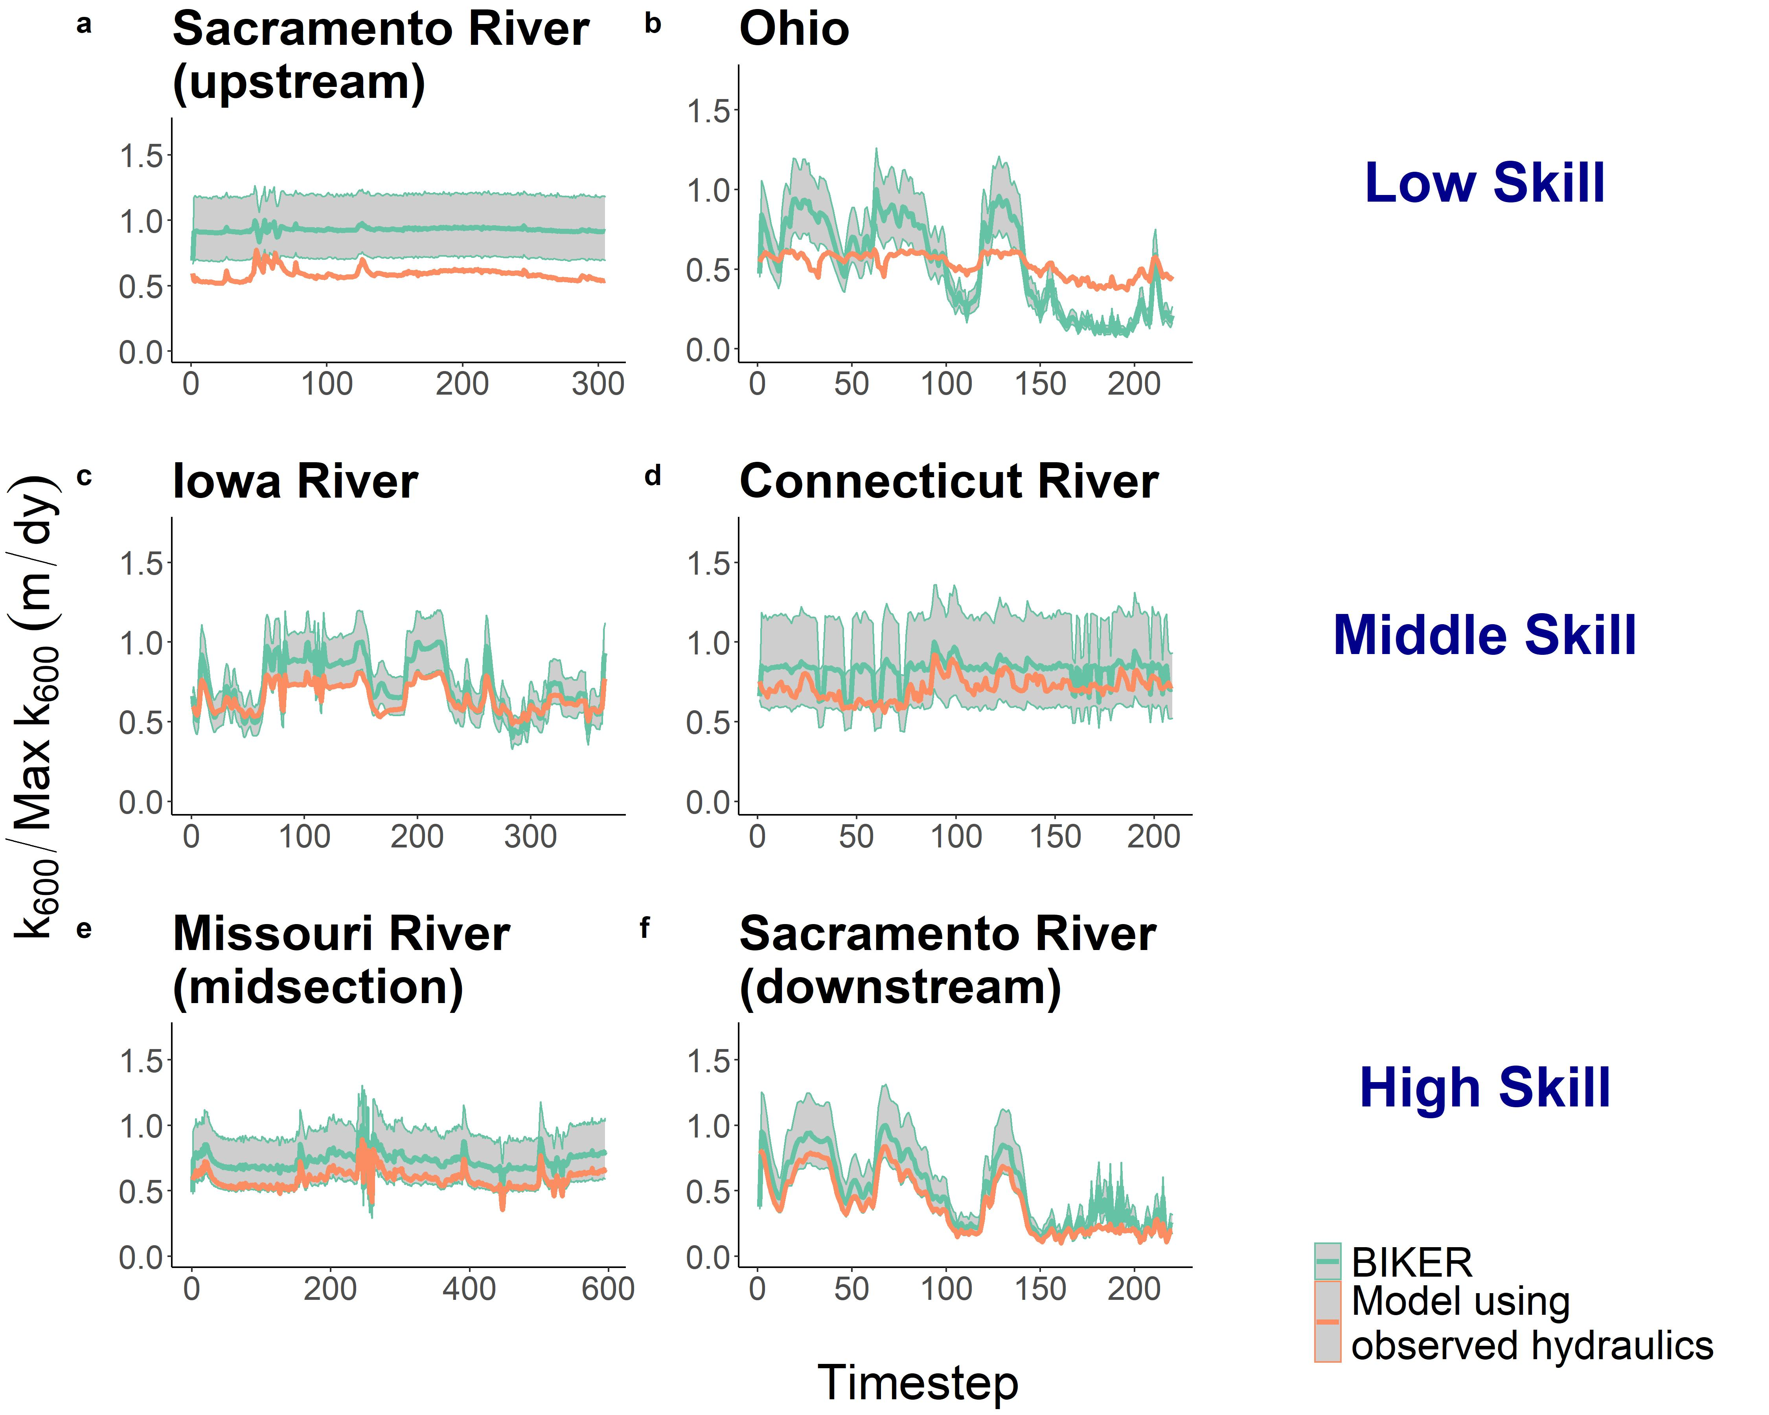

Figure 3. Representative river timeseries plots of . Orange is observed, while green is BIKER and uses SWOT measurements as its sole input. The green ribbon indicates the 95% CIs for the BIKER posteriors. Rivers are sampled from the three tertiles of KGE scores. (a-b) are poorest performing rivers, (c-d) are in the middle, and (e-f) are the best performing rivers. Y axis is normalized by maximum observed values to compare visually.

Next, we calculate performance metrics following Section 3.2.2 and Table 1. These are presented in Figure 4, which plots the scores for the 47 rivers with no measurement errors as empirical cumulative density functions (eCDFs). Median river is 0.37 and median river *r* is 0.91. Further, 38/47 rivers outperform a uniform prediction of the mean (KGE = -0.41). This indicates strong inference of each river’s temporal dynamics given that absolutely no in situ information is being used to predict . NRMSE has a median score of 0.37, highlighting many rivers which have notable positive biases (Figure 3 also confirms this visually). Median NMAE is 35%. Taken in aggregate, Figures 3-4 indicate that BIKER is quite good at capturing temporal dynamics in , however there is often positive bias in its estimates.

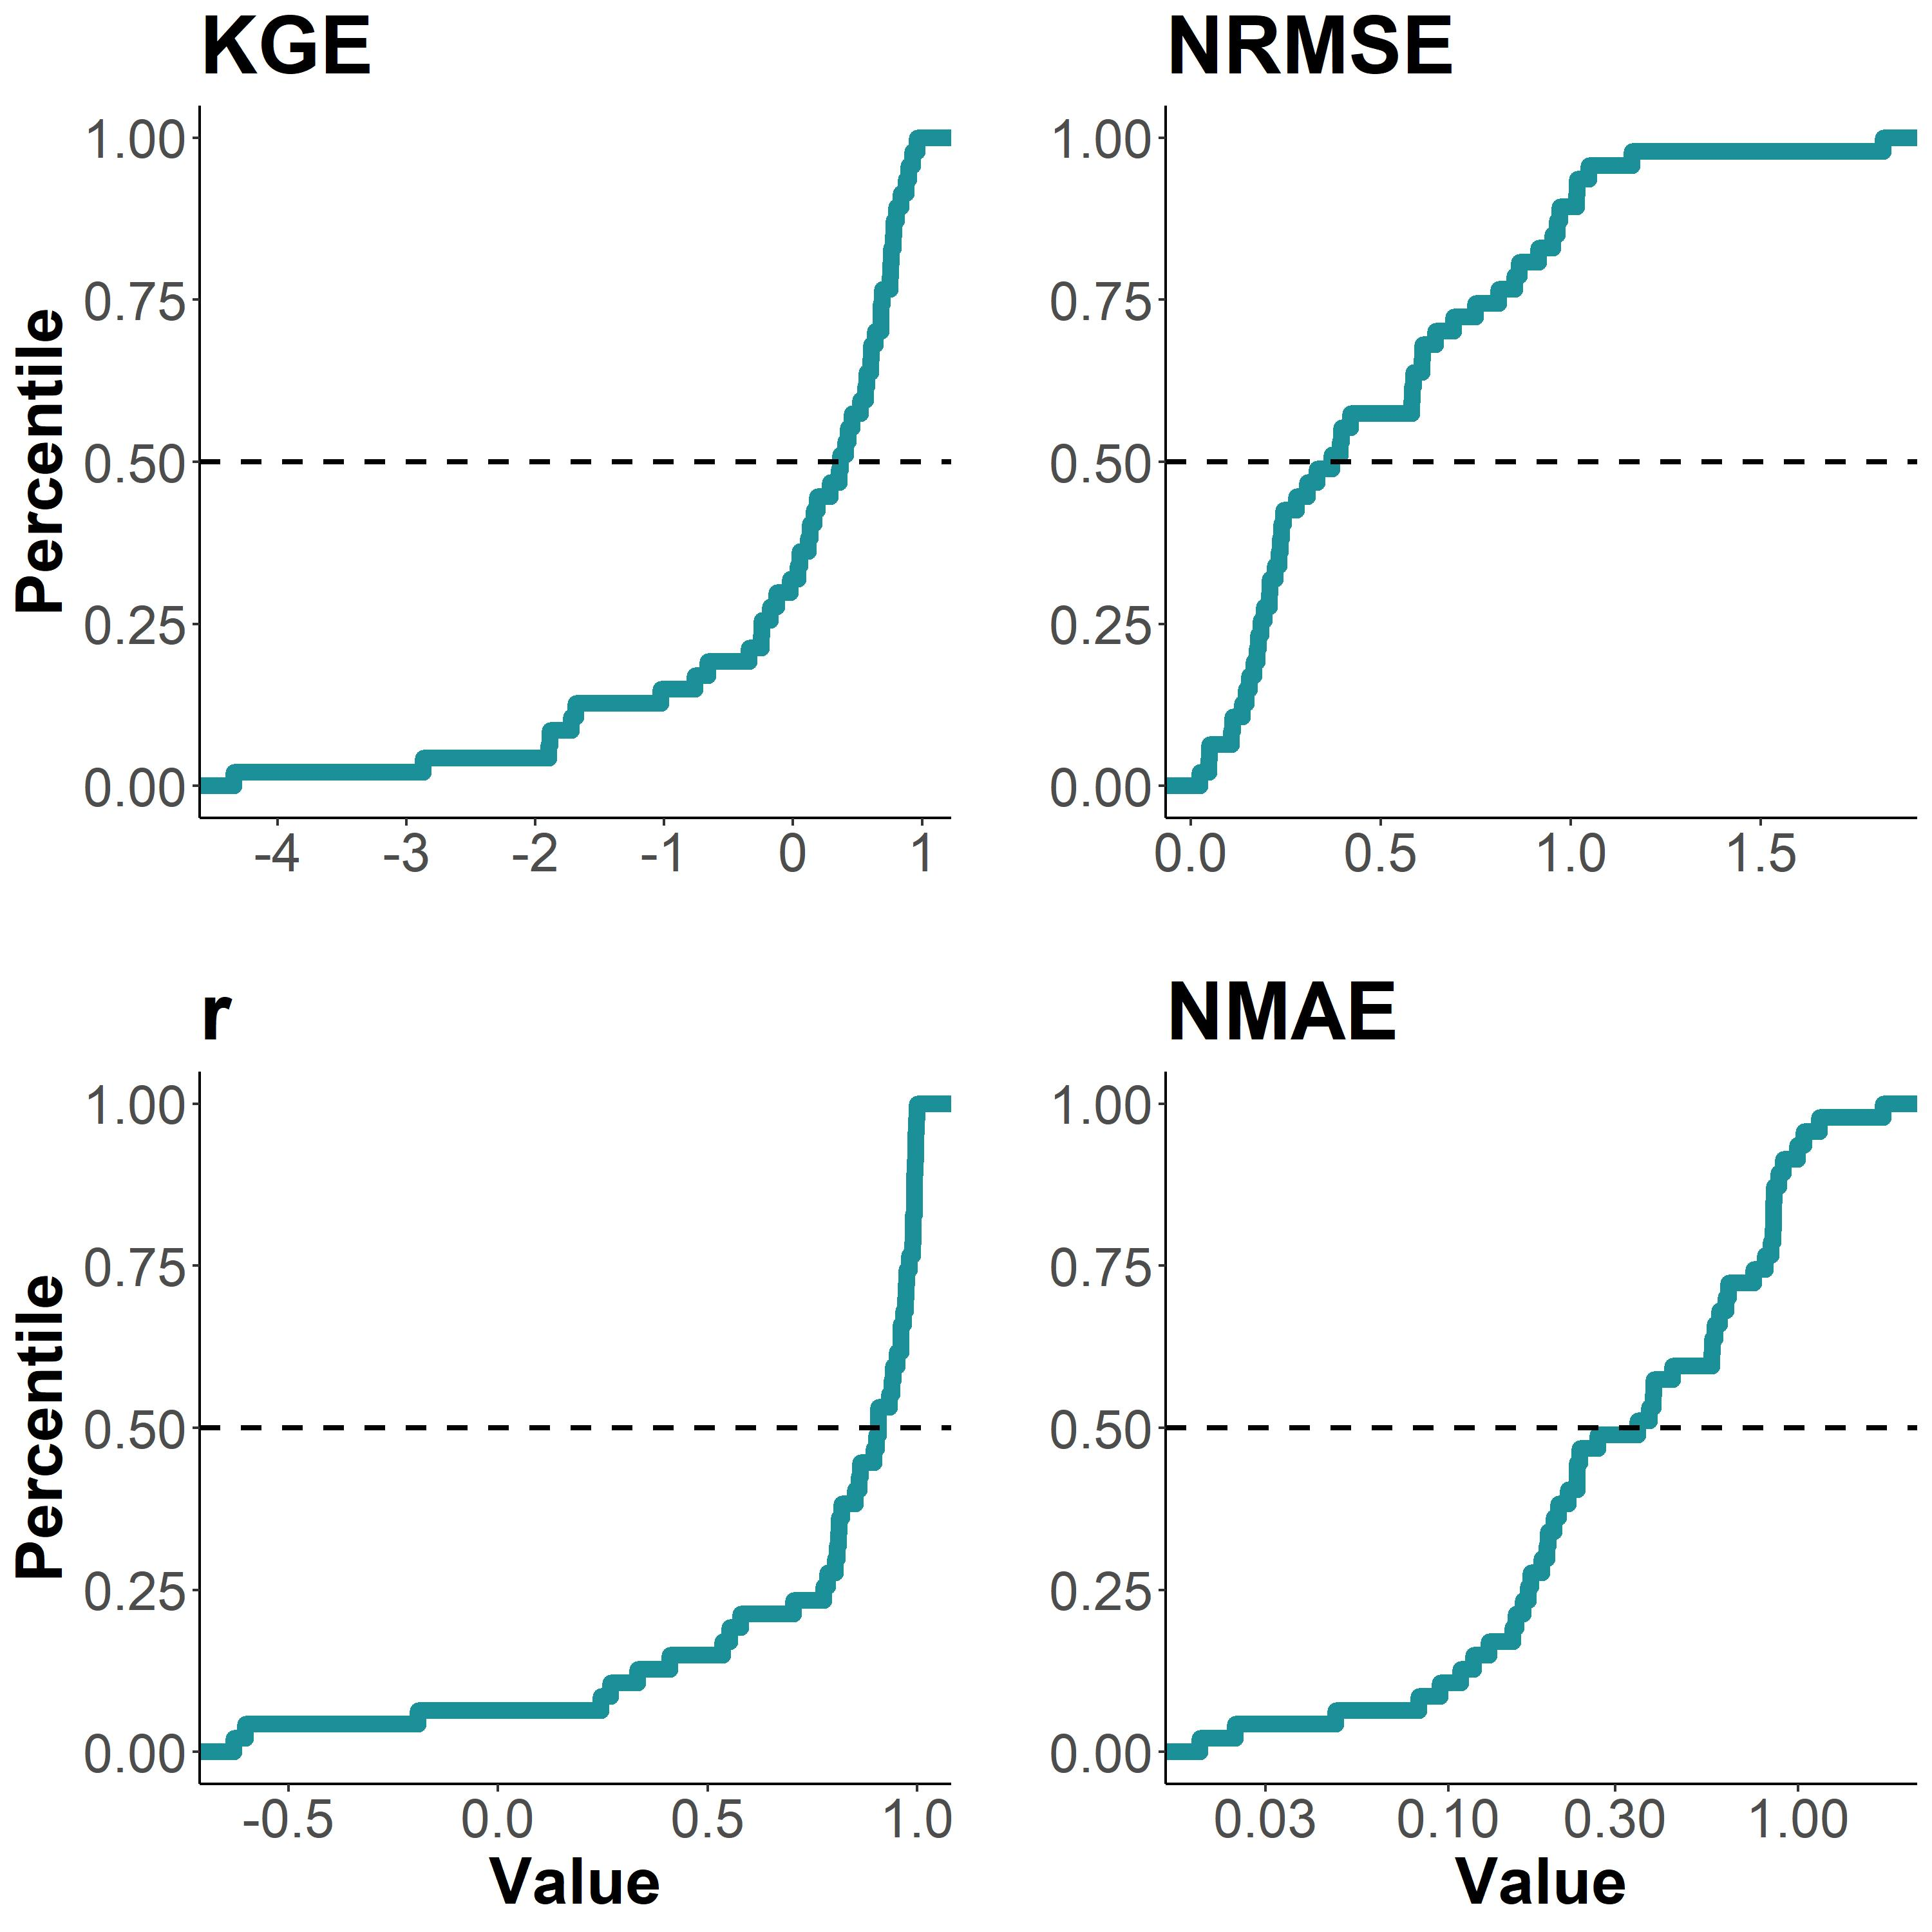

Figure 4. Performance metrics by river, ploted as empirical cummulative density functions (eCDFs). Each subpanel is labelled by its performance metric (defined in Table 1). Dashed lines denote median scores.

Figure 5 compares BIKER results under the ‘no-measurement-error’ and ‘measurement-error’ scenarios for the 16 rivers for which Frasson et al. (2021) provide an error model. Rivers that fall within the purple zone get worse when accounting for measurement error, while rivers in the green get better. Note also that axes are flipped in order to visualize all ‘better performances’ in the upper-right-corner of each sub-plot. BIKER performs nearly identically, regardless of implicit measurement errors in the inputs to the algorithm, i.e. points are scattered along the 1:1 line. Overall, these results strongly suggest that BIKER will be robust to the measurement errors that will be implicit in SWOT’s observations of river width and slope. Given these results, we deem that SWOT measurement error does not exert a significant influence on BIKER performance and so the results presented for the rest of the manuscript assume no measurement error in order to use all 47 rivers.

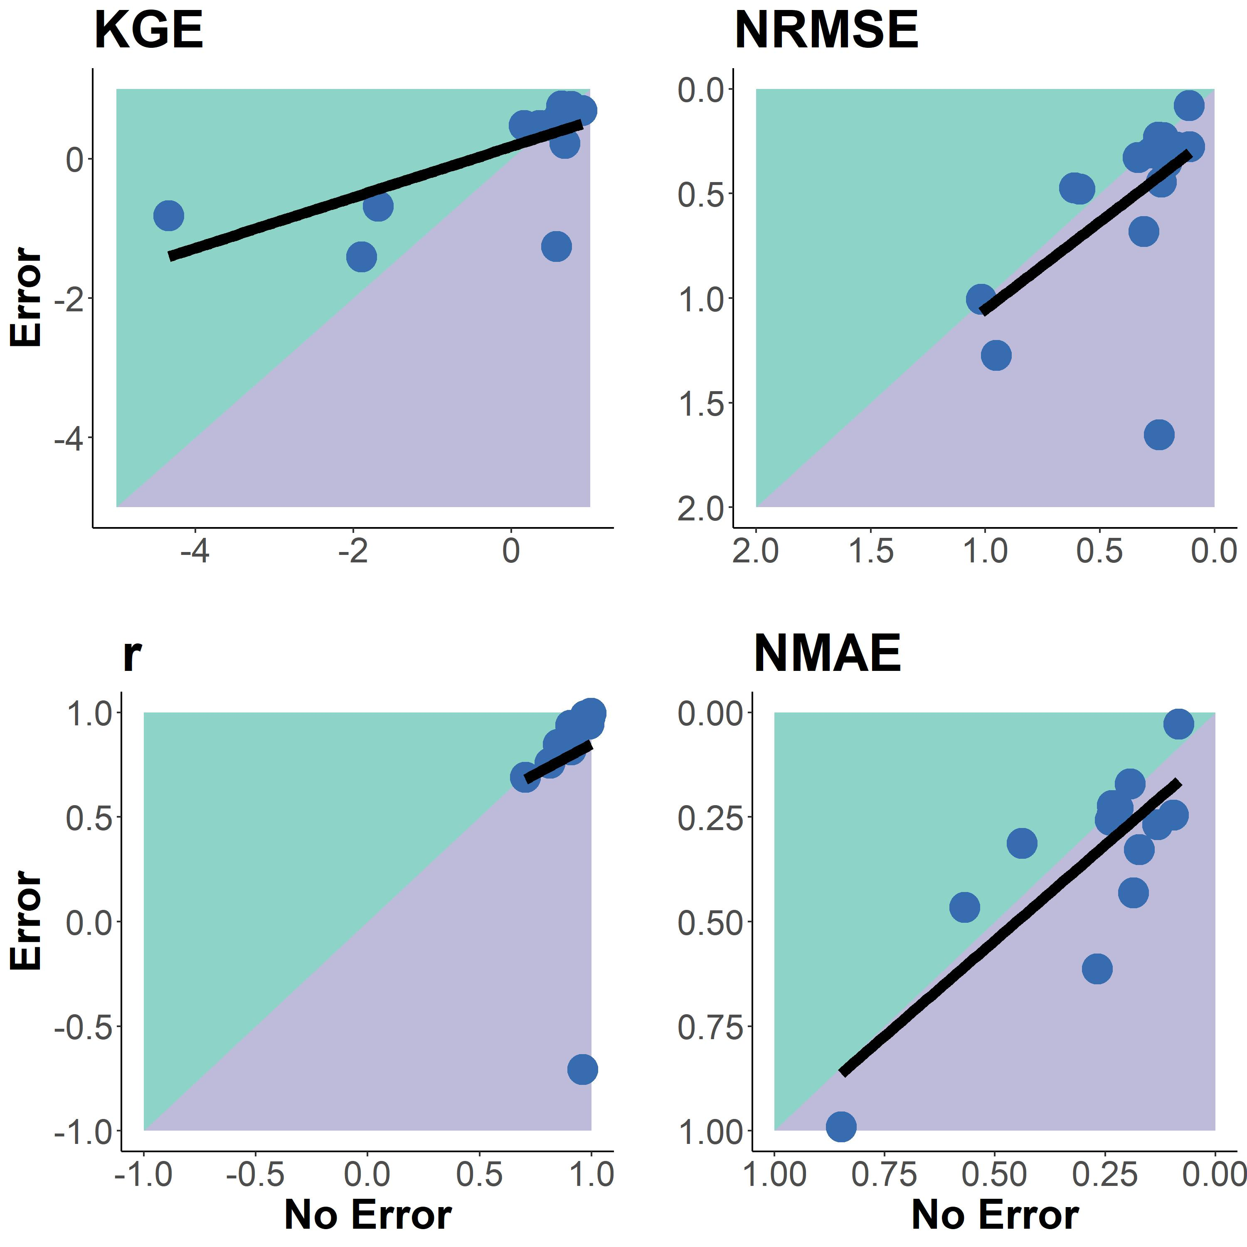

Figure 5: Comparison of BIKER performance when considering measurement error in the SWOT observations for 16 rivers. Each subpanel is labelled by its performance metric (Table 1). Rivers that fall within the purple zone get worse when accounting for measurement error, while rivers in the green get better. Note that some axes are flipped in order to visualize all ‘better performances’ in the upper-right-corner of each sub-plot. Black line denotes linear regression to aid in visualization.

Finally, we sought to explore the overall influence of prior error/bias on . We plot eCDFs of prior and posterior NMAE (see Table 1 for metric definition) across all 47 rivers in Figure 6a. Generally, errors/biases associated with the prior are propagated through the posterior in an approximately 1:1 manner (which is expected), except for a subset of rivers in which posterior error actually increases relative to the prior (approximately percentiles 0.6-0.9). We explore why this happens below.

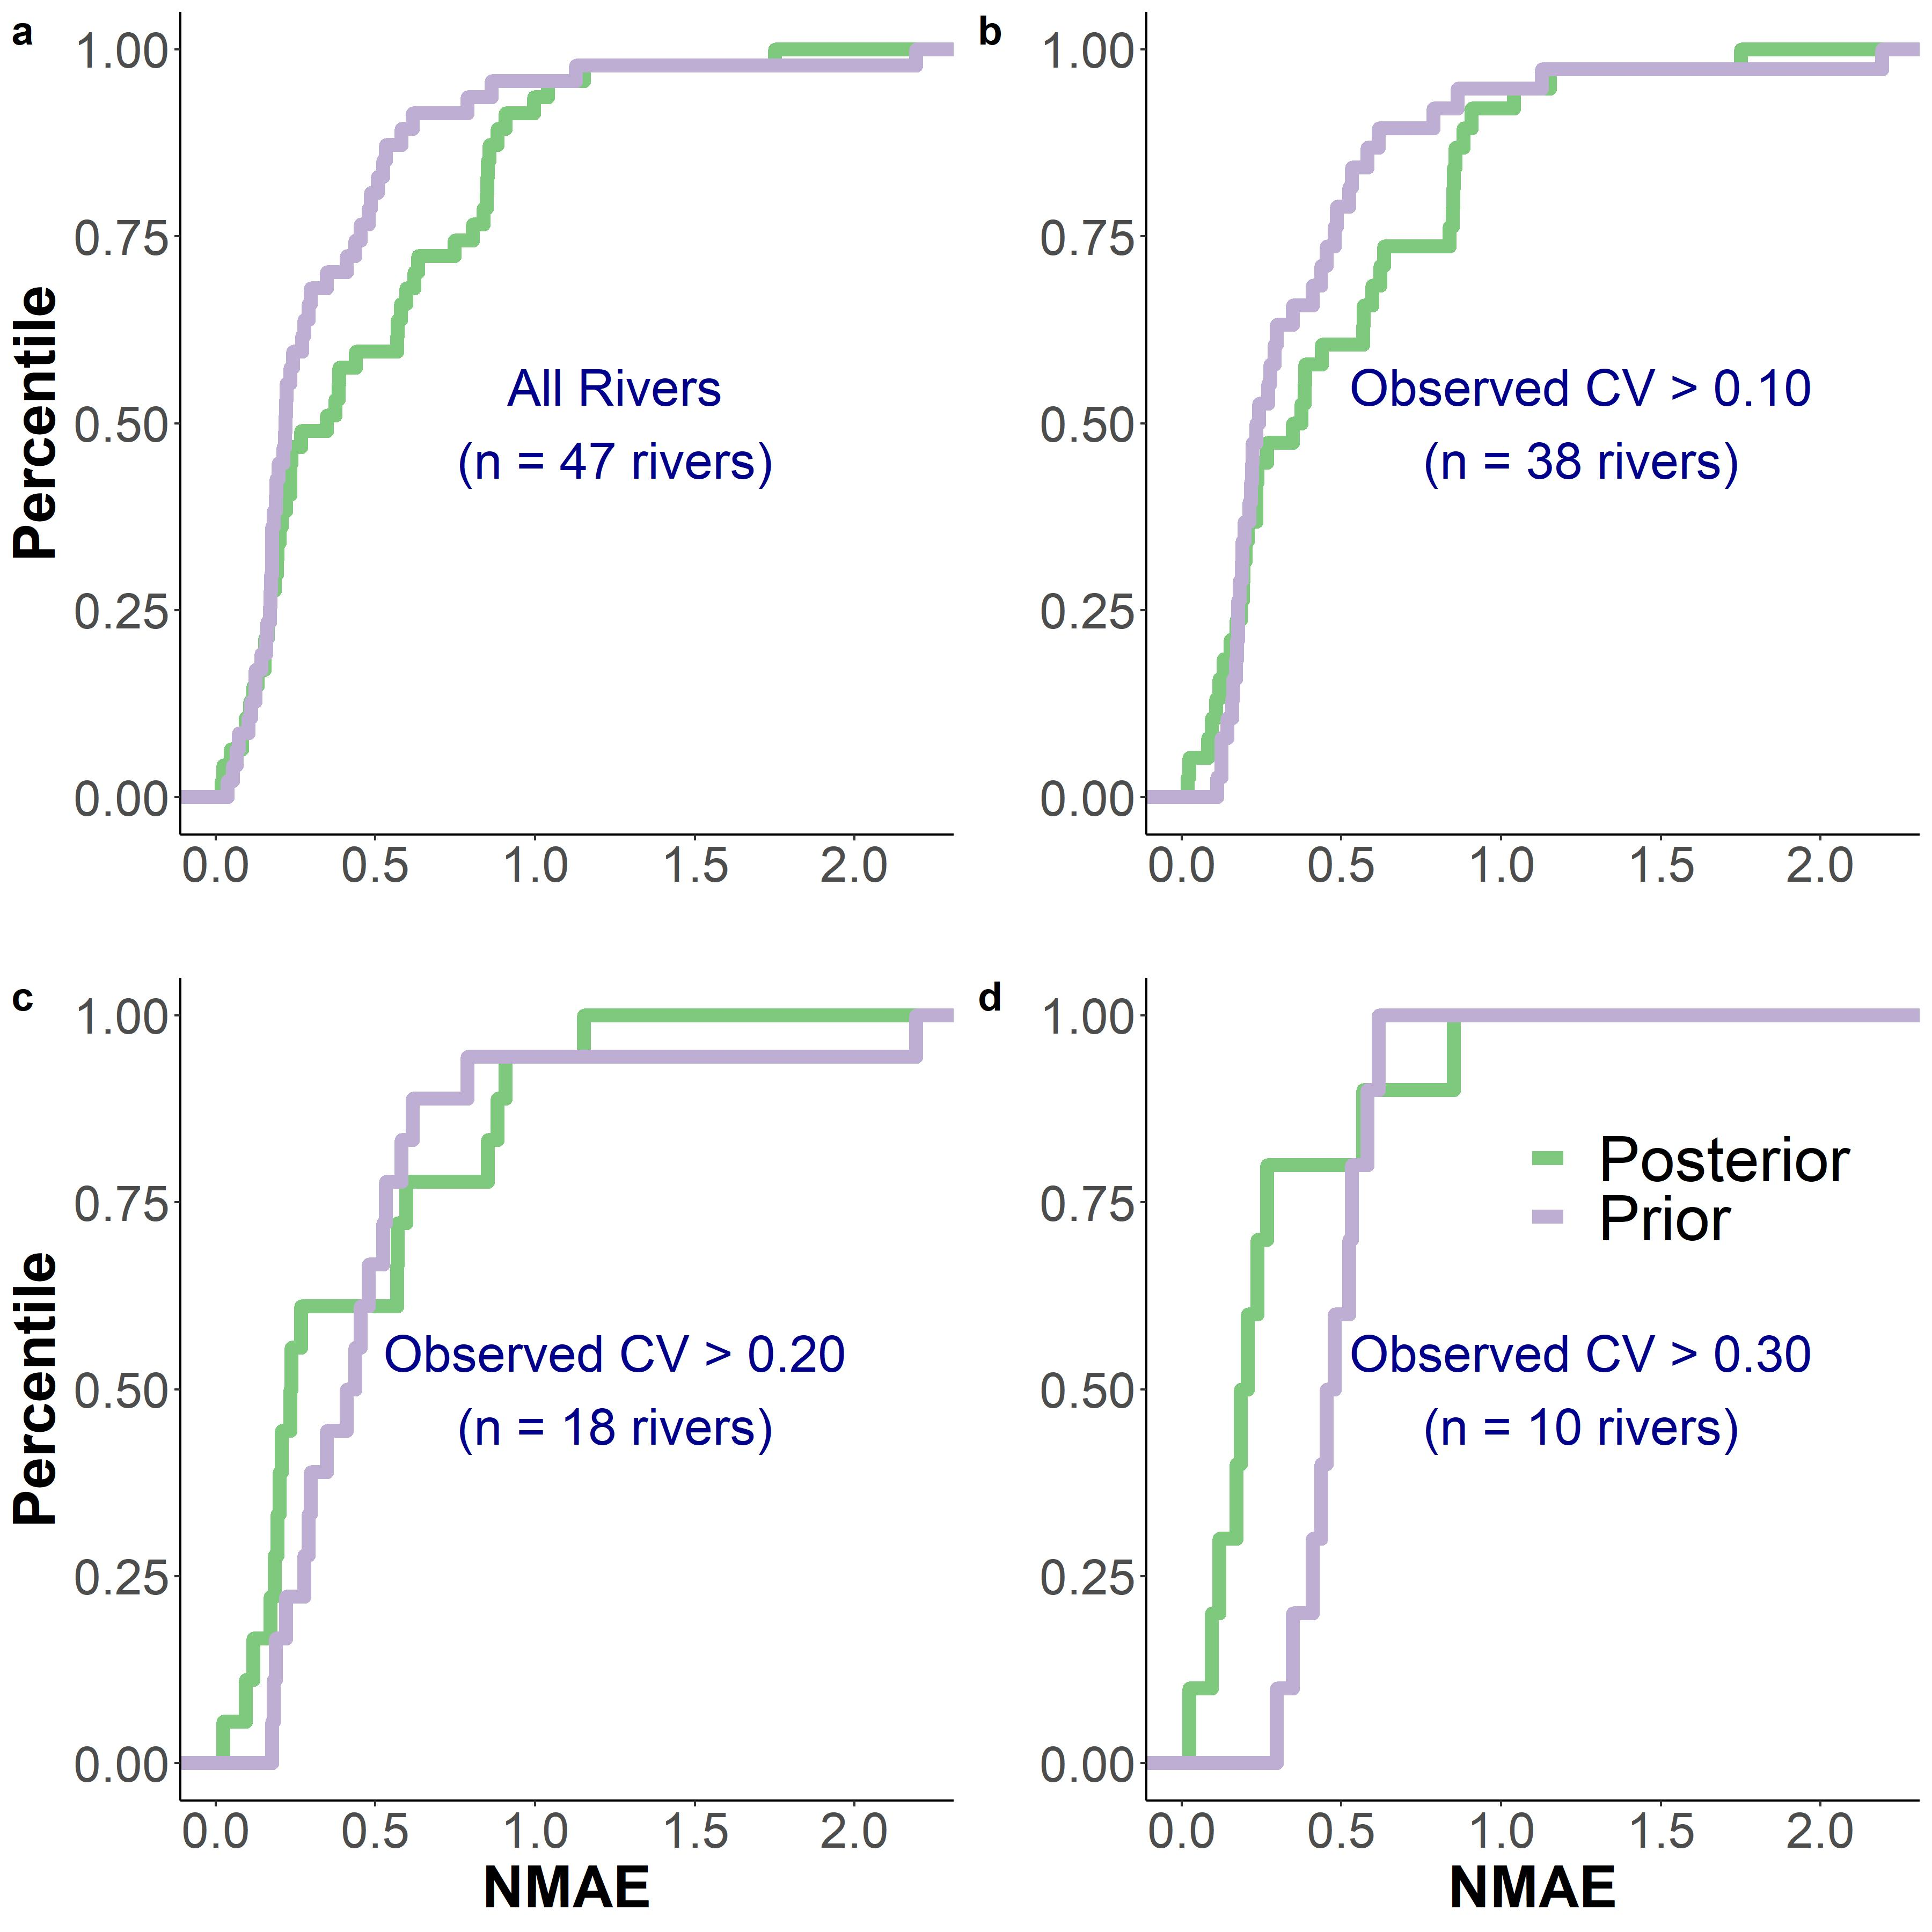

Figure 6: Empirical cummulative density functions for prior and posterior NMAE. See Table 1 for metric definition. a) all rivers. b) Only rivers with a coefficient of varaiton (CV) of observed > 0.10. c) Only rivers with CV > 0.20. d) Only rivers with CV > 0.30. Overall we see that rivers with greater temporal variation in behave better for BIKER, i.e. Bayesian inference reduces bias from prior to posterior.

Recall that BIKER relies on a timeseries of SWOT data, and that these timeseries may not be representative of the full spectrum of values that are actually experienced in the river, therefore potentially biasing both the prior estimation methods (Text S3) and the actual Bayesian inference. Put another way, we suggest that if a SWOT timeseries does not sufficiently capture a river’s temporal dynamics, it will introduce additional error to the inference results. To test this, we subset our validation dataset by progressively higher coefficients of variation (*CV*) (> 10%, >20%, and >30%). These filtered datasets are plotted in Figures 6b-6d (for > 10%, >20%, and >30% *CV*, respectively), where our hypothesis is confirmed. Posterior bias drops once the temporal variability of the SWOT data is sufficiently high, with BIKER posterior error the smallest, and much less than prior error, in Figure 6d. This result is elaborated on in Section 4.2.

#### 3.3.2 Carbon Emissions

Finally, we carry these calculations all the way to annual carbon emissions rates and compare BIKER against established in situ techniques. It is important to remember that only BIKER is completely globally implementable, while the other three models necessarily rely on having a streamflow record or high-quality routed streamflow readily available. Therefore, the in situ methods reflect their ‘best-case scenarios’ while BIKER reflects its worst case scenario, where priors are set entirely from SWOT observations and are generally the least informative they will ever be. This means that BIKER’s annual carbon emission estimate can only improve from what is presented here. We also stress again that the raw emissions rates here are largely meaningless as they are calculated from an identical timeseries applied to every river. We are principally interested in relative differences between techniques employed.

Figure 7 compares the annual carbon emissions rate (via ) from the rivers using BIKER posterior means and the three stream gauge-based HG models. Surprisingly, BIKER outperforms the gauge-based approaches, nearly correctly inferring the annual carbon emissions rate (9.8 Tg-C/yr for BIKER versus 9.35 Tg-C/yr observed). The three HG models overestimate this emissions rate: 14.8, 11.71, and 15.28 for ‘Raymond 2013’, ‘Raymond 2012’, and ‘Brinkerhoff 2019’ respectively. ‘Raymond 2012’ falls within the BIKER CIs and is reasonably close to the observed value, while ‘Raymond 2013’ overestimates the emission rate. ‘Brinkerhoff 2019’’s lower CI is comparable to BIKER’s higher CI. BIKER’s relatively stronger performance than the in situ models is elaborated on in Section 4.3. Finally, BIKER’s uncertainity is on par with the in situ technique, despite being obtained solely from SWOT data. Taken in aggregate, BIKER provides a strong upscaling estimate of the annual carbon emission rate for the rivers and is either comparable or better than established in situ techniques (Figure 7).

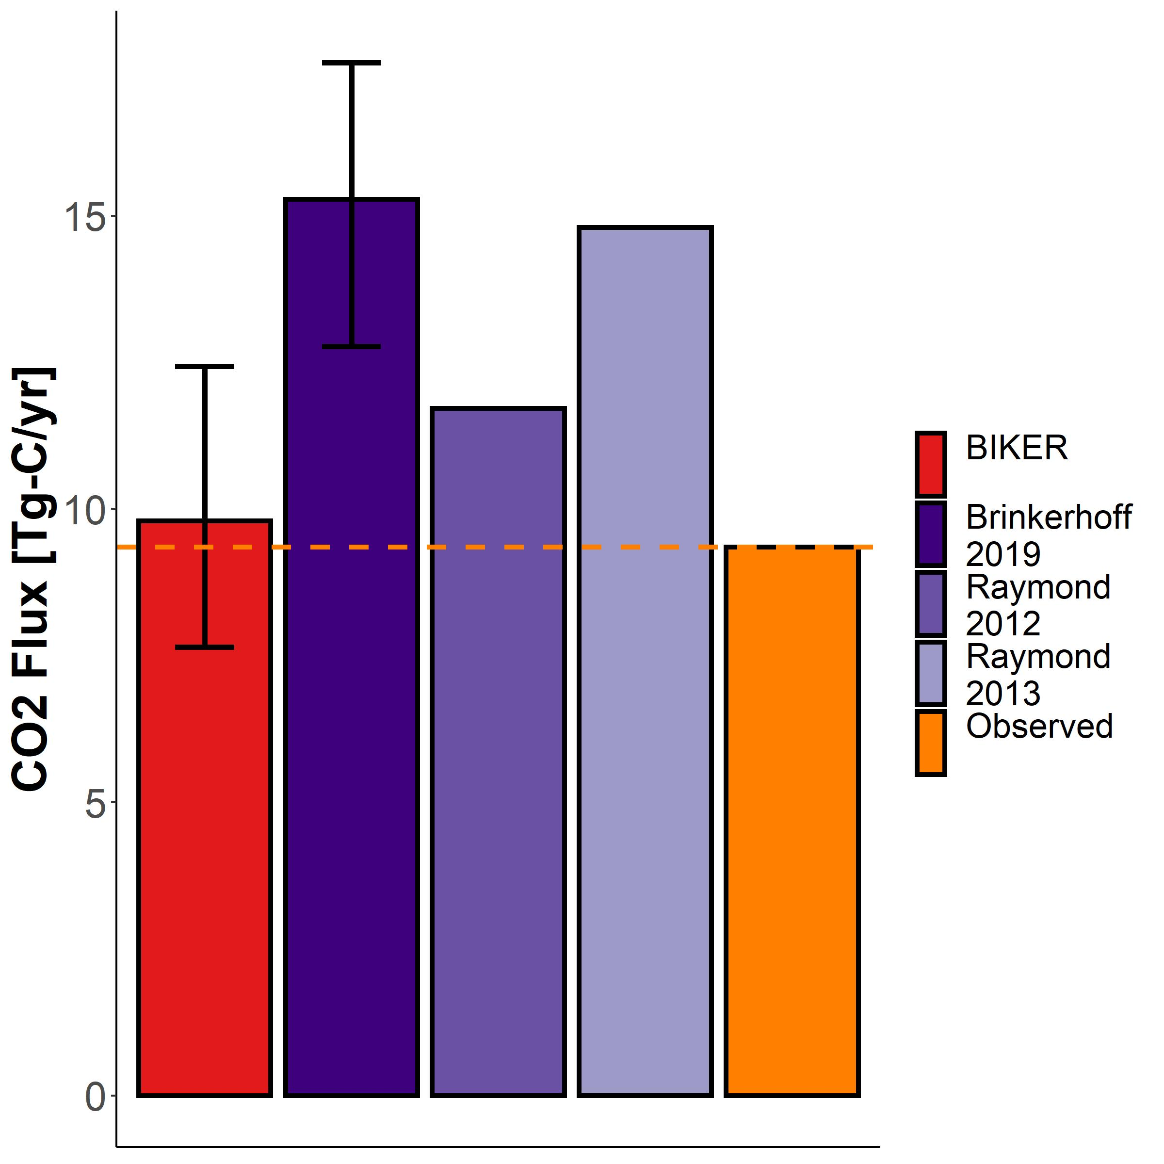

Figure 7: Yearly carbon emissions rate via evasion across all rivers. Completely remotely-sensed methods are colored in red, in situ methods in purple, and the observed in orange. Note that confidence intervals were not calculated for the remaining two models because their uncertainties are not available.

## 4 Discussion

### 4.1 Gas exchange in hydraulically-wide rivers

Field studies of gas exchange in wide rivers have suggested that behaves differently in these rivers than in steeper and smaller rivers (Alin et al., 2011; Beaulieu et al., 2012; Raymond & Cole, 2001; Ulseth et al., 2019; Wang et al., 2021). While much work has focused on the small-stream side of the stream-to-river continuum, comparatively less work has been done in large systems. Here, we focus on the larger, ‘smooth-channel’ end of the continuum, using a model for gas exchange that scales by both and a shear Reynold’s number. This model is empirically validated in Figure 2. Specifically, Figure S1 confirms that scaling with a shear Reynold’s adaption of the small-eddy model (Equation 7) improves the model’s predictions of the smallest values (where the relative decrease in turbulence reaching the surface is greater than the small-eddy model alone suggests, per Equation 7’s theoretical basis- Moog & Jirka, 1999a). Scaling via a shear Reynold’s number is often done to parameterize breaking-wave gas exchange models in the open ocean (Brumer et al., 2017; Zhao et al., 2003; Zhao & Toba, 2001), though this is specific to high wind speeds in open ocean. To our knowledge, Moog & Jirka (1999a)’s specific setup, which imposes a space-and-time varying, fractional area surface turbulence theory on the small-eddy model, has never been empirically validated in rivers. Figure 2 provides this empirical verification for hydraulically wide channels, where it’s theoretical basis should generally hold. Using our full dataset of , we also observed this model breaks down when including non-hydraulically-wide rivers (as the theory would suggest). Future tests should also explore other shear Reynold’s scaling relations for gas exchange in rivers.

Crucially, we are not accounting for wind-driven gas exchange, which is suggested to play an important role in wide rivers because river surface area is sufficiently large that sheltering no longer limits the influence of wind-derived turbulence (Beaulieu et al., 2012; Raymond & Cole, 2001; Wang et al., 2021). None of the existing hydraulics-driven fluvial models account for wind-driven gas exchange either. Additionally, under higher-wind scenarios the turbulent regime will switch from hydraulically-driven to wind-driven turbulence (Zappa et al., 2007) and the assumptions under-pinning BIKER will likely break down. BIKER’s outputs can therefore be interpreted as the ‘ under low-wind conditions’, when surface turbulence is dominated by hydraulics rather than wind. That said, BIKER’s flexible implementation is a good start towards eventually coupling hydraulics-driven gas exchange with wind-driven gas exchange under these moderate-to-high wind scenarios. This is left to future work.

### 4.2 Towards remote sensing of global spatiotemporal dynamics of in large rivers

To date, the studies exploring the spatiotemporal dynamics of riverine gas exchange have arguably been held back by a lack of data. A few studies have investigated these dynamics, but they have been limited to individual rivers and/or limited field seasons (Hall et al., 2012; Sand-Jensen & Staehr, 2012). For example, Wallin et al. (2011) performed a preliminary analysis in northern Sweden relating cross-section specific temporal variability in gas exchange with channel slope, but they were limited to a mean of only 8 measurements per river in a single watershed. While this is a good start, this is insufficient for further developing process-level understandings of gas exchange at the global-scale.

Therefore, inferring from SWOT data is an attractive option to address this problem of limited data. For reference, 95% of the SWOT-visible rivers globally (202,811) will have sufficient SWOT observations along the river to run BIKER at least once every 21 days, with most of the temperate and Arctic rivers having 3+ observations per 21-day cycle (Altenau et al., 2021). While BIKER will not directly measure , it does robustly infer temporal trends in and reasonably infers the absolute magnitude of (Figures 4-6). This much data will provide a novel dataset of on a scale never before possible.

With that said, Figures 4, 5, S4, and S5 all highlight a substantial range of BIKER performance across rivers. These differences in performance are likely due to the representativeness of the priors used for that river. This makes sense as Section 2 has effectively reduced to a function of hydraulics that are nearly all directly measurable by SWOT. Any resulting bias in BIKER’s predictions is likely attributable to either bias in the priors used for the non-remotely sensed terms (Equations 9-10) or in the model itself (Equation 7, including the aforementioned wind errors). For SWOT discharge algorithms, authors have repeatedly shown that the ‘quality’ of prior river knowledge plays a large role in the success of discharge inversions (Andreadis et al., 2020; Brinkerhoff et al., 2020; Frasson et al., 2021; Tuozzolo et al., 2019) and our results here further corroborate this finding.

Furthermore, Figure 6 implies that a sufficient variability in SWOT observations is necessary to strongly infer a timeseries. ‘Hydraulic visibility’, i.e. the ability of a remote sensor to identify a hydrological response in the river (P.-A. Garambois et al., 2017) is applicable here. If we apply hydraulic visibility to a sensor’s ability to identify temporal variations in , Figure 6 suggests that a ‘minimally sufficient’ hydraulic variability in SWOT measurements (in Figure 6b, suggested to be approximately >20% *CV*) is needed to improve upon the prior. This will be important once SWOT launches and BIKER is implemented at the global-scale.

### 4.3 Coupling BIKER with upscaling workflows

Figure 7 confirms that BIKER is quite successful at predicting annual upscaled carbon emissions from the river network when coupled with data. This encouraging result has three main implications for future work.

First, Figure 7 directly implies that BIKER will be useful when coupled with large-scale models, provided these models are accurate. The models would give time and space varying gas exchange. Liu et al. (2022) and Saccardi & Winnick (2021) each propose models that robustly predict reach-scale dissolved concentrations using two different approaches Saccardi & Winnick (2021), but both models yield estimates that would be spatially and temporally consistent with BIKER’s output. Our promising results suggest that BIKER could provide additional (and directly inferred) measurements of to these models, thereby better informing model results through direct observations. This is likely to be accomplished via data assimilation which has proven useful in using remotly-sensed discharge to improve streamflow routing models (Feng et al., 2021; Ishitsuka et al., 2020), and of which the Saccardi & Winnick (2021) model takes a similar form.

Second, at the field-scale Figure 7 confirms that we can couple BIKER with in situ gas concentration loggers to produce estimates at novel temporal resolutions in SWOT-observable rivers. High temporal fidelity datasets of dissolved in SWOT-observable rivers now exist (e.g. Aho, Hosen, et al., 2021) but no such similar datasets for at equivalent temporal resolutions exist. For rivers unobservable by SWOT, we further suggest that BIKER could be run at the field scale (rather than via satellite-based altimeters like SWOT) using arrays of in situ pressure transducers to estimate water surface slope following recent similar work for estimating streamflow (Harlan et al., 2021). Regardless, both approaches would produce and datasets at equivalent temporal resolution and allow us to directly calculate daily to sub-daily fluxes from river reaches.

Finally, Figure 7 also uniquely allows us to directly compare the influence of geomorphic assumptions on total carbon emission rates from river networks, as all other calculations and parameters were held constant across our four tested models (Text S5). Therefore, Figure 7 highlights a potentially large source of uncertainty in current river upscaling estimates: the geomorphic models employed to scale river channel hydraulics with streamflow. In this case, the only difference between the three literature models and the observed estimate in Figure 7 is the specific HG model employed to predict river depth and velocity (Text S5, Table S2), and yet the eventual carbon emissions estimates (Figure 7) are quite different. Further, recall that the BIKER results in Figure 7 reflect a worst-case scenario (relatively uniformed priors), while the three in-situ methods represent best case scenarios (perfect streamflow records). We suggest future work should perform a formal sensitivity analysis for these HG parameters.

## 5 Conclusions

The flux from the global river network is a major natural component of the global carbon cycle, on par with total forest carbon uptake (Pan et al., 2011). Despite much interest and progress, there is still large uncertainty in the temporal dynamics of gas exchange and thus carbon emissions to the atmosphere. Much of this uncertainty stems from uncertainty in at the global scale. In this paper, we propose that the soon-to-launch SWOT satellite will provide enough hydraulic measurements to analyse the temporal dynamics of , and therefore allow for a global-scale analysis of spatiotemporal trends in large-river once SWOT launches. In that context, we developed 1) a hydraulic model for that is nearly entirely SWOT observable and explains 70% of variation in , and 2) the BIKER algorithm to infer using no on-the-ground information. Validating on 47 SWOT-simulated rivers, we show strong recovery of rivers’ temporal dynamics and a hypothetical total annual carbon emission rate across all 47 rivers. These results suggest BIKER can be used to infer global-scale, near daily estimates of fluvial gas exchange velocity once SWOT launches in late 2022. This in turn will be useful in mapping the global-scale spatiotemporal dynamics of fluvial gas exchange in large rivers.

## 6 Acknowledgements

C.B. Brinkerhoff was funded by a NASA Future Investigators in Earth and Space Science Fellowship (80NSSC21K1591). C.J. Gleason was supported by a NASA SWOT Science Team grant (80NSSC20K1141). We thank Renato Frasson, Michael Durand, Amber Ulseth, and Jake Beaulieu for generously making their data available for this study. We also thank the entire SWOT discharge working group for their decade-plus body of work which inspired this study.

## 7 Data availability statement

Datasets required for this research are available from Ulseth et al. (2019) (<https://doi.org/10.1038/s41561-019-0324-8>), Brinkerhoff et al. (2019) (<https://doi.org/10.1029/2019GL084529>), Frasson et al. (2021) (<https://zenodo.org/record/3817817>), Churchill et al. (1964) (<https://pubs.usgs.gov/pp/0737/report.pdf>), Owens et al. (1964) (<https://pubs.usgs.gov/pp/0737/report.pdf>), Beaulieu et al. (2012) (<https://doi.org/10.1029/2011JG001794>), and Durand et al. (2016) (<https://doi.org/10.1002/2015WR018434>). All code to build and generate results and figures is archived at <https://zenodo.org/record/6416069>.

## 8 Software availability statement

The BIKER algorithm remains in active development and is available at <https://github.com/craigbrinkerhoff/BIKER>. The specific version of BIKER used in this study is archived at <https://zenodo.org/record/6415434>.

## 9 Apendix A

*Table A1: Variable description and notation for this study*

| **Notation** | **Description** | **Calculation (if not directly measured)** | **Units** |
| --- | --- | --- | --- |
|  | Channel cross-sectional area |  |  |
|  | Non-SWOT-observable cross-sectional area |  |  |
|  | Active zone fraction (Moog & Jirka 1999) | (Moog & Jirka 1999) |  |
|  | Statistical parameter for Equation S5 scaling relation |  |  |
|  | Statistical parameter for Equation S7 scaling relation |  |  |
|  | Statistical parameter for Equation S13 scaling relation |  |  |
|  | Statistical parameter for Equation 7 scaling relation |  |  |
|  | Water-side concentration |  |  |
|  | Atmospheric-side concentration |  |  |
|  | change in cross-sectional area |  |  |
|  | Molecular diffusion coefficient |  |  |
|  | Dissipation rate of near-surface turbulence |  |  |
|  | log-law-of-the-wall model for |  |  |
|  | Form-drag model for |  |  |
|  | evasion flux from river to atmosphere |  |  |
|  | Upscaling estimate of the global evasion flux from river to atmosphere |  |  |
|  | gravitational acceleration | 9.8 |  |
|  | Mean flow depth |  |  |
|  | Water surface elevation |  |  |
|  | Cross-section discretization within a mass-conserved river reach |  |  |
|  | gas exchange velocity |  |  |
|  | gas exchange velocity normalized to |  |  |
|  | Manning’s roughness coefficient |  |  |
|  | Density of water |  |  |
|  | River discharge |  |  |
|  | Hydraulic radius |  |  |
|  | Shear Reynold’s numbers |  |  |
|  | River slope |  |  |
|  | Schmidt number |  |  |
|  | timestep discretization within river reach |  |  |
|  | Bayesian parameter set |  |  |
|  | Cross-sectional average velocity |  |  |
|  | Shear velocity |  |  |
|  | Viscosity |  |  |
|  | kinematic viscosity |  |  |
|  | Flow width |  |  |
|  | Bayesian data set |  |  |

## References

Aho, K. S., & Raymond, P. A. (2019). Differential Response of Greenhouse Gas Evasion to Storms in Forested and Wetland Streams. *Journal of Geophysical Research: Biogeosciences*, *124*(3), 649–662. <https://doi.org/10.1029/2018JG004750>

Aho, K. S., Fair, J. H., Hosen, J. D., Kyzivat, E. D., Logozzo, L. A., Rocher-Ros, G., et al. (2021). Distinct concentration-discharge dynamics in temperate streams and rivers: CO2 exhibits chemostasis while CH4 exhibits source limitation due to temperature control. *Limnology and Oceanography*, *66*(10), 3656–3668. <https://doi.org/10.1002/lno.11906>

Aho, K. S., Hosen, J. D., Logozzo, L. A., McGillis, W. R., & Raymond, P. A. (2021). Highest rates of gross primary productivity maintained despite CO2 depletion in a temperate river network. *Limnology and Oceanography Letters*, *n/a*(n/a). https://doi.org/<https://doi.org/10.1002/lol2.10195>

Alin, S. R., Rasera, M. de F. F. L., Salimon, C. I., Richey, J. E., Holtgrieve, G. W., Krusche, A. V., & Snidvongs, A. (2011). Physical controls on carbon dioxide transfer velocity and flux in low-gradient river systems and implications for regional carbon budgets. *Journal of Geophysical Research: Biogeosciences*, *116*(G1). https://doi.org/<https://doi.org/10.1029/2010JG001398>

Altenau, E. H., Pavelsky, T. M., Durand, M. T., Yang, X., Frasson, R. P. de M., & Bendezu, L. (2021). The Surface Water and Ocean Topography (SWOT) Mission River Database (SWORD): A Global River Network for Satellite Data Products. *Water Resources Research*, *57*(7), e2021WR030054. <https://doi.org/10.1029/2021WR030054>

Andreadis, K. M., Brinkerhoff, C. B., & Gleason, C. J. (2020). Constraining the assimilation of SWOT observations with hydraulic geometry relations. *Water Resources Research*. <https://doi.org/10.1029/2019WR026611>

Appling, A. P., Hall, R. O., Yackulic, C. B., & Arroita, M. (2018). Overcoming Equifinality: Leveraging Long Time Series for Stream Metabolism Estimation. *Journal of Geophysical Research: Biogeosciences*, *123*(2), 624–645. https://doi.org/<https://doi.org/10.1002/2017JG004140>

Beaulieu, J. J., Shuster, W. D., & Rebholz, J. A. (2012). Controls on gas transfer velocities in a large river. *Journal of Geophysical Research: Biogeosciences*, *117*(G2). <https://doi.org/10.1029/2011JG001794>

Biancamaria, S., Lettenmaier, D. P., & Pavelsky, T. M. (2016). The SWOT Mission and Its Capabilities for Land Hydrology. In A. Cazenave, N. Champollion, J. Benveniste, & J. Chen (Eds.), *Remote Sensing and Water Resources* (pp. 117–147). Cham: Springer International Publishing. <https://doi.org/10.1007/978-3-319-32449-4_6>

Borges, A. V., Darchambeau, F., Teodoru, C. R., Marwick, T. R., Tamooh, F., Geeraert, N., et al. (2015). Globally significant greenhouse-gas emissions from African inland waters. *Nature Geoscience*, *8*(8), 637–642. <https://doi.org/10.1038/ngeo2486>

Brinkerhoff, C. B., Gleason, C. J., & Ostendorf, D. W. (2019). Reconciling at-a-Station and at-Many-Stations Hydraulic Geometry Through River-Wide Geomorphology. *Geophysical Research Letters*, *46*(16), 9637–9647. <https://doi.org/10.1029/2019GL084529>

Brinkerhoff, C. B., Gleason, C. J., Feng, D., & Lin, P. (2020). Constraining Remote River Discharge Estimation Using Reach-Scale Geomorphology. *Water Resources Research*, *56*(11), e2020WR027949. https://doi.org/<https://doi.org/10.1029/2020WR027949>

Brinkerhoff, C. B., Raymond, P. A., Maavara, T., Ishitsuka, Y., Aho, K. S., & Gleason, C. J. (2021). Lake Morphometry and River Network Controls on Evasion of Terrestrially Sourced Headwater CO2. *Geophysical Research Letters*, *48*(1), e2020GL090068. https://doi.org/<https://doi.org/10.1029/2020GL090068>

Brisset, P., Monnier, J., Garambois, P.-A., & Roux, H. (2018). On the assimilation of altimetric data in 1D Saint–Venant river flow models. *Advances in Water Resources*, *119*, 41–59. <https://doi.org/10.1016/j.advwatres.2018.06.004>

Brumer, S. E., Zappa, C. J., Blomquist, B. W., Fairall, C. W., Cifuentes-Lorenzen, A., Edson, J. B., et al. (2017). Wave-Related Reynolds Number Parameterizations of CO2 and DMS Transfer Velocities. *Geophysical Research Letters*, *44*(19), 9865–9875. <https://doi.org/10.1002/2017GL074979>

Calderbank, P. H., & Moo-Young, M. B. (1961). The continuous phase heat and mass-transfer properties of dispersions. *Chemical Engineering Science*, *16*(1), 39–54. <https://doi.org/10.1016/0009-2509(61)87005-X>

Churchill, M. A., Elmore, H. L., & Buckingham, R. A. (1964). The Prediction of Stream Reaeration Rates. In B. A. Southgate (Ed.), *Advances in Water Pollution Research* (pp. 89–136). Pergamon. <https://doi.org/10.1016/B978-1-4832-8391-3.50015-4>

Cole, J. J., Prairie, Y. T., Caraco, N. F., McDowell, W. H., Tranvik, L. J., Striegl, R. G., et al. (2007). Plumbing the Global Carbon Cycle: Integrating Inland Waters into the Terrestrial Carbon Budget. *Ecosystems*, *10*(1), 172–185. <https://doi.org/10.1007/s10021-006-9013-8>

Crawford, J. T., Stanley, E. H., Dornblaser, M. M., & Striegl, R. G. (2017). CO2 time series patterns in contrasting headwater streams of North America. *Aquatic Sciences*, *79*(3), 473–486. <https://doi.org/10.1007/s00027-016-0511-2>

Durand, M. T., Neal, J., Rodríguez, E., Andreadis, K. M., Smith, L. C., & Yoon, Y. (2014). Estimating reach-averaged discharge for the River Severn from measurements of river water surface elevation and slope. *Journal of Hydrology*, *511*, 92–104. <https://doi.org/10.1016/j.jhydrol.2013.12.050>

Durand, M. T., Gleason, C. J., Garambois, P. A., Bjerklie, D., Smith, L. C., Roux, H., et al. (2016). An intercomparison of remote sensing river discharge estimation algorithms from measurements of river height, width, and slope. *Water Resources Research*, *52*(6), 4527–4549. <https://doi.org/10.1002/2015WR018434>

Durand, M. T., Chen, C., Moraes Frasson, R. P. de, Pavelsky, T. M., Williams, B., Yang, X., & Fore, A. (2020). How will radar layover impact SWOT measurements of water surface elevation and slope, and estimates of river discharge? *Remote Sensing of Environment*, *247*, 111883. <https://doi.org/10.1016/j.rse.2020.111883>

Feng, D., Gleason, C. J., Lin, P., Yang, X., Pan, M., & Ishitsuka, Y. (2021). Recent changes to Arctic river discharge. *Nature Communications*, *12*(1), 6917. <https://doi.org/10.1038/s41467-021-27228-1>

Frasson, R. P. de M., Durand, M. T., Larnier, K., Gleason, C., Andreadis, K. M., Hagemann, M., et al. (2021). Exploring the factors controlling the error characteristics of the Surface Water and Ocean Topography mission discharge estimates. *Water Resources Research*, *n/a*(n/a), e2020WR028519. https://doi.org/<https://doi.org/10.1029/2020WR028519>

Garambois, P.-A., & Monnier, J. (2015). Inference of effective river properties from remotely sensed observations of water surface. *Advances in Water Resources*, *79*, 103–120. <https://doi.org/10.1016/j.advwatres.2015.02.007>

Garambois, P.-A., Calmant, S., Roux, H., Paris, A., Monnier, J., Finaud-Guyot, P., et al. (2017). Hydraulic visibility: Using satellite altimetry to parameterize a hydraulic model of an ungauged reach of a braided river. *Hydrological Processes*, *31*(4), 756–767. <https://doi.org/10.1002/hyp.11033>

Garambois, P.-A., Larnier, K., Monnier, J., Finaud-Guyot, P., Verley, J., Montazem, A.-S., & Calmant, S. (2020). Variational estimation of effective channel and ungauged anabranching river discharge from multi-satellite water heights of different spatial sparsity. *Journal of Hydrology*, *581*, 124409. <https://doi.org/10.1016/j.jhydrol.2019.124409>

Gleason, C. J. (2015). Hydraulic geometry of natural rivers: A review and future directions. *Progress in Physical Geography: Earth and Environment*, *39*(3), 337–360. <https://doi.org/10.1177/0309133314567584>

Gleason, C. J., & Smith, L. C. (2014). Toward global mapping of river discharge using satellite images and at-many-stations hydraulic geometry. *Proceedings of the National Academy of Sciences*, *111*(13), 4788–4791. <https://doi.org/10.1073/pnas.1317606111>

Gleason, C. J., Smith, L. C., & Lee, J. (2014). Retrieval of river discharge solely from satellite imagery and at-many-stations hydraulic geometry: Sensitivity to river form and optimization parameters. *Water Resources Research*, *50*(12), 9604–9619. <https://doi.org/10.1002/2014WR016109>

Gleason, C. J., Garambois, P.-A., & Durand, M. T. (2017). Tracking River Flows from Space. *Eos*. <https://doi.org/10.1029/2017EO078085>

Gruber, N., Clement, D., Carter, B. R., Feely, R. A., Heuven, S. van, Hoppema, M., et al. (2019). The oceanic sink for anthropogenic CO2 from 1994 to 2007. *Science*, *363*(6432), 1193–1199. <https://doi.org/10.1126/science.aau5153>

Hagemann, M. W., Gleason, C. J., & Durand, M. T. (2017). BAM: Bayesian AMHG-Manning Inference of Discharge Using Remotely Sensed Stream Width, Slope, and Height. *Water Resources Research*, *53*(11), 9692–9707. <https://doi.org/10.1002/2017WR021626>

Hall, R. O., & Ulseth, A. J. (2020). Gas exchange in streams and rivers. *WIREs Water*, *7*(1), e1391. https://doi.org/<https://doi.org/10.1002/wat2.1391>

Hall, R. O., Kennedy, T. A., & Rosi‐Marshall, E. J. (2012). Air–water oxygen exchange in a large whitewater river. *Limnology and Oceanography: Fluids and Environments*, *2*(1), 1–11. https://doi.org/<https://doi.org/10.1215/21573689-1572535>

Harlan, M. E., Gleason, C. J., Altenau, E. H., Butman, D., Carter, T., Chu, V. W., et al. (2021). Discharge Estimation from Dense Arrays of Pressure Transducers. *Water Resources Research*, *n/a*(n/a), e2020WR028714. https://doi.org/<https://doi.org/10.1029/2020WR028714>

Hoff, P. D. (2009). *A First Course in Bayesian Statistical Methods*. New York: Springer.

Horgby, Å., Segatto, P. L., Bertuzzo, E., Lauerwald, R., Lehner, B., Ulseth, A. J., et al. (2019). Unexpected large evasion fluxes of carbon dioxide from turbulent streams draining the world’s mountains. *Nature Communications*, *10*(1). <https://doi.org/10.1038/s41467-019-12905-z>

Ishitsuka, Y., Gleason, C. J., Hagemann, M. W., Beighley, E., Allen, G. H., Feng, D., et al. (2020). Combining optical remote sensing, McFLI discharge estimation, global hydrologic modelling, and data assimilation to improve daily discharge estimates across an entire large watershed. *Water Resources Research*, *n/a*(n/a). https://doi.org/<https://doi.org/10.1029/2020WR027794>

Katul, G., Mammarella, I., Grönholm, T., & Vesala, T. (2018). A Structure Function Model Recovers the Many Formulations for Air-Water Gas Transfer Velocity. *Water Resources Research*, *54*(9), 5905–5920. https://doi.org/<https://doi.org/10.1029/2018WR022731>

Knoben, W. J. M., Freer, J. E., & Woods, R. A. (2019). Technical note: Inherent benchmark or not? Comparing Nash–Sutcliffe and Kling–Gupta efficiency scores. *Hydrology and Earth System Sciences*, *23*(10), 4323–4331. <https://doi.org/10.5194/hess-23-4323-2019>

Lamont, J. C., & Scott, D. S. (1970). An Eddy Cell Model of Mass Transfer into the Surface of a Turbulent Liquid. *AIChE Journal*, *16*(4), 513–519.

Larnier, K., Monnier, J., Garambois, P.-A., & Verley, J. (2020). River discharge and bathymetry estimation from SWOT altimetry measurements. *Inverse Problems in Science and Engineering*, *0*(0), 1–31. <https://doi.org/10.1080/17415977.2020.1803858>

Lauerwald, R., Laruelle, G. G., Hartmann, J., Ciais, P., & Regnier, P. A. G. (2015). Spatial patterns in CO2 evasion from the global river network. *Global Biogeochemical Cycles*, *29*(5), 534–554. <https://doi.org/10.1002/2014GB004941>

Leopold, L. B., & Maddock, T. (1953). *The Hydraulic Geometry of Stream Channels and Some Physiographic Implications*. U.S. Government Printing Office.

Liu, S., & Raymond, P. A. (2018). Hydrologic controls on pCO2 and CO2 efflux in US streams and rivers. *Limnology and Oceanography Letters*, *3*(6), 428–435. <https://doi.org/10.1002/lol2.10095>

Liu, S., Kuhn, C., Amatulli, G., Aho, K., Butman, D. E., Allen, G. H., et al. (2022). The importance of hydrology in routing terrestrial carbon to the atmosphere via global streams and rivers. *Proceedings of the National Academy of Sciences*, *119*(11), e2106322119. <https://doi.org/10.1073/pnas.2106322119>

Lorke, A., & Peeters, F. (2006). Toward a Unified Scaling Relation for Interfacial Fluxes. *Journal of Physical Oceanography*, *36*(5), 955–961. <https://doi.org/10.1175/JPO2903.1>

Moog, D. B., & Jirka, G. H. (1999a). Air-Water Gas Transfer in Uniform Channel Flow. *Journal of Hydraulic Engineering*, *125*(1), 3–10. <https://doi.org/10.1061/(ASCE)0733-9429(1999)125:1(3)>

Moog, D. B., & Jirka, G. H. (1999b). Stream Reaeration in Nonuniform Flow: Macroroughness Enhancement. *Journal of Hydraulic Engineering*, *125*(1), 6.

Oubanas, H., Gejadze, I., Malaterre, P.-O., Durand, M., Wei, R., Frasson, R. P. M., & Domeneghetti, A. (2018). Discharge Estimation in Ungauged Basins Through Variational Data Assimilation: The Potential of the SWOT Mission. *Water Resources Research*, *54*(3), 2405–2423. <https://doi.org/10.1002/2017WR021735>

Owens, M., Edwards, R. W., & Gibbs, J. W. (1964). Some reaeration studies in streams. *Inter. J. Air Water Poll.*, *8*, 469–486. Retrieved from <https://ci.nii.ac.jp/naid/10025707421/>

Pan, Y., Birdsey, R. A., Fang, J., Houghton, R., Kauppi, P. E., Kurz, W. A., et al. (2011). A Large and Persistent Carbon Sink in the World’s Forests. *Science*, *333*(6045), 988–993. <https://doi.org/10.1126/science.1201609>

Peter, H., Singer, G. A., Preiler, C., Chifflard, P., Steniczka, G., & Battin, T. J. (2014). Scales and drivers of temporal pCO2 dynamics in an Alpine stream. *Journal of Geophysical Research: Biogeosciences*, *119*(6), 1078–1091. https://doi.org/<https://doi.org/10.1002/2013JG002552>

Ran, L., Lu, X. X., & Liu, S. (2017). Dynamics of riverine CO2 in the Yangtze River fluvial network and their implications for carbon evasion. *Biogeosciences*, *14*, 2183–2198.

Raymond, P. A., & Cole, J. J. (2001). Gas Exchange in Rivers and Estuaries: Choosing a Gas Transfer Velocity. *Estuaries*, *24*(2), 312–317. <https://doi.org/10.2307/1352954>

Raymond, P. A., Bauer, J. E., & Cole, J. J. (2000). Atmospheric CO2 evasion, dissolved inorganic carbon production, and net heterotrophy in the York River estuary. *Limnology and Oceanography*, *45*(8), 1707–1717. https://doi.org/<https://doi.org/10.4319/lo.2000.45.8.1707>

Raymond, P. A., Zappa, C. J., Butman, D., Bott, T. L., Potter, J., Mulholland, P., et al. (2012). Scaling the gas transfer velocity and hydraulic geometry in streams and small rivers. *Limnology and Oceanography*, 41–53. <https://doi.org/10.1215/21573689-1597669@10.1002/(ISSN)1939-5590.MethaneVI>

Raymond, P. A., Hartmann, J., Lauerwald, R., Sobek, S., McDonald, C., Hoover, M., et al. (2013). Global carbon dioxide emissions from inland waters. *Nature*, *503*(7476), 355–359. <https://doi.org/10.1038/nature12760>

Rocher‐Ros, G., Sponseller, R. A., Lidberg, W., Mörth, C.-M., & Giesler, R. (2019). Landscape process domains drive patterns of CO2 evasion from river networks. *Limnology and Oceanography Letters*, *4*(4), 87–95. <https://doi.org/10.1002/lol2.10108>

Saccardi, B., & Winnick, M. (2021). Improving Predictions of Stream CO2 Concentrations and Fluxes Using a Stream Network Model: A Case Study in the East River Watershed, CO, USA. *Global Biogeochemical Cycles*, *35*(12), e2021GB006972. <https://doi.org/10.1029/2021GB006972>

Sand-Jensen, K., & Staehr, P. A. (2012). CO2 dynamics along Danish lowland streams: Water–air gradients, piston velocities and evasion rates. *Biogeochemistry*, *111*(1), 615–628. <https://doi.org/10.1007/s10533-011-9696-6>

Talke, S. A., Horner-Devine, A. R., Chickadel, C. C., & Jessup, A. T. (2013). Turbulent kinetic energy and coherent structures in a tidal river. *Journal of Geophysical Research: Oceans*, *118*(12), 6965–6981. <https://doi.org/10.1002/2012JC008103>

Tokoro, T., Kayanne, H., Watanabe, A., Nadaoka, K., Tamura, H., Nozaki, K., et al. (2008). High gas-transfer velocity in coastal regions with high energy-dissipation rates. *Journal of Geophysical Research: Oceans*, *113*(C11). <https://doi.org/10.1029/2007JC004528>

Tuozzolo, S., Lind, G., Overstreet, B., Mangano, J., Fonstad, M., Hagemann, M., et al. (2019). Estimating River Discharge With Swath Altimetry: A Proof of Concept Using AirSWOT Observations. *Geophysical Research Letters*, *46*(3), 1459–1466. <https://doi.org/10.1029/2018GL080771>

Ulseth, A. J., Hall, R. O., Boix Canadell, M., Madinger, H. L., Niayifar, A., & Battin, T. J. (2019). Distinct air–water gas exchange regimes in low- and high-energy streams. *Nature Geoscience*, *12*(4), 259–263. <https://doi.org/10.1038/s41561-019-0324-8>

Vachon, D., Prairie, Y. T., & Cole, J. J. (2010). The relationship between near-surface turbulence and gas transfer velocity in freshwater systems and its implications for floating chamber measurements of gas exchange. *Limnology and Oceanography*, *55*(4), 1723–1732. <https://doi.org/10.4319/lo.2010.55.4.1723>

Wallin, M. B., Öquist, M. G., Buffam, I., Billett, M. F., Nisell, J., & Bishop, K. H. (2011). Spatiotemporal variability of the gas transfer coefficient (KCO2) in boreal streams: Implications for large scale estimates of CO2 evasion. *Global Biogeochemical Cycles*, *25*(3). https://doi.org/<https://doi.org/10.1029/2010GB003975>

Wang, J., Bombardelli, F. A., & Dong, X. (2021). Physically Based Scaling Models to Predict Gas Transfer Velocity in Streams and Rivers. *Water Resources Research*, *57*(3), e2020WR028757. https://doi.org/<https://doi.org/10.1029/2020WR028757>

Zappa, C. J., Raymond, P. A., Terray, E. A., & McGillis, W. R. (2003). Variation in surface turbulence and the gas transfer velocity over a tidal cycle in a macro-tidal estuary. *Estuaries*, *26*(6), 1401–1415. <https://doi.org/10.1007/BF02803649>

Zappa, C. J., McGillis, W. R., Raymond, P. A., Edson, J. B., Hintsa, E. J., Zemmelink, H. J., et al. (2007). Environmental turbulent mixing controls on air-water gas exchange in marine and aquatic systems. *Geophysical Research Letters*, *34*(10). <https://doi.org/10.1029/2006GL028790>

Zhao, D., & Toba, Y. (2001). Dependence of Whitecap Coverage on Wind and Wind-Wave Properties. *Journal of Oceanography*, *57*(5), 603–616. <https://doi.org/10.1023/A:1021215904955>

Zhao, D., Toba, Y., Suzuki, Y., & Komori, S. (2003). Effect of wind waves on air’sea gas exchange: Proposal of an overall CO2 transfer velocity formula as a function of breaking-wave parameter. *Tellus B: Chemical and Physical Meteorology*, *55*(2), 478–487. <https://doi.org/10.3402/tellusb.v55i2.16747>