Potential for remotely sensing riverine gas exchange and carbon efflux from SWOT observations

CB Brinkerhoff, CJ Gleason, PA Raymond, MH Harlan xxx anyone else on pete’s end?xxx

affiliations

2021-02-24

## Highlights (3-5 points, 85 characters each w/ spaces)

* The SWOT satellite should be able to indirectly remotely sense riverine gas exchange
* The BIKER algorithm predicts fluxes when coupled with in situ gas concentration data
* BIKER fluxes compare well with in-situ methods
* Expected SWOT measurement errors exert a marginal influence on BIKER's estimates
* Errors are dominated by process-level uncertainties, not parameter inversion

Keywords

gas exchange, SWOT, remote sensing, carbon, ungauged basin, biogeochemistry

## Abstract

Go BIKER!! max 400 words x x x x x x x x x

## 1 Introduction

Inland waters transport and transform constituents as they move from the landscape to the ocean (Cole et al., 2007). As a result some of these processes, rivers and lakes are usually supersaturated with dissolved greenhouse gases (GHGs) and thus present a significant flux of these gases from water to air (Raymond et al., 2013). This flux is expressed as equation 1 given the gas concentration gradient between the water and the air and the gas exchange velocity . Note that *k* is generally given as normalized by a Schmidt number of 600 () to be gas and temperature agnostic (see Hall and Ulseth, 2020 for a thorough review of gas exchange in rivers).

Xxx transition sentence needed. Start with ‘to measure k600 in a given stream, scientists do xxx (cite cite cite) xxx. It is therefore infeasible to measure directly when working at the network-scale across potentially tens of thousands of streams, and so upscaling functions are used to predict from readily available river geomorphology parameters (e.g. O’Connor and Dobbins, 1958; Palumbo and Brown, 2014; Raymond et al., 2012). Many upscaling functions are based on the basic theory that *k* is empirically correlated with the turbulent energy dissipation *e* at the air-water interface (Zappa et al., 2007). This is convenient for upscaling because in rivers and streams *e* can be equated to the turbulent energy dissipation rate *eD* (Raymond et al., 2012; Ulseth et al., 2019), which is estimated using easily calculated hydraulic parameters: where *g* is gravitational acceleration , *S* is channel slope [*L/L*], and *V* is average flow velocity (Tsivoglou and Neal, 1976). Because *S* is readily available in any hydrographic data product, most efforts to upscale to drainage networks are thereby limited by the quality of the final parameter *V*. Since *V* must be measured in the field or itself estimated by other models/empirical methods, uncertainty in *V* must dominates errors in k600 estimates. This is exacerbated in ungauged basins that cover large sections of the earth system, especially in the carbon-rich Arctic inland waters, as no in situ hydraulic information is available and fieldwork is impractical (Gleason and Durand, 2020).

To circumvent this problem in ungauged basins and at network-scale, researchers have used ‘global-scope’ hydraulic geometry (HG) models: simple power law relations between in this case *V* and discharge that are trained on extensive hydraulics datasets(e.g. Leopold and Maddock, 1953; Borges et al., 2004; Horgby et al., 2019; Lauerwald et al., 2015; Raymond et al., 2013). However, it has long been established that HG parameters are highly variable across landscapes and from river to river (Park, 1977; Rhodes, 1977). Because of this, a large body of geomorphology work has attempted to parse out process-based explanations for HG parameters (e.g. Dingman, 2007; Ferguson, 1986; Parker et al., 2007; Singh, 2003) and an open research question is how to best prescribe a set of HG parameters to a given river (particularly at the global scale). Xxx give me a sentence or two on the problems with this is approach here. You bury the problem with the sentence “however, it has long” but then cover it up. The transition doesn’t work without closing this paragraph with a supported (i.e. with citations) statement explicitly defining why we can’t do the global scope HG approach. xxx

A potential alternative to this ‘global-scope’ HG approach is to directly estimate a river’s hydraulic properties (e.g. *V*) from remote sensing (RS) data. Remote sensing of river hydraulics is a burgeoning subfield within remote sensing of hydrology, typically in service of remote sensing of river discharge (RSQ- see Gleason and Durand (2020) for a thorough review). There are many ways to perform RSQ, from calibrating RS data to local channel hydraulics (e.g. Brakenridge et al., 2007; Pavelsky, 2014; Pavelsky and Smith, 2009; Tarpanelli et al., 2013) to calibrating hydraulic/hydrologic models with both in situ and RS data (e.g. Bjerklie et al., 2005; Chandanpurkar et al., 2017; Lin et al., 2019; Neal et al., 2009) to methods that use no in situ information in their hydraulic/hydrologic models (termed 'ungauged approaches'). Many, but not all, of these ungauged approaches were developed in the context of the upcoming NASA/CNES/UKSA/CSA Surface Water and Ocean Topography (SWOT) satellite mission.

SWOT is expected to in 2022 and provide the world’s first global measurements of water surface extent and elevation at novel temporal resolutions. SWOT is a wide swath Ka-band radar interferometer and will sample rivers every 1 to 7 days per 21 day repeat cycle that will measure rivers wider than 100m with a goal of expanding this to rivers at least 50m wide (Biancamaria et al., 2016). A decade of SWOT work has explored the multi-parameter problem of estimating the river hydraulic parameters of roughness and bathymetry from remote sensing to produce the SWOT discharge product (e.g. Andreadis et al., 2020; Brinkerhoff et al., 2020; Durand et al., 2014; Garambois and Monnier, 2015; Garambois et al., 2020; Gleason et al., 2014; Hagemann et al., 2017; Larnier et al., 2020; Oubanas et al., 2018). A specific subset of these ungauged methods are termed ‘McFLIs’ or ‘Mass Conserved Flow Law Inversion’ algorithms (e.g. Andreadis et al., 2020; Brinkerhoff et al., 2020; Durand et al., 2014; Hagemann et al., 2017). These use basic geomorphic theories and the concept of ‘prior river knowledge’ to estimate discharge from RS data where not all hydraulic terms are RS-able (Gleason et al., 2017; Gleason and Durand, 2020). McFLIs are globally flexible, easily implementable in any river that SWOT can sample, and improve our hydrological understandings of ungauged rivers when little to no information was previously available (Brinkerhoff et al., 2020; Durand et al., 2016). Recently, McFLIs have also shown promise in providing additional and beneficial information to traditional hydrologic modeling via data assimilation (Ishitsuka et al., 2020).

While all McFLIs to date have been developed in the context of RSQ, there is no reason their logic cannot be used to estimate k600, particularly as McFLIs often employ Bayesian inference for equifinal inverse problems Equifinality refers to an under-constrained mathematical system that have essentially infinite parameter combinations that can produce the same result: there are in essence more unknowns than equations(Garambois and Monnier, 2015), and this problem is common to both RSQ and k600 estimation. Bayesian techniques have been previously used to estimate the equifinal concurrently with stream metabolism from dissolved oxygen () datasets (Appling et al., 2018; Grace et al., 2015; Holtgrieve et al., 2010). While these studies are field based and not applicable to estimation in ungauged rivers, they suggest that Bayesian techniques could be useful for remotely sensing when parameter equifinality is a problem, which matches McFLI logic precisely(Andreadis et al., 2020).

In this context, we hypothesize that a combination of SWOT data, a Bayesian McFLI paradigm , and gas exchange theory can successfully estimate k600. This would in turn improve our understanding of riverine GHG fluxes at network scale. Therefore, we developed a method to estimate using solely from SWOT measurements, using hydrologic model data to produce SWOT-like data as SWOT has not yet launched (standard practice in the SWOT community, e.g. Durand et al., 2016)... More specifically, this manuscript aims to answer two questions:

* Is ungauged RS of the gas exchange velocity (k600) possible using soon-to-be-available SWOT river measurements?
* If possible, how will this RS method change estimates of riverine carbon efflux at network scales?

To answer these questions, we develop a new McFLI algorithm that ingests SWOT-like data and produces estimates and its explicit Bayesian uncertainty that requires no in situ inputs of any kind (although in situ data can be ingested and will of course improve results). We name the RS of algorithm BIKER, the ‘Bayesian Inversion of the Rate’. We validate BIKER on simulated SWOT data for 22 rivers. We also quantify BIKER’s sensitivity to expected SWOT measurement errors: while SWOT data represent a sea change in inland water monitoring, SWOT is expected to have an xxx cm error in water surface elevation and xxx m error in width measurements for most cases (cite).. Finally, we use previously published dissolved data to compare the bulk carbon efflux (via evasion) from the 22 rivers as calculated using BIKER and previously published in situ-based techniques to show how BIKER’s k600 estimates translate into carbon efflux.

## 2 Methods

To build BIKER, we first develop a mathematical model that relies on no a priori knowledge of river hydraulics (section 2.1), and then we set that model as the core of a McFLI (section 2.2). Following method descriptions, we describe validation (section 2.3) and the workflow for comparing estimated bulk carbon effluxes from a suite of average flow velocity models (section 2.4). A flowchart detailing the entire study is given as Figure 1.

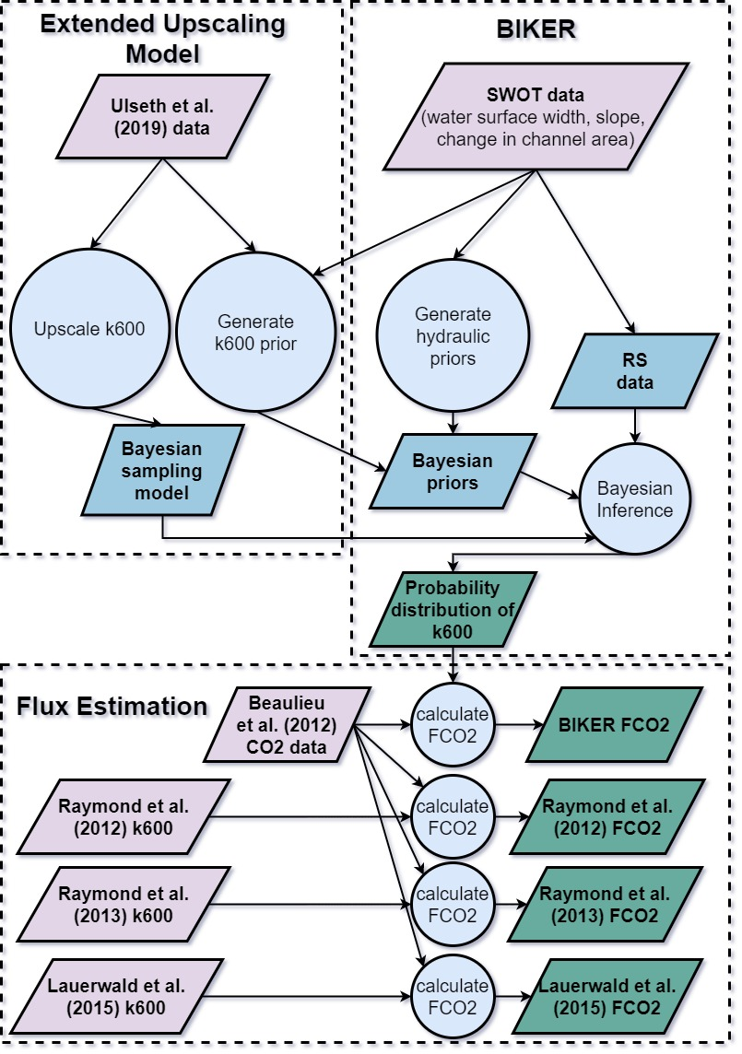

Figure 1. Flowchart of methodology used in this study. ‘Extended Upscaling Model’ is detailed in section 2.1. ‘BIKER’ is detailed in section 2.2 and ‘Flux Estimation’ is detailed in section 2.4. See section 2.3 for the validation setup.

### 2.1 Developing an model for RS

Raymond et al. (2012) first used river hydraulics and the theoretical relationship between *eD* and gas exchange to estimate from average flow velocity and channel slope. This extended earlier work predicting the reaeration coefficient in a similar manner (e.g. O’Connor and Dobbins, 1958; Tsivoglou and Neal, 1976). Later, Ulseth et al. (2019) built upon Raymond et al. (2012) by including measurements from steeper rivers and finding that two distinct k600 regimes exist in low and high energy rivers. More specifically, Ulseth et al. (2019) scale using *eD*, where the resulting model parameters are significantly different whether *eD* is high or low. Their upscaling function is reprinted as equation 2.

2b

While equation 2 would acheives the goal of this manuscript and provides a best-to-date predictive accuracy for , it requires a priori knowledge of *eD* to assign its differential model parameters. We do not have this a priori knowledge in an ungauged river, and in this case we instead only have access to SWOT-observed river widths and heights (and therefore water surface slopes). Thus, we need to extend the Ulseth et al. (2019) model to assign the two model parameters (i.e., chose equation 2a or 2b) using only remotely sensed hydraulics. To do this, we use the basic premise that the scaling relationship is different for different river sizes. We use river width to define river size and train different k600 functions for rivers with similar river sizes (Figure 2, using the data from Ulseth et al., 2019). In doing so, we find that narrow rivers (< 10m wide) are best modelled by further breaking them down into low energy (slope < 0.05) and high energy (slope > 0.05) regimes in order to meet the assumptions necessary to fit a linear regression model proposed by Raymond et al and Ulseth et al (specifically, normally distributed residuals of the predictions). Xxx these two paragraphs need to make it clear before you get to the end that you believe the relationship to be linear, but you will not limit yourself to raymond and/or ulseth. Rather, you wish to find any number of linear relationships that best fit the k600 data as statistically and hydraulicly defined. xxx

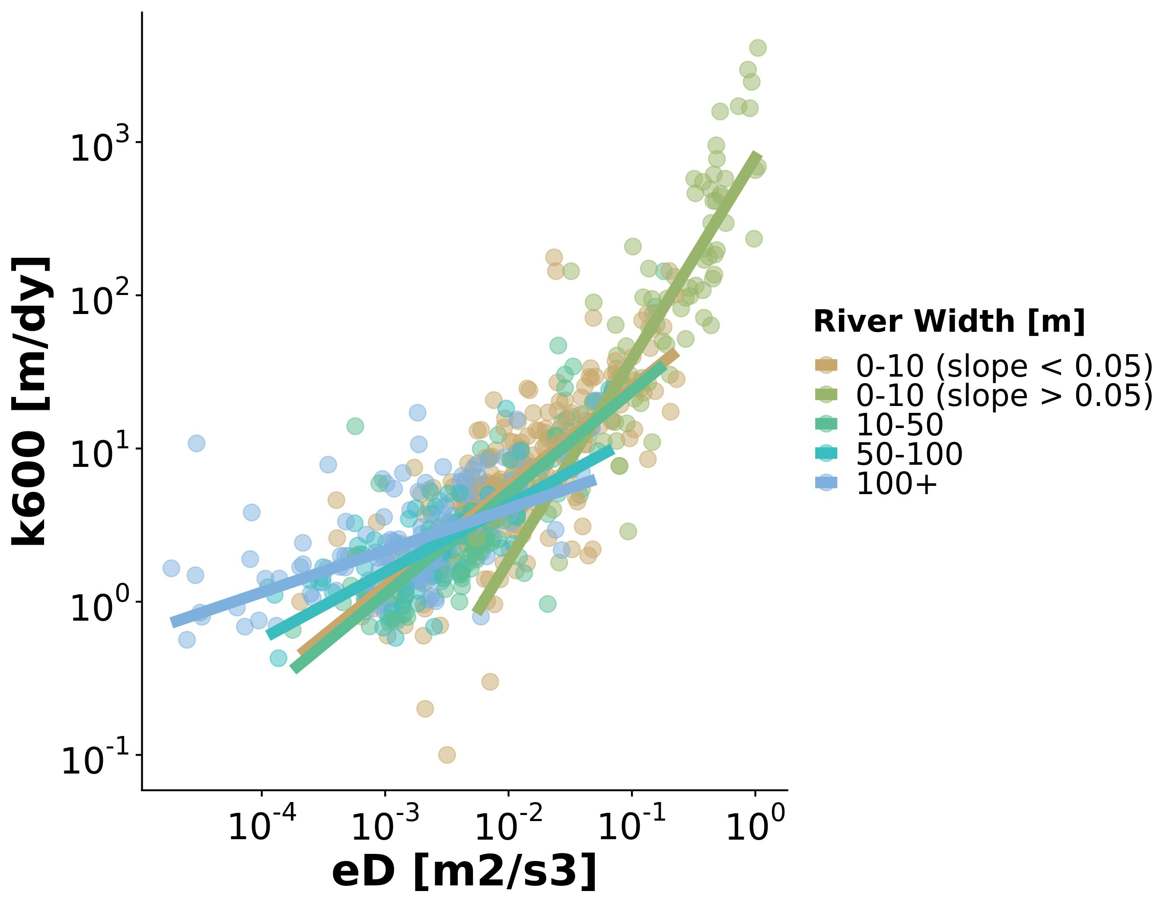

Figure 2: Theoretical basis for the RS-able extension of the Ulseth et al. (2019) k600 upscaling model. Data from Ulseth et al. (2019).

We combined these five regression models into a ‘rule-based regression model’ (equation 3) for river size *i* and model parameters *a* and *b*. Per Figure 2, there are five possible sets of *a* and *b* parameters, as defined for rivers 10-50m wide, 50-100m wide, 100+m wide, low energy rivers 0-10m wide (slope < 0.05), and high energy rivers 0-10m wide (slope > 0.05).

Equation 3 therefore assigns and a priori using just SWOT measurements of water surface width and slope to define *i*. Another implication of this extension of the Ulseth et al. (2019) model is that we now use *a* and *b* parameters that implicitly reflect the distinct geomorphology of different rivers.

Finally, we tested whether Equation 3 can reasonably estimate relative to the original Ulseth et al. (2019) model, with the goal of at least replicating their performance. We compared equation 3 against Ulseth et al and three k600 models given in Raymond et al. (2012) and commonly used in the literature. This was done by training all upscaling functions on 80% of the Ulseth et al. (2019) data and comparing their performance on the remaining 20% of the data. Because the Raymond et al. (2012) models were originally trained on a subset of this dataset, we deemed it fairer to refit their parameters to this expanded dataset (but keep model structure identical).

### 2.2 Developing the BIKER algorithm

With a validated Equation 3 in hand, we turn next to remotely sensing . The approach used here is strongly informed by Hagemann et al. (2017)’s McFLI algorithm for ungauged RSQ via Bayesian inference, further explored in our previous work, e.g. Brinkerhoff et al (2020). These papers conceptualize discharge as a Bayesian remote sensing problem, which we largely follow here to conceptualize as a Bayesian remote sensing problem that can be solved using SWOT data. Below, we translate Hagemann et al.’s ideas from discharge to k600.

SWOT willmeasure river width and height (and thus water surface slope ) at approximately 200m intervals in predefined mass conserved river reaches (cite the PDD, and Elizabeth’s sword paper if it is out). Following Hagemann et al. (2017), the observations needed for Bayesian inference are SWOT measurements of river width and water surface slope, and all other terms in equation 3 (xx list them xx) are treated as statistical parameters (in Bayesian parlance: priors) that cannot be directly observed from SWOT. We also obtain a derived measurement of the ‘change in channel area’ (*dA)* from the river height and width, assuming a rectangular channel geometry. We investigated the sensitivity of BIKER to this rectangular assumption and found it negligible (xxx section x.x if appropriate xxx).

Bayesian inference requires aa sampling model and a likelihood function that estimates the unobservable statisitcal parameters.

We therefore rework equation 4 into a Bayesian sampling model to have all of the observations on the left-hand side sampled from all the unknown model parameters on the right-hand side (equation 5, where *x* are SWOT observables given , a set of statistical parameters). Note that in this formal likelihood specification both sides of equation 5 are log-transformed (natural log) to produce the normal sampling model presented here, however they are written in equation 5 without that transformation for succinctness. The parameter refers to the uncertainty inherent in Equation 4. This will be explained in detail below.

Equation 5 necessitates that Bayesian priors be assigned to model parameters *n*, , and . Bayesian priors formalize the a priori estimates (and uncertainties) for the non-remotely-sensed parameters. To state that more intuitively for these physcial quantities, priors represent our ‘prior river knowledge’ of what *n*, , and probably are for some river given that they cannot be remotely sensed. All priors are formalized within the model as truncated normal distributions of the ln-transformed terms such that for , using prior hyperparameters mean (), standard deviation (), and upper () and lower bounds () for parameter *X*. In order to avoid relying on in situ information, we assign prior hyperparameters using SWOT data only. *n* and prior hyperparameters were assigned following the method developed by Brinkerhoff et al. (2020). They developed a set of river channel prior hyperparameters for McFLI algorithms that are entirely RS-able and reflect differential channel hydraulics as a function of river geomorphology. They used an extensive database of field measurements and machine learning to identify patterns that associate the river width with river geomorphic properties, so these non remotely sensible properties may be assigned to rivers given existing remotely sensed data (e.g. river width from optical imagery). With this method, they showed substantial improvement in the accuracy of ungauged RSQ estimates with no changes to the algorithms or observations. This leave only k600 hyperparameters to be defined. We assigned the prior hyperparameters using a simple slope regression model trained on the Ulseth et al. (2019) dataset to assign (equation 6). was set to the standard error of equation 6: 1.023. λ and ε were set to -3 and 2.7, respectively.

(6b)

Finally, we estimate using Monte Carlo (MC) methods to approximate total uncertainty from equation 4. Specifically, we explore three uncertainty scenarios to assess the realtive influences of different sources of uncertainity. Uncertainty in equation 4 can stem from 1) and parameter uncertainty, 2) error in Manning’s approximation of the average flow velocity, and 3) measurement error for xx, xx, and xxx.. To estimate uncertianties, we run 15,000 unique MC simulations on 5,000 sets of field measurements of river channel hydraulics from Brinkerhoff et al. (2019) under three different uncertainty scenarios. Each MC simulation is itself 10,000 runs, sampling from the normal distributions for and (uncertainty scenario 1), , , and ln-transformed velocity (uncertainty scenario 2), and , , ln-transformed velocity, and water surface slope (uncertainty scenario 3). Estimated uncertainty for Manning’s equation followed Hagemann et al. (2017), who estimated ln-transformed Manning’s equation error to be 0.25.

With the sampling model (equation 5), prior distributions, and the parameter described, a joint posterior distribution conditional on the SWOT data is obtained. To approximate this distribution, we use a Markov Chain Monte Carlo (MCMC) algorithm. Because it is written in the Stan probabilistic programming language, we choose a Hamiltonian Monte Carlo which reduces computation time relative to other sampling algorithms, again following Hagemann et al (2017).

### 2.3 BIKER validation setup

We validated BIKER on 22 rivers using observed and observed First, we detail the 22 rivers, and then we detail how ‘observed’ is calculated.

Because SWOT has yet to launch, it is standard practice to benchmark SWOT-related algorithms on ‘SWOT-like data’. There are three current types of SWOT-like data: 1) AirSWOT, which is an airborne Ka-band inSAR currently limited to five rivers globally, 2) simulated rivers that mimic the type of data SWOT will provide, and 3) the SWOT simulator, which introduces measurement errors to these simulated rivers. Because we are principally interested in algorithm performance, we limit our validation setup to simulated rivers in order to benchmark across as many rivers as possible. These simulated rivers are simply reach-averaged hydraulic model outputs where the water surface heights and widths are labelled as ‘RS observations’ and are used as the sole inputs to the BIKER algorithm. Simulated rivers mimic perfect measurement conditions (i.e. no measurement errors). Here, we use the 22 rivers archived by Frasson et al. (2019) and used by Rodríguez et al. (2020) to develop reach-averaged Saint Vernant equations for the SWOT mission. We omitted the Arial Khan river in Bangladesh due to known problems with that hydraulic model **is that sufficient to say?** and we further sampled the models for only the observations every 11 days to mimic the average SWOT overpass frequency (this also approximately aligns the SWOT observations with the bi-weekly data used later in this study- Section 2.4). All told, this yielded 503 sets of SWOT observations to validate BIKER with.

We also introduced measurement error into these simulated SWOT observations to assess BIKER's performance degradation due to errors inherent in SWOT measurements. Error in SWOT measurements will come from both the error tolerances intrinsic in the satellite data product as well as radar layover error. Here, we assume errors in river width are negligible (Durand et al., 2020) and solely focus on measurement errors in river height and slope. Layover error is the phenomenon when radar returns from different places arrive at the sensor at the same time, leading to taller landscape features appearing closer to the sensor than shorter landscape features that are the same horizontal distance from the sensor. This will occur when the landscape slope is steeper than the radar's incidence angle (Durand et al., 2020) and so generally occurs in areas of high topographic variation (Rees, 2013).

To explore the effect of SWOT measurement errors on BIKER, the SWOT simulator mentioned above is the ideal tool. However, it is cumbersome to run on many rivers **is this sufficient?** and so here we coarsely model measurement error using the results from a recent global anlaysis of SWOT water surface slope/height errors (Durand et al., 2020). They developed a first-principles model for layover error from SWOT observations and, using global hydrography, quantified SWOT measurement error from both error tolerances and radar layover for 220,924 river reaches. The 68th percentiles of these reach-scale errors were 1.7cm/km and 10.4cm for water surface slope and height, respectively. To apply this model to our 22 rivers, we generate new SWOT observations by sampling every observation from normal distributions following equations 7 and 8 for node *i* and timestep *t*. Note that because BIKER ingests *dA*, rather than *H*, reach-scale height errors were converted to *dA* errors again following Durand et al. (2020) and our rectangular channel assumptions: . Note that equation 7 is also used to define slope measurement error in the MC analysis (section 2.2).

Regardless of the validation data used, we do not have observed data for these rivers, and to our knowledge no field dataset of exists in the type of temporal and spatial frequency that SWOT (and therefore the BIKER algorithm) provides. Further, we are principally interested in our ability to reproduce upscaled from RS observations and are less concerend with the actual accuracy of the upscaling model itself (which can be validated using existing datasets like previously done by Raymond et al., 2012; Ulseth et al., 2019). Therefore, we take the best performing upscaling model from sections 2.1 and 3.1 and use that to calculate the ‘observed’ that BIKER is validated against. This is done using equation 9, where is observed river discharge divided by observed channel area. With this setup, we can directly explore BIKER's ability to infer observed *V* and from river width and height alone. It also means that, for a fair validation scheme, must be set to reflect only error from Manning’s equation (and not and ). Thus, is set to 0.25 for this validation. However in practice, it should reflect the total uncertainty calculated in section 2.2 from all three sources.

Validation metrics take two forms (and are detailed in Table 1). To validate across all rivers and timesteps, we used the coefficient of determination and the root mean square error RMSE. Four normalized metrics were used for by-river validation: RRMSE and NRMSE are normalized root mean square errors that have been normalized by the observed value and the mean observed value (respectively) to compare across rivers. rBIAS is a measure of prediction bias that is normalized by the mean observed value to compare across rivers. KGE is a standard metric used in streamflow prediction with an intuitive basis: a value greater than 0 is often interpreted as a useful prediction in ungauged settings, and a value greater than -0.41 indicates a model outperforms a uniform prediction of the mean observed value (Knoben et al., 2019).

*Table 1: Validation metrics used in this study, where r is the correlation coefficient, Nt is number of observations and i is the specific observation. σ refers to the variance of the sample and μ refers to the mean of the sample. As is standard, a carrot accent indicates the predicted value.*

|  |  |  |  |  |  |
| --- | --- | --- | --- | --- | --- |
| **Description** | **Acronym** | **Definition** | **Ideal Score** | **Possible Range** | **Validation Scheme** |
| Coefficient of determination |  |  | 1 | 0 to 1 | All rivers and all timesteps |
| Root-mean-square-error | RMSE |  | 0 | 0 to ∞ | All rivers and all timesteps |
| Relative root-mean-square error | RRMSE |  | 0 | 0 to ∞ | By river |
| Normalized root-mean-square error | NRMSE |  | 0 | 0 to ∞ | By river |
| Relative bias | rBIAS |  | 0 | -∞ to ∞ | By river |
| Kling-Gupta efficiency | KGE |  | 1 | -∞ to 1 | By river |

### 2.4 Upscaling to CO2 evasion and bulk carbon efflux

It is one thing to to predict , but researchers are usually more interested in the gas fluxes from rivers and ultimately the bulk carbon efflux from river to atmosphere. Therefore, we explored 1) the ability of BIKER to reproduce hypothetical carbon dioxide evasion fluxes ( ) from these 22 rivers, and 2) the sensitivity of the estimated bulk carbon efflux via evasion to the method used to estimate reach averaged flow velocity.

First, we calculated . To do this, we paired the modeled values (obtained from ) with field-measurements of water-side concentrations and water temperatures. 26 bi-weekly samples were made by Beaulieu et al. (2012)- Figure S1) at one location in the Ohio River for one calender year from 2008-2009. We paired these 26 values with each 11-day-repeat set of SWOT observations by date, ignoring the timesteps beyond 26 (only ~15% of the SWOT observations were ignored here and we deemed this acceptable). Not all of the SWOT rivers have observations for a full year, and when simulation dates were not available they were assumed to start on January 1st. Note that this data is for the Ohio River only but was applied to all 22 rivers (which includes multiple sections of the Ohio River- Frasson et al. (2019)). Because we are exclusively interested in the relative differences between estimates and not the raw fluxes themselves, any data representative of SWOT-observable rivers was deemed acceptable. Atmospheric was assumed 390 uatm. The Schmidt number, used to backcalculate from , was calculated following Raymond et al. (2012) and Wanninkhof (1992).

Then, we estimated bulk carbon efflux using four models for average flow velocity: BIKER and three gauge-based HG models previously used for upscaling (Lauerwald et al., 2015; Raymond et al., 2013, 2012). See Table S1 for their definitions. It is worth stressing that the Lauerwald et al. (2015) model was developed as one of two components of the Raymond et al. (2013) model, and so was actually developed by the latter’s authors. The names used here refer to the specific implementation used in each study. For this study, all HG methods use the in-situ discharge record while BIKER does not. This allows us to explore the relative differences in bulk carbon efflux estimates if implementing a wholly ungauged method (BIKER) versus gauged methods (all three HG models). Finally, we express the bulk carbon efflux as the average mass flow rate of carbon (via evasion) per year from the 22 rivers after accounting for total river surface area.

## 3 Results

First, we present the results from the upscaling experiment (section 3.1). We then take the best performing upscaling function, implement it within BIKER, and validate it on the 22 SWOT rivers (section 3.2). Finally, we use as modeled by both BIKER and gauge-based HG models to compare and bulk carbon efflux estimates made using gauged and ungauged methods (section 3.3).

### 3.1 Validating the upscaling model

Figure 3 plots the validations for the five upscaling functions tested. Both the original Ulseth et al. (2019) model and our RS-able extension perform the best on this independent set of validation data, with near identical performance. The RS-able Ulseth et al. (2019) model achieves an of 0.83 and an RMSE of 1.98 m/day, which is just marginally better than the original Ulseth et al. (2019) model (0.82 and 2.03 m/day, respectively). The two power-law based Raymond et al. (2012) models (equations 4 and 3 in that study) achieve slightly worse performance, with in the 0.70s and their RMSE scores slightly higher (2.31 and 2.29 m/day, respectively). Raymond et al. (2012) equation 5, which is linear in structure, worked well on their dataset but fails to capture the non-linear relationship evident in this expanded and more geomorphically diverse dataset. In fact, it predicts negative values and error metrics cannot be calculated because the prediction residuals are not normally distributed. **SHOULD I INCLUDE THIS MODEL or not mention it??** Because we successfully reproduced the Ulseth et al. (2019) model, the rest of this manuscript deals exclusively with this RS-able variant of the model.

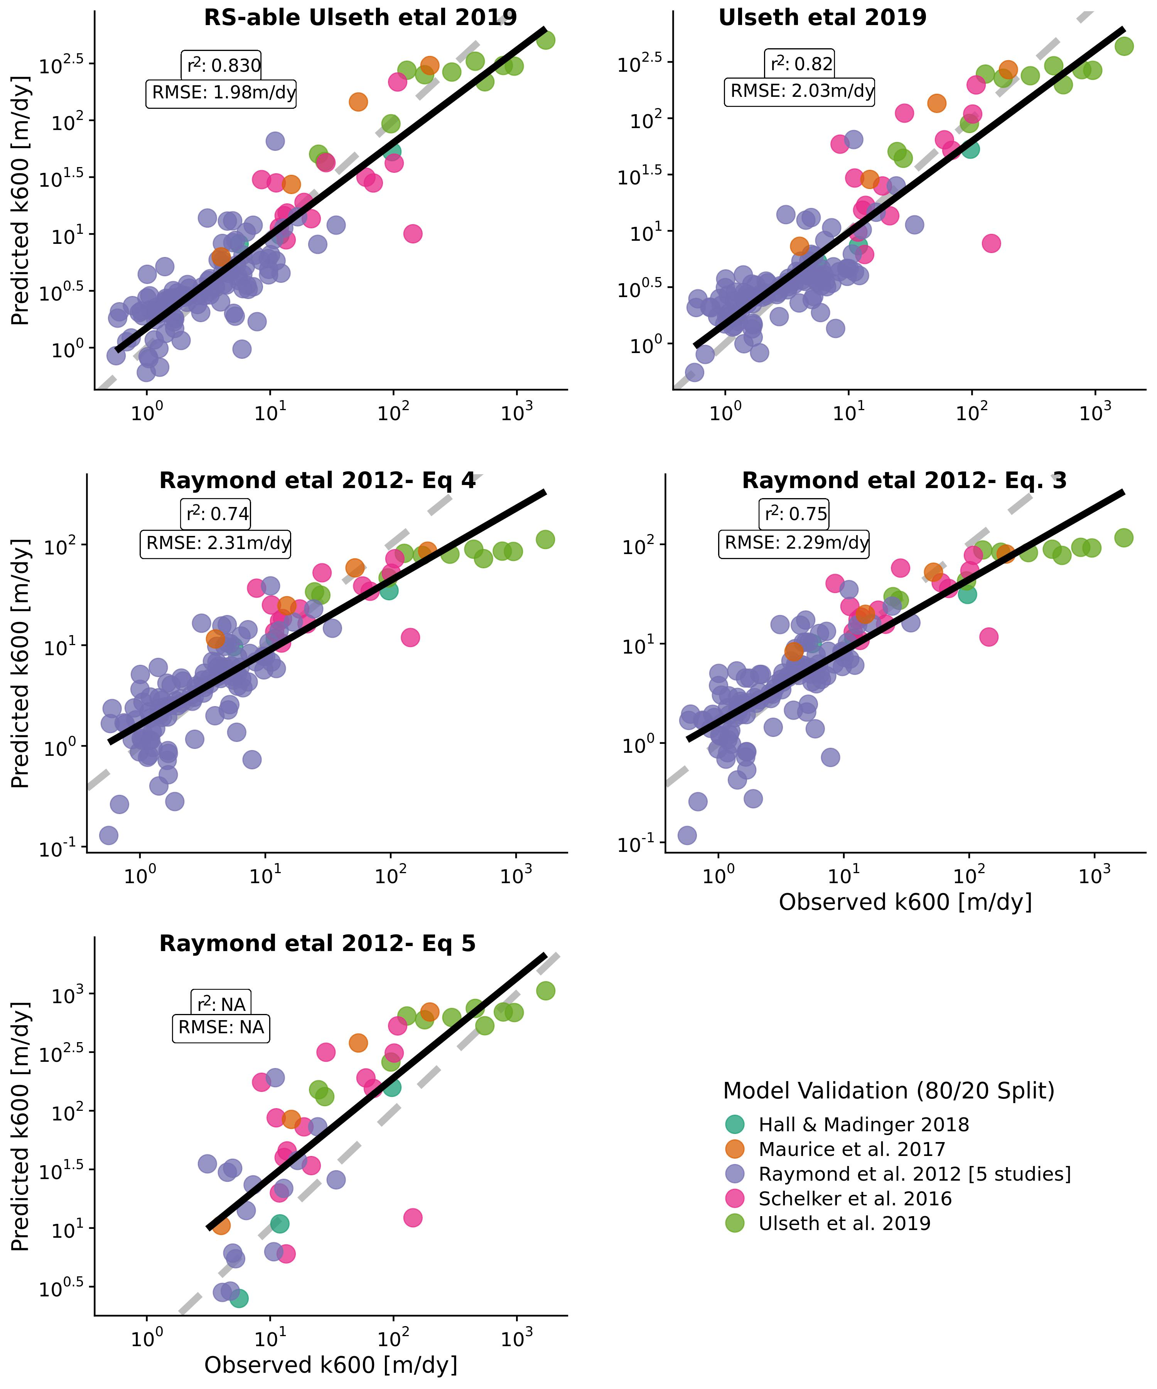

Figure 3. Validation of five k600 upscaling models on 20% of the Ulseth et al (2019) dataset, withheld for independent testing. Raymond et al. (2012) Eq. 5 predicts negative k600 values, which are not plotted here and highlight a limitation of using a linear model for a non-linear problem (though it did work well on their smaller dataset).

Uncertainties were then propagated through the RS-able Ulseth et al. (2019) model via MC simulations for the three uncertainity scenarios (section 2.2) 5,000 times. Figures 4a, 4c, and 4e plot histograms of the 5,000 uncertainty terms extracted from those distributions. Figures 4b, 4d, and 4f plot three of the distributions used to build the histograms as examples. Across the 5,000 tests for the fullest error scenario (Figure 4e), we quantified median ln-transformed uncertainty in equation 4 to be 1.28 (~3.6 m/day- dashed blue line in Figure 4a). Median uncertainty solely from the upscaling model is 1.27 (~3.5608526 m/day), confirming that functionally all uncertainity in the equation 4 estimates is due to upscaling and not due to the assumptions made for BIKER. The only notable difference between these histograms is in the Figure 4e right-hand tail, where the cases when estimate uncertainity is extremely high get larger. Figures 4b, 4d, and 4f are also functionally identical, further corroborating our conclusion.

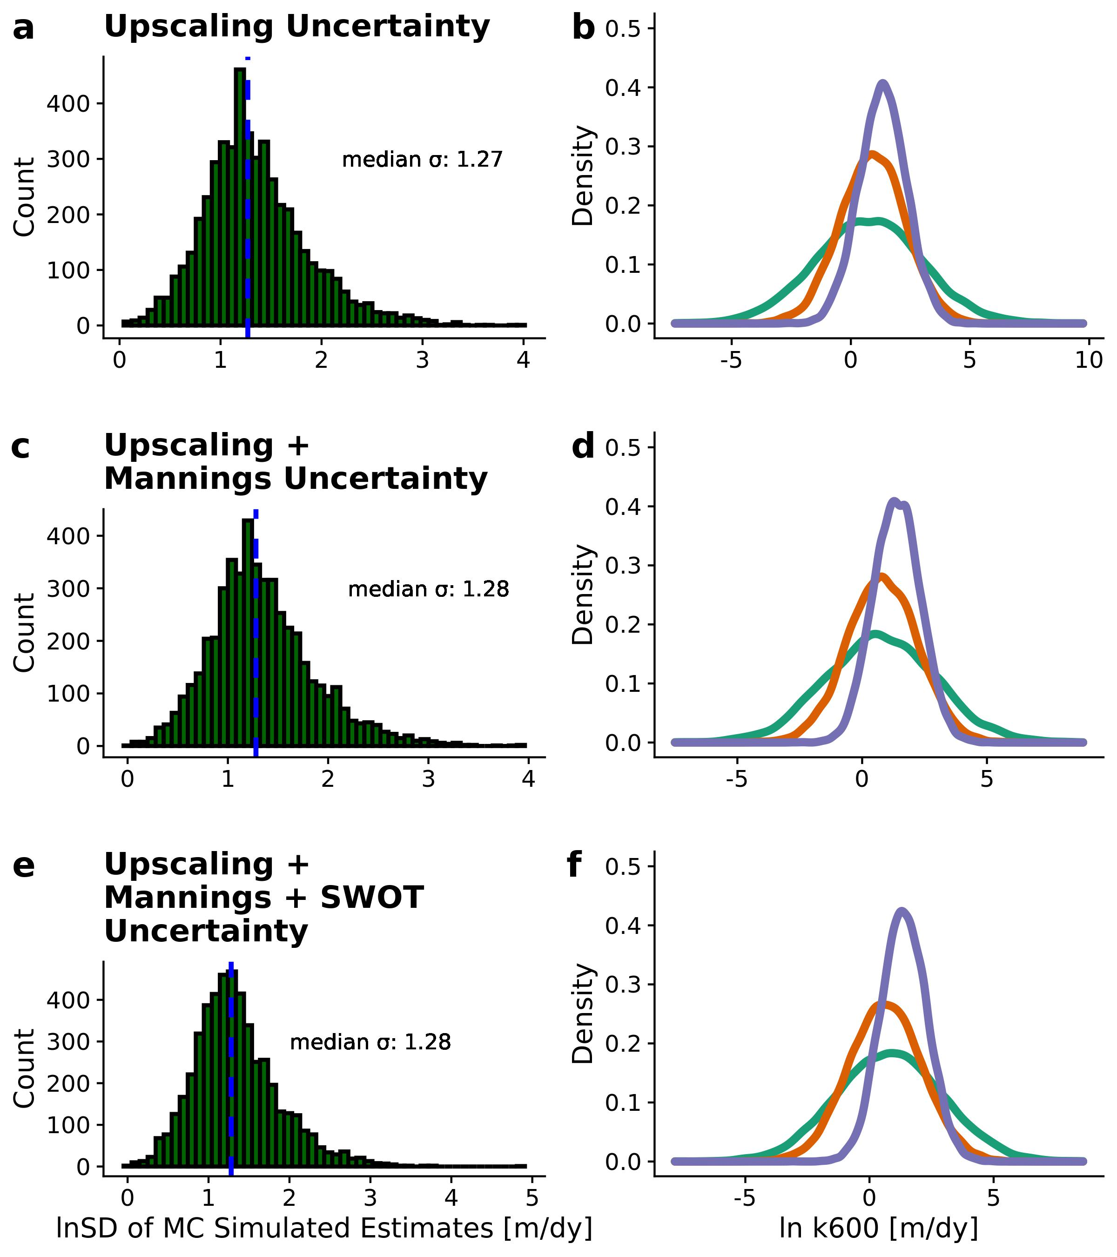

Figure 4 Model uncertainty estimates for three error scenarios, as detailed. Left: histogram of error terms (SD) for all 5,000 MC simulations with blue dashed line denoting the median. Right: Three example MC simulation results of 10,000 samples each.

### 3.2 Validating the BIKER algorithm

Figure 5a plots the validation results for (with no SWOT measurement error) across all 22 rivers and all timesteps. For BIKER, the points are the posterior means while the black lines are the 95% confidence intervals (CIs) for the predictions. is strongly correlated with the predicted by BIKER. BIKER captures the general magnitude of the predictions and most points fall on or near the 1:1 line. However, the 95% prediction intervals (dashed grey lines) highlight reasonably large residuals for many predictions. Regardless, the RMSE for the BIKER predictions is only 0.14 in log10 space (~1.38 m/day) across all predictions. Again, this is substantially less than the RMSEs for the upscaling models (Figure 3) and the MC-propogated uncertainties (Figure 4).

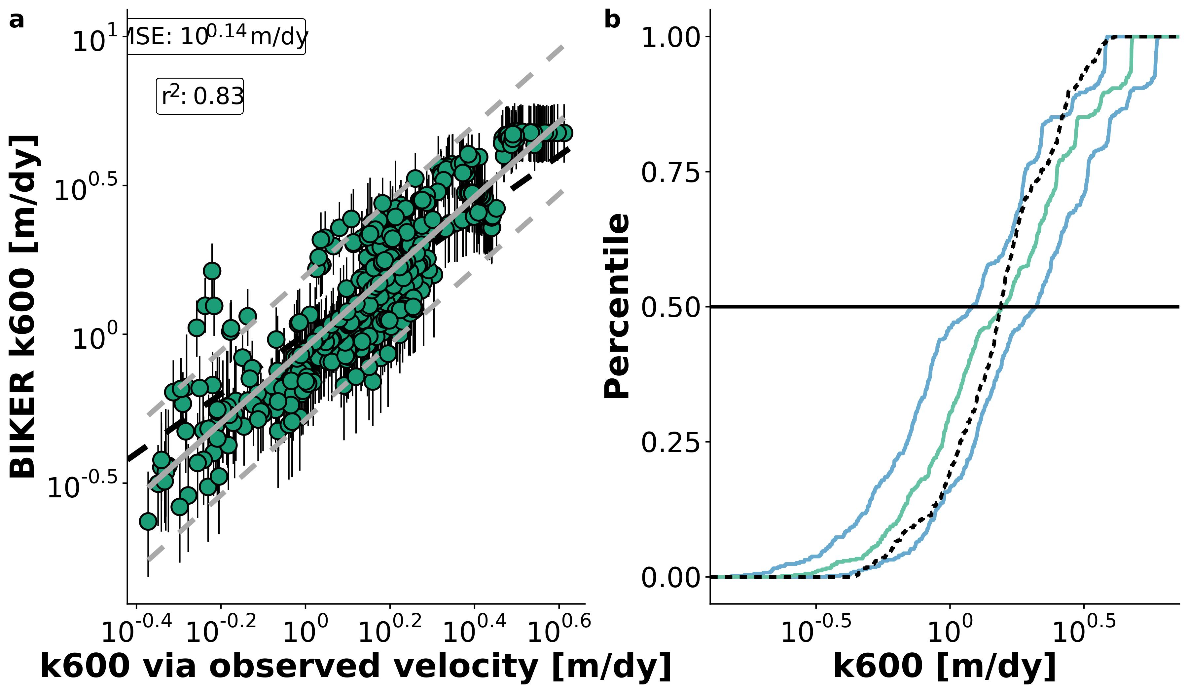

Figure 5. a: Validation of BIKER for 22 SWOT rivers. Black bars are 95% CIs for the modeled values. Grey line is linear regression (and 95% prediction intervals are dashed) and dashed black line is 1:1 line. b: Cumulative density functions (CDFs) of the same results: dashed black line are observed values, green line are BIKER posterior means, and blue lines are BIKER 95% CIs.

Figure 5a suggests a flip in the bias of the predictions, which is confirmed in Figure 5b. Figure 5b plots the cumulative density functions (CDFs) of observed and predicted where the green line is the CDF of the BIKER posterior means and the blue lines are the CDFs of the BIKER posterior 95% CIs. We see, more clearly than in Figure 5a, that the posterior mean is systematically underestimated for values less than the median and systemically overestimated for values above the median . However, the uncertainty in these estimates captures very well: nearly the entire observed CDF falls between, on, or just outside of the 95% CIs (Figure 5b). This highlights one benefit of using Bayesian inference to fully propagate all prior uncertainties through to the posterior. In summary, Figure 5 confirms that we improve upon our baseline understanding of in these rivers. Put another way, we reasonably capture with no in situ information about the river while simultaneously and explicitly accounting for the reasonably large uncertainties inherent in our estimates.

Figure 6a plots validation metrics calculated for each river with and without SWOT measurement error. The boxplots are composed of scores for the 22 rivers- see Table 1 for metric definitions. SWOT measurement uncertainties slightly degrade performance in KGE, neglibily degrade rBIAS and RRMSE, and actually improve performance in NRMSE (Figure 6a). Aside from the modest decrease in KGE, we deem that SWOT measurement error does not exert a significant influence on BIKER and so the results presented for the rest of the manuscript assume no measurement error. Median rBIAS is 0.04, indicating nearly no bias in most rivers’ predictions. However, some rivers are substantially biased in both directions, further supporting the visual evidence in Figure 5 that sometimes BIKER is substantially under/overestimating the magnitude of and that this is river-specific. Median KGE is 0.53, which is excellent given that absolutely no in situ information is being used to predict . NRMSE and RMSE have median scores of 0.29 and 0.28, respectively. While median KGE and rBIAS scores were strong, the ranges of these scores were somewhat large (standard deviation for KGE of 0.53 and for rBIAS of 0.34).

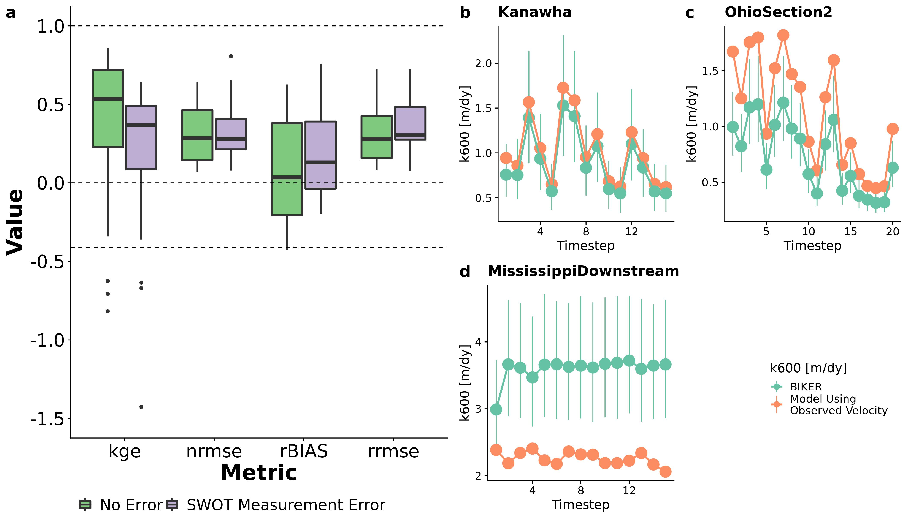

Figure 6. a: Performance metrics by river. See Table 1 for metric definitions. Dashed lines denote scores of 1, 0, and -0.41 for KGE (section 3.2). b-d: validation timeseries for three rivers representative of good, reasonable, and poor performance. b) was randomly selected from the upper tertile of KGE scores, c) was randomly selected from the middle tertile, and d) from the worst tertile. Model results include the posterior means and 95% CIs.

Figure 6b-d are representative timeseries plots of predicted and observed for three rivers chosen randomly from those with ‘good’ KGE scores (b), ‘okay’ KGE scores (c), and ‘bad’ KGE scores (d). See the Figure 6 caption for how this was calculated. For the Kanawha River, the entire timeseries of is correctly predicted, while in the Ohio Section 2 River there is a negative bias in the estimates. However, temporal dynamics are still correctly recovered. In the downstream Mississippi River, there is significant bias in the estimates as well as significant uncertainty (per the 95% CIs). The temporal dynamics are also incorrectly predicted at times.

### 3.3 Influences on carbon efflux estimates

Finally, we explore our ability to 1) use BIKER-produced to estimate and 2) estimate bulk carbon efflux from evasion (section 2.4).

In Figure 7a, there is a strong fit to the observed data, with an RMSE of 1.55 . The is slightly higher than (Figure 7a). There is also less underestimation bias for the smallest of the observed than in the predictions (Figure 5a). This is presumably due to the structure of the equation, which reduces the relative importance of errors in the gas exchange values given that the data is measured in situ. prediction intervals also have a similar relative magnitude to those presented in Figure 5. Figure 7b-d includes subplots for the same rivers as Figure 4b-d, however with plotted instead of . There is functionally perfect recovery of in the Kanawha River, very good recovery (with some positive bias in peak evasion events) for the Ohio Section 2 River, and far less negative bias in the Downstream Mississippi river than is present in the estimates (Figure 5b). Again, the temporal dynamics are accurately modeled in the Kanawha and Ohio Rivers, however there is some bias in the magnitude of the predictions. This suggests that the BIKER model can easily estimate the changing dynamics of gas exchange but is at the mercy of the prior on to accurately estimate the magnitude of the evasion.

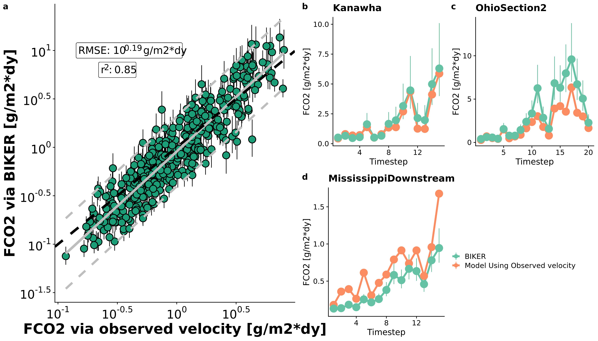

Figure 7. a: FCO2 from BIKER versus using observed average flow velocity for all timesteps for 22 SWOT rivers (grey lines are linear regression and 95% prediction intervals, while black dashed line is the 1:1 line). b-d: timeseries plots for the three example rivers from Figure 5.6.

We then compare the and bulk carbon efflux (via evasion) from the 22 rivers using BIKER posterior means and three gauge-based HG models (Figure 8). Figure 8a are barplots of the bulk carbon efflux (via evasion) across all rivers in gigagrams of carbon per year. The BIKER bulk carbon efflux (1166 gG-C/yr) is slightly overestimated relative to to the bulk carbon efflux calculated using observed velocity (1054 gG-C/yr). However, it is a better estimate than those using a streamgauge and HG (741, 770, and 860 gG-C/yr for ‘Raymond 2012’, ‘Raymond 2013’, and ‘Lauerwald 2015’, respectively). Thus, BIKER reasonably captures the estimated efflux from these rivers purely from RS data, and surprisingly outperforms the gauge-based approaches when assessing this bulk flux property (Figure 8a).

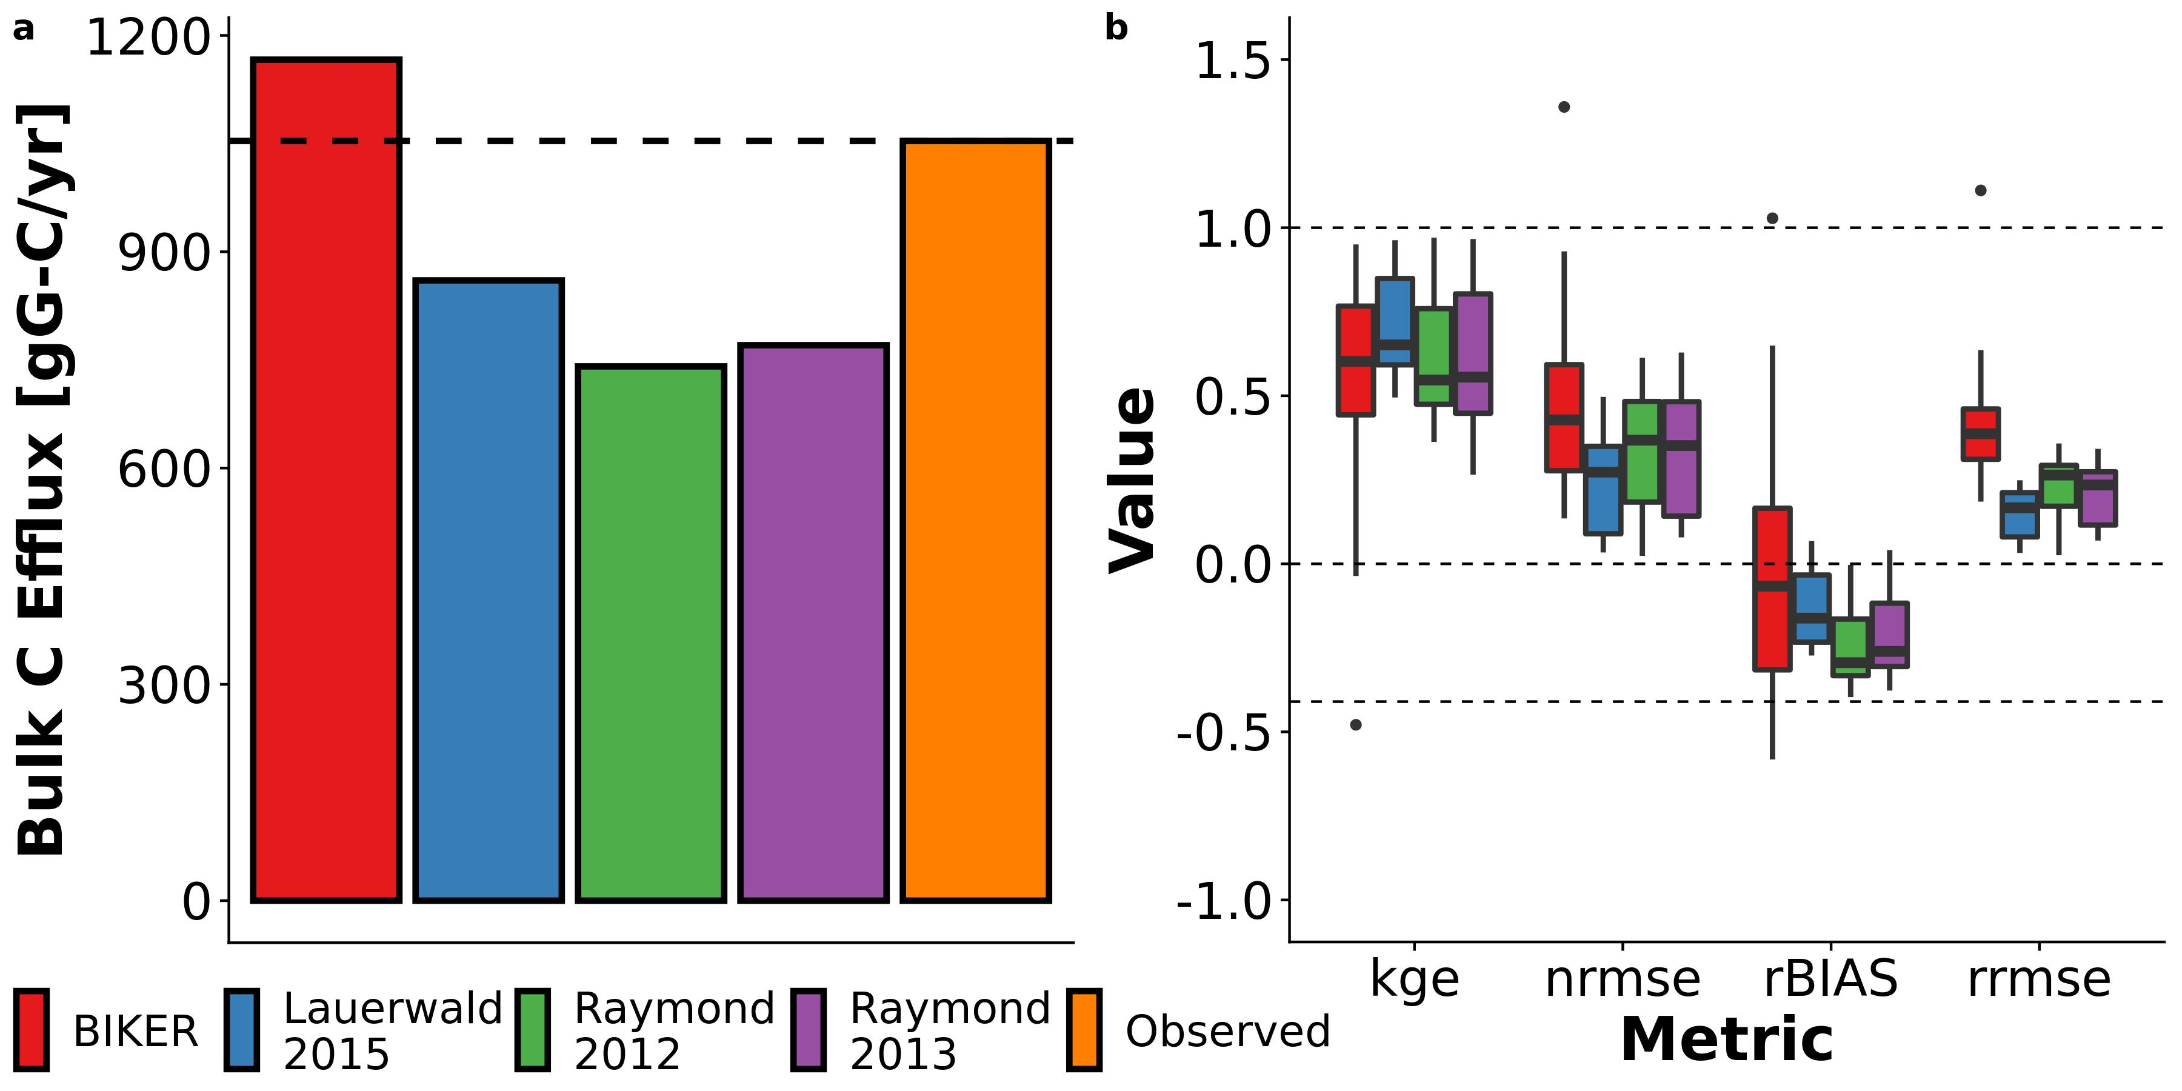

Figure 8. a: Bulk carbon efflux, per year, from the 22 SWOT rivers as calculated using four different average flow velocity estimates: 1) BIKER, 2) through 4) average flow velocity as calculated using HG models from the literature. b: Histograms of by-river performance in estimating FCO2 across all timesteps and rivers for the same four velocity models. Dashed lines are identical to Figure 6a.

Figure 8b plots the by-river performance scores for . For KGE, 'Lauerwald 2015' is the best performing (median KGE: 0.65) while BIKER (median KGE: 0.6) slightly outperforms the other two gauge-based methods (median KGEs: 0.56 and 0.55 for 'Raymond 2013' and 'Raymond 2012', respectively). However, all four scores are very similar. For rBIAS, BIKER indicates the least bias in some rivers and similar bias to the other models in other rivers, as indicated by the scores' inter-quartile range (0.48) and median (-0.07). Meanwhile, all three HG models uniformly produce significant negative bias in their estimates (median scores of -0.16, -0.26, and -0.29 for 'Lauerwald 2015', 'Raymond 2013', and 'Raymond 2012', respectively). BIKER has similar performance for NRMSE and RRMSE, which is generally worse than the HG models. But, BIKER NRMSE is only slightly worse than 'Raymond 2013 and 'Raymond 2012' while BIKER RRMSE (median RRMSE: 0.39) is significantly worse than the gauge-based approaches. RRMSE is highly sensitive to prediction errors in small values and so this suggests that BIKER performs poorly when predicting small fluxes. In summary, BIKER performance for KGE, NRMSE, and rBIAS is either similar or negligibly worse than the gauge-based upscaling approaches tested here and notably worse for RRMSE. This is despite relying on absolutely no in situ information like all three other models do.

## 4 Discussion

### 4.1 Towards remote sensing global spatiotemporal dynamics of

To date, most field-scale studies of riverine gas exchange have focused on 1) its relationship with wind speed (e.g Beaulieu et al., 2012; Borges et al., 2004; Zappa et al., 2007), 2) average flow velocity (e.g. Alin et al., 2011; Beaulieu et al., 2012; Schelker et al., 2016), or 3) discharge (e.g. Roberts et al., 2007; Uehlinger and Naegeli, 1998). However, the spatiotemporal dynamics of riverine gas exchange are still weakly constrained. A few studies have investigated these dynamics, but they have been limited to individual rivers and/or limited field seasons (Hall et al., 2012; Sand-Jensen and Staehr, 2012). Wallin et al. (2011) performed a preliminary analysis in northern Sweden relating river specific (‘at-a-station’) temporal variability in gas exchange with channel slope, but they were limited to an average of only 8 measurements per river in a single watershed. This limited knowledge of large-scale spatiotemporal dynamics is due both to a lack of process-level understanding (Hall and Ulseth, 2020) but also a lack of measurements. Authors have argued that the key to explaining the large residual variation in upscaling models is to explore at-a-station temporal variability in (Hall and Ulseth, 2020).

Therefore, estimating from SWOT data is an attractive option for exploring the spatiotemporal dynamics of at fine temporal resolution and at the global-scale. SWOT will provide daily hydraulic measurements for a 3 month fast sampling period for calibration and validation and sampling thereafter between 1 and 7 days per 21 day repeat cycle (Biancamaria et al., 2016). BIKER's success in 1) infering using simulated SWOT data over a wide range of rivers (Figures 5 and 6) and 2) being robust to measurement errors internal to the SWOT data (Figures 4 and 6a) bode well for BIKER's eventual implementation on real SWOT observations. The results presented here suggest that daily estimation of riverine gas exchange globally could be possible once SWOT launches.

### 4.2 Estimating bulk carbon efflux using the SWOT satellite

Section 3.3 confirms that BIKER is successful at two things without any in situ information for : 1) reproducing (Figure 7) and 2) reproducing the bulk carbon efflux (Figure 5.8). This encouraging result has two main implications for future work. First, section 3.3 confirms that we can couple BIKER and SWOT with in situ gas concentration loggers to produce estimates at novel temporal resolution in SWOT-observable rivers. This is particualry useful given recent advances in high temporal resolution in situ gas concentration measurements **get citations from Kelly**. BIKER can likely also be ran at the field scale using arrays of pressure transducers to estimate water surface slope following recent work doing the same using the Hagemann et al. (2017) RSQ algorithm (Harlan et al., n.d.).

Secondly, it is important to stress that unlike BIKER, the HG models in Figure 8 rely on an in situ streamgauge. This means that Figure 8 represents the best performance that those models could ever have; if ran using modeled discharge their accuracy would necessarily decrease, though this decrease would not be too much due to the generally good performance of those data. Thus, these results suggest that BIKER will be useful in two settings: 1) upscaling in ungauged rivers as hypothesized, but also in 2) potentially improving our bulk efflux understandings at gauged sites. Future work should systematically quantify prediction error from coupling global-scope HG models with modeled discharge, as is the default workflow used in recent upscaling studies (Horgby et al., 2019; e.g. Lauerwald et al., 2015). **I assume Shaoda's paper will still be in review and can't cite here but this is exactly what they do...**

Figure 8 also confirms that the training data used for HG models exerts a significant influence on upscaled carbon emissions from rivers. The 'Lauerwald 2015' model, which was trained on larger rivers than the data used in either the 'Raymond 2013' or 'Raymond 2012' models, should perform best on SWOT-observable rivers (which are greater than 50m wide). Figure 8 confirms this. Meanwhile, BIKER has no similar reliance on hydraulic parameters trained on different river sizes and only assumes that Manning's equation is viable in the river at hand (which is generally the case in rivers large enough to be SWOT-observable- Ferguson, 2010). Upon SWOT's launch, the BIKER approach to estimating gas exchange could be coupled with existing upscaling workflows to improve riverine gas flux predictions where gauges are unavailable but SWOT measurements are.

### 4.2 Sources of BIKER uncertainty: process-level or remote sensing?

Throughout the BIKER validation, we have assumed no parameter uncertainity in the upscaling parameters and . We have shown that BIKER estimate uncertainty is significantly less than and uncertainity (Figures 4 and 5). BIKER provides similar estimates of to those produced by current upscaling models and most of the total uncertainity stems from the upscaling model itself (Figure 4). We argue that BIKER's estimate uncertainity is therefore limited by our current process-level understanding of upscaling and not by BIKER or SWOT, suggesting that BIKER's predictive performance can only improve from advancing our understandings of the physical processes governing gas exchange from SWOT-observable rivers. Developing and validating the BIKER algorithm has provided a unique lense through which we can discuss riverine gas exchange theory. In that context, we next explore some considerations for future work on upscaling in SWOT-observable rivers.

#### 4.2.1 Gas exchange under uniform and non-uniform flow conditions

Section 2.2 highlights that most upscaling studies to date have assumed uniform flow conditions (i.e. ) in order to train upscaling models using readily available slope data. However, the first-principles model previously used by Ulseth et al. (2019) and Raymond et al. (2012) to define *eD* (Tsivoglou and Neal, 1976) does not make this simplifying assumption. Therefore, it is an open research question whether parameterizing upscaling models via can account for some of the unexplained residual variation in current upscaling models (Hall and Ulseth, 2020). Conveniently, SWOT will explicitly measure at unprecendeted spatial and temporal resolutions and will be spatially joined to hydrography that provides . Thus, future researchers can use BIKER and SWOT in conjunction to directly answer this question.

#### 4.2.2 Bed roughness and gas exchange in SWOT rivers

Channel bed roughness affects riverine gas exchange mostly in high energy streams where slope is sufficiently steep for bubble-induced gas exchange to occur (Hall and Ulseth, 2020). Ulseth et al. (2019) showed bed roughness loosely scales with in steep Alpine streams. However, they coarsely estimated bed roughness from arial imagery and to date most similar work has focused on labratory exercises (e.g. Chanson et al., n.d.; Moog and Jirka, n.d.). We argue that bed roughness is not controlling gas exchange in SWOT-observable rivers because they are so large and therefore flat. Instead, gas exchange in SWOT-observable rivers is presumably dominated by water-column, rather than bed friction, turbulence. We show in Figure S2 with the Ulseth et al. (2019) data that the 'effective bed roughness height' scales with only in extremely steep streams (see Text S2 for the calculation of this bed roughness term). This relationship fundamentally breaks down in less steep rivers, and such steep slopes are functionally impossible in SWOT-observable rivers that are over 50m wide. This promising initial result indicates bed roughness controls some aspects of gas exchange and should be explicitly explored in future work, but is less relevant for BIKER's application to SWOT data. This is particularly important because small, steep rivers dominate global river networks and their GHG evasion (Horgby et al., 2019) due to the fractal nature of river systems (Tarboton et al., 1988).

#### 4.2.3 Wind-driven gas exchange in SWOT rivers

In wide rivers like those that SWOT will observe, wind begins to exert a non-trivial influence on gas exchange. It is well established that in lakes and the ocean, wind controls near-surface turbulence and thus gas exchange (Beaulieu et al., 2012; Read et al., 2012). Authors have argued that large rivers are a hybrid of the hydraulics-driven turbulence in small rivers and the wind-driven turbulence in lakes (Beaulieu et al., 2012). As SWOT will measure only rivers wider than 50m, it follows that wind is likely exerting some influence on gas exchange in SWOT-observable reaches. Here, we opted to ignore wind effects in our upscaling model and in BIKER to favor global scalability and implementability for two reasons: 1) current upscaling efforts do not account for wind in their estimation of either and 2) it is infeasible to parameterize every set of SWOT measurements with local wind data. Further, relying on an in situ understanding of wind defeats the purpose of BIKER for ungauged settings. Future work should explore the feasibility of assigning a Bayesian prior on wind speed for BIKER.

## 5 Conclusions

Efforts to upscale gas exchange velocities from river networks generally do so using river channel slope and average flow velocity. Therefore, gas evasion estimates are sensitive to available data on average flow velocity. In ungauged basins, this poses a problem because a velocity~discharge relationships can not be built. To circumvent this problem, we propose using established techniques from the ungauged remote sensing of river discharge literature and applying them to gas exchange velocity in ungauged rivers. This is formalized as the BIKER algorithm and uses data from the upcoming SWOT satellite to remotely sense gas exchange velocity solely from river width and water surface height. We validate BIKER on 22 'rivers' of simulated SWOT data (Frasson et al., 2019), obtaining an RMSE of 1.38 ,/day after accounting for upscaling parameter uncertainity. When generalized to estimate bulk carbon efflux from these 22 rivers, BIKER reasonably captures the observed efflux (1166 gG-C/yr versus 1054 gG-C/yr, respectively). Further, BIKER's estimates across the 22 rivers are either functionally the same or modestly worse than those made using a streamgauge and the HG models frequently used in the literature. This suggests that BIKER will be useful not only for upscaling in ungauged rivers, but also in potentially improving our understandings in gauged rivers too. As drainage network models of GHG evasion gain in sophistication and continue to ingest higher and higher temporal resolution data, BIKER and SWOT should prove useful in providing such information.

## 6 Acknowledgements

C.B. Brinkerhoff was funded on **xxxxxxxxxxxxx**. BIKER is available at <https://github.com/craigbrinkerhoff/BIKER>. All code to build and generate results, figures, and the manuscript is available at <https://github.com/craigbrinkerhoff/RSK600>. Data used in this study was generously made available by the authors of Frasson et al. (2019), Ulseth et al. (2019), and Beaulieu et al. (2012). This manuscript benefitted extensively from the decade plus body of work generated by the SWOT Discharge Algorithm Working Group.

## References

Alin, S.R., Rasera, M. de F.F.L., Salimon, C.I., Richey, J.E., Holtgrieve, G.W., Krusche, A.V., Snidvongs, A., 2011. Physical controls on carbon dioxide transfer velocity and flux in low-gradient river systems and implications for regional carbon budgets. Journal of Geophysical Research: Biogeosciences 116. <https://doi.org/10.1029/2010JG001398>

Andreadis, K.M., Brinkerhoff, C.B., Gleason, C.J., 2020. Constraining the Assimilation of SWOT Observations With Hydraulic Geometry Relations. Water Resources Research 56, e2019WR026611. <https://doi.org/10.1029/2019WR026611>

Appling, A.P., Hall, R.O., Yackulic, C.B., Arroita, M., 2018. Overcoming Equifinality: Leveraging Long Time Series for Stream Metabolism Estimation. Journal of Geophysical Research: Biogeosciences 123, 624–645. <https://doi.org/10.1002/2017JG004140>

Beaulieu, J.J., Shuster, W.D., Rebholz, J.A., 2012. Controls on gas transfer velocities in a large river. Journal of Geophysical Research: Biogeosciences 117. <https://doi.org/10.1029/2011JG001794>

Biancamaria, S., Lettenmaier, D.P., Pavelsky, T.M., 2016. The SWOT Mission and Its Capabilities for Land Hydrology, in: Cazenave, A., Champollion, N., Benveniste, J., Chen, J. (Eds.), Remote Sensing and Water Resources, Space Sciences Series of ISSI. Springer International Publishing, Cham, pp. 117–147. <https://doi.org/10.1007/978-3-319-32449-4_6>

Bjerklie, D.M., Moller, D., Smith, L.C., Dingman, S.L., 2005. Estimating discharge in rivers using remotely sensed hydraulic information. Journal of Hydrology 309, 191–209. <https://doi.org/10.1016/j.jhydrol.2004.11.022>

Borges, A.V., Vanderborght, J.-P., Schiettecatte, L.-S., Gazeau, F., Ferrón-Smith, S., Delille, B., Frankignoulle, M., 2004. Variability of the gas transfer velocity of CO2 in a macrotidal estuary (the Scheldt). Estuaries 27, 593–603. <https://doi.org/10.1007/BF02907647>

Brakenridge, G.R., Nghiem, S.V., Anderson, E., Mic, R., 2007. Orbital microwave measurement of river discharge and ice status. Water Resources Research 43. <https://doi.org/10.1029/2006WR005238>

Brinkerhoff, C.B., Gleason, C.J., Feng, D., Lin, P., 2020. Constraining Remote River Discharge Estimation Using Reach-Scale Geomorphology. Water Resources Research 56, e2020WR027949. <https://doi.org/10.1029/2020WR027949>

Brinkerhoff, C.B., Gleason, C.J., Ostendorf, D.W., 2019. Reconciling at-a-Station and at-Many-Stations Hydraulic Geometry Through River-Wide Geomorphology. Geophysical Research Letters 46, 9637–9647. <https://doi.org/10.1029/2019GL084529>

Chandanpurkar, H.A., Reager, J.T., Famiglietti, J.S., Syed, T.H., 2017. Satellite- and Reanalysis-Based Mass Balance Estimates of Global Continental Discharge (19932015). Journal of Climate 30, 8481–8495. <https://doi.org/10.1175/JCLI-D-16-0708.1>

Chanson, H., Toombes, L., Moog, D., Jirka, G., n.d. Stream Reaeration in Nonuniform Flow: Macroroughness Enhancement 4.

Cole, J.J., Prairie, Y.T., Caraco, N.F., McDowell, W.H., Tranvik, L.J., Striegl, R.G., Duarte, C.M., Kortelainen, P., Downing, J.A., Middelburg, J.J., Melack, J., 2007. Plumbing the Global Carbon Cycle: Integrating Inland Waters into the Terrestrial Carbon Budget. Ecosystems 10, 172–185. <https://doi.org/10.1007/s10021-006-9013-8>

Dingman, S.L., 2007. Analytical derivation of at-a-station hydraulicGeometry relations. Journal of Hydrology 334, 17–27. <https://doi.org/10.1016/j.jhydrol.2006.09.021>

Durand, M., Chen, C., de Moraes Frasson, R.P., Pavelsky, T.M., Williams, B., Yang, X., Fore, A., 2020. How will radar layover impact SWOT measurements of water surface elevation and slope, and estimates of river discharge? Remote Sensing of Environment 247, 111883. <https://doi.org/10.1016/j.rse.2020.111883>

Durand, M., Gleason, C.J., Garambois, P.A., Bjerklie, D., Smith, L.C., Roux, H., Rodriguez, E., Bates, P.D., Pavelsky, T.M., Monnier, J., Chen, X., Baldassarre, G.D., Fiset, J.-M., Flipo, N., Frasson, R.P. d M., Fulton, J., Goutal, N., Hossain, F., Humphries, E., Minear, J.T., Mukolwe, M.M., Neal, J.C., Ricci, S., Sanders, B.F., Schumann, G., Schubert, J.E., Vilmin, L., 2016. An intercomparison of remote sensing river discharge estimation algorithms from measurements of river height, width, and slope. Water Resources Research 52, 4527–4549. <https://doi.org/10.1002/2015WR018434>

Durand, M., Neal, J., Rodríguez, E., Andreadis, K.M., Smith, L.C., Yoon, Y., 2014. Estimating reach-averaged discharge for the River Severn from measurements of river water surface elevation and slope. Journal of Hydrology 511, 92–104. <https://doi.org/10.1016/j.jhydrol.2013.12.050>

Ferguson, R., 2010. Time to abandon the Manning equation? Earth Surface Processes and Landforms 35, 1873–1876. <https://doi.org/10.1002/esp.2091>

Ferguson, R., 1986. Hydraulics and hydraulic geometry. Progress in Physical Geography: Earth and Environment 10, 1–31. <https://doi.org/10.1177/030913338601000101>

Frasson, R.P. de M., Durand, M.T., Rodríguez, E., 2019. Compilation of hydraulic models for the study of the spatial averaging on flow laws. <https://doi.org/10.5281/zenodo.3463541>

Garambois, P.-A., Monnier, J., 2015. Inference of effective river properties from remotely sensed observations of water surface. Advances in Water Resources 79, 103–120. <https://doi.org/10.1016/j.advwatres.2015.02.007>

Garambois, P.A., Larnier, K., Monnier, J., Finaud-Guyot, P., Verley, J., Montazem, A.S., Calmant, S., 2020. Variational estimation of effective channel and ungauged anabranching river discharge from multi-satellite water heights of different spatial sparsity. Journal of Hydrology 581, 124409. <https://doi.org/10.1016/j.jhydrol.2019.124409>

Gleason, C., Garambois, P.-A., Durand, M., 2017. Tracking River Flows from Space. Eos. <https://doi.org/10.1029/2017EO078085>

Gleason, C.J., Durand, M.T., 2020. Remote Sensing of River Discharge: A Review and a Framing for the Discipline. Remote Sensing 12, 1107. <https://doi.org/10.3390/rs12071107>

Gleason, C.J., Smith, L.C., Lee, J., 2014. Retrieval of river discharge solely from satellite imagery and at-many-stations hydraulic geometry: Sensitivity to river form and optimization parameters. Water Resources Research 50, 9604–9619. <https://doi.org/10.1002/2014WR016109>

Grace, M.R., Giling, D.P., Hladyz, S., Caron, V., Thompson, R.M., Nally, R.M., 2015. Fast processing of diel oxygen curves: Estimating stream metabolism with BASE (BAyesian Single-station Estimation). Limnology and Oceanography: Methods 13, e10011. <https://doi.org/10.1002/lom3.10011>

Hagemann, M.W., Gleason, C.J., Durand, M.T., 2017. BAM: Bayesian AMHG-Manning Inference of Discharge Using Remotely Sensed Stream Width, Slope, and Height: BAM FLOW USING STREAM WIDTH SLOPE HEIGHT. Water Resources Research 53, 9692–9707. <https://doi.org/10.1002/2017WR021626>

Hall, R.O., Kennedy, T.A., Rosi-Marshall, E.J., 2012. AirWater oxygen exchange in a large whitewater river. Limnology and Oceanography: Fluids and Environments 2, 1–11. <https://doi.org/10.1215/21573689-1572535>

Hall, R.O., Ulseth, A.J., 2020. Gas exchange in streams and rivers. WIREs Water 7, e1391. <https://doi.org/10.1002/wat2.1391>

Harlan, M.E., Gleason, C.J., Altenau, E.H., Butman, D., Carter, T., Chu, V.W., Cooley, S.W., Dolan, W.D., Durand, M.T., Eidam, E., Fayne, J.V., Feng, D., Ishitsuka, Y., Kuhn, C., Kyzivat, E.D., Langhorst, T., Minear, J.T., Pavelsky, T.M., Peters, D.L., Pietroniro, A., Pitcher, L.H., Smith, L.C., n.d. Discharge Estimation from Dense Arrays of Pressure Transducers. Water Resources Research n/a, e2020WR028714. <https://doi.org/10.1029/2020WR028714>

Holtgrieve, G.W., Schindler, D.E., Branch, T.A., A’mar, Z.T., 2010. Simultaneous quantification of aquatic ecosystem metabolism and reaeration using a Bayesian statistical model of oxygen dynamics. Limnology and Oceanography 55, 1047–1063. <https://doi.org/10.4319/lo.2010.55.3.1047>

Horgby, Å., Segatto, P.L., Bertuzzo, E., Lauerwald, R., Lehner, B., Ulseth, A.J., Vennemann, T.W., Battin, T.J., 2019. Unexpected large evasion fluxes of carbon dioxide from turbulent streams draining the world’s mountains. Nature Communications 10. <https://doi.org/10.1038/s41467-019-12905-z>

Ishitsuka, Y., Gleason, C.J., Hagemann, M.W., Beighley, E., Allen, G.H., Feng, D., Lin, P., Pan, M., Andreadis, K., Pavelsky, T.M., 2020. Combining optical remote sensing, McFLI discharge estimation, global hydrologic modelling, and data assimilation to improve daily discharge estimates across an entire large watershed. Water Resources Research n/a. <https://doi.org/10.1029/2020WR027794>

Knoben, W.J.M., Freer, J.E., Woods, R.A., 2019. Technical note: Inherent benchmark or not? Comparing NashSutcliffe and KlingGupta efficiency scores. Hydrology and Earth System Sciences 23, 4323–4331. <https://doi.org/10.5194/hess-23-4323-2019>

Larnier, K., Monnier, J., Garambois, P.-A., Verley, J., 2020. River discharge and bathymetry estimation from SWOT altimetry measurements. Inverse Problems in Science and Engineering 0, 1–31. <https://doi.org/10.1080/17415977.2020.1803858>

Lauerwald, R., Laruelle, G.G., Hartmann, J., Ciais, P., Regnier, P.A.G., 2015. Spatial patterns in CO2 evasion from the global river network. Global Biogeochemical Cycles 29, 534–554. <https://doi.org/10.1002/2014GB004941>

Leopold, L.B., Maddock, T., 1953. The Hydraulic Geometry of Stream Channels and Some Physiographic Implications. U.S. Government Printing Office.

Lin, P., Pan, M., Beck, H.E., Yang, Y., Yamazaki, D., Frasson, R., David, C.H., Durand, M., Pavelsky, T.M., Allen, G.H., Gleason, C.J., Wood, E.F., 2019. Global Reconstruction of Naturalized River Flows at 2.94 Million Reaches. Water Resources Research 55, 6499–6516. <https://doi.org/10.1029/2019WR025287>

Moog, D.B., Jirka, G.H., n.d. Stream Reaeration in Nonuniform Flow: Macroroughness Enhancement 6.

Neal, J., Schumann, G., Bates, P., Buytaert, W., Matgen, P., Pappenberger, F., 2009. A data assimilation approach to discharge estimation from space. Hydrological Processes 23, 3641–3649. <https://doi.org/10.1002/hyp.7518>

Oubanas, H., Gejadze, I., Malaterre, P.-O., Durand, M., Wei, R., Frasson, R.P.M., Domeneghetti, A., 2018. Discharge Estimation in Ungauged Basins Through Variational Data Assimilation: The Potential of the SWOT Mission. Water Resources Research 54, 2405–2423. <https://doi.org/10.1002/2017WR021735>

O’Connor, D.J., Dobbins, W.E., 1958. Mechanism of Reaeration in Natural Streams. Transactions of the American Society of Civil Engineers 123, 641–666.

Palumbo, J.E., Brown, L.C., 2014. Assessing the Performance of Reaeration Prediction Equations. Journal of Environmental Engineering 140, 04013013. <https://doi.org/10.1061/(ASCE)EE.1943-7870.0000799>

Park, C.C., 1977. World-wide variations in hydraulic geometry exponents of stream channels: An analysis and some observations. Journal of Hydrology 33, 133–146. <https://doi.org/10.1016/0022-1694(77)90103-2>

Parker, G., Wilcock, P.R., Paola, C., Dietrich, W.E., Pitlick, J., 2007. Physical basis for quasi-universal relations describing bankfull hydraulic geometry of single-thread gravel bed rivers. Journal of Geophysical Research: Earth Surface 112. <https://doi.org/10.1029/2006JF000549>

Pavelsky, T.M., 2014. Using width-based rating curves from spatially discontinuous satellite imagery to monitor river discharge. Hydrological Processes 28, 3035–3040. <https://doi.org/10.1002/hyp.10157>

Pavelsky, T.M., Smith, L.C., 2009. Remote sensing of suspended sediment concentration, flow velocity, and lake recharge in the Peace-Athabasca Delta, Canada. Water Resources Research 45. <https://doi.org/10.1029/2008WR007424>

Raymond, P.A., Hartmann, J., Lauerwald, R., Sobek, S., McDonald, C., Hoover, M., Butman, D., Striegl, R., Mayorga, E., Humborg, C., Kortelainen, P., Dürr, H., Meybeck, M., Ciais, P., Guth, P., 2013. Global carbon dioxide emissions from inland waters. Nature 503, 355–359. <https://doi.org/10.1038/nature12760>

Raymond, P.A., Zappa, C.J., Butman, D., Bott, T.L., Potter, J., Mulholland, P., Laursen, A.E., McDowell, W.H., Newbold, D., 2012. Scaling the gas transfer velocity and hydraulic geometry in streams and small rivers. Limnology and Oceanography: Fluids and Environments 2, 41–53. <https://doi.org/10.1215/21573689-1597669>

Read, J.S., Hamilton, D.P., Desai, A.R., Rose, K.C., MacIntyre, S., Lenters, J.D., Smyth, R.L., Hanson, P.C., Cole, J.J., Staehr, P.A., Rusak, J.A., Pierson, D.C., Brookes, J.D., Laas, A., Wu, C.H., 2012. Lake-size dependency of wind shear and convection as controls on gas exchange. Geophysical Research Letters 39. <https://doi.org/10.1029/2012GL051886>

Rees, W.G., 2013. Physical Principles of Remote Sensing. Cambridge University Press.

Rhodes, D.D., 1977. The b-f-m diagram; graphical representation and interpretation of at-a-station hydraulic geometry. American Journal of Science 277, 73–96. <https://doi.org/10.2475/ajs.277.1.73>

Roberts, B.J., Mulholland, P.J., Hill, W.R., 2007. Multiple Scales of Temporal Variability in Ecosystem Metabolism Rates: Results from 2 Years of Continuous Monitoring in a Forested Headwater Stream. Ecosystems 10, 588–606. <https://doi.org/10.1007/s10021-007-9059-2>

Rodríguez, E., Durand, M., Frasson, R.P. de M., 2020. Observing Rivers With Varying Spatial Scales. Water Resources Research 56, e2019WR026476. <https://doi.org/10.1029/2019WR026476>

Sand-Jensen, K., Staehr, P.A., 2012. CO2 dynamics along Danish lowland streams: WaterAir gradients, piston velocities and evasion rates. Biogeochemistry 111, 615–628. <https://doi.org/10.1007/s10533-011-9696-6>

Schelker, J., Singer, G.A., Ulseth, A.J., Hengsberger, S., Battin, T.J., 2016. CO2 evasion from a steep, high gradient stream network: Importance of seasonal and diurnal variation in aquatic pCO2 and gas transfer. Limnology and Oceanography 61, 1826–1838. <https://doi.org/10.1002/lno.10339>

Singh, V.P., 2003. ON THE THEORIES OF HYDRAULIC GEOMETRY. International Journal of Sediment Research 18, 24.

Tarboton, D.G., Bras, R.L., Rodriguez-Iturbe, I., 1988. The fractal nature of river networks. Water Resources Research 24, 1317–1322. <https://doi.org/10.1029/WR024i008p01317>

Tarpanelli, A., Brocca, L., Lacava, T., Melone, F., Moramarco, T., Faruolo, M., Pergola, N., Tramutoli, V., 2013. Toward the estimation of river discharge variations using MODIS data in ungauged basins. Remote Sensing of Environment 136, 47–55. <https://doi.org/10.1016/j.rse.2013.04.010>

Tsivoglou, E.C., Neal, L.A., 1976. Tracer Measurement of Reaeration: III. Predicting the Reaeration Capacity of Inland Streams. Journal (Water Pollution Control Federation) 48, 2669–2689.

Uehlinger, U., Naegeli, M.W., 1998. Ecosystem Metabolism, Disturbance, and Stability in a Prealpine Gravel Bed River. Journal of the North American Benthological Society 17, 165–178. <https://doi.org/10.2307/1467960>

Ulseth, A.J., Hall, R.O., Boix Canadell, M., Madinger, H.L., Niayifar, A., Battin, T.J., 2019. Distinct airWater gas exchange regimes in low- and high-energy streams. Nature Geoscience 12, 259–263. <https://doi.org/10.1038/s41561-019-0324-8>

Wallin, M.B., Öquist, M.G., Buffam, I., Billett, M.F., Nisell, J., Bishop, K.H., 2011. Spatiotemporal variability of the gas transfer coefficient (KCO2) in boreal streams: Implications for large scale estimates of CO2 evasion. Global Biogeochemical Cycles 25. <https://doi.org/10.1029/2010GB003975>

Wanninkhof, R., 1992. Relationship between wind speed and gas exchange over the ocean. Journal of Geophysical Research: Oceans 97, 7373–7382. <https://doi.org/10.1029/92JC00188>

Zappa, C.J., McGillis, W.R., Raymond, P.A., Edson, J.B., Hintsa, E.J., Zemmelink, H.J., Dacey, J.W.H., Ho, D.T., 2007. Environmental turbulent mixing controls on air-water gas exchange in marine and aquatic systems. Geophysical Research Letters 34. <https://doi.org/10.1029/2006GL028790>