Supplemental Information: remote sensing riverine gas exchange and estimating carbon efflux using SWOT observations

CB Brinkerhoff, CJ Gleason, PA Raymond, MH Harlan

2021-02-22

## Text S1

(Tsivoglou and Neal, 1976) outlined an energy dissipation model for the reaeration coefficient (, or k without depth correction) that is frequently generalized and used to scale (Raymond et al., 2012; Ulseth et al., 2019). They showed that scales linearly with the energy dissipation rate eD. Their derivation explicitly shows that for some segment of stream where H is water surface elevation and T is hydraulic residence time. For a stream segment with residence time T, the loss in water surface elevation is synonymous with the downward component of flow velocity V in the h dimension over the reach length (i.e. ). So, we can generalize this to . Finally, this can be converted to an energy dissipation rate per unit weight of water such that . This model is convenient for our use because SWOT will only measure and not channel slope . Further, Manning’s equation under non-uniform flow conditions requires and not and so we can conveniently merge the slope terms across equations and directly measure them from SWOT.

## Text S2

In Figure S4 we show that bed roughness only exerts an influence on when rivers are incredibly steep. We do this using the 'Keulegan effective roughness height' for the channel bed, which is detailed in equation S1 below (in the form from Dingman, 2007). This model was first outlined in the 1930s by Keulegan and outlined explicitly in (Ferguson, 1986) and (Dingman, 2007) in the context of hydraulic geometry (noting that it is a more generalized form of the Manning's and Chezy's velocity~depth relations commonly used in the literature). The model arises from depth integrating the Prandl-von Karman equation for velocity in a turbulent boundary layer (Ferguson, 1986).

is the effective bed roughness height we solved for using the data from (Ulseth et al., 2019) where D is channel depth [L], S is channel slope, g is gravitational acceleration , and V is average flow velocity . Because it is an 'effective/equivalent height', this does not necessairly reflect actual roughness elements in the river channel but is a reasonable way to quantify relative differences in bed roughness across data. It is convenient to use here because it provides an actual roughness height and is not simply a coefficient like the conductance coefficients in Manning's and Chezy's velocity~depth relations.

In Figure S4, this effective roughness height was plotted against and the data was progressively filtered for steeper and steeper rivers.

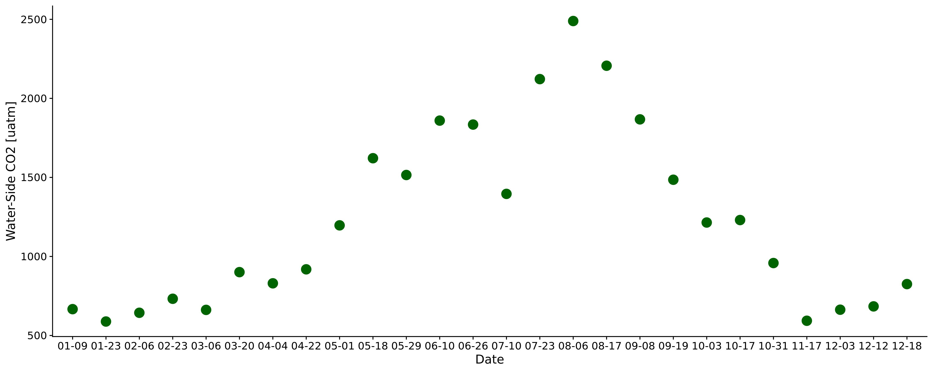

Figure S1 Timeseries of the biweekly CO2 data from Beaulieu et al. (2012). Sampling took place 2008-2009 in the Ohio River (upstream of Cincinnati, OH). Each point here was joined to the 11-day SWOT observations used in this study (section 5.2.4).

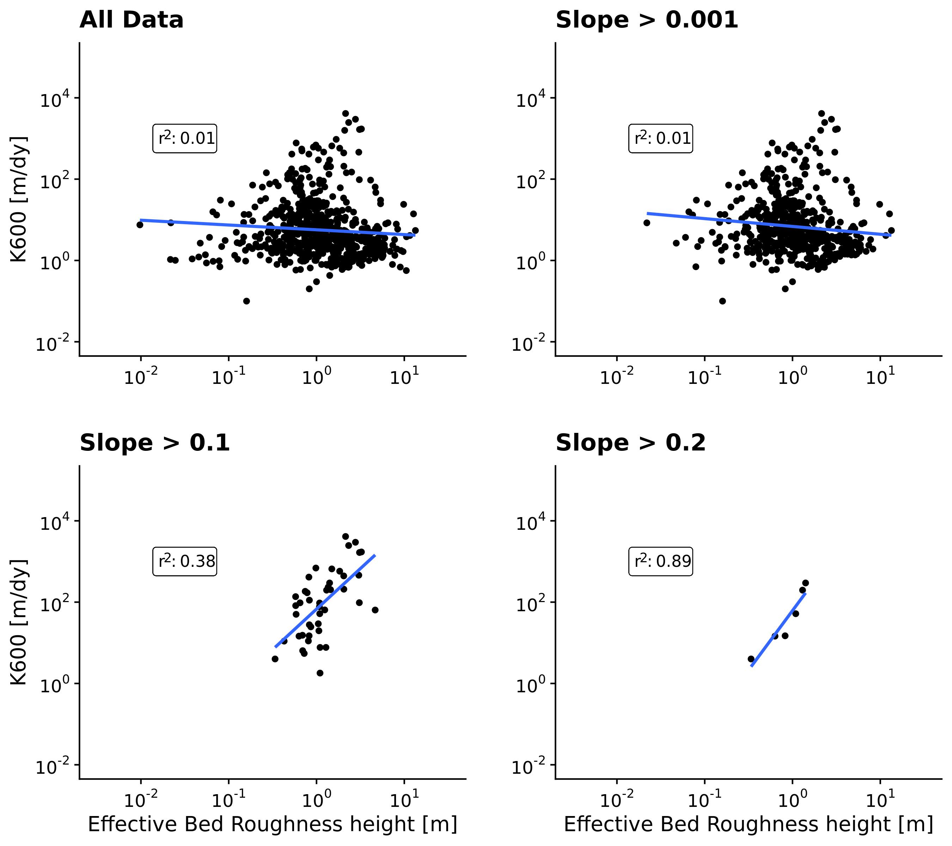

Figure S2. Scaling using an effective bed roughness term (see Text S2). This scaling relationship only exists for rivers with very steep slopes, here presented as greater than 0.1

*Table S1: Details on the 3 velocity rating curve models used to estimate bulk carbon efflux from the SWOT rivers (section 5.2.4).*

|  |  |  |  |  |
| --- | --- | --- | --- | --- |
| **Name** | **Equation** | **Description** | **Reference** |  |
| Raymond 2012 |  | Trained on their dataset | Raymond et al. (2012) |  |
| Raymond 2013 |  | Average of the Raymond 2012 equation and one trained on 9,811 USGS streamgauges | Raymond et al. (2013) |  |
| Lauerwald 2015 |  | Borrowed from ½ of the Raymond 2013 calculation (trained on 9,811 USGS streamgauges) | Lauerwald et al. (2015) |  |

## References

Dingman, S.L., 2007. Analytical derivation of at-a-station hydraulicGeometry relations. Journal of Hydrology 334, 17–27. <https://doi.org/10.1016/j.jhydrol.2006.09.021>

Ferguson, R., 1986. Hydraulics and hydraulic geometry. Progress in Physical Geography: Earth and Environment 10, 1–31. <https://doi.org/10.1177/030913338601000101>

Lauerwald, R., Laruelle, G.G., Hartmann, J., Ciais, P., Regnier, P.A.G., 2015. Spatial patterns in CO2 evasion from the global river network. Global Biogeochemical Cycles 29, 534–554. <https://doi.org/10.1002/2014GB004941>

Raymond, P.A., Hartmann, J., Lauerwald, R., Sobek, S., McDonald, C., Hoover, M., Butman, D., Striegl, R., Mayorga, E., Humborg, C., Kortelainen, P., Dürr, H., Meybeck, M., Ciais, P., Guth, P., 2013. Global carbon dioxide emissions from inland waters. Nature 503, 355–359. <https://doi.org/10.1038/nature12760>

Raymond, P.A., Zappa, C.J., Butman, D., Bott, T.L., Potter, J., Mulholland, P., Laursen, A.E., McDowell, W.H., Newbold, D., 2012. Scaling the gas transfer velocity and hydraulic geometry in streams and small rivers. Limnology and Oceanography: Fluids and Environments 2, 41–53. <https://doi.org/10.1215/21573689-1597669>

Tsivoglou, E.C., Neal, L.A., 1976. Tracer Measurement of Reaeration: III. Predicting the Reaeration Capacity of Inland Streams. Journal (Water Pollution Control Federation) 48, 2669–2689.

Ulseth, A.J., Hall, R.O., Boix Canadell, M., Madinger, H.L., Niayifar, A., Battin, T.J., 2019. Distinct airWater gas exchange regimes in low- and high-energy streams. Nature Geoscience 12, 259–263. <https://doi.org/10.1038/s41561-019-0324-8>