Supplemental Information: remote sensing riverine gas exchange and carbon efflux in ungauged rivers from SWOT observations

CB Brinkerhoff, CJ Gleason, PA Raymond, MH Harlan

2021-05-25

## Contents

This supplementary information contains 7 figures and 1 table. Please consult <https://github.com/craigbrinkerhoff/RSK600> for all code to build and generate results, figures, and the manuscript.

## Figures

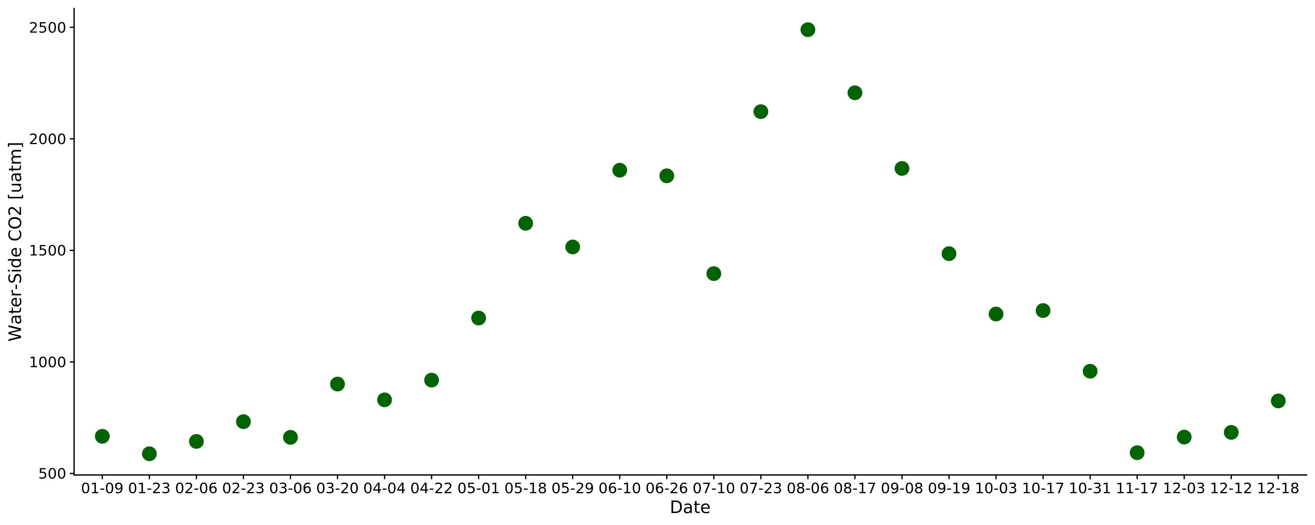

Figure S1 Timeseries of the biweekly CO2 data from Beaulieu et al. (2012). Sampling took place 2008-2009 in the Ohio River (upstream of Cincinnati, Ohio, United States). Each point here was joined to the 11-day SWOT observations used in this study (section 2.4).

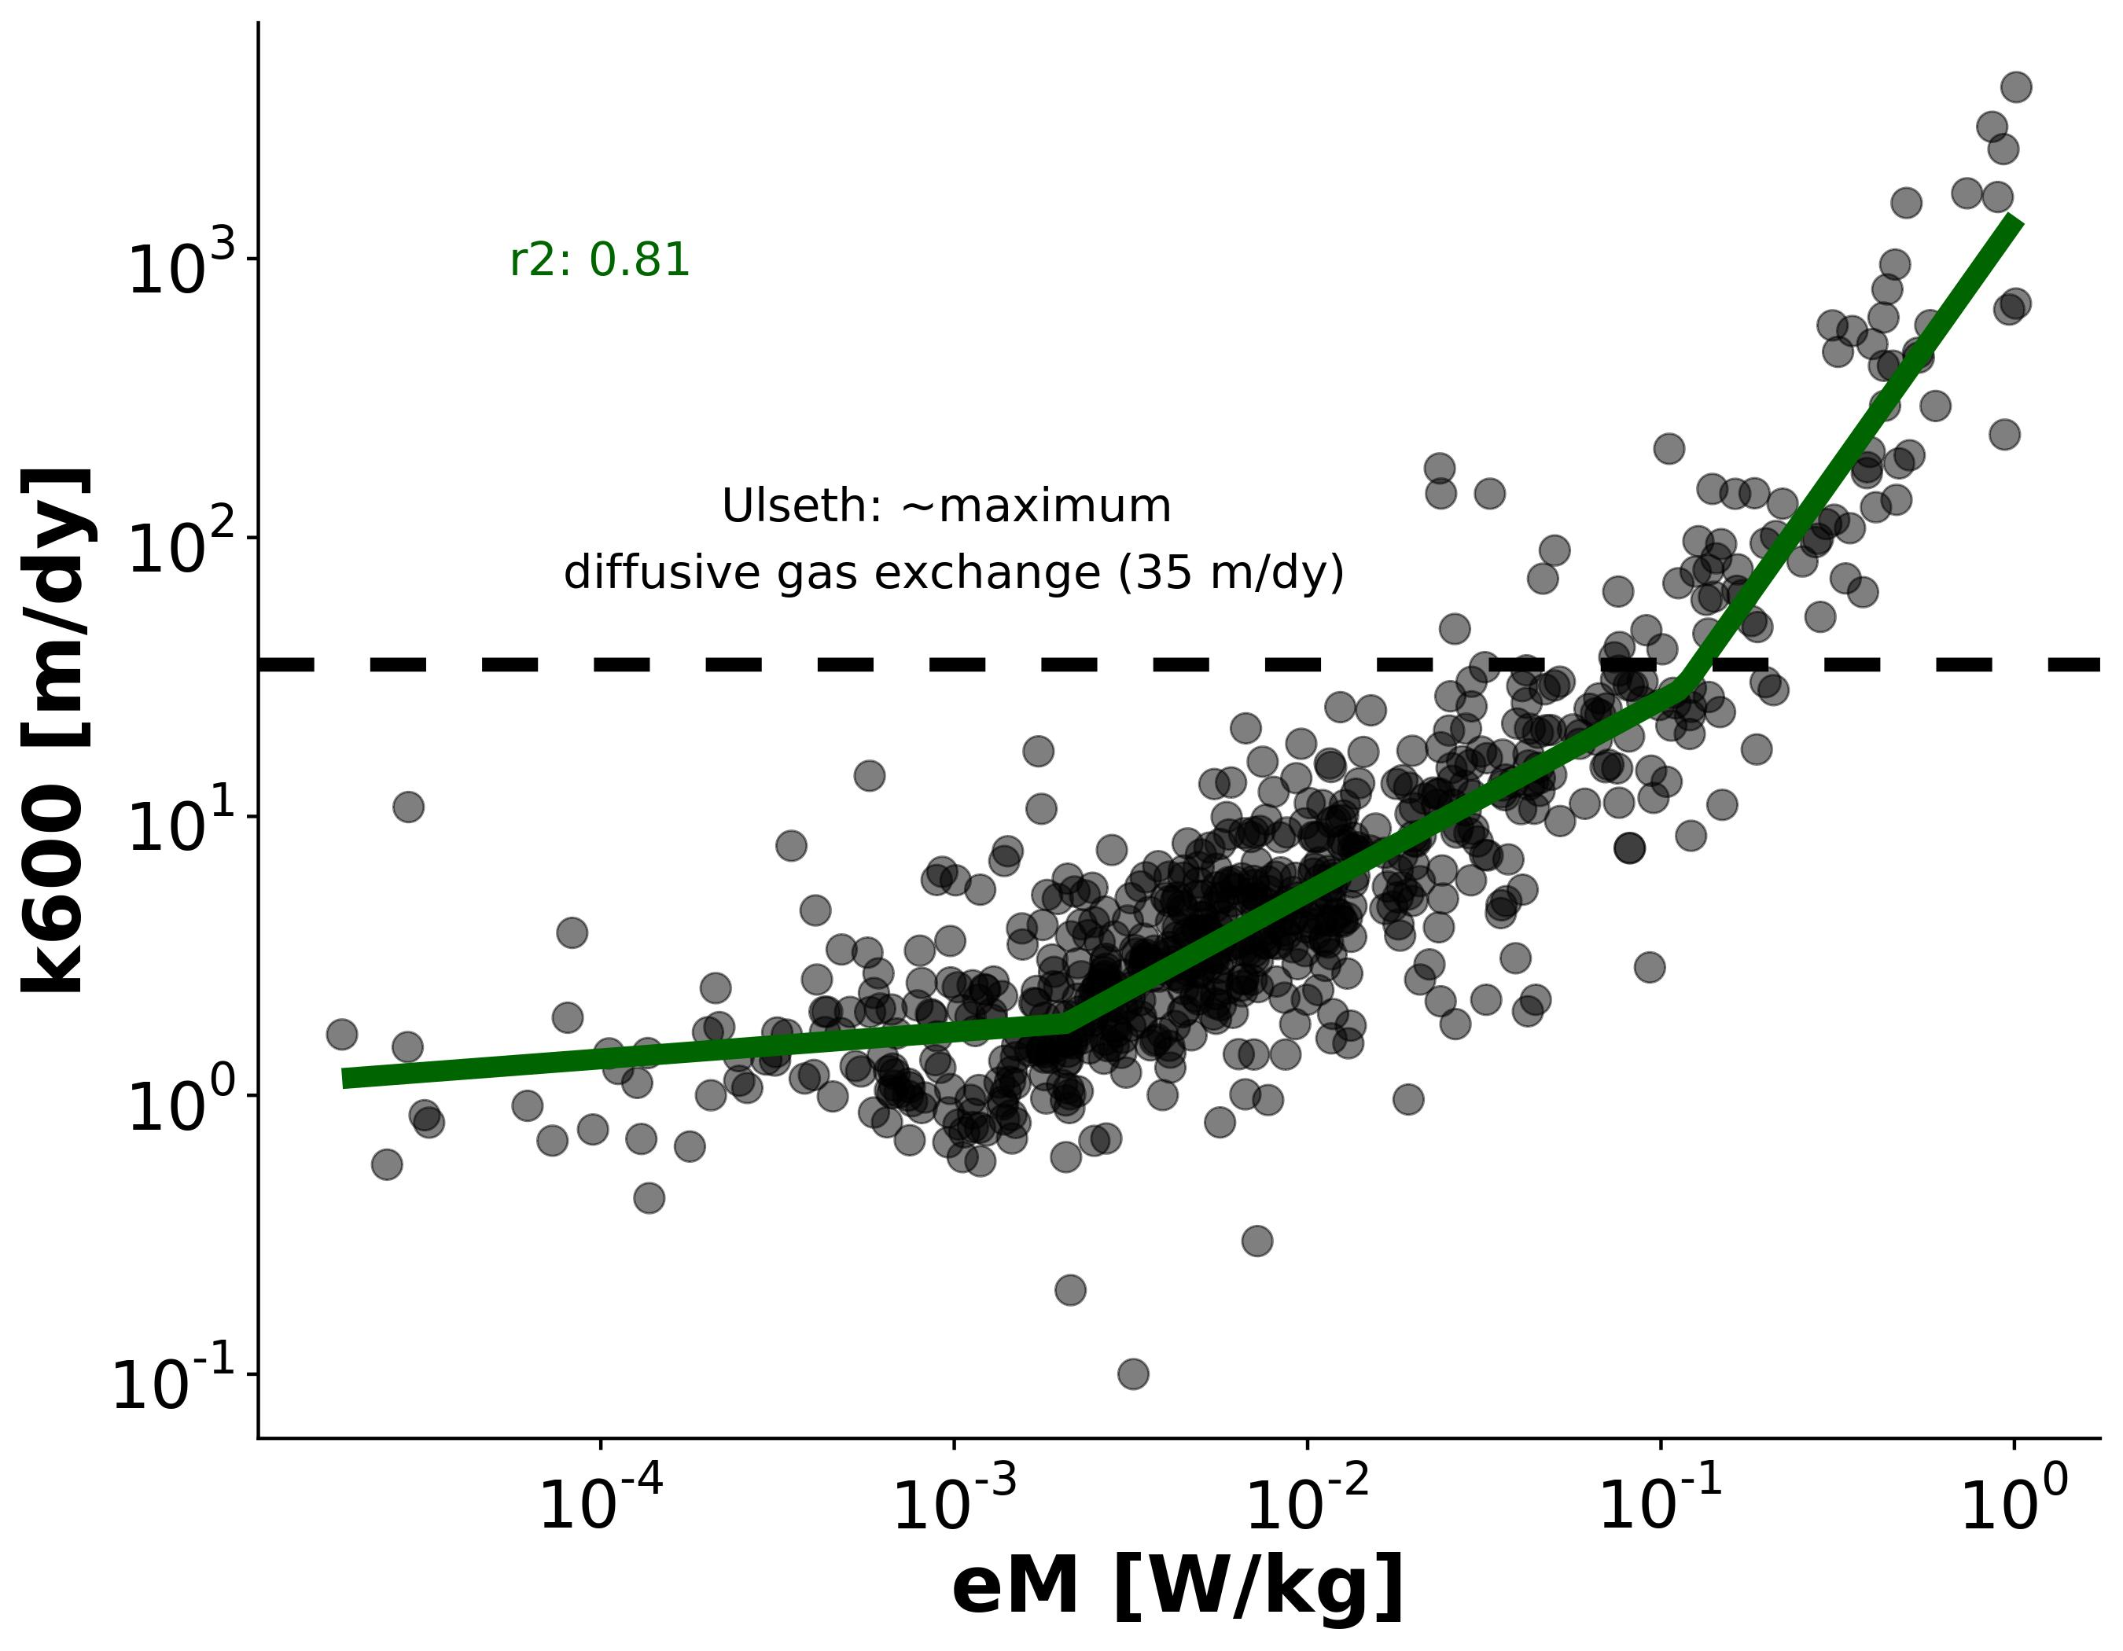

Figure S2. k600 versus the turbulent dissipation rate eD using the data from Ulseth et al. (2019). Colors correspond to whether a measurement is SWOT-observable, i.e. the river's width is > 50m. The k600 ~ eD model fundamentally breaks down in SWOT-observable rivers

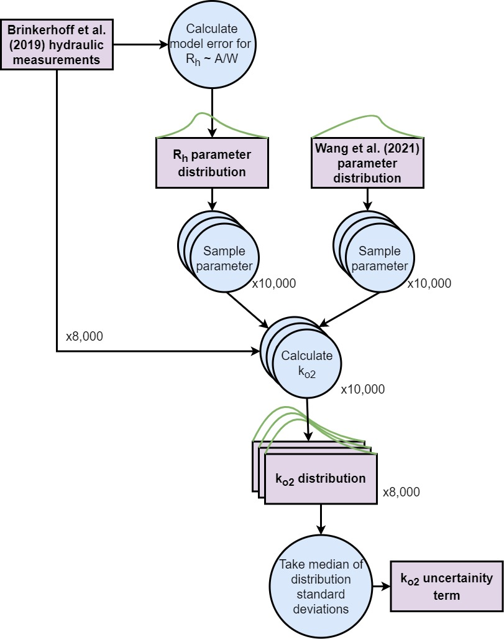

Figure S3: Flowchart detailing the workflow to approximate estimate uncertainity for equation 5 in the main text. Uncertainity can stem from 1) parameter uncertainity and 2) error in our assumption that the hydraulic radius approximates the channel area divided by width. We performed 8,000 different Monte carlo simulations (themselves 10,000 runs each) on 8,000 river channel measurements in the dataset from Brinkerhoff et al. (2019)

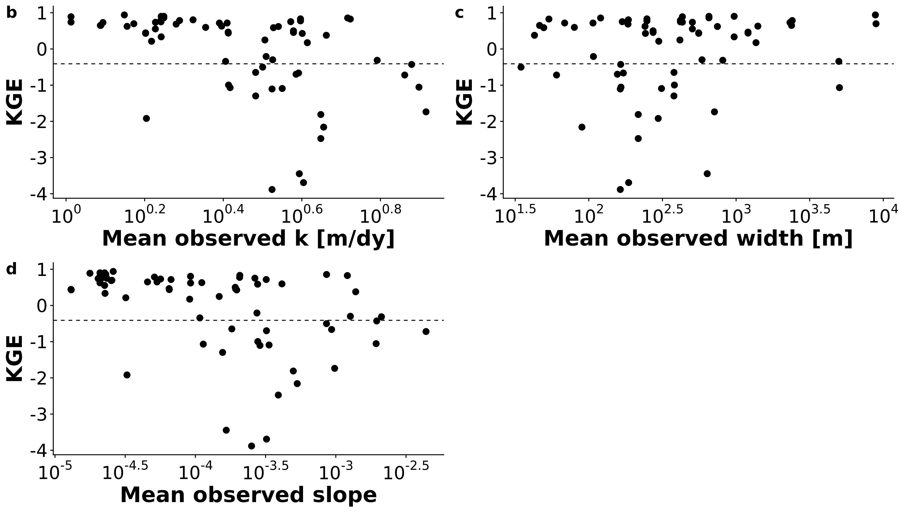

Figure S4: plot of overall BIKER uncertainity



Figure S5: BIKER performance, defined by KGE (see Table 1 in the main text for the metric definition) versus mean river ko2, width, and slope.



Figure S6: BIKER performance, defined by NRMSE (see Table 1 in the main text for the metric definition) versus mean river ko2, width, and slope.



Figure S7: BIKER performance, defined by RRMSE (see Table 1 in the main text for the metric definition) versus mean river ko2, width, and slope.

## Tables

*Table S1: Details on the 3 velocity hydraulic geometry models used to estimate FCO2 from the SWOT rivers (section 2.4).*

|  |  |  |  |  |
| --- | --- | --- | --- | --- |
| **Name** | **Equation** | **Description** | **Reference** |  |
| Raymond 2012 | $ln(V)=−1.64+0.285ln(Q)$ | Trained on their dataset | Raymond et al. (2012) |  |
| Raymond 2013 | $ln(V)=mean(−1.64+0.285ln(Q),−1.06+0.12ln(Q))$ | Average of the Raymond 2012 equation and one trained on 9,811 USGS streamgauges | Raymond et al. (2013) |  |
| Lauerwald 2015 | $ln(V)=−1.06+0.12ln(Q)$ | Borrowed from 1/2 of the Raymond 2013 calculation (trained on 9,811 USGS streamgauges) | Lauerwald et al. (2015) |  |

## References

Beaulieu, J.J., Shuster, W.D., Rebholz, J.A., 2012. Controls on gas transfer velocities in a large river. Journal of Geophysical Research: Biogeosciences 117. <https://doi.org/10.1029/2011JG001794>

Brinkerhoff, C.B., Gleason, C.J., Ostendorf, D.W., 2019. Reconciling at-a-Station and at-Many-Stations Hydraulic Geometry Through River-Wide Geomorphology. Geophysical Research Letters 46, 9637–9647. <https://doi.org/10.1029/2019GL084529>

Lauerwald, R., Laruelle, G.G., Hartmann, J., Ciais, P., Regnier, P.A.G., 2015. Spatial patterns in CO2 evasion from the global river network. Global Biogeochemical Cycles 29, 534–554. <https://doi.org/10.1002/2014GB004941>

Raymond, P.A., Hartmann, J., Lauerwald, R., Sobek, S., McDonald, C., Hoover, M., Butman, D., Striegl, R., Mayorga, E., Humborg, C., Kortelainen, P., Dürr, H., Meybeck, M., Ciais, P., Guth, P., 2013. Global carbon dioxide emissions from inland waters. Nature 503, 355–359. <https://doi.org/10.1038/nature12760>

Raymond, P.A., Zappa, C.J., Butman, D., Bott, T.L., Potter, J., Mulholland, P., Laursen, A.E., McDowell, W.H., Newbold, D., 2012. Scaling the gas transfer velocity and hydraulic geometry in streams and small rivers. Limnology and Oceanography: Fluids and Environments 2, 41–53. <https://doi.org/10.1215/21573689-1597669>

Ulseth, A.J., Hall, R.O., Boix Canadell, M., Madinger, H.L., Niayifar, A., Battin, T.J., 2019. Distinct airWater gas exchange regimes in low- and high-energy streams. Nature Geoscience 12, 259–263. <https://doi.org/10.1038/s41561-019-0324-8>