

**ASSIGNMENT COVER SHEET**

**Student Name: Craig Cormack Stephen Blaney**

**ID Number: B00084363**

**Course:** [**COMP H3012 - Object Orientation with Design Patterns**](http://moodle.itb.ie/course/view.php?id=73)

**Year: Year 3**

**Lecturer:**[**Orla McMahon**](http://moodle.itb.ie/user/view.php?id=1213&course=1)

Title of Assignment: Design Patterns Assignment 2

**Due Date: Sunday 26th of March**

**Date Submitted: Monday 27th of March**

The material contained in this assignment is the authors original work, except where work quoted is duly acknowledged in the text. No aspect of this assignment has been previously submitted for assessment in any other unit or course.

Signed: _______________________________ Date: ______/______/______

# Abstract

The application is used to view and purchase items from a clothing shop for men and women. The details of the shop fall under the headings of jersey, equipment, women’s clothing and men’s clothing. The user should be able to gain extra information about any of the products by selecting the product from the list. Each product has an image that accompanies each of the products.

# Design

## GUI Design

The application design began with how the GUI (graphical user interface) of the application would look like and the colour scheme. There will be 5 JFrame’s used to represent the home page, jersey page, equipment page, women’s clothing page and men’s clothing page. The look will be different for the home page to the other four pages. The home page will be made up of a JList, 4 JButtons and a JMenu. The home page is used to navigate around the application to the other pages and give some information about the store to the user. The other four pages will have the same components like JList, 3 JButtons, 3 JLabels and 2 JRadioButtons. The layout that is used for the four JFrames is border layout which lays out the components to the north, centre, south and east regions on the JFrame. Within each of these regions there is a JPanel which is used to hold all the components. The centre panel layout is set to grid layout of a 2 by 2 with the top left has a jlist, top right has a jlabel, bottom left has a jlabel and bottom right has a jlabel. With the centre panel acting has the screen of the application. The south panel layout is set to a grid layout of a 3 by 1 left has a JButton, centre has a JButton and the right has a JButton. The east panel is set to a grid layout of 2 by 1 top has a JRadioButton and the bottom has a JRadioButton. The Jlabels in the centre panel acts as the screen of the application.

# Class Design

The application is made up of 27 classes the reason for the high amount is that a requirement for this application was that 4 design patterns had to be implemented. Five of these classes are used for the JFrame’s of the home page and the store pages. These classes are MainAppicationPage, Jersey, Equipment, Women and Men. Most of all the data used in this application is stored in a json file. A utility class handles all the backend connection to the json file it is called JsonUtil. In each of the store JFrame pages there is calls to this classes which then displays the data on the Jersey, Equipment, Women and Men pages.

## Class Design Patterns

Four design patterns where used in the making of this application they are simple factory, façade, command and proxy. Each of the patterns implemented certain functionality to the application. For example the simple factory pattern was implemented to create and store the product values in the jlist on the store pages. The pattern is implemented by creating six classes ItemsList, ItemsFactory, JerseyList, EquipmentList, WomenList and MenList. The façade pattern was implemented to hide the message and radio buttons associated with a competition function of the application. The façade pattern is implemented by 6 classes Comp, CompMaker, JerseyComp, EquipmentComp, WomenComp and MenComp.

### Simple Factory Pattern

The ItemsList class is made abstract and acts as an interface of the application. It sets the lists for all the product pages in the constructor of the class. It has the getter methods for these lists. It has a display method which creates an instance of JList which is used to store the products of the store pages. It is made abstract so that any classes that extend it must implement the methods or variables that are declared.

ItemsFactory is used to decide what list is to be created it takes in an argument of string list and depending on this input. It will create an instance of type JerseyList, EquipmentList, WomenList and MenList.

The store pages named NameList classes for example JerseyList extend the ItemsList class which inherit the display method which is used to show the products of the page. The JerseyList constructor uses a StringTokenizer to go through the list of products and adds them to the string array jerseyList. This then adds the contents of the jerseyList to the jlist this is done in the display method this then returns an instance of type JList which will then be called in Jersey to set up the JList in Jersey.

Jersey class creates an object of type string which gets the data from the json file like **String list = new String(Json().getJersey()).** It then creates an instance of ItemsFactory like **ItemsFactory factory = new ItemsFactory()**. Which then uses that instance of the class to set the list of products using the **factory.getItems(list).** To display the products it uses **jlist = factory.getItems(list).display().** This is done for all the pages that implement the simple factory pattern.

### Façade Pattern

The Comp class is made abstract and acts as an interface to the application it sets the method signatures that must be implemented by any of the classes that inherit from it.

The Comp named classes are used to set the functions of the competition functionality of the façade pattern. For example the JerseyComp class implements the Comp class which then means it inherits the methods of the Comp class it is in here which is where the pattern is implemented. The methods are displayYes, displayNo, radioYes and radioNo. The displayYes method returns an object of type String with a message. For example **int num=0 return new String (new JsonUtil().getJerseyComp(num)).** The int num is set to 0 or 1 which is passed in the JsonUtil().getJerseyComp(num)) which then looks up the json file for the message. This is the same for the displayNo method with the int num = 1 which displays a different message. The radioYes method returns an instance of type JRadioButton for example **return new JRadioButton(“Yes”)**. This is the same for the radioNo method with the only difference being the text of the button will be “No”.

The CompMaker class sets up instances of the named classes in its constructor. It then has four methods for each of the Comp named classes. For example the Jersey class has displayJerseyYes, displayJerseyNo, displayRadioYes and displayRadioNo. The displayJerseyYes method returns a type String like **return jersey.displayYes().** This is the same for the displayJerseyNo method with the return being displayNo(). The displayRadioYes method returns a type JRadioButton like **return jersey.displayRadioYes().** This is the same for the displayRadioNo method with the return being displayRadioNo().

The Jersey class creates an instance of the class CompMaker and JsonUtil. Inside methods of Json() and getComp(). It then use these to set the messages and radio buttons. It builds the radio buttons by **yes = getComp().displayRadioYes() and no = getComp().displayNo()**. It sets the messages by placing them behind the actions of clicking the radio buttons like so **labelComp.setText ("<html>"+getComp().displayJerseyYes()+"<br></html>") and labelComp.setText ("<html>"+getComp().displayJerseyNo()+"<br></html>")**.

# Data Design

The data for most of the application is stored in a json file called content.json which is accessed through the JsonUtil class. It uses a StringTokenizer to populate the jlist items on the store pages. To get the images and the descriptions of the products it takes the index of the item selected in the jlist and passes this to the method in the JsonUtil file. This will then look up the json array and pull the data matching the parameters passed in. The data for the competition messages is pulled by a parameter in the Comp named methods. 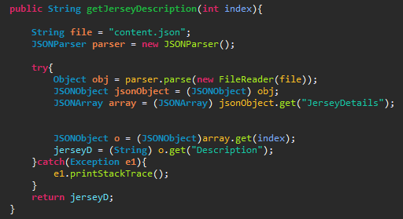  
2.1 Json Jersey Description

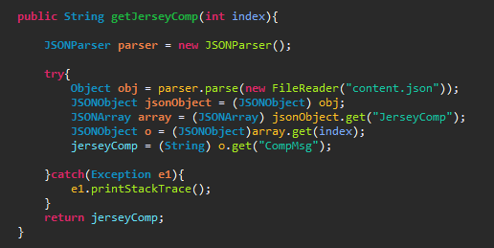  
2.2 Json Jersey Competition Message

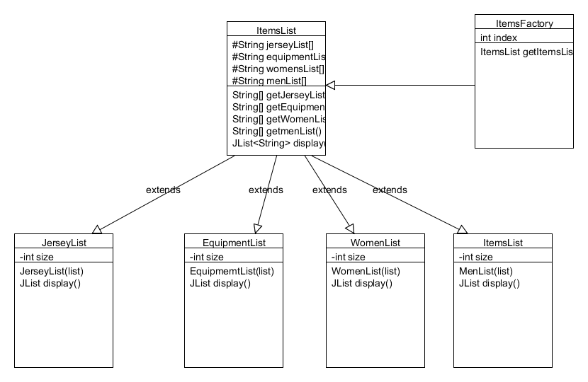  
2.3 Simple Factory Pattern UML

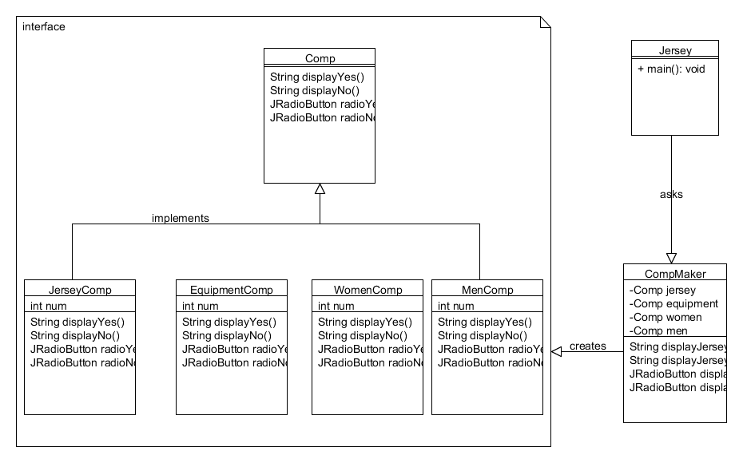  
2.4 Façade pattern UML

# Adding Design

To add more products to the store you can add a supplementList array into the ItemsList and add a method getSupplementList. You then create a class called SupplementList class which will use a StringTokenizer to populate an array which then uses the display method to populate the JList. You would then create a class called Supplement which would then create an instance of the class ItemsFactory, JsonUtil. It would then create an object of type String and use the JsonUtil instance to populate the String. It would then use the factory instance to set the jlist using **jlist = factory.getItemsList().display()**. You would put the data for the new Supplement class into the json file.

To add a message for the competition and radio buttons you would then create the class SupplementComp which implements the Comp abstract class. You would then implement the methods from Comp in SupplementComp and set the messages in displayYes and displayNo you would add the messages to the json file and set up a new method in the JsonUtil class to handle the request. The creation of the messages is done like so in the SupplementComp class **return new String (new JsonUtil().getSupplementComp(num))** .

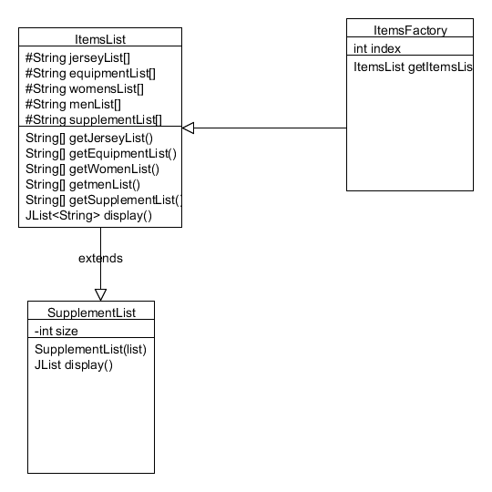  
2.5 Simple Factory Pattern Adding UML

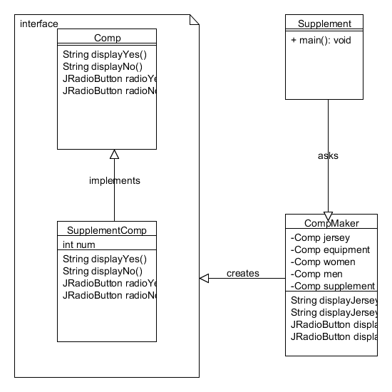  
2.6 Façade Pattern Adding UML

# References

Jersey Images

Manchester City <https://www.google.ie/search?q=Manchester+city+jersey+2016&biw=1366&bih=662&tbm=isch&source=lnt&tbs=isz:ex,iszw:230,iszh:230#imgrc=xgz6RDumOFc-uM>:

Liverpool

<https://www.google.ie/search?q=liverpool+home+jersey+2016&biw=1366&bih=662&tbm=isch&source=lnt&tbs=isz:ex,iszw:230,iszh:230#imgrc=_>

Barcalona

[https://www.google.ie/search?q=celtic+home+jersey+2016/2017&biw=1366&bih=662&tbm=isch&source=lnt&tbs=isz:ex,iszw:230,iszh:230#tbs=isz:ex,iszw:230,iszh:230&tbm=isch&q=Barcalona+home+jersey+2016/2017&*&imgrc=Gqqo51JZHmD_dM](https://www.google.ie/search?q=celtic+home+jersey+2016/2017&biw=1366&bih=662&tbm=isch&source=lnt&tbs=isz:ex,iszw:230,iszh:230#tbs=isz:ex,iszw:230,iszh:230&tbm=isch&q=Barcalona+home+jersey+2016/2017&*&imgrc=Gqqo51JZHmD_dM):

Bayern Munich

[https://www.google.ie/search?q=celtic+home+jersey+2016/2017&biw=1366&bih=662&tbm=isch&source=lnt&tbs=isz:ex,iszw:230,iszh:230#tbs=isz:ex,iszw:230,iszh:230&tbm=isch&q=Bayern+home+jersey+2016/2017&*&imgrc=k_LyRpGx_cEMxM](https://www.google.ie/search?q=celtic+home+jersey+2016/2017&biw=1366&bih=662&tbm=isch&source=lnt&tbs=isz:ex,iszw:230,iszh:230#tbs=isz:ex,iszw:230,iszh:230&tbm=isch&q=Bayern+home+jersey+2016/2017&*&imgrc=k_LyRpGx_cEMxM):

Arsenal

[https://www.google.ie/search?q=celtic+home+jersey+2016/2017&biw=1366&bih=662&tbm=isch&source=lnt&tbs=isz:ex,iszw:230,iszh:230#tbs=isz:ex,iszw:230,iszh:230&tbm=isch&q=Arsenal+home+jersey+2016/2017&*&imgrc=_](https://www.google.ie/search?q=celtic+home+jersey+2016/2017&biw=1366&bih=662&tbm=isch&source=lnt&tbs=isz:ex,iszw:230,iszh:230#tbs=isz:ex,iszw:230,iszh:230&tbm=isch&q=Arsenal+home+jersey+2016/2017&*&imgrc=_)

Celtic

<https://www.google.ie/search?q=celtic+home+jersey+2016/2017&biw=1366&bih=662&tbm=isch&source=lnt&tbs=isz:ex,iszw:230,iszh:230#imgrc=7NtO7D6-dMbpTM>:

Equipment

Dumbbells

[https://www.google.ie/search?q=celtic+home+jersey+2016/2017&biw=1366&bih=662&tbm=isch&source=lnt&tbs=isz:ex,iszw:230,iszh:230#tbs=isz:ex,iszw:230,iszh:230&tbm=isch&q=dumb+bells&*&imgrc=JpPhg8AzM3U1VM](https://www.google.ie/search?q=celtic+home+jersey+2016/2017&biw=1366&bih=662&tbm=isch&source=lnt&tbs=isz:ex,iszw:230,iszh:230#tbs=isz:ex,iszw:230,iszh:230&tbm=isch&q=dumb+bells&*&imgrc=JpPhg8AzM3U1VM):

Bench press

[https://www.google.ie/search?q=celtic+home+jersey+2016/2017&biw=1366&bih=662&tbm=isch&source=lnt&tbs=isz:ex,iszw:230,iszh:230#tbs=isz:ex,iszw:230,iszh:230&tbm=isch&q=bench+press&*&imgrc=vXMjSIPuoR69yM](https://www.google.ie/search?q=celtic+home+jersey+2016/2017&biw=1366&bih=662&tbm=isch&source=lnt&tbs=isz:ex,iszw:230,iszh:230#tbs=isz:ex,iszw:230,iszh:230&tbm=isch&q=bench+press&*&imgrc=vXMjSIPuoR69yM):

ThreadMill  
[https://www.google.ie/search?q=celtic+home+jersey+2016/2017&biw=1366&bih=662&tbm=isch&source=lnt&tbs=isz:ex,iszw:230,iszh:230#tbs=isz:ex,iszw:230,iszh:230&tbm=isch&q=treadmill&*&imgrc=4F7NyW6swZuDoM](https://www.google.ie/search?q=celtic+home+jersey+2016/2017&biw=1366&bih=662&tbm=isch&source=lnt&tbs=isz:ex,iszw:230,iszh:230#tbs=isz:ex,iszw:230,iszh:230&tbm=isch&q=treadmill&*&imgrc=4F7NyW6swZuDoM):

Medicine Ball

[https://www.google.ie/search?q=celtic+home+jersey+2016/2017&biw=1366&bih=662&tbm=isch&source=lnt&tbs=isz:ex,iszw:230,iszh:230#tbs=isz:ex,iszw:230,iszh:230&tbm=isch&q=medicine+ball&*&imgrc=HvDdvqAVBCxmdM](https://www.google.ie/search?q=celtic+home+jersey+2016/2017&biw=1366&bih=662&tbm=isch&source=lnt&tbs=isz:ex,iszw:230,iszh:230#tbs=isz:ex,iszw:230,iszh:230&tbm=isch&q=medicine+ball&*&imgrc=HvDdvqAVBCxmdM):

Tennis racket

[https://www.google.ie/search?q=celtic+home+jersey+2016/2017&biw=1366&bih=662&tbm=isch&source=lnt&tbs=isz:ex,iszw:230,iszh:230#tbs=isz:ex,iszw:230,iszh:230&tbm=isch&q=tenis+racket&*&imgrc=iYJnrLGQpPr6RM](https://www.google.ie/search?q=celtic+home+jersey+2016/2017&biw=1366&bih=662&tbm=isch&source=lnt&tbs=isz:ex,iszw:230,iszh:230#tbs=isz:ex,iszw:230,iszh:230&tbm=isch&q=tenis+racket&*&imgrc=iYJnrLGQpPr6RM):

Golf clubs

[https://www.google.ie/search?q=celtic+home+jersey+2016/2017&biw=1366&bih=662&tbm=isch&source=lnt&tbs=isz:ex,iszw:230,iszh:230#tbs=isz:ex,iszw:230,iszh:230&tbm=isch&q=golf+clubs&*&imgrc=7ieJdBFc4AmXBM](https://www.google.ie/search?q=celtic+home+jersey+2016/2017&biw=1366&bih=662&tbm=isch&source=lnt&tbs=isz:ex,iszw:230,iszh:230#tbs=isz:ex,iszw:230,iszh:230&tbm=isch&q=golf+clubs&*&imgrc=7ieJdBFc4AmXBM):

Equipment Bios

Thread mill

<http://www.argos.ie/static/Product/partNumber/3197570/c_1/1%7Ccategory_root%7CSports+and+leisure%7C14419152/c_2/3%7C15701400%7CHome+gym+equipment%7C14419293/c_3/4%7Ccat_14419293%7CTreadmills%7C14419318.htm>

Medicine ball

<http://www.argos.ie/static/Product/partNumber/2788478/Trail/searchtext%3EMEDICINE+BALL.htm>

Tennis racket

<http://www.argos.ie/static/Product/partNumber/4049641/c_1/1%7Ccategory_root%7CSports+and+leisure%7C14419152/c_2/3%7Ccat_19536186%7CTennis%7C14419063.htm>

Golf clubs

<http://www.argos.ie/static/Product/partNumber/2143927/Trail/searchtext%3EGOLF+CLUBS.htm>

Pattern

<https://www.tutorialspoint.com/design_pattern/facade_pattern.htm>