

**ASSIGNMENT COVER SHEET**

**Student Name: Craig Cormack**

**ID Number: B00084363**

**Course:** [**COMP H3012 - Object Orientation with Design Patterns**](http://moodle.itb.ie/course/view.php?id=73)

**Year: Year 3**

**Lecturer:**[**Orla McMahon**](http://moodle.itb.ie/user/view.php?id=1213&course=1)

Title of Assignment: Design Patterns Assignment 1

**Due Date: Monday 27th of February**

**Date Submitted: Monday 27th of February**

The material contained in this assignment is the authors original work, except where work quoted is duly acknowledged in the text. No aspect of this assignment has been previously submitted for assessment in any other unit or course.

Signed: _______________________________ Date: ______/______/______

Contents

Abstract 1

Design 1

GUI Design 1

1 Home Page 2

1.2Galway Page 3

1.4Kildare Page 3

Class Design 4

Data Design 4

UML Design 5

Adding Design 6

UML add county 6

Conclusion 6

References 7

# Abstract

The application is used to search and view a range of different trip details of counties in Ireland. These details fall under the headings of hotels, restaurants, places of interests and things to do. The user should be allowed to obtain extra information about a hotel, restaurant, place of interest and things to do. By selecting it and choosing one of the options of name, description or location. The number of counties that the application covers is four Dublin, Kildare, Cork and Galway. Accompanying the above features will be an image of the county on a map along with a brief description about that county.

# Design

## GUI Design

The application design began with how the GUI (graphical user interface) would be designed. There will be five JFrames used to represent each of the counties the four county pages will be exactly the same with only the content changing. The other page will be the home page which will have an image and some text with four JButtons which will be used for navigation around the pages by the user. The layout that is used for the JFrames is border layout this lays out the components in the north, south, east and west regions on the JFrame. Within each of these headings there are JPanels which are used to hold all the components like JButtons, JLabels etc on the JFrame. The east, west and south regions hold the JButtons for the application. The centre region holds the JLabel which act like the screen of the application which displays the actions to the user input.

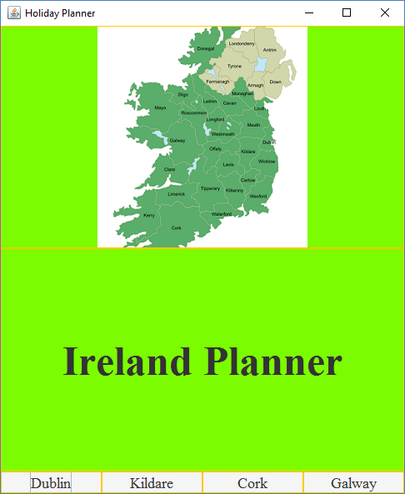

### 1 Home Page

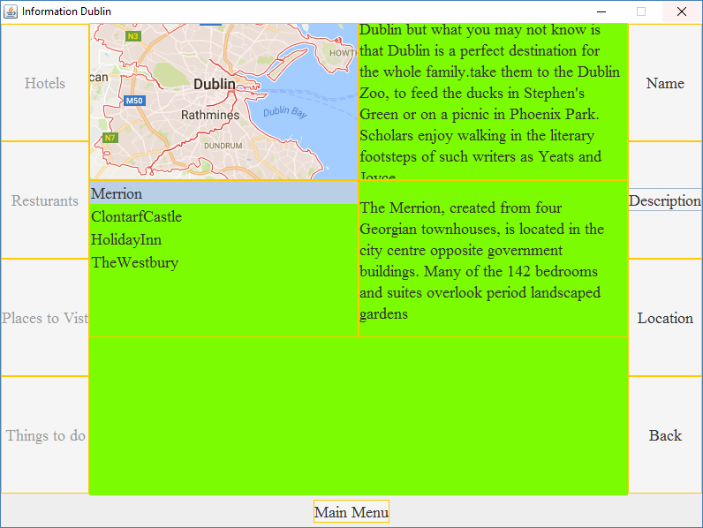  
1.1 Dublin Page

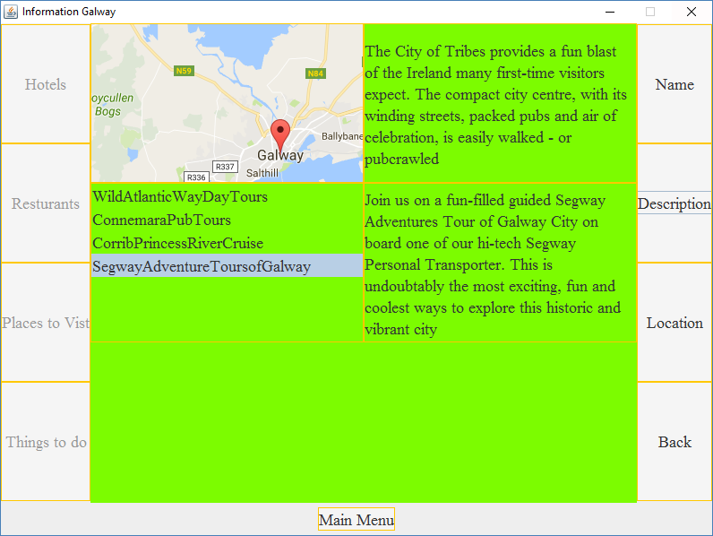

### 1.2Galway Page

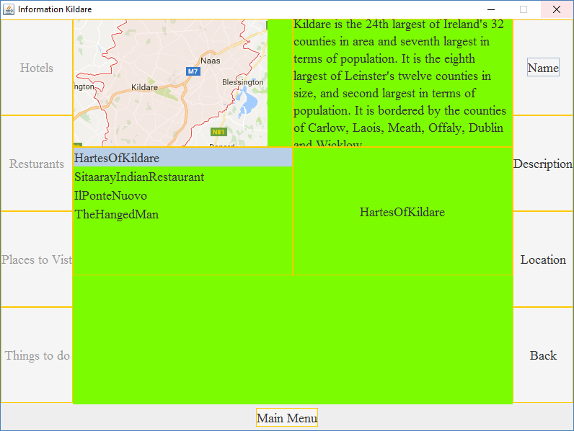

### 1.4Kildare Page

## Class Design

The application is made up of eleven classes five of which represent the JFrames the five classes are ShowDublinInfo, ShowKildareInfo, ShowCorkInfo, ShowGalwayInfo and Planner. Most of the data used in the application is stored in a json file. Four of the classes are used for the backend handling of the data they act has utility classes that handle the connection between the application and the json file. They contain the object creation and getter and setter methods for the application also. The names of these classes are DublinCounty, KildareCounty, CorkCounty and GalwayCounty.

A design pattern was used in the class design for the application. The particular pattern chosen was the abstract factory pattern. The two classes which are used to implement the pattern is County which is made abstract and Information. The abstract class acts as the interface of the application this is where the methods which you want mandatory in the application to be declared. This means anything declared in here must be implemented by any class that subclasses the County class which is what the DublinCounty, KildareCounty, CorkCounty and GalwayCounty does. The Information class is where the constructors and getter methods are declared for object creation. The concrete implementations of the objects are created in DublinCounty, KildareCounty, CorkCounty and GalwayCounty.

## Data Design

The data for the application is stored in a json file which uses arrays each of the sections for hotels, restaurants, places and things to do are stored in an array under those headings. The name, description and location are all stored in a separate array. To access the json file from the application the json-simple-1.1.jar file had to be imported into the project. This then allowed for the use of the methods to pull the data from the json file. The application when launched uses a StringTokenizer to search through the first array populating the JList with the entries. The second array with the particular information on each entry is accessed by passing a parameter of the selected value from the StringTokenizer option which then searches the second array and returns the value to be displayed in the JLabel.

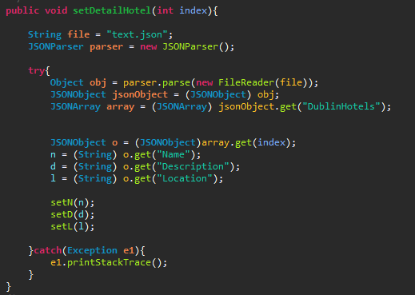

2 json code in DublinCounty to pull the information of particular entry for hotels

## UML Design

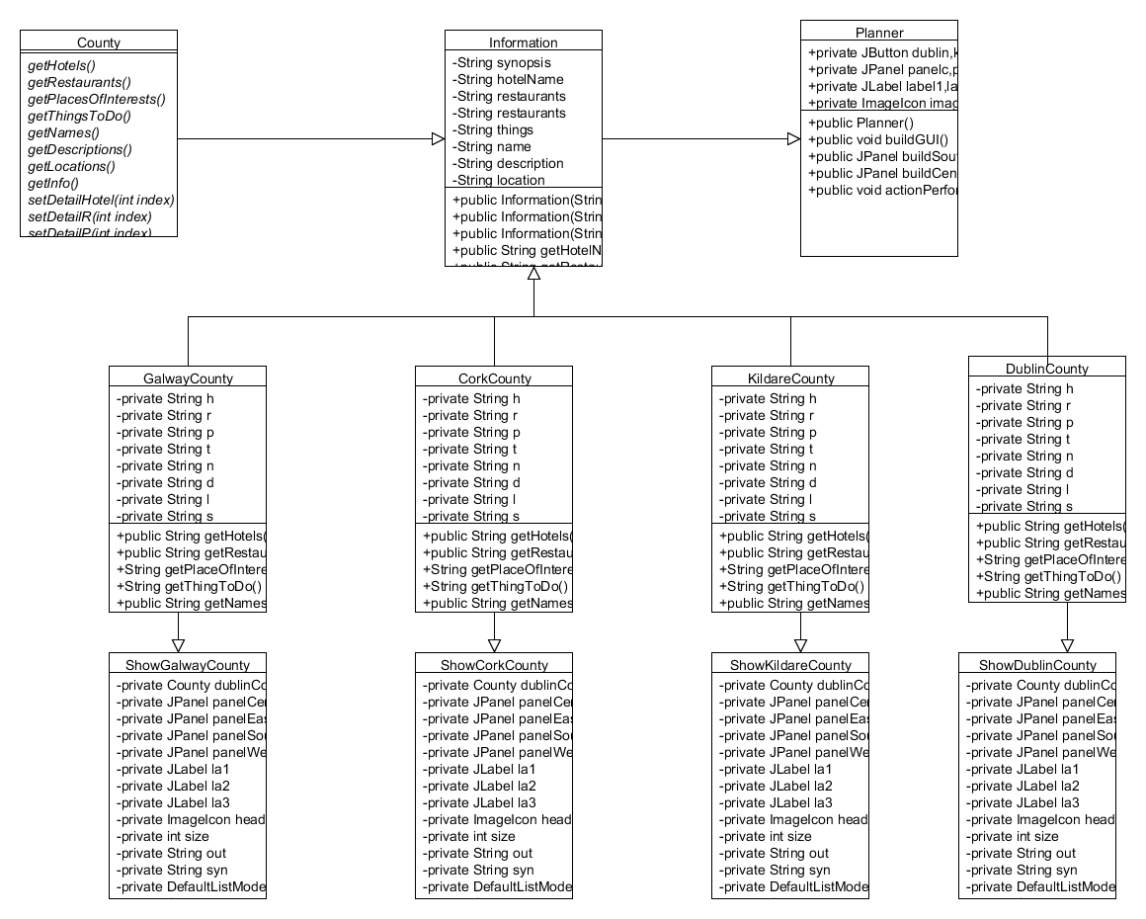

## Adding Design

To add another county to the application you would create two classes for example WaterfordCounty which has the getter and setter methods. The methods which are used to access the json file. The content of the classes is created here by creating an object of the information class. You would then create the ShowWaterfordInfo this is the JFrame class which is used to display the GUI of the county. It uses the WaterfordCounty class to retrieve the information in the json file.

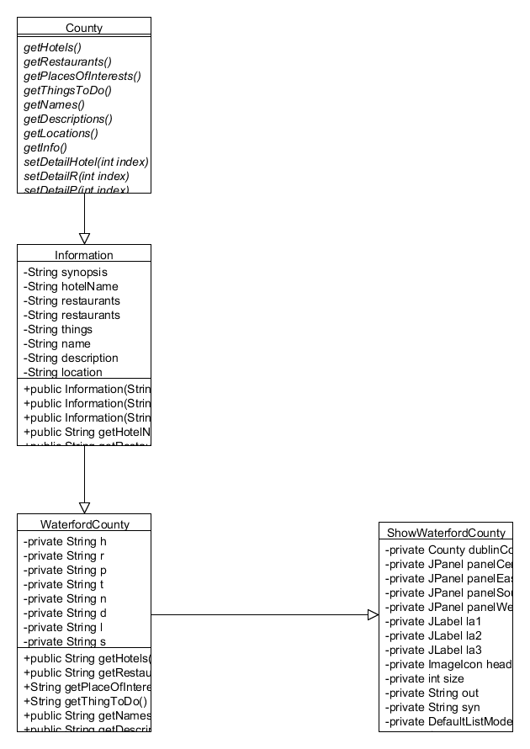

### UML add county

# Conclusion

The project was a success with all the targets being achieved. The most difficult task was the storing of the data in a json file. The time spent on that part of the application was about eight hours but was worth all the time spent because a new skill was gained which can be used sometime in the future. The GUI design is a fairly basic one which should aid the user experience of using it. A lot of the time for the application was spent on the backend so the look may not be as good as it should be. The emphasis on functionality over the look of the application was a personal choice which is believed to be of higher importance. If more time was allocated the embedding of google maps into the application would have been implemented. This would have allowed the user to conduct searches of their own accord enhancing the productivity of the application.

# References

Dublin restaurants ref

https://www.tripadvisor.ie/Restaurant_Review-g186605-d1146791-Reviews-Dax_Restaurant-Dublin_County_Dublin.html

https://www.tripadvisor.ie/Restaurant_Review-g186605-d2239110-Reviews-Mulberry_Garden-Dublin_County_Dublin.html

https://www.tripadvisor.ie/Restaurant_Review-g186605-d10004867-Reviews-Pickle-Dublin_County_Dublin.html

Dublin places ref

https://www.tripadvisor.ie/AttractionProductDetail?product=2776GUINSIGNATURE&d=189694&aidSuffix=xsell&partner=Viator

https://www.tripadvisor.ie/Attraction_Review-g186605-d214882-Reviews-Dublin_Castle-Dublin_County_Dublin.html

https://www.tripadvisor.ie/Attraction_Review-g186605-d10119599-Reviews-GPO_Witness_History_Visitor_Centre-Dublin_County_Dublin.html

Dublin hotels

https://www.tripadvisor.ie/Hotel_Review-g186605-d10693049-Reviews-Holiday_Inn_Express_Dublin_City_Centre-Dublin_County_Dublin.html

https://www.tripadvisor.ie/Hotel_Review-g186605-d212688-Reviews-Clontarf_Castle_Hotel-Dublin_County_Dublin.html

https://www.tripadvisor.ie/Hotel_Review-g186605-d208232-Reviews-The_Merrion_Hotel-Dublin_County_Dublin.html

https://www.tripadvisor.ie/Hotel_Review-g186605-d209084-Reviews-The_Westbury-Dublin_County_Dublin.html

Dublin things ref

https://www.tripadvisor.ie/Attraction_Review-g186605-d546279-Reviews-Croke_Park_Stadium_Tour_GAA_Museum-Dublin_County_Dublin.html

https://www.tripadvisor.ie/Attraction_Review-g186605-d191025-Reviews-Kilmainham_Gaol-Dublin_County_Dublin.html

https://www.tripadvisor.ie/Attraction_Review-g186605-d214896-Reviews-Glasnevin_Cemetery_Museum-Dublin_County_Dublin.html

https://www.tripadvisor.ie/Attraction_Review-g186605-d6748565-Reviews-Dublin_Free_Walking_Tour-Dublin_County_Dublin.html

dublin overview ref

https://www.tripadvisor.ie/Tourism-g186605-Dublin_County_Dublin-Vacations.html

kildare hotels ref

https://www.tripadvisor.ie/Hotel_Review-g656612-d7262971-Reviews-Kildare_House_Hotel-Kildare_County_Kildare.html

https://www.tripadvisor.ie/Hotel_Review-g656612-d1727441-Reviews-Lord_Edward-Kildare_County_Kildare.html

https://www.tripadvisor.ie/Hotel_Review-g656612-d6418436-Reviews-The_Curragh_B_B_Country_House_Accommodation-Kildare_County_Kildare.html

Kildare restaurants

https://www.tripadvisor.ie/Restaurant_Review-g656612-d2217132-Reviews-Hartes_Of_Kildare-Kildare_County_Kildare.html

https://www.tripadvisor.ie/Restaurant_Review-g656612-d4734628-Reviews-Sitaaray_Indian_Restaurant-Kildare_County_Kildare.html

https://www.tripadvisor.ie/Restaurant_Review-g315876-d8659399-Reviews-Il_Ponte_Nuovo-Newbridge_County_Kildare.html

https://www.tripadvisor.ie/Restaurant_Review-g656612-d1439859-Reviews-The_Hanged_Man-Kildare_County_Kildare.html

Kildare Places

https://www.tripadvisor.ie/Attraction_Review-g656612-d4588216-Reviews-Saint_Brigid_s_Cathedral_and_Round_Tower-Kildare_County_Kildare.html

https://www.tripadvisor.ie/Attraction_Review-g656612-d982971-Reviews-Kildare_Village-Kildare_County_Kildare.html

https://en.wikipedia.org/wiki/Curragh_Racecourse

Kildare Things

https://www.tripadvisor.ie/Attraction_Review-g3673688-d318741-Reviews-Irish_National_Stud_Gardens-Tully_Kildare_County_Kildare.html

https://www.tripadvisor.ie/Attraction_Review-g656612-d4581920-Reviews-Wallaby_Woods_Donadea-Kildare_County_Kildare.html

https://www.tripadvisor.ie/Attraction_Review-g656612-d10343246-Reviews-Ace_Casino-Kildare_County_Kildare.html

https://www.tripadvisor.ie/Attraction_Review-g656612-d10463250-Reviews-Highfield_Golf_and_Country_Club-Kildare_County_Kildare.html

Kildare Overview Ref

https://en.wikipedia.org/wiki/County_Kildare

Cork hotels ref

https://www.tripadvisor.ie/Hotel_Review-g186600-d587469-Reviews-The_River_Lee-Cork_County_Cork.html

https://www.tripadvisor.ie/Hotel_Review-g186600-d214503-Reviews-Cork_Airport_Hotel-Cork_County_Cork.html

https://www.tripadvisor.ie/Hotel_Review-g186600-d212728-Reviews-Maryborough_Hotel_Spa-Cork_County_Cork.html

https://www.tripadvisor.ie/Hotel_Review-g186600-d206816-Reviews-Jurys_Inn_Cork-Cork_County_Cork.html

Cork restaurants ref

https://www.tripadvisor.ie/Restaurant_Review-g186600-d1205606-Reviews-Greenes_Restaurant-Cork_County_Cork.html

https://www.tripadvisor.ie/Restaurant_Review-g186600-d2579477-Reviews-Haveli_Indian_Restaurant-Cork_County_Cork.html

https://www.tripadvisor.ie/Restaurant_Review-g186600-d743255-Reviews-Cafe_Mexicana-Cork_County_Cork.html

https://www.tripadvisor.ie/Restaurant_Review-g186600-d2579477-Reviews-Haveli_Indian_Restaurant-Cork_County_Cork.html

Cork Places ref

https://www.tripadvisor.ie/Attraction_Review-g186600-d216041-Reviews-Fitzgerald_Park-Cork_County_Cork.html

https://www.tripadvisor.ie/Attraction_Review-g186600-d7119165-Reviews-Elizabeth_Fort-Cork_County_Cork.html

https://www.tripadvisor.ie/Attraction_Review-g186600-d214826-Reviews-St_Fin_Barre_s_Cathedral-Cork_County_Cork.html

Cork Things ref

https://www.tripadvisor.ie/Attraction_Review-g186600-d546289-Reviews-Fota_Wildlife_Park-Cork_County_Cork.html

https://www.tripadvisor.ie/Attraction_Review-g186600-d214822-Reviews-Crawford_Municipal_Art_Gallery-Cork_County_Cork.html

https://www.tripadvisor.ie/Attraction_Review-g186600-d790056-Reviews-Lee_Valley_Golf_Country_Club-Cork_County_Cork.html

https://www.tripadvisor.ie/Attraction_Review-g186600-d7238184-Reviews-Walking_Tours_Cork-Cork_County_Cork.html

Galway hotels ref

https://www.tripadvisor.ie/Hotel_Review-g186609-d212627-Reviews-Harbour_Hotel_Galway-Galway_County_Galway_Western_Ireland.html

https://www.tripadvisor.ie/Hotel_Review-g186609-d206806-Reviews-Jurys_Inn_Galway-Galway_County_Galway_Western_Ireland.html

https://www.tripadvisor.ie/Hotel_Review-g212512-d212626-Reviews-Maldron_Hotel_Galway-Oranmore_Galway_County_Galway_Western_Ireland.html

https://www.tripadvisor.ie/Hotel_Review-g186609-d226394-Reviews-Radisson_Blu_Hotel_Spa_Galway-Galway_County_Galway_Western_Ireland.html

Galway restaurants

https://www.tripadvisor.ie/Restaurant_Review-g186609-d3380392-Reviews-The_Quay_Street_Kitchen-Galway_County_Galway_Western_Ireland.html

https://www.tripadvisor.ie/Restaurant_Review-g212512-d5016342-Reviews-Oran_Tandoori-Oranmore_Galway_County_Galway_Western_Ireland.html

https://www.tripadvisor.ie/Restaurant_Review-g186609-d8852720-Reviews-The_Chili_Shack-Galway_County_Galway_Western_Ireland.html

https://www.tripadvisor.ie/Restaurant_Review-g186609-d8554129-Reviews-Da_Paulino_s_Ristorante_Italiano-Galway_County_Galway_Western_Ireland.html

Galway places

https://www.tripadvisor.ie/Attraction_Review-g186609-d215066-Reviews-Galway_Cathedral-Galway_County_Galway_Western_Ireland.html

https://www.tripadvisor.ie/Attraction_Review-g186609-d526250-Reviews-Quay_Street-Galway_County_Galway_Western_Ireland.html

https://www.tripadvisor.ie/Attraction_Review-g186609-d215974-Reviews-The_Spanish_Arch-Galway_County_Galway_Western_Ireland.html

Galway Things

https://www.tripadvisor.ie/Attraction_Review-g186609-d6861622-Reviews-Wild_Atlantic_Way_Day_Tours-Galway_County_Galway_Western_Ireland.html

https://www.tripadvisor.ie/Attraction_Review-g186609-d6923070-Reviews-Connemara_Pub_Tours-Galway_County_Galway_Western_Ireland.html

https://www.tripadvisor.ie/Attraction_Review-g186609-d536189-Reviews-Corrib_Princess_River_Cruise-Galway_County_Galway_Western_Ireland.html

https://www.tripadvisor.ie/Attraction_Review-g186609-d1994861-Reviews-Segway_Adventure_Tours_of_Galway-Galway_County_Galway_Western_Ireland.html