Kafka
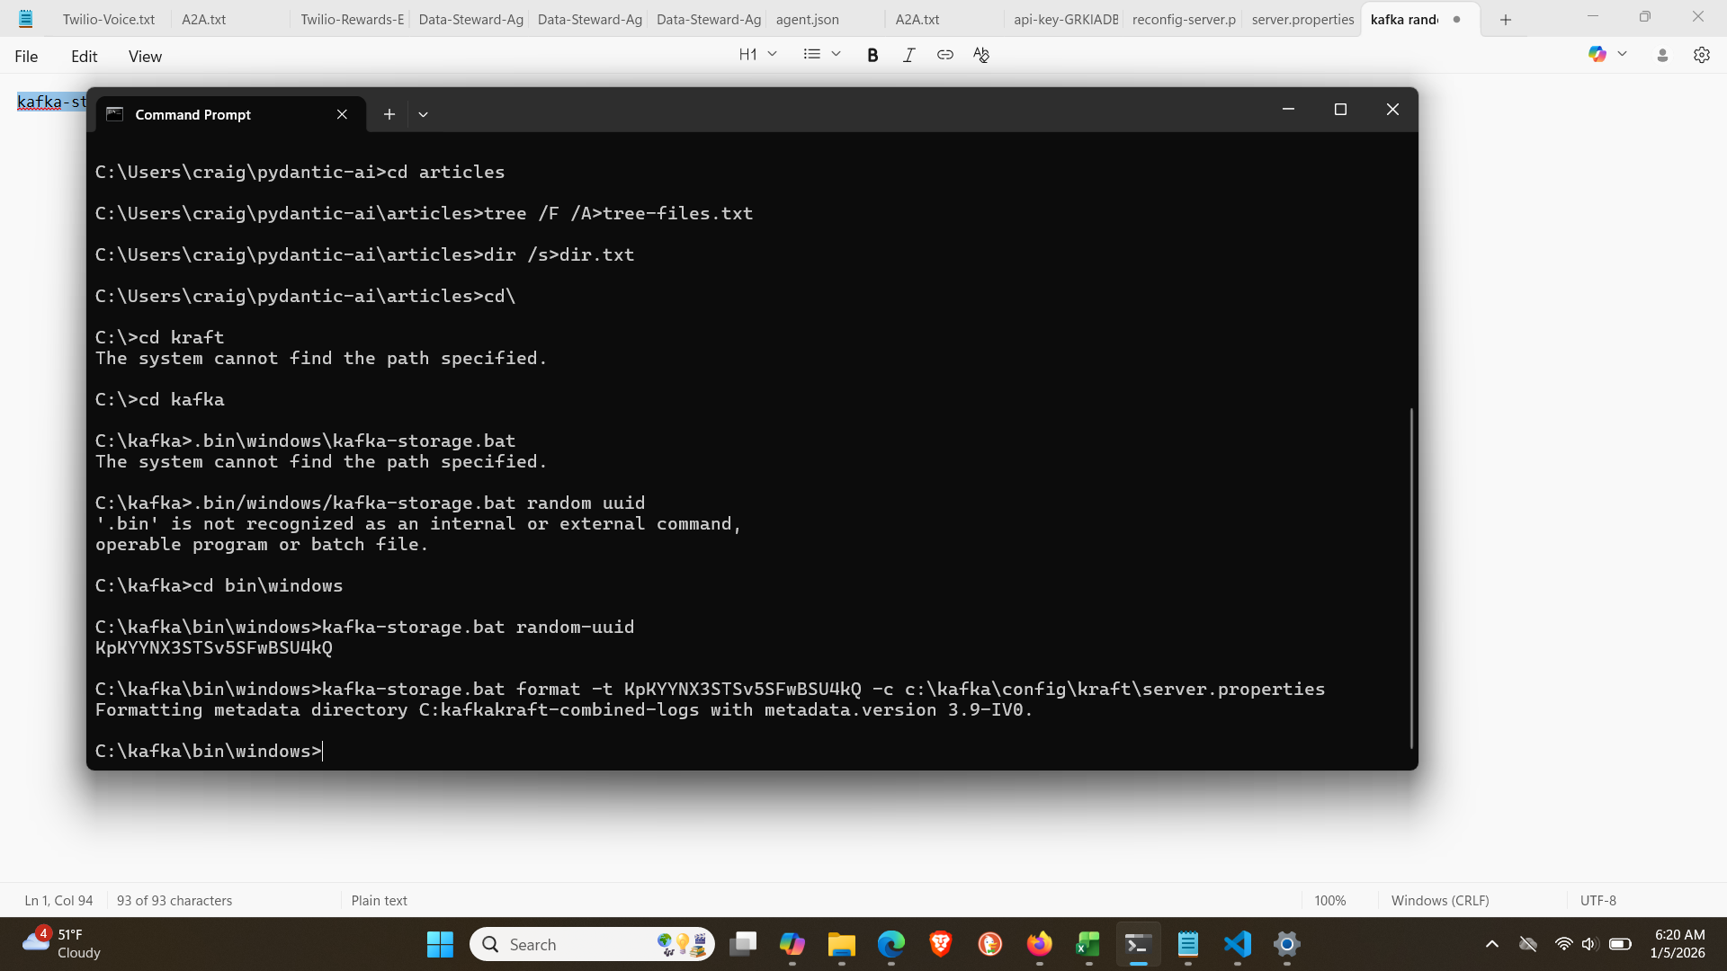
kafka-storage.bat format -t KpKYYNX3STSv5SFwBSU4kQ -c c:\kafka\config\kraft\server.properties

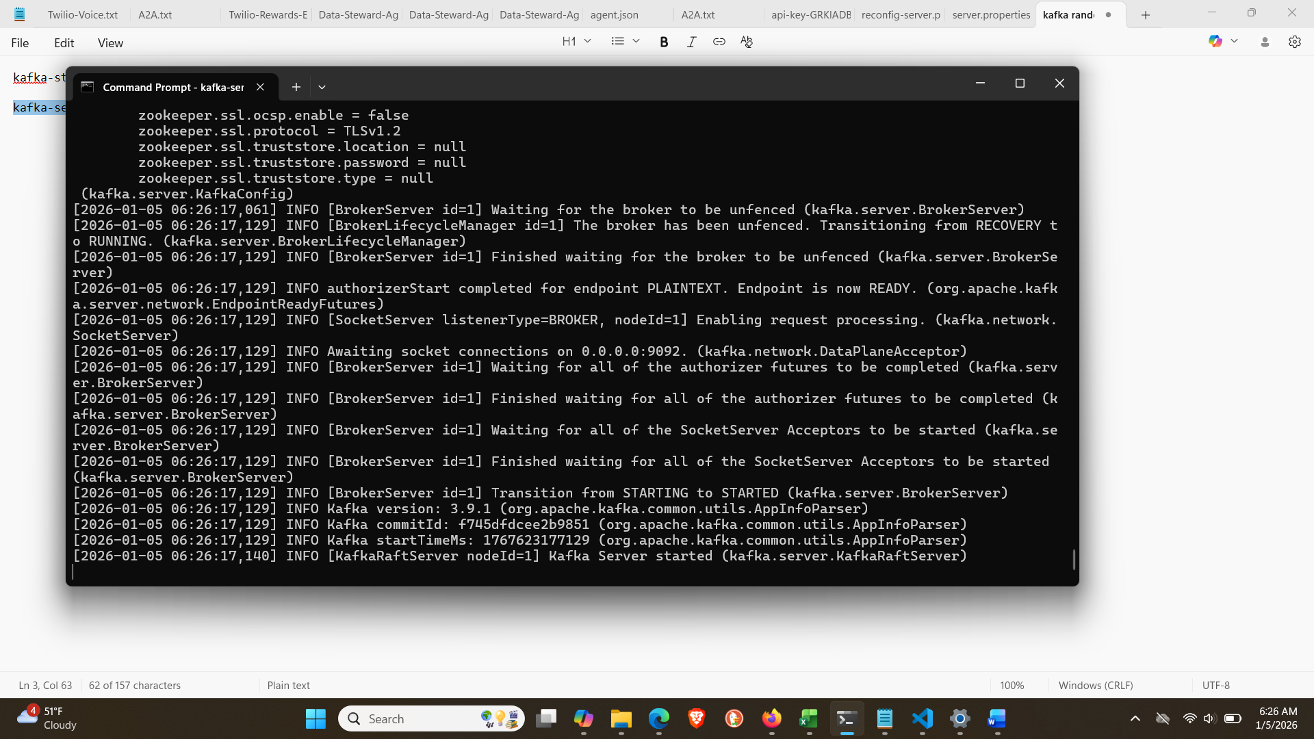
kafka-server-start.bat c:\kafka\config\kraft\server.properties

kafka-topics.bat –create --topic

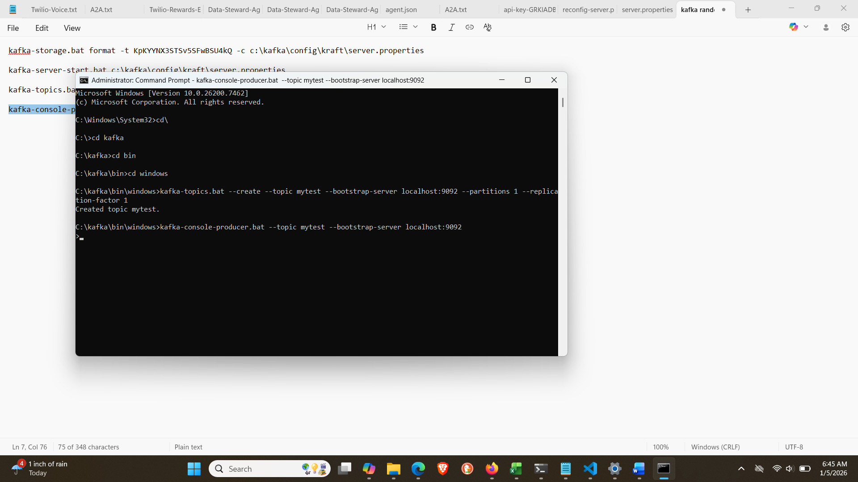
kafka-console-producer.bat --topic mytest --bootstrap-server localhost:9092

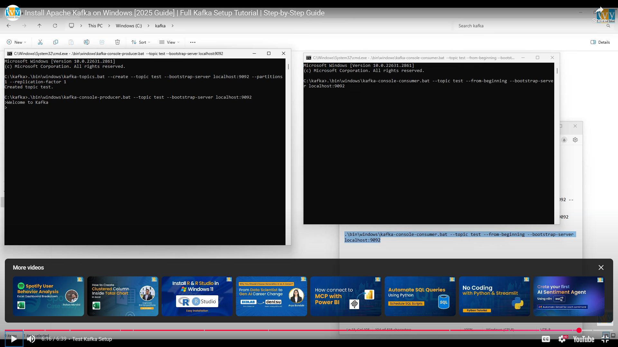

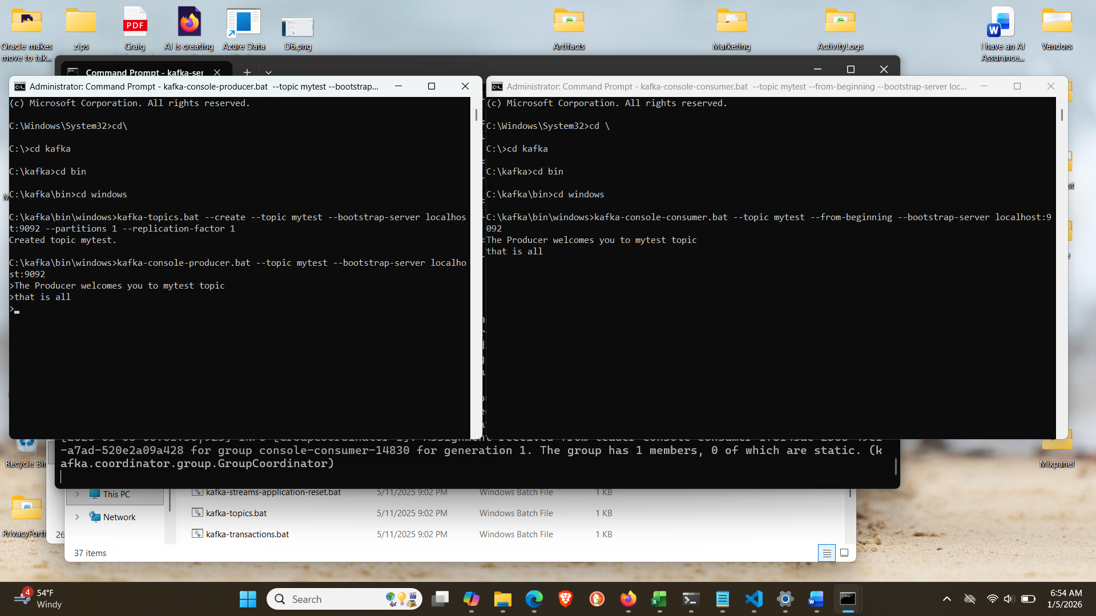

kafka-console-consumer.bat --topic mytest --from-beginning --bootstrap-server localhost:9092
AdminClient Lifecycle: Creating, Configuring and Closing
In order to use Kafka’s AdminClient, the first thing you have to do is construct an instance of the AdminClient class. This is quite straight forward:
Properties props = new Properties(); props.put(AdminClientConfig.BOOTSTRAP_SERVERS_CONFIG, "local AdminClient admin = AdminClient.create(props);
// TODO: Do something useful with AdminClient
admin.close(Duration.ofSeconds(30));

1/13/2026:
From Logging.docx:
4. Route
Kafka topics should be purpose-built, not generic.
Recommended topics:
- agent.lifecycle
- agent.activity
- agent.negotiation
- agent.decisions
- provider.calls
- provider.errors
- audit.events
- task.events
- task.traces
- security.events

1. Topic taxonomy
Topic name | Domain focus | Typical producers | Typical consumers
agent.lifecycle | Creation, registration, status changes | Onboarding flows, registry services | Dashboards, audit, risk scoring
agent.activity | Routine agent actions | Door-Keeper, Solicitor-General, tools | Analytics, behavior modeling, anomaly detect
agent.negotiation | Negotiation steps and outcomes | Solicitor-General, complaint/reward flows | Assurance, replay, dispute resolution
task.events | Task creation, updates, completion | Orchestrators, workflows, schedulers | Orchestration, monitoring, replay
task.traces | Fine-grained execution traces | Workers, tools, adapters | Debugging, performance analysis
provider.calls | All external provider invocations | LLM clients, external tools, providers adapters | Costing, performance, vendor liability
provider.errors | Failures from providers | Same as above | Reliability, alerting, vendor eval
audit.events | Security/compliance relevant events | Everywhere: API GW, auth, access control, critical ops | Compliance, legal, incident response
security.events | Authz failures, abuse, anomaly signals | Authorizers, WAF, Door-Keeper, fraud detectors | Security ops, automated mitigation
platform.events | Infra/ops events | Deploy systems, health checks, infra monitoring | SRE, status pages
All messages in all topics use the same envelope schema; only eventType and payload differ.

2. Retention and compaction strategy
You can tune per topic; here’s a strong default:
- agent.lifecycle
  - Retention: very long (e.g., 365+ days)
  - Compaction: enabled (compacted by agentId to keep latest state while preserving key lifecycle events if needed via eventType)
  - Usage: reconstruct agent registry, show latest agent state
- agent.activity
  - Retention: moderate to long (30–180 days depending on storage/cost)
  - Compaction: off (you care about each action)
  - Usage: behavioral analytics, funnels, engagement modeling
- agent.negotiation
  - Retention: long (365+ days or legal constraint)
  - Compaction: off (each negotiation step matters)
  - Usage: replay negotiation threads; show “case file” for a complaint or dispute
- task.events
  - Retention: moderate (30–90 days; longer if needed for replay)
  - Compaction: optional by taskId if you want quick “latest status” views
  - Usage: show task lifecycle, orchestrator dashboards
- task.traces
  - Retention: shorter (7–30 days)
  - Compaction: off (fine-grained debugging, high volume)
  - Usage: debugging, performance tuning
- provider.calls
  - Retention: moderate to long (90–365 days)
  - Compaction: off
  - Usage: cost and performance analytics, vendor liability evidence
- provider.errors
  - Retention: moderate (90–365 days)
  - Compaction: off
  - Usage: reliability metrics, SLO breach analysis, provider scorecards
- audit.events
  - Retention: very long (policy-driven; often 365+ days)
  - Compaction: off (you don’t want to lose audit history)
  - Usage: formal audit, DSAR evidence, regulator inquiries
- security.events
  - Retention: long (180–365 days; align with security policy)
  - Compaction: off
  - Usage: incident response, threat hunting, abuse investigations
- platform.events
  - Retention: moderate (30–90 days)
  - Compaction: optional depending on volume
  - Usage: SRE, operational health trends

3. Partitioning strategy
Partitioning should help you:
- Retain ordering within a logical stream
- Distribute load predictably
- Avoid hot partitions
Recommended keys:
- agent.lifecycle
  - Partition key: agentId
  - Guarantees ordering of lifecycle events per agent.
- agent.activity
  - Partition key: agentId (or correlationId for flows tied to a single journey)
  - Gets per-agent sequential behavior.
- agent.negotiation
  - Partition key: correlationId (or negotiationId if you mint one)
  - Ensures all steps in a negotiation are in order in the same partition.
- task.events
  - Partition key: taskId
  - Task state changes stay ordered.
- task.traces
  - Partition key: taskId or correlationId
  - You can replay all trace segments in order.
- provider.calls
  - Partition key: provider.requestId or correlationId
  - Allows replay/analysis of one call’s lifecycle.
- provider.errors
  - Partition key: provider.requestId or correlationId
  - Same as calls; easy to join with provider.calls.
- audit.events
  - Partition key: principalId or agentId
  - Makes it easy to query all audit-relevant events for a specific actor.
- security.events
  - Partition key: principalId or IP/correlationId
  - Useful for abuse patterns.
- platform.events
  - Partition key: service name or host ID
  - Keeps infra logs grouped by component.

4. Event type conventions
Within the envelope, define stable eventType names to ensure semantic clarity. For example:
- agent.lifecycle.created
- agent.lifecycle.registered
- agent.lifecycle.deactivated
- agent.activity.invocation
- agent.activity.state-changed
- agent.negotiation.started
- agent.negotiation.message.sent
- agent.negotiation.message.received
- agent.negotiation.resolved
- provider.call.started
- provider.call.completed
- provider.call.failed
- audit.event.access-granted
- audit.event.access-denied
- audit.event.data-exported
- audit.event.policy-updated
- security.event.suspicious-activity
- security.event.abuse-detected
All of them share the same envelope schema; only payload changes per eventType.
`

