# Introduction

The statement "Smartphones have revolutionised the way we shop" is one that I believe to be true, though the market and key technologies remain the need to make further advances to fulfil the claim more solidly.

GIVE DEFINITION OF REVOLUTIONARY

To look into further depth behind my reasons for this, this report gives an insight into how much smartphones have developed in terms of shopping support, and how they have become a more prominent force in quicker purchases, advertising and ease of use for shoppers. Social, ethical and legal issues have also been considered in my decision, looking at what restrictions shopping through a smartphone may occur compared to contemporary face to face shopping. /par

As with any argument, an opposing opinion has also been considered, in order to back up my own personal choice by comparing the two.

# Key technologies in the shopping market

Upon investigating the major advances made in the retail market since the introduction and rise of smartphones, several papers and statically reports provided useful in analysing the statement mentioned earlier. In a paper by M. K. Janiak \cite{overview}, they give a good overview of new technologies offered by the smartphone market in terms of retail experiences, and break the advances into seven main categories as shown in figure 1. \par

--- Ref

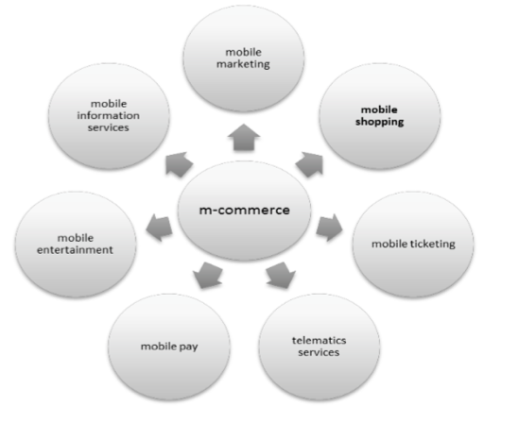

By having a look at some of the major categories defined in this paper, examples of these technologies will provide support for the argument that the statement is true. One clear great advantage that comes with the post 2010 era of mobile phones is the availability to pay for products in a number of retailers and food outlets directly via a phone’s near-field communication functionality. \par

With application such as Apple pay and Android pay (Though this is only yet released in the US as of the time of this paper) now usabile in an increasing number of businesses, consumers have gained from the speed of transactions, and the reduced need to have either cash or card on their person when shopping. Figure 2 shows that although this is early

--- Ref

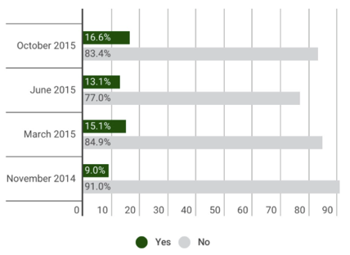

<http://www.pymnts.com/news/2015/new-apple-pay-adoption-numbers/>

pymnts 2015

----

One click buy on amazon, the ability to buy quickly, security implications

QR codes

Uses of location for unique discounts when entering shops

Mobile web sites with means of purchase, even if they are small and do not have an app

Browsing Internet at any time to be able to purchase on the fly- 4g

--- Ref

1. Enhanced usability: the ability of the smartphone to enable users to enjoy seamless Internet services (*Okazaki/Navarro-Bailo ́n/Molina-Castillo* 2012);
2. (2)  Ubiquity: the possibility of using the smartphone anywhere and anytime (*Cox* 2004; *Wagner* 2011);
3. (3)  Synchronicity: the ability of the smartphone to syn- chronize temporally and spatially consumers’ needs (*Shankar et al.* 2010);
4. (4)  All in one: the ability to perform multiple tasks and to use multiple applications in one tool (*Barkhuus/ Polichar* 2011).

<http://www.igr.univ-rennes1.fr/sites/default/files/fichier-publication/Marketing%20ZFP%202-2014%20Cliquet_et_al.pdf>

Shopping with a Smartphone: A French-Japanese Perspective

Ge ́rard Cliquet 2014

----

Deals, gambling and prices can be updates instantly in real time. Gets offers to users as soon as possible

Social media effects

Support from staff of companies to help customers

# Legal, social and ethical implications of key technologies

Privacy of users, location and shopping habbits

Data protection act, Privacy acts etc.

Passwords on phones, being watched by others, or people see banking details

Security of QR codes?

# Arguments against revololutionary shopping through smartphones

Entire population effected?

Age and ability of user?

Can it be better?

# Conclusion