**Frontend Development Assignment**

In this assignment, you are asked to develop a section on a page using React components. There is no perfect answer and the components can be developed in many different ways. Here, we just want to have a clean and maintainable implementation from your perspective.

**Description**

Assume that you are tasked with developing the following section:

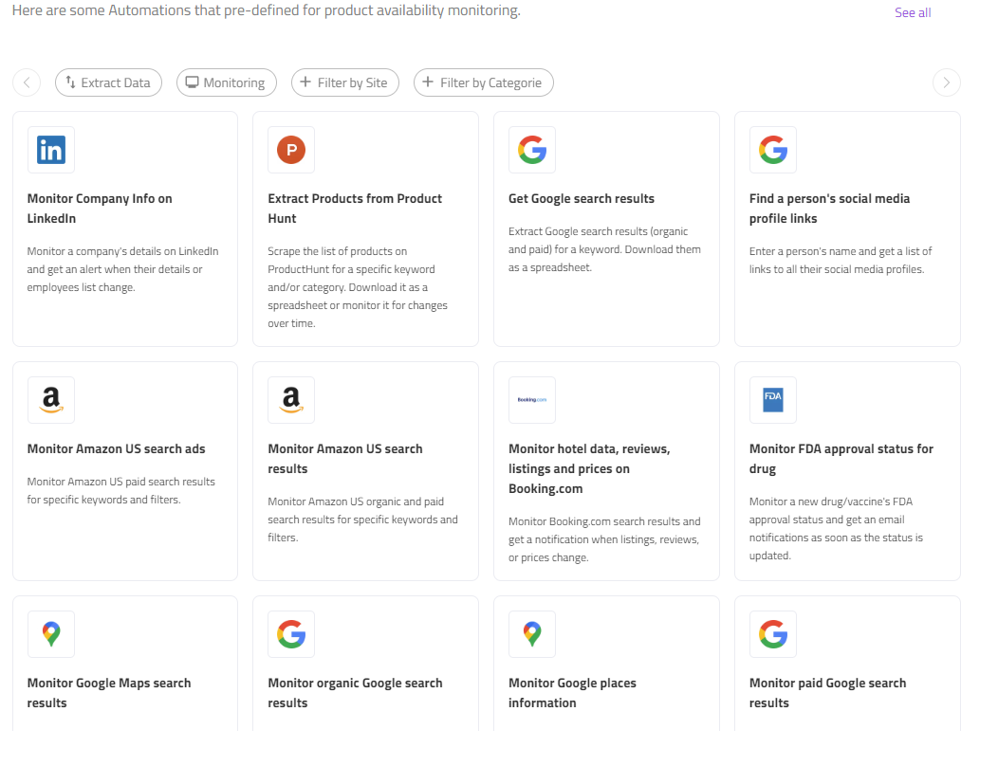

The more challenging part of this design is the filters section at the top. In this section, the user can select from the following filters to narrow down the list of automations that are displayed:

* Extract data (yes or no)
* Monitor (yes or no)
* Filter by Site (multiple select)
  + ProductHunt
  + Indeed
  + LinkedIn
  + Eventbrite
  + …
* Filter by Category (single select)
  + SEO
  + Competitive Intelligence

All the automations will be pre-loaded as soon as the page loads. For the purpose of your assignment, let’s assume that the backend is still under development and you are provided with the following sample JSON to use in your development:



The implementation has to be accessible, compatible with mobile devices, and responsive. Only function components are allowed and styles must be organized in a component-based manner wherever possible.

Multiple filters can be applied and should have a scrolling functionality

**Bonus points**

* Animations in filter components when a filter is selected, unselected or upon scrolling.
* CSS Modules is preferred.
* Unit Tests
* Automation Tests

(Dont forget to add the scripts to run these in the package.json and add the relevant steps into your readme file)

**Design**

A list of automations is designed below. This list can be filtered by our new components: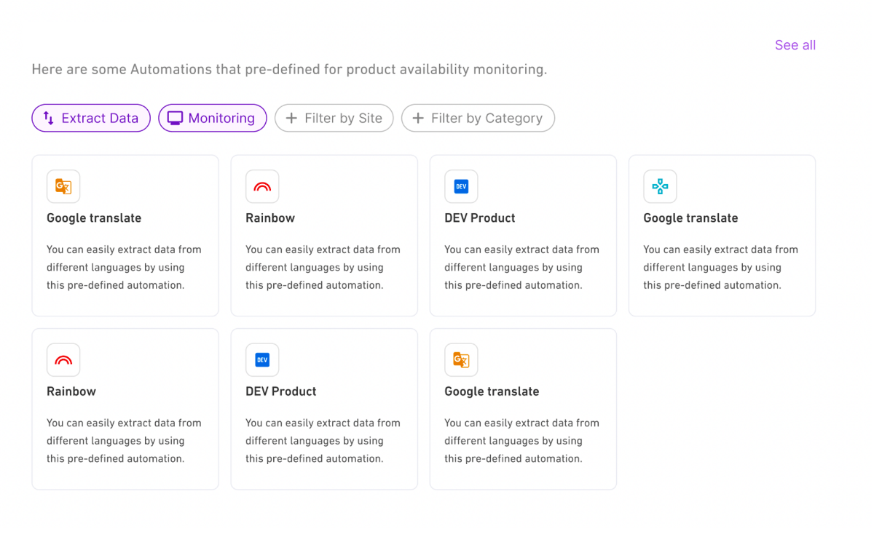

There are 3 type of filters:

**A. Switch Chip** These chips have two state: On or Off

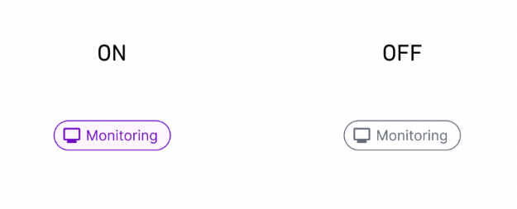

**B. Single/Multiple Select Chips** These are clickable and after click they do a job.

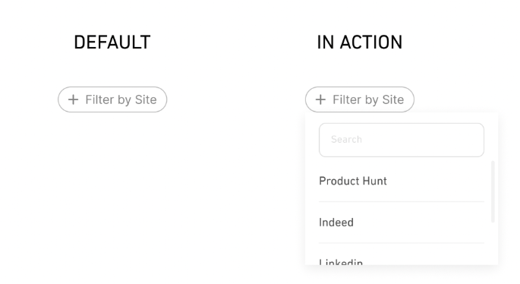

**C. Selected Chips** These are not selectable, they appear when we have an option selected in a select. They are removable.

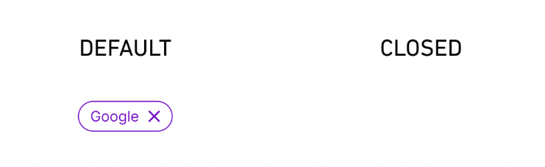

Multiple Filters: Multiple filters can be applied and should scroll.

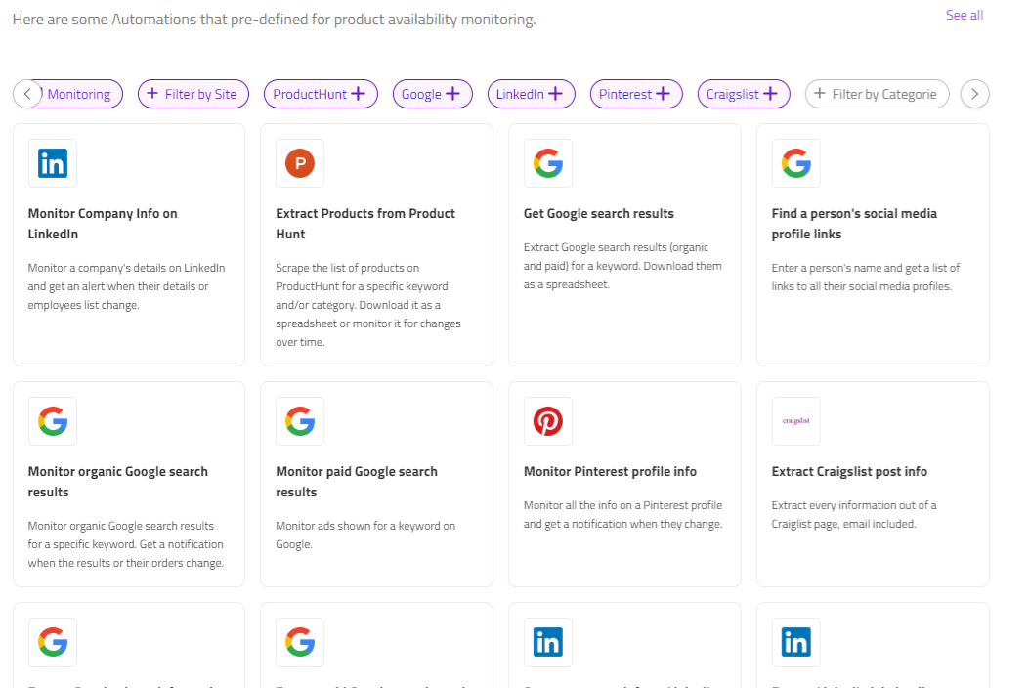

**User Flow:**



**Responsiveness**

If the filters went to the out of our container, the Arrow Button appears at the end/beginning of row. With clicking on the Arrow, All chips slides to the side:

**Deliverables**

The code has to be committed to a public Github repository.

It should also be deployed to a test environment. The link to this environment should be in your repository’s Readme file. The Readme file should also contain brief instructions for running the project locally.