I am not exactly sure what we are supposed to do for this report. So, I included the questions I had and the research I did. I also included a comment I posted in the forum.

Questions:

1. What is a Float Label?
   1. <https://material.io/develop/web/components/input-controls/floating-label/>
   2. <https://bradfrost.com/blog/post/float-label-pattern/>
   3. <https://css-tricks.com/float-labels-css/>
2. I was told never to use placeholder text as a label, in part because screen-readers can't read it and it will hurt SEO. Is this true about a Float Label?
   1. Brad frost blog answers this question under the inline label pros/cons section <https://bradfrost.com/blog/post/float-label-pattern/>
3. How do I find the code for the one input credit card example by Brad Frost
   1. Found at [bradfrost.com](https://bradfrost.com/blog/post/single-field-credit-card-input-pattern/)
   2. [Github](https://github.com/zdfs/toscani/)
4. Where is example code for the advertising as a parabolic scroll with rise from bottom nav in video 5 at 4 minutes?

Comments:

I hope the following comments aren't interpreted as blasphemy by worshipers of the Google Gods. I sold websites to some of the nations high producing auto dealerships. They live and die by these websites. I fully agree that speed should be optimized for the user. However, I feel the following statistic from the Sitepoint video [Master Mobile UX (Links to an external site.)](https://www.sitepoint.com/premium/courses/master-mobile-ux-2952) (lesson 1, step 2 approx 5 min mark) can be very misleading. Many of my customers were in Miami. I had the number one volume Lamborghini, Pagani, BMW, Mercedes Benz AMG, Porsche, Ford, and Kia dealers for my customers.

When you read in the slide below that only 1.77% of the world has 4G access, process that information intelligently. My competitors tried to sell their sites mostly on ratings like [PageSpeed Insights (Links to an external site.)](https://developers.google.com/speed/pagespeed/insights/" \t "_blank). I sold my customers on not being a mindless follower. Even most people who purchase a KIA are in the top 1% by the whole world standard. In Miami there are few places without fast 4G LTE speeds. The experience my websites offered converted more customers than my competitors. If you believe I speak heresy and am definitely wrong, test Amazon (highest conversion), most of Google's, and Apple's website, SRP and product pages. Because they obviously have something to learn based on their scores.  I am not blasting common sense; simply advocating the use of grey-matter.  I am saying, build for your customers' best interest. Stripped-down ultra-fast sites save Google indexing costs and make AdSense ads look better, but is that your ultimate goal?  [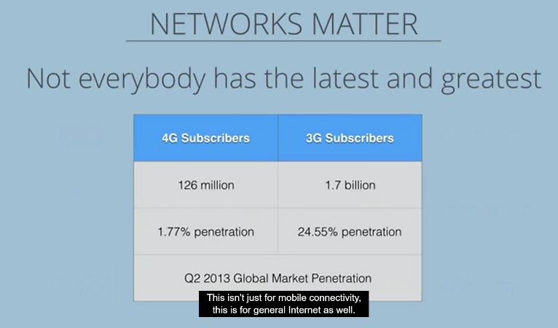](https://www.sitepoint.com/premium/courses/master-mobile-ux-2952/lesson/1/step/2)